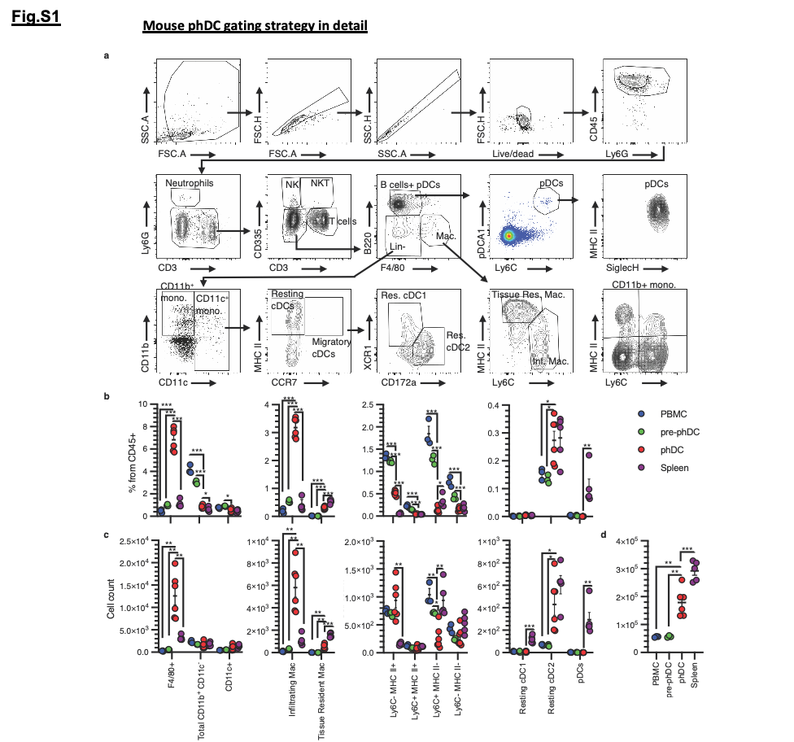
Fig S1. Mouse peripheral blood monocyte transactivation in the Transimmune (TI) plate leads to their stimulation and differentiation to physiological dendritic cells (phDCs). (a) Gating strategy for dendritic cells and innate immune cell HD-FCM immunophenotyping. (b-d). Quantification of innate immune cell subset frequencies from CD45⁺ cells (b) and total numbers (c) and total CD45⁺ numbers (d) in PBMC, pre-phDC, phDC and splenocytes analyzed by HD-FCM (a). * p < 0.05, ** p < 0.005, *** pv< 0.0005. N = 3 for PBMC and pre-phDC, 6 for phDC, and 5 for splenocytes.

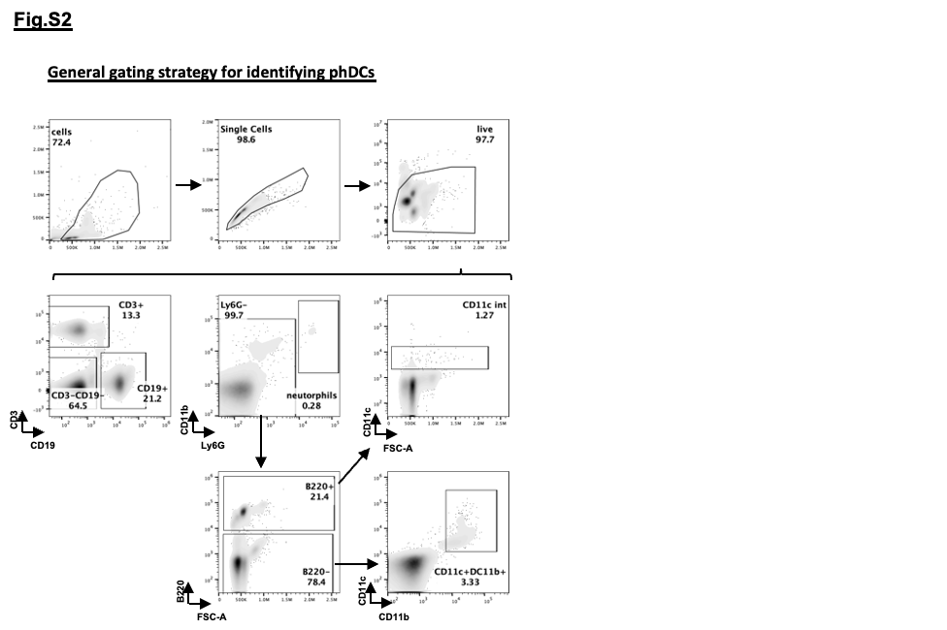

Fig S2. Gating strategy to identify murine phDCs for subsequent analysis. FACs analysis of PBMC that were plate-passed via TI plate. PhDC, which differentiate from circulating monocytes, are identified by gating out neutrophils (Ly6G+) and plasmacytoid DC (B220+) from the PBMC. PhDC are predominantly positive for CD11b+.

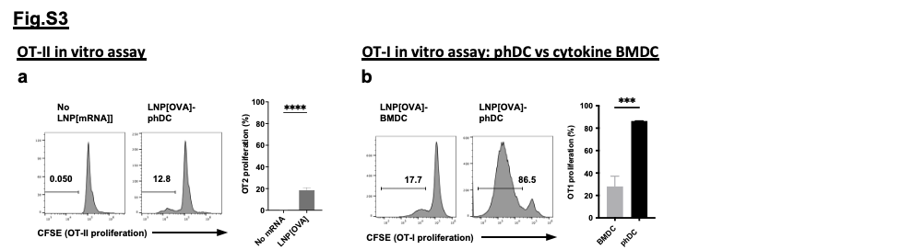

Fig S3. a, Evaluating the capacity of the LNP[OVA]-phDC to stimulate OVA specific CD4⁺ T cells via OT-II in vitro stimulation assay. Similarly to the OT-I assay, phDC transfected with LNP[OVA] were co-incubated with CFSE labeled OT-II cells (splenic CD4⁺ T cells isolated from OT-II mice), which were then analyzed via FACs for cell proliferation activity via CFSE diminution level on the CD4⁺ OT-II cells. b, Comparison of OT-I stimulation level between phDC and cytokine derived BMDC that were pulsed with LNP[OVA]. Bar graph comparing the percentage of OT-I T cells with CFSE diminution. (n=3-4, one-way ANOVA or student’s t-test analysis, mean ± s.d.).

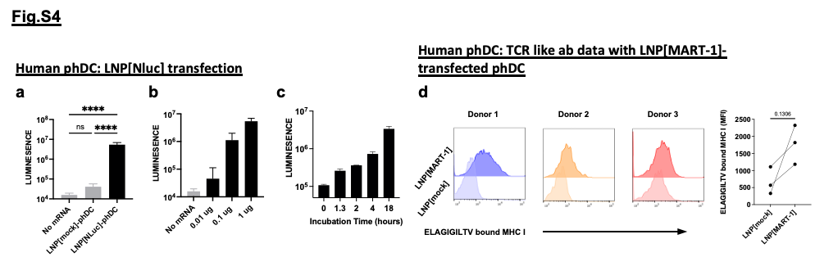

Fig S4. a, PhDC generated from human PBMC were transfected over-night with LNP[NLuc]. Subsequently, luciferase substrate was added to the cells for detecting luminescence signal. Bar graph showing signal comparison to phDC that were transfected with LNP[mock] or received no LNP[mRNA] (1 ug/ml of mRNA used for NLuc and mock). b, Signal observed in phDC that were transfected over-night with ranging LNP[mRNA] dose (0.01-1 ug/ml). c, Signal observed in phDC transfected with LNP[NLuc] (1 ug/ml) at ranging incubation period (1.3 hr to 18 hr). (a-c, n=12 from 4 donors for each group, one-way ANOVA mean ± s.d). d, Surface expression of ELAGIGILTV bound MHC-I was detected on phDCs transfected with MART-1 peptide (ELAGIGILTV) mRNA encapsulating LNP (LNP[MART-1]) using TCR like antibody. PhDC was generated from 3 separate HLA-A2 donors. Signal comparison on phDC (CD14⁺ subset) that were transfected with LNP[mock] is shown in histograms and line graph (MFI, 3 donors, one-way ANOVA mean ± s.d).

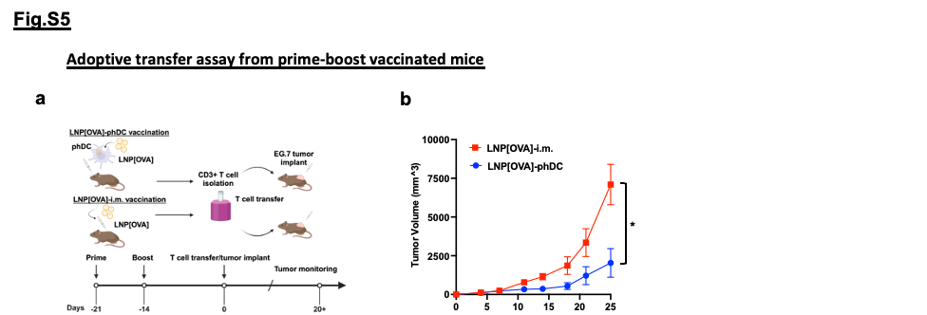

Fig S5. a, Schematic description of CD3⁺ T cell adoptive transfer assay using mice vaccinated with LNP[OVA]-phDC or LNP[OVA]-i.m. as is injection. CD3⁺ splenocytes isolated from respective groups are transferred into naïve mice that are freshly implanted with EG.7 tumor cells (s.c.). b, Tumor size kinetics between the two groups. (n=5-20 mice, student’s t-test analysis, mean ± s.e.m.).

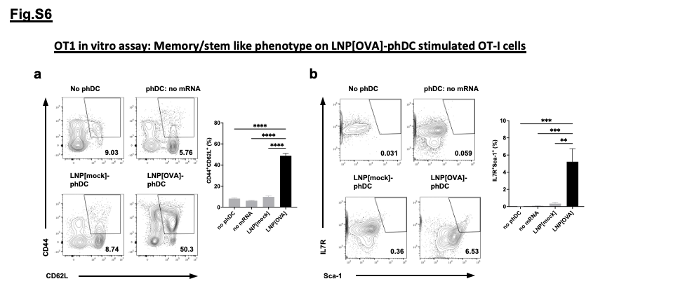

Fig S6. Phenotypic profile of the OT-I T cells after in vitro co-incubation with phDC. a, FACs plot showing CD44 and CD62L expression level on the CD8⁺ OT-I T cells after 3-day incubation without phDC, phDC without LNP-mRNA transfection, phDC transfected with LNP[mock] or phDC transfected with LNP[OVA]. Bar graph comparing the percentage of CD44⁺CD62L⁺ (central memory phenotype) in the CD8⁺ subset. b, FACs plot and bar graph of IL7R and Sca-1 expression level on the CD8⁺ OT-I T cells after the 3-day co-incubation period. (n=3-4, one-way ANOVA analysis, mean ± s.d.).

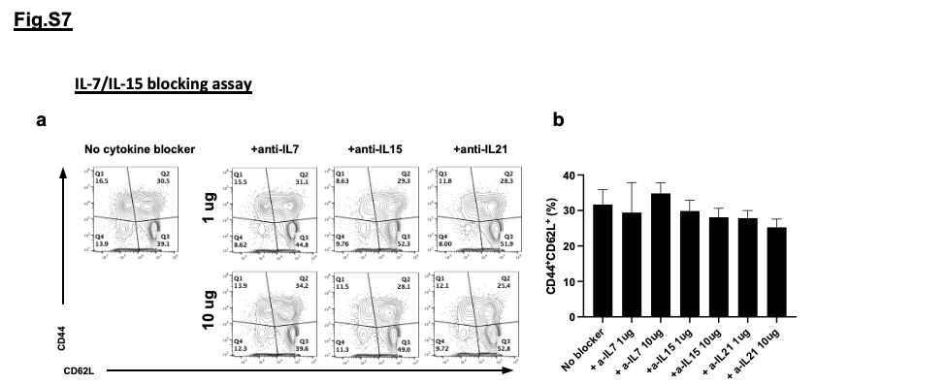

Fig S7. CD8 T cells isolated from OT-1 mice were co-cultured with OVA mRNA LNP transfected phDC, with or without blocking antibody against IL-7 (Clone A7R34), IL-15 (Clone GRW15PLZ) or IL-21 (Clone 4A9) (at 1 ug/ml or 10 ug/ml). After the 3-day co-incubation period, cells were analyzed via FACs for CD44/CD62L surface expression. a, FACs plot showing CD44/CD62L expression on CD8⁺ OT-1 T cells. b, Bar graph showing the frequency of CD44⁺CD62L⁺ population in each groups (no statistical differences, mean ± s.d.).

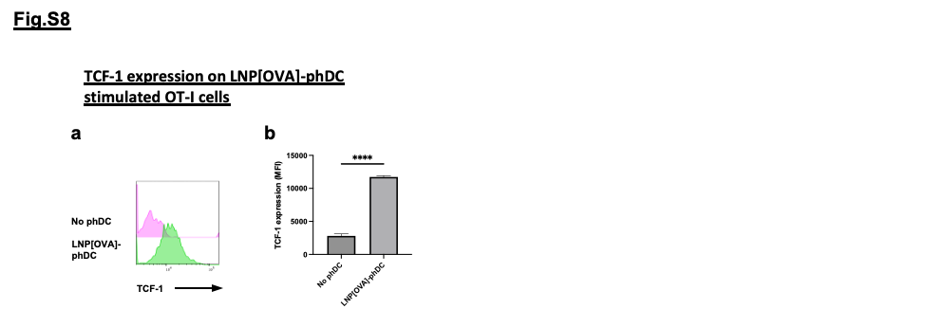

Fig S8. Evaluation of TCF-1 expression level in OT-I T cells that were stimulated in vitro with LNP[OVA]-phDC. 3 days post co-culture, cells were harvested and analyzed via FACs. a, Intracellular TCF-1 expression level in OT-I T cells stimulated by LNP[OVA]-phDC or non-transfected phDC. b, Bar graph comparing the TCF-1 MFI level between the two groups (n=3, student t-test mean ± s.d.).

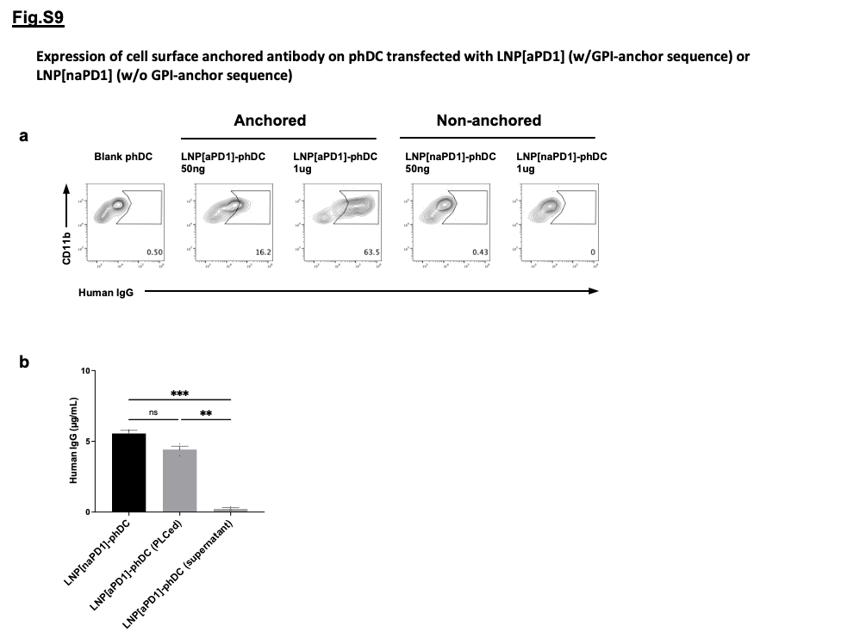

Fig S9. a, Murine phDC was transfected with LNP[aPD1] (mRNA encoding for anti-mouse PD1 antibody with human IgG Fc-backbone that includes GPI-anchor sequence) or LNP[naPD1] (mRNA that does not include the GPI-anchor sequence). mRNA-LNP was used at either 50 ng/ml or 1ug/ml respectively. Surface expression of human IgG was assessed on the CD11b⁺ murine phDC after over-night transfection. Expression level on non-transfected phDC shown as control. b, Antibody production and detection of non-anchored and anchored forms of anti-mouse PD1 antibodies in culture supernatant of transfected cells. Antibodies were produced in Expi293F expression system and detected by ELISA directly in the supernatant, or after treatment with PLC to release GPI-anchored antibodies from the cell membrane (n=3/group).

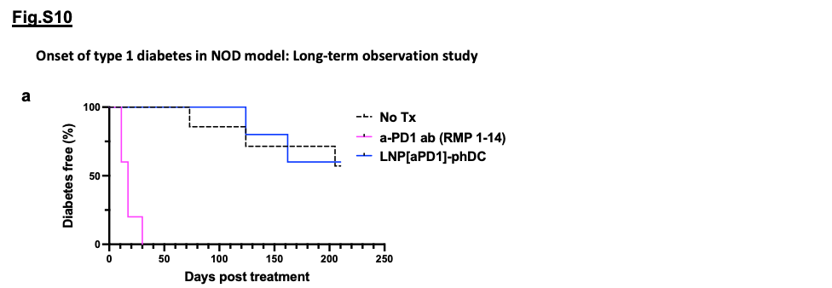

Fig S10. a, NOD mice were treated with anti-mouse PD1 antibody (RMP 1-14, 200 ug/mouse) or LNP[aPD1]-phDC (200 ng/mouse) 2 times a week for total of 6 treatments. Diagnosis of diabetes was made upon two-consecutive measurements of hyperglycemia (250 mg/dl). Long-term observation study of >200 days post treatment. (n=5-7 mice per group).

