BP Neural Network Model for Late-Night Effects Prediction in Postgraduates' Hypertension
Yanrui Chea, Guangqing Lia,*, Jingyao Lib,*
a College of Health Management, Jilin Medical University, Jilin 132013, China.
b School of Materials Science and Engineering, Jinlin Jianzhu University, Changchun 130000, China.
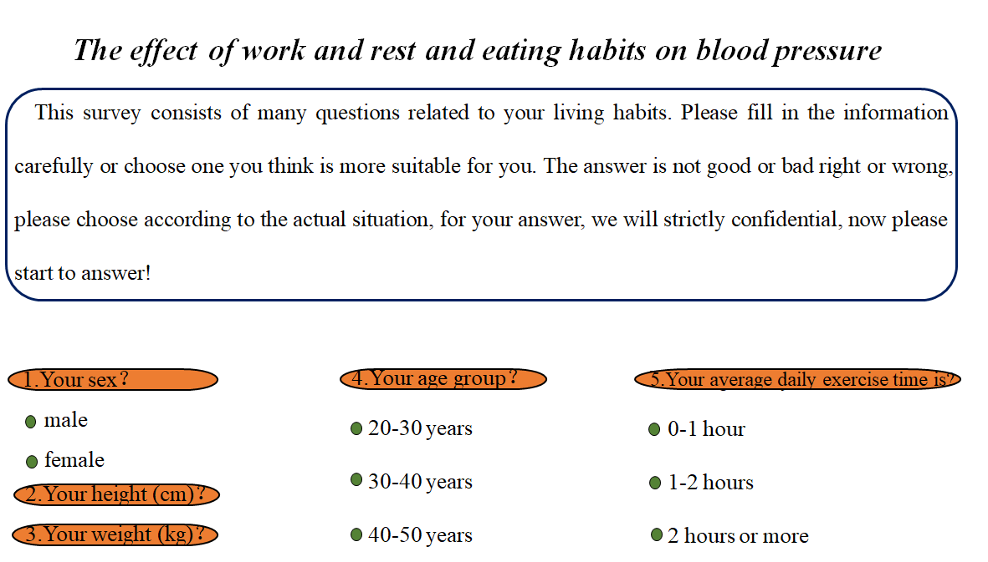
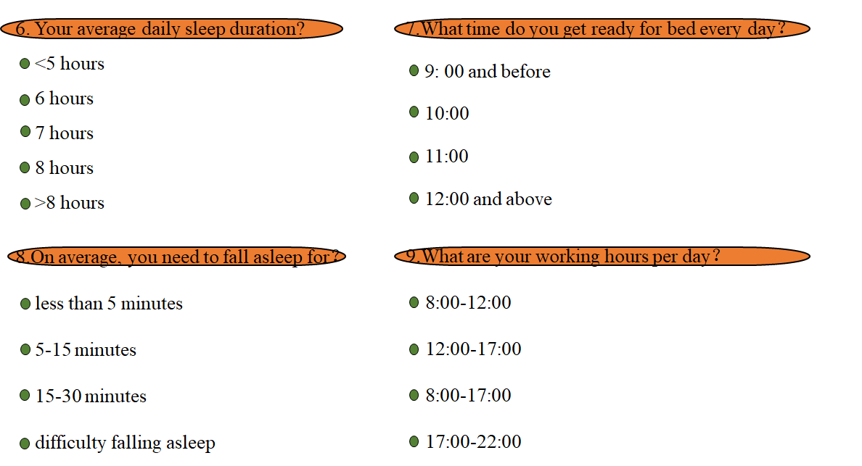
Data availability
The datasets generated during and analysed during the current study are available from
https://downdoc.wjx.cn/exceldown/255768450/255768450_%E6%8C%89%E6%96%87%E6%9C%AC_%E4%BD%9C%E6%81%AF%E4%B8%8E%E9%A5%AE%E9%A3%9F%E4%B9%A0%E6%83%AF%E5%AF%B9%E8%A1%80%E5%8E%8B%E7%9A%84%E5%BD%B1%E5%93%8D_122_120.xlsx?Expires=1739715895&OSSAccessKeyId=LTAIkYiHONyE2mHz&Signature=fOtcfD3xMIccDbYJrgFSvIz3hdQ%3D

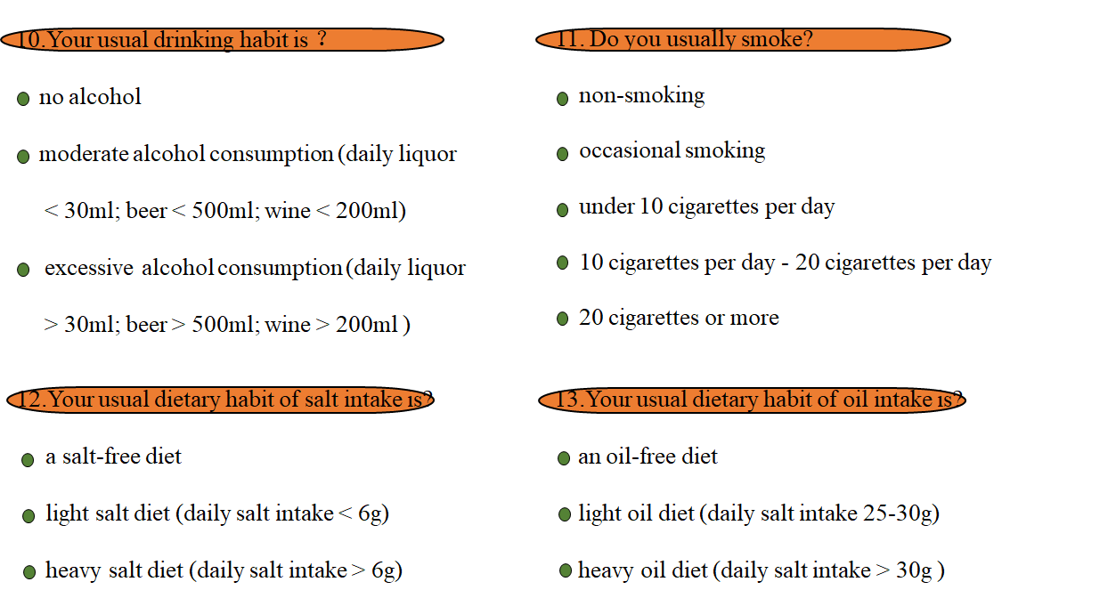
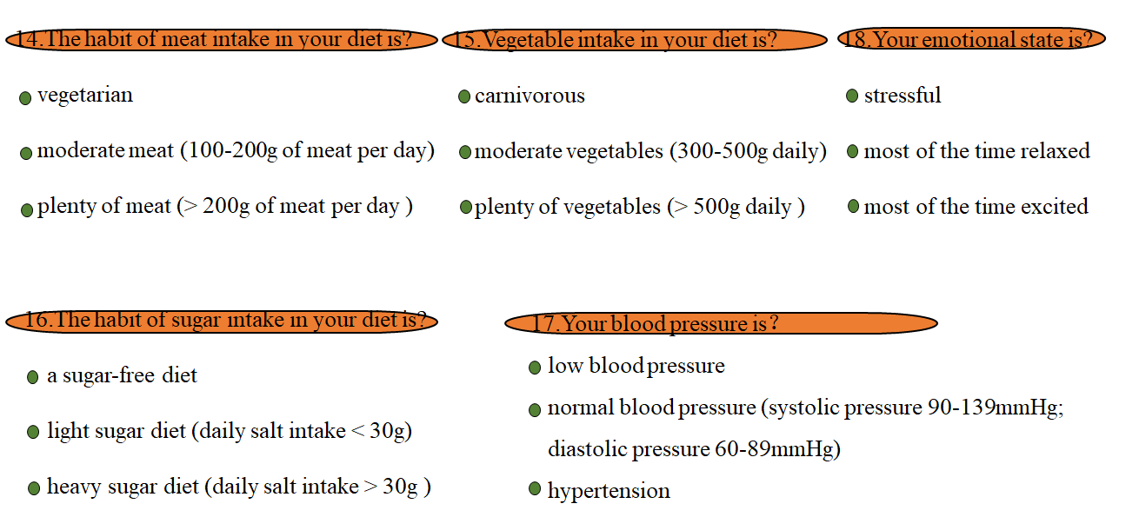
Fig. S1 Sample chart of the questionnaire

