Supplementary Materials

Supplementary Figure 1.
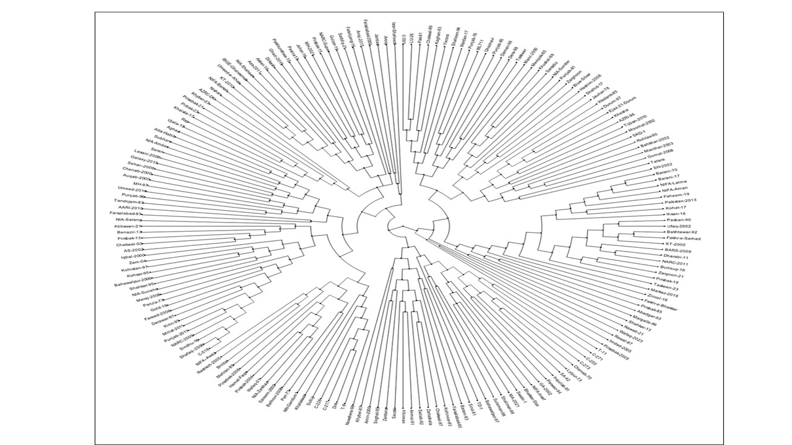
Fig S1. Genotypic diversity among 190 genotypes with neighbor-joining method

Supplementary Figure 2.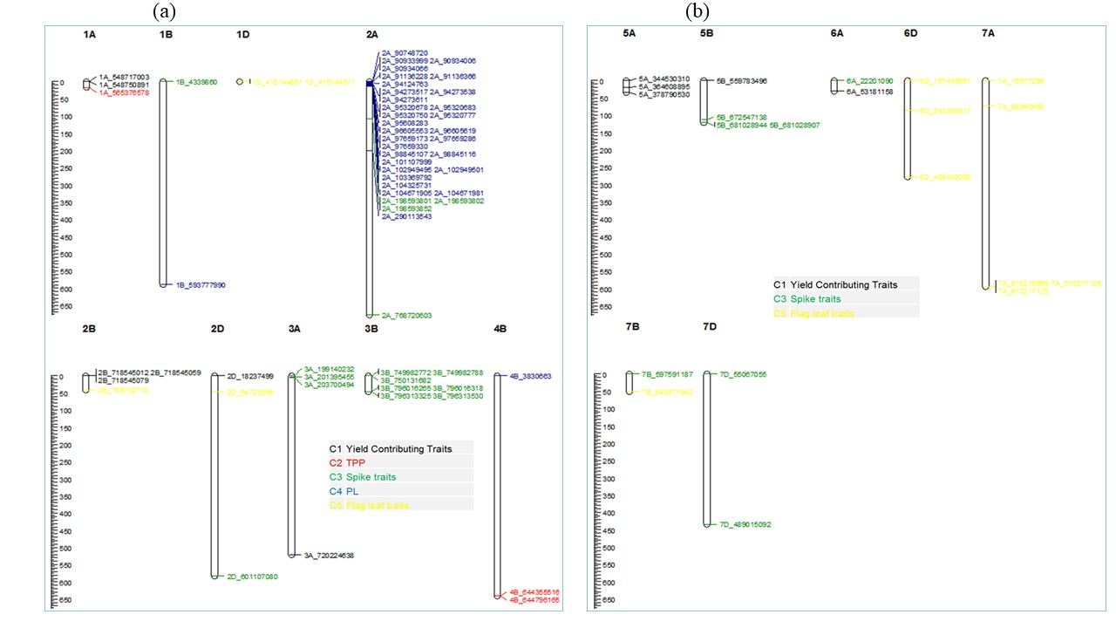
Fig S2. (a) Chromosomal maps showing the potential loci (at right) controlling the studied traits with the mega-base pair distance (Mbp); the scale shown at the left is the length of chromosome in mega-base pairs genotyped with SNPs; (b) Chromosomal maps showing the potential loci (at right) controlling the studied traits with the mega-base pair distance (Mbp); the scale shown at the left is the length of chromosome in mega-base pairs genotyped with SNPs

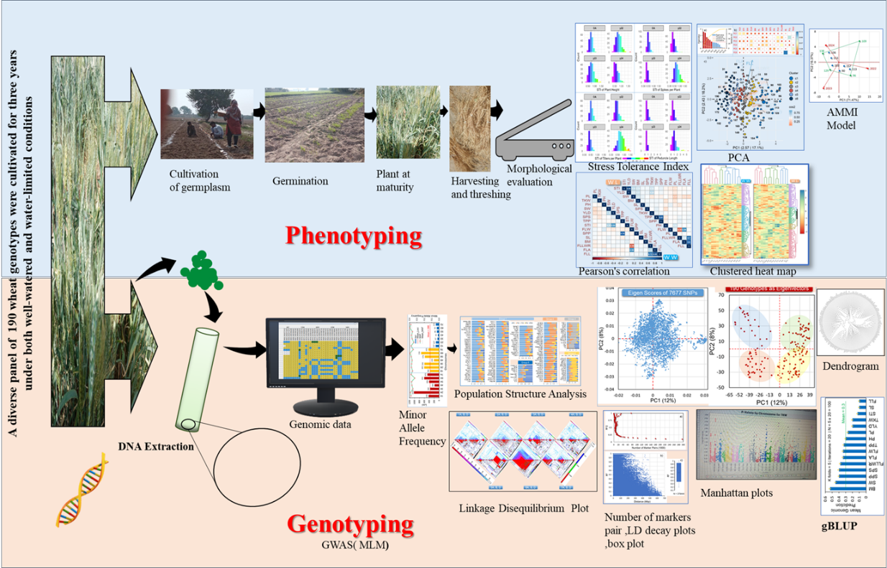

Fig S3. Graphical abstract: diverse panel of 190 genotypes, phenotypic and genotypic data used in genome-wide association study (GWAS) for genomic best linear unbiased genomic prediction (gBLUP) model.

Supplementary Table
Table S1 Pedigree of 190 genotypes studied
sn | Line ID | Pedigree
1 | T-9 | Selection from landrace
2 | T-11 | _
3 | Dirk | FORD/DONDEE ( I )
4 | C-518 | T9 × 8A
5 | C-591 | T9 × 8A
6 | C-228 | HARD FEDERATION X 9D
7 | C-217 | C 516 X C 591
8 | C-250 | Hard Federation x 9D
9 | C-271 | C 230 × IP 165
10 | C-273 | C 209 × C 591
11 | Mexipak-65 | PJ62/GB55
12 | Khushal-69 | 21931-CHAPINGO53/ANDES SIB/3/Y50/4/C271
13 | Chenab-70 | C271/WI(E)//SON64
14 | Barani-70 | PIT/GB//C271
15 | Blue-Silver | 1154388/NA/3/YT54/N10B/LR64
16 | SA-42 | NAI60/CB151//S949/3/MEXIPAK
17 | Lylpur-73 | BB/NOR67
18 | Pari-73 | CNO67//SN64/KLRE/3/8156
19 | Parula-73 | _
20 | Yecora | CNO67//SN64/KLRE/3/8156
21 | LU-26 | BLS/KHUSHAL
22 | Punjab-76 | NAI60/CB151//S949/3/MEXIPAK
23 | WL711 | S308/CHRIS//KAL
24 | Jauhar-78 | Nayab* (Fast neutran 600rads (Mutagensis)
25 | Zarghoon | CC-Inia/Tobari-C.fon/BB
26 | Pak-81 | KVZ//BUHO//KAL/BB
27 | Punjab-81 | KVZ//BUHO//KAL/BB
28 | Sind-81 | Norento x Mexipak
29 | Faisalabad-83 | FURY/KAL/BB
30 | Kohinoor-83 | OREF1158/FDL/MFN/2*TIBA63/3/COC
31 | Barani-83 | BB/GLL/3/GTO/7C//BB/CN0
32 | Faisalabad-85 | MAYA/MON//KVZ/TRM
33 | Sarsabz | BY/MAYA/4/BB//HD832.5.5/ON/3/CNO67/PJ62 or PITIC-62/FROND//MEXIPAK/3/PITIC-62/MAZOE-79-75-76 [wheatpedigree.net] or PI/FRND//MXP/3/PI/M20/79
34 | Tandojam-83 | TZPP/PL//7C
35 | Pirsbak-85 | KVZ/BUHO/BB
36 | Punjab-85 | KVZ/TRM//PTM/ANA
37 | Wadank-85 | GUIL/SNIPE//GDOVZ449
38 | Chakwal-86 | Fln/ACS//ANA
39 | Rawal-87 | MAYA/MON//KVZ/TRM
40 | Khyber-87 | KVZ/TRM//PTM/ANA-CM 43930
41 | Sutluj-86 | CMT/YR//MON
42 | Shalimar-88 | PB81/HD2182//PB81
43 | Zardana | Ciano"S" 67-8156 x Tobari-66-CNO 67/NOV-66/11-12300/LR6408156-PAN-76
44 | Mehran-89 | VEERY 'S'
45 | Rohtas-90 | INIA F 66/ A.DISTCHUM//INIA66/3/GEN
46 | Inquilab-91 | WL-711/CROW’S’
47 | Pasban-90 | INIA66/A. DISTT//INIA66/3/GEN
48 | Soghat-90 | Pavon Mutant-3
49 | Bakhtawar-92 | JUP/BJYG//URES
50 | Kaghan-93 | TTR/JUN
51 | Anmol-91 | KVZ/TRM//PTM/ANA
52 | Shaheen-94 | MLT"S"
53 | Parwaz-94 | V5648/PRL’S’ = V-87189
54 | Shahkar-95 | WL 711//F3.71/TRM
55 | Kohsar-95 | PSN/BOW
56 | Kirin-95 | WL-711/CROW’S’
57 | Nowshera-96 | BUCK/FLK//MYNA/VUL
58 | Punjab-96 | SA 42 *2/3/CC/INIA4// BB/4/INIA/HD832
59 | Suleman-96 | F-6.74/BUN//SIS/3/VEE #7 (F6)
60 | Abadgar-93 | CNO SIB/NO/3/C273//NP875/PI SIB/4/HD1981
62 | Tatara | JUP/ALO"S"//KLT"S"/3/VEE"S"
63 | AZRI-96 | MEN’ SIB/MY48//4/14/3/YAYLA 305
65 | Bahawalpur-97 | MTI ‘S’
66 | MH-97 | ATTILA = ND/VG9144/KAL/BB/3/YACO/4/VEE#5
67 | Kohistan-97 | V-1562//CHRC`S'/HORK/3/KUFRA-I/4/CARP`S'/BJY`S'
68 | Fakhr-e-Sarhad | PFAU"S"/SERI/BOW "S"
69 | Chakwal-97 | BUC'S' / FCT'S'
70 | Durum-97 | _
71 | Darawar-97 | SASONO KOMUGI/NORIN//BOB’S’
72 | Daman-98 | BOW”S”/3/CAR853/COC//VEE”S”,
73 | Dera-98 | F12-71/COC//CNO79
74 | Ghaznavi | _
75 | Zarlashata | Ures"s" / Bow
76 | Margalla-99 | OPATA/BOW'S'
77 | Bahawalpur-2000 | AU/UP301//GLL/Sx/3/PEW ‘S’/4/MAI ‘S’/MAY A ‘S’//PEW’S’
78 | Marvi-2000 | CMH-77 A917/KPV-1600//RL-6010/6*SKA
79 | Takbeer | _
80 | Iqbal-2000 | BURGUS/SORT 12-13//KAL/BB/3/PAK 81
81 | Auqab-2000 | CROW'S'/NAC//BOW'S'
82 | Amin-2000 | PASTOR/OPATA
83 | Saleem-2000 | CHAM-6//KITE/PGO
85 | Khatakwal | _
86 | Raj | KAUZ* 2/TRAP//KAUZ
87 | Chenab-2000 | CHUM18/BAU
88 | Wafaq-01 | OPATA/RAYON//KAUZ
89 | SH-2002 | INQ91/FINK’S’
90 | Bahkhar-2002 | P20102//PIMA/SKA/3/TTR 'S' /BOW
91 | AS-2002 | KHP/D31708//CM74A370/3/CIAN079/4/RL6043/*4NAC
92 | GA-2002 | DWL5023/SNB//SNB
93 | Ufaq-2002 | V.84133/V83150
94 | Manthar-2003 | KAUZ//ALTAR84/AOS
95 | KT-2000 | GEN#WHETON
96 | Pirsbak-2004 | KAUZ/STAR
97 | Bhittai | VEE/TRAP#1//SOGHAT-90
98 | Zam-04 | KAUZ* 2/OPATA//KAUZ
99 | TD-1 | H-68XMAISXNORTENO
100 | Pirsabak-2005 | MUNIA/SHTO//AMSEL
101 | Rashkoh-2005 | Cow"S"**/YACO//Cow"S"
102 | Moomal-2002 | BUC 'S'/4/TZPP//TRN46/CN067/3/PRT
103 | Sehar-2006 | CHIL/2*STAR/4/BOW/CROW//BUC/PVN/3/….
104 | Shafaq-2006 | LU26/HD2179//2*INQ-91
105 | Saussi | CHIL / ALD // PVN / Yecora-70
106 | Fareed-2006 | PTS/3/TOB/LFN//BB/4/BB/HD-832-5//ON/5/GV/ALD’S’//HPO’S’
107 | SKD-1 | HD-2329
108 | Imdad-2005 | CHIL/2*STAR
109 | Khirman | ULC/PVN//TAN/3/BUC
110 | Chakwal-50 | ATTILA/3/HUI/CARC//CHEN/CHTO/4/ATTILA
111 | Lasani-2008 | LUAN/Koh-97
112 | Meraj-2008 | SPARROW/INIA//V.7394/WI-711/3/BAU’S’
113 | Faisalabad-2008 | PBW-65/2*PASTOR
114 | Bathoor-2008 | PFAU/JUN//KAUZ
115 | Gomal-2008 | ATTILA
116 | Hashim-2008 | JUP/ALD’S’//KLT’S’/3/VEE’S’/6/BEZ//0APTOB/8156/4/ON/3/6*TH/KF//6* LEE/KF/5
117 | Pirsabak-2008 | KAUZ/PASTOR
118 | NARC-2009 | INQALAB 91*2/TUKURU
119 | BARS-2009 | PFAU/SERI//BOW
120 | AARI-2010 | SH-88/90A204//MH-97
121 | NIFA-Barsat | FRET2
122 | NIA-Amber | VEE//5 'S'/SARA//SOGHAT90
123 | NIA-Sunehri | Cham4//URES/BOW 'S'
124 | Janbaz | GEN*2//BUC/FILK/3/BUCHIN
125 | Tijban-2010 | W3918A/JUP
126 | Atta-Habib | INQILAB 91*2/TUKURU
127 | Seren | PBW343*2/KUKUN
128 | KT-2010 | ALTAR84/AE.SQUARROSA.(219)01//SERI
129 | Aas-2011 | PRL/PASTOR//2236(V6550/SUTLEH-86)
130 | Punjab-2011 | ALTAR84/AE.SQUARROSA.(219)01//SERI
131 | Millat-2011 | CHENAB2000/INQ-91
132 | Dharabi-11 | HXL7573/2*BAV//PASTOR
133 | NARC-2011 | Oasiss/Kauz//4*BC/3/2*Pastor
134 | NIA-Sunder | Sarsabz/Sunco*2`
135 | NIA-Sarang | SHA 4/WEAVER//SKAUZ*2/SRMA`
136 | Benazir-13 | CHEN/AEGILOPSSQARROSA(TAUS)//BCN/3/VEE#7/..
137 | Shahkar-13 | CMH84.3379/CMH78.578// MILAN
138 | Pirsbak-13 | CS/TH.SC//3*PVN/3/MIRLO/BUC/4/MILAN/5/TILHI
139 | Hamal-Faqir | LFN/1158.57//PRL/3/HAHN/4/KAUZ/5/KAUZ
140 | Pakistan-2013 | MEX94.27.1.20/3/SOKOLL//ATTIALA/3*BCM
141 | NIFA-Lalma | PASTOR/3/ALTAR 84/AEGILOPS SQUARROSA (TAUS)//OPATA
142 | Galaxy-2013 | PB96/87094/MH97
144 | Umeed-2014 | PARUS
145 | Pakhtunkhwa-15 | WBLLI*2/4/YACO/PBW65/3/KAUZ*2/TRAP//KAUZ
146 | Pirsbak-15 | MILLAN/S87230//BABAX
147 | Ujala-15 | KIRITATI/4/2*//WEAVER/TSL//WEAVER/3/WEAVER
148 | IBGE-Ghaneemat | CROC-1/AE.SQUARROSA(205)//KAU2/3/ATTILA
149 | NIFA-Insaf | Tatara/Inqilab-91
150 | Sindhu-16 | FLAKE*2/BISU/3/CHEN/AEGILOPS SQUARROSA (TAUS)
151 | Zincol-16 | CROC_AE.SQUARROSA(210)//INQILAB-91*2/KUKUNA /3/ PBW343* 2/ KUKUNA
152 | Boroloug-16 | RFUG99RE 09/10 CIMMYT Selection#08 (2009-10)
153 | NIFA-Aman | PRL/2*PASTOR//PBW343*2/KUKUNA/3/ROLY07
154 | Gold-16 | PR-32/INQ-91
155 | Johar-16 | KAUZ/PASTOR//V.3009
156 | Ihsan-16 | SOKOLLl
157 | Fatehjang-16 | ERAF2000/4/ FONCHAN #3/TRT"S"//VEE#9/3/COOK/VEES// DOVE" S/SERI
158 | NN-Gandum1 | Chirya-3/Opata//2*Parula/3/Rohtas-90
159 | Wardan-17 | YAV79//DACK/RABI/3/SNIPE/4/ AE. SQUARROSA
160 | Pasina17 | MTRWA92.161/PRINIA/5/SERI*3//RL6010/4*YR/3/PASTOR/4
161 | Khaista-17 | KAUZ//ALTAR 84/AOS/3/MILAN/KAUZ/4/HUITES/7/ CAL/NH//H567.71/3/SERI/4/CAL/ NH//H567.71 /5/2*KAUZ/6/PASTOR
162 | Israr-Shaheed | ESDA/ / ALTAR 84 / AE.AQUARROSA (211) /3/ ESDA/4/
163 | Shahid-17 | BYJ/COC/PRL/BOW/3/URES/JUN/KAUZ
164 | Kohat-17 | SOKOLL/WBLLI
165 | Anaj-2017 | BABAX/LR43//BABAX/6/MOR/VEE#5//DUCULA/3/DUCULA/4/MILAN/5/BAU/MILAN/7/SKAUZ/BAV92
166 | Fakhr-e-Bhakkar | TTRS/SKA//WL711/3/CHI/4/CROW'S'/NAC//BOW'S'
167 | Barani-17 | SOKOLL/EXCALIBER
168 | Bhakkar-Star | CHEN/AEGILOPS SQUARROSA(TAUS)//BCN/3/AV92
169 | Markaz-2019 | MUTUS*2/HARIL#1
170 | NIFA-Awaz | PSN/BOW//MILAN/3/2*BERKUT
171 | Faheem-19 | MILAN/KAUZ//PRINIA/3/BAV92/4/2*SOKOL
172 | Ghazi-2019 | WBLL*2/4/4YACO/PBW.65/3/KAUZ*2/TRAP//KAUZ/5/…..
173 | NIA-Zarkhaz | KAUZ/Gen
174 | NIA-Shaheen | Kiran/Khirman/Bhittai
175 | Akber-19 | Becard/Quaiu#1
176 | Gulzar-19 | VORB/3/T.DICOCCON9194625/AE.SQUARROSA(372)//3*PASTOR
177 | Pirsbak-19 | NAC/THAC//3*PVN/3/MIRLO/BUC/4/2*PASTOR/5/KACHU/6/KACHU
178 | Aghaz | Croc.1/A.E SQUARRAOSA(205)11KAUZ/PASTOR
179 | Khosha | Land race
180 | AZRC-DK | BECARD/KACHU
181 | Umeed-e-Khas | ATTILA/WBL11
182 | Pirsabak-21 | KACHU/3/PBW343*2/KUKUNA//PBW343*2/KUKUNA
183 | Abbasen-21 | SALEEM-200 X PS-05
184 | Zargoon-21 | SOKOLL/3/PASTOR//HXL7573/2*BAU*2/4/PASTOR//MILAN/KAUZ/3/BAV92
185 | NARC-Super | MUTUS*2/HARIL#1
186 | Swabi-1 | ND643/2*WBLL1/4/WHEAR/KUKUNA/3/C80.1/3*BATAVIA//2*WBLL1
187 | MA-2021 | TRCH/SRTU//KACHU*2/3/KINGBIRD #1
188 | Nishan | NAC/TH_AC//3*PVN/3/MIRLO/BUC/4/*2PASTOR/4/HUA234
189 | Subhani | KACHU/SAUAL*2/5/SERI.1B//KAUZ/HEVO/3/AMAD*2/4/KIRITATI
190 | Dilkash | WBLL*2/4/SNI/TRAP”1/3/KAUZ*2/TRAP//KAUZ/5/PB96/Watan
191 | MH-2021 | WAXWING/4/SNI/TRAP#1/3/KAUZ*2/TRAP//KAUZ/5/TECUE#1
192 | Nawab-21 | 1G094.7.1.12/2*QUAIU#/3/VIUAJUAREZ F22009/SPLALA//..
193 | Saddiq-21 | QUAIU/5/UP2338*2/SHAMA/3/MILAN/KAUZ/CHIL/…
194 | Sariab-92 | BB/GLL//CARP/3/PVN
195 | Arooj | SOKOLL/3/PASTOR//HXL7573/2*BAU*2/6/OASIS/5*BORL95/5/CNDO/R143//ENTE/MEX175/3/AE.SQ/4/2*OCI
196 | Taskeen-23 | C80.1/3*BATAVIA//2*WBLL1/5/REH/HARE//2*BCN/3/CROC_1/AE.SQUARROSA (213)// PGO/4/ HUITES*2/6/TRCH/SRTU//KACHU
197 | Pirbak-23 | KACHU/SAUAL*2/5/SERI.1B//KAUZ/HEVO/3/AMAD*2/4/KIRITATI
198 | Khyber-23 | UP2338*2/SHAMA/3/MILAN/KAUZ//CHIL/CHUM18/4/UP2338*2/SHAMA*2/5/PBW343*2/KUKUNA*2//FRTL/PIFED
199 | Wafaq-2023 | VILLA JUAEWZ F2009/3/T.DICOCCON P194625/AE.SQUARROSA (372)//3*PASTOR/4/WBLL1*2/BRAMBLING/5/BAJ#1/AKURI
200 | Ejaz-21-Durum | Terbol97-5/Geruftel2

