TIME | BMFC |  | MFC
Day | Volts | mA | Volts | mA
Day1 | 0.271 | 0.001 | 0.041 | 0.000
Day2 | 0.324 | 0.039 | 0.480 | 0.001
Day3 | 0.480 | 0.079 | 0.498 | 0.010
Day4 | 0.498 | 0.324 | 0.499 | 0.032
Day5 | 0.499 | 0.324 | 0.631 | 0.113
Day6 | 0.542 | 0.524 | 0.639 | 0.271
Day7 | 1.009 | 0.618 | 1.009 | 0.324
Day8 | 1.148 | 0.698 | 1.393 | 0.388
Day9 | 1.424 | 0.883 | 1.458 | 0.410
Day10 | 1.733 | 0.906 | 1.508 | 0.618
Day11 | 1.883 | 1.126 | 1.645 | 1.126
Day12 | 1.885 | 1.133 | 1.733 | 1.133

Table: 1 Electricity Generation diurnally

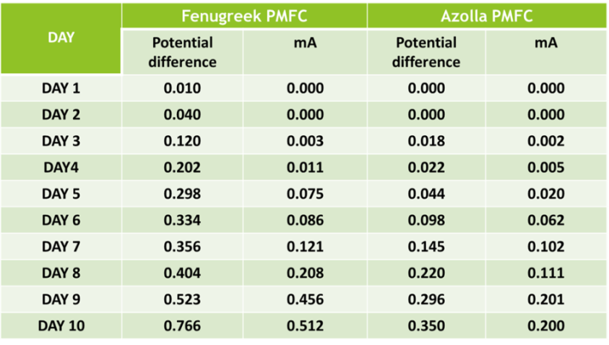
[Table 2: Electricity Generation diurnally]

