Sup. Mat. Figure 1. Biplot for non-metric multidimensional scaling (NMDS) for the complete sampling period, showing similarity among BGUs and overlay of the percentage of a) rainy season-open areas, b) dry season-open areas, c) rainy season-constructed areas, d) dry season-constructed areas, e) rainy season-arboreal vegetation, f) dry season-arboreal vegetation. The suitability level of each BGU is indicated by a letter within the circle (H=high level, M=medium level, and L=low level), with its corresponding polygon.
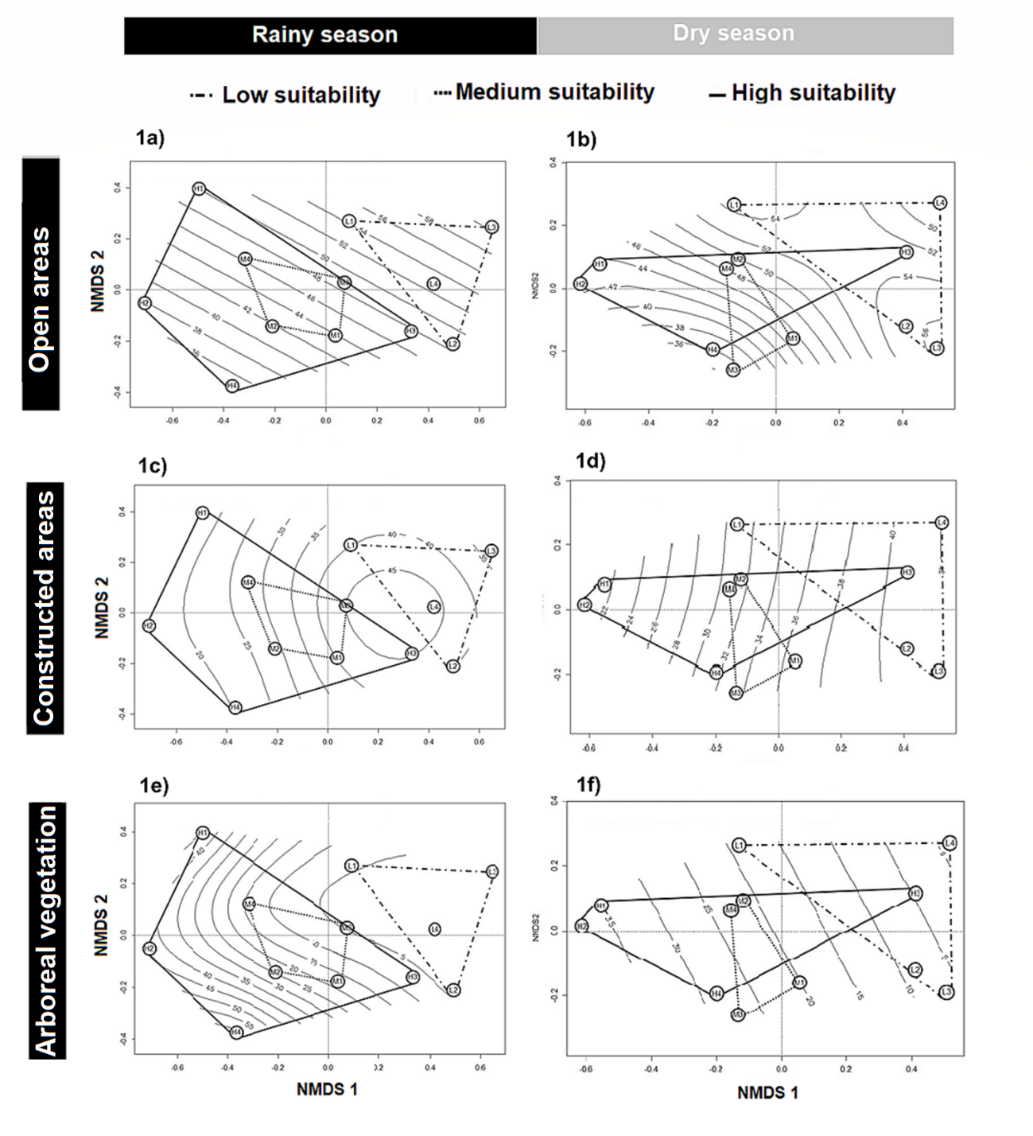

Sup. Mat. Figure 2. Average accuracy of correct classification per species.

