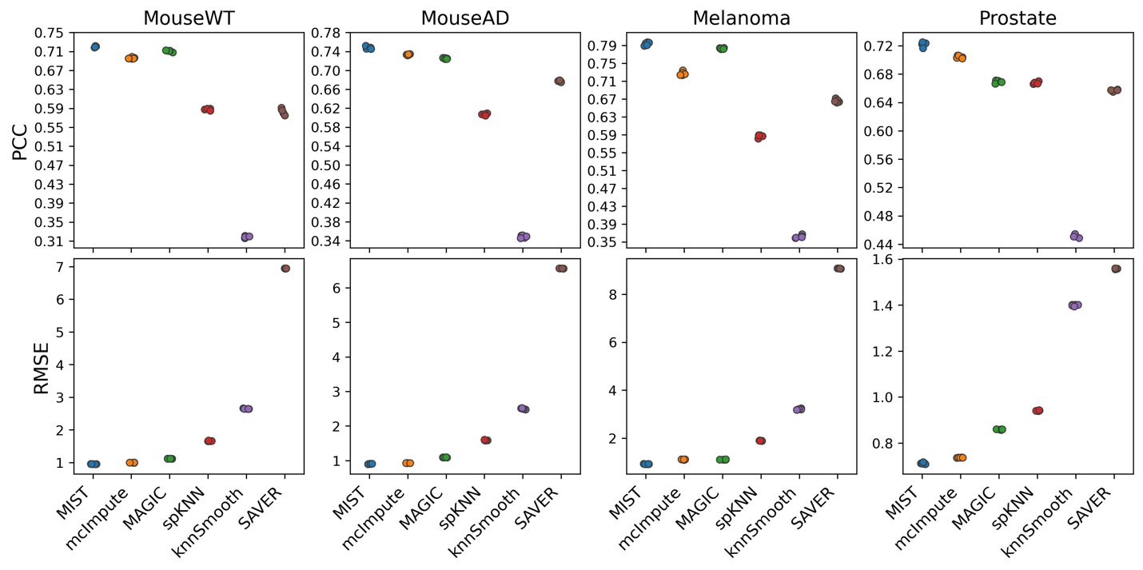
a
b
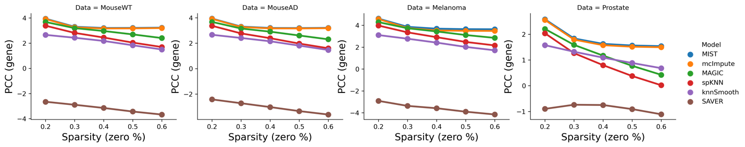
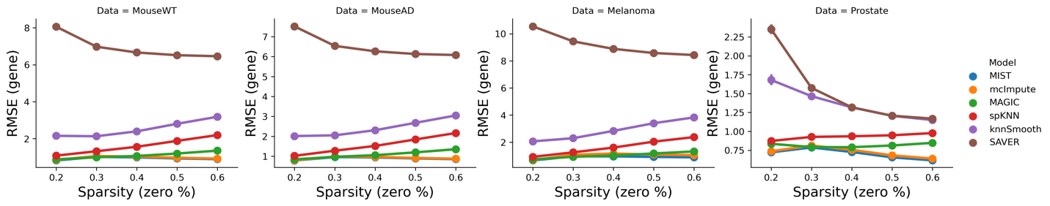
Extended Figure 3.1 | Holdout test performance. a-b, Holdout experiment performance across multiple data sets using metrics a, PCC and b, RMSE. Each column is an individual data set. Points in the same color indicate the 5 non-overlap fold of tests for each model.
a
b

Extended Figure 3.2 | Gene-level holdout test performance. a. RMSE (y-axis) for every gene as a function of gene sparsity (x-axis). b. PCC for every gene as a function of gene sparsity.

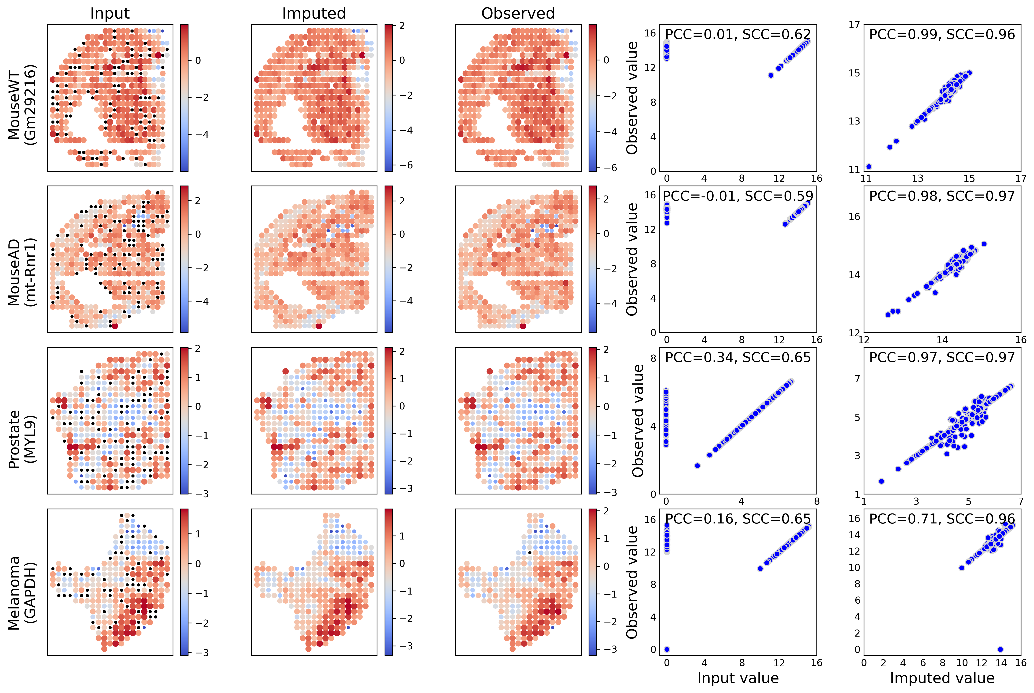
Extended Figure 3.3 | MIST recovered gene expression patterns in holdout experiments. Column 1 is the spatial pattern of the input to MIST with random non-zero values held out. Column 2 is the denoised gene expression pattern. Column 3 is the original observed gene expression pattern. Column 4 shows the correlation between input values and observed values. Column 5 shows the correlation between the denoised expression values and the observed expression values. a, Expression patterns recovered for gene Gm29216 in the Mouse WT brain. b, Expression patterns recovered for gene mt-Rnr1 in the Mouse AD brain. c, Expression patterns recovered for gene Gm29216 in the Prostate sample.
Input value
Denoised value
a
b
c

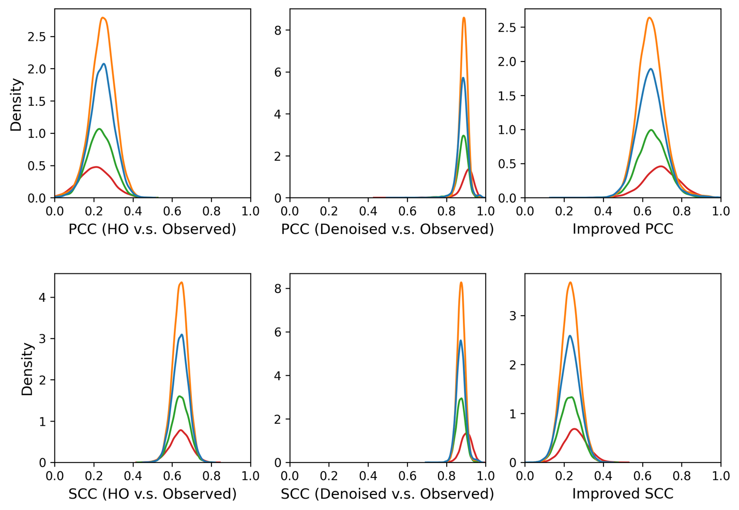
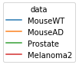
Extended Figure 3.4 | Distribution of improved PCC and SCC in holdout experiments. a, PCC distribution of HO vs. Observed non-zero gene expression. b, PCC distribution of denoised vs. Observed non-zero gene expression. c, Distribution of improved PCC for nonzero values of each held out gene. d, SCC distribution of HO vs. Observed non-zero gene expression. e, SCC distribution of denoised vs. Observed non-zero gene expression. f, Distribution of improved SCC for nonzero values of each held out gene.
a
b
c
d
e
f

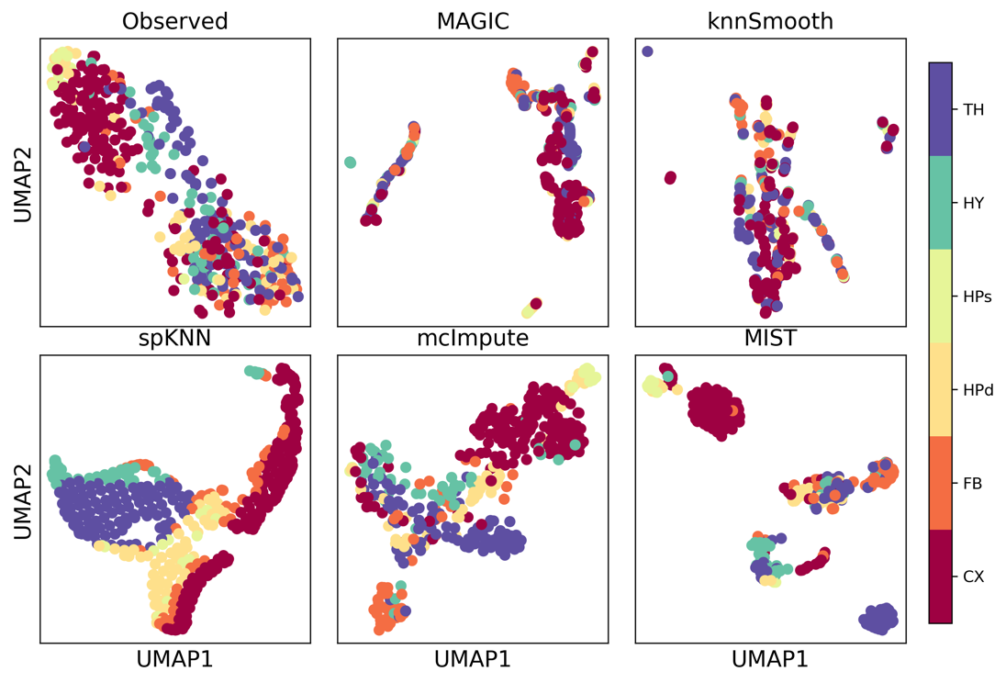
Extended Figure 4.1 | UMAP visualization of Mouse WT brain using data denoised by different algorithms.
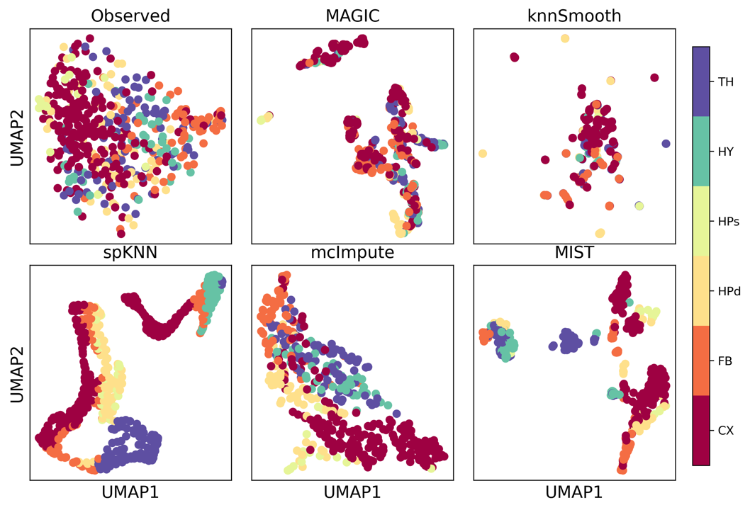

Extended Figure 4.2 | UMAP visualization of Mouse AD brain using data denoised by different algorithms.

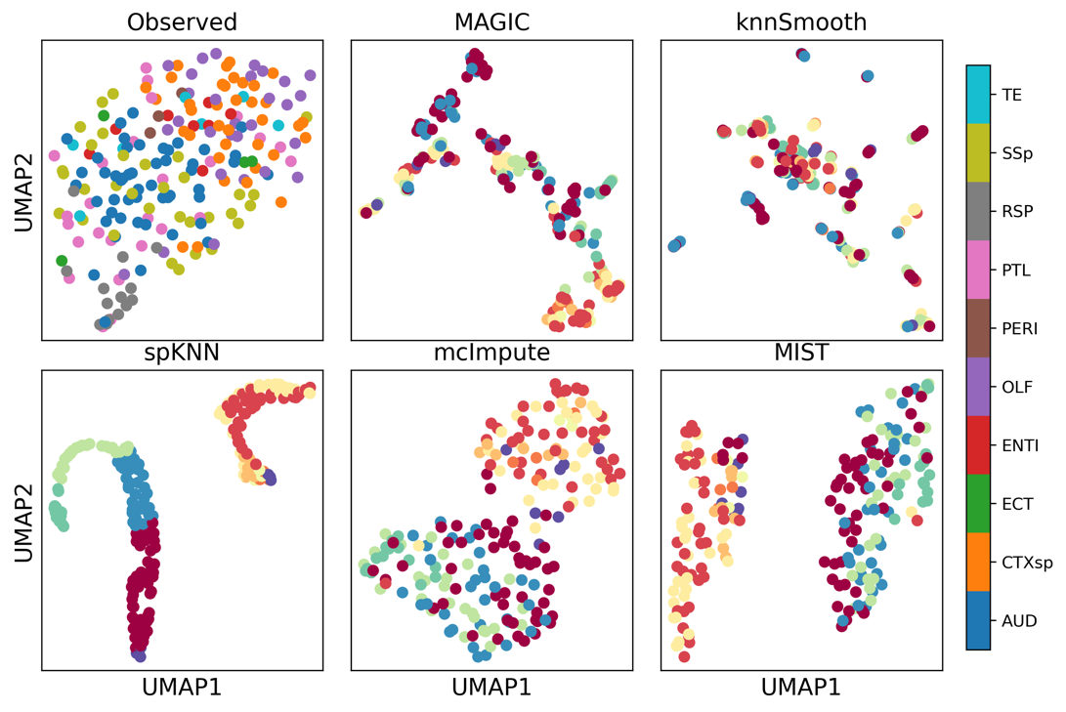
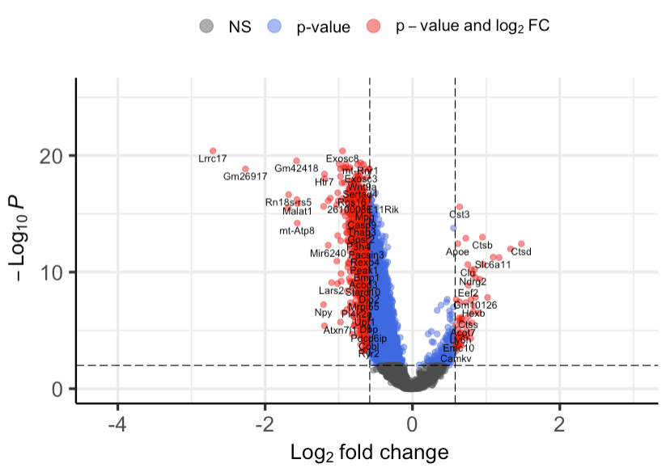
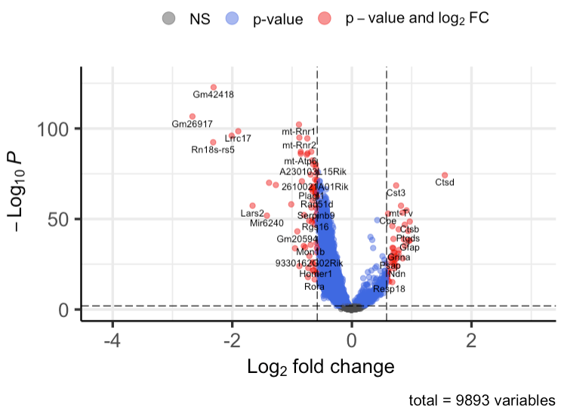
Extended Figure 4.3 | UMAP visualization of Mouse AD Cortex using data denoised by different algorithms.
b
a

Extended Figure 4.4 | Volcano plots of AD vs. WT differential expression analysis. a, Volcano plot of differential gene expression analysis results comparing AD vs. WT mouse brain using Cluster 1 MIST-denoised data. Red dots are significant genes with absolute LFC > 0.58 and FDR < 0.01. b, Volcano plot of differential gene expression analysis results comparing AD vs. WT mouse brain using Cluster 2 samples.

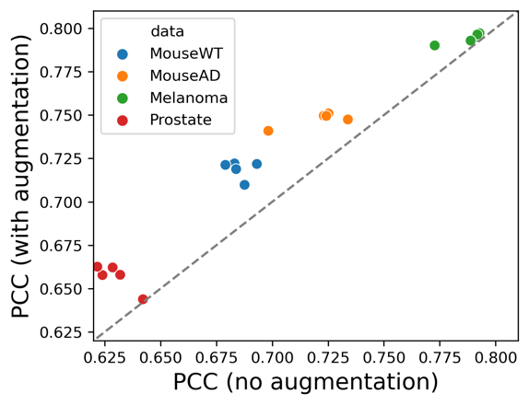
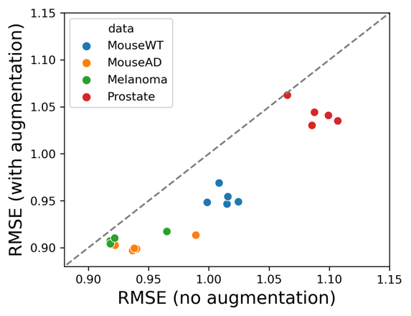
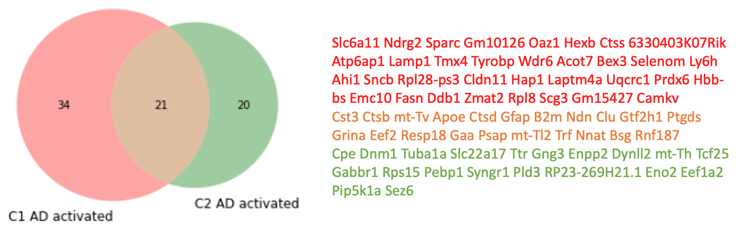
Extended Figure 4.5 | Consensus and difference of AD activated genes between spatial cortex clusters. Circle and gene symbols in red color indicate genes that are only activated in Cluster 1 (C1, CTXsp, OLF, ENTI, TE, ECT and PERI). Circle and gene symbols in green are genes that are only activated in Cluster 2 (C2, AUD, PTL, RSP, SSp). Orange color indicates AD activated genes that are shared across these two spatial cortex clusters.
a
b

Extended Figure 6. | Region augmentation improved MIST’s performance. Scatter plots showing paired performance comparing before augmentation (x-axis) and after augmentation (y-axis) in terms of (a) PCC and (b) RMSE. Every point represents a hold-out experiment colored by samples.

