Supplementary materials:
Beyond the Buzz: analysing actors promoting regenerative agriculture in Europe
Corresponding author: Loekie Schreefel (loekie.schreefel@wur.nl)
Index
A: More detail about the regenerative themes promoted 2
B: Full list of micro and meso-clusters 4
C: Country specific results 9
D: Regenerative practices among the top three actor types 13
E: PRISMA 2020 statement 14
F: Threshold values to determine actor sizes 24
References 26

A: More detail about the regenerative themes promoted
Number of regenerative themes mentioned among groups of actors
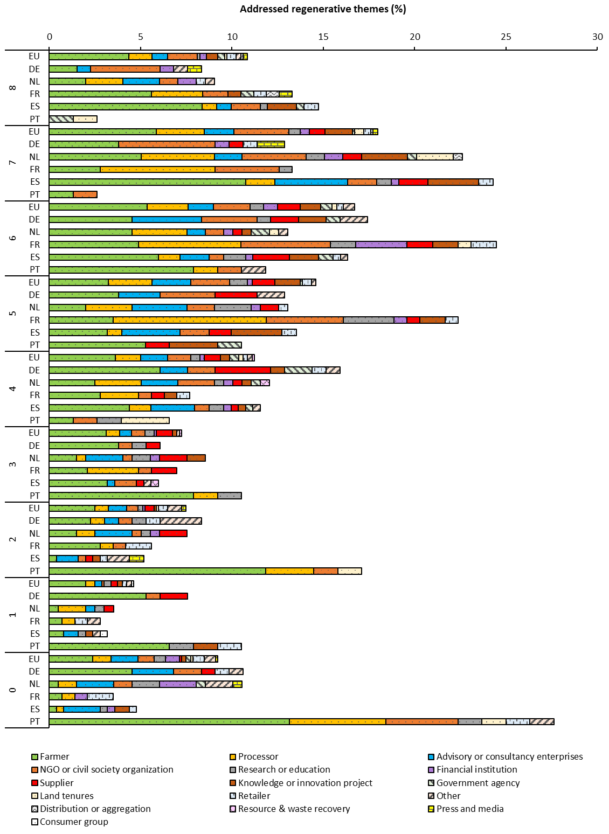

Coverage of themes per actor type as percentage of the total number of theme mentions (n=3917)
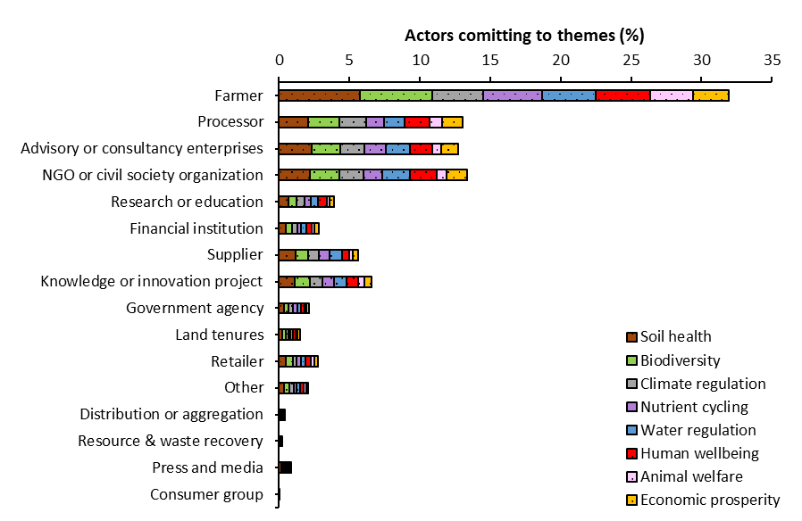

Coverage of themes per actor relative to their own actor type
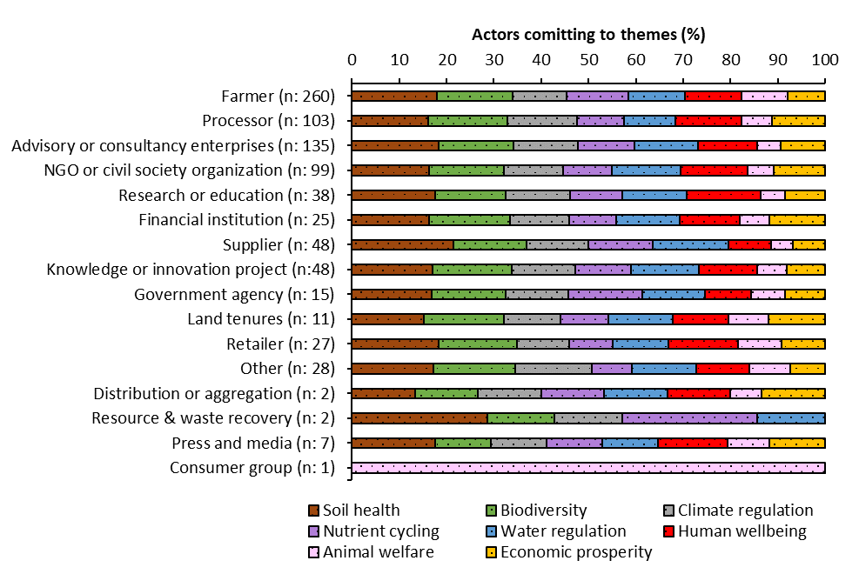

B: Full list of micro and meso-clusters
Practices identified during the systematic search on actor websites and farm interviews which were categorized into micro- and meso-clusters for analysis.
- Micro-clusters, represent individual practices, grouped only to standardize terminology (e.g. "reduce tillage" and "minimize tillage" are considered equivalent).
- Meso-clusters, represent aggregated groups of individual practices, organized into broader categories (e.g. practices like intercropping, strip cropping, polyculture, and avoiding monocultures are grouped under "crop diversification").
The practices were further analysed based on their functional orientation i.e. directive, normative, explanatory:
- Directive practices (D), defined as practices described in prescriptive terms ("must (not) do" or "should (not) do”).
- Normative practices (N), reflect embedded values (e.g., fairness) or overarching visions (e.g. preventing harm).
- Approaches to farming (AF), conceptualize and frame agricultural approaches or disciplines (e.g. conservation agriculture).
Meso-cluster | Micro-cluster | D | N | AF | Total
63 | 207 | 4646 | 97 | 194 | 4935
Cover crops |  | 0 | 0 | 0 | 405
 | Cover crops | 241 | 0 | 0 | 241
 | Year-round soil cover | 30 | 0 | 0 | 30
 | Maximum soil cover | 61 | 0 | 0 | 61
 | Vegetation cover | 20 | 0 | 0 | 20
 | Ground cover | 5 | 0 | 0 | 5
 | Catch crops | 27 | 0 | 0 | 27
 | Permanent greening | 21 | 0 | 0 | 21
Green manure |  | 0 | 0 | 0 | 81
 | Green manure | 81 | 0 | 0 | 81
Crop diversity |  | 0 | 0 | 0 | 342
 | Crop diversification | 176 | 0 | 0 | 176
 | Polyculture | 18 | 0 | 0 | 18
 | Strip cropping | 2 | 0 | 0 | 2
 | Intercropping | 89 | 0 | 0 | 89
 | Companion planting | 11 | 0 | 0 | 11
 | Alley cropping | 4 | 0 | 0 | 4
 | Biointensive market garden | 6 | 0 | 0 | 6
 | Biointensive | 8 | 0 | 0 | 8
 | Under sowing | 24 | 0 | 0 | 24
 | Mixed cropping | 2 | 0 | 0 | 2
 | No monocultures | 2 | 0 | 0 | 2
Extensive crop rotations |  | 0 | 0 | 0 | 173
 | Crop rotation | 173 | 0 | 0 | 173
Deep rooted species |  | 0 | 0 | 0 | 5
 | Deep rooted species | 5 | 0 | 0 | 5
Keep living roots |  | 0 | 0 | 0 | 24
 | Keep living roots | 24 | 0 | 0 | 24
N-fixing plants |  | 0 | 0 | 0 | 74
 | N-fixing plants | 23 | 0 | 0 | 23
 | Legumes | 51 | 0 | 0 | 51
Direct seeding |  | 0 | 0 | 0 | 66
 | Direct seeding | 66 | 0 | 0 | 66
Weeding |  | 0 | 0 | 0 | 9
 | Mechanical weeding | 4 | 0 | 0 | 4
 | Natural weed control | 4 | 0 | 0 | 4
 | Integrated weed management | 1 | 0 | 0 | 1
Mulching |  | 0 | 0 | 0 | 165
 | Mulching | 109 | 0 | 0 | 109
 | Crop residues back to field | 56 | 0 | 0 | 56
Pollinator integration |  | 0 | 0 | 0 | 17
 | Include bees | 1 | 0 | 0 | 1
 | Natural pollination | 1 | 0 | 0 | 1
 | Pollinator integration | 15 | 0 | 0 | 15
Keyline design |  | 0 | 0 | 0 | 28
 | Keyline design | 28 | 0 | 0 | 28
Terracing |  | 0 | 0 | 0 | 9
 | Terracing | 9 | 0 | 0 | 9
Paludiculture |  | 0 | 0 | 0 | 2
 | Paludiculture | 2 | 0 | 0 | 2
Reduce machinery |  | 0 | 0 | 0 | 33
 | No heavy machinery | 8 | 0 | 0 | 8
 | Minimize tractor use | 2 | 0 | 0 | 2
 | Reduce heavy machinery | 8 | 0 | 0 | 8
 | Reduce mechanization | 9 | 0 | 0 | 9
 | Manual/low tech farming | 5 | 0 | 0 | 5
 | only use machinery on dry periods | 1 | 0 | 0 | 1
Controlled traffic lanes |  | 0 | 0 | 0 | 2
 | Controlled traffic lanes | 2 | 0 | 0 | 2
Use perennials |  | 0 | 0 | 0 | 39
 | Use perennials | 26 | 0 | 0 | 26
 | Aromatic plants | 9 | 0 | 0 | 9
 | Perennial pastures | 4 | 0 | 0 | 4
Agroforestry and permaculture |  | 0 | 0 | 0 | 340
 | Food forest | 29 | 0 | 0 | 29
 | Syntropic farming | 32 | 0 | 0 | 32
 | Agroforestry | 203 | 0 | 0 | 203
 | Permaculture | 75 | 0 | 0 | 75
 | shade tree planting | 1 | 0 | 0 | 1
Reforestation |  | 0 | 0 | 0 | 14
 | Afforestation | 2 | 0 | 0 | 2
 | Reforestation | 10 | 0 | 0 | 10
 | Forest conservation | 1 | 0 | 0 | 1
 | replanting trees | 1 | 0 | 0 | 1
Holistic grazing |  | 0 | 0 | 0 | 171
 | Rotational/strip grazing | 116 | 0 | 0 | 116
 | Holistic grazing | 35 | 0 | 0 | 35
 | MOB grazing | 7 | 0 | 0 | 7
 | Voisin rational grazing | 13 | 0 | 0 | 13
Crop-livestock integration |  | 0 | 0 | 0 | 178
 | Crop - livestock integration | 139 | 0 | 0 | 139
 | Montado (agro-silvo-pastoralism) | 20 | 0 | 0 | 20
 | Silvopasture | 14 | 0 | 0 | 14
 | Polyface farming | 5 | 0 | 0 | 5
Extensive grazing |  | 0 | 0 | 0 | 6
 | Extensive grazing | 22 | 0 | 0 | 22
 | No intensive mowing | 0 | 0 | 0 | 0
Double purpose cows |  | 0 | 0 | 0 | 2
 | Double purpose cows | 2 | 0 | 0 | 2
Avoid antibiotics |  | 0 | 0 | 0 | 6
 | Avoid antibiotics | 3 | 0 | 0 | 3
 | Avoid hormones and antibiotics | 3 | 0 | 0 | 3
Permanent grassland |  | 0 | 0 | 0 | 28
 | Permanent grassland | 23 | 0 | 0 | 23
 | Preserve grasslands | 5 | 0 | 0 | 5
Herb-rich grassland |  | 0 | 0 | 0 | 24
 | Herb-rich grassland | 19 | 0 | 0 | 19
 | Multi-specie meadows | 4 | 0 | 0 | 4
 | Grassland diversity | 1 | 0 | 0 | 1
Livestock diversification |  | 0 | 0 | 0 | 7
 | Animal diversity | 6 | 0 | 0 | 6
 | Double purpose cows | 1 | 0 | 0 | 1
Mobile chicken coops |  | 0 | 0 | 0 | 18
 | Mobile chicken coops | 18 | 0 | 0 | 18
No synthetic pesticides |  | 0 | 0 | 0 | 63
 | No synthetic pesticides | 58 | 0 | 0 | 58
 | No herbicides | 3 | 0 | 0 | 3
 | No fungicides | 1 | 0 | 0 | 1
 | No insecticides | 1 | 0 | 0 | 1
Reduce synthetic pesticides |  | 0 | 0 | 0 | 173
 | Reduce synthetic pesticides | 49 | 0 | 0 | 49
 | Reduce herbicides | 6 | 0 | 0 | 6
 | Reduce fungicides | 3 | 0 | 0 | 3
 | Reduce insecticides | 4 | 0 | 0 | 4
 | Natural pest management | 73 | 0 | 0 | 73
 | Integrated pest management | 38 | 0 | 0 | 38
No artificial fertilizers |  | 0 | 0 | 0 | 50
 | No synthetic fertilizer | 50 | 0 | 0 | 50
Reduce artificial fertilizers |  | 0 | 0 | 0 | 239
 | Reduce artificial fertilizers | 49 | 0 | 0 | 49
 | Reduce artificial N fertilizers | 5 | 0 | 0 | 5
 | Reduce synthetic fertilizers | 21 | 0 | 0 | 21
 | Use organic fertilizers (e.g. animal manure) | 127 | 0 | 0 | 127
 | Sheep wool fertilizer | 2 | 0 | 0 | 2
 | Foliar application | 3 | 0 | 0 | 3
 | Biofertilizer | 32 | 0 | 0 | 32
No external inputs |  | 0 | 0 | 0 | 78
 | No external inputs | 1 | 0 | 0 | 1
 | No synthetic inputs | 77 | 0 | 0 | 77
Reduce external inputs |  | 0 | 0 | 0 | 264
 | Minimize external inputs | 58 | 0 | 0 | 58
 | Minimize synthetic inputs | 76 | 0 | 0 | 76
 | Input reduction | 2 | 0 | 0 | 2
 | Use of natural/renewable resources | 19 | 0 | 0 | 19
 | No dependence on fossil fuel use | 12 | 0 | 0 | 12
 | Self-sufficiency | 0 | 46 | 0 | 46
 | Recycled/reused materials | 34 | 0 | 0 | 34
 | No residual streams | 1 | 0 | 0 | 1
 | Circular system | 0 | 10 | 0 | 10
 | Use local inputs | 6 | 0 | 0 | 6
Reduce concentrate feed |  | 0 | 0 | 0 | 16
 | Reduce concentrate feed | 2 | 0 | 0 | 2
 | Grass fed | 11 | 0 | 0 | 11
 | No concentrate feed | 3 | 0 | 0 | 3
No GMO |  | 0 | 0 | 0 | 13
 | No GMO | 13 | 0 | 0 | 13
No tillage |  | 0 | 0 | 0 | 161
 | No tillage | 155 | 0 | 0 | 155
 | Use a roller-crimper | 6 | 0 | 0 | 6
Reduce tillage |  | 0 | 0 | 0 | 227
 | Reduce tillage | 206 | 0 | 0 | 206
 | Minimize soil disturbance | 0 | 12 | 0 | 12
 | Strip tillage | 9 | 0 | 0 | 9
Composting |  | 0 | 0 | 0 | 218
 | Composting | 168 | 0 | 0 | 168
 | Humanure composting | 3 | 0 | 0 | 3
 | Compost tea | 32 | 0 | 0 | 32
 | Vermicomposting | 9 | 0 | 0 | 9
 | Hügelkultur | 2 | 0 | 0 | 2
 | Wood chips | 3 | 0 | 0 | 3
 | Worm farming | 1 | 0 | 0 | 1
Bokashi |  | 0 | 0 | 0 | 15
 | Bokashi | 15 | 0 | 0 | 15
Biochar |  | 0 | 0 | 0 | 41
 | Biochar | 41 | 0 | 0 | 41
Soil inoculation |  | 0 | 0 | 0 | 110
 | Soil inoculation with microorganisms | 8 | 0 | 0 | 8
 | Bio inoculants | 37 | 0 | 0 | 37
 | Bio stimulant | 34 | 0 | 0 | 34
 | Effective microorganisms | 21 | 0 | 0 | 21
 | Organic-based preparations | 8 | 0 | 0 | 8
 | Zeolite | 2 | 0 | 0 | 2
Soil amendments |  | 0 | 0 | 0 | 21
 | Shells | 1 | 0 | 0 | 1
 | Stone flower | 4 | 0 | 0 | 4
 | Natural amendments | 16 | 0 | 0 | 16
Minimize water use |  | 0 | 0 | 0 | 51
 | Dry farming | 1 | 0 | 0 | 1
 | Drip irrigation | 15 | 0 | 0 | 15
 | Minimize irrigation | 9 | 0 | 0 | 9
 | Reduce water use | 26 | 0 | 0 | 26
Water storage |  | 0 | 0 | 0 | 149
 | Natural water harvesting | 51 | 0 | 0 | 51
 | Infiltration channels | 4 | 0 | 0 | 4
 | Rainfed system | 7 | 0 | 0 | 7
 | Water buffers | 21 | 0 | 0 | 21
 | Swales | 13 | 0 | 0 | 13
 | Water filtration | 3 | 0 | 0 | 3
 | Water reservoirs | 22 | 0 | 0 | 22
 | Pond | 27 | 0 | 0 | 27
 | Ditches | 1 | 0 | 0 | 1
Habitat provision |  | 0 | 0 | 0 | 263
 | Flower/herb/nature strips | 51 | 0 | 0 | 51
 | Grass strips | 4 | 0 | 0 | 4
 | Riparian buffers | 26 | 0 | 0 | 26
 | Biodiversity shelters (e.g. bushes) | 79 | 0 | 0 | 79
 | Natural buffer zones | 7 | 0 | 0 | 7
 | Trees and hedges | 77 | 0 | 0 | 77
 | Bushes and trees as wind borders | 3 | 0 | 0 | 3
 | Insect hotels | 9 | 0 | 0 | 9
 | Bird and bat boxes | 7 | 0 | 0 | 7
Native crop and animal species |  | 0 | 0 | 0 | 24
 | Local or native crop and animal species | 22 | 0 | 0 | 22
 | Native trees | 1 | 0 | 0 | 1
 | Protect native species | 0 | 1 | 0 | 1
Mechanization |  | 0 | 0 | 0 | 28
 | High-tech practices | 24 | 0 | 0 | 24
 | Autonomous and Electric Systems | 2 | 0 | 0 | 2
 | anaerobic digesters | 1 | 0 | 0 | 1
 | Milking robot | 1 | 0 | 0 | 1
Holistic management |  | 0 | 0 | 0 | 57
 | Holistic management | 57 | 0 | 0 | 57
Certification |  | 0 | 0 | 0 | 21
 | Cotton Connect | 1 | 0 | 0 | 1
 | Fulfil Sustainable Cotton Programme of Primark | 1 | 0 | 0 | 1
 | ZQRX programme | 1 | 0 | 0 | 1
 | Carbon credits | 3 | 0 | 0 | 3
 | MRV schemes | 15 | 0 | 0 | 15
Other approaches to farming |  | 0 | 0 | 0 | 194
 | Biodynamic agriculture | 0 | 0 | 11 | 11
 | Organic production | 0 | 0 | 100 | 100
 | JADAM Organic farming | 0 | 0 | 6 | 6
 | Conservation agriculture | 0 | 0 | 25 | 25
 | Market gardening | 0 | 0 | 18 | 18
 | Agroecology | 0 | 0 | 22 | 22
 | Precision agriculture | 0 | 0 | 12 | 12
Monitoring |  | 0 | 0 | 0 | 52
 | Monitoring | 30 | 0 | 0 | 30
 | Soil analysis | 3 | 0 | 0 | 3
 | Satellite imagery and monitoring | 9 | 0 | 0 | 9
 | Remote sensing and monitoring | 9 | 0 | 0 | 9
 | Plant juice analysis | 1 | 0 | 0 | 1
Other practices |  | 0 | 0 | 0 | 48
 | Food crops only | 1 | 0 | 0 | 1
 | Marine inputs | 5 | 0 | 0 | 5
 | Minimize artificial light | 2 | 0 | 0 | 2
 | Pest resistant crops | 1 | 0 | 0 | 1
 | Fermentation | 9 | 0 | 0 | 9
 | Leave treatment | 10 | 0 | 0 | 10
 | Free-range breeding system | 4 | 0 | 0 | 4
 | Forest soil transplantation | 7 | 0 | 0 | 7
 | No plastic | 3 | 0 | 0 | 3
 | Create wetlands | 4 | 0 | 0 | 4
 | Biomimicry | 2 | 0 | 0 | 2
Knowledge exchange |  | 0 | 0 | 0 | 28
 | Provide training | 5 | 0 | 0 | 5
 | Knowledge exchange & capacity Building | 23 | 0 | 0 | 23
Locally produced |  | 0 | 0 | 0 | 10
 | Locally produced | 4 | 0 | 0 | 4
 | Short value chain | 1 | 0 | 0 | 1
 | Prioritize local sales | 0 | 5 | 0 | 5
Animal welfare practices |  | 0 | 0 | 0 | 6
 | Animal welfare related | 0 | 0 | 0 | 6
Community involvement |  |  |  |  | 13
 | Community involvement | 13 | 0 | 0 | 13
More free time |  |  |  |  | 3
 | More free time | 0 | 3 | 0 | 3
Other |  |  |  |  | 4
 | Other | 0 | 0 | 0 | 4
Sustainable farm income |  |  |  |  | 18
 | Financial resilience and sustainable business models | 0 | 10 | 0 | 10
 | Financial diversification | 1 | 0 | 0 | 1
 | long-term farm partnerships | 0 | 1 | 0 | 1
 | Fair wage | 0 | 6 | 0 | 6
Women’s economic empowerment |  |  |  |  | 3
 | Women’s economic empowerment | 0 | 3 | 0 | 3
Tourism |  |  |  |  | 2
 | Involve tourism in business model | 2 | 0 | 0 | 2
Other |  |  |  |  | 4
 | Other | 0 | 0 | 0 | 4

C: Country specific results
Regenerative themes:
 | EU | % | DE | % | NL | % | FR | % | ES | % | PT | %
1 | Soil health | 81 | Soil health | 86 | Soil health | 82 | Soil health | 85 | Soil health | 89 | Biodiversity | 41
2 | Biodiversity | 74 | Biodiversity | 61 | Biodiversity | 79 | Biodiversity | 83 | Biodiversity | 83 | Soil health | 40
3 | Water | 60 | Water | 60 | Human | 65 | Climate | 71 | Nutrient | 75 | Climate | 31
4 | Climate | 59 | Nutrient | 52 | Climate | 60 | Human | 69 | Water | 74 | Nutrient | 31
5 | Human | 58 | Climate | 50 | Nutrient | 58 | Economic | 68 | Human | 65 | Animal | 28
6 | Nutrient | 54 | Economic | 50 | Economic | 54 | Water | 68 | Climate | 65 | Water | 27
7 | Economic | 42 | Human | 48 | Water | 50 | Nutrient | 34 | Animal | 57 | Human | 21
8 | Animal | 33 | Animal | 25 | Animal | 19 | Animal | 24 | Economic | 24 | Economic | 10

Regenerative practices (meso-clusters):
Meso cluster | NL | Meso cluster | PT
Crop diversity | 70 | Agroforestry and permaculture | 67
Cover crops | 68 | Cover crops | 26
No synthetic pesticides | 53 | Composting | 25
Agroforestry and permaculture | 48 | Habitat provision | 21
No artificial fertilizers | 47 | Other approaches to farming | 20
Reduce artificial fertilizers | 46 | Holistic grazing | 19
No tillage | 46 | Reduce external inputs | 17
Composting | 40 | Water storage | 17
Reduce external inputs | 36 | Crop diversity | 15
Reduce tillage | 36 | Crop-livestock integration | 13
Habitat provision | 34 | Extensive crop rotations | 10
Extensive crop rotations | 31 | Mulching | 10
Crop-livestock integration | 27 | Keyline design | 10
Holistic grazing | 26 | Minimize water use | 10
Reduce synthetic pesticides | 21 | Reduce synthetic pesticides | 9
Herb-rich grassland | 20 | Reduce tillage | 9
Green manure | 19 | No external inputs | 8
Mulching | 17 | Mechanization | 7
Use perennials | 12 | Direct seeding | 6
Reduce machinery | 9 | Community involvement | 6
Other approaches to farming | 9 | Reforestation | 5
Reduce concentrate feed | 8 | No tillage | 5
Permanent grassland | 7 | Soil inoculation | 5
Minimize water use | 7 | Keep living roots | 4
No external inputs | 6 | Weeding | 4
Deep rooted species | 5 | Mobile chicken coops | 4
Weeding | 5 | Green manure | 3
Water storage | 5 | No artificial fertilizers | 3
Knowledge exchange | 5 | Reduce artificial fertilizers | 3
Locally produced | 5 | Reduce machinery | 2
Direct seeding | 4 | No synthetic pesticides | 2
Extensive grazing | 4 | No GMO | 2
Avoid antibiotics | 4 | Native crop and animal species | 2
Mechanization | 4 | Tourism | 2
Other | 4 | Holistic management | 1
Other | 4 | Deep rooted species | 0
Terracing | 3 | N-fixing plants | 0
Bokashi | 3 | Pollinator integration | 0
Certification | 3 | Terracing | 0
Other practices | 3 | Paludiculture | 0
Animal welfare practices | 3 | Controlled traffic lanes | 0
Women economic empowerment | 3 | Use perennials | 0
Pollinator integration | 2 | Extensive grazing | 0
Paludiculture | 2 | Double purpose cows | 0
Controlled traffic lanes | 2 | Avoid antibiotics | 0
Double purpose cows | 2 | Permanent grassland | 0
Livestock diversification | 2 | Herb-rich grassland | 0
No GMO | 2 | Livestock diversification | 0
Biochar | 2 | Reduce concentrate feed | 0
Soil amendments | 2 | Bokashi | 0
Native crop and animal species | 2 | Biochar | 0
Holistic management | 2 | Soil amendments | 0
Sustainable farm income | 2 | Certification | 0
Reforestation | 1 | Monitoring | 0
Soil inoculation | 1 | Other practices | 0
Keep living roots | 0 | Knowledge exchange | 0
N-fixing plants | 0 | Locally produced | 0
Keyline design | 0 | Animal welfare practices | 0
Mobile chicken coops | 0 | More free time | 0
Monitoring | 0 | Other | 0
Community involvement | 0 | Sustainable farm income | 0
More free time | 0 | Women economic empowerment | 0
Tourism | 0 | Other | 0

Meso cluster | ES | Meso cluster | FR
Cover crops | 114 | Cover crops | 131
Habitat provision | 108 | Crop diversity | 107
Reduce external inputs | 103 | Reduce external inputs | 85
Reduce artificial fertilizers | 93 | Reduce synthetic pesticides | 82
Agroforestry and permaculture | 91 | Habitat provision | 82
Composting | 86 | Other approaches to farming | 82
Water storage | 83 | Agroforestry and permaculture | 81
Crop diversity | 81 | Reduce tillage | 78
Mulching | 72 | Reduce artificial fertilizers | 76
Crop-livestock integration | 68 | Extensive crop rotations | 61
Reduce tillage | 64 | Crop-livestock integration | 52
Holistic grazing | 62 | N-fixing plants | 41
Reduce synthetic pesticides | 61 | Mulching | 33
No tillage | 57 | Holistic grazing | 33
Extensive crop rotations | 49 | No tillage | 28
Soil inoculation | 46 | Water storage | 27
Holistic management | 46 | Direct seeding | 25
No external inputs | 43 | Composting | 23
Monitoring | 43 | Soil inoculation | 22
Other approaches to farming | 37 | Permanent grassland | 15
N-fixing plants | 23 | Mechanization | 14
Knowledge exchange | 23 | Green manure | 13
Green manure | 22 | Minimize water use | 12
Minimize water use | 22 | Keyline design | 8
Other practices | 21 | No synthetic pesticides | 8
Native crop and animal species | 20 | Reduce machinery | 7
Biochar | 18 | Reforestation | 7
Certification | 18 | Mobile chicken coops | 6
Soil amendments | 16 | Livestock diversification | 5
Pollinator integration | 15 | Monitoring | 5
Use perennials | 15 | Use perennials | 4
Direct seeding | 11 | Herb-rich grassland | 4
Sustainable farm income | 10 | No GMO | 4
Reduce concentrate feed | 8 | Biochar | 4
Bokashi | 8 | Other practices | 4
Community involvement | 7 | No external inputs | 3
Terracing | 6 | More free time | 3
Permanent grassland | 6 | Deep rooted species | 0
Keep living roots | 5 | Keep living roots | 0
Reduce machinery | 5 | Weeding | 0
Locally produced | 5 | Pollinator integration | 0
Mobile chicken coops | 4 | Terracing | 0
No GMO | 4 | Paludiculture | 0
Extensive grazing | 2 | Controlled traffic lanes | 0
Avoid antibiotics | 2 | Extensive grazing | 0
Mechanization | 2 | Double purpose cows | 0
Deep rooted species | 0 | Avoid antibiotics | 0
Weeding | 0 | No artificial fertilizers | 0
Keyline design | 0 | Reduce concentrate feed | 0
Paludiculture | 0 | Bokashi | 0
Controlled traffic lanes | 0 | Soil amendments | 0
Reforestation | 0 | Native crop and animal species | 0
Double purpose cows | 0 | Holistic management | 0
Herb-rich grassland | 0 | Certification | 0
Livestock diversification | 0 | Knowledge exchange | 0
No synthetic pesticides | 0 | Locally produced | 0
No artificial fertilizers | 0 | Animal welfare practices | 0
Animal welfare practices | 0 | Community involvement | 0
More free time | 0 | Other | 0
Other | 0 | Sustainable farm income | 0
Women economic empowerment | 0 | Women economic empowerment | 0
Tourism | 0 | Tourism | 0
Other | 0 | Other | 0

Meso cluster | DE
Crop diversity | 69
Cover crops | 66
Agroforestry and permaculture | 53
Other approaches to farming | 46
Composting | 44
Reduce tillage | 40
Soil inoculation | 36
Mulching | 33
Holistic grazing | 31
No tillage | 25
Green manure | 24
Reduce external inputs | 23
Extensive crop rotations | 22
Reduce artificial fertilizers | 21
Direct seeding | 20
Other practices | 20
Crop-livestock integration | 18
No external inputs | 18
Habitat provision | 18
Biochar | 17
Water storage | 17
Keep living roots | 15
N-fixing plants | 10
Keyline design | 10
Reduce machinery | 10
Use perennials | 8
Holistic management | 8
Sustainable farm income | 6
Mobile chicken coops | 4
Bokashi | 4
Monitoring | 4
Soil amendments | 3
Animal welfare practices | 3
Reforestation | 1
No GMO | 1
Mechanization | 1
Deep rooted species | 0
Weeding | 0
Pollinator integration | 0
Terracing | 0
Paludiculture | 0
Controlled traffic lanes | 0
Extensive grazing | 0
Double purpose cows | 0
Avoid antibiotics | 0
Permanent grassland | 0
Herb-rich grassland | 0
Livestock diversification | 0
No synthetic pesticides | 0
Reduce synthetic pesticides | 0
No artificial fertilizers | 0
Reduce concentrate feed | 0
Minimize water use | 0
Native crop and animal species | 0
Certification | 0
Knowledge exchange | 0
Locally produced | 0
Community involvement | 0
More free time | 0
Other | 0
Women economic empowerment | 0
Tourism | 0
Other | 0

D: Regenerative practices among the top three actor types
Three frequently emphasized practices - synthetic pesticide use, artificial fertilizer application, and tillage - examined among the three largest actor types (i.e. farmers, processors, and advisories), with their focus on either the complete elimination or reduction of these practices. The error bars indicate the standard deviation across case study countries relative to the EU average.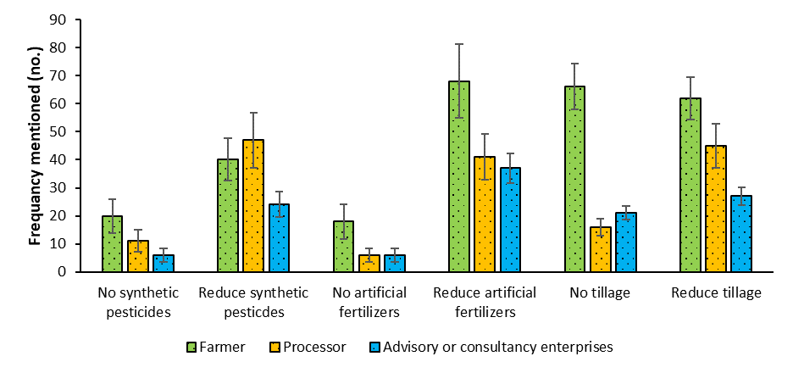

E: PRISMA 2020 statement
The following adapted checklist for reporting the PRISMA 2020 statement was used ¹ which ensures a transparent search strategy.
Section | # | Checklist item | Reported
TITLE
Title | 1 | Identify the report as a systematic review. | No
ABSTRACT
Abstract | 2 | See the PRISMA 2020 for Abstracts checklist.  See descriptions below. | Yes
INTRODUCTION
Rationale | 3 | Describe the rationale for the review in the context of existing knowledge.  This study addresses the pressing need to understand the landscape of regenerative agriculture initiatives in Europe, focusing on the involvement of diverse actors including farmers, NGOs, and governments. Regenerative agriculture has gained significant momentum in recent years as a solution to the global food system’s impact on planetary boundaries, yet its adoption and interpretation vary widely across regions and actors. Despite its potential, there are concerns regarding exaggerated claims, corporate greenwashing, and a lack of regulatory standards. While the academic literature on regenerative agriculture is growing, much of it focuses on narrow perspectives or specific geographic regions, limiting a comprehensive understanding of the alignment between food system actors involved. By reviewing actor websites and farm interviews, this study maps the actors involved in promoting regenerative agriculture in Southern and Western Europe. Understanding the roles of different actors—particularly as multinational corporations become more involved—will help clarify the movement’s trajectory and guide policy development. | Yes
Objectives | 4 | Provide an explicit statement of the objective(s) or question(s) the review addresses.  In this paper, we analyse the current configuration of actors promoting regenerative agriculture in five case countries across Southern and Western Europe (further referred to as Europe): Germany, the Netherlands, France, Spain, and Portugal. | Yes
METHODS
Eligibility criteria | 5 | Specify the inclusion and exclusion criteria for the review and how studies were grouped for the syntheses.  Search filter (used with query):  - Google Advanced search: case-country  - LinkedIn: case-country; people; companies  Inclusion criteria:  - Online presence with a website found on Google  - Online presence on LinkedIn  - Farmers were directly included and invited for an interview  - All other actors were only included if also their websites showed a commitment to regenerative agriculture  - In English or the case-country language  Exclusion criteria initial screening, based on the titles and "snippets" (the descriptions that appear under search results).  - Duplicates  - Not relevant: a search result that does not represent an actor (e.g. newspaper item or blog spot)  Exclusion criteria full website screening:  - No access  - Not relevant: an actor that was not engaged or practising regenerative agriculture, only mentioning the search terms. For example, we found several instances of leadership training programs on a regenerative farm.  Snowballing:  - Items not considered as actors, such as newspaper articles, were screened for mentions of regenerative actors. These identified actors were subsequently included in the screening process to determine their eligibility for inclusion in this study. | Yes
Information sources | 6 | Specify all databases, registers, websites, organisations, reference lists and other sources searched or consulted to identify studies. Specify the date when each source was last searched or consulted.  Database used: Google Advanced Search; LinkedIn search  Date of search and website data extraction: | Yes
  Case country: | Date of search web extraction:
  Germany: | 01/08/2024 – 01/09/2024
  The Netherlands: | 01/12/2023 – 01/02/2024
  France: | 02/06/2023 – 11/07/2024
  Spain: | 01/04/2024 – 01/11/2024
  Portugal: | 02/01/2024 – 02/07/2024
Search strategy | 7 | Present the full search strategies for all databases, registers and websites, including any filters and limits used.  Final queries and filters used. Wildcards (*) did not yield in more actors, only in more noise.  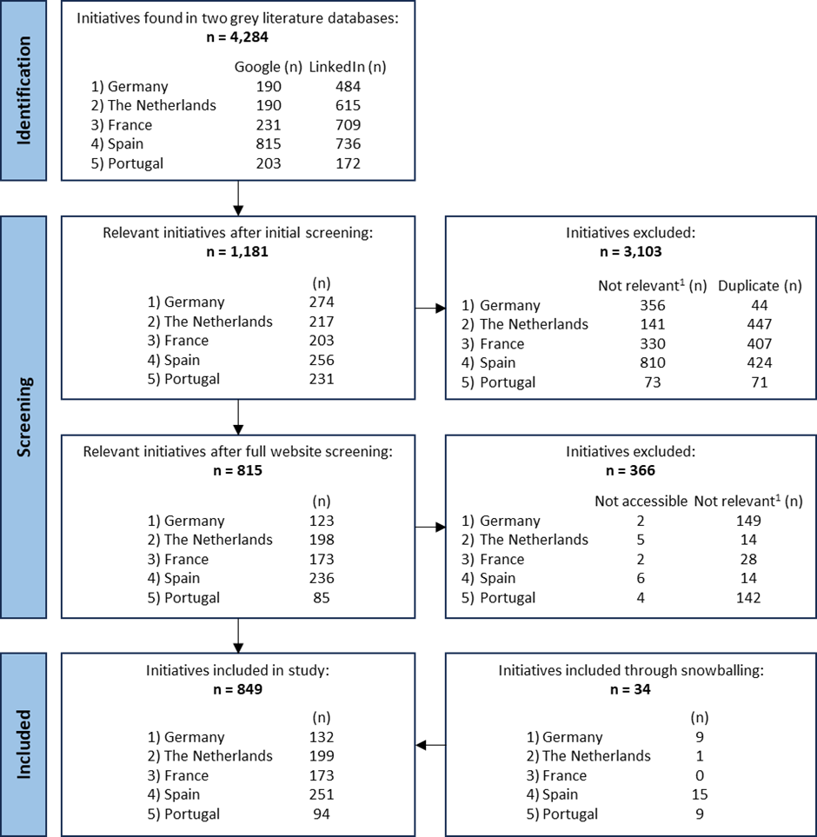 | Yes
  Database: | Filter A: location | Filter B: | Query:
  Google | Germany | n/a | "regenerative agriculture" OR "regenerative farming" OR "Regenerative Landwirtschaft" OR "Regenerativer Landbau"
  Google | The Netherlands | n/a | "regenerative agriculture" OR "regenerative farming" OR "regeneratieve landbouw"
  Google | France | n/a | "regenerative agriculture" OR "regenerative farming" OR "agriculture régénérative" OR "agriculture régénératrice"
  Google | Spain | n/a | "regenerative agriculture" OR "regenerative farming" OR “Agricultura regenerative”
  Google | Portugal | n/a | “regenerative agriculture” OR “regenerative farming” OR “agricultura regenerativa”
  LinkedIn | Germany | people; company | As separate entries: "regenerative agriculture" | "regenerative farming" | "Regenerative Landwirtschaft" | "Regenerativer Landbau"
  LinkedIn | The Netherlands | people; company | As separate entries: "regenerative agriculture" | "regenerative farming" | "regeneratieve landbouw"
  LinkedIn | France | people; company | As separate entries: "regenerative agriculture" | "regenerative farming" | "agriculture régénérative" | "agriculture régénératrice"
  LinkedIn | Spain | people; company | As separate entries: "regenerative agriculture" | "regenerative farming" | "agricultura regenerative"
  LinkedIn | Portugal | people; company | As separate entries: “regenerative agriculture” | “regenerative farming” | “agricultura regenerativa”
Selection process | 8 | Specify the methods used to decide whether a study met the inclusion criteria of the review, including how many reviewers screened each record and each report retrieved, whether they worked independently, and if applicable, details of automation tools used in the process.  A single reviewer, fluent in the case-country language, screened the initial search records (actor websites) from two online search engines for their respective case-country and compiled those meeting the search criteria into an MS Excel database. They followed the procedures detailed in steps #5 until #7 to finalize the search records. Any uncertainties about including or excluding initiatives were documented and discussed with the lead author at each stage of the exclusion process. Final decisions on inclusion or exclusion were made collaboratively. | Yes
Data collection process | 9 | Specify the methods used to collect data from reports, including how many reviewers collected data from each report, whether they worked independently, any processes for obtaining or confirming data from study investigators, and if applicable, details of automation tools used in the process.  In total, five reviewers extracted data from the sources identified. Each reviewer was fluent in the language of their respective case-country and concentrated exclusively on their assigned case-country. Any ambiguities encountered during the process were discussed with the lead author, and decisions regarding the usability of the collected data were made collaboratively. | Yes
Data items | 10a | List and define all outcomes for which data were sought. Specify whether all results that were compatible with each outcome domain in each study were sought (e.g. for all measures, time points, analyses), and if not, the methods used to decide which results to collect.  The information extracted from the data sources included the name of the initiative, its location, the year it committed to regenerative agriculture, the type and size of the initiative, the themes it promoted, and the practices it advocated. Here below the data extraction process is articulated:  - Name initiatives: initiatives website  - Location: initiatives website, the location of each initiative was recorded as the head office if there were multiple locations within a case-country; if initiatives operated in more than one case-country, the one was listed operating in the respective case-country.  - Year of commitment to regenerative agriculture: initiatives website, annual reports where their first commitment was indicated, or from the website's source code. The source code was only used if a respective page mentioned their first commitment but there was no date attached to it on the web page itself.  - Type of initiatives: the initiatives were classified into 16 archetypes, following Moreira-Dantas et al. ²: supplier, farmer, processor, distribution or aggregation, retailer, consumer group, resource and waste recovery, financial institution, government agency, press and media, NGO or civil society organization, research or education, knowledge or innovation project, advisory or consultancy enterprises, land tenures, and other. When initiatives embodied multiple archetypes (e.g., a farmer also offering advisory services and education), the primary type was selected. See also #10b.  - Size of initiatives: the extracted information to get data on the size of initiatives was dependent on the initiative types, see here below. The collected data was benchmarked against national inventories for different initiative types and rated on a scale from 1 (very small) to 5 (very large), as detailed 13b.  - Livestock systems: animal numbers; livestock units  - Crop and forestry systems: hectares of land  - Private sector: employee numbers  - Projects: project capital  - Regenerative themes promoted: information was extracted on the initiative’s website/page dedicated to regenerative agriculture that matched the eight themes established by Schreefel et al. (2022a, 2020): soil health, biodiversity, nutrient cycling, water regulation, climate regulation, economic prosperity, human well-being, and animal well-being.  - Regenerative practices promoted: all practices mentioned by the initiatives were recorded and in a later stage grouped into clusters. For instance, "reducing" or "minimizing" tillage were grouped as "reduce tillage," while "no-tillage" was considered a distinct category. | Yes
Data items | 10b | List and define all other variables for which data were sought (e.g. participant and intervention characteristics, funding sources). Describe any assumptions made about any missing or unclear information.  Actor type definitions: | Yes
  # | Actor type | Description | Examples
  1 | Supplier | Initiatives that produce or provide resources to farmers | e.g. animal feed, fertilizers, pesticides seeds, machinery, services, materials
  2 | Farmer | Agricultural producers who implement regenerative practices on their land | e.g. dairy, arable, fruit, chicken, beef, mixed
  3 | Processor | Entities or companies that undertake the transformation of raw materials or components into finished or semi-finished products. | e.g. meat, milk, chips, textiles
  4 | Distribution or aggregation | Initiatives that transport agricultural products between initiatives | e.g. logistic companies
  5 | Retailer | Businesses or individuals that sell goods or services directly to consumers. | e.g. web shops, supermarkets, farmer markets
  6 | Consumer group | Community and consumer advocacy groups who support and promote the purchase of products from regenerative agriculture | e.g. groups that promote vegan or vegetarian diets
  7 | Resource & waste recovery | Initiatives that separate materials from waste that can be recycled into new products or used as an energy alternative. | e.g. waste recovery and processing companies
  8 | Financial institution | Financial institutions and investors interested in supporting and financing regenerative agriculture projects and initiatives. | e.g. banks, philanthropic organizations, impact investors
  9 | Government agency | Government agencies and regulatory bodies responsible for overseeing agricultural practices, environmental protection, and land management. | e.g. regional or national policy initiatives
  10 | Press and media | Initiatives that can influence public opinion and perception of the organization. | e.g. journalists, reporters, and media outlets
  11 | NGO or civil society organization | Non-Governmental Organizations that advocate for sustainable and regenerative agricultural practices | e.g. nature conservancy groups, branch organization, think tanks
  12 | Research or education | Research institutions and scientists conducting research on regenerative agricultural techniques, soil health, and ecosystem services. | e.g. universities, applied science schools, commercial research institutes
  13 | Knowledge or innovation project | Temporary endeavours undertaken to create a unique product, service, or result. | e.g. projects within the private sector or from governmental bodies
  14 | Advisory or consultancy enterprises | Services that concentrate on providing strategic guidance and advice on high-level business issues or specific problems and challenges. | e.g. big international consultancy groups, local farm advisory services
  15 | Land tenure | Initiatives that hold land and either provide, sell, or lease it to farmers | e.g. large landowners that subcontract farmers, or initiatives that collectively buy land for regeneration
  16 | Other | Other initiative types not captured by the current classification | e.g. lawyers
Study risk of bias assessment | 11 | Specify the methods used to assess risk of bias in the included studies, including details of the tool(s) used, how many reviewers assessed each study and whether they worked independently, and if applicable, details of automation tools used in the process.  In this study, we identified three potential biases:  - Algorithmic bias in online search engines: online search engines use algorithms that often prioritize personalized feeds, which can complicate the reproducibility of search results ⁵. To address this, we used VPNs and incognito modes to mitigate personalized search results on our queries ^{6,7}. Moreover, we were able to include and screen all search records, meaning that any prioritized search records did not hamper or change the final pool of search records included in the study.  - Additionally, literature has highlighted biases related to the excessive number of search results, which can result in unmanageable datasets ⁷. For instance, Briscoe and Rogers (2024) found that a specific query generated 463 relevant results, while Google initially reported a figure of 569,454,000 hits. Besides, the inflated search numbers reported by Google they suggest that using Google’s Advanced Search with targeted filters can produce even more manageable datasets, making Google a viable tool for systematic reviews.  - Interpretation Bias from Independent Reviewers: each case study country was assessed by an independent reviewer fluent in the local language. The review process was overseen by experts to ensure rigour. Any ambiguities in data collection, processing, and analysis were discussed with the lead author, and decisions were made collectively to maintain objectivity. Yet, to be eligible for classification as a systematic review, at least two independent reviewers are required. Therefore, we do not refer to this study as a systematic review. | Yes
Effect measures | 12 | Specify for each outcome the effect measure(s) (e.g. risk ratio, mean difference) used in the synthesis or presentation of results.  Three reporting biases were identified which includes the aggregation of objectives and aspiration into themes, the aggregation of practices in different clusters, and the creation of actor type sizes. To minimize reporting bias in the clustering of issues into themes or practices, we ensured that any ambiguities were transparently addressed and communicated with all authors. Any disagreements or uncertainties regarding the clustering were resolved collaboratively. Additionally, each step of the review process was thoroughly discussed and evaluated by all co-authors. For the actor sizes we have chosen to use national inventories, see further information in 13b and 13d. | Yes
Synthesis methods | 13a | Describe the processes used to decide which studies were eligible for each synthesis (e.g. tabulating the study intervention characteristics and comparing against the planned groups for each synthesis (item #5)).  All initiatives remaining after the exclusion process were deemed eligible for data collection. Given that many farmers had limited or no online presence, we invited all identified farmers to participate in semi-structured interviews to ensure comprehensive data collection. | Yes
Synthesis methods | 13b | Describe any methods required to prepare the data for presentation or synthesis, such as handling of missing summary statistics, or data conversions.  In addition to clustering issues into themes and practices as outlined in 10a, and categorizing initiatives into various archetypes as detailed in 10b, we have utilized criteria derived from national inventories to assess the size of initiatives, ranging from very small to very large. These criteria are listed in supplement materials B. | Yes
Synthesis methods | 13c | Describe any methods used to tabulate or visually display results of individual studies and syntheses.  MS Excel was used for listing, processing, analysing, and visualizing results. | Yes
Synthesis methods | 13d | Describe any methods used to synthesize results and provide a rationale for the choice(s). If meta-analysis was performed, describe the model(s), method(s) to identify the presence and extent of statistical heterogeneity, and software package(s) used.  Synthesis was required only for the initiative type, size, themes, and practices. For initiative types, we aimed to understand the different types of initiatives engaged in regenerative agriculture, so we employed widely used archetypes (#10b). To assess size, we created a scale from 1 (very small) to 5 (very large) and used national inventories as benchmarks (see our response to 13b) to compare initiatives across different countries. For evaluating initiatives' contributions to regenerative themes, we utilized the themes established by Schreefel et al. (2022a, 2020), which were derived from a global literature review following the PRISMA guidelines. We assessed how these themes related to the initiatives by listing the aspirations to these themes. Practices were listed and clustered using a Cultural Domain Analysis (CDA) ⁸. This process began with a frequency distribution to identify core practices mentioned on multiple initiative websites, followed by a list of unique practices mentioned only once. These practices were marked and organized iteratively in an MS Excel spreadsheet. Clusters were identified based on their coherence, though these clusters do not necessarily represent cultural domains. Determining the salience of items was based on expert judgment, as salience is relative and not standardized ⁹. Therefore, the formation of clusters was guided by the expert opinions of all co-authors. For example, practices like "reducing" or "minimizing" tillage were grouped under "reduce tillage," while "no-tillage" was categorized separately. | Yes
Synthesis methods | 13e | Describe any methods used to explore possible causes of heterogeneity among study results (e.g. subgroup analysis, meta-regression).  Databases were initially built for the case countries and later merged into a single EU-wide database. Within these individual databases, we identified various initiatives operating across multiple case countries. To cross-check actors active in multiple countries and there collected data associated, we used ‘fuzzy matching’. Fuzzy matching helps identify duplicates with up to 5% similarity, allowing for the detection of variations caused by typos, capitalization, or spacing differences. The fuzzy matching software used was Data MatchingWorks (BETA): https://www.datamatchingworks.com/record_linkage/. | yes
Synthesis methods | 13f | Describe any sensitivity analyses conducted to assess robustness of the synthesized results. | No
Reporting bias assessment | 14 | Describe any methods used to assess risk of bias due to missing results in a synthesis (arising from reporting biases).  Any missing results were made transparent by mentioning in the results that a certain number of data entries were unknown or by showing in the figures a category unknown. No specific methods were used to assess the risk of the bias. | Yes
Certainty assessment | 15 | Describe any methods used to assess certainty (or confidence) in the body of evidence for an outcome.  See our response in #11. | Yes
RESULTS
Study selection | 16a | Describe the results of the search and selection process, from the number of records identified in the search to the number of studies included in the review, ideally using a flow diagram.  See our response in #7. | Yes
Study selection | 16b | Cite studies that might appear to meet the inclusion criteria, but which were excluded, and explain why they were excluded.  At this point it would be too comprehensive to list all excluded studies from the initial search as this would encompass over 3,400 web pages. However, we can elaborate on the process. After an initial screening, duplicates and irrelevant entries (e.g. news articles or blog posts) were excluded based on the titles and "snippets" (the descriptions that appear under search results). In the second screening, initiatives were excluded if their websites were inaccessible or irrelevant. An initiative was considered irrelevant during full-text screening if it met the initial criteria but did not actively engage in regenerative agriculture. For example, we found several leadership training programs held on regenerative farms that were excluded because they did not directly contribute to regenerative practices. | Yes
Study characteristics | 17 | Cite each included study and present its characteristics.  All data is presented within the study and its supplementary materials. However, the database, which includes over 800 assessed actors and contains privacy-sensitive information, can only be made available upon reasonable request to the corresponding author. | Yes
Risk of bias in studies | 18 | Present assessments of risk of bias for each included study. | No
Results of individual studies | 19 | For all outcomes, present, for each study: (a) summary statistics for each group (where appropriate) and (b) an effect estimate and its precision (e.g. confidence/credible interval), ideally using structured tables or plots.  See response #17. | Yes
Results of syntheses | 20a | For each synthesis, briefly summarise the characteristics and risk of bias among contributing studies.  See response #11 and #17. | Yes
Results of syntheses | 20b | Present results of all statistical syntheses conducted. If meta-analysis was done, present for each the summary estimate and its precision (e.g. confidence/credible interval) and measures of statistical heterogeneity. If comparing groups, describe the direction of the effect. | No
Results of syntheses | 20c | Present results of all investigations of possible causes of heterogeneity among study results. | No
Results of syntheses | 20d | Present results of all sensitivity analyses conducted to assess the robustness of the synthesized results.  See response #13f. | Yes
Reporting biases | 21 | Present assessments of risk of bias due to missing results (arising from reporting biases) for each synthesis assessed.  See manuscript figure on size of initiatives label ‘unknown’ and theme figure label ‘0’ that indicates missing information in the study. | Yes
Certainty of evidence | 22 | Present assessments of certainty (or confidence) in the body of evidence for each outcome assessed. | No
DISCUSSION
Discussion | 23a | Provide a general interpretation of the results in the context of other evidence.  There is currently no comprehensive study that systematically examines the diverse actors involved in the regenerative agriculture landscape or identifies who is shaping its future direction. While several reviews have explored the ambitions and practices associated with regenerative agriculture ^{3,10,11}, these studies often focus primarily on academic literature, feature limited sample sizes, or concentrate on a single type of actor—such as farmers—while overlooking others. Furthermore, many of these studies are geographically limited, restricting the broader applicability of their findings. These constraints impede a nuanced understanding of regenerative agriculture and pose challenges for developing cohesive strategies to advance sustainable food systems. Consistent with previous research, we observe that the adoption of regenerative agriculture has been growing exponentially since 2018 ^{12,13}, with soil health and other regenerative themes being more frequently emphasized compared to socio-economic aspects of sustainable food production ^{3,10}. The most commonly cited practices also align with those reported in earlier studies. However, this study uniquely specifies which types of initiatives mention these themes and practices, as well as which actors have committed to regenerative agriculture over time. Moreover, our findings reveal that, while farmers are the most frequently associated with regenerative agriculture, large-scale processing companies also play a significant role in this space. Most initiatives are concentrated in urban areas, and although there is widespread commitment to multiple regenerative themes, a substantial number of initiatives claim to engage in regenerative agriculture without clearly defining what they mean by the term. | Yes
Discussion | 23b | Discuss any limitations of the evidence included in the review.  The main limitation of the evidence lies in the use of web-based data extraction. While this method allows for rapid data collection, it may only capture a partial view of the information available from the initiatives, particularly regarding the themes and practices they promote. In various cases, details were unclear or missing, such as the timeline of when initiatives began engaging with regenerative agriculture, resulting in data gaps. Farmers, in particular, had a limited online presence. To address this, self-identified regenerative farmers found during the search were invited for semi-structured interviews to fill in the missing data. However, this introduces potential bias, as other non-farming initiatives with limited or no online presence were not given the same opportunity to contribute further data. Consequently, this may lead to an underestimation of certain findings, such as the themes and practices promoted of initiatives beyond farmers. | Yes
Discussion | 23c | Discuss any limitations of the review processes used.  The primary limitation of the review process employed in this study is the reliance on individual reviewers for each case-country, which can introduce interpretation bias. However, studies of this nature, including the one outlined in this protocol, are often constrained by limited time and resources, making it difficult to conduct reviews with multiple reviewers for every case. To mitigate this limitation, we introduced a second reviewer whenever the first reviewer encountered ambiguities in their assessments. These ambiguities were then resolved collaboratively through discussion. | Yes
Discussion | 23d | Discuss implications of the results for practice, policy, and future research.  The study examining the landscape of regenerative agriculture initiatives in Southern and Western Europe has several important implications for practice, policy, and future research:  1. Implications for Practice:  - Tailored support for actors: the study highlights the diverse actors involved in regenerative agriculture, from farmers to multinational corporations. This suggests the need for tailored support for different stakeholder groups, especially small-scale farmers, who may face different challenges compared to larger companies. Practical support mechanisms, such as advisory services and financial incentives, can be developed to address the specific needs of these groups.  - Awareness and education: as the understanding of regenerative agriculture varies across regions and actors, practical training programs and knowledge-sharing platforms could help standardize best practices. Farmers and other stakeholders may benefit from clear, accessible guidelines that are adaptable to local conditions.  - Mitigating greenwashing: given the concerns about corporate greenwashing, there is a need for transparent communication and verification processes. This could include third-party certification or robust reporting mechanisms to ensure that regenerative agriculture practices are genuinely contributing to sustainability goals, rather than being used for marketing purposes.  2. Implications for Policy:  - Establishing standards: one of the key criticisms of regenerative agriculture is the absence of government-supported standards. Policymakers could play a vital role in creating clear, scientifically backed standards for regenerative agriculture. This would help ensure consistency and credibility across the sector, preventing misuse or greenwashing by corporations.  - Incentivizing adoption: given the environmental urgency reflected in the study (e.g., planetary boundaries being crossed), governments could introduce policies that incentivize the adoption of regenerative practices. These could include subsidies, tax breaks, or grants for farmers and companies that implement verified regenerative practices.  - Engaging all stakeholders: policymakers should engage with all stakeholders—including small farmers, NGOs, and corporations—to ensure that policies are inclusive and address the diverse needs of actors involved in regenerative agriculture. This multi-stakeholder approach could foster collaboration and minimize tensions between grassroots movements and corporate involvement.  3. Implications for Future Research:  - Comprehensive actor mapping: the study identifies a gap in understanding the full spectrum of actors involved in regenerative agriculture. Future research could expand this analysis to other regions, providing a global perspective on how regenerative agriculture is shaped and who the key players are. This could lead to more strategic and inclusive development of the field.  - Longitudinal studies on impact: to address concerns about the long-term efficacy of regenerative practices, future research should focus on longitudinal studies that track the environmental, social, and economic outcomes of these practices over time. This would provide clearer evidence on the true impact of regenerative agriculture and could inform both policy and practice.  - Exploring socio-economic dimensions: current studies tend to emphasize environmental aspects of regenerative agriculture, while socio-economic dimensions (such as livelihoods, equity, and market dynamics) remain underexplored. Future research should aim to fill this gap, examining how regenerative practices impact local communities and economies, particularly smallholder farmers.  - Corporate influence: further research should investigate the growing influence of multinational corporations on regenerative agriculture and assess how this dynamic affects the principles and goals of the movement. Understanding whether corporate involvement supports or undermines the original grassroots nature of regenerative agriculture will be crucial for the field's future direction. | Yes
OTHER INFORMATION
Registration and protocol | 24a | Provide registration information for the review, including register name and registration number, or state that the review was not registered. | No
Registration and protocol | 24b | Indicate where the review protocol can be accessed, or state that a protocol was not prepared.  The protocol can be assessed in the supplementary materials of the respective paper. | Yes
Registration and protocol | 24c | Describe and explain any amendments to information provided at registration or in the protocol. | No
Support | 25 | Describe sources of financial or non-financial support for the review, and the role of the funders or sponsors in the review.  The work presented in this paper was financed by The Nest Family Office (TNFO). The present work reflects only the authors’ views, and the Funding Agencies cannot be held responsible for any use that may be made of the information it contains. | Yes
Competing interests | 26 | Declare any competing interests of review authors.  The authors declare that they have no known competing financial interests or personal relationships that could have appeared to influence the work reported in this paper. | Yes
Availability of data, code and other materials | 27 | Report which of the following are publicly available and where they can be found: template data collection forms; data extracted from included studies; data used for all analyses; analytic code; any other materials used in the review.  - Raw data extracted from included studies: only on request as these are privacy sensitive  - Data used for all analysis: only on request as these might be privacy sensitive  - Template data collection forms: MS Forms was used to engage in semi-structured interviews with farmers to address the following specific questions:  - What is your name?  - What is the name of your farm?  - What type of farm do you have?  - What is the size of your farm (e.g. in ha, animals, livestock units, employees)?  - What is the address of your farm?  - When did you started with regenerative agriculture?  - What themes are considered in regenerative agriculture?  - Which regenerative practices are you applying?  - Can we use the data and make it publicly available (e.g. on a geographic map)?  - Do you want the receive the final results of this study? | Yes

F: Threshold values to determine actor sizes
Thresholds values were used to determine actor sizes. These were sector specific and based on national inventories, ranging from very small to very large. Some clusters were adapted from the national inventories to maintain five ranges of actor sizes, these clusters are marked with an Asterix. Mixed (crop-livestock) farming systems, were too diverse to be benchmarked against national inventories. Their sizes were based on their dominant operations (arable or livestock) and clustered in a respective size category.
Cat. | Country | Unit | 1. Very small | 2. Small | 3. Medium | 4. Large | 5.Very large | Ref.
Arable | DE | Area (ha) | ≤10 | >10-50 | >50-100 | >100-200 | >200 | ¹⁴
Arable | NL | Area (ha) | ≤10 | >10-50 | >50-100 | >100-300 | >300 | ¹⁵
Arable | FR | Area (ha) | ≤10 | >10-50 | >50-100 | >100-200 | >200 | ¹⁶
Arable | ES | Area (ha) | ≤6 | >6-13 | >13-30 | >30-70 | >70 | ¹⁷
Arable | PT | Area (ha) | ≤1 | >1-5 | >5-20 | >20-100 | >100 | ¹⁸
Dairy | DE | Cows (n) | ≤20 | >20-50 | >50-100 | >100-200 | >200 | ¹⁹
Dairy | NL | Cows (n) | ≤50 | >50-100 | >100-150 | >150-250 | >250 | ²⁰
Dairy | FR | Cows (n) | ≤40 | >40-60 | >60-80 | >80-150 | >150 | ²¹
Dairy | ES | Area (ha) | ≤4 | >4-12 | >12-29 | >29-81 | >81 | ²²
Dairy | PT | LU | ≤10 | >10-50 | >50-100 | >100-300 | >300 | ¹⁸
Horticulture | DE | Area (ha) | ≤1 | >1-5 | >5-10 | >10-20 | >20 | ¹⁹
Horticulture | NL | Area (ha) | ≤1.25 | >1.25-2.5 | >2.5-5 | >5-10 | >10 | ²³
Horticulture | ES | Area (ha) | ≤0.8 | >0.8-1.2 | >1.2-2.0 | >2.0-4.6 | >4.6 | ²²
Orchards | DE | Area (ha) | ≤2 | 2-5 | 5-10 | 10-20 | >20 | ²⁴
Orchards | NL | Area (ha) | ≤1 | >1-5 | >5-10 | >10-20 | >20 | ²⁵
Orchards | ES | Area (ha) | ≤0.7 | >0.7-1.6 | >1.6-3.8 | > 3.8-10.9 | >10.9 | ²²
Private sector | DE | Employees (n) | ≤10 | 10-50 | 50-250 | 250-500 | >500 | ²⁶
Private sector | NL | Employees (n)* | ≤5 | >5-10 | >10-50 | >50-100 | >100 | ²⁷
Private sector | FR | Employees (n) | ≤1 | >2-10 | >10-50 | >50-200 | >201 | ²⁸
Private sector | ES | Employees (n) | ≤9 | >9-20 | >20-50 | >50-250 | >250 | ²⁹
Private sector | PT | Employees (n) | ≤1 | >2-10 | >10-50 | >50-100 | >100 | ¹⁸
Projects | DE | Capital (€ x 1,000) | ≤100 | >100-500 | >500-1,000 | >1,000-5,000 | >5,000 | Expert judgement
Projects | NL | Capital (€ x 1,000) | ≤100 | >100-500 | >500-1,000 | >1,000-5,000 | >5,000 | Expert judgement
Projects | FR | Capital (€ x 1,000) | ≤100 | >100-500 | >500-1,000 | >1,000-5,000 | >5,000 | Expert judgement
Projects | ES | Capital (€ x 1,000) | ≤100 | >100-500 | >500-1,000 | >1,000-5,000 | >5,000 | Expert judgement
Projects | PT | Capital (€ x 1,000) | ≤100 | >100-500 | >500-1,000 | >1,000-5,000 | >5,000 | Expert judgement

Cat. | Country | Unit | 1. Very small | 2. Small | 3. Medium | 4. Large | 5.Very large | Ref.
Pigs | DE | Pigs (n) | ≤100 | >100-400 | >400-1,000 | >1,000-2,000 | >2,000 | ¹⁹
Pigs | NL | Pigs (n) | ≤500 | >500-1,500 | >1,500-3,000 | >3,000-7,500 | >7,500 | ³⁰
Flowers | NL | Area (ha) | ≤25 | >25-50 | >50-100 | >100-150 | >150 | ³¹
Granivore farms | ES | Area (ha) | ≤2.2 | >2.2-7.9 | >7.9-20.6 | >20.6-55.4 | >55.4 | ¹⁷
Mixed livestock | ES | Area (ha) | ≤3.5 | >3.5-20.2 | >20.2-73.4 | > 73.4-213.4 | >213.4 | ¹⁷

References
1. Page, M. J. et al. The PRISMA 2020 statement: an updated guideline for reporting systematic reviews. BMJ n71 (2021) doi:10.1136/bmj.n71.
2. Moreira-Dantas, I. R., Martínez-Zarzoso, I. & Torres-Munguía, J. A. Sustainable Food Chains to Achieve SDG-12 in Europe: Perspectives from Multi-stakeholders Initiatives. in 1–26 (2022). doi:10.1007/978-3-030-91261-1_90-1.
3. Schreefel, L., Schulte, R. P. O., de Boer, I. J. M., Schrijver, A. P. & van Zanten, H. H. E. Regenerative agriculture – the soil is the base. Glob Food Sec 26, 100404 (2020).
4. Schreefel, L. et al. How to make regenerative practices work on the farm: A modelling framework. Agric Syst 198, 103371 (2022).
5. Paez, A. Gray literature: An important resource in systematic reviews. J Evid Based Med 10, 233–240 (2017).
6. Cook, N., Goodwin, D., Porter, J. & Collins, J. Food and food‐related waste management strategies in hospital food services: A systematic review. Nutrition & Dietetics 80, 116–142 (2023).
7. Briscoe, S. & Rogers, M. An alternative screening approach for Google Search identifies an accurate and manageable number of results for a systematic review (case study). Health Info Libr J 41, 149–155 (2024).
8. Borgatti, S. P. Cultural Domain Analysis. Journal of Quantitative Anthropology vol. 4 261–278 Preprint at (1994).
9. Quinlan, M. B. The freelisting method. in Handbook of Research Methods in Health Social Sciences 1–16 (Springer Singapore, Singapore, 2017). doi:10.1007/978-981-10-2779-6_12-1.
10. Newton, P., Civita, N., Frankel-Goldwater, L., Bartel, K. & Johns, C. What Is Regenerative Agriculture? A Review of Scholar and Practitioner Definitions Based on Processes and Outcomes. Front Sustain Food Syst 4, (2020).
11. Jayasinghe, S. L., Thomas, D. T., Anderson, J. P., Chen, C. & Macdonald, B. C. T. Global Application of Regenerative Agriculture: A Review of Definitions and Assessment Approaches. Sustainability 15, 15941 (2023).
12. Giller, K. E., Hijbeek, R., Andersson, J. A. & Sumberg, J. Regenerative Agriculture: An agronomic perspective. Outlook Agric 50, 13–25 (2021).
13. Schreefel, L. Towards regenerative agriculture: the case of dairy and arable farming in the Netherlands. (Wageningen University, 2023). doi:https://doi.org/10.18174/581810.
14. BMEL. Tabellen zur Landwirtschaft. https://www.bmel-statistik.de/landwirtschaft/tabellen-zur-landwirtschaft#c8262 (2023).
15. CBS. Bedrijven met akkerbouw per grootteklasse, 2000-2018*. https://www.cbs.nl/nl-nl/maatwerk/2018/47/bedrijven-met-akkerbouw-per-grootteklasse-2000-2018- (2018).
16. Statista. Nombre d’exploitations selon la Superficie Agricole Utilisée (SAU) en France en 2010 et 2020. https://fr-statista-com.ezproxy.library.wur.nl/statistiques/1294799/nombre-de-fermes-par-superficie-france/ (2025).
17. INE. Agricultural Census 2020. https://ine.es/dyngs/INEbase/es/operacion.htm?c=Estadistica_C&cid=1254736176851&menu=resultados&idp=1254735727106#_tabs-1254736194955 (2020).
18. INE. Farm Structure Survey 2016. file:///C:/Users/schre064/Downloads/IEEA_2016a_EN.pdf (2017).
19. BMEL. Tabellen zur Landwirtschaft. https://www.bmel-statistik.de/landwirtschaft/tabellen-zur-landwirtschaft#c8266 (2020).
20. Agrimatie. Schaalgrootte en inkomen melkveehouderij. https://agrimatie.nl/PublicatiePage.aspx?subpubID=2525&sectorID=2245&themaID=7458&indicatorID=7452 (2018).
21. Agreste. Les Exploitations Bovines Laitières En France Métropolitaine En 2020. https://agreste.agriculture.gouv.fr/agreste-web/download/publication/publie/Dos2304/Dossiers2023-4_BovinsLait.pdf (2023).
22. INE. Censo Agrario 2020. (2024).
23. Agrimatie. Bedrijfsgrootte van glastuinbouwbedrijven. (2024).
24. BMEL. Tabellen zur Landwirtschaft. https://www.bmel-statistik.de/landwirtschaft/tabellen-zur-landwirtschaft#c8264 (2022).
25. LEI. Takverkenning Fruitteelt. https://edepot.wur.nl/266529 (1998).
26. Statistisches Bundesamt. Rechtliche Einheiten und abhängig Beschäftigte nach Beschäftigtengrößenklassen und Wirtschaftsabschnitten. https://www.destatis.de/DE/Themen/Branchen-Unternehmen/Unternehmen/Unternehmensregister/Tabellen/unternehmen-beschaeftigtengroessenklassen-wz08.html?nn=208520 (2022).
27. CBS. Aantal bedrijven naar sector en aantal werknemers, 2020. (2021).
28. Microsoft. Company Size Codes. https://learn.microsoft.com/en-us/linkedin/shared/references/reference-tables/company-size-codes (2023).
29. Eurostat. Enterprise statistics by size class and NACE Rev.2 activity (from 2021 onwards). https://ec.europa.eu/eurostat/databrowser/view/sbs_sc_ovw/default/table?lang=en&category=bsd.sbs.sbs_ovw (2022).
30. Agrimatie. Schaalgrootte en inkomen varkensbedrijven. https://agrimatie.nl/PublicatiePage.aspx?subpubID=2525&sectorID=2255&themaID=7458&indicatorID=7452 (2018).
31. Agrimatie. Bedrijfsgrootte van bloembollenbedrijven. https://agrimatie.nl/noord-holland/kerncijfers/bedrijfsgrootte-van-bloembollenbedrijven/ (2024).

