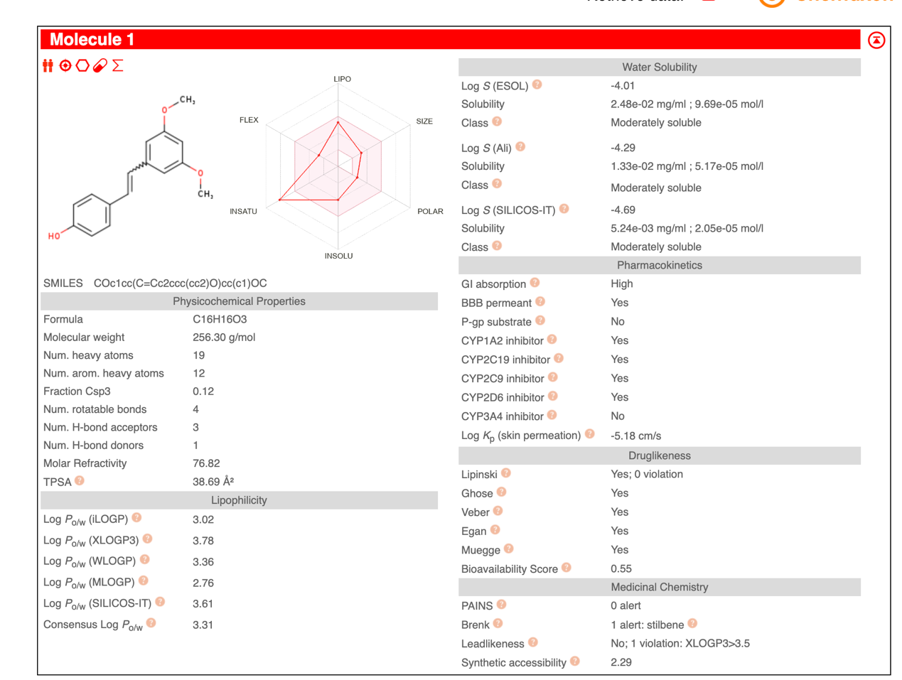
Figure S1. Drug Properties of PT.

