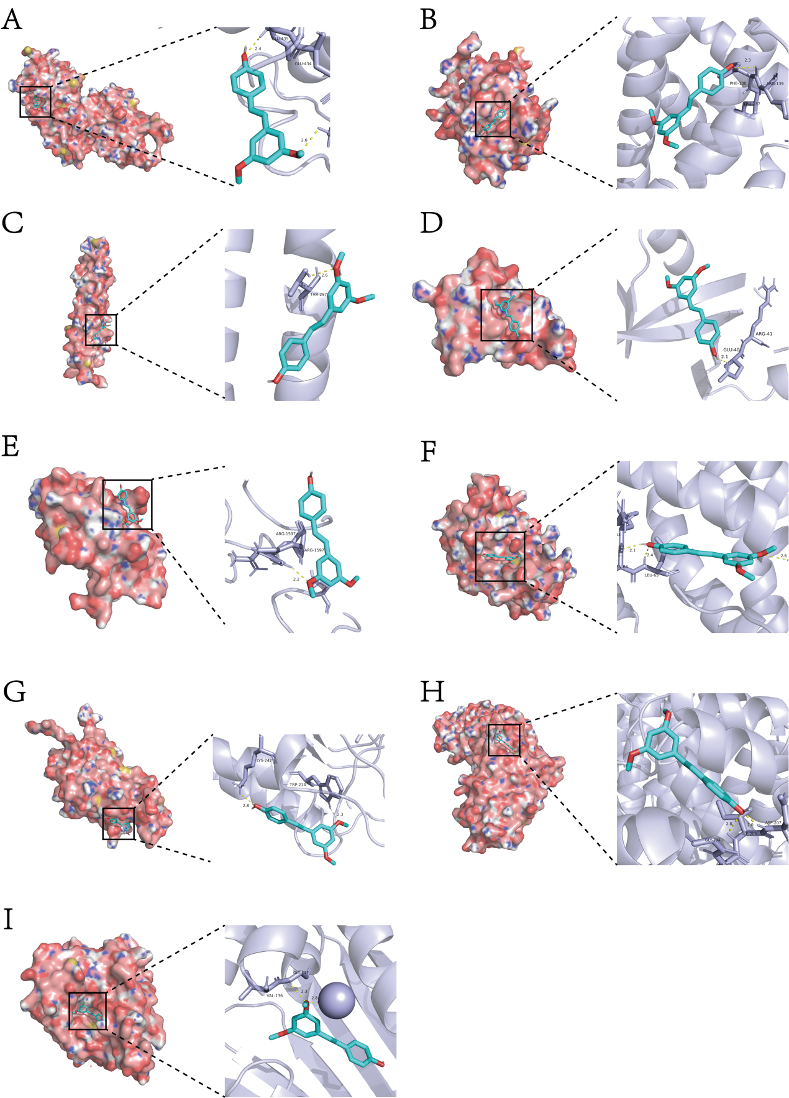
Figure S2. Molecular docking results of PT with hub proteins. A: STAT3, B: BCL2, C: JUN, D: AKT1, E: TP53, F: IL6, G: CASP3, H: HIF-1α, I: HSP90AA1.

