Additional file 1:
Supplementary Table
Table S1: Quality of RNA extracted from the orbital muscles
Tissue characteristics |  |  |  |  |  |  | Expression of reference genes |  | Expression of target genes
Phenotype | Muscle | Weight (mg) | RIN | Conc. | A260/280 | A260/230 | expressed/  profiled | Mean/median Cq (±SD/IQR) | expressed/profiled | Mean/median Cq (±SD/IQR)
OP-MG | OOM | 7 | 7.6 | 11.3 | 1.7 | 0.9 | 5/5 | 22.4 (±3.58) | 119/120 | 27.7 (±2.63)
OP-MG | OOM | 3 | 7.3 | 15.6 | 1.6 | 0.4 | 5/5 | 26.8 (±2.82) | 100/120 | 31.4 (29.4: 32.6)
OP-MG | OOM | 8 | 6.1 | 9.3 | 1.8 | 0.8 | 5/5 | 24.0 (±3.25) | 117/120 | 28.4 (±2.54)
OP-MG | OOM | 6 | 6.9 | 18.6 | 1.6 | 0.5 | 5/5 | 25.5 (±3.60) | 113/120 | 29.1 (±2.35)
OP-MG | OOM | 6 | 6.6 | 35.3 | 1.6 | 0.4 | 5/5 | 25.3 (±3.23) | 104/120 | 30.3 (28.9: 31.8)
Control | OOM | 11 | 7.4 | 11.8 | 1.8 | 1.0 | 5/5 | 22.1 (±3.37) | 118/120 | 27.7 (26.2: 29.4)
Control | OOM | 9 | 7.0 | 18.3 | 1.7 | 0.5 | 5/5 | 23.4 (±3.73) | 119/120 | 28.5 (±2.91)
Control | OOM | 12 | 6.7 | 4.9 | 1.6 | 0.3 | 5/5 | 26.5 (±3.91) | 105/120 | 31.3 (29.5: 32.8)
Control | OOM | 26 | 5.5 | 39.7 | 1.9 | 0.7 | 5/5 | 27.4 (±3.15) | 101/120 | 29.9 (28.1: 31.1)
OP-MG | EOM | 21 | 5.2 | 49.0 | 1.9 | 1.6 | 5/5 | 20.1 (±3.63) | 120/120 | 24.8 (±2.68)
Control | EOM | 8 | 7.5 | 40.1 | 1.9 | 0.8 | 5/5 | 20.8 (±3.45) | 120/120 | 25.7 (±2.68)

Legend: RNA integrity number (RIN); concentration (conc.); quantitation cycle (Cq). The Cq values are mean with standard deviation (SD) or median with interquartile range (IQR) depending on data distribution (Shapiro-Wilk test of normality). Only Cq values <35 are included. Ophthalmoplegic myasthenia gravis (OP-MG); extraocular muscle (EOM); orbicularis oculi muscle (OOM).

Table S2. Reference gene selection
 | Average fold change OP-MG/ controls | p value | geNorm  (m value) | Bestkeeper  (SD; CV)
Orbicularis oculi samples (5 OP-MG; 4 control)
RPLP0 | 0,98 | 0.977 | 1.58 | 1.13; 3.78
ACTB | 0.40 | 0.439 | 1.71 | 2.11; 8.17
GAPDH | 0.55 | 0.565 | 2.08 | 2.41; 10.33
CSNK2A2 | 0.91 | 0.891 | 1.40 | 1.70; 7.44
ACTN2 | 1.39 | 0.559 | 1.50 | 1.05; 4.74
Average RPLP0-ACTN2 | 1.19 | 0.769 | 0.44 | 1.09; 4.19
Medial rectus samples (1 OP-MG; 1 control)
RPLP0 | 1.68 | - | 0.35 | 0.37; 1.43
ACTB | 0.94 | - | 0.71 | 0.04; 0.21
GAPDH | 1.41 | - | 0.40 | 0.25; 1.31
CSNK2A2 | 1.92 | - | 0.39 | 0.47; 2.70
ACTN2 | 2.77 | - | 0.67 | 0.74; 4.04
Average ACTB-GAPDH | 1.15 | - | 0.29 | 0.10; 0.51
Average RPLP0-CSNK2A2 | 1.79 | - | 0.13 | 0.42; 1.94

Treatment-resistant ophthalmoplegic myasthenia gravis (OP-MG); Fold change = 2^{-∆Cq} (∆Cq=OP-MG Cq^{ref}- controls Cq^{ref}). “Average fold change” refers to the arithmetic mean of OP-MG 2^{-Cq} divided by the arithmetic mean of the controls. In the medial recti samples only the fold change is presented as no statistical tests could be performed on the limited number of samples. The “geNorm m value” refers to the average expression stability value calculated using the geometric mean. SD is the standard deviation and CV is the coefficient of variance.

Table S3. Genes highly expressed in extraocular muscle (EOM) and orbicular oculi muscle (OOM)
Gene Symbol | Average 2^{-ΔCq} (EOM) | Average 2^{-ΔCq} (OOM) | Fold change (EOMs/OOMs) | p value
CSNK2A2 | 27,74 | 11,18 | 2,48 | 0,005
MYH2 | 16,55 | 14,70 | 1,13 | NS
DES | 15,96 | 26,51 | 0,60 | NS
ACTN2 | 15,69 | 15,62 | 1,00 | NS
MYL12B | 11,18 | 9,96 | 1,12 | NS
GAPDH | 9,83 | 16,98 | 0,58 | NS
MYH1 | 7,61 | 22,36 | 0,34 | NS
MYH3 | 7,42 | 0,84 | 8,84 | 0,0001
ANKRD1 | 5,40 | 1,57 | 3,44 | 0,029
CTGF | 2,22 | 0,83 | 2,67 | 0,007
DDX17 | 1,93 | 1,12 | 1,73 | NS
ACTB | 1,92 | 2,23 | 0,86 | NS
TMBIM6 | 1,71 | 1,67 | 1,02 | NS
SH3BGR | 1,32 | 2,41 | 0,55 | NS
BNIP3 | 1,12 | 0,85 | 1,33 | NS
CHRNA1 | 1,11 | 0,11 | 10,00 | 0,036
CANX | 0,91 | 0,42 | 2,16 | 0,033
NFKBIA | 0,83 | 0,56 | 1,49 | NS
PDK4 | 0,75 | 0,92 | 0,82 | NS
ZFP36L2 | 0,75 | 0,71 | 1,05 | NS
DAF/CD55 | 0,70 | 1,86 | 0,38 | NS
CYR61 | 0,58 | 0,93 | 0,62 | NS
DDR2 | 0,51 | 0,61 | 0,84 | NS
PPP1R2 | 0,44 | 0,84 | 0,53 | NS
MMP2 | 0,44 | 0,72 | 0,61 | NS
GPNMB | 0,41 | 0,73 | 0,56 | NS
RGS2 | 0,34 | 0,70 | 0,49 | NS
IL6 | 0,16 | 1,69 | 0,10 | NS

Comparisons of gene expression in EOMs and OOMs is presented as fold change and p values are determined by unpaired Student’s t tests or *Mann-Whitney U test. NS refers to p>0.05. Bold refers to the OP-MG genes prioritized in (Nel et al., 20109)

Supplementary Figures
Figure S1. Differentially co-expressed gene pairs between OP-MG and control orbicularis oculi muscle ranked by significance derived from Fisher’s Z test.
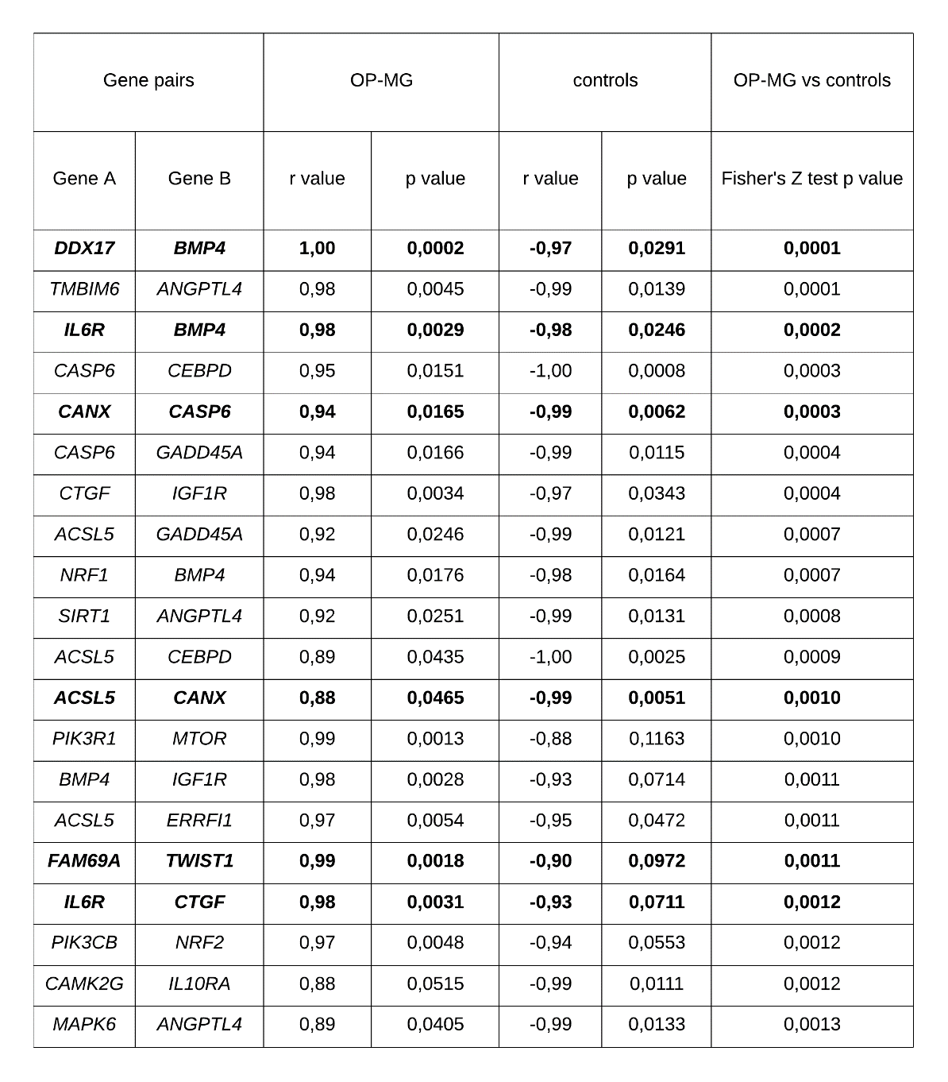
Differences between OP-MG and control correlations for each gene pair were tested for significance using the Fisher’s Z test. “r value” refers to the Pearson’s correlation co-efficient. Ophthalmoplegic myasthenia gravis (OP-MG). Gene pairs involving OP-MG genes are shown in bold text (Nel et al., 2019).

Figure S2. Scatter plot of gene expression levels in two extraocular muscles and nine orbicularis oculi muscles.
- Each data point represents the average 2^{-ΔCq} value for a single gene (n=125). Error bars
indicate the median and interquartile range. After normalization, the distribution of gene expression levels for extraocular muscles (EOM) and orbicularis oculi (OOM) were similar (Mann-Whitney U test). Highly expressed genes/pathways are bracketed in (B). *indicates the gene transcripts which differed significantly between EOMs and OOMs.

