Supplementary Information for
Ultra-High Thermal Stability of Anatase TiO₂ Nanorods by Surface Reconstructing
Xiaoyun Guo^{1†}, Yujing Zhang^{2,3†}, Chao Yang⁴, Yunhao Lu^{4,5}, Yang Ou¹, Beien Zhu^{2,3}, Ying Jiang¹, Zhong-kang Han^{1*}, Wentao Yuan^{1*}, Hangsheng Yang¹, Yi Gao^{2,3}, Ze Zhang¹ and Yong Wang^{1*}

¹Center of Electron Microscopy and State Key Laboratory of Silicon and Advanced Semiconductor Materials, School of Materials Science and Engineering, Zhejiang University, Hangzhou, 310027, China
²Photon Science Research Center for Carbon Dioxide, Shanghai Advanced Research Institute, Chinese Academy of Sciences, Shanghai, 201210, China
³Key Laboratory of Interfacial Physics and Technology, Shanghai Institute of Applied Physics, Chinese Academy of Sciences, Shanghai, 201800, China
⁴State Key Laboratory of Silicon and Advanced Semiconductor Materials, School of Materials Science and Engineering, Zhejiang University, Hangzhou, 310027, China
⁵Zhejiang Province Key Laboratory of Quantum Technology and Device, School of Physics, Zhejiang University, Hangzhou, 310027, China
†These authors contributed equally to this work.
*Corresponding author. Email: wentao_yuan@zju.edu.cn; hanzk@zju.edu.cn; yongwang@zju.edu.cn;

Table of Contents
- Supplementary Figures (1-6)
- Supplementary Videos (1-3)

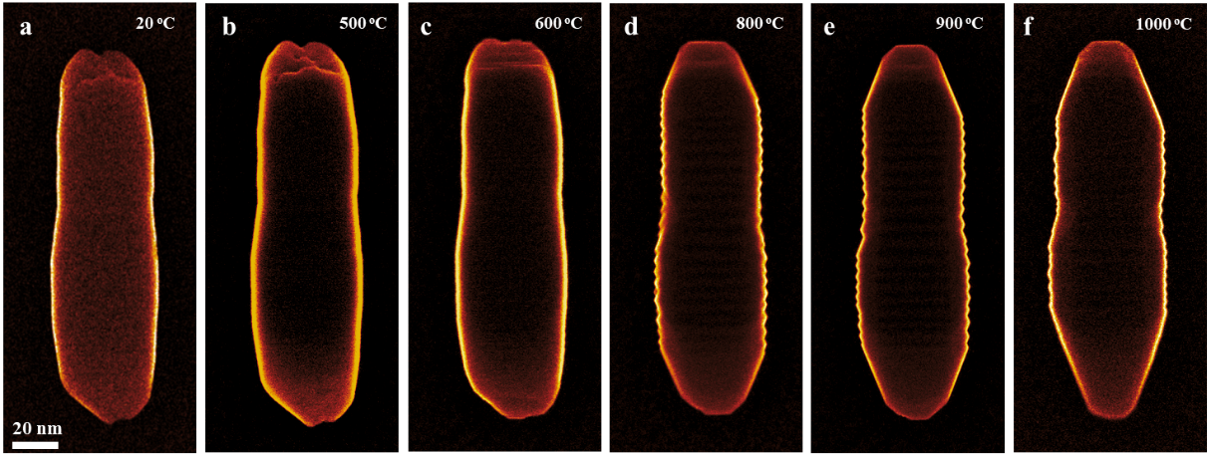
Supplementary Fig. 1. The morphology evolution of a anatase TiO₂ nanorod. In situ HRSEM images of a typical anatase TiO₂ nanorod in the heating process in vacuum (TEM column pressure: 5×10⁻⁵ Pa). a-f, A typical morphology evolution process of the anatase TiO₂ nanorod at different temperatures.

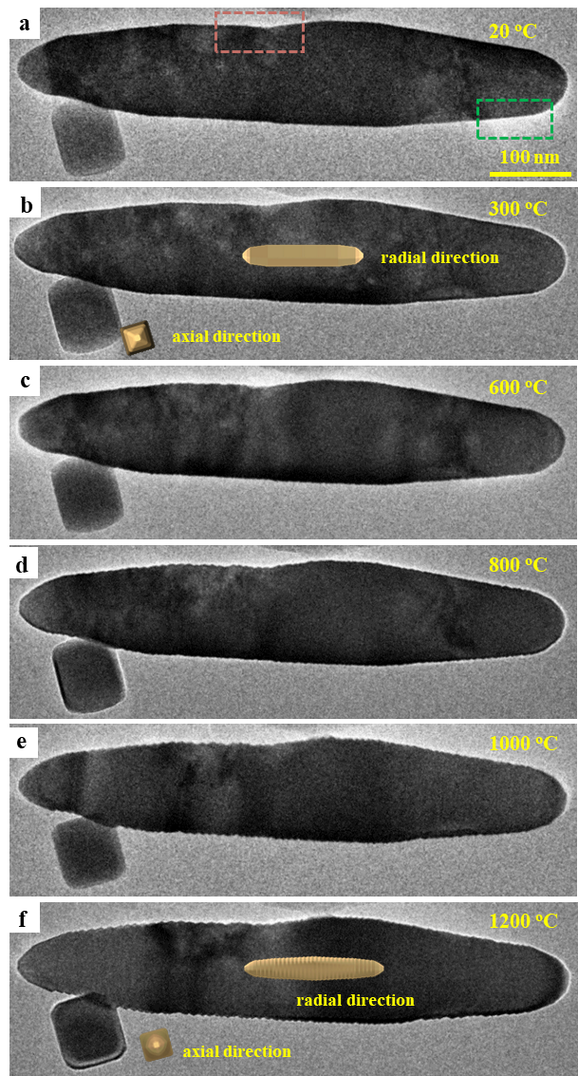
Supplementary Fig. 2. a-f, In situ TEM images from (Supplementary Video 1) show the structure evolution of the typical anatase TiO₂ nanorods in the heating process in vacuum (Temperature: 20-1200 °C; TEM column pressure: 5×10⁻⁵ Pa). The two TiO₂ nanorods were observed from two directions, both axial [001] and radial [010] viewing directions, respectively.

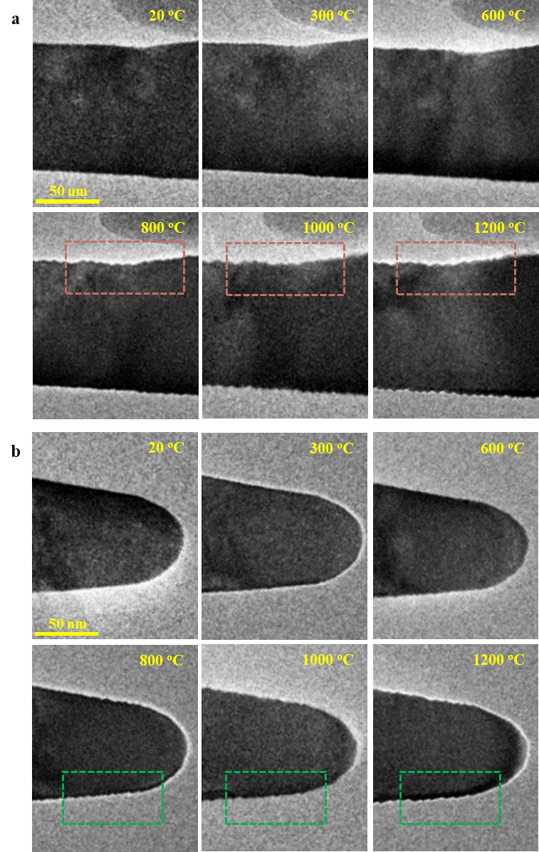
Supplementary Fig. 3. (a-b) The enlarged in situ TEM images show the structural evolution of the marked area (red box and green box areas) in Supplementary Fig. 2a. The images were collected in the heating process in vacuum (TEM column pressure: 5×10⁻⁵ Pa) show the at the corresponding temperatures. During the heating process, the originally flat {100} surfaces (a) and (301) surfaces (b) became roughened, reconstructing into distinct protruding structures.
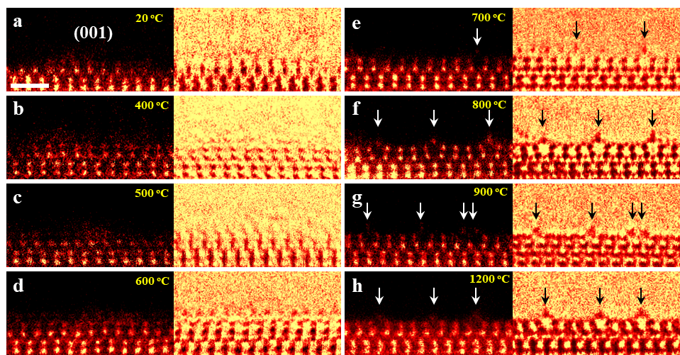
Supplementary Fig. 4. The atomic structural evolution of the anatase TiO₂ nanorod tip surface at the elevated temperatures. (a-h) The atomic level in situ HAADF STEM images show the structure evolution of (001) surface at the tip of anatase TiO₂ nanorod, in vacuum (Temperature: 20 °C to 1200 °C; TEM column pressure: 5×10⁻⁵ Pa). Scale bar: 2nm. During the heating process, the defective (001) surface progressively gradually becomes unstable and begins to undergo reconstruction above 700 °C, and ultimately forms a (1×4) reconstruction structure at 1200 °C.

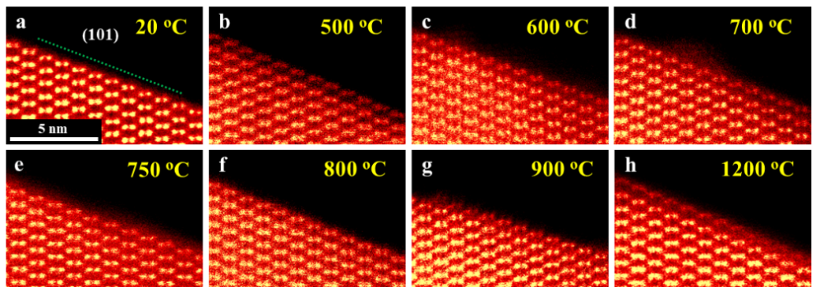
Supplementary Fig. 5. (a) The atomic-level HAADF STEM images show the structure evolution of anatase TiO₂ (101) surface, in vacuum. (TEM column pressure: 5×10⁻⁵ Pa). The images (b-h) are acquired at the corresponding temperatures.

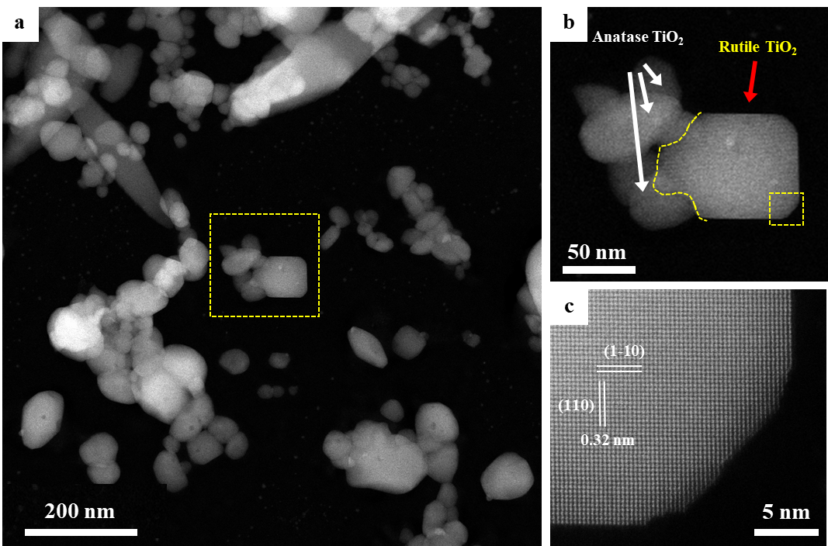
Supplementary Fig. 6. The in situ HAADF STEM images show the nucleation of rutile TiO₂ crystallite (Temperature: 1000 °C; TEM column pressure: 5×10⁻⁵ Pa). a-c, The low magnification (a-b) and the atomic level (c) HAADF STEM images show the rutile TiO₂ nucleated at the multi-grain boundaries by the convergence of adjacent anatase TiO₂ particles.

Captions of Videos
Video 1: In situ TEM video show the structure evolution of the typical anatase TiO₂ nanorods in the heating process in vacuum, viewed along both axial and radial directions. (Temperature: 20-1200 °C; TEM column pressure: 5×10⁻⁵ Pa).
Video 2: In situ atomic level STEM video show the surface structural evolution during the restructuring of a single crystalline TiO₂ nanorod, indicating a significant mass transportation via surface diffusion. The video collected at 1000 °C in vacuum (TEM column pressure: 5×10⁻⁵ Pa)
Video 3: In situ STEM video show the surface structural evolution of the sample in Video 1 at low magnification. The video collected at 1000 °C in vacuum (TEM column pressure: 5×10⁻⁵ Pa)

