Table 1. Relativity Analysis
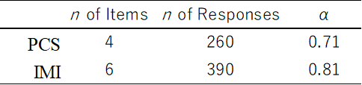

Table 2. Mann Whitney U Between Groups Comparison for PCS and IMI
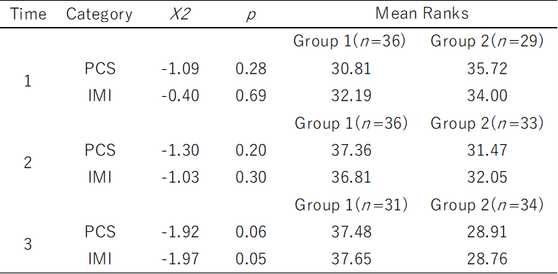

note: r = 0.24 for p = 0.05 in Time 3 comparison

Table 3. Group 1 Paired Wilcoxon Signed-Ranks Test Results
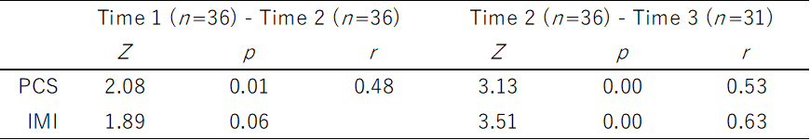

Table 4. Group 2 Paired Wilcoxon Signed-Ranks Test Results
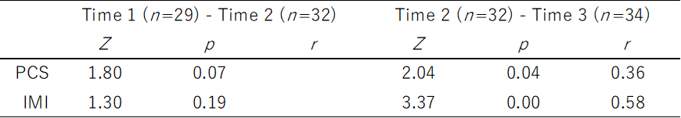

Table 5. Results of Levene’s Test of Equality of Error Variances
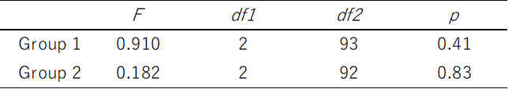

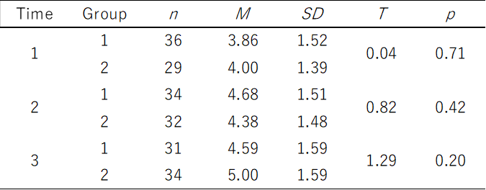
Table 6. t-test Results of Between Group Analysis

