Support Information (SI)

Progressive Hypoxia Enhances Lung Preservation via Oil Sealing
Guangjian Zhang^{1,4#}, Heng Zhao^{1,4#}, Bangrui Yu^{2,3}, Jingteng Feng^{1,4}, Ming Li^{1,4}, Rui Zhao^{1,4}, Haotian Bai^{1,4}, Yixing Li^{1,4}, Kun Fan^{1,4}, Mengke Zhu⁵, Zhe Chen^{1,4}, Shuo Li^{1,4}, Hongyi Wang^{1,4}, Shan Gao^{1,4}, Ye Sun⁶, Borui Sun⁶, Haishui Huang^{2,3}*
¹ Department of Thoracic Surgery, The First Affiliated Hospital of Xi’an Jiaotong University, Xi’an, 710061, P.R. China
² The Key Laboratory of Biomedical Information Engineering of Ministry of Education, Xi’an Jiaotong University, Xi'an, Shaanxi, 710049, P.R. China
³ Bioinspired Engineering and Biomechanics Center (BEBC), School of Life Science and Technology, Xi’an Jiaotong University, Xi'an, Shaanxi, 710049, P.R. China
⁴ Key Laboratory of Enhanced Recovery After Surgery of Integrated Chinese and Western Medicine, Administration of Traditional Chinese Medicine of Shaanxi Province, The First Affiliated Hospital of Xi'an Jiaotong University, Xi'an, 710061, P.R. China
⁵ Department of Pathology, The First Affiliated Hospital of Xi’an Jiaotong University, Xi’an, 710061, P.R. China
⁶ Department of Anesthesia and Surgery, The First Affiliated Hospital of Xi’an Jiaotong University, Xi’an, 710061, P.R. China
# These authors contribute equally to this work.
* Correspondence should be addressed to:
Haishui Huang, PhD
School of Life Science and Technology, Xi’an Jiaotong University
Xi’an, Shaanxi, 710049, P. R. China
E-mail: haishuihuang@xjtu.edu.cn
Figure Captions
- Fig. S1 Experimental design for rat lung preservation and transplantation models.
- Fig. S2 Assessment of apoptosis and IL-10 secretion after cold lung preservation.
- Fig. S3 Rat orthotopic left lung transplantation and molecular analyses.
- Fig. S4 Analysis of intracellular ROS levels and cell viability under different preservation conditions.
- Fig. S5 Comparative lung preservation and transplantation procedures in large mammals.

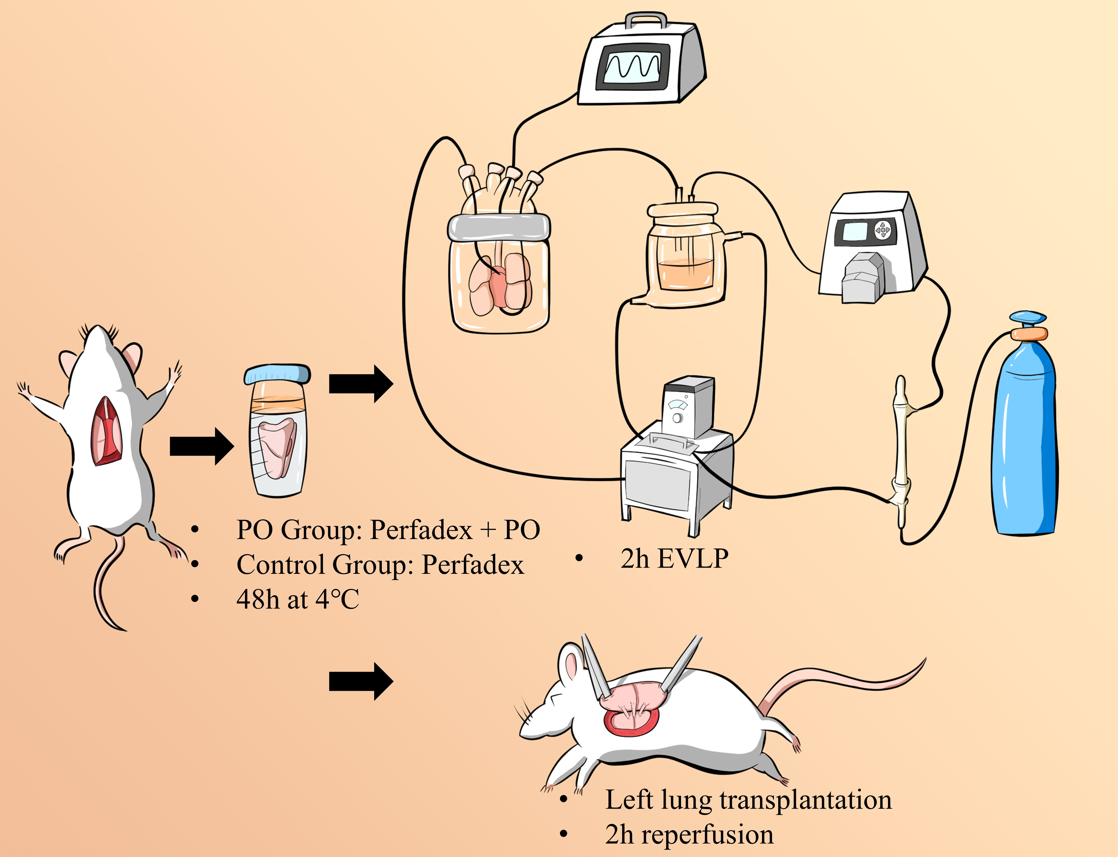
Figure S1. Experimental design for rat lung preservation and transplantation models.

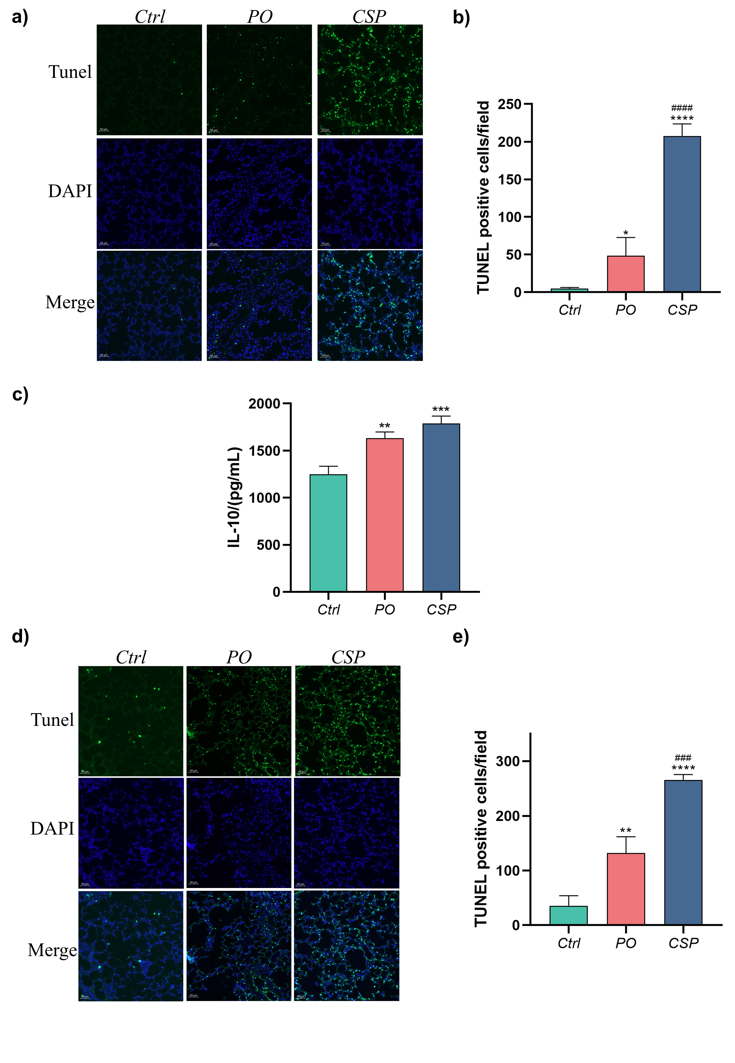
Figure S2. Assessment of apoptosis and IL-10 secretion after cold lung preservation. a) Tunel staining in lung tissues after cold preservation. b) Statistical analysis of Tunel positive cells. c) The IL-10 levels in lung tissue. d) Tunel staining in lung tissues after EVLP. e) Statistical analysis of Tunel positive cells. *P<0.05; **P<0.01; ***P<0.001; ****P<0.0001. * Compared with Ctrl group, # Compared with PO group.
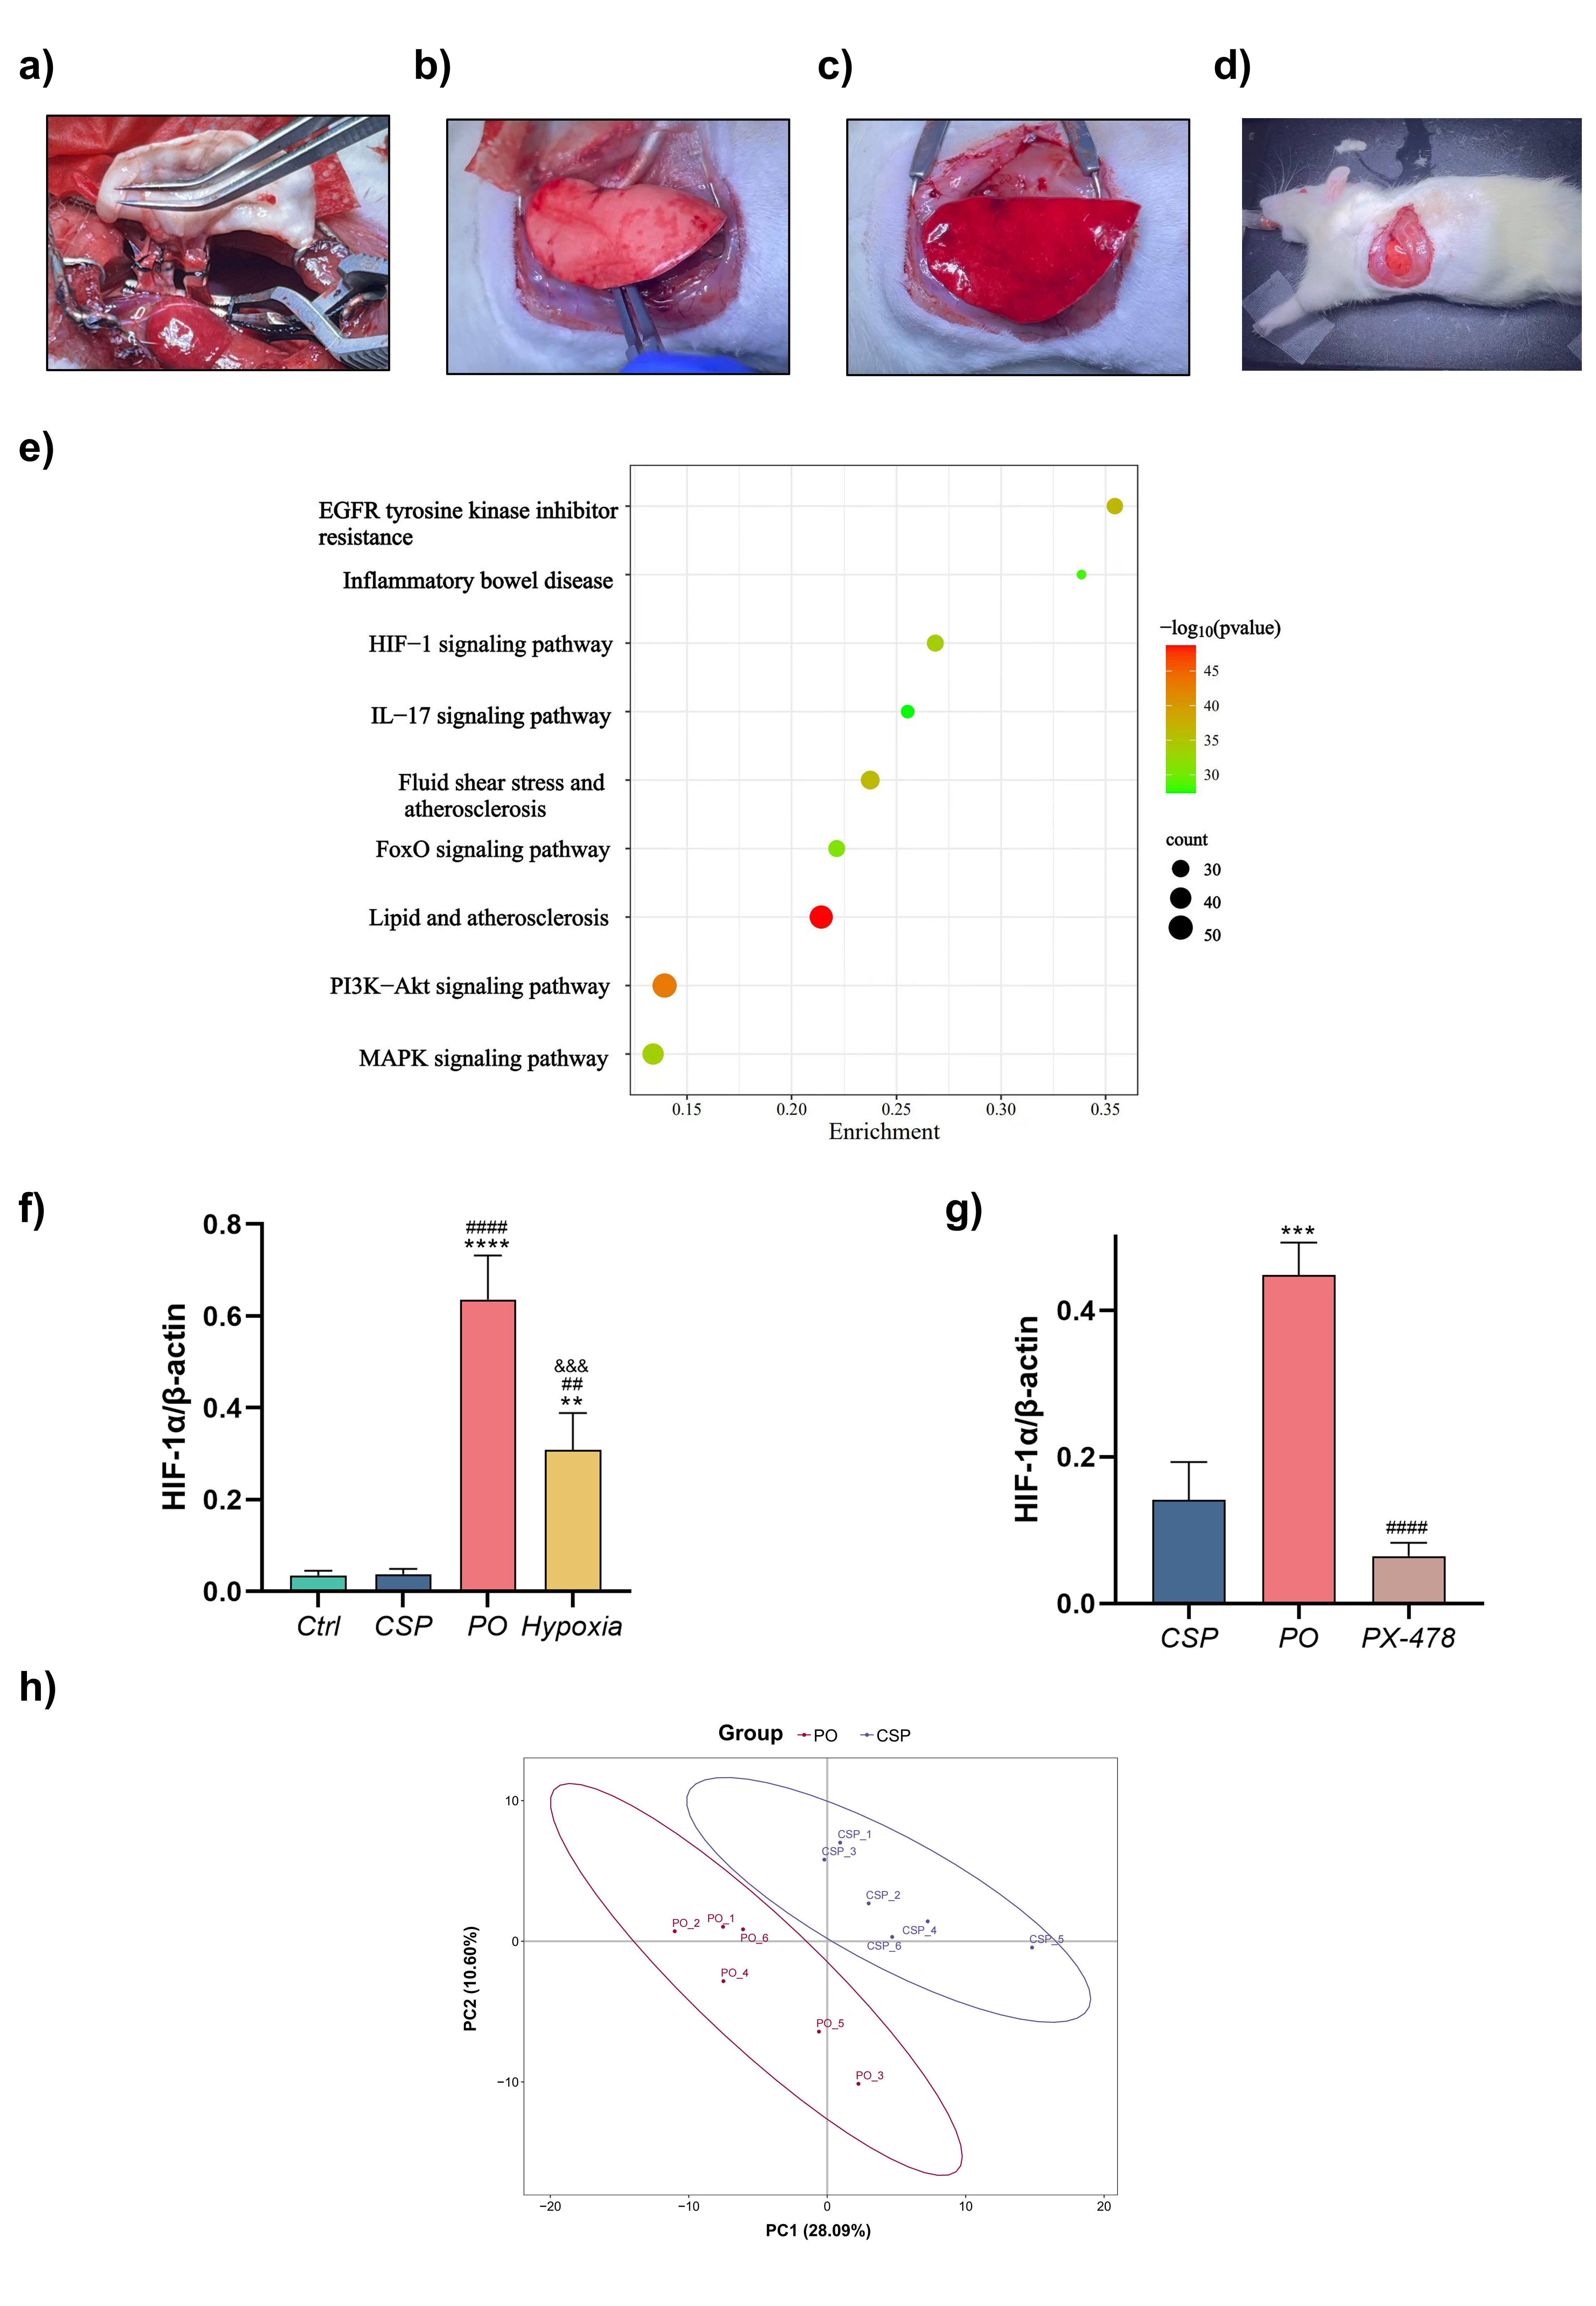
Figure S3. Rat orthotopic left lung transplantation and molecular analyses. a) Completed anastomosis of the bronchus, artery, and vein. b) Re-aeration of the transplanted lung following ventilation. c) Reperfusion of the transplanted lung after circulation restoration. d) Post-transplantation appearance of the rat with the transplanted left lung in situ. e) HIF-1 pathway in the enrichment analysis of KEGG. f) Quantitative analysis of figure 4b. *P<0.05; **P<0.01; ***P<0.001; ****P<0.0001. * Compared with Ctrl group. # Compared with CSP group. & Compared with PO group. g) Quantitative analysis of figure 4c. *P<0.05; **P<0.01; ***P<0.001; ****P<0.0001. * Compared with CSP group. # Compared with PO group. h) PCA analyses of metabolomics.

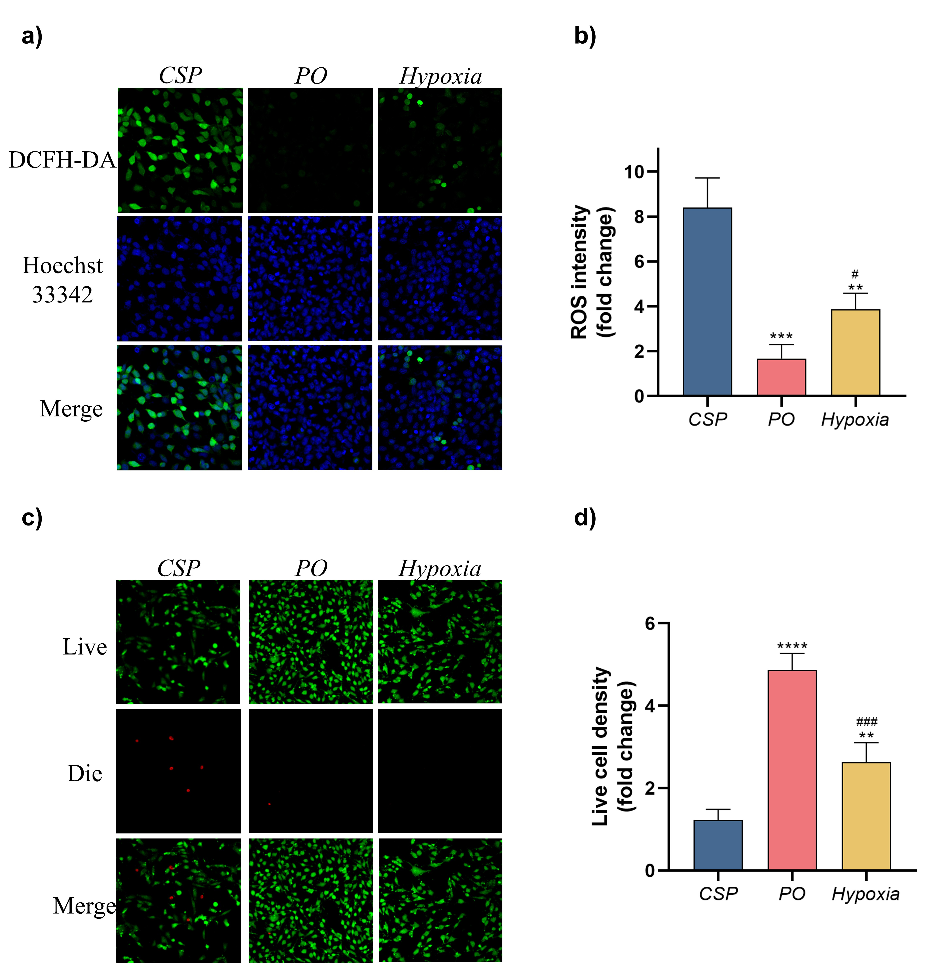
Figure S4. Analysis of intracellular ROS levels and cell viability under different preservation conditions. a) Representative fluorescence images of intracellular ROS staining using DCFH-DA (green) and nuclear staining with Hoechst 33342 (blue) in cells. b) Quantification of ROS intensity. c) Live/dead cell staining showing live cells (green) and dead cells (red) across the three groups. d) Quantification of live cell density (fold change). *P<0.05; **P<0.01; ***P<0.001; ****P<0.0001. * Compared with CSP group, # Compared with PO group.

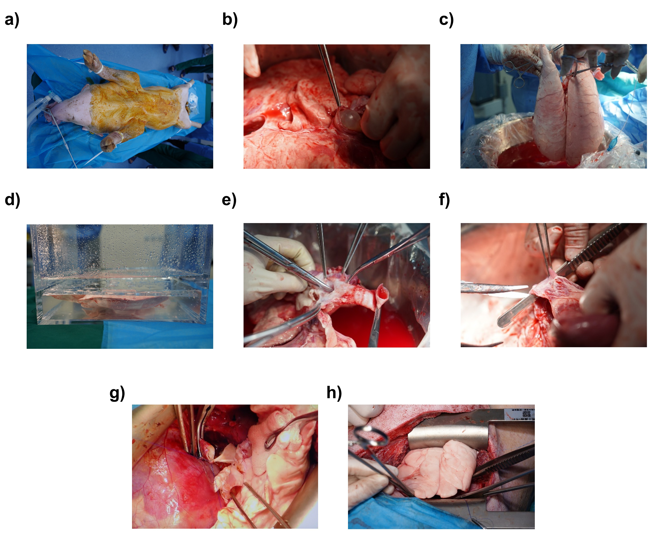
Figure S5. Comparative lung preservation and transplantation procedures in large mammals. a) Pig positioned in the supine position under general anesthesia. b) Perfusion of the donor lung with Perfadex solution. c) Harvested donor lung following perfusion. d) Donor lung preserved using the paraffin oil sealing method. e) Dissection of the recipient's left main bronchus. f) Trimming of the left pulmonary vein to create an “atrial cuff.” g) Anastomosis of the pulmonary artery. h) Reventilation of the transplanted lung.

