Photodegradation behavior of nanosilica-filled PMMA composite: synergistic effect of mixed solvents and interfacial functional groups
Supplementary Material
Zhiping Xu¹, Liangchen Li^{1†}, Ying Liu¹, Rui Yang^{1*}
- Department of Chemical Engineering, Tsinghua University, Beijing, China
*Corresponding author(s), E-mail(s): yangr@mail.tsinghua.edu.cn
†These authors contributed equally to this work
Table S1 lists the specific feeding information of Nano-SiO₂ with different surface chemical modifications. According to the literature, the maximum density of hydroxyl groups that can be accommodated on the surface of silica is about 5 hydroxyl groups/nm¹. Therefore, in this work, the required silane coupling agent additions were all calculated based on the molar ratio of surface silica hydroxyl groups to coupling agent molecules of 1:4.
Table S1 Feeding information of silane coupling agents for SiO₂ surfaces chemical modification
Silanes | Feed | Products
APTES | 12.6 mmol (2.95 ml) | SiO₂@NH₂
EPPTMS | 12.6 mmol (2.78ml) | SiO₂@Ep
MAPTMS | 12.6 mmol (2.84 ml) | SiO₂@MA
MPTMS | 12.6 mmol (2.34 ml) | SiO₂@SH
PhTMS | 12.6 mmol (2.36 ml) | SiO₂@Ph
PTES | 12.6 mmol (2.91 ml) | SiO₂@Propyl
OTMS | 12.6 mmo (3.26 ml) | SiO₂@Octyl

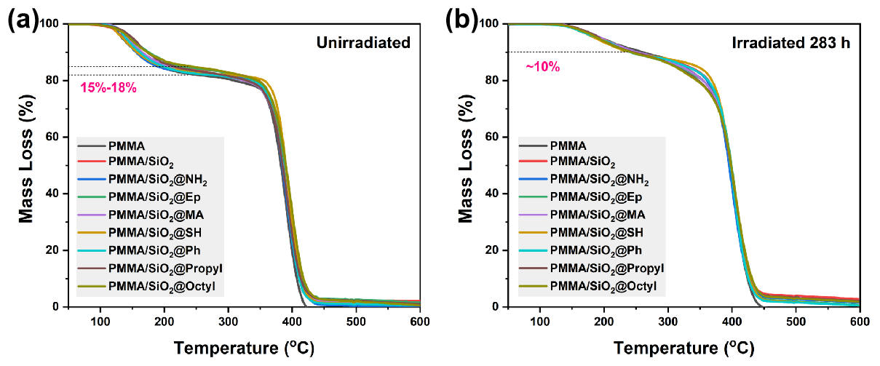
Fig. S1 Thermogravimetric curves of PMMA and its SiO₂ filled composite films before and after photooxidative aging: (a) before photooxidative aging; (b) after photooxidative aging for 283h

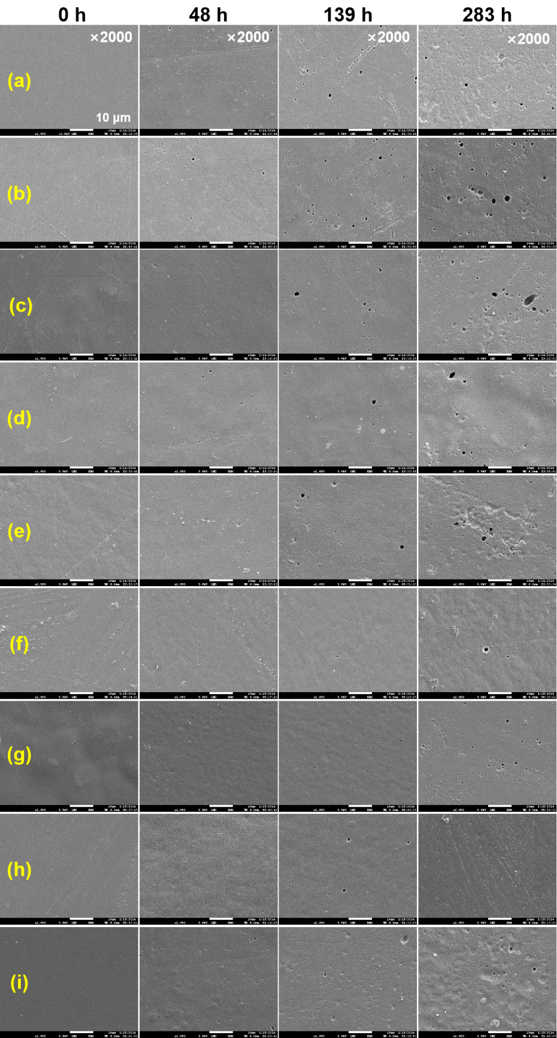
Fig. S2 Surface morphology changes of the film during photooxidative aging: (a) PMMA; (b) PMMA/SiO_{2;} (c) PMMA/SiO₂@NH₂; (d) PMMA/SiO₂@Ep; (e) PMMA/SiO₂@MA; (f) PMMA/SiO₂@SH; (g) PMMA/SiO₂@Ph; (h) PMMA/SiO₂@Propyl; (i) PMMA/SiO₂@Octyl

References
1. Zhuravlev LT (2000) The surface chemistry of amorphous silica. Zhuravlev model. Colloids Surf Physicochem Eng Asp 173(1):1-38. https://doi.org/10.1016/S0927-7757(00)00556-2

