Supplementary Materials for
Donor-reactive T cells and innate immune cells promote pig-to-human decedent xenograft rejection
Farshid Fathi^{1†}, Nathan Suek^{1†}, Benjamin Vermette^{1†}, Kevin Breen¹, Yasmeen S. Saad¹, Constanza Bay¹, Christopher A. Parks¹, Jeffrey Stern², Karen Khalil², Jacqueline Kim², Ian S. Jaffe², Imad Aljabban², Ekaterina Novikova³, Elizabeth Severa³, Ramin Sedaghat Herati³, Lars Burdorf⁴Adam D. Griesemer², Robert A. Montgomery ², Megan Sykes^{1,5,6*}

†These authors contributed equally to this work
*Corresponding author. Email: ms3976@cumc.columbia.edu

The PDF file includes:

Materials and Methods
Extended Data Figures 1-10
Tables S1 to S6
References (13, 24, 36)

Materials and Methods
Experimental Model and Transplantation Protocol
A thymokidney was transplanted from an α-Gal KO (GalSafeTM) source pig (United Therapeutics Corporation and its subsidiary, Revivicor, Inc.) to a human decedent recipient following bilateral native kidney nephrectomy, as described in detail (13). The source pig was a female, 199-day-old at time of procurement, and weighed 80.7 kg. The brain-dead recipient was a 56-year-old male, weighing 79.5 kg with stage IV glioblastoma, making him unsuitable for organ donation. The total ischemia time was 4 hours and 45 minutes. The immunosuppression regimen is shown in Table S1. Five months before transplantation, autologous thymus tissue was implanted under the source pig’s kidney capsule. The native kidneys were subsequently removed, and one thymokidney was transplanted orthotopically to the decedent.

Patient Sample Collection
Blood, lymphocele, lymph node tissues and kidney biopsies were collected at different timepoints pre-transplant and on PODs -3,0, 7, 14, 21, 28, 33, 35, 42, 45, 49, 56, and 61.

Sample Processing
PBMCs were obtained from blood samples at each time point using Ficoll (Sigma-Aldrich, catalogue number 10771-500ml) density gradient centrifugation. Isolated PBMCs were washed with phosphate buffered saline (PBS, Cytvia, catalogue number SH30256.02) and red blood cells (RBCs) were lysed by ACK lysing buffer (Gibco, catalogue number A10492-02) for 3 minutes, followed by another PBS wash. PBMCs were cryopreserved in liquid nitrogen in freezing media containing human AB serum (Gem Cell, catalogue number 100512) and 10% DMSO (Sigma Aldrich, D2650-100 ml).

Kidney core needle biopsies were collected on various PODs, including 14, 28, 33 and 61. The kidney tissues were digested using the Gentle MACS kit (Multi Tissue Dissociation Kit 1, Miltenyi Biotec, catalogue number 130-110-201) according to the manufacturer’s instructions and human leukocytes were isolated via human CD45⁺ FACS sorting (BD, Influx). Lymph nodes were gently crushed, strained through 70 μm filters and washed twice with PBS and single-cell suspensions were prepared. Additionally, a perinephric lymphocele drainage sample was obtained on POD14. Leukocytes from the lymphocele sample were isolated using a Ficoll density gradient.

Direct and Indirect Mixed Lymphocyte Reactions (MLR)
We developed direct and indirect MLR assays using healthy control T cells as responders. For direct MLR, porcine DCs were differentiated from PBMCs and used as stimulators. Twenty-five million porcine PBMCs were plated in MLR medium (AIM-V supplemented with 5% AB heat-inactivated human AB serum, 0.01 M HEPES, and 50 mM 2- mercaptoethanol, 1% penicillin/streptomycin) at a concentration of 2 × 10⁶ cells/mL. After 12 hours, non-adherent cells were harvested and discarded, and the medium was replaced with fresh medium containing 50 ng/ml of porcine granulocyte-macrophage colony-stimulating factor (pGM-CSF, bioteche, catalogue number 711-PG) and 20 ng/mL porcine interleukin-4 (pIL-4, bioteche, catalogue number 654-p4-025/CF). On day 3, 1 mL of medium containing 10x concentrated porcine cytokines (500 ng/mL pGM-CSF, 200 ng/mL pIL-4) was added. On day 4 (12 hours before harvesting) DCs were matured/activated by adding 1μg/mL of LPS (Milipore Sigma, catalogue number L2387). On day 5, DCs were detached by agitation with cold MACS buffer. Pig DCs were then resuspended in PBS and labelled with BD Horizon Violet Proliferation Dye 450 (VD450, catalogue number 562158). After labelling, cells were washed twice, resuspended in MLR medium at 2× 10⁶ cells/mL, and irradiated at 30 to 35 Gy, and subsequently co-cultured with responder cells. The responders comprised human CD3⁺ T cells isolated using a CD3-negative (to keep the T cells untouched) MACS sorting kit (Pan T Cell Isolation Kit II, Miltenyi Biotec, catalogue number 130-096-535) and labelled with CFSE (CellTrace CFSE Proliferation Kit, Invitrogen, catalogue number C34554). These T cells were resuspended in PBS at 1 × 10⁶ cells/mL, labelled with CFSE at a concentration of 0.2 to 0.5 μM, washed three times, and resuspended in MLR medium. We used 96-well round bottom plates with 200,000 responder T cells and 20,000 pig DC stimulators per well (10:1 ratio) (total well volume, 200 μl). MLR cultures were incubated at 37°C for 6 days. CFSE^{low} (proliferated) CD4 and CD8 T cells were FACS sorted and DNA was extracted (Qia gen, catalogue number 69504) and deep TCRB sequencing was carried out at Adaptive Biotech as described (24). Detailed information on the materials, reagents, and antibodies used in this study is provided in tables S5 and S6.

For the indirect MLR, macrophages were differentiated from human monocytes and loaded with apoptotic pig cells generated as described below, serving as stimulators. CD14⁺ monocytes were isolated from 30 million human PBMCs using a MACS negative selection kit (Classical Monocyte Isolation Kit, Miltenyi Biotec, Cat number 130-117-337). Subsequently, they were plated in IMDM (Gibco, catalogue umber 12440-053) supplemented with 10% human AB serum (100,000 cell/cm²). After 12 hours, non-adherent cells were removed, and fresh media containing 50 ng/ml M-CSF (PeproTech, catalogue number 300-25) was added. On day 4, the media, now including M-CSF (50 ng/ml) and IL-4 (20 ng/ml, PeproTech, catalogue number 200-04), was refreshed. On day 6, 3 million differentiated macrophages were harvested and co-cultured with 9 million apoptotic (100 Gy-irradiated) porcine PBMCs in 6 wells of a 6-well plate (1:3 ratio, 150,000 macrophages versus 450,000 apoptotic porcine PBMC in each well). After 12 hours, IFN-γ (50ng/ml, PeproTech, catalogue number 300-02) and LPS (50 ng/μl) were added to the media. Twelve hours later, activated and antigen-loaded macrophages were harvested and purified again by CD14-negative MACS sorting. After MACS sorting, 500,000 cells were retrieved and stained by VD450 and used as stimulators (see above). The responder cells were stained by CFSE and cocultured with activated, antigen-loaded, and VD450 stained macrophages at a ratio of 5 to 1(200,000 responders and 40,000 stimulators). After 6 days at 37°C, CD4 and CD8 CFSE^{low} proliferated cells were isolated, DNA was extracted, and deep TCRB CDR3 sequencing was carried out at Adaptive Biotech (24). Other- ratios of responders and stimulators were tested, and the greatest proliferation was seen at a 5 to 1 ratio (data not shown).

Direct and indirect MLRs for decedent recipient against source pig
After establishing our direct and indirect MLR assays, we employed this method in our decedent study. 150 mL blood samples were collected from both the source pig and the decedent recipient one day prior to the procedure. On PODs 28 and 49 we received 50 and 22.5 ml of blood (Fig. 2A). PBMCs were isolated from blood samples and preserved in cryopreservation media for use in subsequent experiments. During the PBMC preparation and thawing processes, an unexpected issue was observed: the cells demonstrated unusual clumpiness, resulting in a yield of PBMCs that was significantly lower than anticipated. Consequently, while we were able to set up both direct and indirect MLR with low total cell numbers for the pre-transplant time point, we were able to only do direct MLR for POD28 and total MLR (recipient PBMC as responder versus source pig PBMCs as stimulator) for POD49. Due to the low number of cells and hence clones obtained from our pre- transplant MLR, we also used T cells isolated from pre-transplant lymph node as responders versus source pig DC as stimulators in a direct MLR. High throughput TCR sequencing was done on sorted unstimulated CD4 and CD8 T cells and CD4 CFSE^{low} and CD8 CFSE^{low} T cells after stimulation in the direct and indirect MLR assays described above.

Bulk TCRB CDR3 sequencing
Deep TCRB CDR3 sequencing was performed on genomic DNA extracted from CD4 CFSE^{low} and CD8 CFSE^{low} cells pre- and post-transplantation. Genomic DNA from unsorted and unstimulated PBMCs samples was also sent for bulk TCRB CDR3 sequencing. Additionally, sorted CD4⁺ and CD8⁺ sorted cells from post-transplant peripheral blood samples obtained at POD28, 33, and 49 were sequenced. The extracted genomic DNA was sent to Adaptive Biotechnologies for TCRB chain CDR3 sequencing according to their immunoSEQ Platform protocols, which include standards for sequencing and error correction.

Sample Processing
We loaded a table of the CDR3 amino acid and nucleotide sequences of the TCRB sequences into RStudio (version 4.3.1) and screened them for known lab contaminants at the nucleotide level. The few contaminants found were removed. The sequences were further processed using a modified `resolveambiguous` function (36) with an ambiguity ratio of 5. Using this function, clones present in both CD4⁺ and CD8⁺ populations of the same sample, with a frequency in one population at least 5 times higher than in the other, were removed from the population with the lower frequency. A slight modification was made to the `resolveambiguous` function to preserve putative sequences present in both populations at an ambiguity ratio lower than 5. These clones had to meet a minimum frequency threshold of 1E-5 in both CD4⁺ and CD8⁺ populations to be preserved, which reduced the possibility of cross-contamination or sorting error.

XDRTCCs were then identified at the amino acid levels. Unique sequences from CD4⁺ and CD8⁺ CFSE^{Low} populations were individually compared to their respective abundance in the pre-transplant peripheral repertoire. To be defined as a XDRTCC, individual clones needed to have an abundance in their respective CFSE^{Low} repertoires that was at least twice their abundance in the pre-transplant unstimulated repertoire (table S2). Because XDRTCCs identified post-transplant and not pre-transplant are likely to have already expanded in vivo in response to the xenograft, the criteria for their identification included a comparison to their frequency in pre-transplant rather than simultaneous post-transplant unstimulated populations. The remaining XDRTCCs from all the different MLRs were then pooled together according to their CD4⁺ and CD8⁺ identity and combined into a single repertoire to facilitate analysis and tracking. Each clone was only counted once in the pooled repertoires.

Non-xenogeneic donor-reactive T cell clones (non-XDRTCCs) were defined by exclusion, starting with the pre-transplant unsorted peripheral blood repertoire. Specifically, CD4 clones detected in the pre-transplant unsorted, unstimulated peripheral blood repertoire but not in the CD4⁺ CFSE^{Low} populations constituted the CD4 non-XDRTCC repertoire. Similarly, non-overlapping CD8 clones between the pre-transplant unsorted, unstimulated peripheral blood T cell repertoire and the CD8⁺ CFSE^{Low} populations constituted the CD8 non-XDRTCC repertoire. Although the poor PBMC yields precluded separate sorting of unstimulated CD4⁺ and CD8⁺ T cells pre-transplant, many of the same clones were later mapped to post-transplant sorted populations, allowing us to assign their CD4⁺ or CD8⁺ identity. The total number of CD4⁺ and CD8⁺ templates in the unsorted pre-transplant peripheral population was estimated using pre-transplant flow cytometric data, which showed that 74.0% of CD3⁺ T cells were CD4⁺ and 20.0% were CD8⁺ (Extended Data Fig.10C). This allowed us to estimate the number of CD4⁺ and CD8⁺ non-XDRTCCs.

The CD4⁺ and CD8⁺ XDRTCC and non-XDRTCC repertoires were then mapped onto post-transplant CD4⁺ and CD8⁺ sorted peripheral populations. We calculated clonal abundance, or frequency, defined as the total number of templates associated with a mappable clone divided by the total number of templates, in these populations (Fig. 3A, 3B).

Since XDRTCCs and non-XDRTCCs were identified by amino acid sequence, individual clones could have more than one synonymous nucleotide sequence associated with them (Extended Data Fig.3E). A clonal convergence analysis was done comparing the average number of unique TCR nucleotide sequences associated with the same amino acid sequence for XDRTCCs and non-XDRTCCs found in the peripheral blood.

The computations were done in RStudio, and most plots were produced in GraphPad Prism. Other R packages used included immunarch and eulerr.

Single-cell RNA and TCR sequencing
Kidney biopsy and lymphocele samples were processed as described above and sorted CD45⁺ immune cells were submitted to the Columbia Human Immune Monitoring Core for standard single-cell RNA using 10X GEM Chromium 5’ Ver2. TCR libraries were prepared from the same samples. Gene expression libraries were sequenced at a minimum depth of 25,000 reads per cell and TCR sequencing at a depth of 5,000 reads per cell. FACS sorted CD4 and CD8 CFSE^{low} cells in the healthy control MLR assays were loaded and submitted according to the same protocol.

Sample Processing CellRanger (v.6.1.2 pipeline) was used to pre-process sequenced reads against reference GRCh38-2020-A (from Cellranger) and Sscrofa11.1(from Ensembl). A hybrid human and pig reference sequence set were generated using Cellranger’s mkref function. The hybrid reference was used to map the transcripts all cells. The barcodes of cells with significant pig transcript counts were identified. The human-only reference set was then used to map the transcripts of all cells. Any overlapping barcodes of the previously identified pig cells were removed. Downstream analysis of the filtered UMI expression profile was completed using R (v.4.4.0) and Seurat (v.5.0.3). CellRanger outputs were assembled into the count matrix using and cells with at least 500 unique features, between 1000 to 25000 UMIs, and mitochondrial RNA < 15% were retained for further analysis. Features expressed in less than 50 cells were also removed. Data were then normalized using SCTransform and data from different samples were integrated using Seurat’s CCA based workflow. Cells were assigned cell cycle scores using S and G2M phase genes (from cc.genes included in the Seurat package). Data were normalized and scaled with S and G2M scores regressed out. Thirty principal components were used to construct a K nearest neighbors graph and clusters identified by the shared nearest neighbor (SNN) algorithm. Clusters were visualized using the UMAP algorithm. Differential expression was done using Seurat’s implementation of the Wilcoxon rank sum test with FindMarkers. Violin plots were generated in Seurat. Heatmaps were generated using the pheatmap library. Pathway analysis was done using Seurat’s DEenrichrPlot modified to use the top differentially expressed genes by log fold change. Cytotoxicity gene signature was conducted using the gene set M12145 and AddModuleScore. Cell-cell interaction predictions were generated using CellChat package. Reference based cell labeling using the Human Primary Cell Atlas was conducted using SingleR.

Statistical Methods
Analyses were conducted in Graphpad Prism 9.0 or 10.0 (GraphPad Software, USA) as well as RStudio (version v.4.4.0).

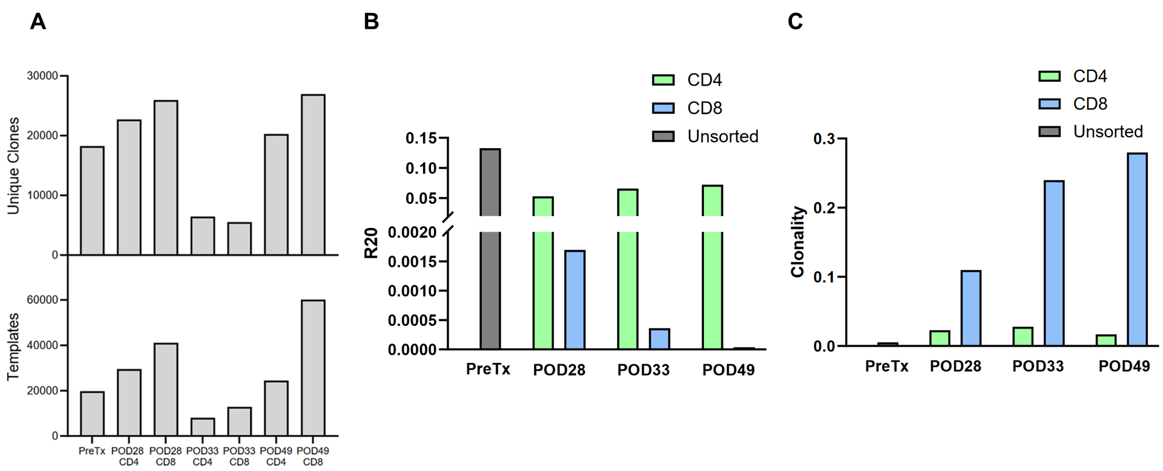

Extended Data Fig.1
Number of unique clones, templates and diversity metrics of post-operative peripheral blood t cell repertoire. (A) Number of unique clones and templates in unstimulated TCRB sequencing samples from peripheral blood. (B) The proportion of clonotypes needed to account for 20% of total TCRB CDR3 templates (R20) was calculated for both CD4 and CD8 repertoires at each timepoint. An R20 of 0.20 represents the maximum value, indicating a maximally diverse repertoire with no clonotype expansion. (C) Clonality was measured for the different repertoires at each post-operative timepoint. A clonality of 0 indicates a maximally diverse repertoire where all clonotypes are unique, while a clonality of 1 indicates that all cells in the repertoire share the same clonotype.
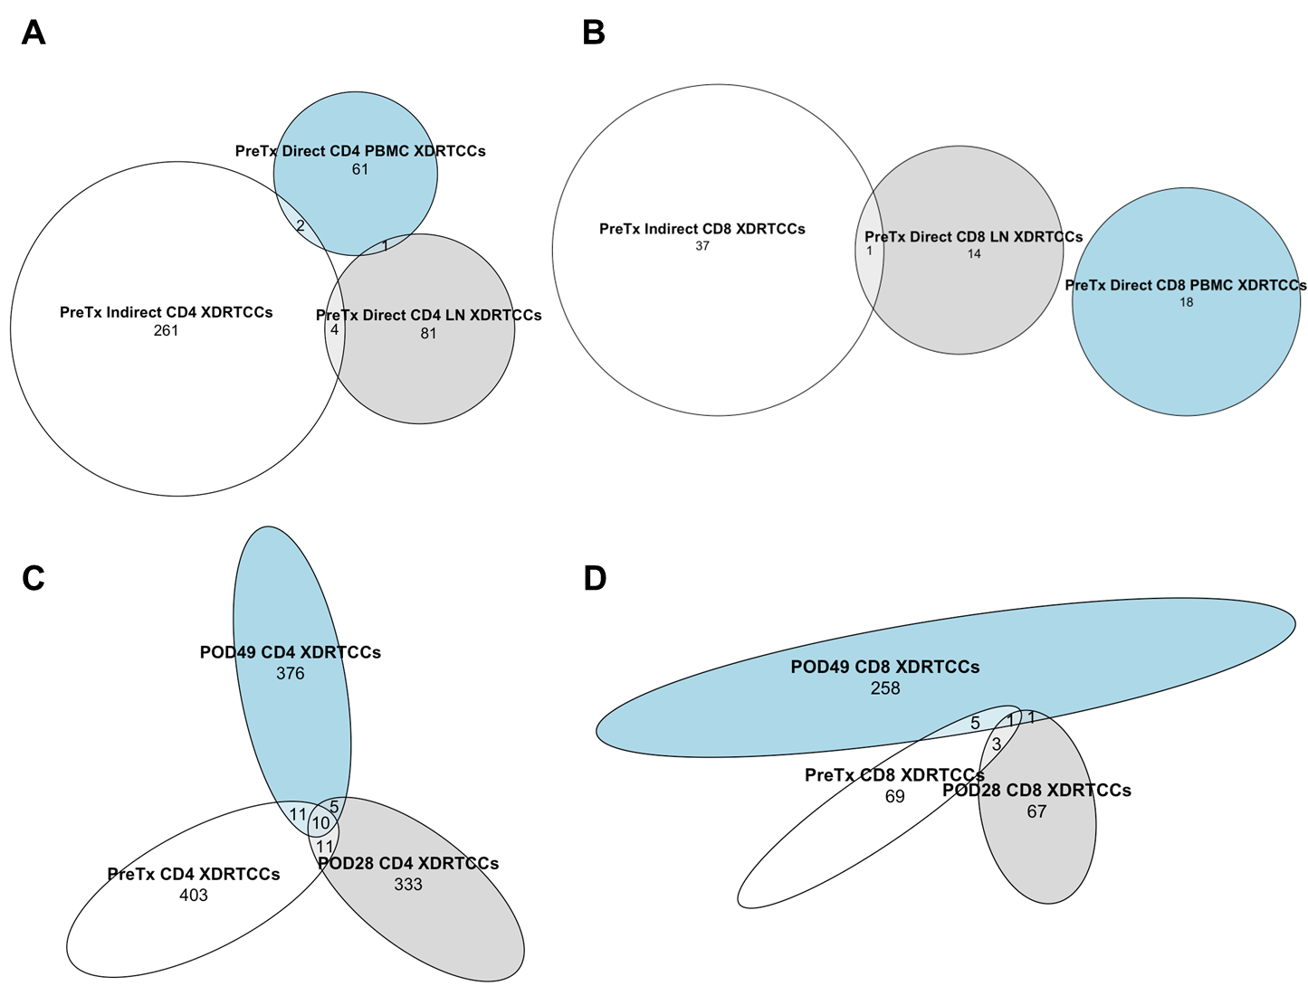

Extended Data Fig.2
MLRs summary and repertoire overlap analysis. Proportional Venn diagrams show: (A) Pre-transplant CD4 XDRTCC overlap between PBMC direct and indirect responses and lymph node (LN) direct responses. (B) Pre-transplant CD8 XDRTCC overlaps between PBMC direct and indirect responses and LN direct responses. (C) Overlap between pre-transplant, POD28 and POD49 CD4 XDRTCCs. Pre-transplant CD4 XDRTCCs from direct and indirect PBMC and direct LN responses are combined into one repertoire composed of all unique clones. (D) Overlap between pre-transplant, POD28 and POD49 CD8 XDRTCCs. Pre-transplant CD8 XDRTCCs from direct and indirect PBMC and direct LN responses are combined into one repertoire composed of all unique clones.
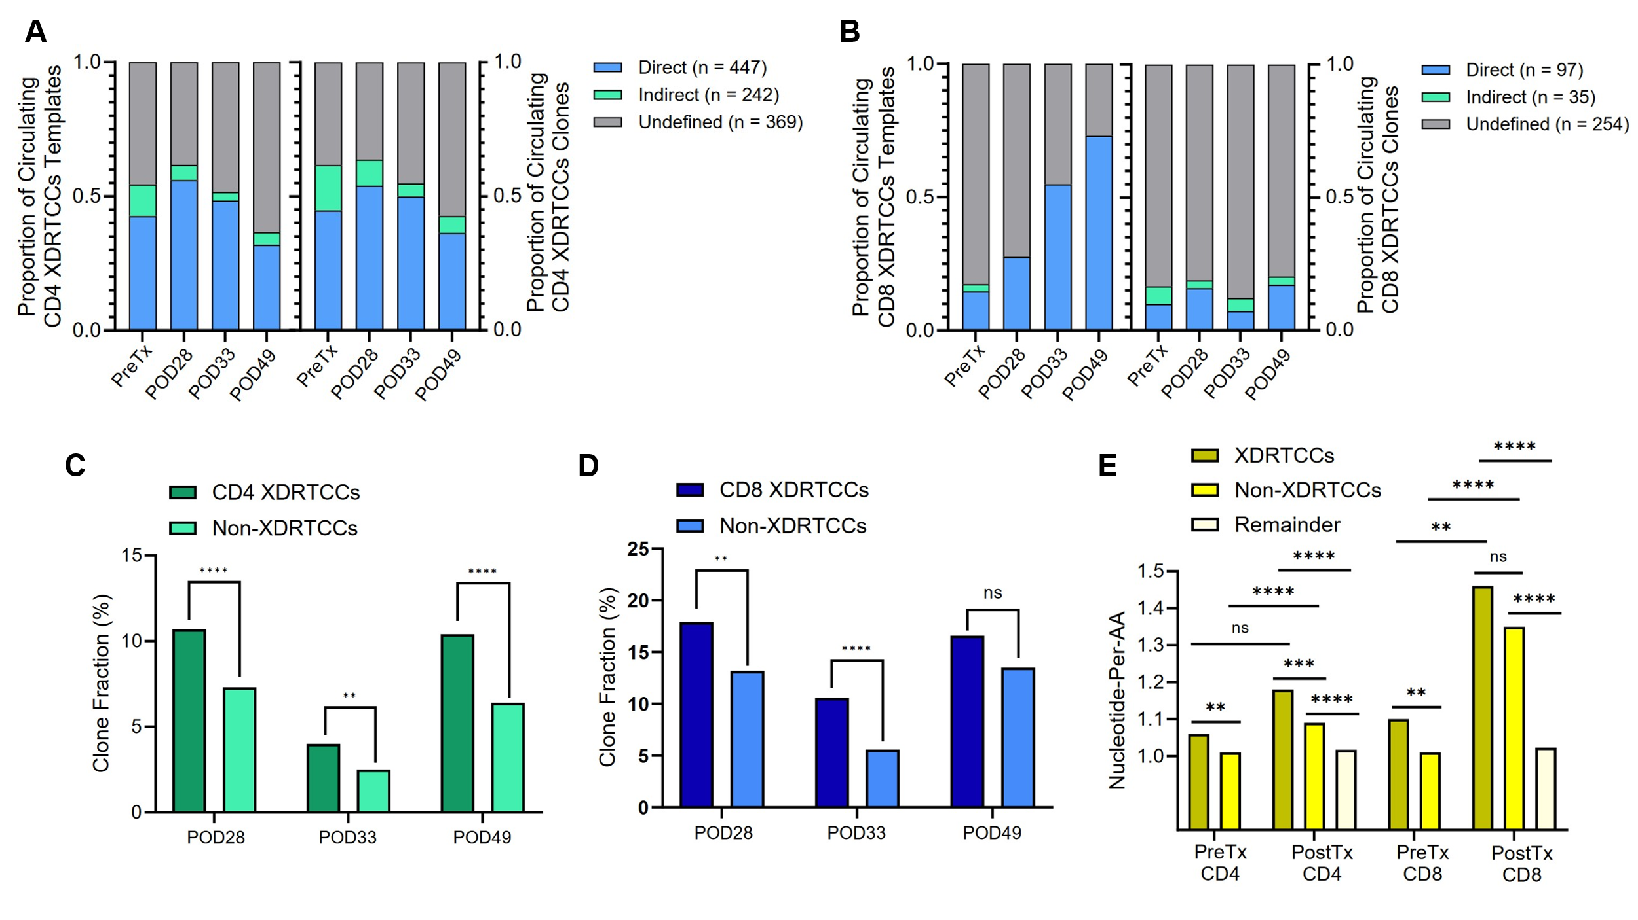

Extended Data Fig.3
XDRTCC relative metrics. (A) Origin of circulating CD4 XDRTCC templates (left panel) and unique clones (right panel). “Undefined” indicates that the clone was found in the indirect as well as in any direct MLRs or was only identified in the POD49 PBMC-on-PBMC MLR. The number of unique clones comprising every category is shown in brackets. (B) Origin of circulating CD8 XDRTCC templates (left panel) and clones (right panel). “Undefined” indicates that the clone was found in the indirect as well as in any direct MLRs or was only identified in the POD49 PBMC-versus-PBMC MLR. The number of unique clones comprising every category is shown in brackets. (C) Fraction of total post-transplant peripheral blood CD4 clones mappable to XDRTCC and non-XDRTCC clone sets. Pre-transplant non-XDRTCCs comprised almost 100% of clones in pre-transplant unstimulated peripheral blood and is therefore not shown. Statistical analysis was done using the Z-test. (D) Fraction of total post-transplant peripheral blood CD8 clones mappable to XDRTCC and non-XDRTCC clone sets. Pre-transplant non-XDRTCCs comprised almost 100% of clones in pre-transplant unstimulated peripheral blood and is therefore not shown. Statistical analysis was done using the Z-test. (E) Average number of nucleotide sequences encoding each unique amino acid sequence (nucleotide-per-aa) for XDRTCCs and non-XDRTCCs found in the pre-transplant and post-transplant peripheral blood. “Remainder” indicates clones that were identifiable as neither XDRTCCs nor non-XDRTCCs post-transplant. Statistical analysis was done using the Z-test. *P < 0.05, ** P < 0.01, ***P < 0.001, ****P < 0.0001, by Z test.

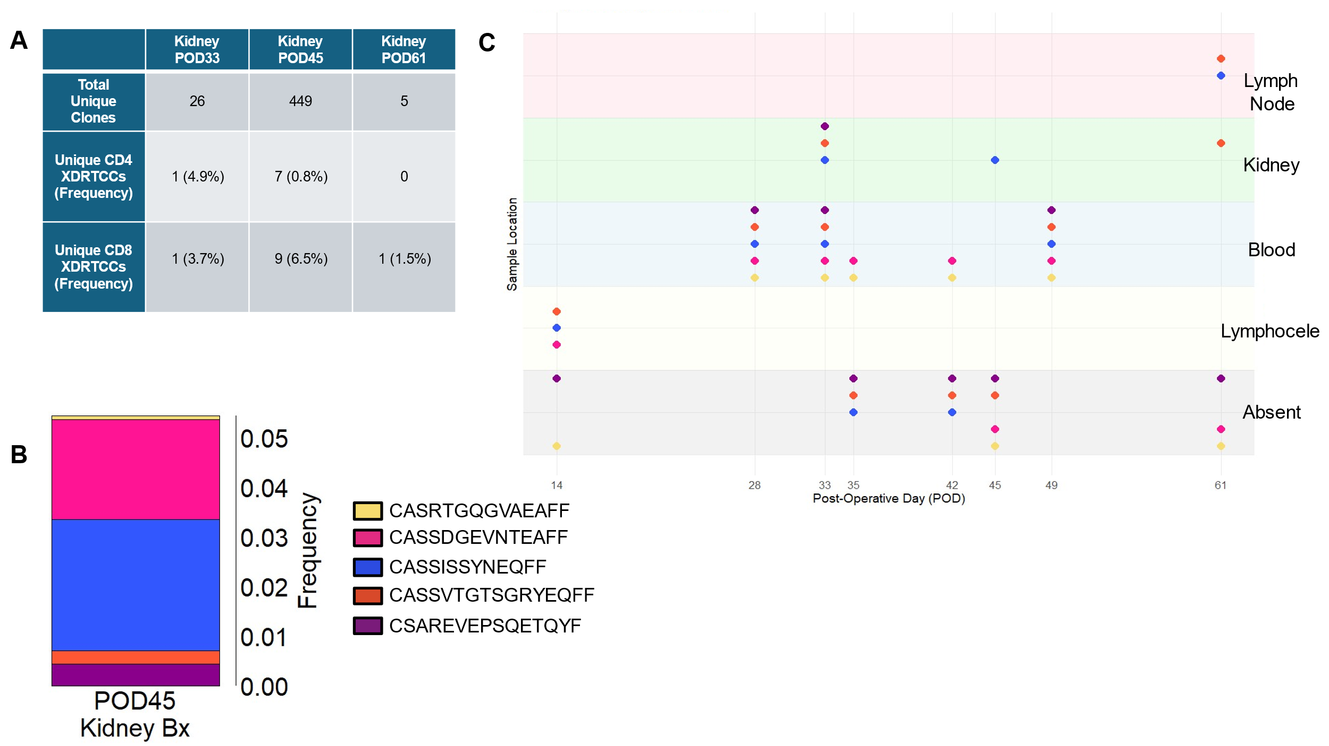

Extended Data Fig.4
Tracking XDRTCCs across locations over time. (A) Table summarizing the bulk RNA sequencing data, displaying the number of unique TCRBs identified in each biopsy (upper row), along with the number and frequencies of unique CD4 and CD8 XDRTCCs found in each biopsy (second and third rows, respectively). (B) Frequencies of five circulating immunodominant CD8 XDRTCCs, previously identified in Figures 2D and 3C, within the POD45 biopsy. (C) The location of different clonotypes is shown over time for the top 5 circulating immunodominant CD8 XDRTCCs of Figures 2D and 3C. Several of these dominant clones can be traced preceding rejection at POD14 through to POD61, at study termination.
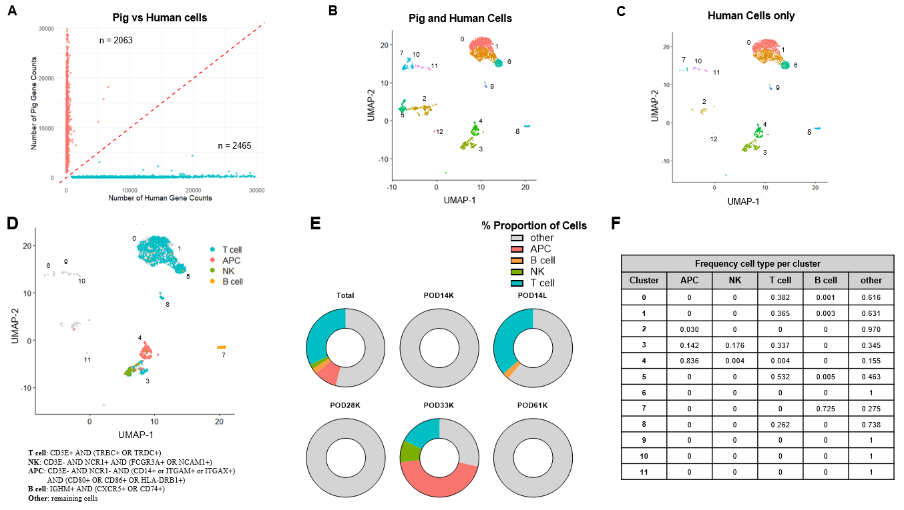

Extended Data Fig.5
Identifying Pig vs Human cells and the composition of human cell subsets across samples. (A) The number of pig and human transcripts per cell is shown for the leukocyte samples isolated from kidney biopsies and the POD14 lymphocele, with the majority of cells containing primarily pig (y axis) or human cells (x axis) only. (B) Sequencing data were run in CellRanger using a human only reference generating the UMAP shown. (C) Pig cells (along y axis) and their associated barcodes in panel A were identified and removed from the UMAP in panel B, resulting in the UMAP shown, containing only human cells. Cluster 5 was composed entirely of pig cells and removed in the final human UMAP. Clusters were renumbered in Panel D after removal of this pig cell cluster. (D) UMAP with different cell populations highlighted with their corresponding definitions below. All definitions were mutually exclusive. (E) Proportion of each cell type at different PODs and (F) Frequency of each population per cluster.
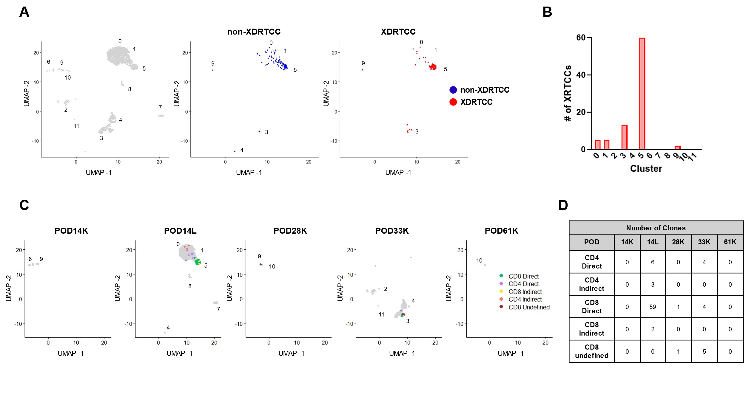

Extended Data Fig.6
XDRTCCs and non-XDRTCCs are detected in the lymphocele and kidney. (A, B) XDRTCCs are found at highest frequency in clusters 5 and 3. (C, D) XDRTCCs detected in the POD14L (clusters 0, 1, 6) and POD33 kidney biopsy (cluster 3) are primarily CD8 T cells from the direct pathway.
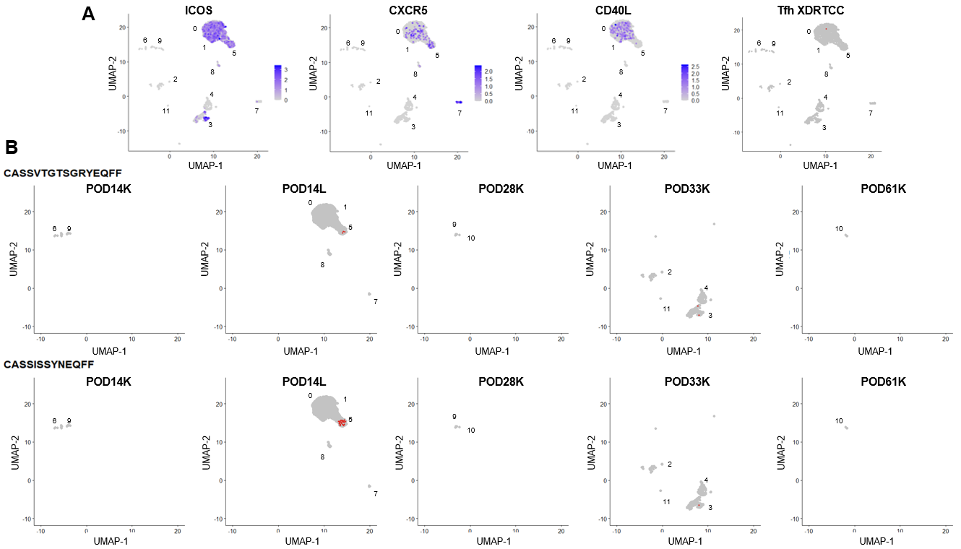

Extended Data Fig.7
Tfh XDRTCC detection in POD14 lymphocele and XDRTCC clonotype sharing between the lymphocele and kidney biopsy rejection specimen. (A) Cells in clusters 0 and 1 expressed CXCR5, CD40L, and ICOS, consistent with a Tfh phenotype. One XDRTCC was identified among these Tfh. (B) XDRTCCs (labeled in red) with the indicated TCRB CDR3 sequences were detected in both the perinephric lymphocele at POD14 and within the kidney biopsy at POD33.

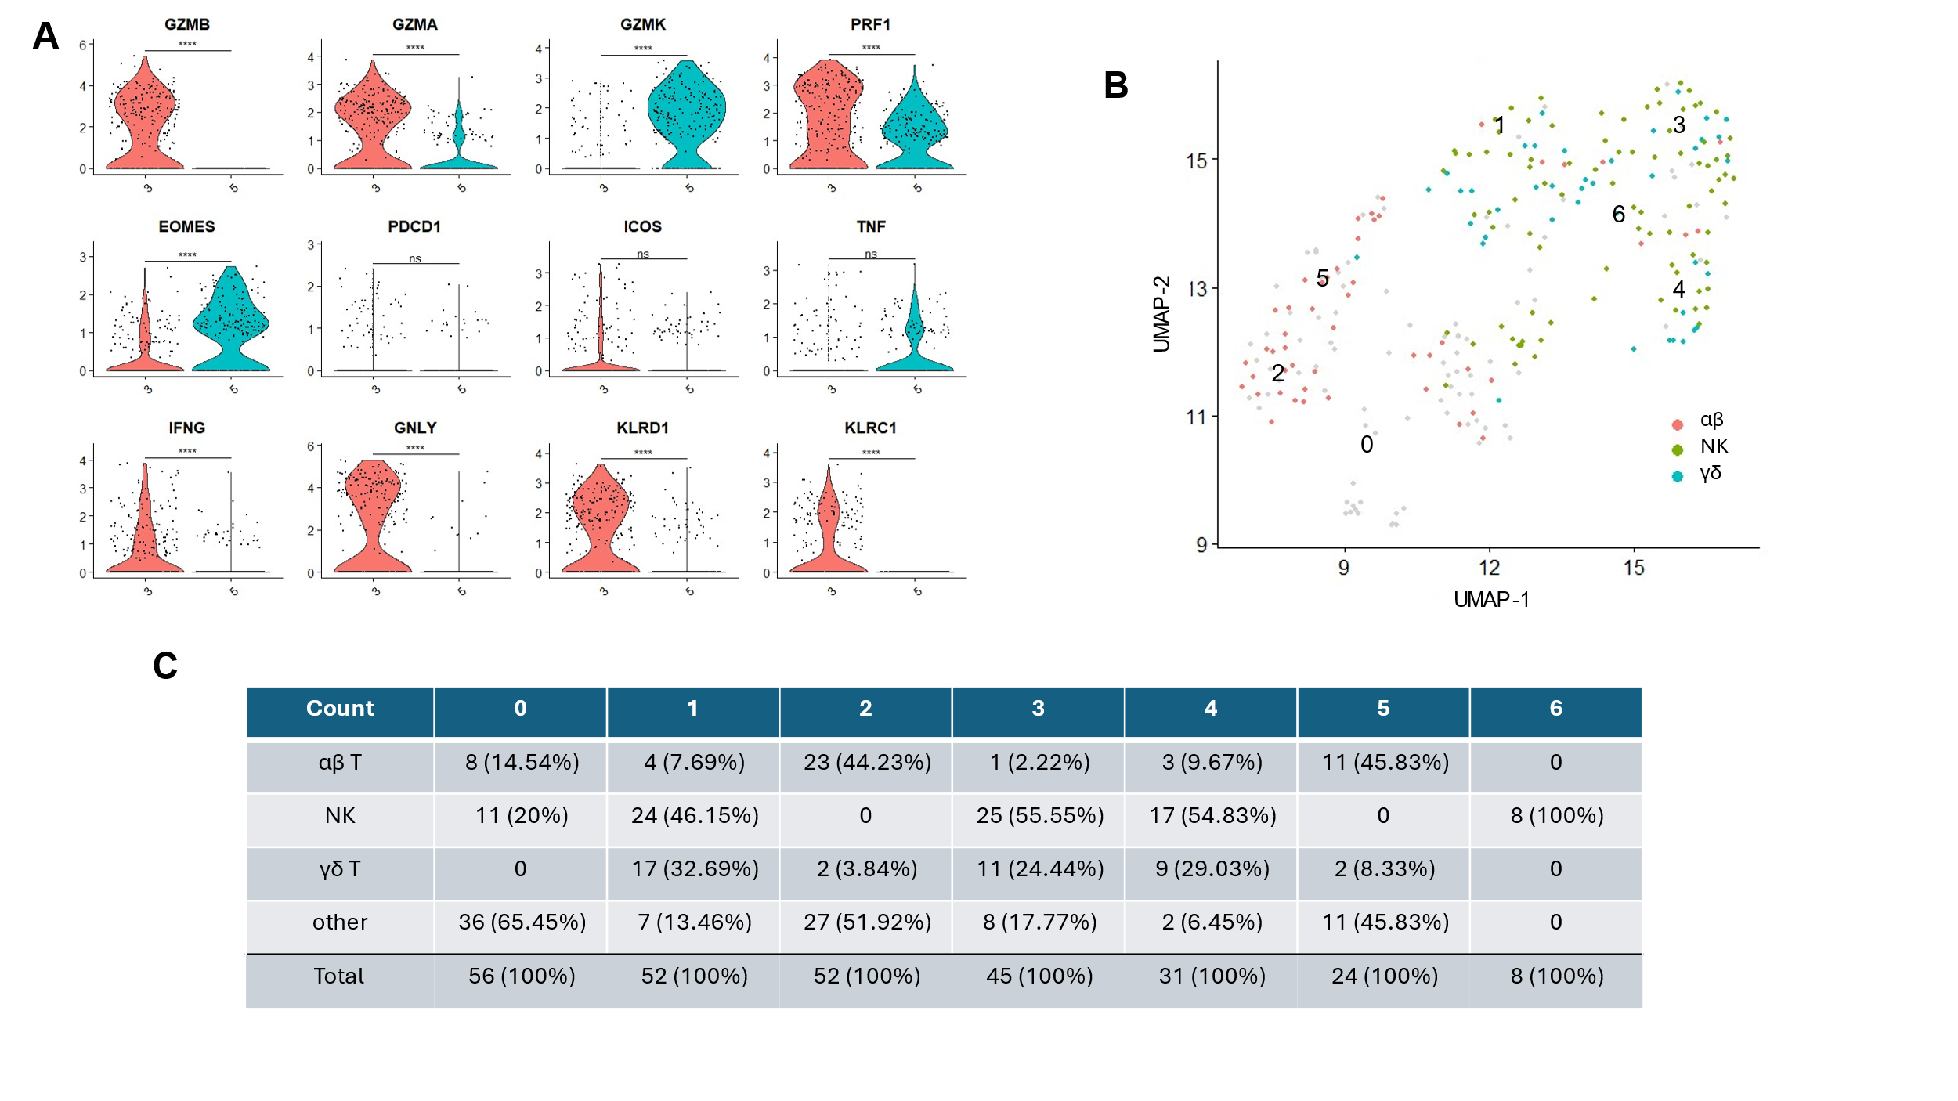

Extended Data Fig.8
Clusters 3 and 5 contain cytotoxic XDRTCCs while Cluster 3 contains also cytotoxic innate cells. (A) Cluster 3 expresses increased markers of T cell cytotoxicity (GZMB, GZMA, PRF1) as well as increased markers of innate lymphocyte cytotoxicity (GNLY, KLRD1, KLRC1) compared to Cluster 5. *P < 0.05, ** P < 0.01, ***P < 0.001, ****P < 0.0001, by Wilcoxon Rank Sum test. (B) αβ and γδ T cells demonstrate distinct clustering on the UMAP, indicating differing RNA expression profiles (C) Quantification and quantification by percentage of cell counts of each type per cluster.
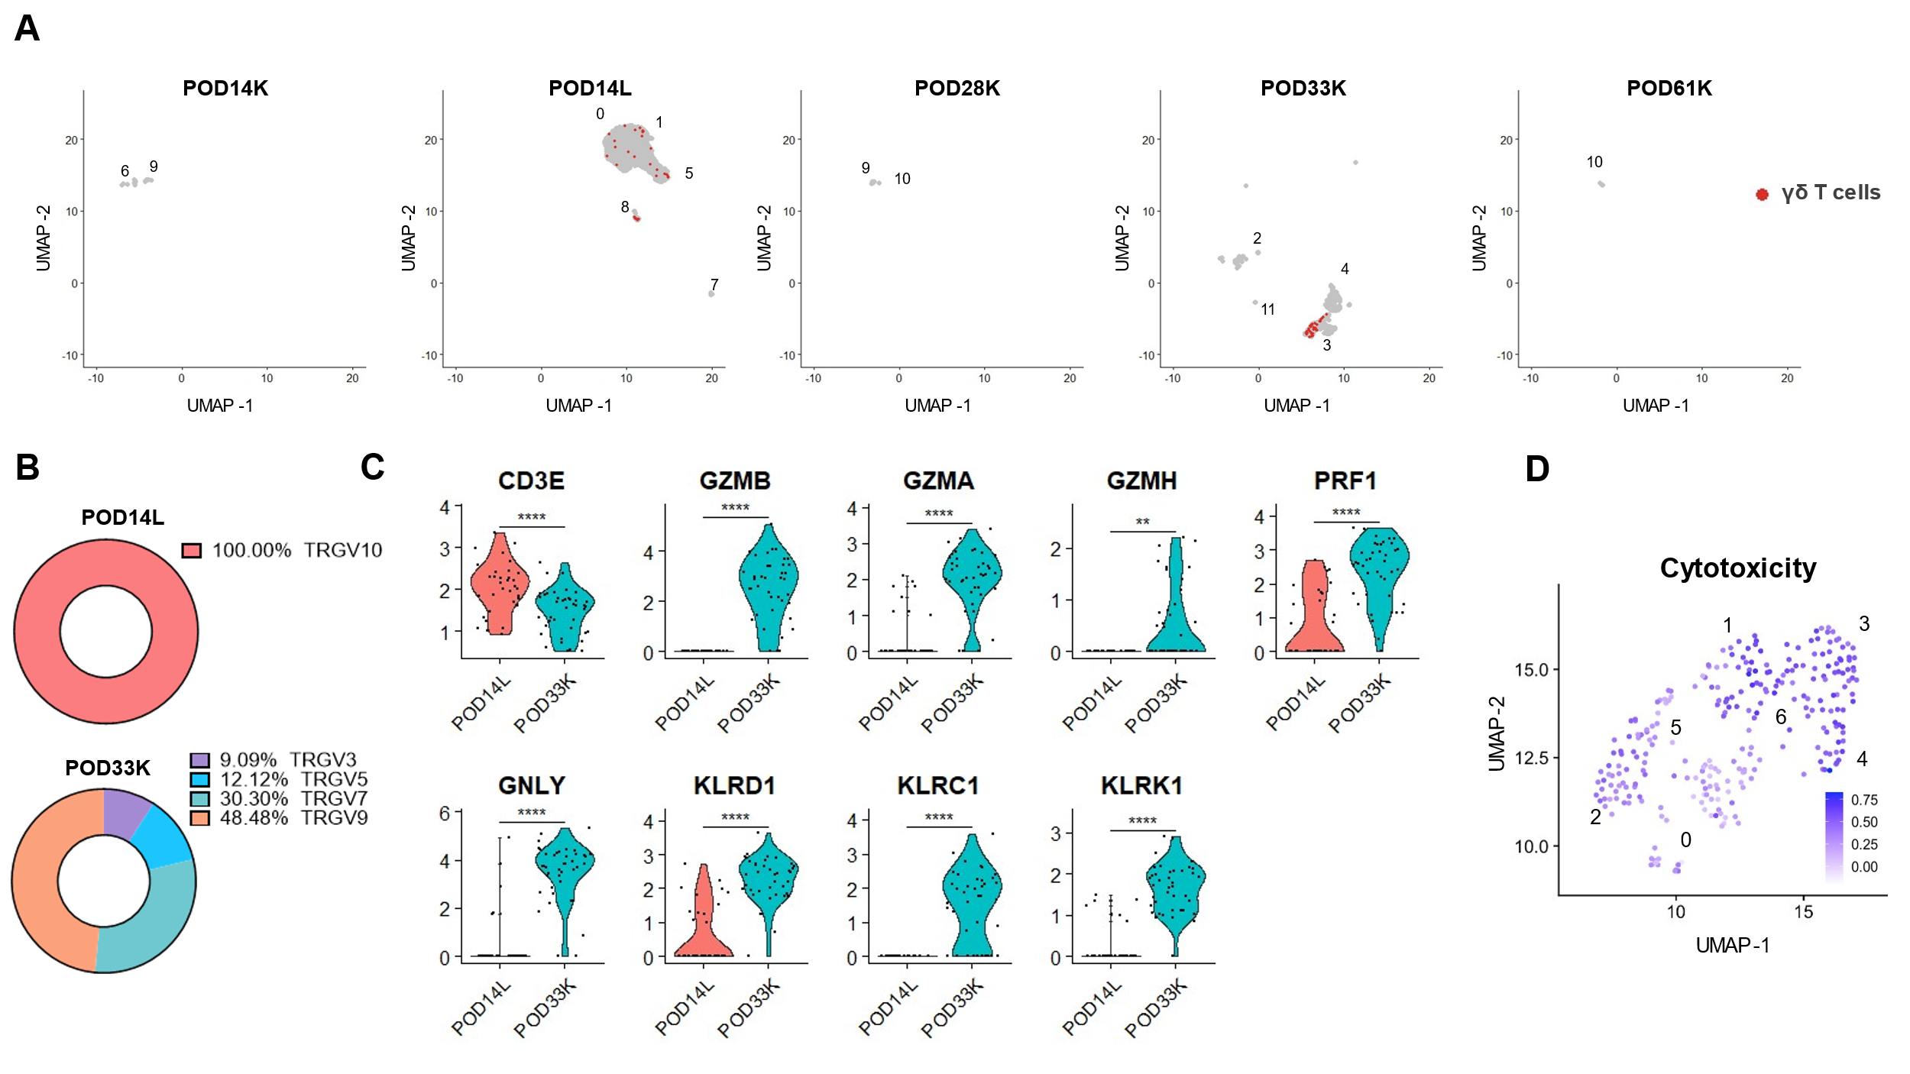

Extended Data Fig.9
γδ T cells are found in multiple samples and demonstrate a strong cytotoxic transcriptional profile in POD33 kidney biopsy. (A) γδ T cells were detected in POD14L and POD33 kidney. (B) γδ T cells from POD14L and POD33K express markedly different TRGV genes (C) Comparing γδ T cells (defined as CD3E⁺ TRDC⁺) at POD14 and POD33, those at POD33 demonstrate higher activation of cytotoxic transcripts. (D) Clusters 1, 3, 4, and 6 (upper half of UMAP) containing the majority of γδ T cells demonstrate high expression of a T cell cytotoxic signature from the Molecular Signatures Database (MSigDB) *P < 0.05, ** P < 0.01, ***P < 0.001, ****P < 0.0001, by Wilcoxon Rank Sum test.
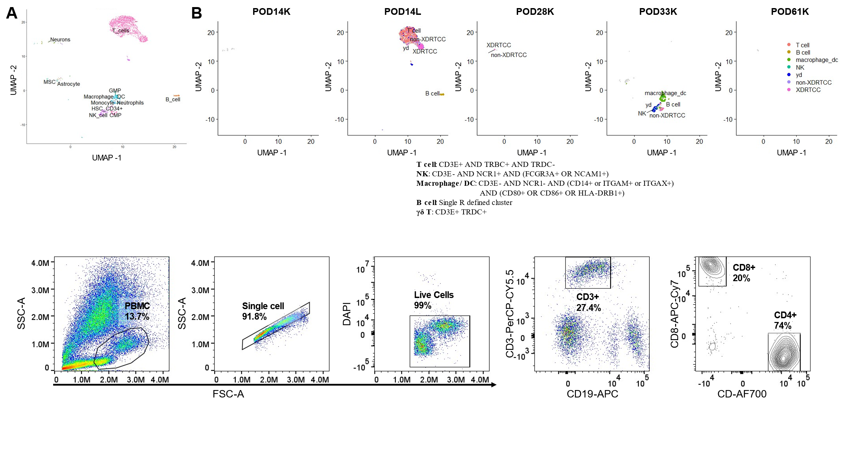

Extended Data Fig.10
Cell-cell interaction prediction and flow cytometric data of pre-transplant decedent PBMCs. (A) Reference-based labeling of all single-cell RNAseq samples using the Single R package. (B) Cluster labelling using the combination of manual annotation and reference-based prediction. The populations defined manually by gene expression show high agreement with the predicted annotations in panel A. (C) Gating of CD4⁺ and CD8⁺ cells, which comprise 74.0% and 20.0% of CD3⁺ cells, respectively.
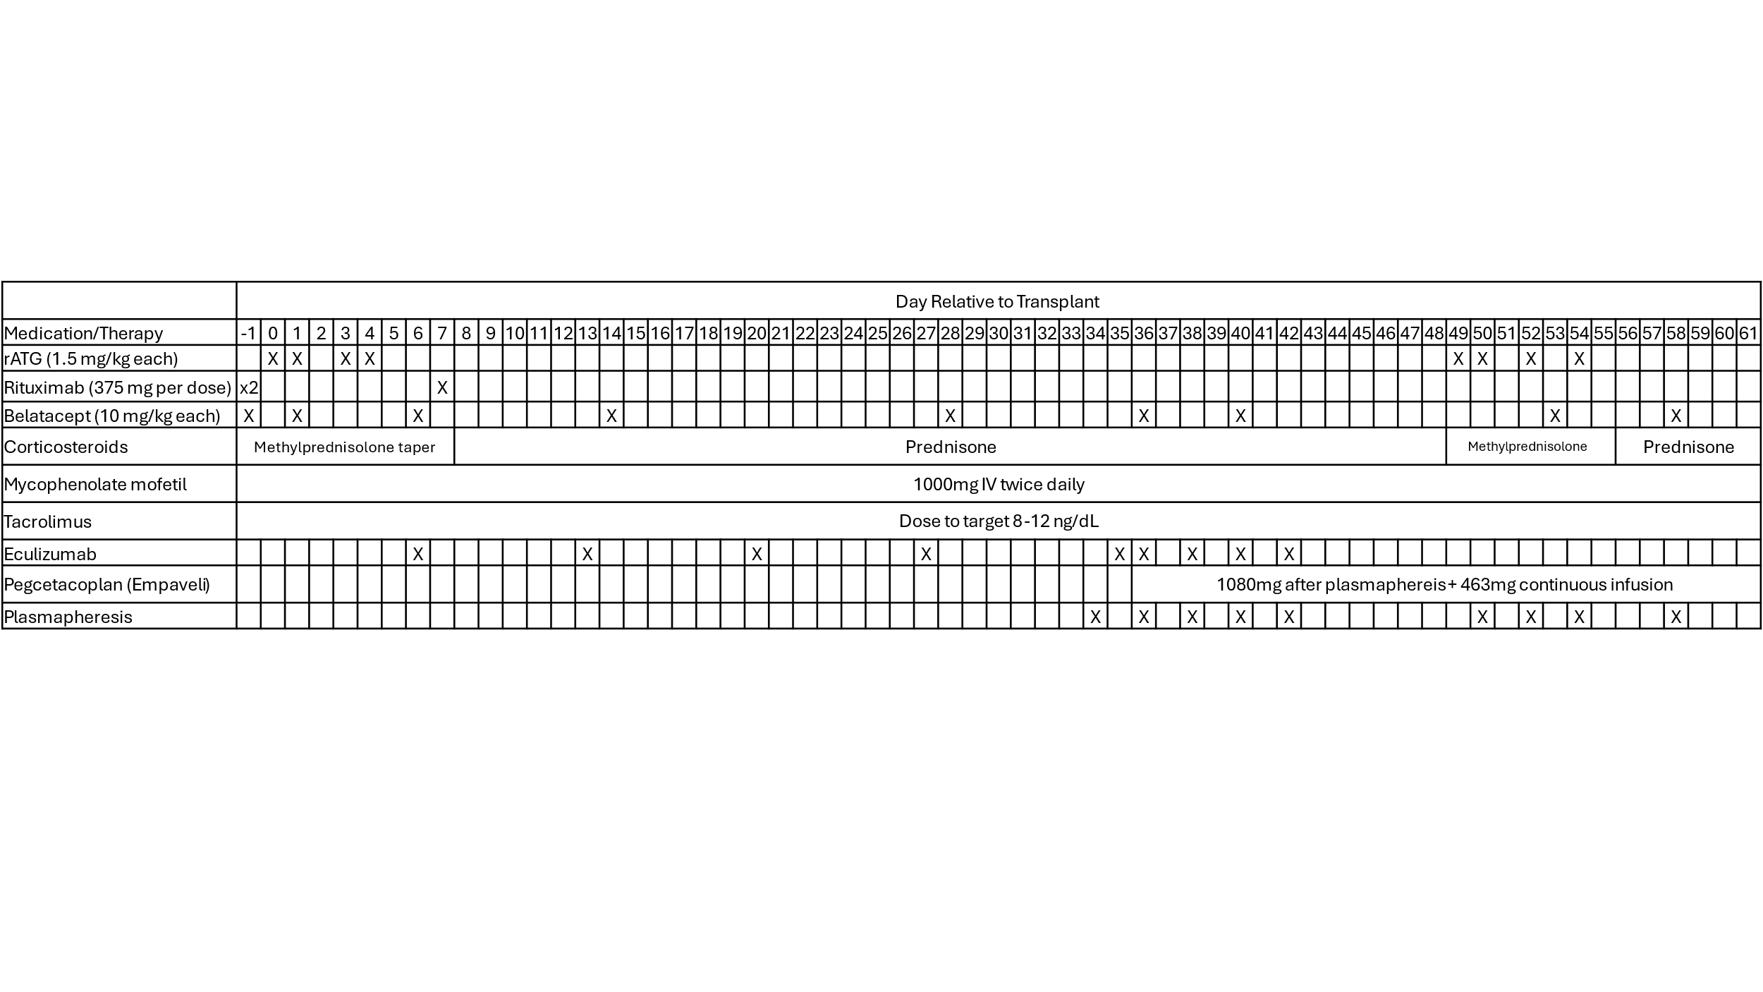

Table S1.
Induction and maintenance immunosuppression. Induction immunosuppression consisted of rituximab, rabbit anti-thymocyte globulin (rATG), and methylprednisolone. Eculizumab was given from POD6 through POD42. Maintenance therapy included belatacept, tacrolimus (target 8-12 ng/mL), mycophenolate mofetil, and corticosteroids. In response to antibody-mediated rejection, treatment with plasmapheresis spanned PODs 34-42 and PODs 50-58. Pegcetacoplan was initiated on day 36 after plasma exchange, delivered as a continuous infusion and bolus after plasmapheresis. In response to incompletely resolved AMR detected on the POD49 biopsy, T cell re-depletion with additional rATG and a methylprednisolone pulse were administered.
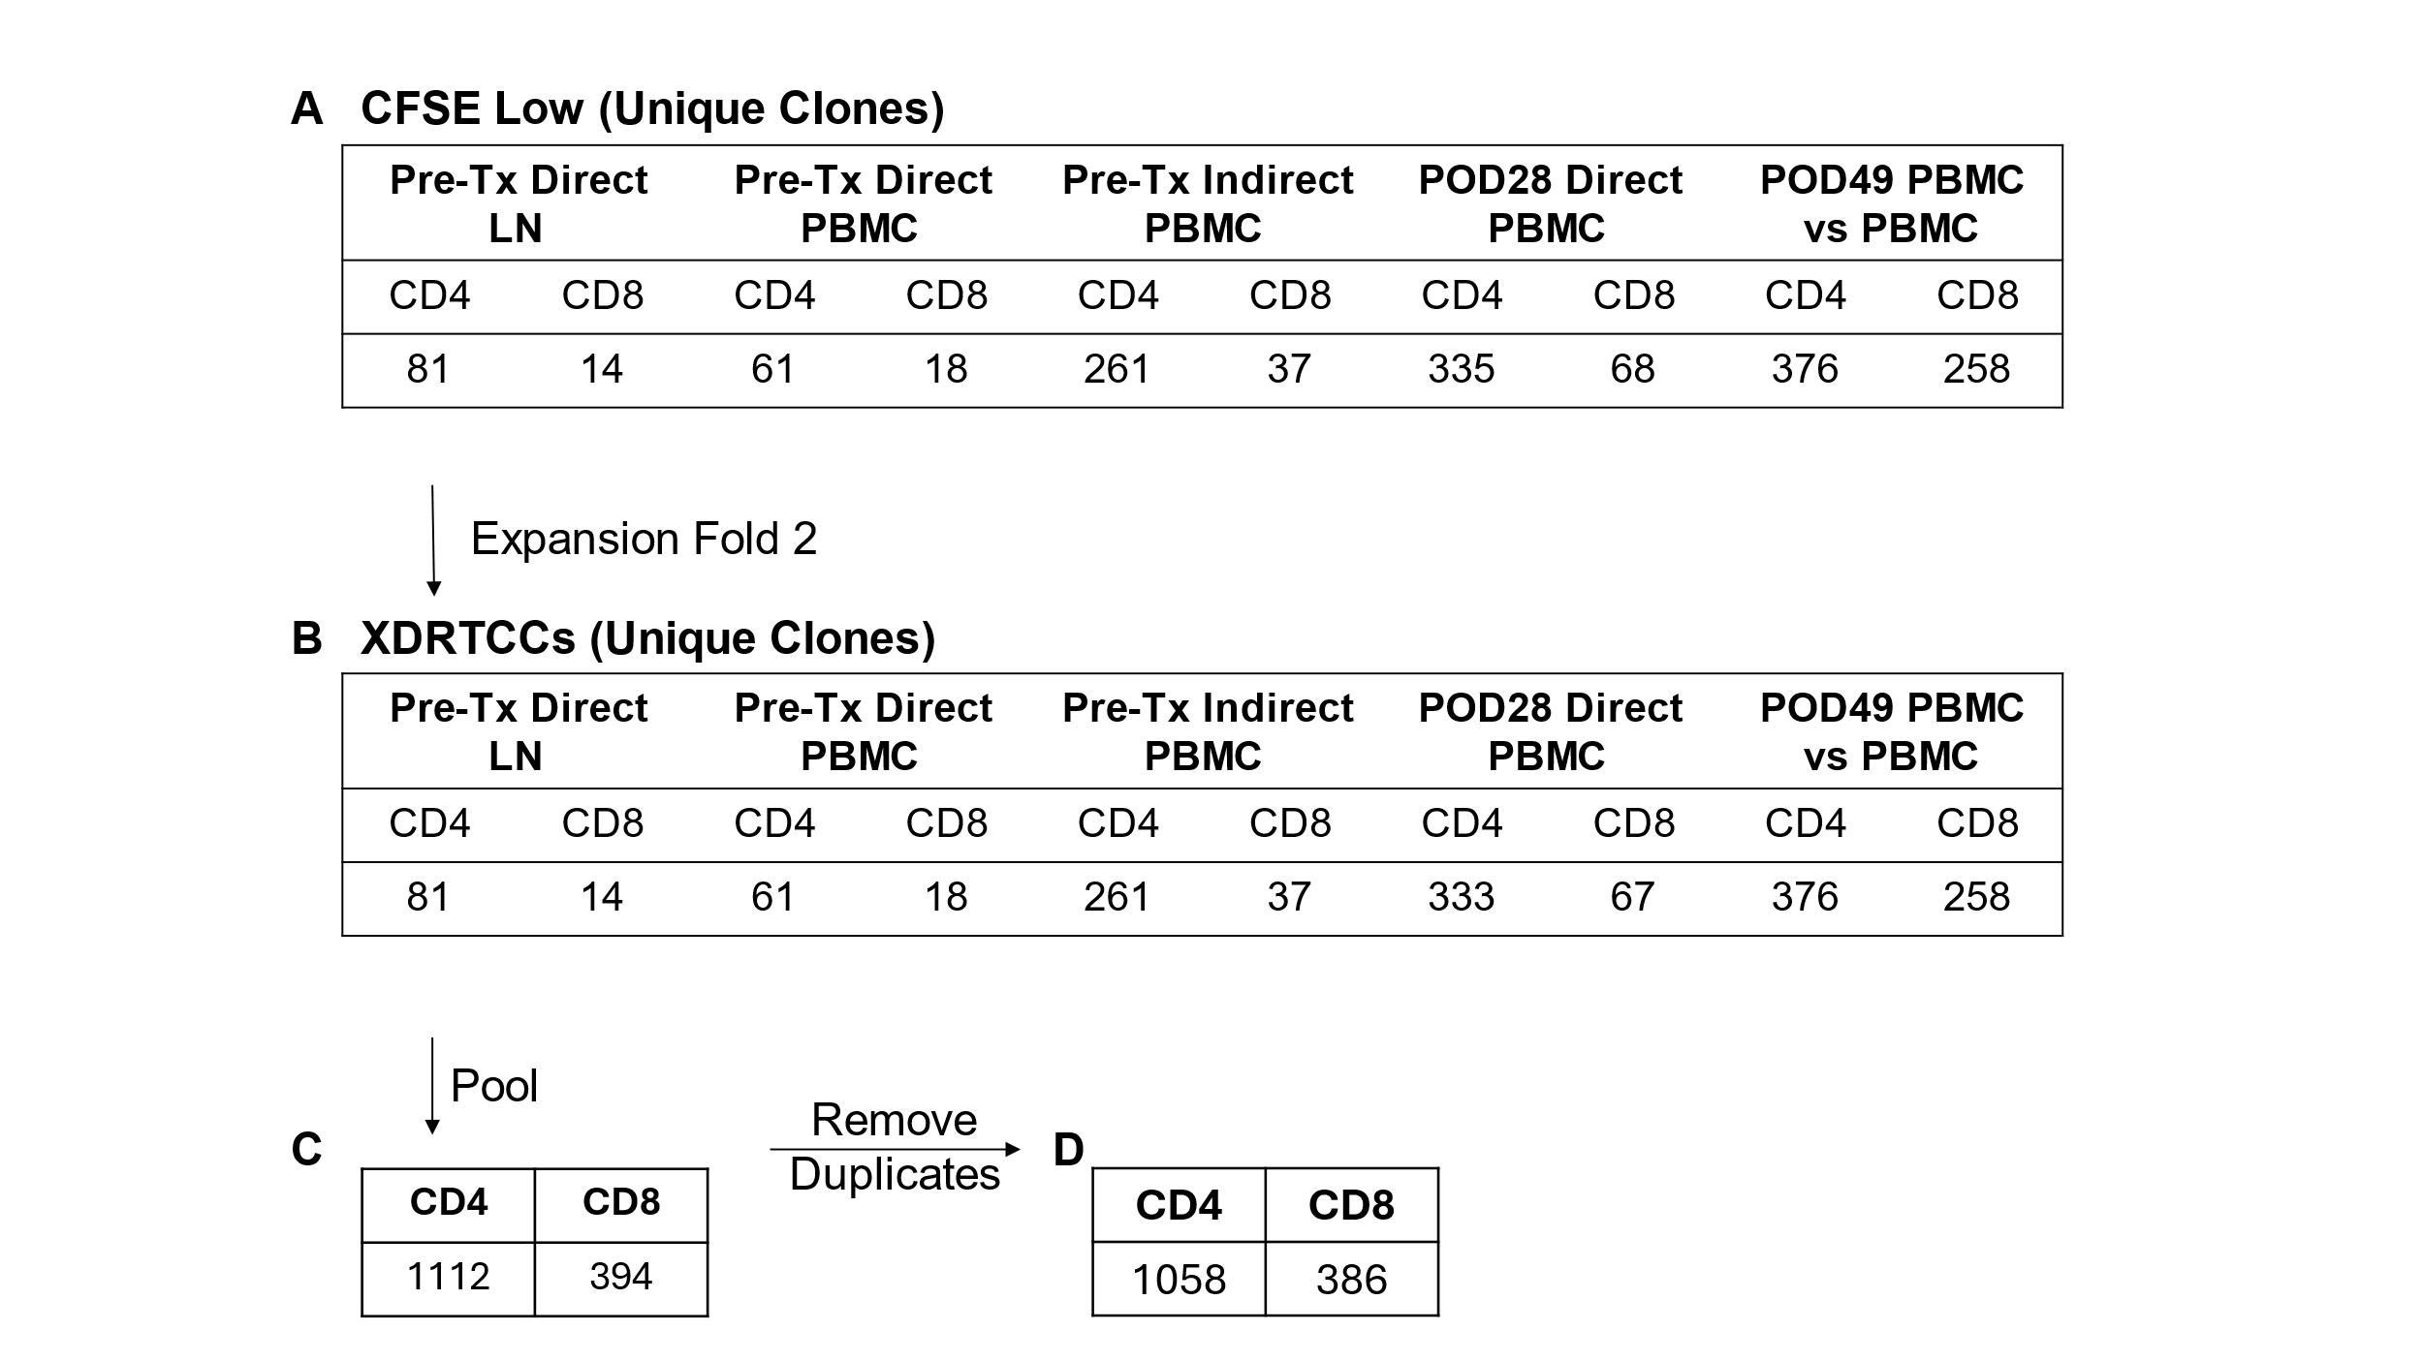

Table S2.
Workflow to identify XDRTCCs. (A) Number of unique CD4 and CD8 clones present in the divided subpopulations of the different MLRs performed. (B) Number of unique CD4 and CD8 clones remaining after removing the clones whose frequencies in the CFSE^{low} population were not at least twice that in the pre-transplant unstimulated population, the criterion for XDRTCC definition. (C) Number of total CD4 and CD8 XDRTCCs from the different MLRs. (D) Number of unique CD4 and CD8 XDRTCCs identified by our method.
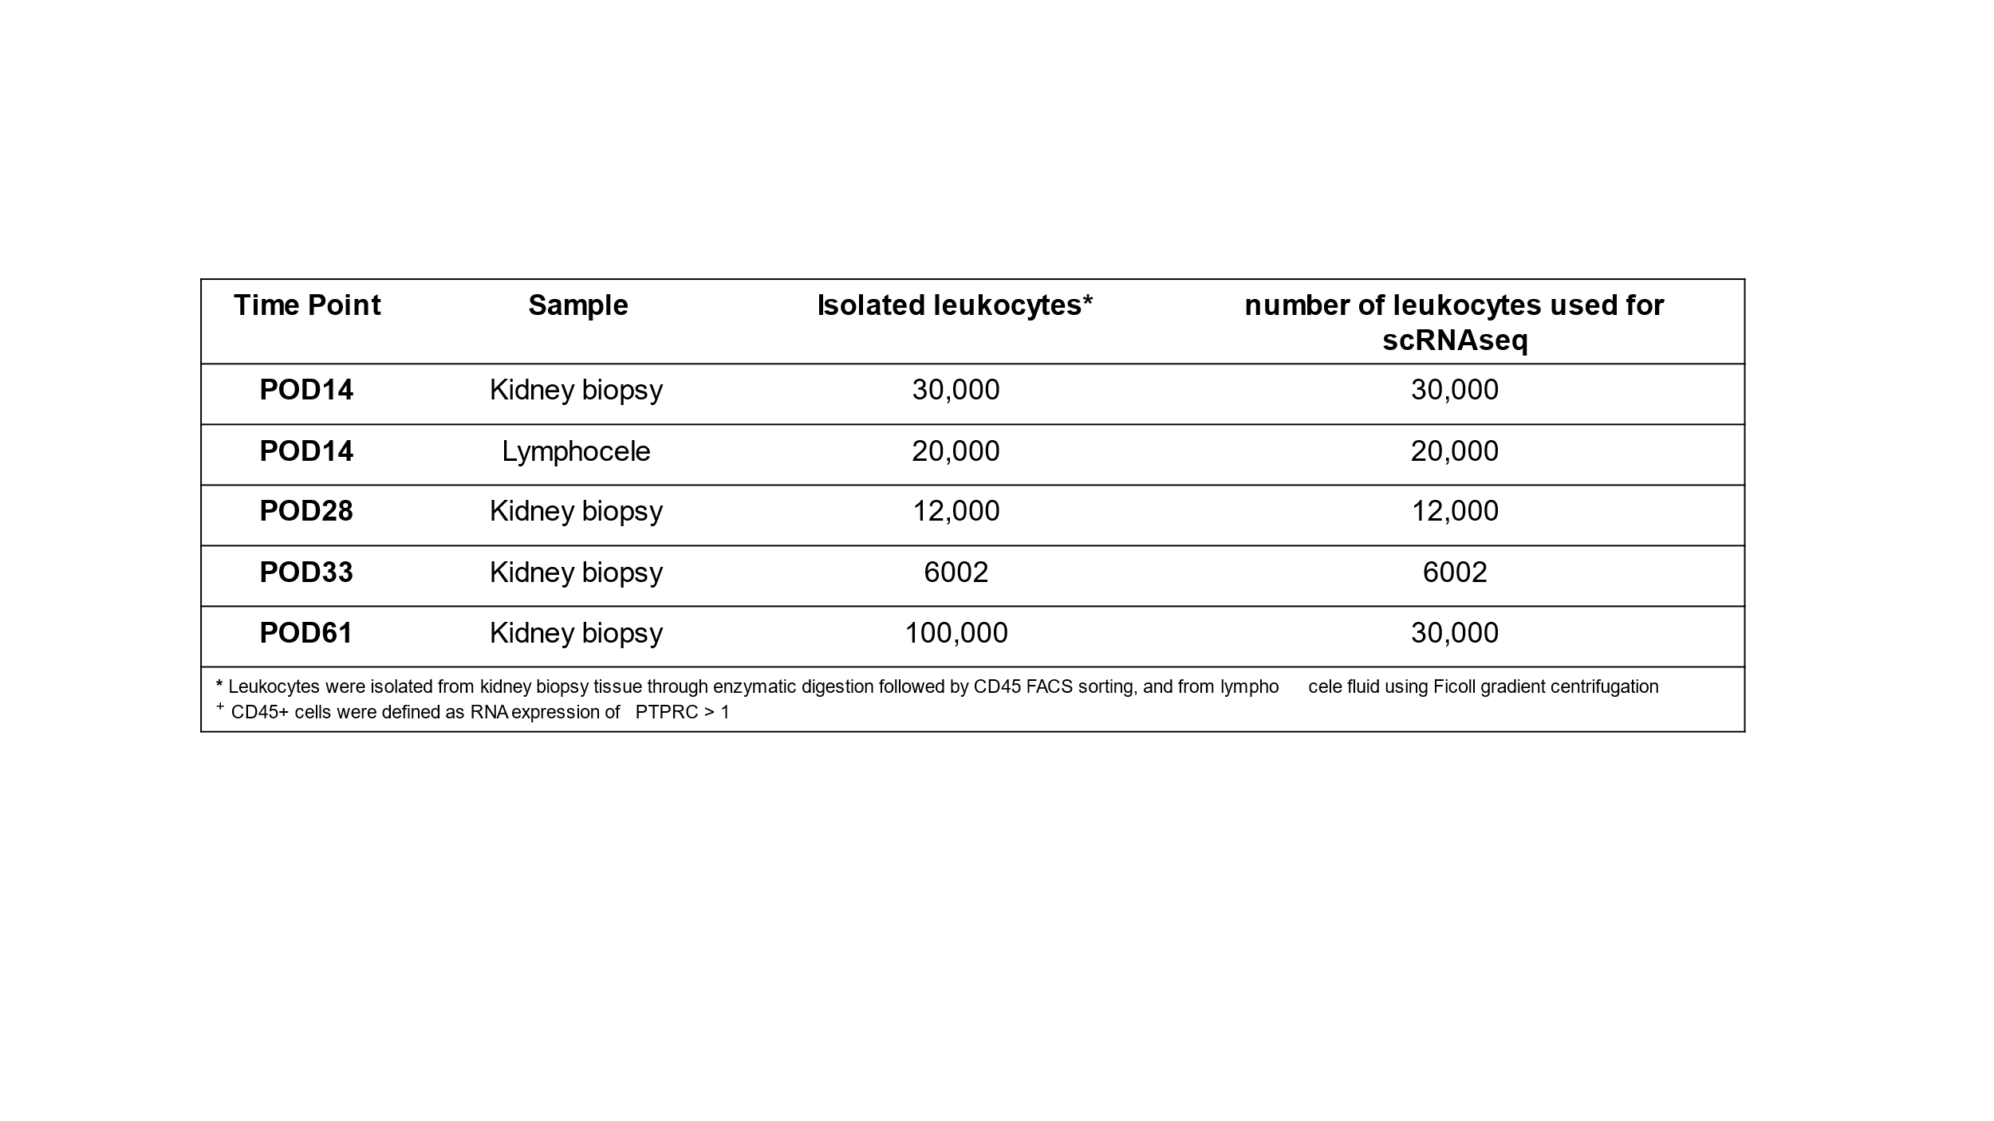

Table S3.
The number of isolated leukocytes from each sample. The indicated number of leucocytes was isolated from kidney biopsies/lymphocele sample and submitted for single-cell RNA sequencing.
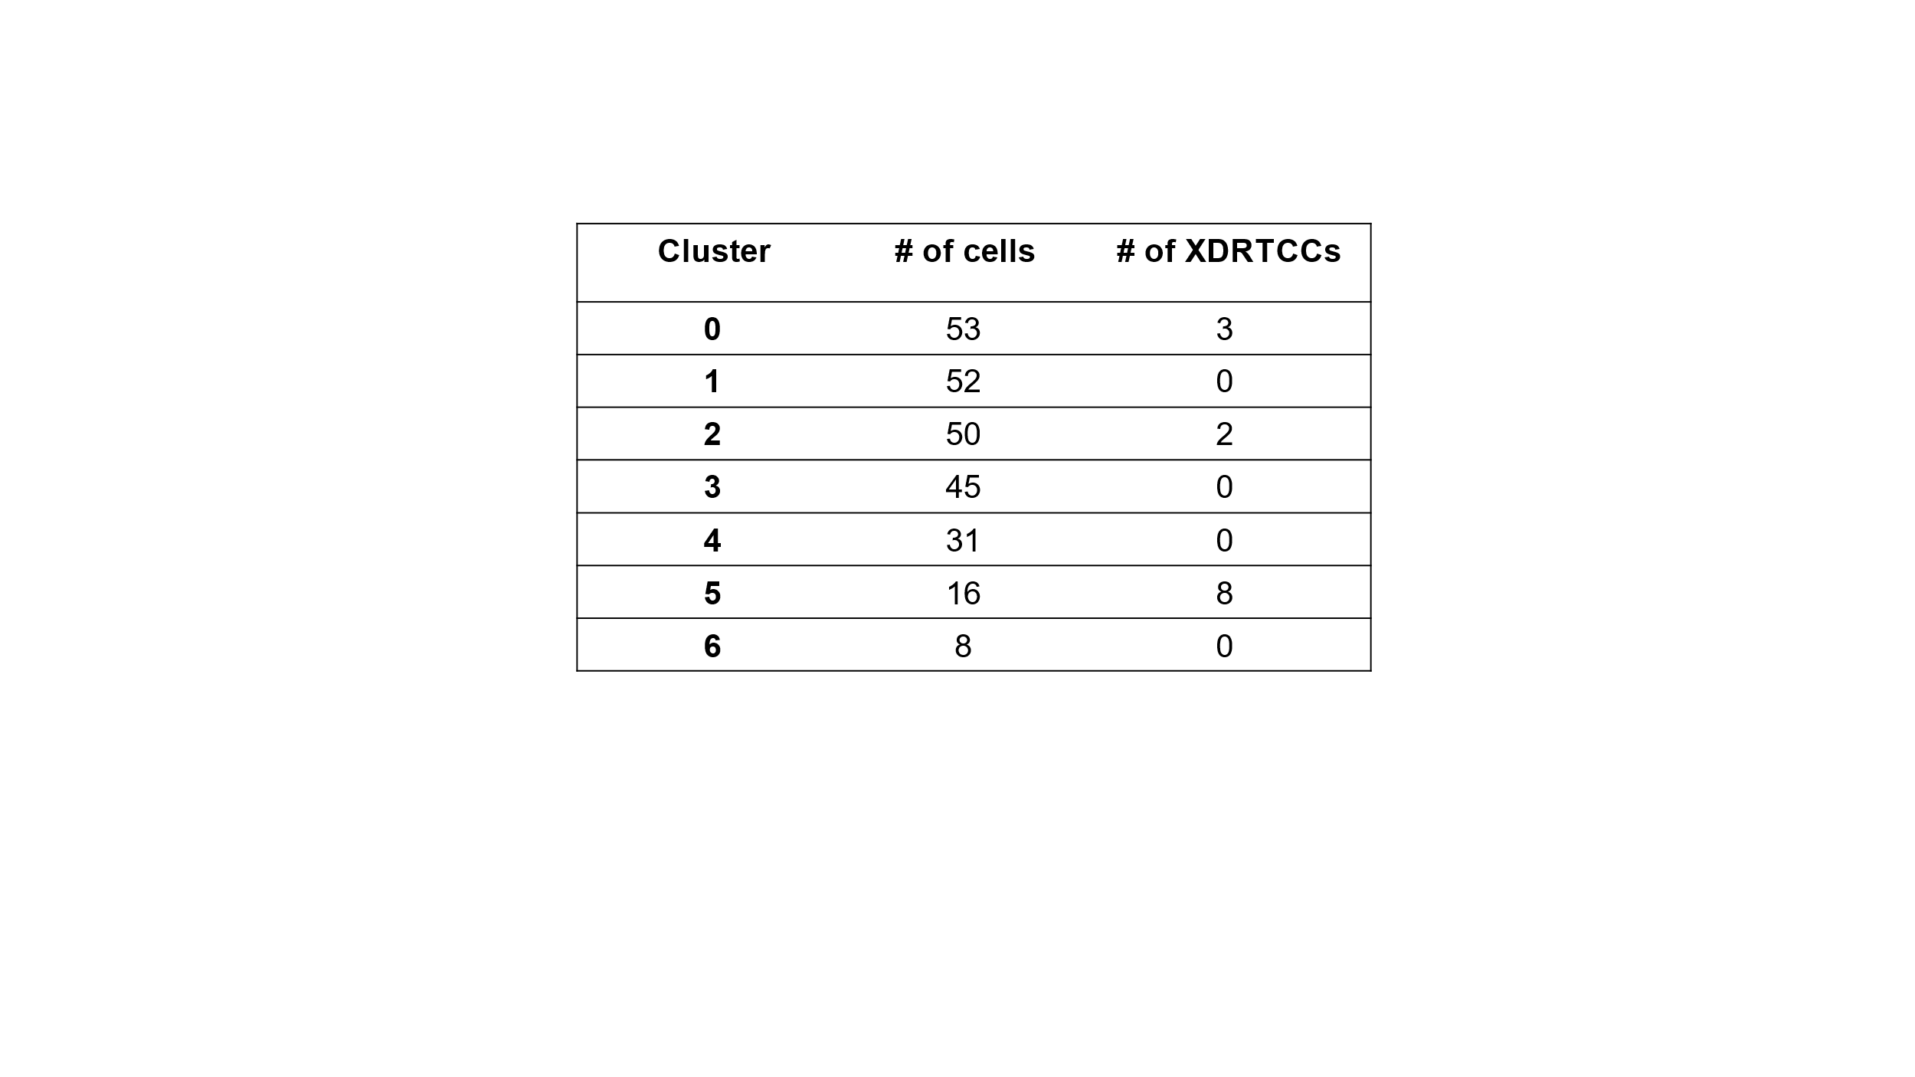

Table S4.
Number of XDRTCCs per cluster. Clustering is according to the numbering in the reclustered UMAP in Figure 6.
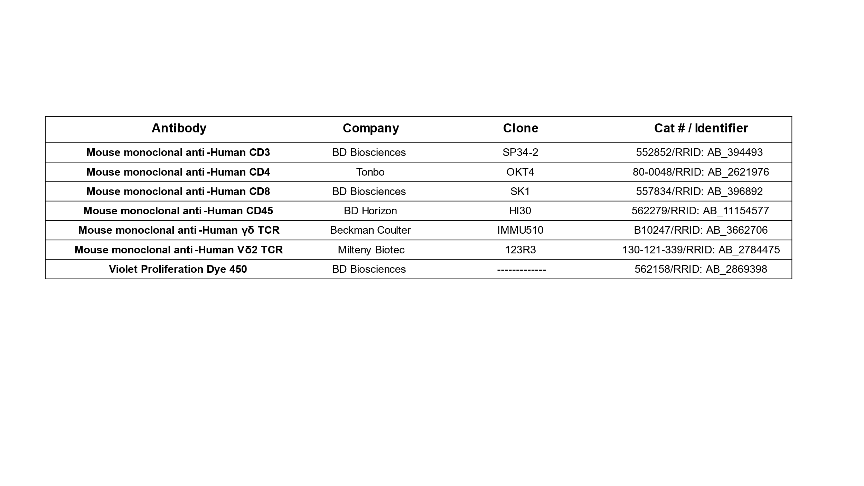

Table S5.
List of antibodies used for flow cytometry to detect different antigens.
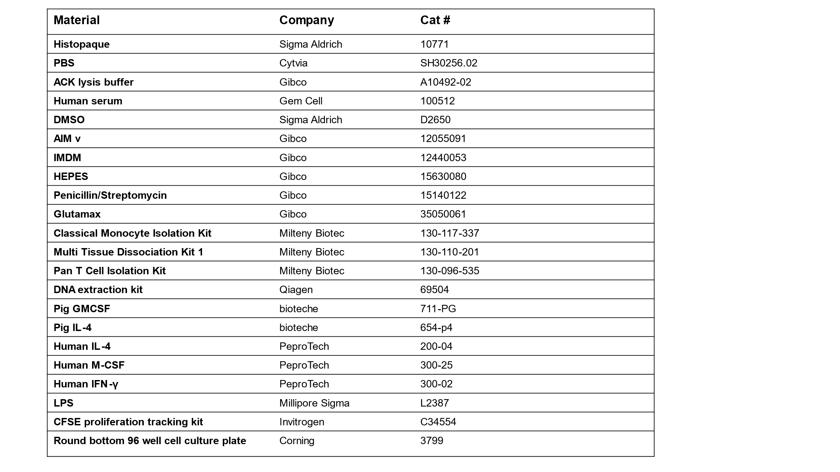

Table S6.
List of materials used in the study.

