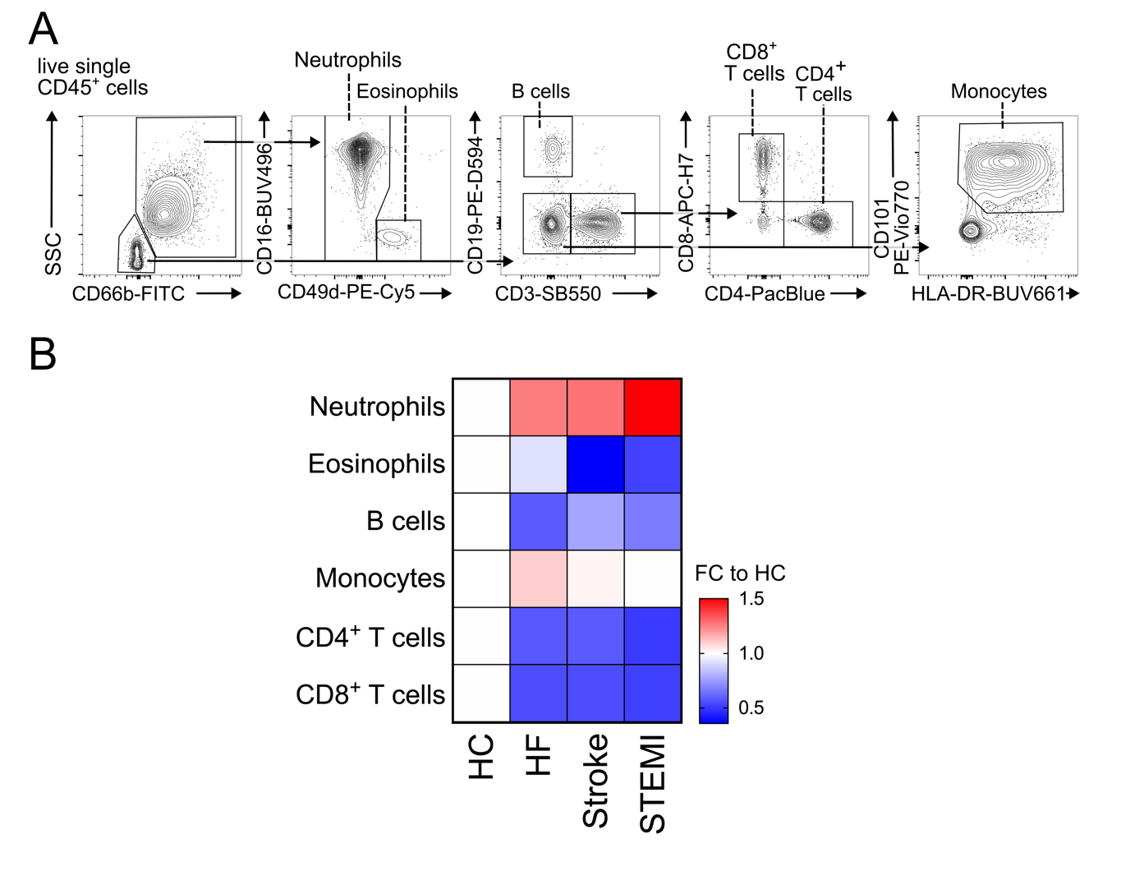
Supplementary Figure 1: Cardiovascular inflammation induces neutrophilia. (A) Flow cytometry gating strategy. (B) Normalized blood counts of indicated leukocyte subsets. n = 59 for HC, n = 67 for HF, n = 21 for stroke, n = 37 for STEMI; HC, health control; HF, heart failure; STEMI, ST-elevation myocardial infarction.

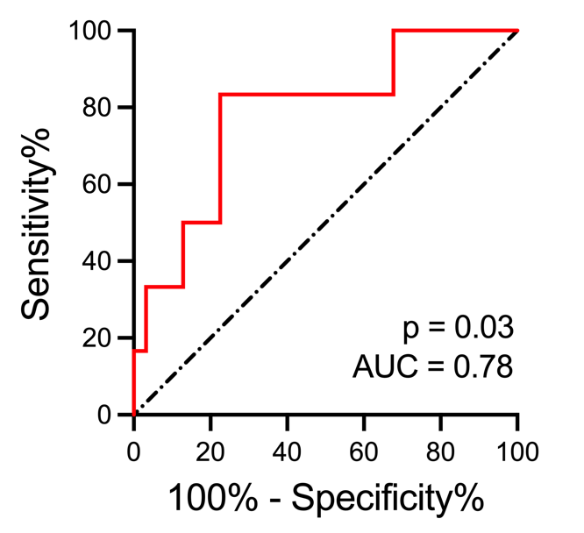
Supplementary Figure 2: PreNeu counts are predictive of survival. Receiver-operator characteristic (ROC) of preNeu counts on admission as a predictor of survival. n = 37.

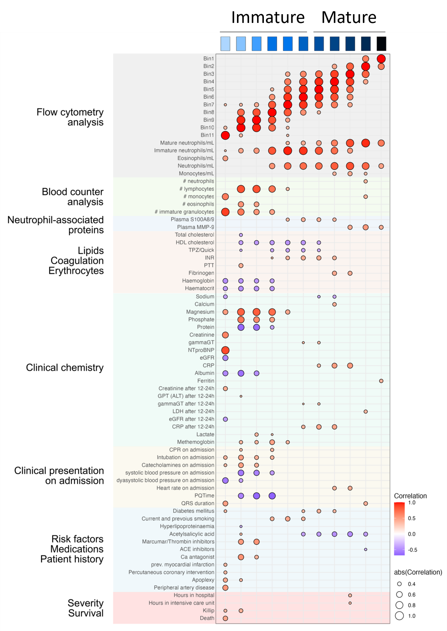
Supplementary Figure 3: Correlation analysis. Pearson correlations of absolute counts of neutrophil maturation bins with clinical parameters including blood counter analysis, clinical chemistry, clinical presentation, patient characteristics and severity/outcome.
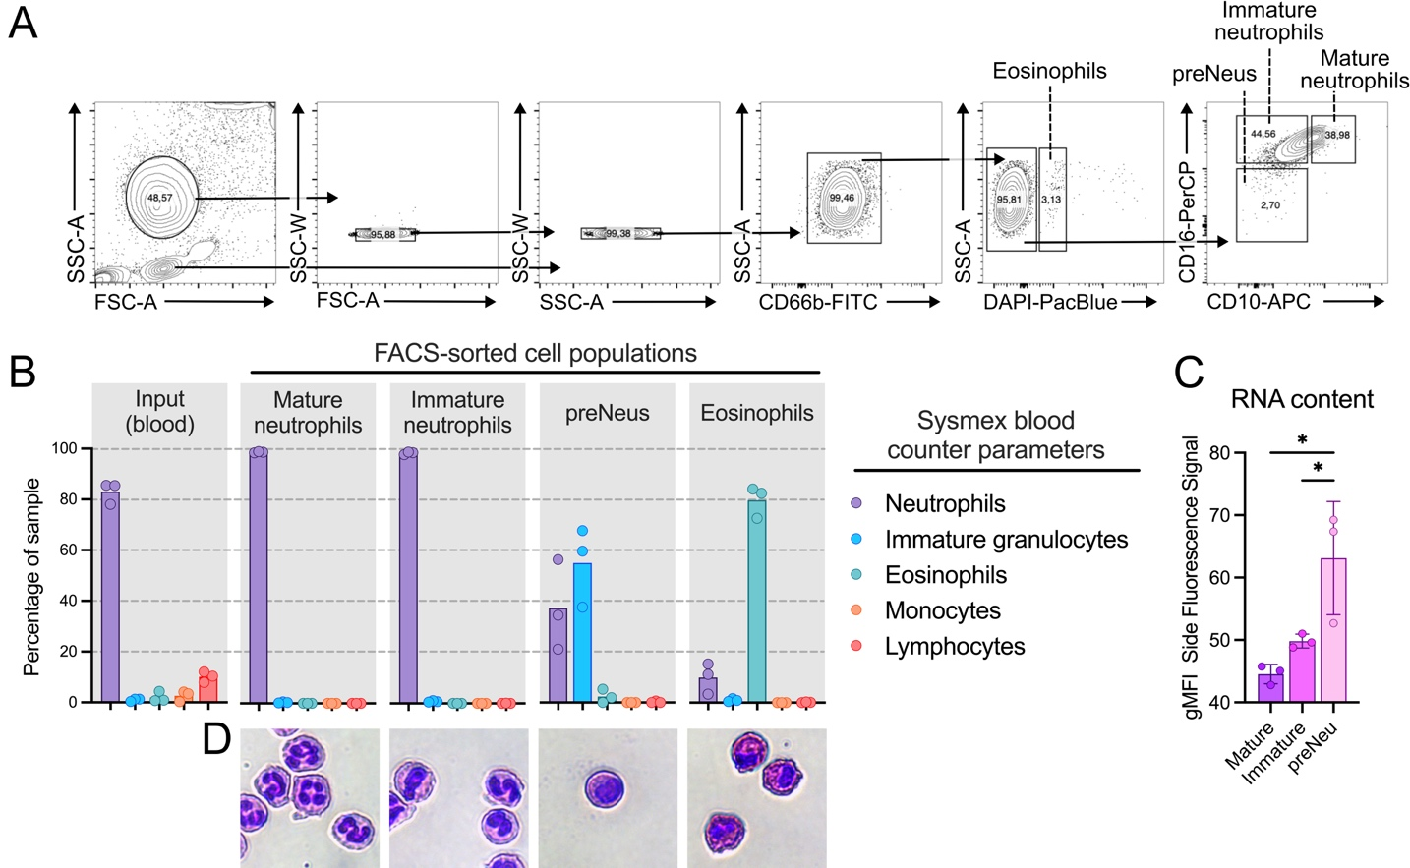
Supplementary Figure 4: preNeus but not mature or immature neutrophils or eosinophils are identified as immature granulocytes in automated blood counter analysis. (A) FACS sorting strategy to isolate mature neutrophils, immature neutrophils, preNeus and eosinophils. (B) Percentage of identified cells from Sysmex blood counter analysis in blood (left) and FACS-isolated cell populations (right). n = 3. (C) RNA content identified by Side Fluorescence Signal in Sysmex blood counter analysis of isolated mature neutrophils, immature neutrophils and preNeus. n = 3. One-way ANOVA. (D) Giemsa staining of isolated cell populations.

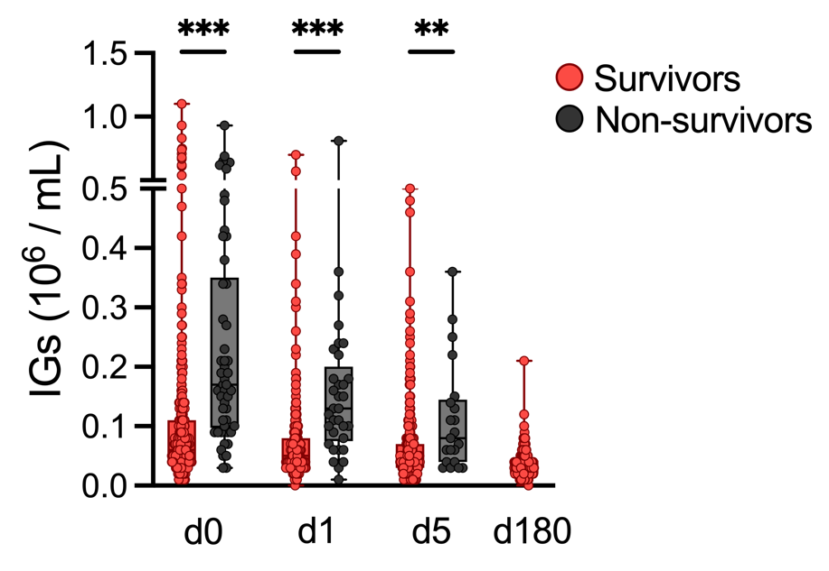

Supplementary Figure 5: Immature granulocytes remain predictive of mortality until 5 days post STEMI. IG measurements at different days after STEMI. d0: n = 441 Survivors, n = 50 Non-survivors. d1: n = 363 Survivors, n = 33 Non-survivors. d5: n = 401 Survivors, n = 21 Non-survivors. d180: n = 290 Survivors. Kruskal-Wallis.

Supplementary Table 1 Descriptive parameters of the exploratory cohort (Münster).

Characteristics | ACP  (n = 29) | STEMI survivors  (n = 31) | STEMI  non-survivors  (n = 6) | p-value
Age, years, median (IQR) | 54.5 (47.75 – 67.25) | 58 (48 – 68) | 62 (60 – 71) | 0.2774
Male, n (%) | 19 (65%) | 27 (87%) | 6 (100%) | 0.0510
Body-mass-index, kg/m², median (IQR) | 25,00 (25,00 – 27,45) | 26,43 (24,87 – 29,34) | 30,75 (23,85 – 33,49) | 0.4823
Systolic arterial pressure, mmHg, median (IQR) | 135 (123 – 150) | 127 (103 – 139) | 81 (76 – 100) | 0.0012
Diastolic arterial pressure, mmHg, median (IQR) | 87 (77 – 95) | 78 (59 – 85) | 64 (32.5 – 66.5) | 0.0004
Heart rate, bpm, median (IQR) | 86 (71 – 97) | 82 (68 – 96) | 84,5 (73.25 – 106.5) | 0.7798
Risk factors
Diabetes mellitus, n (%) | 2 (7%) | 5 (16%) | 3 (50%) | 0.0269
Current and previous smoking, n (%) | 9 (31%) | 15 (48%) | 3 (50%) | 0.3513
Arterial hypertension, n (%) | 11 (38%) | 11 (35%) | 3 (50%) | 0.7984
Hyperlipoproteinemia, n (%) | 6 (21%) | 16 (52%) | 0 (0%) | 0.0076
Positive family history for MI, n (%) | 3 (10%) | 10 (32%) | 0 (0%) | 0.0458
Medication
Acetylsalicylic acid, n (%) | 7 (24%) | 5 (16%) | 1 (17%) | 0.7240
Clopidogrel/P2Y inhibitors, n (%) | 1 (3%) | 1 (3%) | 0 (0%) | 0.9009
Marcumar/Thrombin inhibitors, n (%) | 0 (0%) | 1 (3%) | 0 (0%) | 0.5637
Beta-blocker, n (%) | 7 (24%) | 5 (16%) | 3 (50%) | 0.1880
ACE inhibitors, n (%) | 3 (10%) | 4 (13%) | 2 (33%) | 0.3234
Diuretic drugs, n (%) | 4 (14%) | 1 (3%) | 0 (0%) | 0.2310
Ca antagonist, n (%) | 1 (3%) | 0 (0%) | 1 (17%) | 0.0915
AT-1 blocker, n (%) | 6 (21%) | 5 (16%) | 1 (17%) | 0.8960
Lipid-lowering drugs, n (%) | 6 (21%) | 5 (16%) | 1 (17%) | 0.8960
Aldosterone antagonist, n (%) | 4 (14%) | 1 (3%) | 0 (0%) | 0.2310
Antidiabetic drugs, n (%) | 3 (10%) | 3 (10%) | 2 (33%) | 0.2473
Patient history
Myocardial infarction, n (%) | 3 (10%) | 4 (13%) | 1 (17%) | 0.8958
Percutaneous coronary intervention, n (%) | 6 (21%) | 4 (13%) | 1 (17%) | 0.7211
Apoplexy, n (%) | 0 (0%) | 2 (6%) | 2 (33%) | 0.0078
Peripheral artery disease, n (%) | 1 (3%) | 2 (6%) | 1 (17%) | 0.4627

Supplementary Table 2. Descriptive parameters of the retrospective derivation cohort (Münster).

Characteristics | STEMI survivors  (n = 314) | STEMI non-survivors  (n = 62) | p-value
Age, years, median (IQR) | 63,50 (55.5 – 73) | 66,70 (57.5 – 81) | 0.06
Male, n (%) | 239 (76%) | 47 (76%) | 0.96
Body-mass-index, kg/m², median (IQR) | 27,04 (24.69 – 30.66) | 26,66 (24.69 – 31.07) | 0.84

Supplementary Table 3. Descriptive parameters of the validation cohort (SYSTEMI trial – Düsseldorf).

Characteristics | STEMI survivors  (n = 441) | STEMI non-survivors  (n = 50) | p-value
Age, years, median (IQR) | 62.30 (55.75 – 71.4) | 75.80 (63.53 – 82) | < 0.0001
Body-mass-index, kg/m², median (IQR) | 26.17 (24.22 – 29.39) | 26.76 (24.46 – 29.34) | 0.322
Male, n (%) | 337 (76%) | 34 (68%) | 0.189
Systolic arterial pressure, mmHg, median (IQR) | 136.0 (116 – 157) | 120.0 (98 – 157.5) | 0.111
Diastolic arterial pressure, mmHg, median (IQR) | 81.00 (69.75 – 96) | 70.00 (59.25 – 84.75) | 0.001
Heart rate, bpm, median (IQR) | 76.00 (64 – 91) | 84.00 (65.5 – 105) | 0.075
Cardiogenic shock n, (%) | 51 (12%) | 38 (76%) | < 0.0001
Risk factors
Diabetes mellitus, n (%) | 166 (38%) | 14 (28%) | 0.18
Current smoking, n (%) | 193 (44%) | 10 (20%) | < 0.0001
Hypertension, n (%) | 283 (64%) | 18 (36%) | 0.0001
Dyslipidemia, n (%) | 152 (34%) | 8 (16%) | 0.008
Patient history
Myocardial infarction, n (%) | 48 (11%) | 4 (8%) | 0.53
Percutaneous coronary intervention, n (%) | 121 (27%) | 18 (36%) | 0.203
Atrial fibrillation, n (%) | 31 (7.0%) | 6 (12%) | 0.251
Stroke, n (%) | 12 (2.7%) | 4 (8.0%) | 0.069
Peripheral artery disease, n (%) | 30 (6.8%) | 8 (16%) | 0.043

