Many diets for many people: planetary health diets
and their health and environmental impacts at global, regional, national, and demographic levels

Supplementary Information

Table of Contents
S1 Estimates of dietary intake 2
S2 Nutritional assessment 4
S3 Comparative risk assessment 6
S4 Environmental assessment 10
S5 Supplementary results 12
Supplementary references 30

S1 Estimates of dietary intake

We used global estimates of food intake that are differentiated by country and demographic group within countries ¹. They combine estimates of dietary composition from waste-adjusted food availability estimates sourced from the Food and Agriculture Organization of the United Nations ^{2,3} with demographic trends in intake from dietary surveys sourced from the Global Dietary Database ⁴, normalised to estimates of energy intake required to sustain measured levels of body weight, height, and physical activity ⁵. The latter were derived by applying predictive equations for estimating energy requirements ⁶ (developed based on a global dataset of doubly labelled water studies) to global estimates of body weight, height, and physical activity with country-level and demographic detail ^{7–10}. Table S1 provides an overview of the estimates of food intake.

The estimates of food intake address key shortcomings of existing proxies ^{11,12}. Estimates of food availability capture the composition of food demand, but they are known to overestimate actual intake when not carefully adjusted for food waste ^{13,14}. In contrast, dietary surveys are the only source for inferring demographic variation in intake, but they are prone to substantial underreporting in total intake ^{15–19}, and existing global databases tend to focus on specific dietary components (e.g., fruits and vegetables, whole and refined grains, and red and processed meat) without capturing complete diets ^{4,20}. Combining information from both sources and adjusting them to estimates of energy intake that are in line with anthropometric measures ensures that the estimates of food intake are in line with observed trends in underweight, overweight, and obesity ⁹.

Table S1. Overview of estimated dietary intake in 2020 by food category, food group, and income region in grams per person per day (g/d) and kilocalories per person per day (kcal/d). The category of processed foods converts some of the previously listed foods into whether they are processed or not and are therefore not included in the total sum. All food groups except processed foods refer to primary commodity equivalents (e.g., the amount of milk or sugar contained in all unprocessed and processed foods).

S2 Nutritional assessment

We estimated nutrient intake and adequacy by combining estimates of food intake with nutrient densities and requirements. We used several sources of nutrient densities and matched them to the level of food groups used for defining the dietary patterns. For most food groups and nutrients, we relied on estimates provided by the Global Expanded Nutrient Supply (GENuS) model. GENuS includes nutrient availabilities for 23 individual nutrients across 225 food categories and all countries ²¹. To obtain nutrient densities, we divided national-level nutrient availabilities by matched intake values and then aggregated the densities to the more general list of foods used in our analysis. We supplemented the data by estimates from the Harvard Nutrient Database for missing nutrients (pantothenate and vitamin B12) and selected foods and groups (whole grains, coloured vegetables, and soybeans) not comprehensively covered by GENuS. In addition, we adopted iodine densities of foods from the USDA nutrient database ²², phytate densities from a dedicated and standardised food composition table ²³, and nutrient densities of algae from the latest edition of the Japanese food composition table ²⁴.

For comparing nutrient intake to requirements, we used a set of harmonised nutrient reference values that specify the average nutrient requirements of populations by age and sex ²⁵. The estimates draw primarily from reference values developed by the European Food Safety Authority (EFSA) and the National Academies of Sciences, Engineering, and Medicine of the USA (NASEM), giving priority to whichever values were developed more recently. Estimated average requirements are generally provided for a specific reference population (Europe for EFSA and the USA for NASEM). For our global analysis, we adapted the estimated average requirements to other populations by adjusting the reference weights used by the different institutes to the average body weights of the populations of interest. We used isometric (linear) scaling or allometric (non-linear) scaling depending on the nutrient, following the recommendations provided by the institutes from which the initial reference value originated. We harmonised all age and sex estimates to the age and sex groups used in our analysis and, in addition, calculated population averages by weighing each demographic group by its population (including pregnant and lactating women, as well as infants).

We accounted for changes in the bioavailability of zinc and iron modulated by food intake. For zinc, we used the equations developed by Miller and colleagues ²⁶ with updated parameter values from Hambidge and colleagues ²⁷ that describe zinc absorption dependent on phytate concentrations. For iron, we separately accounted for heme and non-heme absorption. For non-heme absorption, we used the equations developed by Armah and colleagues ²⁸ that describe absorption dependent on the dietary content of non-heme, phytate, vitamin C, calcium, meat, tea, and serum ferritin levels.

We calculated the intake of and changes in nutrients across the different diets and population groups for 26 nutrients. For nutrients for which adequacy-related average requirements were available, we also calculated nutrient adequacy ratios (NARs) as the ratio between estimated intake and recommended intake capped at one, and summed those across nutrients to derive an overall adequacy scores (mean adequacy ratio, MAR) for each population ²⁹. We omitted nutrients in this calculation whose recommended intake were based on balance studies and customary intake instead of requirements to avoid deficiency ^{30,31}. Table S2 provides an overview of the nutrients included, their current average intake, and their estimated average requirement related to adequacy where available.

Table S2. Overview of recommend intake and current intake of nutrients included in the analysis.

S3 Comparative risk assessment

We estimated the mortality and disease burden attributable to dietary and weight-related risk factors by calculating population impact fractions (PIFs) which represent the proportions of disease cases that would be avoided when the risk exposure was changed from a baseline situation to a counterfactual situation. For calculating PIFs, we used the general formula^{32–34}:

$$PIF=\frac{\int{RR\left(x\right)P\left(x\right)dx-\int{RR\left(x\right)P^{'}\left(x\right)dx}}}{\int{RR\left(x\right)P\left(x\right)dx}}$$

where $RR\left(x\right)$ is the relative risk of disease for risk factor level $x$, $P\left(x\right)$ is the number of people in the population with risk factor level $x$ in the baseline scenario, and $P^{'}\left(x\right)$ is the number of people in the population with risk factor level $x$ in the counterfactual scenario. We assumed that changes in relative risks follow a dose-response relationship,³³ and that PIFs combine multiplicatively, i.e. $PIF=1-\prod_{i}{(1-PIF_{i})}$ where the i’s denote independent risk factors.^{33,35}

The number of avoided deaths due to the change in risk exposure of risk i, Δdeaths_{i}, was calculated by multiplying the associated PIF by disease-specific death rates, DR, and by the number of people alive within a population, P:

$$Δdeaths_{i}(r,s,a,d)=PIF_{i}(r,s,a,d)∙DR(r,s,a,d)∙P(r,s,a)$$
where PIFs are differentiated by region r, sex s, age group a, and disease/cause of death d; the death rates are differentiated by region, sex, age group, and disease; the population groups are differentiated by region, sex, and age group; and the change in the number of deaths is differentiated by region, sex, age group, and disease.

We used publicly available data sources to parameterize the comparative risk analysis. Mortality and population data were adopted from the Global Burden of Disease project.³⁶ Baseline data on the weight distribution in each country were adopted from a pooled analysis of population-based measurements undertaken by the NCD Risk Factor Collaboration.³⁷

The relative risk estimates that relate the risk factors to the disease endpoints were adopted from meta-analyses of prospective cohort studies for dietary and weight-related risks.^{38–44} In line with the meta-analyses, we included non-linear dose-response relationships for fruits, vegetables, and nuts and seeds, and assumed linear dose-response relationships for the remaining risk factors. As our analysis was primarily focused on mortality from chronic diseases, we focused on adults aged 20 year or older, and we adjusted the relative-risk estimates for attenuation with age based on a pooled analysis of cohort studies focussed on metabolic risk factors,⁴⁵ in line with other assessments.^{34,46} Table S3 provides an overview of the relative-risk parameters used.

Table S3. Relative risk parameters (mean and low and high values of 95% confidence intervals) for dietary risks and weight-related risks.
The selection of risk-disease associations used in the health analysis was supported by available criteria used to judge the certainty of evidence, such as the Bradford-Hill criteria used by the Nutrition and Chronic Diseases Expert Group (NutriCoDE),⁴⁶ the World-Cancer-Research-Fund criteria used by the Global Burden of Disease project,⁴⁷ as well as NutriGrade (Table S4).⁴⁸ The certainty of evidence supporting the associations of dietary risks and disease outcomes as used here were graded as moderate or high with NutriGrade,^{41–43} and/or assessed as probable or convincing by the Nutrition and Chronic Diseases Expert Group,⁴⁶ and by the World Cancer Research.⁴⁹ The certainty of evidence grading in each case relates to the general relationship between a risk factor and a health outcome, and not to a specific relative-risk value.

Table S4. Overview of existing ratings on the certainty of evidence for a statistically significant association between a risk factor and a disease endpoint. The ratings include those of the Nutrition and Chronic Diseases Expert Group (NutriCoDE),⁴⁶ the World Cancer Research Fund,⁴⁹ and NutriGrade.^{41–43} The ratings relate to the risk-disease associations in general, and not to the specific relative-risk factor used for those associations in this analysis.
We did not include all available risk-disease associations that were graded as having a moderate certainty of evidence and showed statistically significant results in the meta-analyses that included NutriGrade assessments.^{41–43} That was because for some associations, such as for milk and fish, more detailed meta-analyses (with more sensitivity analyses) were available that indicated potential confounding with other major dietary risks or health status at baseline.^{50–52} Such sensitivity analyses were not presented in the meta-analyses that included NutriGrade assessments, but they are important for health assessments that evaluate changes in multiple risk factors.

For each risk factor, we constrained the maximum attainable risk reduction to minimal risk exposure values established by NutriCoDe and available meta-analyses ^{38–43,46,53}. They included 300 g/d for fruits, 500 g/d for vegetables, 100 g/d for legumes, 20 g/d for nuts, 125 g/d for whole grains, and 0 g/d for red meat and processed meat. For a sensitivity analysis, we also attributed the burden of weight-related risks to the under and overconsumption of foods and the associated calorie imbalances. We used the reference values for healthy eating (Fig 1A) as implemented in the set of healthy and sustainable dietary patterns the comparator for that analysis. We used the calorie distribution across underconsumed (encouraged) foods to attribute the burden of underweight, and the distribution across overconsumed (discouraged) foods to attribute to burden of overweight and obesity.

For the different diet scenarios, we calculated uncertainty intervals associated with changes in mortality based on standard methods of error propagation and the confidence intervals of the relative risk parameters. For the error propagation, we approximated the error distribution of the relative risks by a normal distribution and used that side of deviations from the mean which was largest. This method leads to conservative and potentially larger uncertainty intervals as probabilistic methods, such as Monte Carlo sampling, but it has significant computational advantages, and is justified for the magnitude of errors dealt with here (<50%) (see e.g. IPCC Uncertainty Guidelines).

S4 Environmental assessment

For the estimating food-related environmental impacts, we converted the estimates of food intake to total food demand, and then paired those with a set of trade-adjusted and regionalised environmental footprints ⁵⁴. Table S5 provides an overview of the footprints used and their food-related detail. The main methods section explains how we converted food intake to food demand and provides further details on how the environmental footprints were derived.

Table S5. Overview of environmental footprints per kg of product.
Food group | GHG emission (ktCO₂eq) | Land use (km²) | Freshwater use (km³) | Eutrophication potential (ktPO₄³⁻eq)
wheat | 1.19 | 2.54 | 585.96 | 5.04
rice | 3.39 | 1.94 | 2070.04 | 8.85
maize | 0.72 | 1.08 | 125.33 | 1.45
other grains | 1.00 | 2.01 | 353.03 | 3.45
roots | 0.55 | 0.79 | 31.48 | 2.63
vegetables | 0.42 | 0.19 | 107.92 | 1.92
fruits (tropical) | 0.51 | 0.64 | 108.30 | 1.48
fruits (temperate) | 0.61 | 0.75 | 149.80 | 1.54
fruits (starchy) | 0.72 | 0.87 | 100.26 | 2.09
legumes | 1.26 | 10.58 | 375.39 | 11.14
soybeans | 1.27 | 1.19 | 54.23 | 2.35
nuts | 0.60 | 4.91 | 1797.69 | 9.34
seeds | 0.95 | 1.81 | 355.65 | 3.25
vegetable oils | 3.96 | 11.70 | 604.89 | 17.56
palm oil | 7.51 | 2.42 | 6.58 | 10.56
sugar | 2.28 | 1.24 | 410.71 | 7.68
beef | 31.94 | 69.42 | 1284.11 | 156.99
lamb | 26.48 | 80.72 | 1142.03 | 65.02
pork | 6.46 | 8.38 | 1108.60 | 31.49
poultry | 5.21 | 7.10 | 423.46 | 21.70
other meat | 39.51 | 110.08 | 923.00 | 203.81
eggs | 4.28 | 5.80 | 582.66 | 21.29
milk | 2.46 | 2.03 | 547.62 | 9.90
animal fats | 4.02 | 4.67 | 648.61 | 17.62
fish | 1.11 | 0.76 | 449.97 | 33.72
shellfish | 4.89 | 0.26 | 915.23 | 46.29
stimulants | 3.29 | 10.08 | 134.52 | 21.80
other crops | 1.26 | 1.29 | 32.19 | 2.76
In addition to reporting changes in environmental impacts for each domain, we also calculated an overall indicator of food-related environmental impacts for which we weighed the changes in each domain by the needed contribution of dietary changes towards staying within food-related environmental limits (or planetary boundaries), also considering other food-system measures ⁵⁵. The dietary contributions to mitigation in line with staying within planetary boundaries amounted to 70% for GHG emissions, 18% for land use, 19% for water use, 17% for nitrogen application, and 18% for phosphorus application (Figure S1). Normalised to sum to 100% and assigning the contributions of diet-related reduction in nitrogen and phosphorus application to eutrophication (which ecologically is related to both) resulted in weighing fractions of 46% for GHG emissions, 12% each for land use and water use, and 30% for eutrophication potential.

Figure S1. Contribution of mitigation measures to simultaneously reduce environmental impacts below environmental limits (planetary boundaries); adapted from Springmann and colleagues ⁵⁵ (Figure 4). The mitigation measures include dietary changes to flexitarian diets (FLX), technological improvements of medium (tech) and high ambition (tech+), halving of food loss and waste (w/2), and socioeconomic development with higher income growth and lower population growth (SSP1).

S5 Supplementary results

Figure S2. Regional variation in current energy intake (A), energy requirements associated with recommended body weights and physical activity levels (B), energy requirements associated with recommended body weights at current physical activity levels (C).
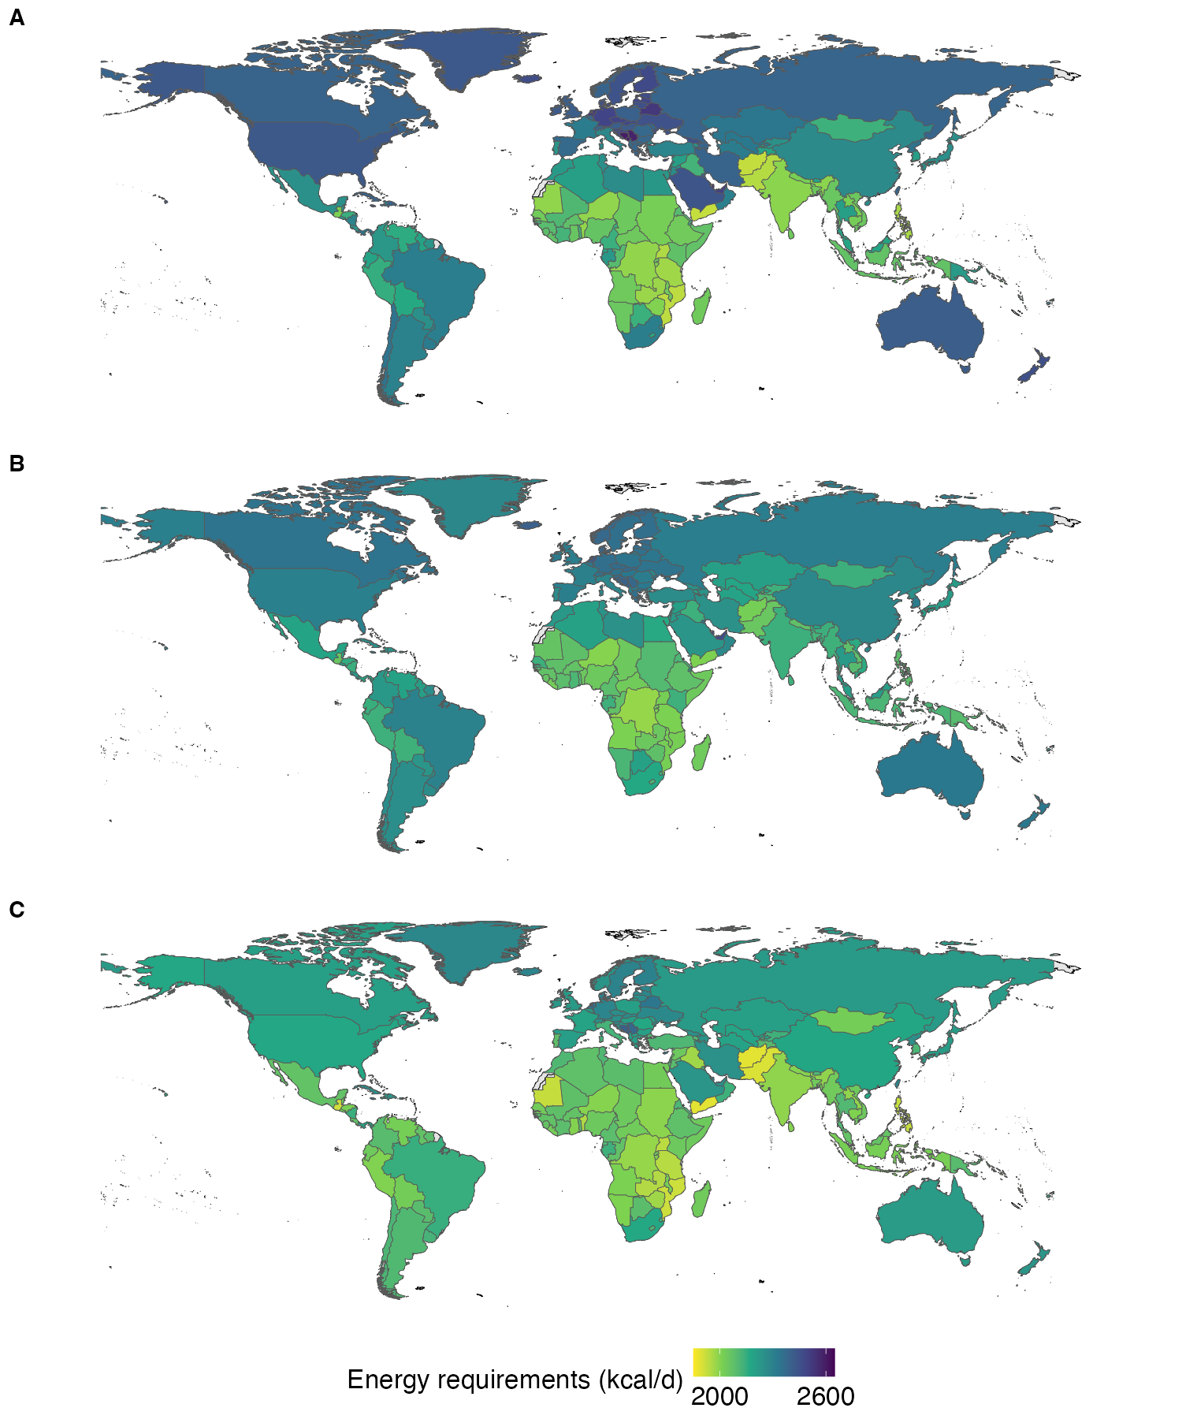

Figure S3. Food intake by dietary pattern, and for the example of flexitarian diets by region, age, and sex in terms of kilocalories per person per day (A), grams per person per day (B), and servings per person per day (C). The dietary patterns include flexitarian (FLX), pescatarian (PSC), vegetarian (VEG), and vegan (VGN) diets. The regions include North America (NAC), Latin America & Caribbean (LCN), Europe & Central Asia (ECS), Middle East & North Africa (MEA), South Asia (SAS), East Asia & Pacific (EAS), and Sub-Saharan Africa (SSF).

Figure S4. Change in food intake by dietary pattern, and for the example of flexitarian diets by region, age, and sex in terms of kilocalories per person per day (A), grams per person per day (B), and servings per person per day (C). The dietary patterns include flexitarian (FLX), pescatarian (PSC), vegetarian (VEG), and vegan (VGN) diets. The regions include North America (NAC), Latin America & Caribbean (LCN), Europe & Central Asia (ECS), Middle East & North Africa (MEA), South Asia (SAS), East Asia & Pacific (EAS), and Sub-Saharan Africa (SSF).

Figure S5. Change in food intake, including in processed foods, by dietary pattern, and for the example of flexitarian diets by region, age, and sex in terms of kilocalories per person per day (A), grams per person per day (B), and servings per person per day (C). The dietary patterns include flexitarian (FLX), pescatarian (PSC), vegetarian (VEG), and vegan (VGN) diets. The regions include North America (NAC), Latin America & Caribbean (LCN), Europe & Central Asia (ECS), Middle East & North Africa (MEA), South Asia (SAS), East Asia & Pacific (EAS), and Sub-Saharan Africa (SSF).

Figure S6. Overall change in food intake by food group and diet scenario (%), including primary foods (A) and processed foods (B).

Figure S7. Overall percentage changes in the intake of encouraged foods with minimum targets (min targets, A) and of to-be-limited foods with maximum targets (max targets, A) by dietary pattern, and for the example of flexitarian diets also by region, age, and sex. Panel B depicts the same overall changes, but with proportional contributions of each food to the overall percentage change.

Figure S8. Overall percentage changes in the intake of encouraged (A) and to-be-limited (B) foods by country and for the example of flexitarian diets.
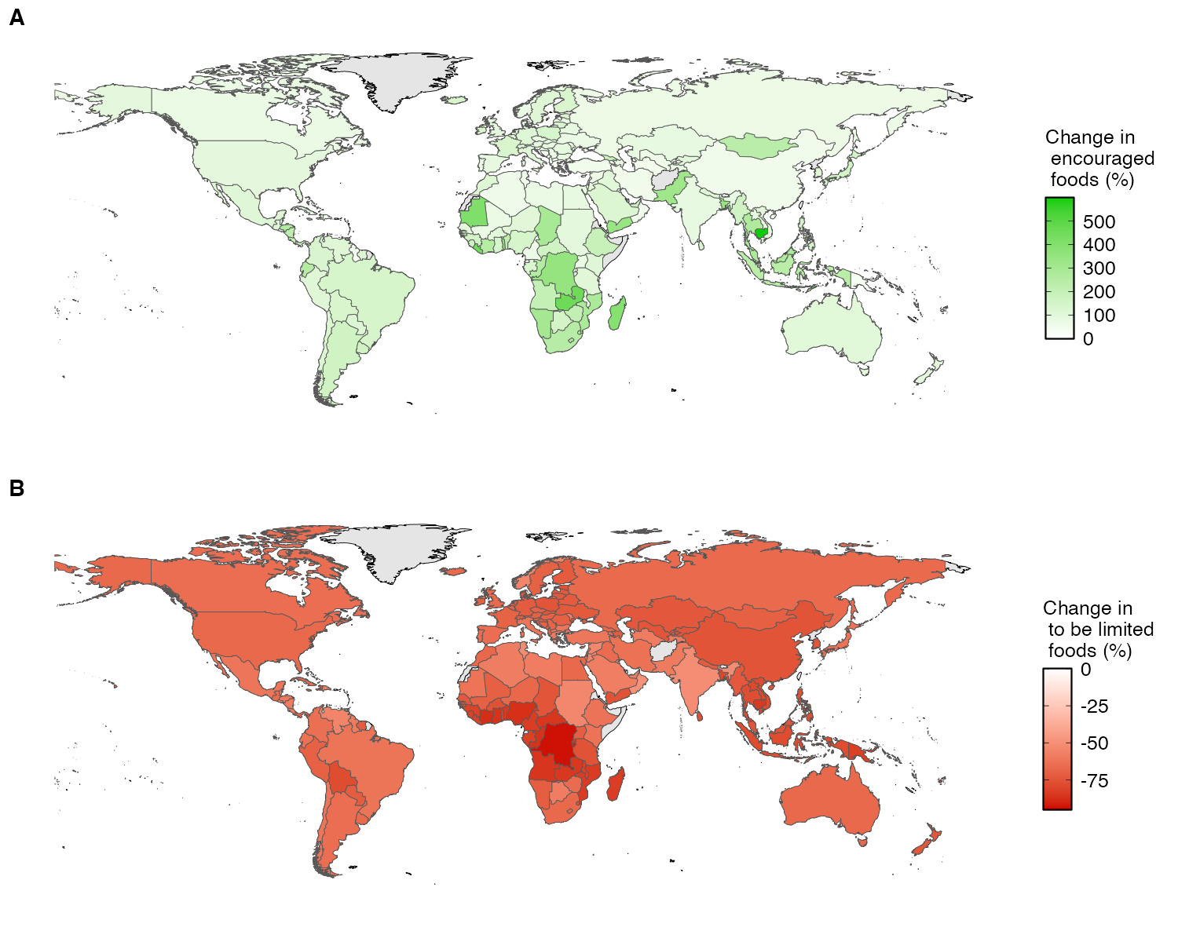

Figure S9. Globally averaged percentage changes in nutrient intake by nutrient and dietary pattern.

Figure S10. Mean adequacy scores by region, age, and sex in the baseline and the dietary patterns. The scores were calculated by summing nutritional adequacy ratios over nutrients with adequacy-related recommendations and dividing by their number.

Figure S11. Regional distribution of mean adequacy ratios in the baseline (A) and the dietary patterns (B). Please note that mean adequacy scores of 100% at a country level are averages and do not indicate full adequacy of each population group.

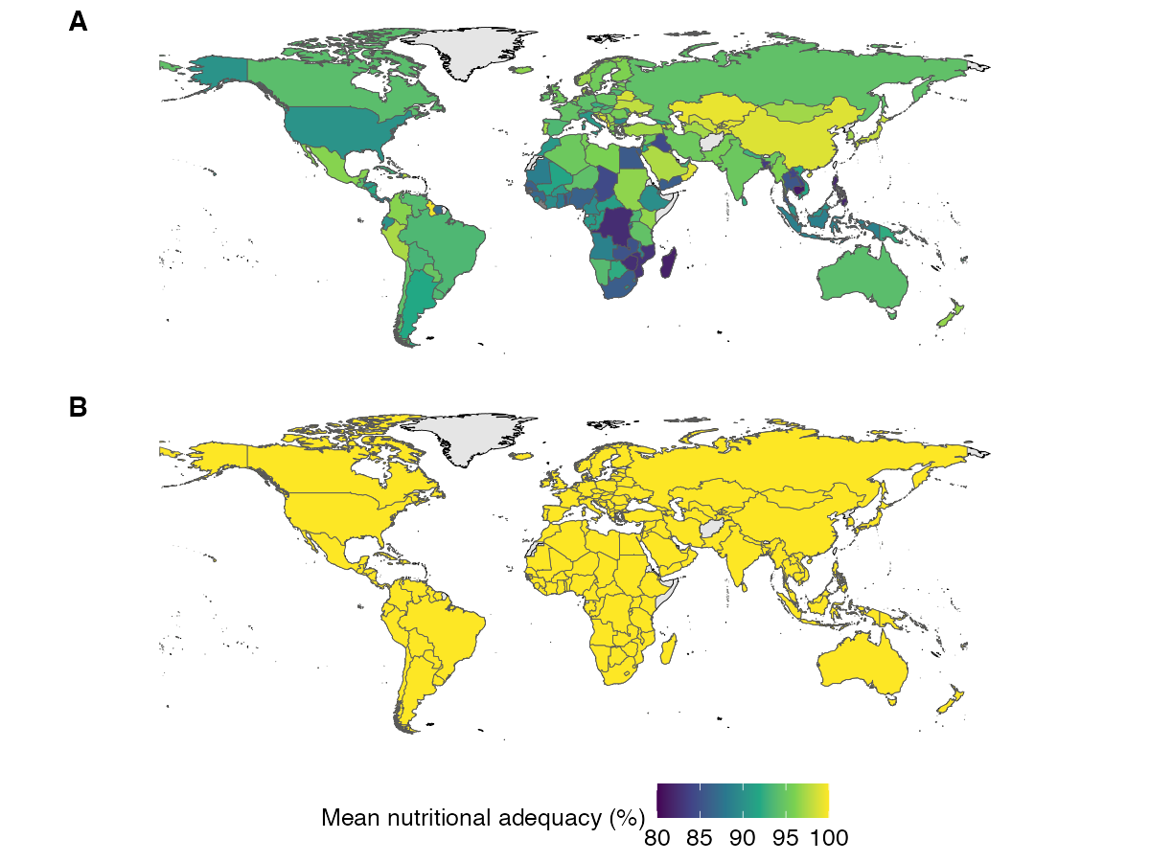

Figure S12. Global reduction in mortality by risk factor and dietary pattern. Risk factors include low intake of whole grains, vegetables, fruits, legumes, nuts and seeds; high intake of red meat and processed meat; and imbalances in energy intake associated with underweight, overweight, and obesity.

Figure S13. Reduction in mortality by dietary pattern, and for flexitarian diets also by region, age group, and sex. Panel A displays the reduction in mortality attributed to changes in diet and weight-related risk factors. Panel B displays the reduction in mortality with diet-related risk factors as in panel A and with weight-related risk factors attributed the under and overconsumption of foods (including to foods directly associated with diet-related risks).
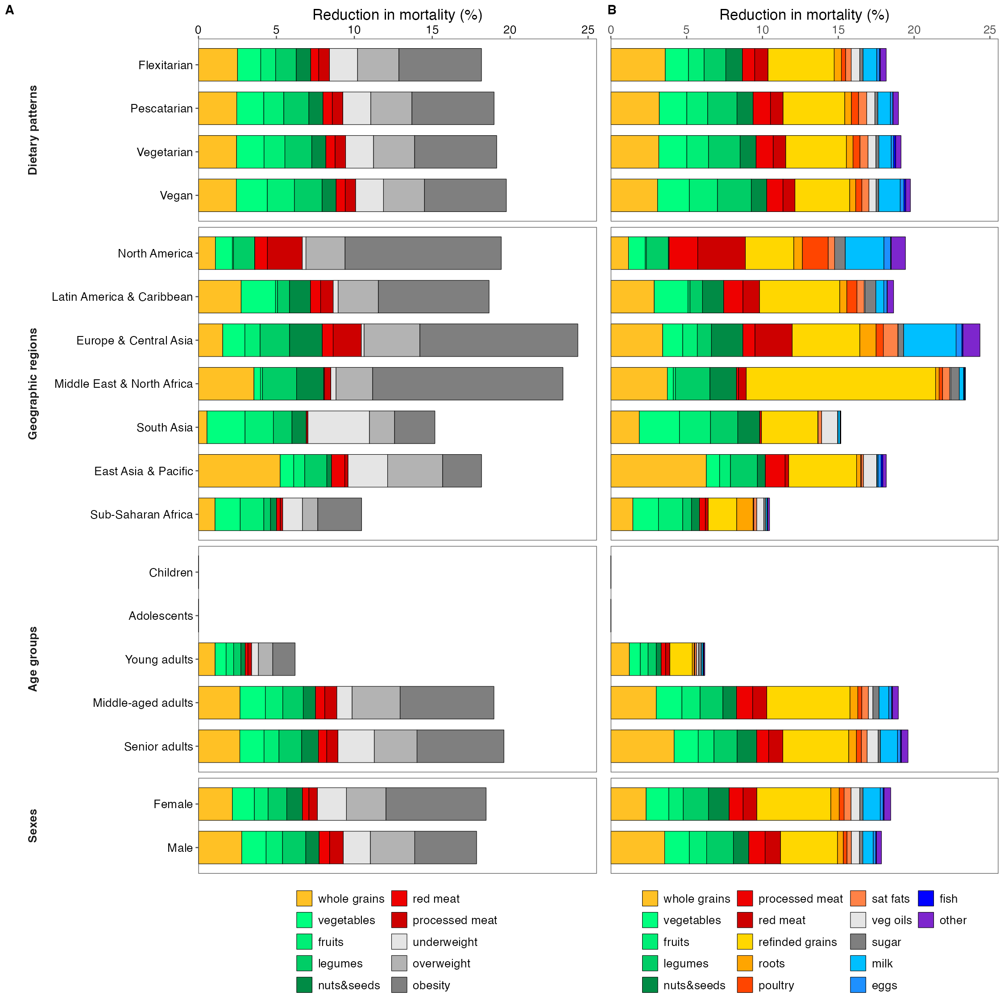

Figure S14. Change in mortality by country and dietary pattern, including flexitarian (A), pescatarian (B), vegetarian (C), and vegan (D) diets.
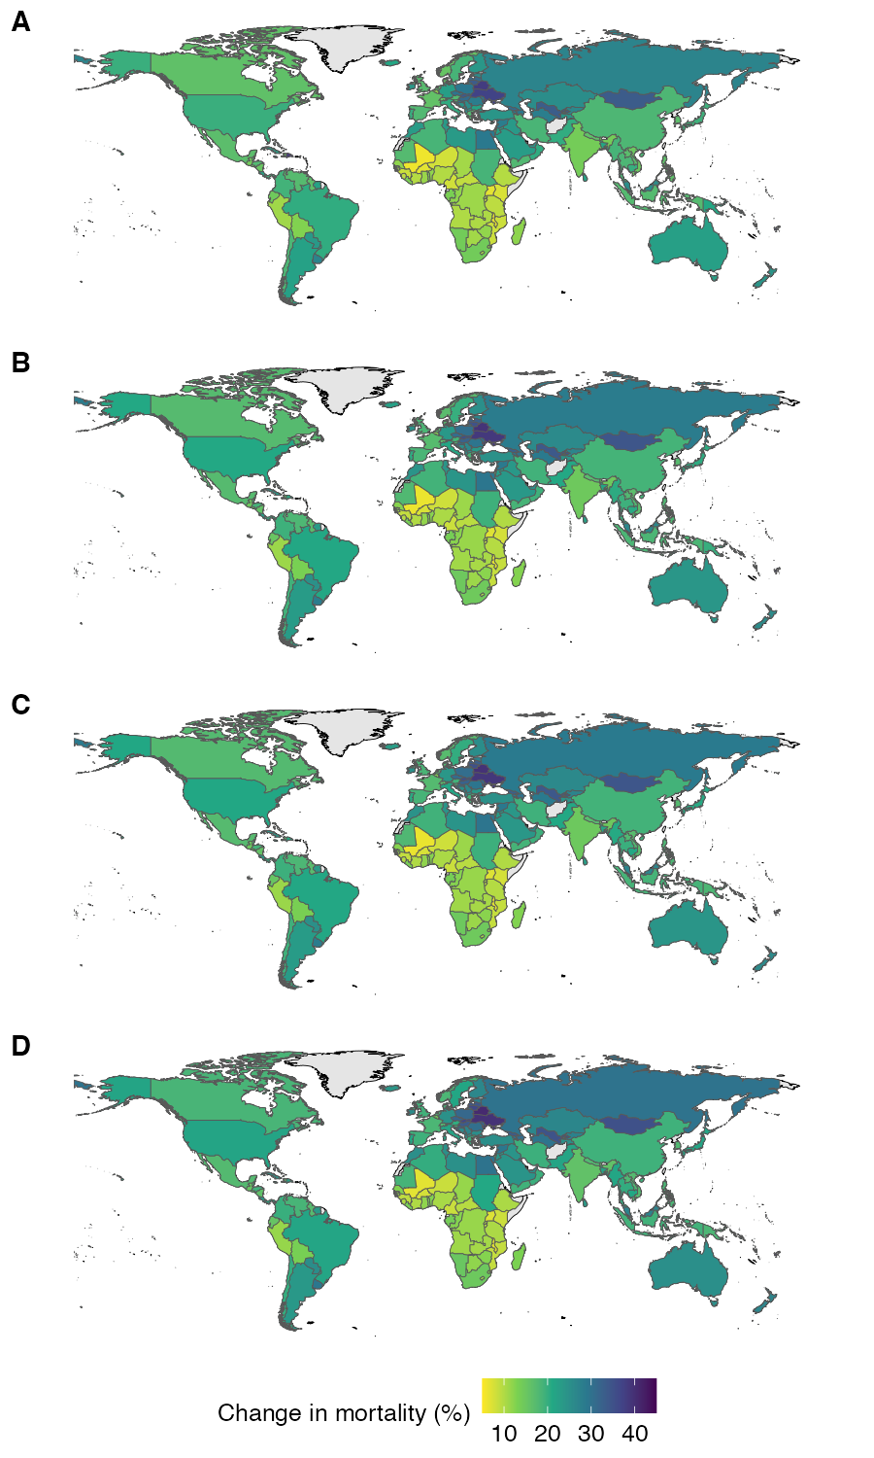

Figure S15. Global reduction in environmental resource use and pollution by environmental indicator and dietary pattern.

Figure S16. Reduction in averaged environmental resource demand by dietary pattern, and for flexitarian diets also by region, age group, and sex. The changes in environmental impacts were averaged across domains (GHG emissions, land use, water use, and eutrophication potential), weighted by the importance of dietary changes for mitigation in that domain.

Figure S17. Reduction in environmental resource use and pollution by dietary pattern, and for flexitarian diets also by region, age group, and sex across environmental domains, including GHG emissions (A), land use (B), water use (C), and eutrophication potential (D).

Figure 18. Change in averaged environmental impacts by country and dietary pattern, including flexitarian (A), pescatarian (B), vegetarian (C), and vegan (D) diets.
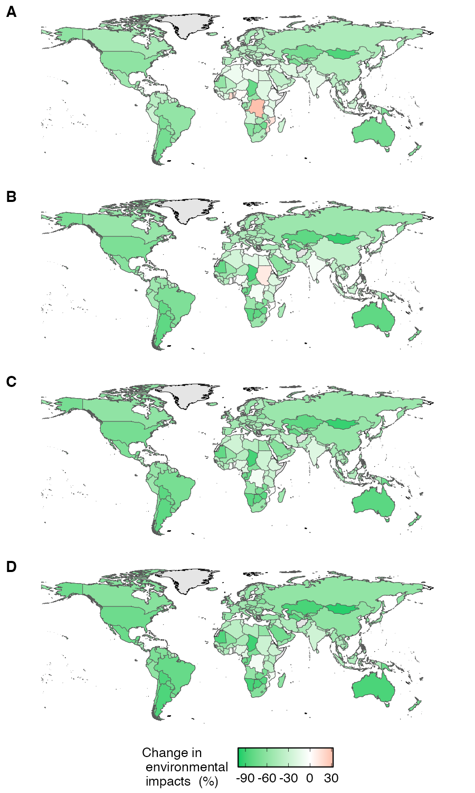

Figure S19. Sensitivity analysis of different ways of developing planetary health diets. The sensitivity analysis compares four ways of developing the dietary patterns (A) and the associated impacts on mortality by risk factor (B) and environmental resource demand by food group (C). They include the main variants which regionalise dietary recommendations without penalising greater than recommended intake of encouraged foods and lower than recommended intake of to-be-limited foods (main), static variants with strict adherence to the dietary reference values (static), variants that are regionalised as the main and adapted to the energy requirements of populations that meet recommended levels of physical activity (active), and variants that include static adherence to the reference values and illustrate the impacts of misapplying the energy requirements of one population group with energy requirements of 2500 kcal/d to all other groups (adult).

Supplementary references

1. Springmann, M. The Global Dietary Database for Impact Assessments (GDD-IA): facilitating diet-related analysis at global, regional, national, and sociodemographic levels.
2. Food and Agriculture Organization of the United Nations. FAOSTAT Statistical Database. (2022).
3. Gustavsson, J., Cederberg, C., Sonesson, U., Van Otterdijk, R. & Meybeck, A. Global Food Losses and Food Waste: Extent, Causes and Prevention. (FAO Rome, 2011).
4. Miller, V. et al. Global Dietary Database 2017: data availability and gaps on 54 major foods, beverages and nutrients among 5.6 million children and adults from 1220 surveys worldwide. BMJ Global Health 6, e003585 (2021).
5. Springmann, M. Estimates of energy intake, requirements, and imbalances based on anthropometric measurements at global, regional, and national levels and for sociodemographic groups. BMJ Public Health (under review).
6. Dietary Reference Intakes for Energy. (National Academies Press, Washington, D.C., 2023). doi:10.17226/26818.
7. Strain, T. et al. National, regional, and global trends in insufficient physical activity among adults from 2000 to 2022: a pooled analysis of 507 population-based surveys with 5·7 million participants. Lancet Glob Health 12, e1232–e1243 (2024).
8. Guthold, R., Stevens, G. A., Riley, L. M. & Bull, F. C. Global trends in insufficient physical activity among adolescents: a pooled analysis of 298 population-based surveys with 1·6 million participants. The Lancet Child & Adolescent Health 4, 23–35 (2020).
9. NCD Risk Factor Collaboration (NCD-RisC). Worldwide trends in underweight and obesity from 1990 to 2022: a pooled analysis of 3663 population-representative studies with 222 million children, adolescents, and adults. Lancet 403, 1027–1050 (2024).
10. NCD Risk Factor Collaboration (NCD-RisC). A century of trends in adult human height. eLife 5, e13410 (2016).
11. Bailey, R. L. Overview of dietary assessment methods for measuring intakes of foods, beverages, and dietary supplements in research studies. Current Opinion in Biotechnology 70, 91–96 (2021).
12. Micha, R., Coates, J., Leclercq, C., Charrondiere, U. R. & Mozaffarian, D. Global Dietary Surveillance: Data Gaps and Challenges. Food Nutr Bull 39, 175–205 (2018).
13. Gobbo, L. C. D. et al. Assessing global dietary habits: a comparison of national estimates from the FAO and the Global Dietary Database. The American Journal of Clinical Nutrition 101, 1038–1046 (2015).
14. Serra-Majem, L. et al. Comparative analysis of nutrition data from national, household, and individual levels: results from a WHO-CINDI collaborative project in Canada, Finland, Poland, and Spain. Journal of Epidemiology and Community Health 57, 74–80 (2003).
15. Black, A. E. et al. Critical evaluation of energy intake data using fundamental principles of energy physiology: 2. Evaluating the results of published surveys. Eur J Clin Nutr 45, 583–599 (1991).
16. Burrows, T. L., Ho, Y. Y., Rollo, M. E. & Collins, C. E. Validity of Dietary Assessment Methods When Compared to the Method of Doubly Labeled Water: A Systematic Review in Adults. Front Endocrinol 10, 850 (2019).
17. Livingstone, M. B. E., Robson, P. J. & Wallace, J. M. W. Issues in dietary intake assessment of children and adolescents. British Journal of Nutrition 92, S213–S222 (2004).
18. Burrows, T. L., Martin, R. J. & Collins, C. E. A Systematic Review of the Validity of Dietary Assessment Methods in Children when Compared with the Method of Doubly Labeled Water. Journal of the American Dietetic Association 110, 1501–1510 (2010).
19. Subar, A. F. et al. Using Intake Biomarkers to Evaluate the Extent of Dietary Misreporting in a Large Sample of Adults: The OPEN Study. American Journal of Epidemiology 158, 1–13 (2003).
20. Khatibzadeh, S. et al. A global database of food and nutrient consumption. Bull World Health Organ 94, 931–934 (2016).
21. Smith, M. R., Micha, R., Golden, C. D., Mozaffarian, D. & Myers, S. S. Global expanded nutrient supply (GENuS) model: a new method for estimating the global dietary supply of nutrients. PLOS ONE 11, e0146976 (2016).
22. U.S. Department of Agriculture, Agricultural Research Service & Beltsville Human Nutrition Research Center. FoodData Central. https://fdc.nal.usda.gov/ (2024).
23. Wessells, K. R., Singh, G. M. & Brown, K. H. Estimating the Global Prevalence of Inadequate Zinc Intake from National Food Balance Sheets: Effects of Methodological Assumptions. PLOS ONE 7, e50565 (2012).
24. Watanabe, T. & Kawai, R. Advances in food composition tables in Japan-Standard Tables Of Food Composition in Japan – 2015 – (Seventh Revised Edition)–. Food Chemistry 238, 16–21 (2018).
25. Allen, L. H., Carriquiry, A. L. & Murphy, S. P. Perspective: Proposed Harmonized Nutrient Reference Values for Populations. Advances in Nutrition 11, 469–483 (2020).
26. Miller, L. V., Krebs, N. F. & Hambidge, K. M. A mathematical model of zinc absorption in humans as a function of dietary zinc and phytate. J Nutr 137, 135–141 (2007).
27. Hambidge, K. M., Miller, L. V., Westcott, J. E., Sheng, X. & Krebs, N. F. Zinc bioavailability and homeostasis. Am J Clin Nutr 91, 1478S-1483S (2010).
28. Armah, S. M., Carriquiry, A., Sullivan, D., Cook, J. D. & Reddy, M. B. A complete diet-based algorithm for predicting nonheme iron absorption in adults. J Nutr 143, 1136–1140 (2013).
29. Tufts University. Data4Diets: Building Blocks for Diet-related Food Security Analysis, Version 2.0. (2023).
30. Bajaj, S. & Springmann, M. A review of the quality of evidence of nutrient reference values. Lancet Planetary Health (under review).
31. European Food Safety Authority (EFSA). Dietary Reference Values for nutrients Summary report. EFS3 14, (2017).
32. Murray, C. J. L., Ezzati, M., Lopez, A. D., Rodgers, A. & Vander Hoorn, S. Comparative quantification of health risks: conceptual framework and methodological issues. Population Health Metrics 1, 1 (2003).
33. Lim, S. S. et al. A comparative risk assessment of burden of disease and injury attributable to 67 risk factors and risk factor clusters in 21 regions, 1990–2010: a systematic analysis for the Global Burden of Disease Study 2010. The Lancet 380, 2224–2260 (2012).
34. Forouzanfar, M. H. et al. Global, regional, and national comparative risk assessment of 79 behavioural, environmental and occupational, and metabolic risks or clusters of risks in 188 countries, 1990–2013: a systematic analysis for the Global Burden of Disease Study 2013. The Lancet 386, 2287–2323 (2015).
35. Murray, C. J. L. et al. GBD 2010: design, definitions, and metrics. Lancet 380, 2063–2066 (2012).
36. Wang, H. et al. Global age-sex-specific fertility, mortality, healthy life expectancy (HALE), and population estimates in 204 countries and territories, 1950–2019: a comprehensive demographic analysis for the Global Burden of Disease Study 2019. The Lancet 396, 1160–1203 (2020).
37. NCD Risk Factor Collaboration (NCD-RisC). Trends in adult body-mass index in 200 countries from 1975 to 2014: a pooled analysis of 1698 population-based measurement studies with 19·2 million participants. The Lancet 387, 1377–1396 (2016).
38. Afshin, A., Micha, R., Khatibzadeh, S. & Mozaffarian, D. Consumption of nuts and legumes and risk of incident ischemic heart disease, stroke, and diabetes: a systematic review and meta-analysis. The American Journal of Clinical Nutrition ajcn.076901 (2014) doi:10.3945/ajcn.113.076901.
39. Aune, D. et al. Nut consumption and risk of cardiovascular disease, total cancer, all-cause and cause-specific mortality: a systematic review and dose-response meta-analysis of prospective studies. BMC medicine 14, 207 (2016).
40. Aune, D. et al. Fruit and vegetable intake and the risk of cardiovascular disease, total cancer and all-cause mortality–a systematic review and dose-response meta-analysis of prospective studies. International Journal of Epidemiology (2016).
41. Bechthold, A. et al. Food groups and risk of coronary heart disease, stroke and heart failure: A systematic review and dose-response meta-analysis of prospective studies. Critical Reviews in Food Science and Nutrition 59, 1071–1090 (2019).
42. Schwingshackl, L. et al. Food groups and risk of type 2 diabetes mellitus: a systematic review and meta-analysis of prospective studies. European Journal of Epidemiology 32, 363–375 (2017).
43. Schwingshackl, L. et al. Food groups and risk of colorectal cancer. International Journal of Cancer 142, 1748–1758 (2018).
44. Global BMI Mortality Collaboration, E. Di et al. Body-mass index and all-cause mortality: individual-participant-data meta-analysis of 239 prospective studies in four continents. Lancet (London, England) 388, 776–86 (2016).
45. Singh, G. M. et al. The Age-Specific Quantitative Effects of Metabolic Risk Factors on Cardiovascular Diseases and Diabetes: A Pooled Analysis. PLOS ONE 8, e65174 (2013).
46. Micha, R. et al. Etiologic effects and optimal intakes of foods and nutrients for risk of cardiovascular diseases and diabetes: Systematic reviews and meta-analyses from the Nutrition and Chronic Diseases Expert Group (NutriCoDE). PLOS ONE 12, e0175149 (2017).
47. GBD 2017 Diet Collaborators, A. et al. Health effects of dietary risks in 195 countries, 1990-2017: a systematic analysis for the Global Burden of Disease Study 2017. Lancet (London, England) 0, (2019).
48. Schwingshackl, L. et al. Perspective: NutriGrade: A Scoring System to Assess and Judge the Meta-Evidence of Randomized Controlled Trials and Cohort Studies in Nutrition Research. Advances in Nutrition: An International Review Journal 7, 994–1004 (2016).
49. World Cancer Research Fund/American Institute for Cancer Research. Diet, Nutrition, Physical Activity and Cancer: A Global Perspective. Continuous Update Project Expert Report. (2018).
50. Aune, D., Norat, T., Romundstad, P. & Vatten, L. J. Dairy products and the risk of type 2 diabetes: a systematic review and dose-response meta-analysis of cohort studies. The American Journal of Clinical Nutrition 98, 1066–1083 (2013).
51. Aune, D. et al. Dairy products and colorectal cancer risk: a systematic review and meta-analysis of cohort studies. Annals of Oncology: Official Journal of the European Society for Medical Oncology 23, 37–45 (2012).
52. Mohan, D. et al. Associations of Fish Consumption With Risk of Cardiovascular Disease and Mortality Among Individuals With or Without Vascular Disease From 58 Countries. JAMA Internal Medicine (2021) doi:10.1001/jamainternmed.2021.0036.
53. Aune, D. et al. Fruit and vegetable intake and the risk of cardiovascular disease, total cancer and all-cause mortality—a systematic review and dose-response meta-analysis of prospective studies. International Journal of Epidemiology 46, 1029–1056 (2017).
54. Poore, J. & Nemecek, T. Reducing food’s environmental impacts through producers and consumers. Science 360, 987–992 (2018).
55. Springmann, M. et al. Options for keeping the food system within environmental limits. Nature 562, 519–525 (2018).

