SUPPLEMENTAL INFORMATION

Article: Estimates of wildlife species richness, occupancy, and habitat preference in a human-impacted landscape in New York State

Journal: Urban Ecosystems

Authors: Stacy Mowry^{1*}, Jennifer Pendleton¹, Felicia Keesing², Marissa Teator¹, and Richard S. Ostfeld¹
¹Cary Institute of Ecosystem Studies, Millbrook, NY 12545 USA
²Program in Biology, Bard College, Annandale, NY 12504
*To whom correspondence should be addressed. mowrys@caryinstitute.org

Setting | Options | Selection
Mode | Camera, Video, Hybrid | Camera
Image Size | 3M Pixel, 8M Pixel, 14M Pixel | 14M Pixel
Image Format | Full Screen, Wide Screen | Full Screen
Capture Number | 1 Photo, 2 Photo, 3 Photo | 3 Photo
LED Control | Low, Medium, High | High
Video Size | Skip | Skip
Video Length | Skip | Skip
Interval | 1-59 seconds, 1-60 minutes | 2S
Sensor Level | Low, Normal, High, Auto | Auto
NV Shutter | High, Medium, Low | Medium
Camera Mode | 24hrs, Day, Night | 24hrs
Time Stamp | On, Off | On
Field Scan | On, Off | Off
Coordinate Input | On, Off | Off
Video Sound | On, Off | Off
Default Set | Cancel, Execute | Cancel
Table S1 Camera setting selections

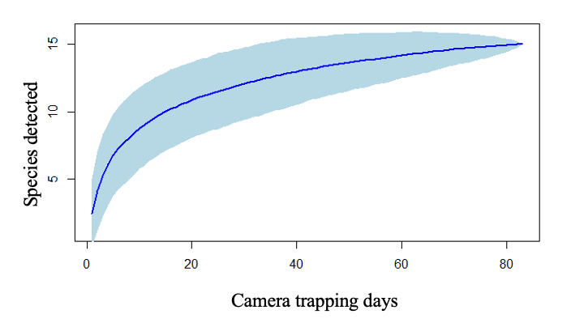
Fig. S1 Number of mammal and non-passerine bird species detected in our 2016-2017
camera-trap season as a function of camera trap days. Light blue shading depicts
the standard error of the estimate

Species  (common name) | Species  (scientific name) | Bayesian p-value
Coyote | Canis latrans | 0.476
Eastern chipmunk | Tamias striatus | 0.460
Eastern cottontail | Sylvilagus floridanus | 0.494
Eastern gray squirrel | Sciurus carolinensis | N/A
Gray fox | Urocyon cineroargenteus | 0.470
Racoon | Procyon lotor | N/A
Red fox | Vulpes vulpes | N/A
Red squirrel | Sciurus vulgaris | 0.481
Striped skunk | Mephitis mephitis | 0.473
Virginia Opossum | Didelphis virginiana | N/A
White-tailed deer | Odocoileus virginianus | N/A
Wild turkey | Meleagris gallopavo | 0.591
Woodchuck | Marmota monax | 0.486

Table S2 Bayesian p-values from site-occupancy models for each species with a naïve
occupancy > 0.10. Note: Bayesian p-values were not calculated for species with a
naïve occupancy = 1

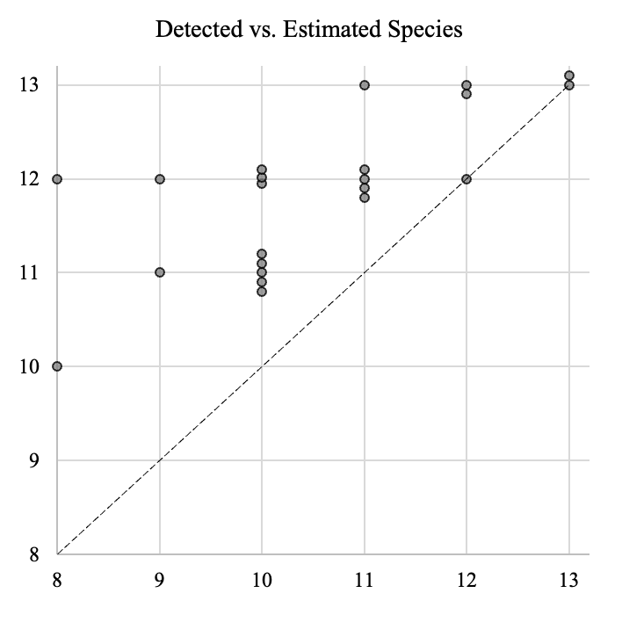
Fig. S2 Number of detected (x-axis) vs estimated (y-axis) non-passerine and mammal species
with naïve occupancies > 0.10 for each of our 22 study neighborhoods according to our
species occupancy models. Points on the dashed line indicates all species estimated
to be present in the neighborhood were detected. Points are vertically jittered around
integers

