Supplementary Information for

Ball-Lightning-like Terahertz Solitons
Authors: Chuliang Zhou^{1,2}†, Dongdong Zhang^{1,2}†, Rong Qi^{1,2}†, Yafeng Bai^{1,2}†, Yushan Zeng^{1,2}, Zhuorui Zheng^{1,2}, Liwei Song^{1,2}*, Ye Tian^{1,2}*, Ruxin Li^{1,2,3}*

*Corresponding author. Email: ruxinli@siom.ac.cn (R.L.), slw@siom.ac.cn (L.S.), tianye@siom.ac.cn (Y.T.)

This file includes:

Methods
Fig. S1
References

Other Supplementary Information for this manuscript include the following:

Movies S1

Methods
Laser system and diagnosis set-up
The strong terahertz (THz) fields are generated by focusing intense femtosecond laser pulse onto a metal wire that has been well studied as a ‘waveguide’ for both THz surface plasmon polaritons (SPP) and electrons in our previous research¹⁻³. The THz band in our experiments is 0.1-0.6 THz. When adopting an axisymmetric metal wire as the target, the interaction between SPP and electrons results in coherent energy transfer from the electrons to the SPP, giving rise to a quasi-single-cycle intense SPP pulse on the wire waveguide. In the current experiment, the tungsten needle has a tip radius of 50 nm extending from the 500 μm diameter shank with a taper angle of 2.3°. To prevent the laser-driven free electrons from affecting the subsequent excitation of the electromagnetic (EM) soliton, a Teflon plate which is transparent to the THz SPP is placed 3 mm away from the laser focus to block the electrons. According to our previous work, we estimate there is about 4 mJ of the SPP energy ($E_{spp}$) at the wire tip with a local field strength reaching up to 10 GV/m at the tip apex. Note that the given field strength already includes a field-enhancement factor $β≈10$ obtained in our experiment, as shown in Fig. S1a-c. Thus, Ar gas can be ionized by THz SPP and field distribution near nanotips leads to the generation of solitons.
For the study of EM solitons, infrared laser have long been used to achieve relativistic field strengths by free-space focusing. Due to the inherent properties of Gaussian beams, the laser pulse focusing in free space is limited by diffraction, resulting in an approximately uniform field strength distribution at the focal spot. In our experiment, relativistic field strength is achieved through field enhancement of SPP mode via a nano tip, which improves the THz field strength by one order of magnitude. Additionally, the characteristics of the SPP field distribution are a key factor in the generation of novel THz solitons. The radial electric field distribution of SPPs at the nanoneedle tip, which decays exponentially, leads to the size of the initial ionization region determining the characteristic dimensions of the THz soliton no longer depends on the wavelength of THz itself. Field ionization distribution near nanotips and the percentage of different ionization states are shown in Fig. S1d and e.
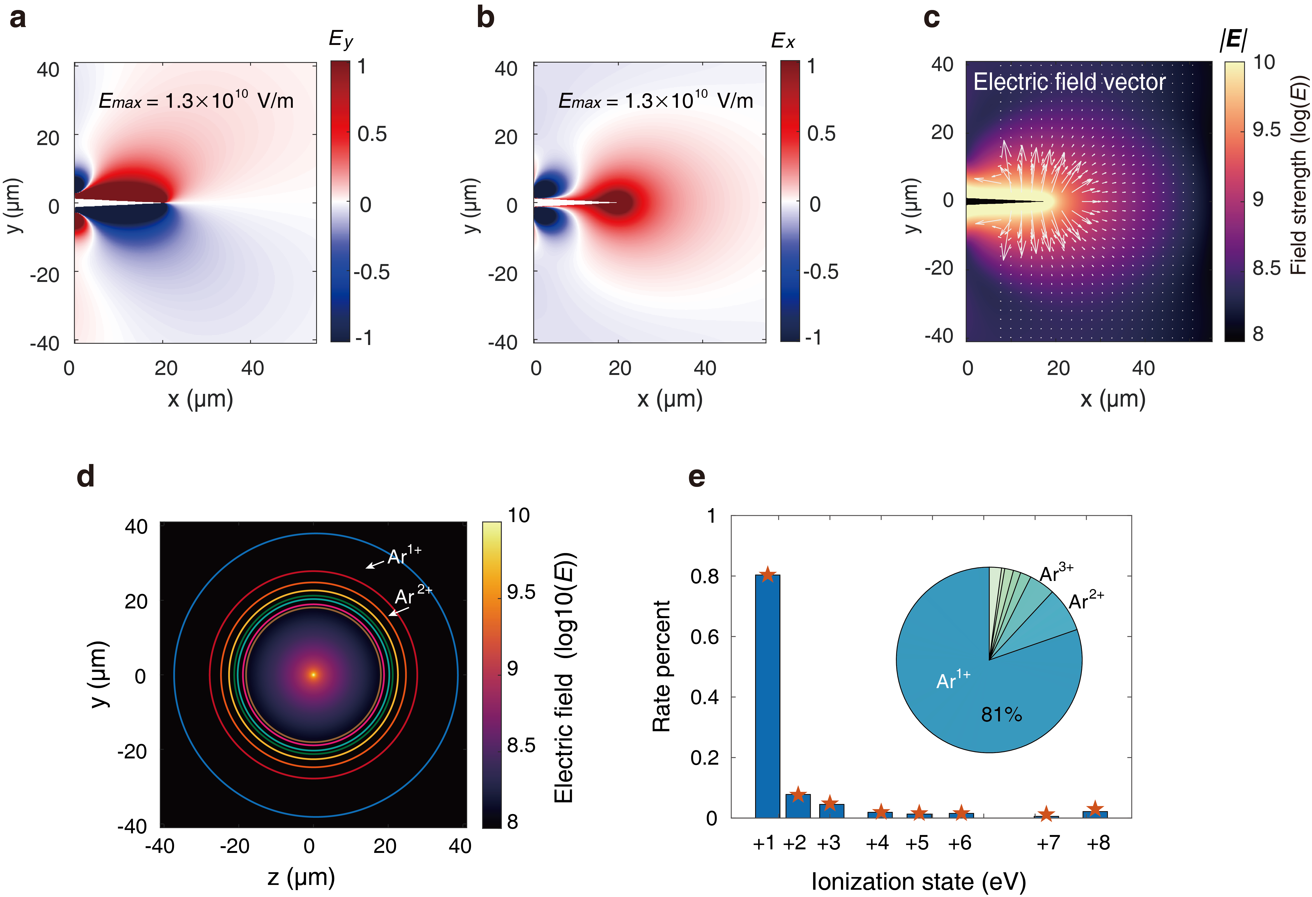
Fig. S1 THz SPP electric field distribution on the tip apex and field ionization region. a, and b, Electric field component Ey and Ex distribution at the tip apex. c, Total electric field strength distribution and electric field vector (xy-plane) at tip apex. d, Cross-sectional(yz-plane) field distribution of tungsten nanotips and the corresponding distribution of different ionization states; e, The percentage of different ionization states.
High-pressure Ar gas is applied for the preparation of the plasma environment. A designed supersonic gas jet is equipped under the tungsten tip with a distance of 3 mm to produce variable gas density and ensure stable density distribution in the interaction area. The back pressure is set to 8 bar to satisfy the requirement of gas density, which offers an electron density of $4.68×{10}^{15} cm^{-3}$ in the case near the critical density. The single-shot images of generated solitons are captured with a confocal microscope at 5X objective lens amplification and recorded by a gated intensified charge-coupled device (ICCD) camera. The temporal and spatial resolution of image capturing are 2 ns and 2.6 μm, respectively. We diagnose the temporal evolution of EM solitons by adjusting the time delay of the ICCD camera's shutter, which was synchronized with the laser pulse using a delay signal generator. Comprehensive time-series images are recorded, as shown in Fig. S1d.

Tip enhancement simulation
To theoretically estimate the near-field enhancement in the vicinity of the tungsten nanotip, we numerically solve Maxwell’s equations utilizing three-dimensional finite-difference time-domain (FDTD) simulations. The nanotip is modeled as a sphere with a radius of 100 nm that smoothly transitions to a cone with an opening angle of 2.3°. The simulations predict a peak field-enhancement factor of about 7.44 close to the surface at the tip apex. At the end of the nano-tip, the THz EM field is enhanced to $\sim 1.3×{10}^{10} V/m$, as illustrated in Fig. S1a, which is enough to produce plasmas and drive solitons. Under the framework of the Sommerfeld model, the dominant mode is the azimuthally symmetric TM₀₁ mode, and the higher modes have very high attenuations and vanish almost immediately. The field components of the Sommerfeld wave in the metal (left) and air (right) can be written as follows, respectively:
(1)
,
where and are constants, is the propagation constant of the guided wave, is the angular frequency of the electromagnetic wave. and indicate Bessel function zero and first order, respectively. $k_{c}=\sqrt{ωμ_{c}σ_{c}}e^{-jπ/4}$ are the wave vector in the metal. $γ_{c}=\sqrt{k_{c}^{2}-h^{2}}$ is the propagation constant of the surface wave. $H_{0}^{(1)}$ and $H_{1}^{(1)}$ are Hankel functions of the first kind, and zero and first order, respectively. $k_{0}=ω\sqrt{ε_{0}μ_{0}}$ is the wave vector in the outer free space and $γ_{0}=\sqrt{k_{0}^{2}-h^{2}}$.

Particle-in-cell simulations
We study the soliton formation by inputting radially polarized THz pulses in a uniform plasma zone. The simulation of bubble formation in Fig. 3b is done in the xy-plane. The THz-SPP propagates from a vacuum to a uniform plasma along the x-axis. The parameters used in the simulations are comparable to the experimental conditions. The THz pulses are centered at 0.3 THz, with a peak electric field of $6.4×10^{9}V/m$, and a full width at half-maximum (FWHM) duration of 2 cycles, which are launched from the left boundary of the simulation box. We take a plasma density of $n_{0}= 0.4 n_{c}$ and resolution of 300 grids per wavelength along the x- and y-axes. Ar atom is set as an average atom weight of 39.95 and a charge state of Z = 1. The THz field is enhanced at the tip (illustrated in Fig. S1) and captured by Ar gas plasma (as shown in Fig. S1b). At the edge of the luminescent sphere, the electron density is higher than the THz critical density of THz frequency. The excitation and evolution of solitons are simulated over an 80-ns duration.

EM soliton steady-state model approximation
Soliton-like self-sustaining standing waves can be simulated by using proper plasma density and EM field. It has been prophesied that EM soliton can be created in laboratory via the interaction of intense THz pulses and gas plasmas, which lays the foundation for systematic research. In our experiment, the generation of static EM solitons is achieved by injecting THz SPP into Ar gas via a tungsten tip, where a plasma ball is formed and bounds the injected EM energy. Solitons can be generated by controlling EM field strength and plasma density. Since the driving pulses are in THz frequency, the resulting solitons have large spatial dimensions which make them easy be observed. During its propagation through a preformed plasma, the THz experiences, in fact, a significant energy loss, which is mostly translated into a red shift of its wavelength. In sub-critical plasmas, this frequency decrease may be sufficient for the THz to locally experience an overcritical plasma, thus becoming trapped in plasma cavities. Relativistic electromagnetic solitons are either stationary or have a certain finite drift velocity, in both cases they are EM structures that exist for a long time and are trapped in a quasi-static electron density hole. It is crucial to discuss the EM soliton model under steady-state conditions and determine the essential conditions for soliton generation in THz frequency range. We develop the discussion from two aspects: plasma density pressure and the radiation pressure of the electromagnetic field within the soliton.
For the soliton origin, we defined the $\sim ps$ duration as $t_{0}$ which accounts for soliton ignition at the tip boundary. The THz single photon energy of the tip SPP is defined as $ℏω_{ph}$, and the total number of photons is $N_{ph}$. Considering the initial mode volume is $V_{0}=\frac{4}{3}πR_{0}^{3}$ where $R_{0}$ is the initial radius, the initial energy is $ξ_{0}=ℏω_{ph}N_{ph}$. We next derive the equilibrium state from the “snowplow” model⁴. Setting $n_{0}$ as the plasma density, and $m_{i}$ as the ion mass, the plasma mass pushed by the EM wave at the radius $R$ is
$M(R)=\frac{4}{3}πR^{3}n_{0}m_{i}$, (2)
where a uniform distribution of the mass is hypothesized. According to second Newton's law, the density force is,
$F_{p}=\frac{d}{dt}(M(R)\dot{R})$. (3)
Thus, the plasma density pressure writes:
$P_{p}=F_{p}/4πR^{2}=\frac{n_{0}m_{i}}{3R^{2}}\frac{d(R^{3}\dot{R})}{dt}=n_{0}m_{i}({\dot{R}}^{2}+\frac{1}{3}R\ddot{R})$, (4)
Then, for the EM wave trapped by soliton, the energy density of the EM wave is $u=\frac{1}{2}(ε_{0}E^{2}+\frac{1}{μ_{0}}B^{2})=ε_{0}E^{2}$. Therefore, the adiabatic invariant action is the ratio between the energy and the EM frequency as a constant,
$\int{ε_{0}E^{2}/ω_{s}dV=ε_{0}N_{ph}ℏ}=const$. (5)
Applying the electric dipole approximations in a spherical cavity with radius R, the EM frequency is $ω_{s}∝c/R$, thus the electric field variation with radius is $E^{2}∝R^{-4}$. The relationship between light intensity and field strength is $I=\frac{1}{2}ε_{0}cE^{2}$, and the corresponding laser normalized vector potential $a=\frac{eE}{m_{e}ω_{s}c}$. According to the pondermotive force $F_{p}=\frac{e^{2}}{4m_{e}ω_{s}^{2}}∇E^{2}$, we can write the force applied to the plasma shell by substituting the above equation, the pressure of the EM field on the plasma shell can be obtained in Gaussian units:
$S_{p}=\frac{F_{p}}{4πR^{2}}=\frac{\left\langle E^{2}\right\rangle }{8π}$, (6)
where, $\left\langle E^{2}\right\rangle =\left\langle E_{0}^{2}\right\rangle (\frac{R_{0}}{R})^{4}$, is the amplitude of the electric field inside the soliton, $R_{0}=c/ω_{pe}$ is the initial radius of the soliton, $ω_{pe}$ is plasma frequency .The soliton field strength versus expansion radius is given as $E∼1/R^{2}$ in Ref ⁵. Therefore, EM field pressure inside the soliton $S_{p}∼R^{-4}$. So, we can consider the equilibrium condition where the EM field radiation pressure is equal to the plasma density pressure:
$S_{p}=P_{p}$. (7)
Then,
$\frac{d}{dt}(M\frac{dR}{dt})=4πR^{2}\frac{\left\langle E^{2}\right\rangle }{8π}$, (8)
which can be rewritten as
$\frac{d}{dt}(R^{3}\frac{dR}{dt})=\frac{3R_{0}^{4}\left\langle E^{2}\right\rangle }{8πn_{0}m_{i}R^{2}}$. (9)
The soliton expansion radius increases as
$R(t)≈R_{0}(2t/τ_{0})^{1/3}$, (10)
where $τ_{0}=\sqrt{6π{R_{0}}^{2}n_{0}m_{i}/\left\langle {E_{0}}^{2}\right\rangle }$ is the time factor. Experimentally, by adjusting back pressure to ensure a suitable plasma density to match the condition to trap the SPP EM solitons, the critical density of the plasma for 0.3 THz is $n_{c}=ε_{0}m_{e}ω_{THz}^{2}/e^{2}=1.11{10}^{15} cm^{-3}.$ We refer to this steady-state condition as an EM soliton or post-soliton, because by the time a steady state is reached, the lighter electrons have been expelled to the periphery of the sphere, leaving behind ions that are gradually expanding and dissipating.

Plasma dynamics and temperature estimation
The population of ions at each energy level of radiation $n_{k,z}$ and total ion density $n_{z}$ satisfies the following Boltzmann relation:
$\frac{n_{k,z}}{n_{z}}=\frac{g_{k,z}}{P_{z}}\exp{(}-\frac{E_{k,z}}{k_{B}T})$. (11)
Under the optically thin approximation, the spectral integral intensity $I_{z}$ of the energy level transition from $k$ to lower energy level in the ionized state $Z$, can be written as,
$I_{z}=\frac{hc}{4πλ_{ki,z}}A_{ki,z}n_{k,z}L=\frac{hc}{4πλ_{ki,z}}A_{ki,z}L\frac{n_{z}}{P_{z}}g_{k,z}\exp{(}-\frac{E_{k,z}}{k_{B}T})$. (12)
Taking logarithms on both sides gives that,
$\ln{(}\frac{I_{z}λ_{ki,z}}{g_{k,z}A_{ki,z}})=-\frac{1}{k_{B}T}E_{k,z}+\ln{(}\frac{hcLn_{z}}{4πP_{z}})$. (13)
Obviously, for a fixed ionized state $Z$, the second part $\ln{(}\frac{hcLn_{z}}{4πP_{z}})$ is constant. We take $E_{k,z}$ as the independent variable, and $\ln{(}\frac{I_{z}λ_{ki,z}}{g_{k,z}A_{ki,z}})$ is an implicit variable, and the slope represents the electron temperature of the ionized state $Z$. The results show that the temperature of Ar should be around 0.3 to 1.0 eV; The temperature of Ar¹⁺ is around 2.0 to 6.0 eV, where Ar denotes neutral argon atoms Ar¹⁺ denotes primary ionized argon ions. i.e., the difference between the temperatures of the two may arise from differences in distribution areas. The overall thermal temperature of their mixture is 5.88 eV when other ionized states are neglected. Further analysis of additional data reveals that the thermal temperature for Ar¹⁺ indeed lies within the 2 to 6 eV range, whereas that for Ar appears relatively lower, estimated to be around 0.2 eV based on existing data. This indicates that the temperatures of the two states do not fully correspond, which may result from differences in energy acquired by electrons in soliton fields due to their distribution in different regions. According to equilibrium conditions, the temperature ratio between various spectral bands should be a constant, hence the intensity ratios signify the degree of deviation from equilibrium. At the condition of local thermodynamic equilibrium (LTE), it is possible to simulate the EM soliton spectrum.
We assume the equilibrium conditions as a plasma temperature of 6 eV and a plasma density of $n_{e}=5×10^{15}$cm⁻³. The theoretical thermal temperature is closer to the experimental situation, and the spectral profile is more harmonized with the experimental spectrum results, although a small portion of the spectra deviates from the equilibrium state. The red section is Ar¹⁺ and the blue section is Ar. We can see that the spectrum of Ar¹⁺ is mainly below 680 nm, while the spectrum of Ar is above it, and in the equilibrium state, their intensity contrast is determined by the density of electrons and the thermal temperature. Therefore, as the thermal temperature decreases, the ratio of their densities will gradually increase. Methods based on Boltzmann distribution⁶
$n_{e}=\frac{I_{Z}^{*}}{I_{Z+1}^{*}}6.04×10^{21}T^{3/2}\exp\left[\frac{-E_{k,Z+1}+E_{k,Z}-χZ}{k_{B}T}\right]\text{c}{\text{m}}^{-3}$, (14)
where the estimated density is $5×{10}^{15} cm^{-3}$ when the thermal temperature is 6 eV.

Soliton duration estimation
During the expansion process, owing to radiation losses and the diffusion effect, the internal pressure of the soliton diminishes. The time evolution of the soliton radius R adheres to the equation (10), the volume $V$ evolves over time $t$ :
$V(t)=\frac{4}{3}πR^{3}≈\frac{4}{3}π{C_{0}}^{3}t$, $V_{0}=\frac{4}{3}π{R_{0}}^{3}$. (15)
The volume will change linearly with time. According to the snowplow model, $\int{E^{2}dV/ω_{s}=\text{const}}$, the amplitude of the electric field in the soliton is obtained: $E∼1/R^{2}$. We assume that:
$E(t)=C_{1}E_{0}/R^{2}=\frac{C_{1}E_{0}}{{C_{0}}^{2}}t^{-2/3}$, $C_{1}$ is a constant. (16)
The electromagnetic energy density in a soliton sphere:
$u\left(t\right)=\frac{1}{2}\left(ε_{0}E^{2}+\frac{1}{μ_{0}}B^{2}\right)=ε_{0}E^{2}=\frac{ε_{0}{C_{1}}^{2}{E_{0}}^{2}}{{C_{0}}^{4}}t^{-\frac{4}{3}}$. (17)
Electromagnetic radiation pressure in solitons:
$P_{rad}(t)=\frac{2I}{c}=\frac{2uc}{c}=2u=\frac{2ε_{0}{C_{1}}^{2}{E_{0}}^{2}}{{C_{0}}^{4}}t^{-4/3}$. (18)
It is assumed that the interior of the soliton cavity is in thermodynamic equilibrium, satisfying the ideal gas equation, the thermal pressure caused by the difference in particle population density is written as:
$P_{thermal}(t)=(n_{plasma}-n_{bubble})k_{B}T$, (19)
where $n_{plasma}$ is electron density outside the soliton, $n_{bubble}$ is electron density inside the soliton cavity, in our experiments, it's almost zero. In the radiative cooling process of soliton plasma, the plasma temperature is estimated by the following exponential function:
$T=T_{0}\exp{(}-t/τ_{cool})$, (20)
where $τ_{cool}$ is the temperature cooling coefficient, which can be calculated according to the previously diagnosed soliton temperature and the experimental soliton duration. The expression for plasma thermal pressure becomes:
$P_{thermal}(t)=(n_{plasma}-n_{bubble})k_{B}T_{0}\exp{(}-t/τ_{cool})$. (21)
In the beginning, the electromagnetic radiation pressure is higher than the thermal pressure of the plasma, when at some point, the balance between the radiation pressure inside the soliton and the thermal pressure of the plasma is broken, then the soliton will collapse or break. From this, we can estimate the duration of the solitons.

Movies S1:
Experimentally observed images of the evolution of THz solitons in time. The soliton generation continues to evolve up to nearly 100 ns.

Reference:

1 Tian, Y. et al. Femtosecond-laser-driven wire-guided helical undulator for intense terahertz radiation. Nat. Photonics 11, 242-246 (2017). https://doi.org/10.1038/nphoton.2017.16
2 Zhang, D. et al. Coherent surface plasmon polariton amplification via free-electron pumping. Nature 611, 55-60 (2022). https://doi.org/10.1038/s41586-022-05239-2
3 Zeng, Y. et al. Guiding and emission of milijoule single-cycle THz pulse from laser-driven wire-like targets. Opt. Express 28, 15258-15267 (2020). https://doi.org/10.1364/OE.390764
4 Naumova, N. M. et al. Formation of Electromagnetic Postsolitons in Plasmas. Phys. Rev. Lett. 87, 185004 (2001). https://doi.org/10.1103/PhysRevLett.87.185004
5 Borghesi, M. et al. Macroscopic Evidence of Soliton Formation in Multiterawatt Laser-Plasma Interaction. Phys. Rev. Lett. 88, 135002 (2002). https://doi.org/10.1103/PhysRevLett.88.135002
6 Griem, H. R. Principles of Plasma Spectroscopy. (Cambridge University Press, 1997).

