Supplementary figures
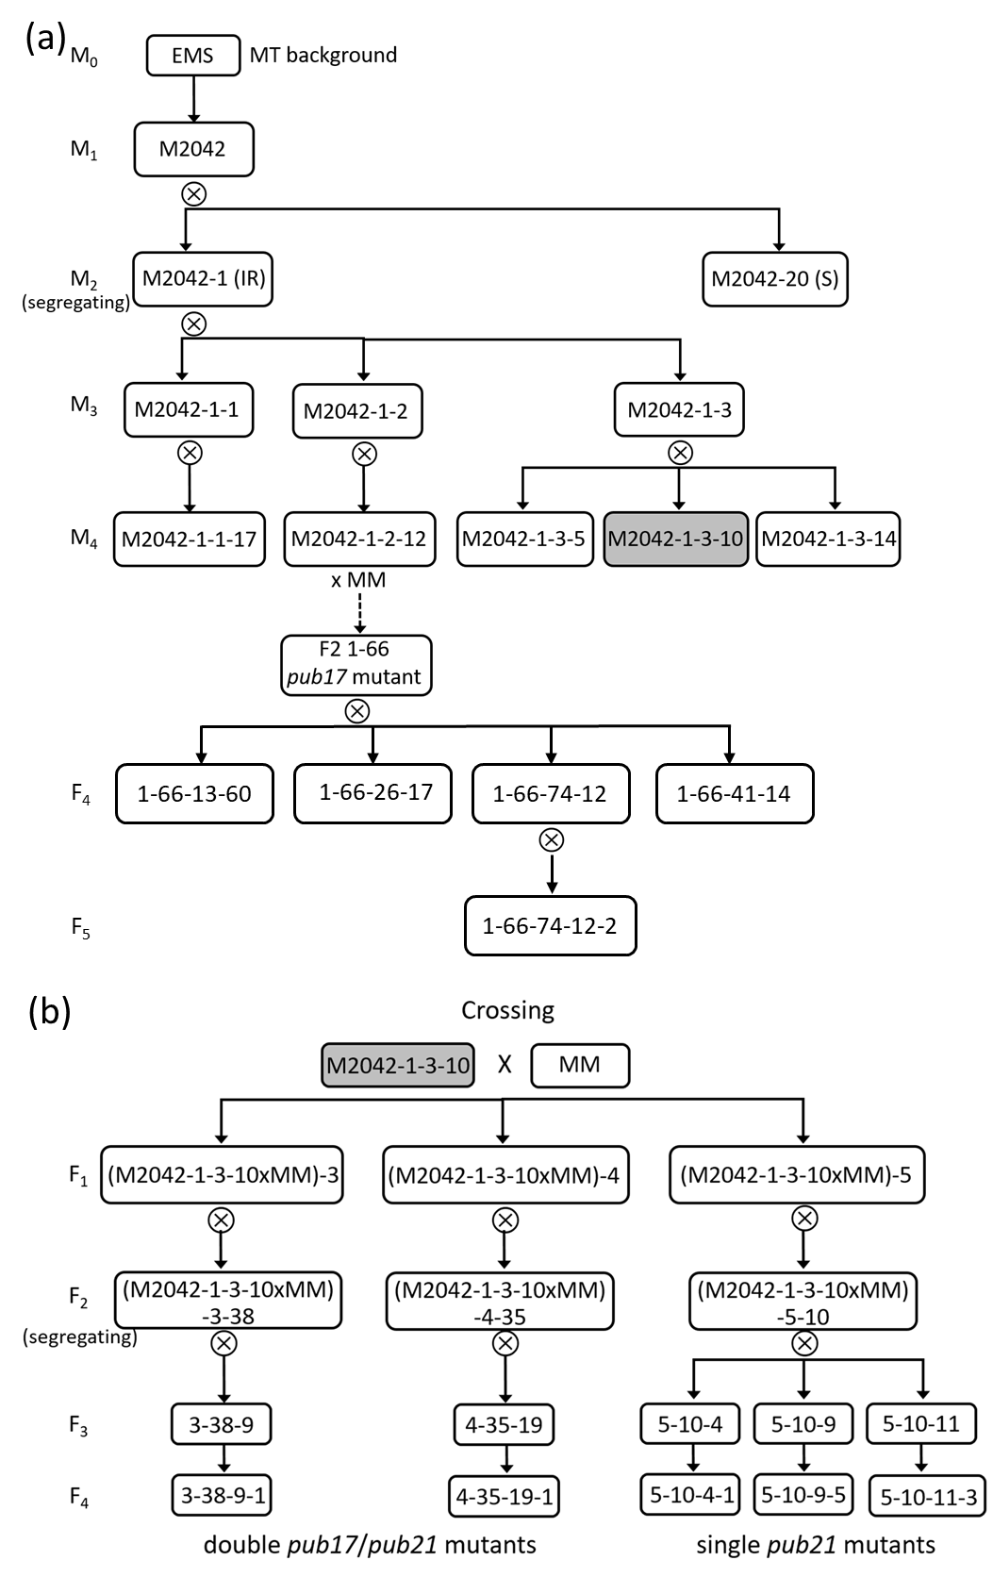
Fig. S1 Pedigree of M2042 mutant. (a) Selfing generations of M2042 in Micro-Tom (MT) background. (b) Crossing generations after crossing resistant M4 plant M2042-1-3-10 with Moneymaker (MM). IR, intermediate resistance; S, susceptible.
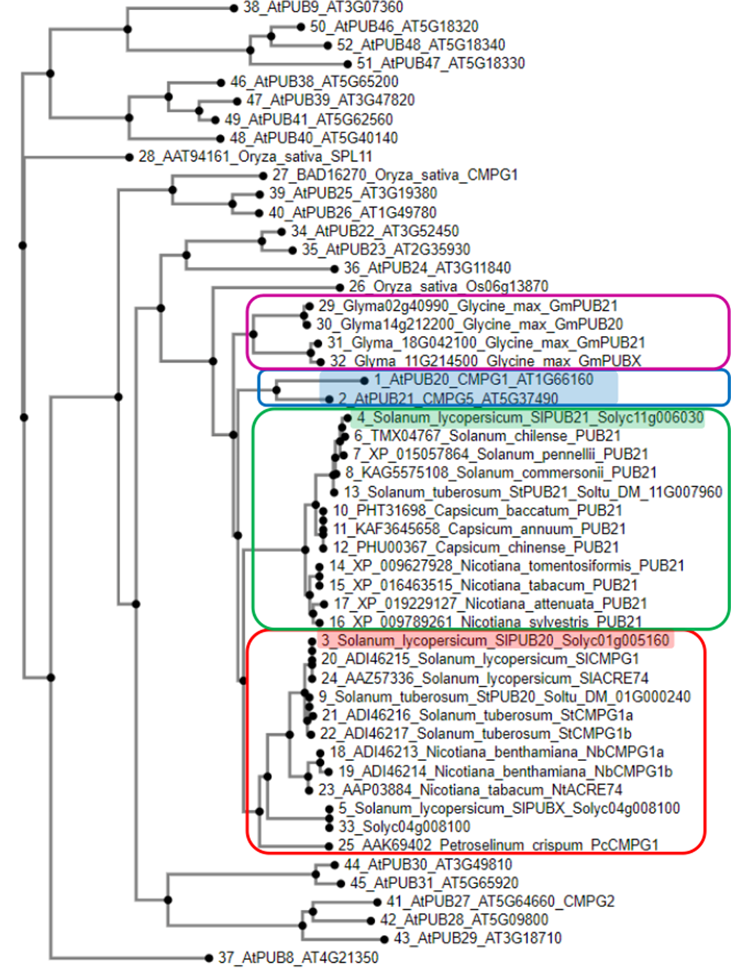
Fig. S2 Phylogenetic tree of PUB20, PUB21 and Arabidopsis clade IV PUB proteins with short ARM repeats. Arabidopsis PUB20- and PUB21 proteins are shaded in the blue box. The Solanaceous PUB21 proteins are clustered in the red box, while the PUB20 proteins are clustered in the red box. Soybean (Glycine max) PUB20/PUB21 orthologous protein are clustered in the purple box. Protein sequence alignment and phylogenetic tree construction were performed using MAFFT7.

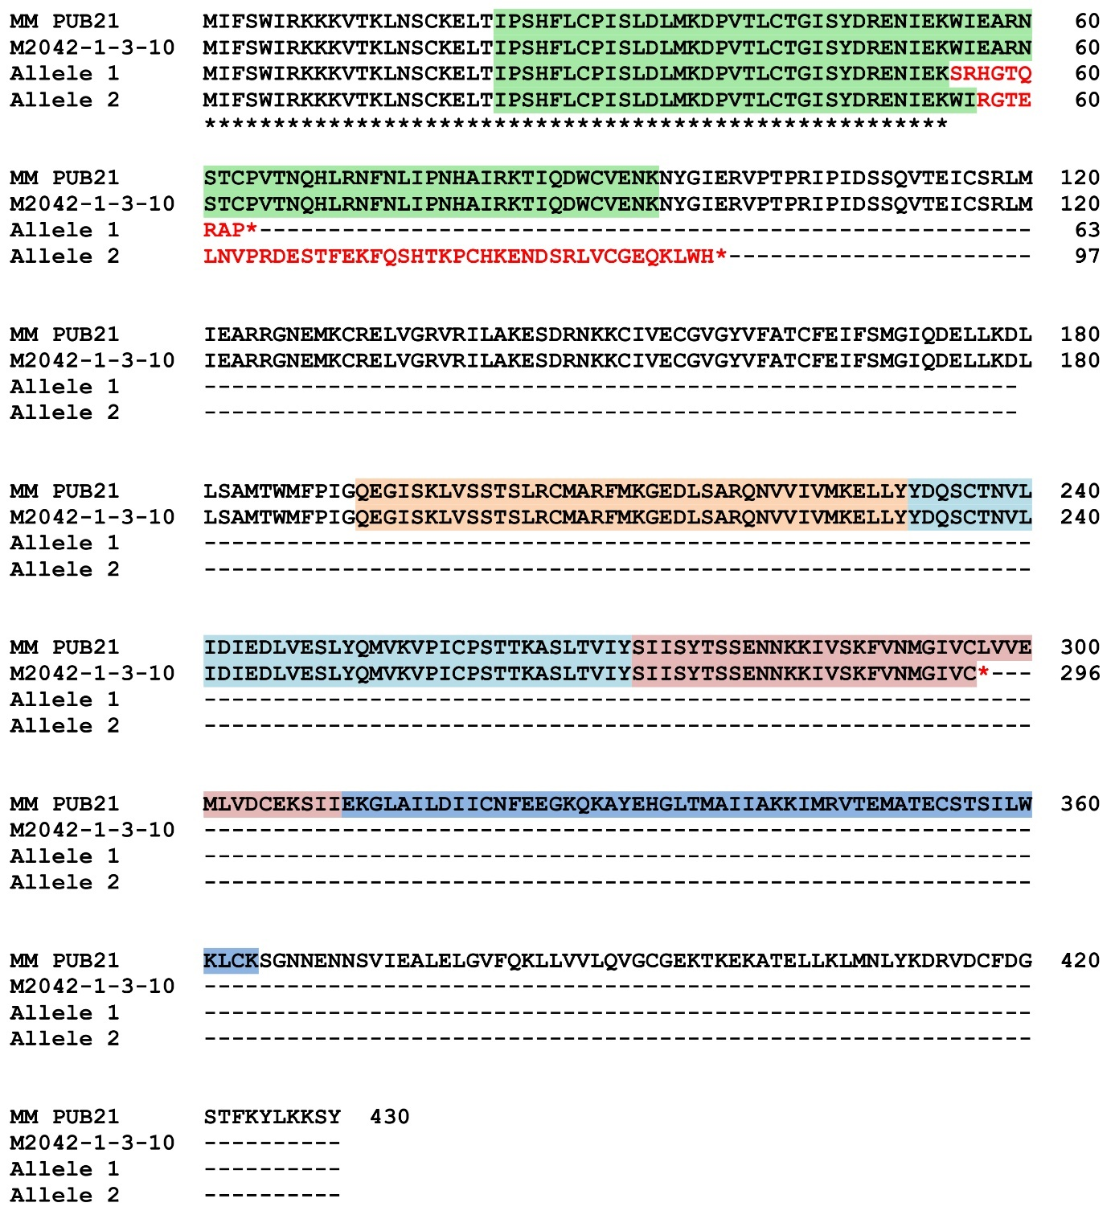
Fig. S3 Multiple protein sequence alignment of S. lycopersicum Moneymaker (MM) wild-type and mutant PUB21 alleles (EMS mutant M2042-1-3-10, and CRISPR alleles 1-2) using MAFFT7 multiple sequence alignment. Predicted coding sequence from each complete DNA sequence was translated to protein using the ExPASy translate tool (Gasteiger et al. 2003). The U-box domain is highlighted in green while the four ARM domains are highlighted in orange, light blue, pink and dark blue. Amino acids deviating from the wild-type protein are indicated with red letters.

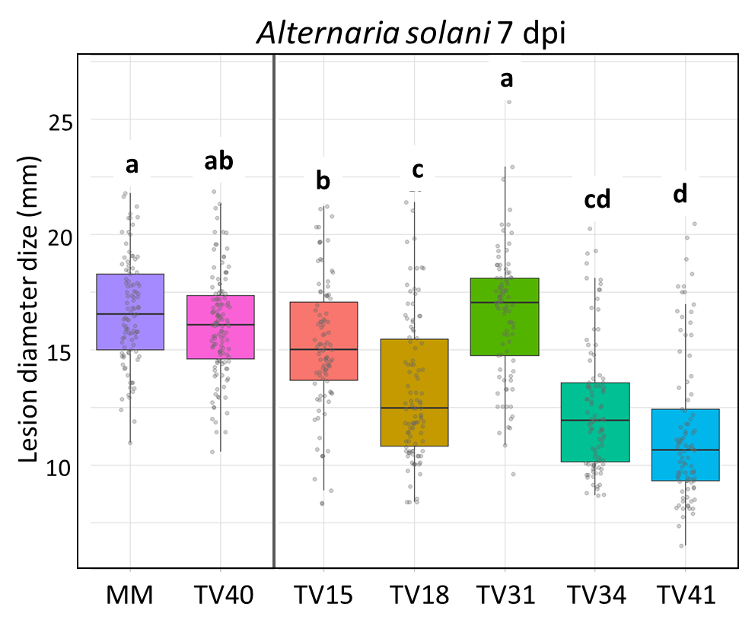
Fig. S4. Boxplot of Alternaria solani lesion diameters on leaves from PUB21 RNAi T3 families with the two negative controls (TV202240 and MM) on the left of each panel, results from 7 dpi.

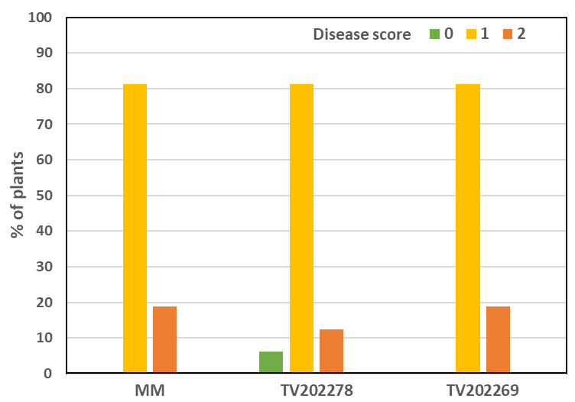
Fig. S5 Powdery mildew disease scoring of PUB21 CRISPR mutants. Plants from homozygous mutant TV202269, with susceptible controls Moneymaker and non-mutant T3 family TV202278 were inoculated with a spore solution of Pseudoidium neolycopersici isolate On. Disease was scored on a scale from 0 (no symptoms) to 2 (susceptible).

Supplementary table
Table S1. List of primers
Primer Name | Primer Sequence 5’→3’ | PCR product size | Used for
SP_F | TGAGACGGACAAGATGACATGA | 218 bp | Self-pruning (sp) SNP
SP_R | TGTCATTTCCCCTTCCAAAGT | 218 bp | Self-pruning (sp) SNP
C | GGAACTTGGTGTAGCAGAAATTTCCACATTTC | 243 bp | Dwarf (d) SNP Marti et al., 2006
D | TTAGTGAGCTGAAACTCTAATCCGTAGAC | 243 bp | Dwarf (d) SNP Marti et al., 2006
AWPUB21F | CATCAAGTGAAAATAACAAGAA | 248 bp | Confirmation PUB21 SNP
AWPUB21R | CAAAATTGAAGTTGAACATTC | 248 bp | Confirmation PUB21 SNP
PUB17_qPCR_Fw1 | GGAAGTGAAGGTGTTGCGA | 100 bp | PUB17 gene expression
PUB17_qPCR_Rv1 | CTACTGCCATTTCCTCATTGC | 100 bp | PUB17 gene expression
PUB21_qPCR_Fw | TGAAGAAGGGAAACAAAAGGCT | 100 bp | PUB21PUB21 gene expression
PUB21_qPCR_Rv | AGTTGAACATTCTGTGGCCA | 100 bp | PUB21PUB21 gene expression
Ef1a-Fw | ATTGGAAACGGATATGCCCCT | 101 bp | Reference gene expression
Ef1a-Rv | TCCTTACCTGAACGCCTGTCA | 101 bp | Reference gene expression
PUB21 RNAi1 FWD | caccATTGAAGCTCGACGAGGGAA | 195 bp | PUB21 RNAi fragment 1
PUB21 RNAi1 REV | CGTCATCGCCGATAACAAGT | 195 bp | PUB21 RNAi fragment 1
PUB21 RNAi10 FWD | caccCGGTGATATACTCTATTATCTC | 205 bp | PUB21 RNAi fragment 10
PUB21 RNAi10 REV | GTCAATCCATGTTCATAAGC | 205 bp | PUB21 RNAi fragment 10
PUB21 sgRNA1 | AAACATCGAGAAATGGATCG |  | PUB21 CRISPR guides
PUB21 sgRNA2 | AATCGATTCGTCTCAAGTAA |  | PUB21 CRISPR guides
PUB21 sgRNA3 | GATAGAGTGGATTGCTTTGA |  | PUB21 CRISPR guides
 | TGTGGTCTCA[sgRNAsequence]GTTTTAGAGCTAGAAATAGCAAG |  | Cloning CRISPR guides
 | TGTGGTCTCAAGCGTAATGCCAACTTTGTAC |  | Cloning CRISPR guides
FWD_MR_GY_CRISPR | TCCATCTCATTTTCTTTGTCCGA | 1358 bp | Identification CRISPR mutants
REV_AW_GY_CRISPR | TGCTGAGATCCTCCAAAACTATCA | 1358 bp | Identification CRISPR mutants
AWPUB21F2 | AATAAATTCACTTTTCCCATATA | 705 bp | Identification CRISPR mutants
AWPUB21R2 | GCCGATAACAAGTCCTTC | 705 bp | Identification CRISPR mutants
NPTII_421_Fw | GAAGGGACTGGCTGCTATTG | 421 bp | Confirmation transformants
NPTII_421_Rv | AATATCACGGGTAGCCAACG | 421 bp | Confirmation transformants
35S_597_Fw | TACAAAGGCGGCAACAAAC | 597 bp | Confirmation transformants
35S_597_Rv | AGCAAGCCTTGAATCGTCC | 597 bp | Confirmation transformants

