Supplementary Information

Self-Powered Liquid Metal Interfaces Enable Autonomous Electrochemical Sensing of Pipeline Microleaks in Extreme Environments
Xueke Wang^{1,2}, Guomin Ye^{1,2}, Xinyang Zhang^{1,2}, Yi Chen^{1,2}, Yingfei Hu^{1,2}, Qiang Wu^{1,2}, Yilan Yang^{1,2}, Hongyao Luo^{1,2}, Nailiang Yang^{3*,} Peng Yang^{1,2*}, Yanfen Wan^{1,2*}

¹Yunnan Key Laboratory for Micro/Nano Materials & Technology, Yunnan Key Laboratory of Electromagnetic Materials and Devices, National Center for International Research on Photoelectric and Energy Materials
²School of Materials and Energy, Yunnan University, Kunming 650091, P. R. China.
³State Key Laboratory of Biopharmaceutical Preparation and Delivery, Institute of Process Engineering, Chinese Academy of Sciences, P. R. China; University of Chinese Academy of Sciences, P. R. China

*E-mail: nlyang@ipe.ac.cn, pyang@ynu.edu.cn, yfwan@ynu.edu.cn
Contents
Supplementary Figures 3
Supplementary Figure S1. 3
Supplementary Figure S2. 3
Supplementary Figure S3. 3
Supplementary Figure S4. 4
Supplementary Figure S5. 4
Supplementary Figure S6. 4
Supplementary Figure S7. 5
Supplementary Figure S8. 5
Supplementary Figure S9. 6
Supplementary Table 7
Supplementary Table S1. 7
Supplementary Movie 8
Supplementary Movie S1. 8
Supplementary Movie S2. 8
Supplementary Movie S3. 8
Supplementary Movie S4. 8
Supplementary Movie S5. 8
References 8

Supplementary Figures
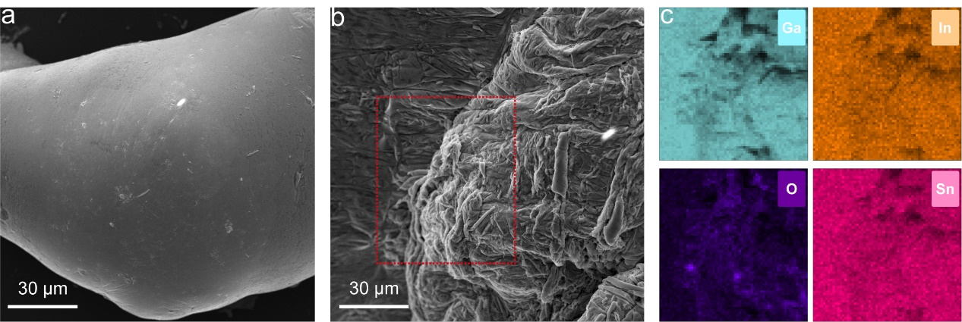
Supplementary Figure S1. SEM images of core metal (a) and oxide layers (b) and EDS mapping image of the liquid metal oxide layer (c).

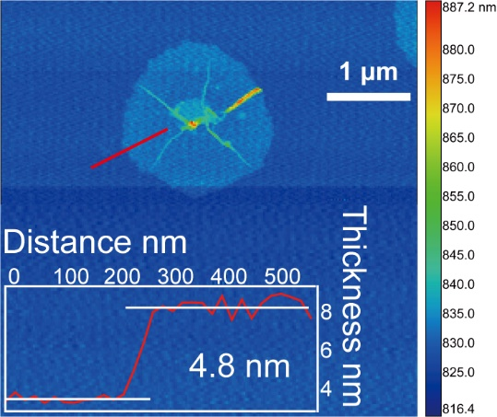
Supplementary Figure S2. The AFM images of the oxide layer and its thickness distribution are at the red line shown in the inset.

Supplementary Figure S3. The images of a single liquid metal bubble from generation to bursting captured by High-speed camera.

Supplementary Figure S4. Finite element simulation results of the entire process from generation to bursting of a single bubble.

Supplementary Figure S5. Simulated snapshots of bubble generation inside liquid metal at different gas flow velocities.

Supplementary Figure S6. The entire process of liquid metal breaking by bubble shear stress captured by a high-speed camera.

Supplementary Figure S7. Voltage response over a wide range of flow velocities. As the gas flow velocity increases, the amplitude of the voltage signal shows a significant decrease, while the frequency of voltage signal shows a significant increase.

Supplementary Figure S8. Larger voltage differences induce longer oxidation times (a) and the correspondence between different voltage differences and time differences (b). (c) Open-circuit voltage of liquid metal bubble generators in electrolyte liquids with different dissolved oxygen levels. Air-saturated-electrolyte liquid and nitrogen-saturated-electrolyte liquids were achieved by ventilating a glass vial with air and nitrogen, respectively, for 5 minutes prior to use.

Supplementary Figure S9. Sensitivity results between frequency of electrical signal and flow velocity.

Supplementary Table
Supplementary Table S1. Comparison of the detection resolution and sensitivity of LMBG with other advanced works.
Detection principle | Material | Resolution (cm³) | Sensitivity (V·cm⁻³) | References
Triboelectric | Cu electrode, PTFE | 0.5 | / | ^{[1]}
Triboelectric | Al electrode, PTFE | 0.35 | / | ^{[2]}
Triboelectric | Cu electrode, PTFE | 0.3 | 13.2 | ^{[3]}
Triboelectric | Cu electrodes, Polyamide 12 | 0.25 | / | ^{[4]}
Triboelectric | Conductive cloth tape, Ethylene Propylene | 0.11 | / | ^{[5]}
Capacitive | Cu electrodes, ESP32 Microcontroller | 0.035 | / | ^{[6]}
Optical | Optical sensor | 0.025 | / | ^{[7]}
Strain sensor | Thermoplastic polyurethane/carbon nanotubes/graphene nanosheets flexible sensor | 0.01 | / | ^{[8]}
Conductivity | Cu electrode | 0.001 | / | ^{[9]}
Capacitive | Printed circuit board | 0.00034 | 23.5 | ^{[10]}
Capacitive | Printed circuit board | 0.0001 | 23.5 | ^{[11]}
Electrochemical cell | Liquid metal | 0.001 | 319.9 | This work

Supplementary Movie
Supplementary Movie S1. Single liquid metal bubble bursting captured by high-speed camera.
Supplementary Movie S2. Generation of LMB at different pipe diameters captured by high-speed camera and corresponding finite element simulation results.
Supplementary Movie S3. Generation of LMB at different flow velocities captured by high-speed camera and corresponding finite element simulation results.
Supplementary Movie S4. Experiments and simulations of bubble generation under different surface tensions.
Supplementary Movie S5. Open-circuit voltage output of bubble generator due to bubble bursting by syringe pump gas injection.

References
1. Zhang X, Dong Y, Xu X, Qin H, Wang D. A new strategy for tube leakage and blockage detection using bubble motion-based solid-liquid triboelectric sensor. Science China Technological Sciences 65, 282-292 (2022).
2. Li C, Liu X, Yang D, Liu Z. Triboelectric nanogenerator based on a moving bubble in liquid for mechanical energy harvesting and water level monitoring. Nano Energy 95, 106998 (2022).
3. Luo B, et al. Liquid–Solid Triboelectric Probes for Bubbles Status Monitoring. Adv. Funct. Mater. 34, 2315725 (2024).
4. Wang X, et al. Liquid-solid triboelectric nanogenerator for bubbles real-time detecting. Chemical Engineering Journal 506, 160049 (2025).
5. Dong K, et al. Tiny bubble triboelectric nanogenerator functionalized by liquid film rupture. Nano Energy 131, 110256 (2024).
6. Kok CL, Dai Y, Lee TK, Koh YY, Teo TH, Chai JP. A Novel Low-Cost Capacitance Sensor Solution for Real-Time Bubble Monitoring in Medical Infusion Devices. Electronics 13, 1111 (2024).
7. Delwiche K, Senft-Grupp S, Hemond H. A novel optical sensor designed to measure methane bubble sizes in situ. Limnol. Oceanogr. Methods. 13, 712-721 (2015).
8. Zhou W, et al. Bioinspired Ultrasensitive Flexible Strain Sensors for Real-Time Wireless Detection of Liquid Leakage. Nano-Micro Letters 17, 68 (2024).
9. Wu C, Wen G, Han L, Wu X. Research on the Conductivity-Based Detection Principles of Bubbles in Two-Phase Flows and the Design of a Bubble Sensor for CBM Wells. Sensors 16, 1520 (2016).
10. Quoc TV, Quoc TP, Duc TC, Bui TT, Kikuchi K, Aoyagi M. Capacitive sensor based on PCB technology for air bubble inside fluidic flow detection. Sensors, 2014 IEEE, Valencia, Spain, pp. 237-240 (2014).
11. Vu Quoc T, Nguyen Dac H, Pham Quoc T, Nguyen Dinh D, Chu Duc T. A printed circuit board capacitive sensor for air bubble inside fluidic flow detection. Microsystem Technologies 21, 911-918 (2015).

