In vivo quantitative assessment of therapeutic response to bortezomib therapy in disseminated animal models of multiple myeloma with ¹⁸F-FDG and ⁶⁴Cu-LLP2A PET
Anchal Ghai¹, Nikki Fettig¹, Francesca Fontana², John DiPersio³, Mike Rettig³, Julie O Neal³, Samuel Achilefu^{1, 4, 5}, Kooresh Shoghi¹, Monica Shokeen^{1, 4*}
¹Department of Radiology, Washington University School of Medicine, St. Louis, MO
²Department of Internal Medicine, Washington University School of Medicine, St. Louis, MO
³Department of Medicine, Washington University School of Medicine, St Louis, MO
⁴Department of Biomedical Engineering, Washington University in St. Louis, St. Louis, MO
⁵Department of Biochemistry and Molecular Biophysics, Washington University School of Medicine, St. Louis, MO
*Corresponding author: Monica Shokeen, Department of Radiology, Mallinckrodt Institute of Radiology, 4515 McKinley Avenue, 2nd floor, St Louis, MO 63110. Email: shokeenm@wustl.edu

Methods:
Quality control of ⁶⁴Cu-LLP2A
VLA4 targeted peptide, LLP2A-CB-TE1A1P (LLP2A) was radiolabeled with copper 64 (⁶⁴Cu). Ammonium acetate (0.1M; pH 5.5) was used as the radiolabeling buffer. LLP2A precursor (2.5 µg; 1.61 nmol) was incubated with ⁶⁴Cu-chloride (74 MBq) for 30-40 min at 70°C with slight shaking. The radiolabeling efficiency was determined by high performance liquid chromatography (HPLC) using XB-C18 Kinetex column (Fig S1). 0.1%TFA in water and 0.1% TFA in acetonitrile were used as aqueous and organic mobile phase solvents.
Survival study
NOD SCID Gamma (NSG) mice were injected with MM.1S-CG and U266-CG human myeloma cell lines via tail vein. The tumor burden in these mice was evaluated weekly by BLI. The tumor bearing mice were divided into two cohorts where, one group was treated with bortezomib (1mg/kg; intraperitoneal injections) twice a week and the mice from second group did not receive any treatment. MM.1S-CG and U266-CG systemic tumors bearing mice were imaged longitudinally with ¹⁸F-FDG and ⁶⁴Cu-LLP2A. These mice were observed daily for any weight loss or paralysis and were evaluated for therapy response and survival. Mice were euthanized with the onset of morbidity/paralysis as per institutional guidelines. Survival was assessed until week 5 post inoculation of tumors (Fig S2).

Supplemental figures:

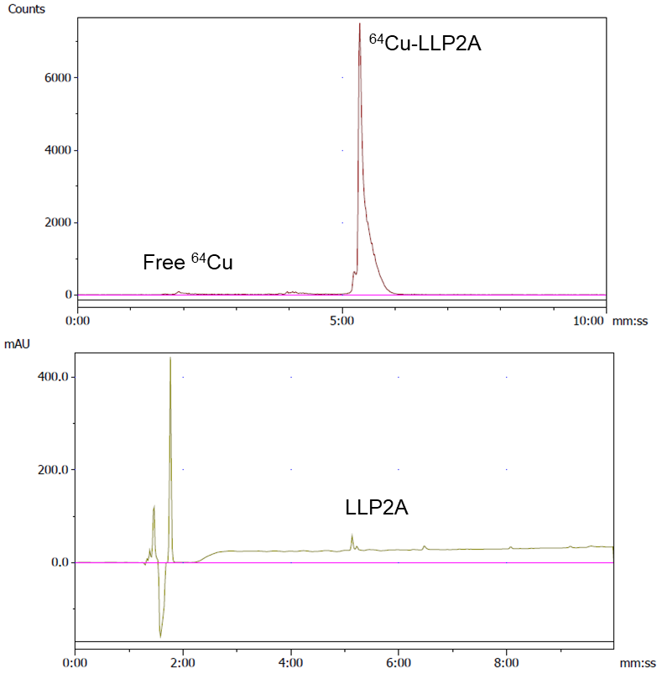
(a)
(b)
Fig S1 (a) Radio-HPLC chromatogram of ⁶⁴Cu-LLP2A showing > 99% of radiolabeled product at the retention time of 5.6 min. (b) UV-visible spectrum showing the LLP2A peak at the same retention time as that of radiolabeled LLP2A

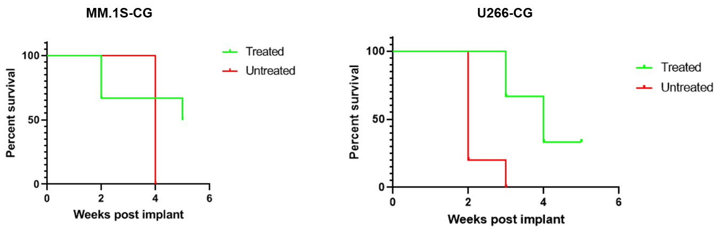
Fig S2 Kaplan-Meier survival plots of MM.1S-CG and U266-CG disseminated tumors bearing mice (treated; n=6 and untreated; n=6)

