Journal: BMC Pulmonary Medicine

Title: Fluoroquinolone resistance and mutational profile of gyrA in pulmonary MDR tuberculosis patients
Authors: Saba Kabir¹, Zarfishan Tahir², Nadia Mukhtar³, Muhammad Sohail¹, Muhammad Saqalein⁴, Abdul Rehman¹*
Supplementary data (Figure)

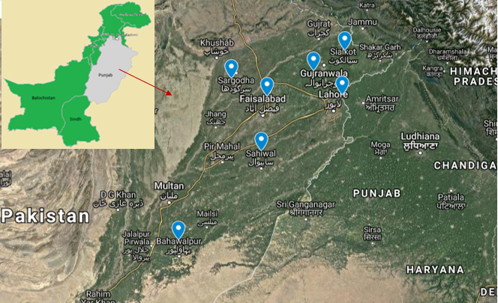
Figure S1: Samples were collected from sites involved in programmatic management of drug resistant tuberculosis (PMDT) within seven different districts (Lahore, Faisalabad, Gujranwala, Sahiwal, Sargodha, Sialkot, and Bahawalpur) from period of May 2018 to March 2019.

