Automated Analysis of Emotional Expressions in Dogs based on AI-Enhanced Geometric Morphometrics

George Martvel^{1,@} and Stefanie Riemer²
¹ Tech4Animals Lab, University of Haifa, Abba Khoushy Ave 199, 3498838 Haifa, Israel
² Messerli Research Institute, University of Veterinary Medicine, Vienna, Veterinärplatz 1, 1210 Vienna, Austria
@ martvelge@gmail.com

Supplementary Information

Supplementary Table 1. Demographic information about the subjects, whether they were included in the analysis (sufficient frames with facial landmarks detected), and the ear shape of included dogs.
Breed | Age (years) | Sex | Neuter status | Included in analysis | Ear shape
Mixed breed | 3.92 | Female | Neutered | Yes | rose ears
Mixed breed | 6.42 | Male | Neutered | Yes | rose ears
Shiba Inu | 3.46 | Female | Intact | Yes | pointy, upright
Mixed breed | 4.34 | Male | Neutered | Yes | floppy
Chinese Crested Powderpuff | 3.44 | Female | Neutered | Yes | pointy, mostly upright
Mixed breed | 9.33 | Male | Neutered | Yes | rose ears
Chihuahua | 6.63 | Male | Neutered | Yes | pointy, upright
Australian Shepherd | 3.67 | Male | Chemical castration | Yes | cocked
German Shepherd | 7.45 | Male | Neutered | Yes | pointy, upright
Coton de Tuléar | 8.88 | Female | Neutered | Yes | button ears
Chihuahua | 4.81 | Female | Neutered | Yes | pointy, upright
Mixed breed | 2.67 | Female | Neutered | Yes | floppy
Border Collie | 6.32 | Male | Intact | No
Labrador Retriever | 6.63 | Female | Intact | No
Mixed breed | 8.59 | Female | Neutered | No
German Shepherd | 2.54 | Male | Neutered | No
Mixed breed | 4.11 | Female | Neutered | No
Mixed breed | 8.99 | Male | Neutered | No
German Shepherd | unknown | Male | Intact | No
Small Münsterländer | 9.92 | Male | Intact | No
Flat-coated Retriever | 10.94 | Male | Intact | No
Mini Australian Shepherd | 0.66 | Female | Intact | No
French Bulldog | 0.43 | Female | Intact | No
Swiss Mountain Dog | 9.75 | Male | Neutered | No
Mixed breed | 3.27 | Male | Neutered | No
Mixed breed | 9.42 | Male | Neutered | No
Yorkshire Terrier | 1.11 | Male | Neutered | No
Mixed breed | 6.69 | Male | Neutered | No
Golden Retriever | 0.74 | Female | Intact | No
Mixed breed | 1.9 | Female | Neutered | No
Mixed breed | 6.67 | Male | Neutered | No
German Pinscher | 8.45 | Female | Neutered | No
Mixed breed | 10.64 | Male | Intact | No
Mixed breed | 3.58 | Female | Neutered | No
French Bulldog | 0.43 | Female | Intact | No
Golden Retriever | 3.61 | Male | Chemical castration | No
Mixed breed | unknown | Female | Neutered | No
Mixed breed | 12.6 | Female | Neutered | No
Magyar Vizsla | 9 | Female | Neutered | No
Border Collie | 4.91 | Male | Intact | No
Giant Schnauzer | 9.24 | Female | Neutered | No
Mixed breed | 0.87 | Female | Neutered | No

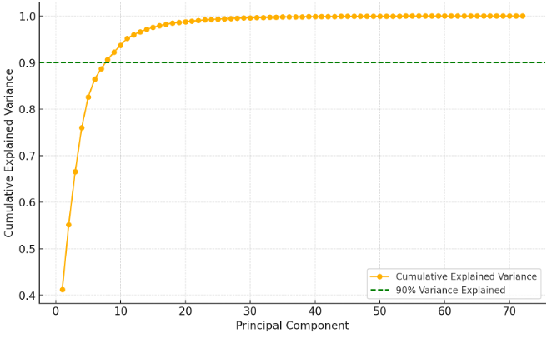
Supplementary Figure 1. Cumulative variance explained by the principal components (cutoff point: 90% of variance).

Supplementary Table 2. Results of ANOVA testing for differences of the first eight principal component scores (accounting for 90% variance) between the firework condition and the control condition. Significant results are bolded.

PC | F | Num DF | p
PC1 | 1.603 | 1 | 0.234
PC2 | 0.251 | 1 | 0.627
PC3 | 0.002 | 1 | 0.960
PC4 | 0.923 | 1 | 0.359
PC5 | 13.574 | 1 | 0.004
PC6 | 0.104 | 1 | 0.753
PC7 | 1.199 | 1 | 0.299
PC8 | 0.535 | 1 | 0.481

