Supplementary materials
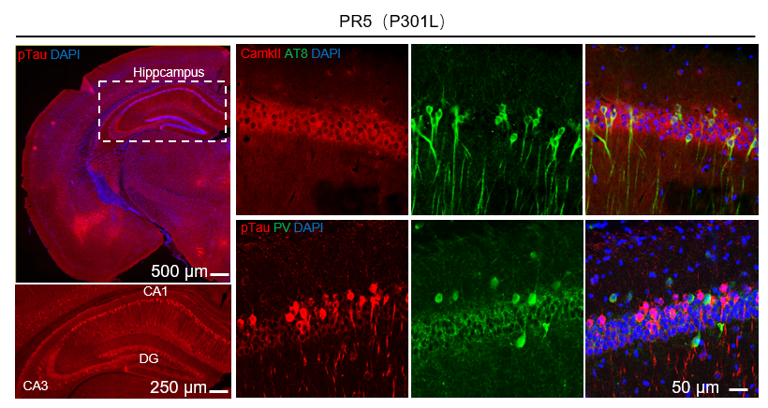
Figure S1. pTau accumulation in hippocampal excitatory neurons of PR5 (P301L) Tg mice. 7-month-old PR5 Tg mice exhibited hippocampal-predominant phosphorylated tau (pTau) aggregated (detected by pT205-tau antibodies), particularly in the CA1 pyramidal cell layer and DG granule cell layer.pTau aggregates localized mainly to CamkII-positive excitatory neurons, almost no colocalization observed in PV- positive inhibitory neurons.

Figure S2. Aged 16-month - old Tg hTau368 mice treated with Dox for 2 months had a shorter latency of generalized seizures (GS) induced by optogenetics.
(A) In the Veh group, one mouse required 327 s of optogenetic seizure induction to reach GS. 16 s after the seizure, the mouse resumed normal free movement.
(B) In the Dox group, one mouse needed only 45 s of optogenetic seizure induction to reach GS. 27s after the seizure, the mouse returned to normal free - moving behavior.

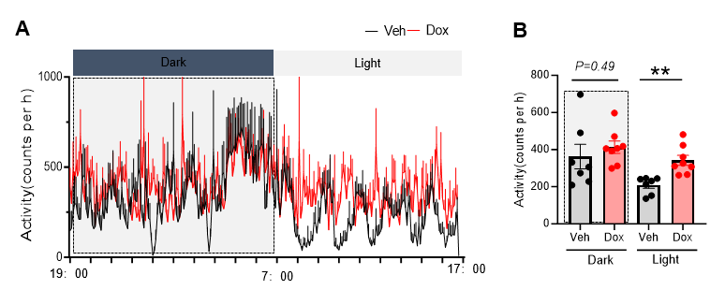
Figure S3. Increased locomotor activity in aged Tg Tau-driven mice.
(A) The number of movements every 5 min at different times within 24 h of aged Tg hTau368 mice treated with Veh/Dox for 2 months, and (B) quantitative statistics of mean movements during night (Dark, 19:00-7:00) and day (Light, 7:00-19:00). Unpaired Student’s t - test was used, with **P < 0.01. 16-month - old homozygous mice, 7 - 8 mice per group. Data were presented as Mean±SEM.

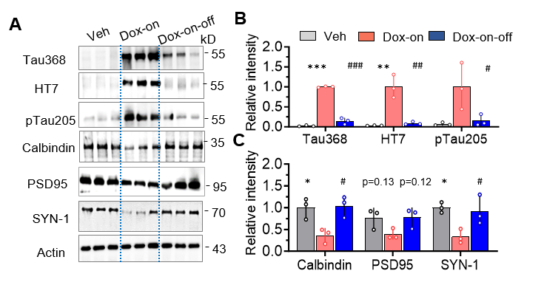
Figure S4. A correlated hippocampal tau aggregation with reduced CB and synapse - related proteins.
- Representative Western blotting images of hippocampal tissue, and (B - C) Quantitative statistics. In Tg hTau368 mice treated with Dox for 2 months (Dox on), hTau368 and pTau aggregation occurred in the hippocampus, and the levels of CB and synapse - related proteins were reduced. However, after withdrawing Dox for 3 months (Dox - on - off), the clearance of hTau368 and pTau was accompanied by the recovery of the expression of CB and synapse - related proteins. One - way analysis of variance was performed, followed by Post hoc Tukey’s multiple comparison test. *P < 0.05, **P < 0.01, ***P < 0.001 vs Veh group, #P < 0.05, ##P < 0.01, ###P < 0.001 vs Dox - on group. 7- month - old homozygous hTau368 transgenic mice, 3 mice per group. Data are presented as Mean±SEM.

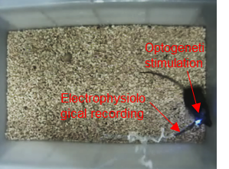
Supplementary Video 1. Optogenetic seizures induction and in vivo electrophysiological recording. This video demonstrated the novel process of optogenetically inducing epileptic seizures in aged mice and synchronously recording brain electrophysiological signals in vivo created by our lab. At the 4s of the video, we turned on the blue light to activate the hippocampus and induce epileptic seizures. At 4 min and 12 s of the video, the mouse began to exhibit grade 4-5 generalized seizures, and the latency period was recorded as 252 s. After continuing the light stimulation for another 15 s, we turned off the blue light and recorded the highest seizure stage. Then, the mouse gradually returned to normal free movement.

