Intracellular responses of glial cells to monomeric tau protein are closely mediated by heparan sulfate proteoglycans (HSPGs)
Liqing Song^{1,a}, Daniel E. Oseid^{2, a}, Evan A. Wells¹, Troy Coaston², Anne S. Robinson^{1,2}
1. Department of Chemical Engineering, Carnegie Mellon University, Pittsburgh, PA, 15213, USA
2. Tulane Brain Institute, Tulane University, New Orleans LA, 70118, USA
a. These authors contributed equally to this work.
*corresponding author: Anne S. Robinson, asrobins@andrew.cmu.edu; https://orcid.org/0000-0001-7235-1481

Supplementary Materials
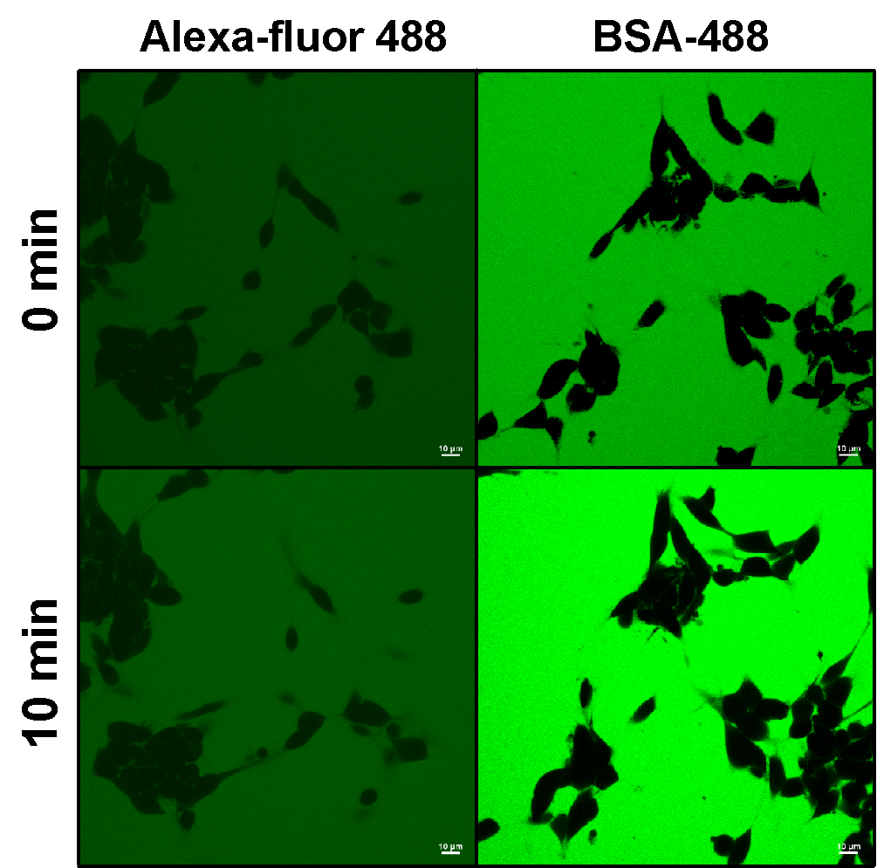
Fig.S1 No internalization of label or BSA occurs over short imaging periods. Although some fluctuations in intensity were observed, free Alexa fluor 488 and labeled BSA remain excluded from SH-SY5Y cells over a ten-minute imaging period.
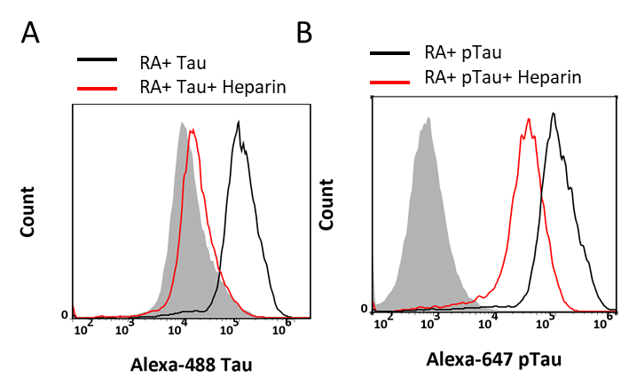
Fig.S2 Quantification of different tau isoforms uptake by primary astrocytes. The propensity of Alexa Fluor-488-labeled monomeric 0N4R tau uptake and Alexa Fluor-647-labeled ptau were quantified in primary astrocytes by flow cytometry. Grey filled line: negative control; Black line: cells without heparin; red line: cells with heparin incubation.
Supplemental Table S1. List of primers for sequencing, sgRNAs and RT-qPCR
Name | Forward Primer 5’ to 3’ (F) | Reverse Primer 5’ to 3’ (R)
Exon7 sgRNA | CACCGAATGTCTATGACGAACCAGA | AAACTCTGGTTCGTCATAGACATTC
Exon7 Sequencing | ACAGGTCATGGAGTCCCAGGGC | GCATCTTGCTCTGCCTGGGACC
Xylt1 | GACACTGGAGACATGGATGATG | GTCAGTGCCAACCTCAGAAA
LRP1 | GGCGTGGTGTTCTGGTATAA | GTAGGTAGGGTTTCCGATTTCC
Il-6 | GAAGTTAGAGTCACAGAAGGAGTG | GTTTGCCGAGTAGACCTCATAG
TNF-α | ACCTTATCTACTCCCAGGTTCT | GGCTGACTTTCTCCTGGTATG
Il-1β | CTATGGCAACTGTCCCTGAA | GGCTTGGAAGCAATCCTTAATC
β-actin | ACAGGATGCAGAAGGAGATTAC | ACAGTGAGGCCAGGATAGA

