Supplementary Information for

Simultaneous Enhancement of Photocatalytic CH₄ Conversion and H₂O₂ Production through Water Confinement in Nanoporous Core-Shell Catalysts
Fanxun Lv¹, Xiaoyan Wu¹, Xuan Wang¹, Yi Yu^{1,2}, Chenlu Xie^{1,2*}
¹ School of Physical Science and Technology, ShanghaiTech University, Shanghai, 201210, China
² Shanghai Key Laboratory of High-Resolution Electron Microscopy, ShanghaiTech University, Shanghai, 201210, China
*Corresponding author: xiechl@shanghaitech.edu.cn

Supplementary Materials and Methods
Materials
All reagents were commercially obtained without purification. Titanium dioxide (P25), gold (III) chloride trihydrate, chloroplatinic acid, palladium chloride were purchased from Sigma Aldrich. Silver nitrate was purchased from Alfa Aeaser. Dodecyltrimethylammonium bromide (C₁₂TAB), cetyltrimethylammonium bromide (C₁₆TAB), tetraethyl silicate (TEOS), methanol, formaldehyde, acetic acid, ammonium acetate, deuterium water, H₂¹⁸O, coumarin, 7-hydroxycoumarin, potassium titanium oxalate, hydrogen peroxide (30 %), acetylacetone, benzoic acid, hydroxybenzoic acid, 5,5-dimethyl-1-pyrrolidinium N-oxide (DMPO) was purchased from Aladdin. Ammonia (ammonium hydroxide) (25-28%), formic acid, dimethyl sulfoxide, concentrated sulfuric acid (98%), hydrochloric acid (37%), nitric acid (65.0-68.0%) were purchased from Sinopharm Chemical Reagent Co., Ltd., China.
Preparation of TiO₂@pSiO₂ and TiO₂@pSiO₂-Au
The synthesis procedure for TiO₂@pSiO₂ was same as the synthesis of M/TiO₂@pSiO₂ except using TiO₂ as the starting materials. The synthesis procedure for TiO₂@pSiO₂-Au was same as the synthesis of Au/TiO₂, except using TiO₂@pSiO₂ as supporting materials.
HCHO quantification
The amount of HCHO was quantified using the acetylacetone color-development method¹⁻³. Typically, 0.5 mL of the sample liquor, 2 mL of deionized water and 0.5 mL of reagent solution (consisting of 15 g of ammonium acetate, 0.3 mL of acetic acid, and 0.2 mL of acetylacetone dissolved in 100 mL H₂O) were mixed and placed in a water bath at 35 ℃ for 40 minutes. The absorption value of the mixture at 412 nm was then measured using UV-visible absorption spectroscopy (PerkinElmer, Lambda 265).
H₂O₂ quantification
The concentration of produced H₂O₂ was determined using the titanium oxalate spectrophotometric method³. To prepare the test solution, 0.636 g of potassium titanium oxalate and 0.02 mL of concentrated sulfuric acid were dissolved in 99.98 mL of DI H₂O. Then, 1 mL of the above test solution was mixed with 1 mL of the reaction sample. The absorption of the mixture was measured at 390 nm using UV-visible absorption spectroscopy (PerkinElmer, Lambda 265).
CH₄ conversion rates and oxygenates selectivity calculation
The methane conversion and oxygenates selectivity in this process are calculated according to the following equations:
$$Conversion \left(CH_{4}\right)=\frac{{mol}_{total formed products}}{{mol}_{initial methane}} ×100\%$$
$$Oxygenates selectivity= \frac{{mol}_{produced CH_{3}OH, CH_{3}OOH, HCHO and HCOOH}}{{mol}_{ total formed products}}×100\%$$
The initial methane amount in the system is calculated according to the following equation (V is the volume of the headspace of the reactor):
$$Initial methane \left(mol\right)= \frac{P_{methane}×V }{R×T (298K)}$$
The apparent quantum yield (AQY) of CH₄ conversion was calculated according to the following equation:
$$AQY= \frac{N\left(electrons\right)}{N(photons)}×100\%$$
where N(electrons) and N(photons) represent the number of reacted electrons and the number of incident photons, respectively. N(photons) = IAt/E, where I, A, t and E represent incident light 𝜆 intensity (W/cm²), irradiation area (cm²), light incident time (s) and photo energy (J), respectively. For the calculation of N(electrons), we use the approach following the reported work^{4,5}: N(electrons) = N(electrons) = n(CH₃OOH) + 3n(CH₃OH) + 5n(HCHO) + 7n(HCOOH) + 9n(CO₂), where n(CH₃OOH), n(CH₃OH), n(HCHO), n(HCOOH) and n(CO₂) represent the mole numbers of produced CH₃OOH, CH₃OH, HCHO, HCOOH and CO₂, respectively.
Catalyst cycling test
To study the reusability of the catalyst, the solid catalyst was separated by centrifugation after each reaction run. The catalysts were re-used in the next run after drying at 90 °C overnight under vacuum and annealed at 300 ºC in air to remove any adsorbed organic species.
Active species scavenging experiments
The experiments were conducted by adding different types of radical scavengers was used to understand the role of radical species involved in the photocatalytic CH₄ oxidation. Tetra-methylpiperidine N-oxide (TEMPO) as scavenger for all radicals, and ammonium oxalate (NH₄)₂C₂O₄), sodium iodate (NaIO₃), salicylic acid (HOC₆H₄COOH) as scavengers for photogenerated holes, photogenerated electrons, hydroxyl radicals, respectively⁶.
In a typical experiment, 10 mg photocatalyst was dispersed in 100 mL distilled water containing 1 mmol radical scavengers. After finely sealed, the suspension was purged with ultrapure Ar (99.999%) for 20 min to completely remove air. Then O₂ (99.999%) and CH₄ (99.999 %) were injected to acquire the desired pressure. The reaction was conducted for 10 mins. Products including CH₃OH, CH₃OOH, HCHO, HCOOH and CO₂ were measured according to the method shown above.

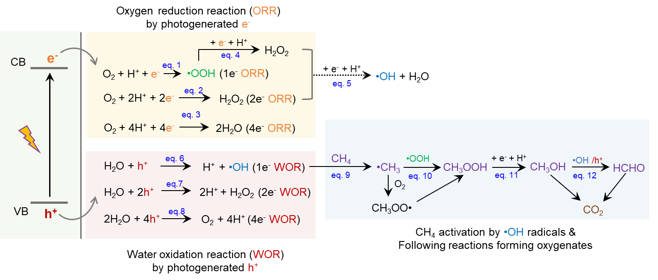
Supplementary Scheme 1. Schematic illustration of the complex electron and proton transfer steps in the photocatalytic CH₄ oxidation process. This process generates various reactive oxygen species (ROS) including •OH, •OOH and H₂O₂.
Note: In our system of Au/TiO₂@pSiO₂, the ROS generation process involves a 2e⁻ ORR and a 1e⁻ WOR, resulting in the formation of •OH radicals and H₂O₂.

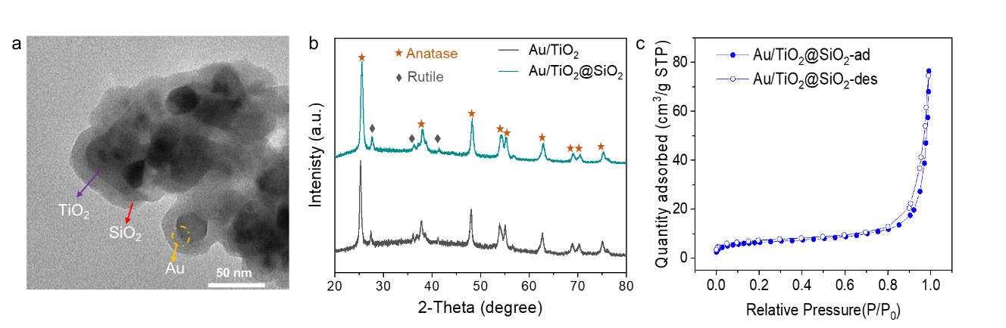
Supplementary Fig. 1. Structure characterization of Au/TiO₂@SiO₂. a, TEM image of Au/TiO₂@SiO₂. b, XRD pattern of as-synthesized Au/TiO₂@SiO_{2.} c, N₂ adsorption isotherm of Au/TiO₂@SiO₂. The surface area of Au/TiO₂@SiO₂ measured by Brunauer–Emmett–Teller (BET) method is 20.74 m²/g.

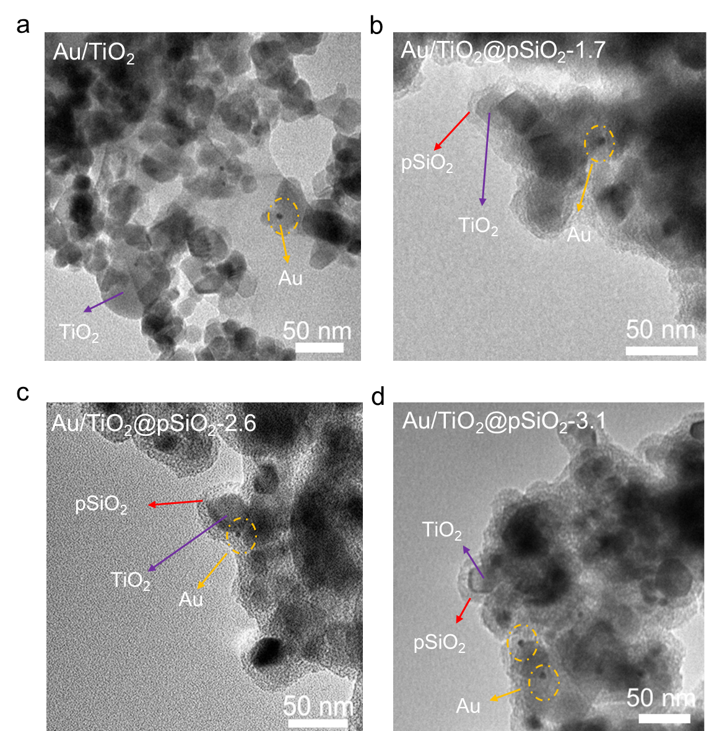
Supplementary Fig. 2. TEM characterization of photocatalysts. a, TEM image of Au/TiO₂. b, TEM image of Au/TiO₂@pSiO₂-1.7. c, TEM image of Au/TiO₂@pSiO₂-2.6. d, TEM image of Au/TiO₂@pSiO₂-3.1.

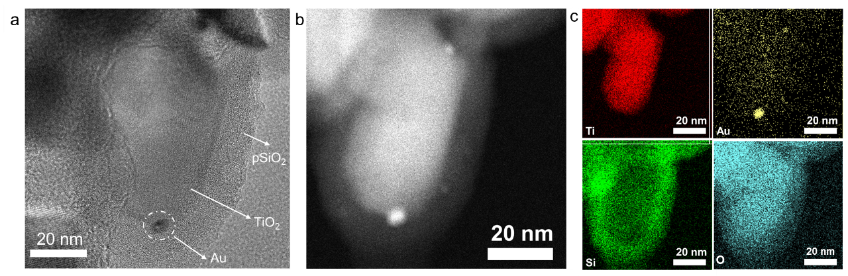
Supplementary Fig. 3. TEM characterization of Au/TiO₂@pSiO₂-1.7 nm. a, HR-TEM image of Au/TiO₂@pSiO₂-1.7. b, HAADF-STEM image. c, EDS elemental maps.

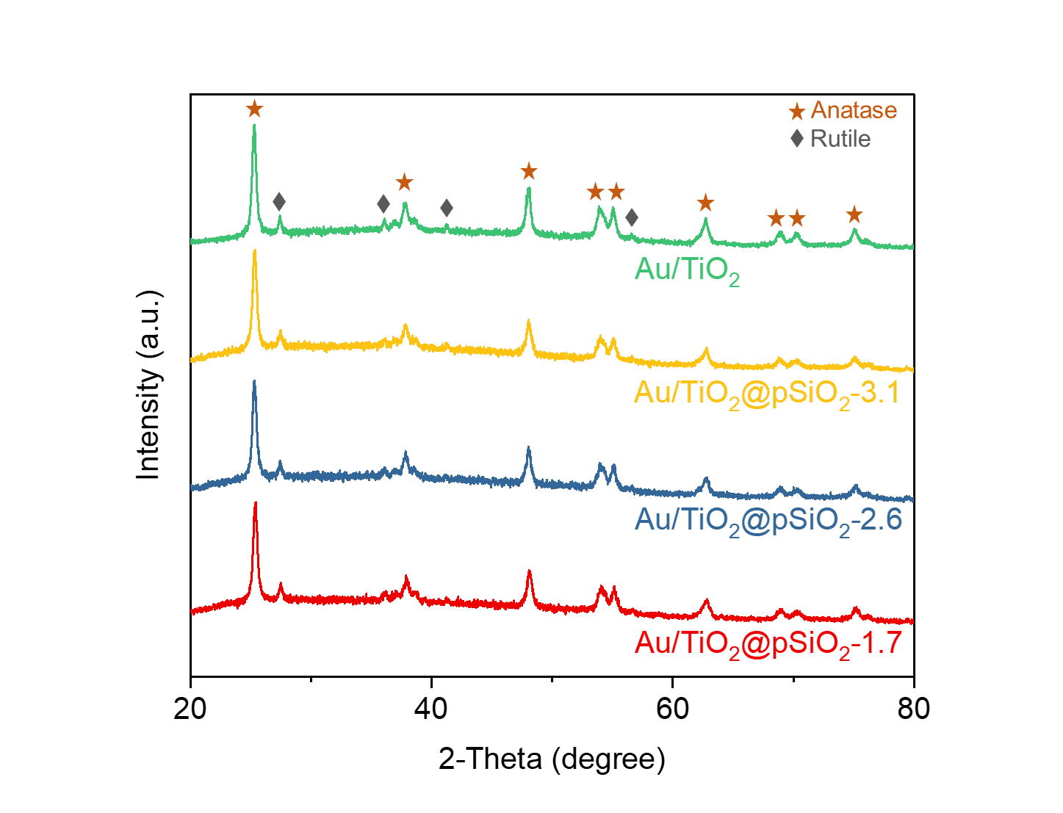
Supplementary Fig. 4. XRD patterns of Au/TiO₂ and Au/TiO₂@pSiO₂-X.

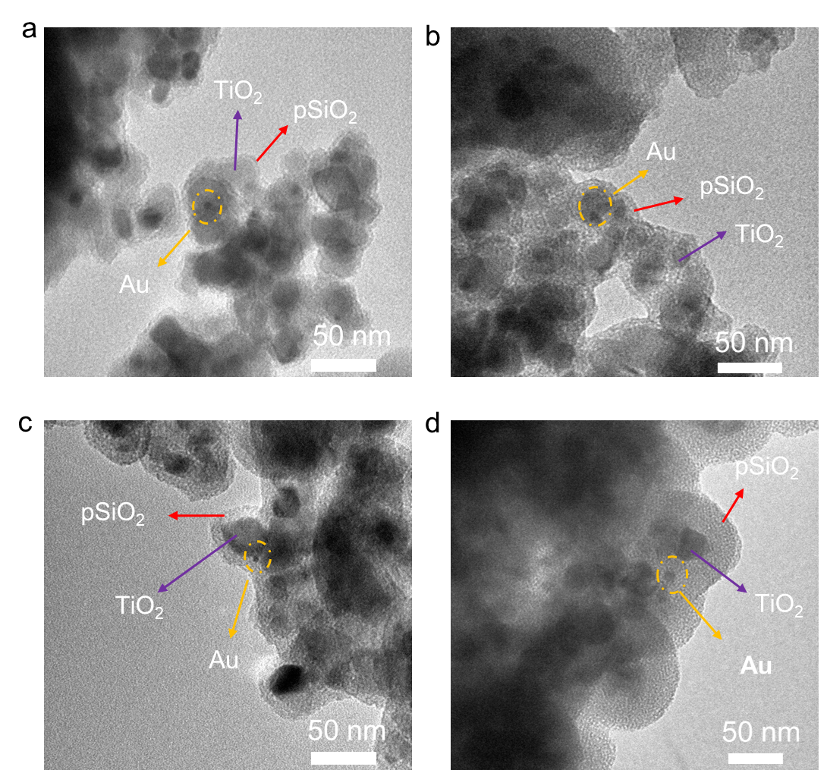
Supplementary Fig. 5. TEM images of Au/TiO₂@pSiO₂-2.6 with different SiO₂ thickness: a, 3.6 nm. b, 6 nm. c, 8 nm. d, 30 nm.

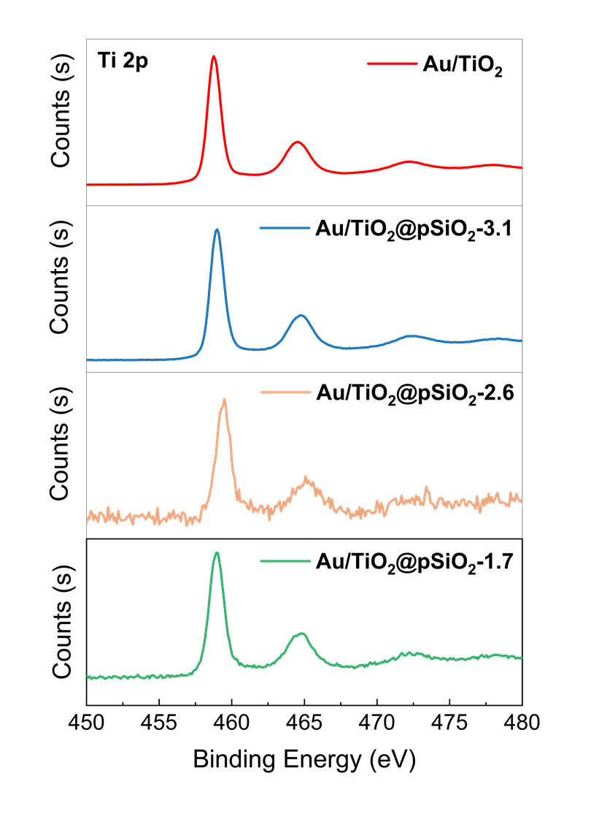
Supplementary Fig. 6. Ti 2p XPS spectrum of Au/TiO₂ and Au/TiO₂@pSiO₂-X catalysts.

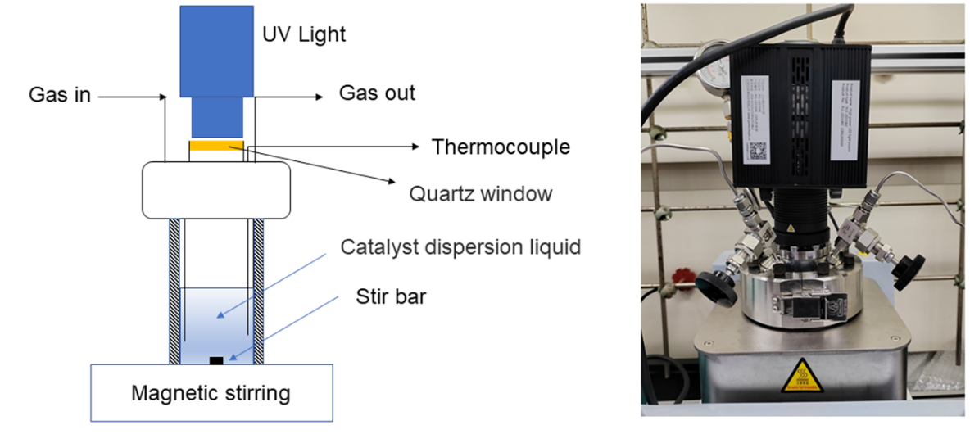
Supplementary Fig. 7. Schematic and image of the photocatalytic batch reactor setup.

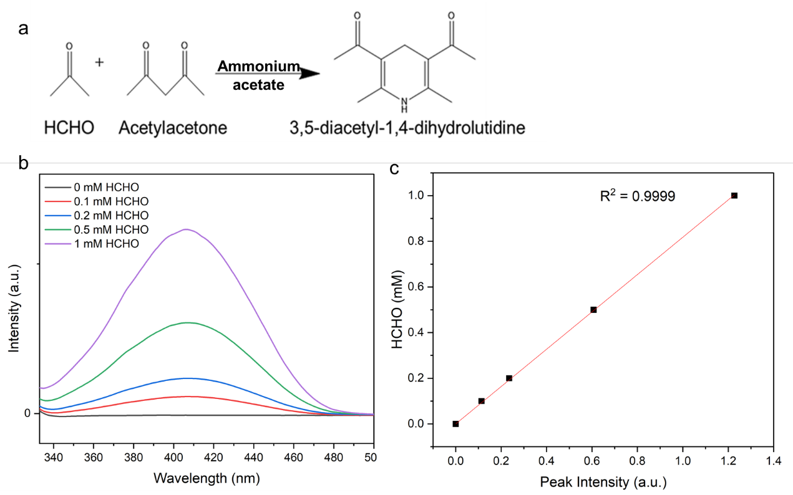
Supplementary Fig. 8. Quantification method for formaldehyde (HCHO). a, Reaction mechanism on acetylacetone color-developing method to detect HCHO. b, UV-Vis absorption spectra of yellow-colored 3,5-diacetyl-1,4-dihydrolutidine formed from varying concentrations of HCHO standard solutions. c, Calibration curve for the quantification of HCHO by colorimetric method.
Note: The quantitative determination of formaldehyde (HCHO) in aqueous solutions using the acetylacetone method is based on the Hantzsch reaction². In the presence of excess ammonium salt, HCHO reacts with acetylacetone and ammonia to form yellow-colored 3,5-diacetyl-1,4-dihydrolutidine. This compound has a characteristic UV-Vis absorption peak at 412 nm, and the intensity of this peak is directly proportional to the HCHO concentration.

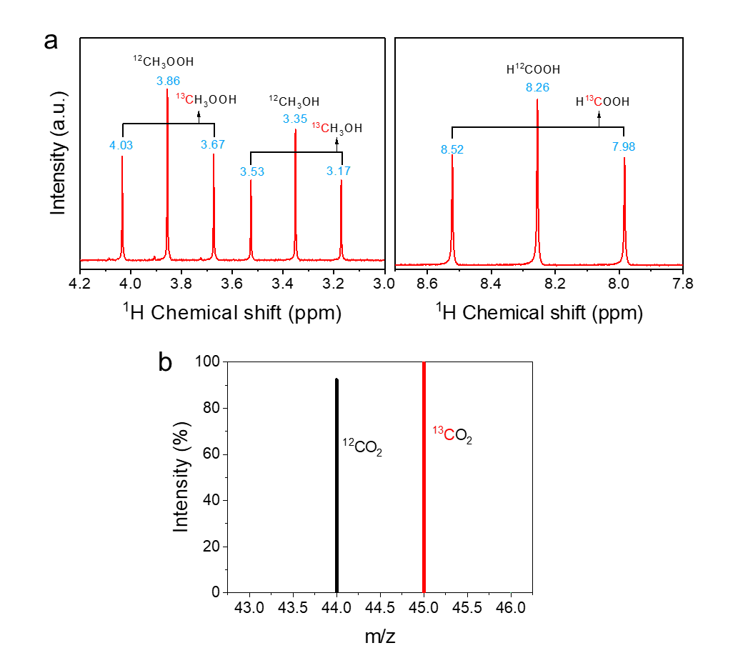
Supplementary Fig. 9. ¹³CH₄ isotope labeling experiments on Au/TiO₂@pSiO₂-1.7. a, ¹H NMR spectrum of methane oxidation reaction Au/TiO₂@pSiO₂-1.7 carried out with ¹³CH₄ and ¹²CH₄ mixture (55% ¹³CH₄ and 45% ¹²CH₄). DMSO is used as internal standard. ¹³CH₃OH (δ = 3.53 and δ = 3.17), ¹³CH₃OOH (δ = 4.03 and δ = 3.67), and H¹³COOH (δ = 8.52 and δ = 7.98) satellite peaks are observed along with main ¹²C peaks (δ = 3.35, δ = 3.86 and δ= 8.26, respectively); The integrated area of the satellite ¹³C peaks vs the integrated area of the ¹²C peak corresponding to the 0.55:0.45 ratio of ¹³CH₄ and ¹²CH₄ feeding gas. b, GC-MS spectra of CO₂ formed during photocatalytic methane oxidation with ¹³CH₄ and ¹²CH₄ mixture (55% ¹³CH₄ and 45% ¹²CH₄). ¹³CO₂ and ¹²CO₂ peaks with ratios of 0.55:0.45 were observed.

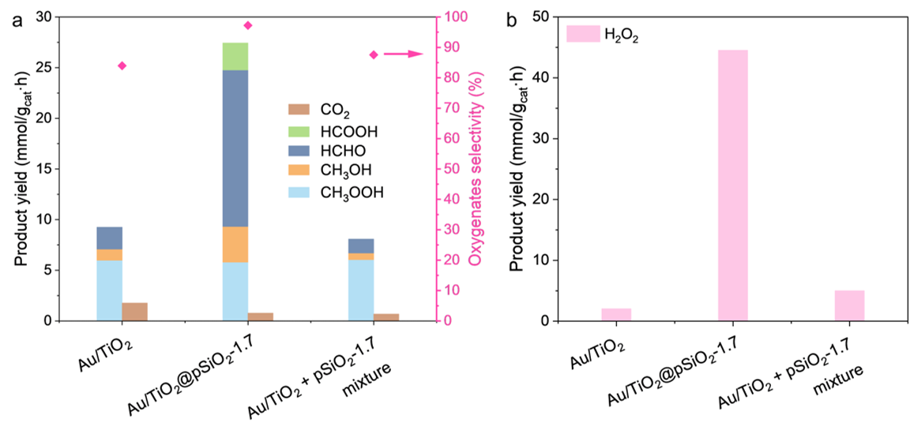
Supplementary Fig. 10. Comparison of catalytic activity of Au/TiO₂@pSiO₂-1.7 and the physical mixture of Au/TiO₂ and porous silica (pSiO₂-1.7). Reaction conditions: 10 mg Catalysts, 100 mL H₂O, 2.5 MPa CH₄, 1 MPa O₂, 1 h reaction time, reaction temperature of 25 °C, light source: 365 nm UV LED, 80 mW/cm².

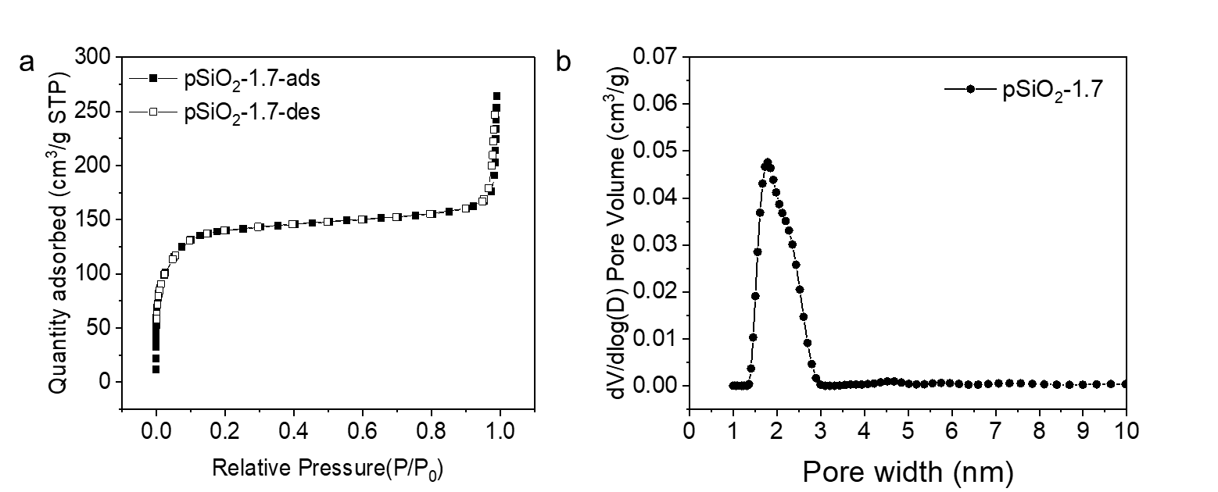
Supplementary Fig. 11. Porosity characterization of as-synthesized porous SiO₂ with 1.7 nm pore (i.e., pSiO₂-1.7). a, Nitrogen adsorption-desorption isotherms. b, Pore size distribution calculated from the N₂ adsorption isotherms.

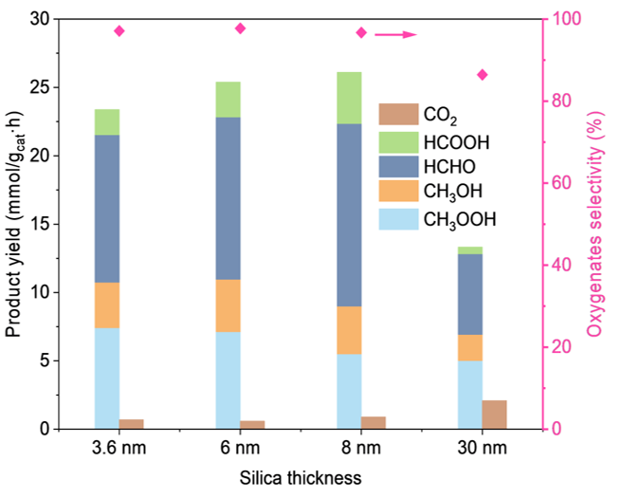
Supplementary Fig. 12. Photocatalytic performance of CH₄ oxidation over Au/TiO₂@pSiO₂-1.7 with different silica thickness. Reaction condition: 10 mg photocatalyst, 100 mL H₂O, 2.5 MPa CH₄, 1 MPa O₂, 1h reaction time, 25±3 ᵒC reaction temperature, light source: 365 nm UV LED, 80 mW/cm².

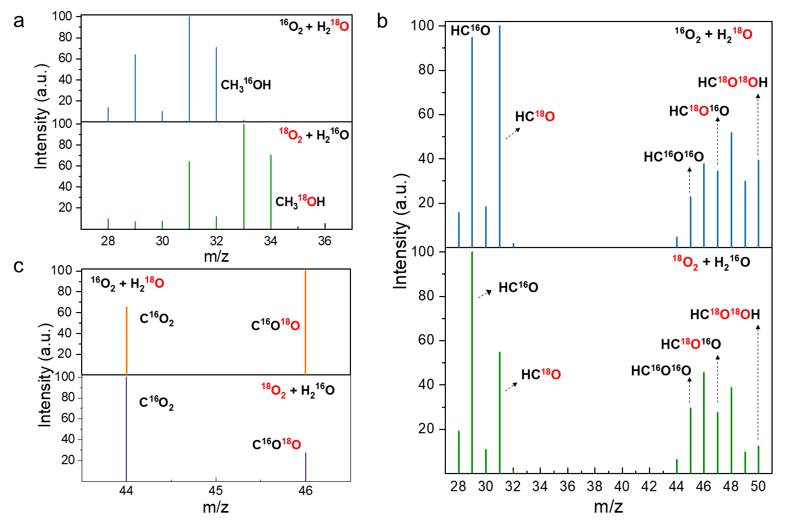
Supplementary Fig. 13. ¹⁸O isotopic labeling experiment over Au/TiO₂@pSiO₂-1.7 in photocatalytic CH₄ oxidation. a, GC-MS spectra of CH₃OH. b, GC-MS spectra of HCOOH. c, GC-MS spectra of CO₂.
Note: For CH₃OH, m/z= 33 and 34 were only observed when ¹⁸O₂ and H₂¹⁶O were used, indicating 100% of the ¹⁸O in ¹⁸O₂ was incorporated into CH₃OH. No CH₃¹⁸OH was detected in reactions with ¹⁶O₂ and H₂¹⁸O. These results suggest that the O in CH₃OH originate solely from O₂. Although the amount of HCHO produced is too low to analyze its isotopic composition using GC-MS, it can readily be formed through the photocatalytic dehydrogenation of CH₃OH⁴. Thus, the O atoms of HCHO should also be derived from O₂ in photocatalytic CH₄ oxidation.
For both HCOOH and CO₂, fragment ion peaks labeled with ¹⁸O and ¹⁶O were observed in the experiments with ¹⁸O₂ + H₂¹⁶O and ¹⁶O₂ + H₂¹⁸O. This indicates that the oxygen atoms in HCOOH and CO₂ originate from both H₂O and O₂.

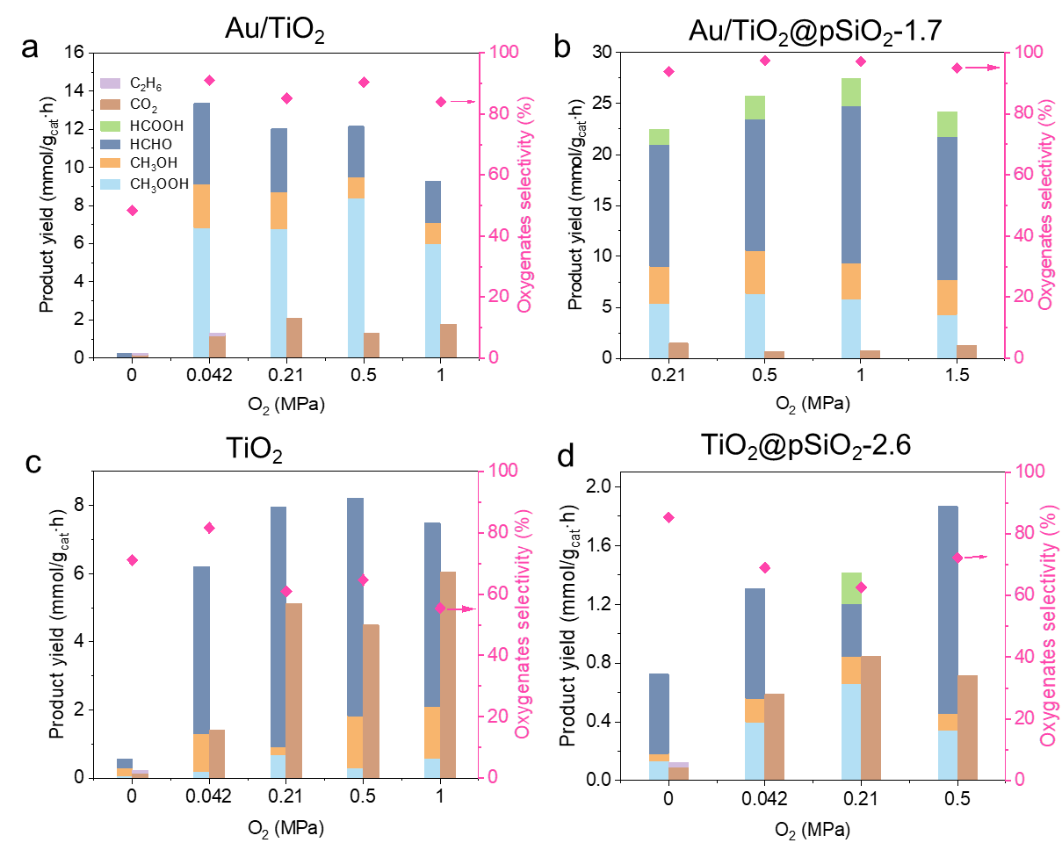
Supplementary Fig. 14. Photocatalytic performance of CH₄ oxidation under different O₂ partial pressure. a, Photocatalytic activity of Au/TiO₂. b, Photocatalytic activity of Au/TiO₂@pSiO₂-1.7. c, Photocatalytic activity of TiO₂. d, Photocatalytic activity of TiO₂@pSiO₂-2.6. Reaction conditions: 10 mg Catalysts, 100 mL H₂O, 2.5 MPa CH₄, 1 h reaction time, reaction temperature of 25 °C, light source: 365 nm UV LED, 80 mW/cm².

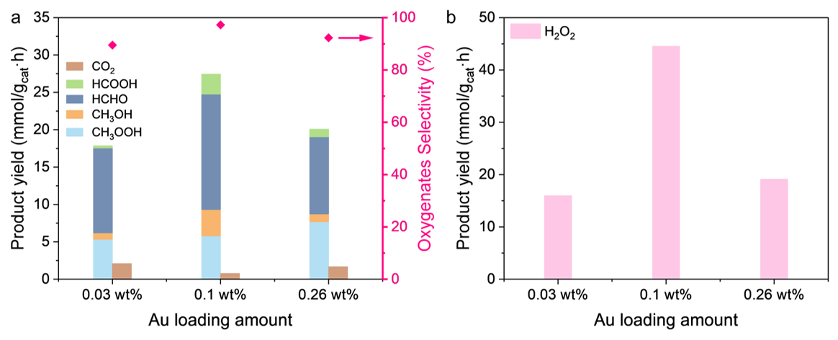
Supplementary Fig. 15. Photocatalytic performance of CH₄ oxidation over Au/TiO₂@pSiO₂-1.7 with varying Au loading amount. a, Photocatalytic activity of CH₄ oxidation to oxygenates. b, H₂O₂ production. Reaction condition: 10 mg photocatalyst, 100 mL H₂O, 2.5 MPa CH₄, 1 MPa O₂, 1h reaction time, 25±3 ᵒC reaction temperature, light source: 365nm UV LED, 80 mW/cm².
Note: 0.1 wt. % Au loaded photocatalyst produced the optimum oxygenates yields. Further increasing Au loading led to lower oxygenates and H₂O₂ production and can be attributed to the shielding effect: Au blocks light from reaching the TiO₂ surface

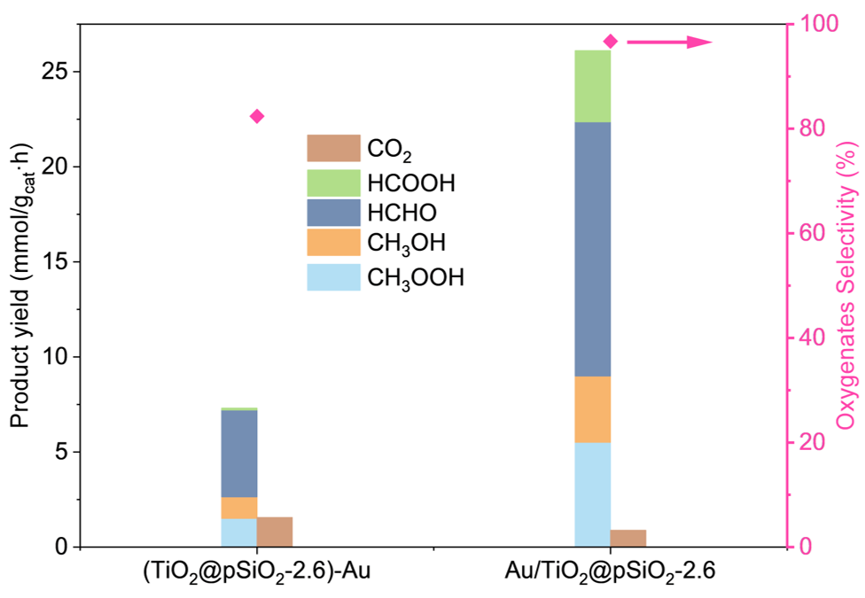
Supplementary Fig. 16. Effect of Au cocatalyst position on the photocatalytic methane oxidation performance of TiO₂@pSiO₂ catalysts. One the left: Au loaded on the outer layer of SiO₂ shell; On the right: Au loaded onto TiO₂, which is enclosed within the SiO₂ shell. Reaction conditions: 10 mg Catalysts, 100 mL H₂O, 2.5 MPa CH₄, 1 MPa O₂, 1 h reaction time, reaction temperature of 25 °C, light source: 365 nm UV LED, 80 mW/cm².

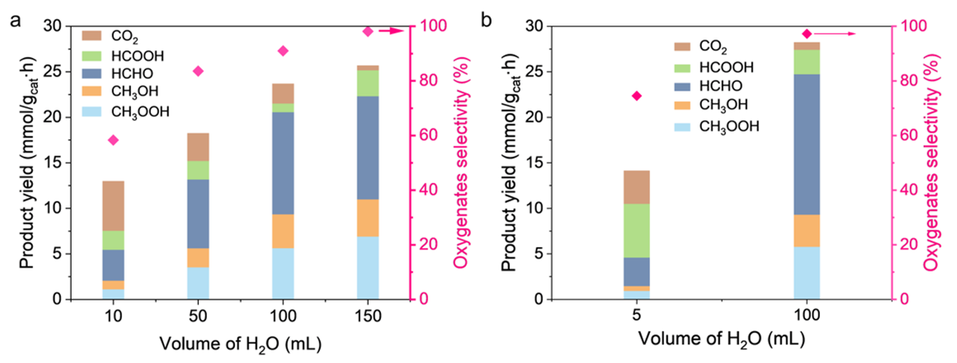
Supplementary Fig. 17. Effect of water amount on the catalytic performance. a, Photocatalytic activity of Au/TiO₂@pSiO₂-2.6. Reaction conditions: 10 mg Catalyst, 2.5 MPa CH₄, 0.5 MPa O₂, 365nm UV (80 mW/cm²). b, Photocatalytic activity of Au/TiO₂@pSiO₂-1.7. Reaction conditions: 10 mg Catalyst, 2.5 MPa CH₄, 1 MPa O₂, 365nm UV (80 mW/cm²).

Supplementary Fig. 18. Cycling measurements of photocatalytic CH₄ oxidation over Au/TiO₂@pSiO₂-1.7. Reaction conditions: 10 mg catalysts, 100 mL H₂O, 2.5 MPa CH₄, 0.5 MPa O₂, 1 h reaction time, reaction temperature of 25 °C, light source of 365 nm UV LED, 75 mW/cm².

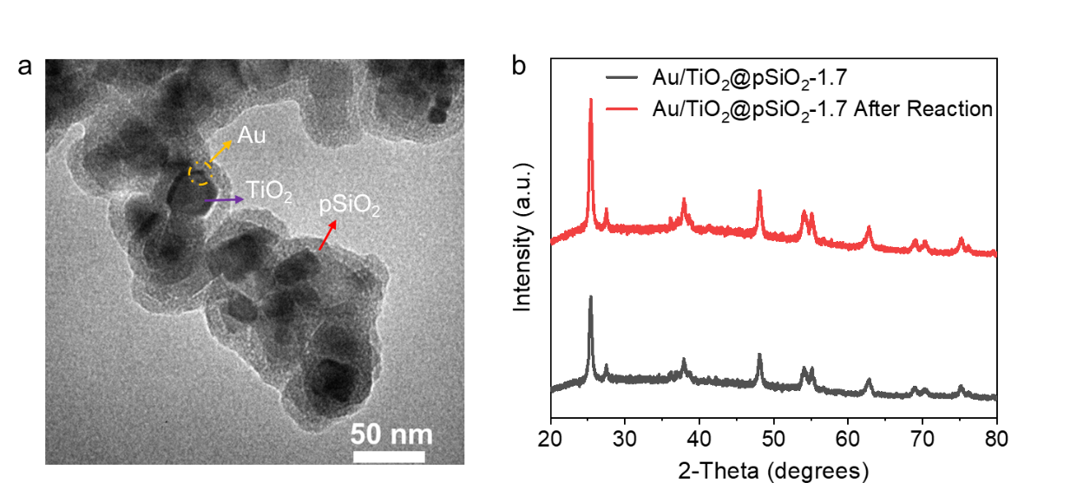
Supplementary Fig. 19. Structure characterization of Au/TiO₂@pSiO₂-1.7 after four cycles of reactions. a, TEM image of Au/TiO₂@pSiO₂-1.7 after reaction. b, XRD pattern of Au/TiO₂@pSiO₂-1.7 after reaction. No obvious structure changes were observed.

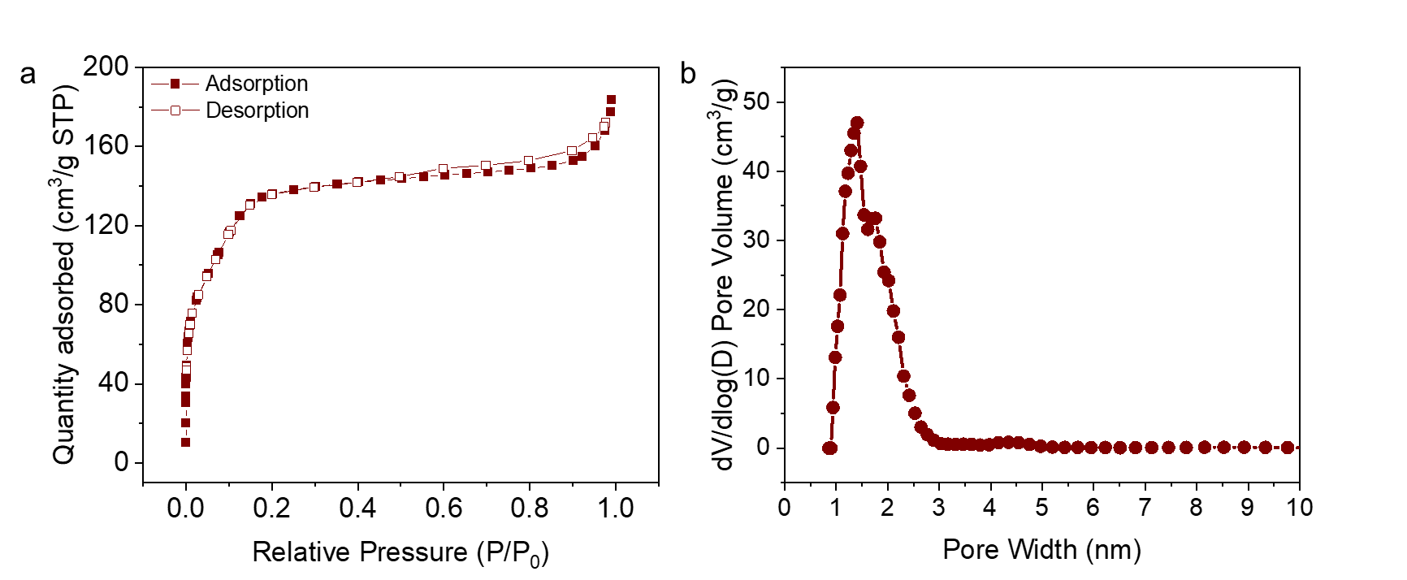
Supplementary Fig. 20. Porosity characterization of Au/TiO₂@pSiO₂-1.7 after four cycles of reactions. a, Nitrogen adsorption-desorption isotherms. b, Pore size distribution calculated from the N₂ adsorption isotherms. The pore size distribution and surface area of the recycled catalysts were similar to those of the fresh catalysts.

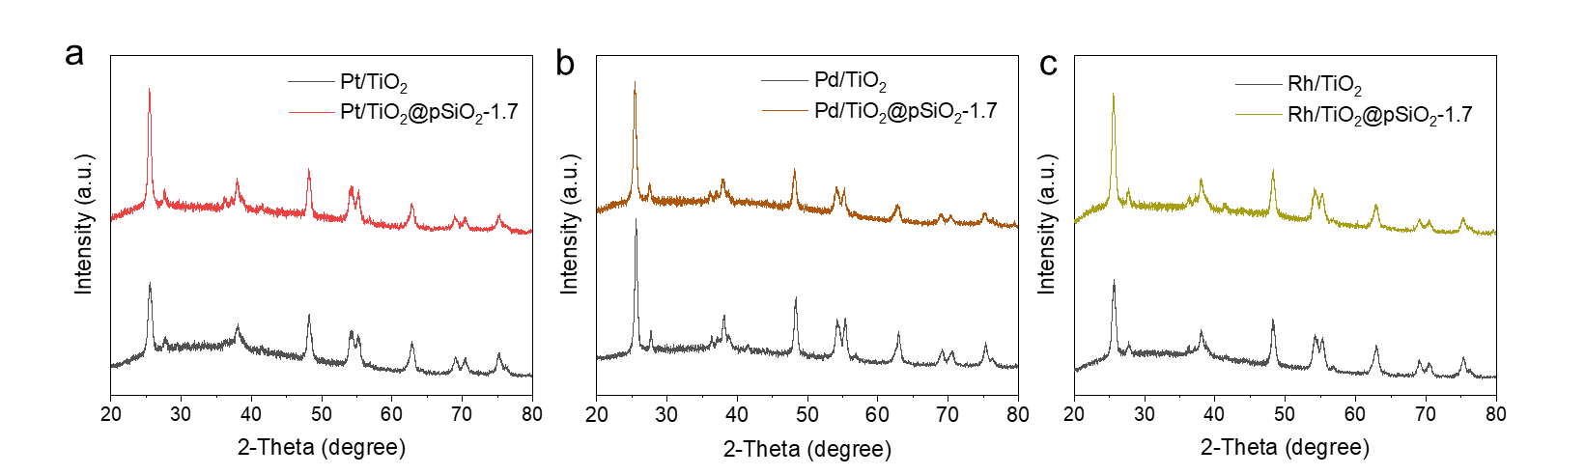
Supplementary Fig. 21. XRD patterns of M/TiO₂ and M/TiO₂@pSiO₂-1.7. M refers to Pt (a), Pd (b), and Rh (c), respectively.

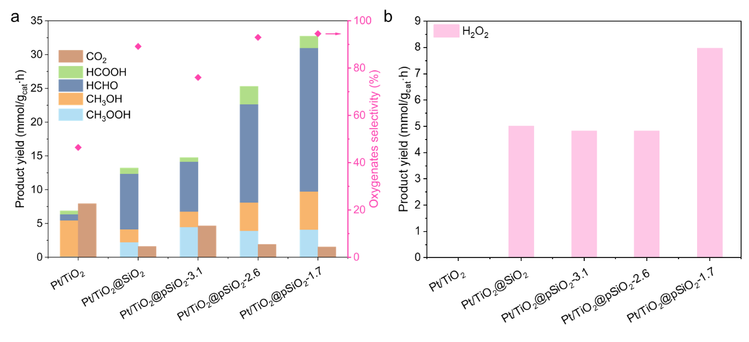
Supplementary Fig. 22. Photocatalytic activity of CH₄ oxidation with O₂ over Pt/TiO₂@pSiO₂-X with different silica pore size. a, Oxygenates yields from CH₄ oxidation over different photocatalysts. b, H₂O₂ production from CH₄ oxidation over different photocatalysts. Reaction condition: 10 mg photocatalyst, 100 mL H₂O, 2.5 MPa CH₄, 1 MPa O₂, 1 h reaction time, 25±3 ᵒC reaction temperature, light source: 365 nm UV LED, 80 mW/cm² .

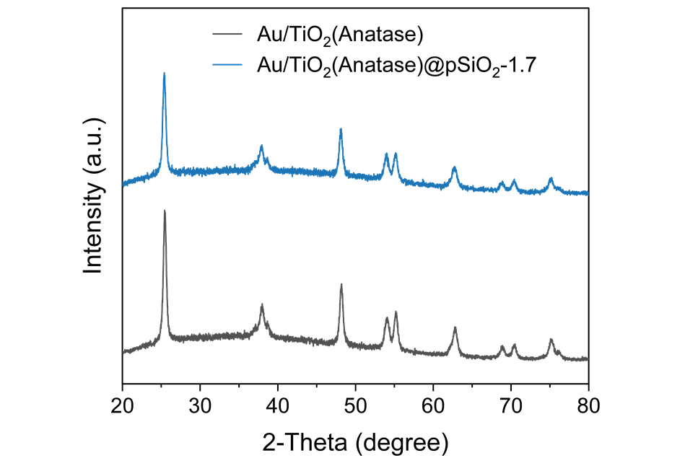
Supplementary Fig. 23. XRD patterns of as-synthesized Au/A-TiO₂ and Au/A-TiO₂@pSiO₂-1.7.

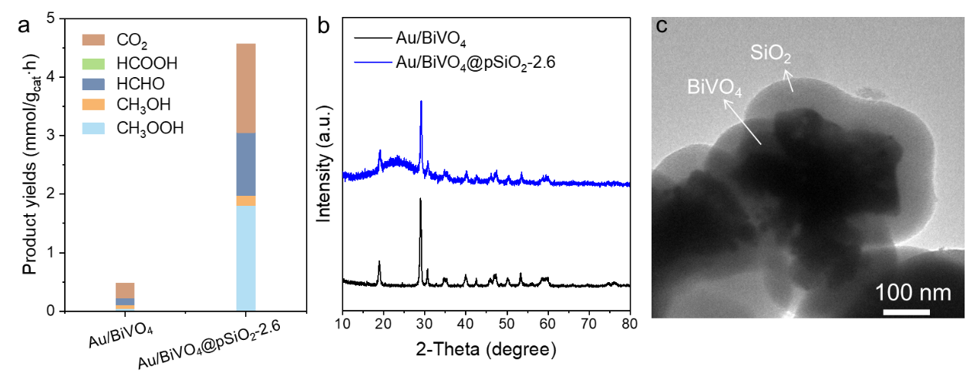
Supplementary Fig. 24. Photocatalytic activity of CH₄ oxidation with O₂ over Au/BiVO₄ and Au/BiVO₄@pSiO₂-2.6. a, Oxygenates yields from CH₄ oxidation over different photocatalysts. Reaction condition: 10 mg photocatalyst, 100 mL H₂O, 2.5 MPa CH₄, 1 MPa O₂, 1h reaction time, 25±3 ᵒC reaction temperature, light source: 365 nm UV LED, 80 mW/cm² .b, XRD patterns of Au/BiVO₄ and Au/BiVO₄@pSiO₂-2.6. c, TEM images of as-synthesized Au/BiVO₄@pSiO₂-2.6.

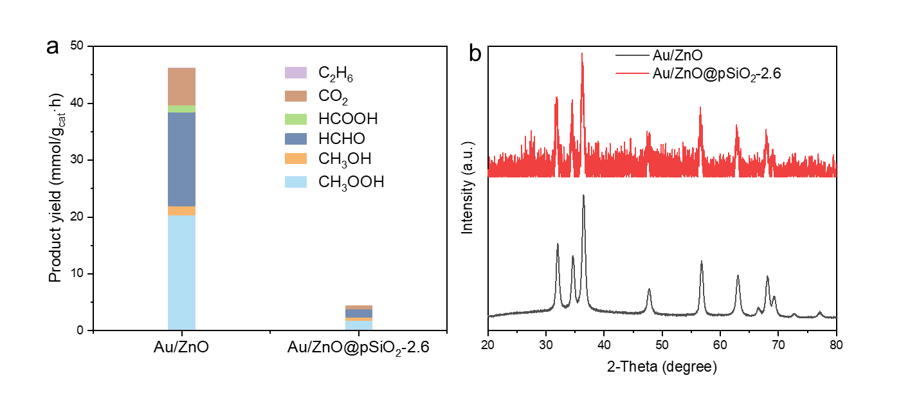
Supplementary Fig. 25. Photocatalytic activity of CH₄ oxidation with O₂ over Au/ZnO and Au/ZnO@pSiO₂-2.6. a, Oxygenates yields from CH₄ oxidation over different photocatalysts. Reaction condition: 10 mg photocatalyst, 100 mL H₂O, 2.5 MPa CH₄, 1 MPa O₂, 1h reaction time, 25±3 ᵒC reaction temperature, light source: 365 nm UV LED, 80 mW/cm² .b, XRD patterns of Au/ZnO and Au/ZnO@pSiO₂-2.6 .
Note: Encapsulating ZnO with porous SiO₂ significantly decreased its CH₄ conversion rates. This is likely due to ZnO dissolution in the ammonia solution used during SiO₂ coating, as supported by the broader and more noisy peaks for Au/ZnO@pSiO₂-2.6 in XRD pattens.

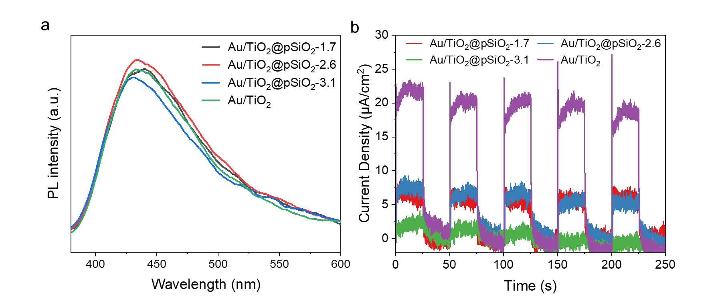
Supplementary Fig. 26. Photoelectrochemical and photoluminescence characterization. a, Steady-state PL spectra of Au/TiO₂ and Au/TiO₂@pSiO₂-X. b, Photocurrent measurement Au/TiO₂ and Au/TiO₂@pSiO₂-X as catalysts under light irradiation.

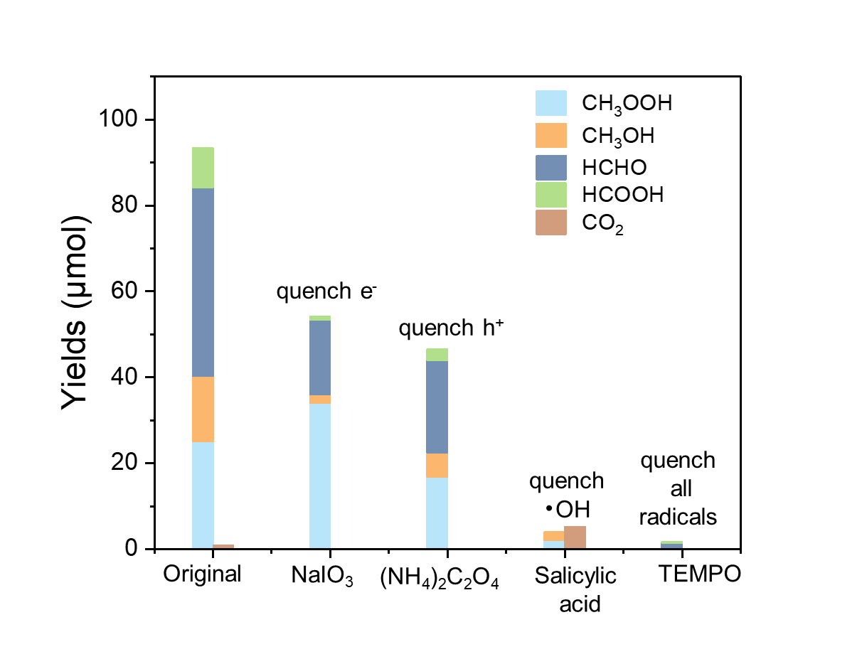
Supplementary Fig. 27. Photocatalytic CH₄ oxidation over Au/TiO₂@pSiO₂-1.7 with the addition of scavengers. Reaction conditions: 10 mg catalyts, 100 mL H₂O, 2.5 MPa CH₄, 0.5 MPa O₂, UV irridiation for 10 min, 149.04 mW/cm².

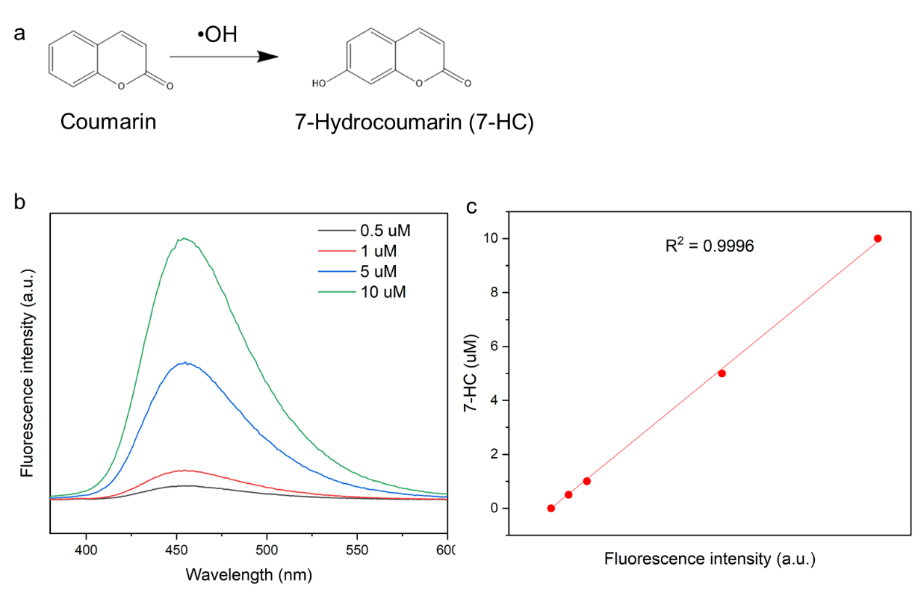
Supplementary Fig. 28. Hydroxyl radical detection with coumarin probe. a, Schematic of hydroxyl radical detection using coumarin, leading to the formation of 7-hydroxycoumarin (7-HC) as a fluorescent product. b, Fluorescence spectra of 7-hydroxycoumarin formed from coumarin at varying concentrations. c, Standard curves for the quantification of 7-HC via fluorescence spectra.

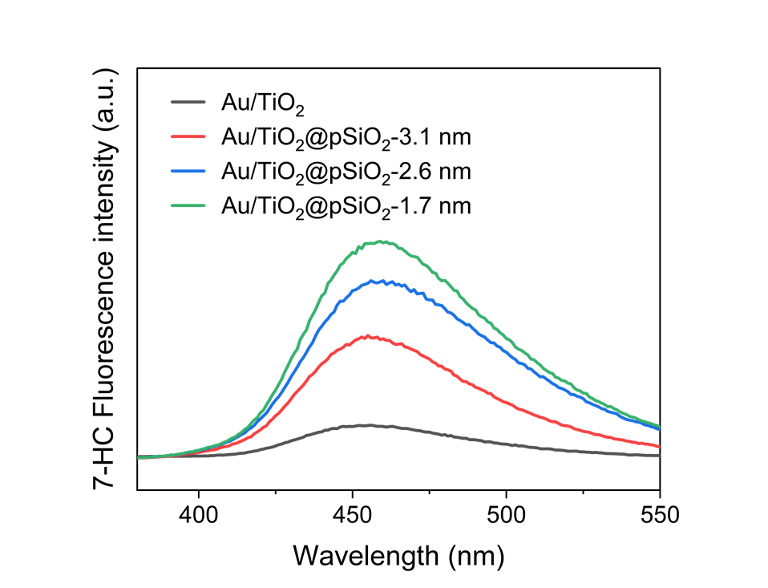
Supplementary Fig. 29. Fluorescence spectra of the produced 7-HC for •OH radical detection over different photocatalysts under UV irradiation.

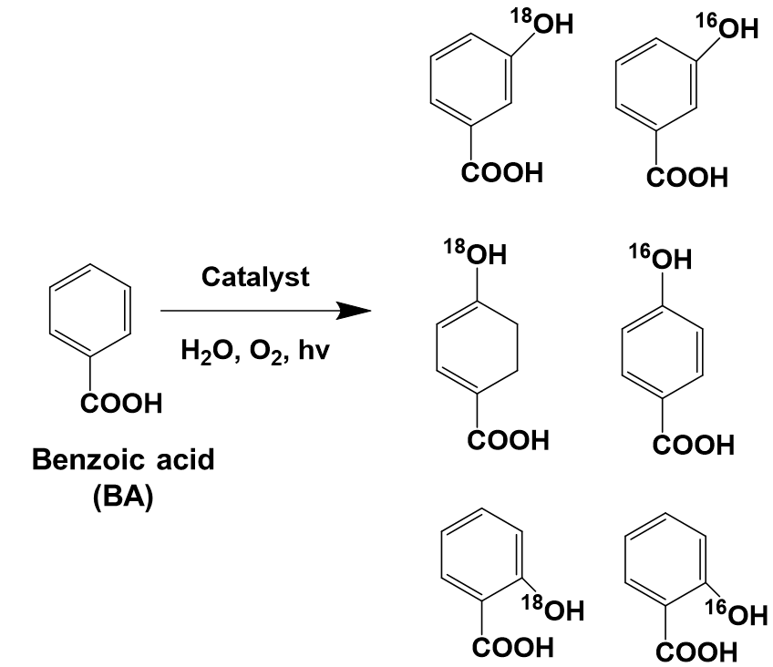
Supplementary Fig. 30. Illustration of in situ •OH capture using benzoic acid as a probe. Hydroxybenzoic acid is formed as the product, which was analyzed by LC-MS.

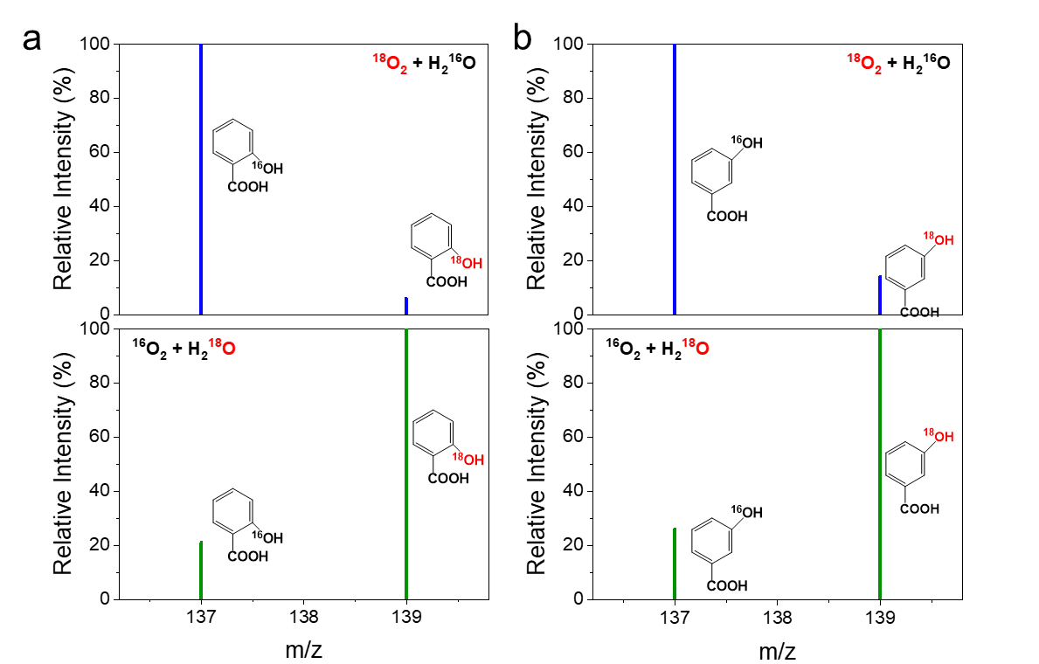
Supplementary Fig. 31. ¹⁸O isotopic studies on the origins of •OH radicals over Au/TiO₂@pSiO₂-1.7. Benzoic acid (BA) was used as a probe to in situ capture •OH, resulting in the formation of hydroxybenzoic acid. a, Mass spectra of 2-hydroxybenzoic acid. b, Mass spectra of 3-hydroxybenzoic acid. The mass spectra of 4-Hydroxybenzoic acid was shown in Fig. 4c.
Reaction conditions: 2mg Catalyst, 1 mL 1 mM BA/H₂¹⁸O + ¹⁶O₂ bubbling or 1 mL 1 mM BA/H₂¹⁶O + ¹⁸O₂ bubbling , UV 10 min.

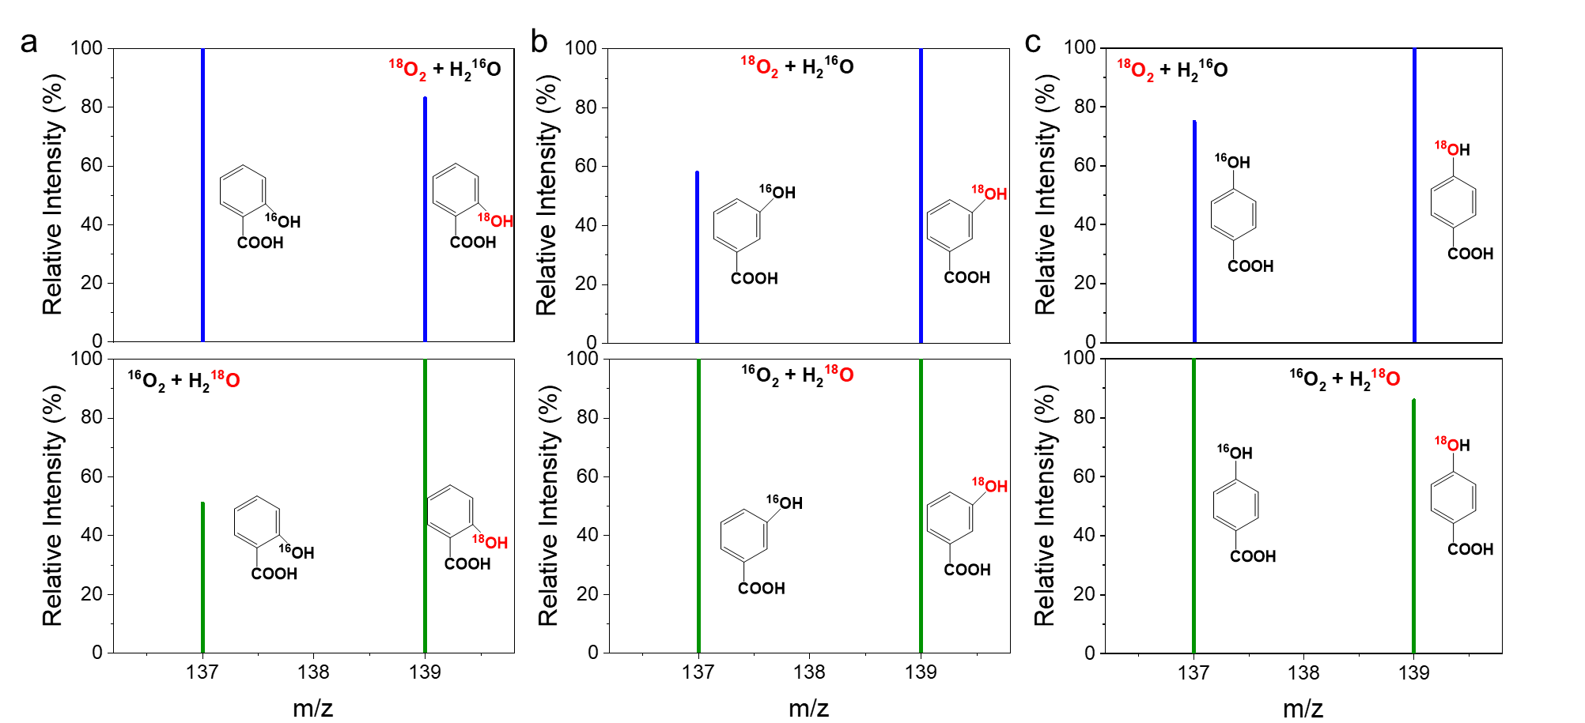
Supplementary Fig. 32. ¹⁸O isotopic studies on the origins of •OH radicals over Au/TiO₂. Benzoic acid (BA) was used as a probe to in situ capture •OH, resulting in the formation of hydroxybenzoic acid a, Mass spectra of 2-hydroxybenzoic acid. b, Mass spectra of 3-hydroxybenzoic acid. c, Mass spectra of 4-hydroxybenzoic acid. Reaction conditions: 2 mg Catalyst, 1 mL 1 mM BA/H₂¹⁸O + ¹⁶O₂ bubbling or 1 mL 1 mM BA/H₂¹⁶O + ¹⁸O₂ bubbling, UV 10 min.
Note: Under both BA/H₂¹⁶O + ¹⁸O₂ and BA/H₂¹⁸O + ¹⁶O₂ conditions, we observed roughly equal signnals for H¹⁶OC₆H₄CO₂H (m/z=137) and H¹⁸OC₆H₄CO₂H (m/z=139). This suggest that both H₂O and O₂ contribute for •OH radical generation over Au/TiO₂, in stark contrast to our findings for Au/TiO₂@pSiO₂.

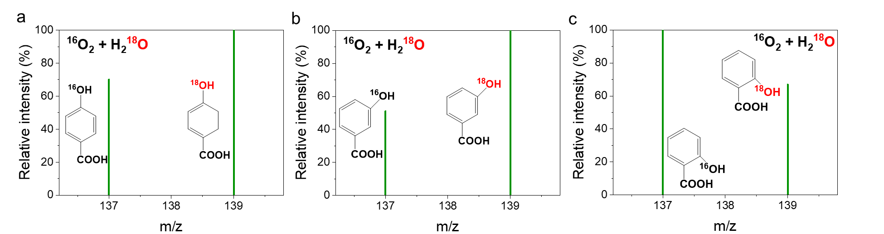
Supplementary Fig. 33. ¹⁸O isotopic studies on the origins of •OH radicals over TiO₂. Benzoic acid (BA) was used as a probe to in situ capture •OH, resulting in the formation of hydroxybenzoic acid a, Mass spectra of 4-hydroxybenzoic acid. b, Mass spectra of 3-hydroxybenzoic acid. c, Mass spectra of 2-hydroxybenzoic acid. Reaction conditions: 2 mg catalyst, 1 mL 1 mM BA/H₂¹⁸O + ¹⁶O₂ bubbling, UV 10 min.

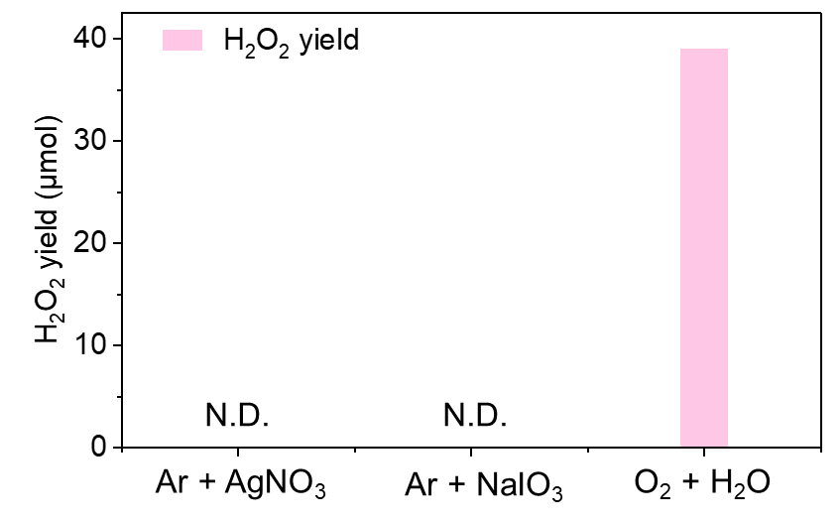
Supplementary Fig. 34. H₂O₂ production over Au/TiO₂@pSiO₂-1.7 with addition of electron acceptor (10 mM AgNO₃ or NaIO₃ aqueous solution) under Ar atmosphere. Reaction conditions: 10 mg Catalysts, 5 mL H₂O or 1 mM AgNO₃, 1 mM NaIO₃, 1 MPa O₂ or 1 MPa Ar, 1 h reaction time, reaction temperature of 25 °C, light source of 365 nm UV LED, 79.6 mW/cm².
N.D. (not detected) means that H₂O₂ cannot be detected in the photocatalytic system.

Supplementary Fig. 35. Comparison of H₂O₂ decomposition rates over different photocatalysts. The initial amount of H₂O₂ is 500 μmol. Reaction conditions: 10 mg Catalysts, 50 mL 10 mM H₂O₂, 2 MPa Ar, 900 s reaction time, reaction temperature of 25 °C, light source of 365 nm UV LED 79.6 mW/cm².

Note: After 1 hour of UV irradiation, less than 10% of H₂O₂ decomposes over Au/TiO₂@pSiO₂-1.7, whereas nearly all H₂O₂ is decomposed over Au/TiO₂.

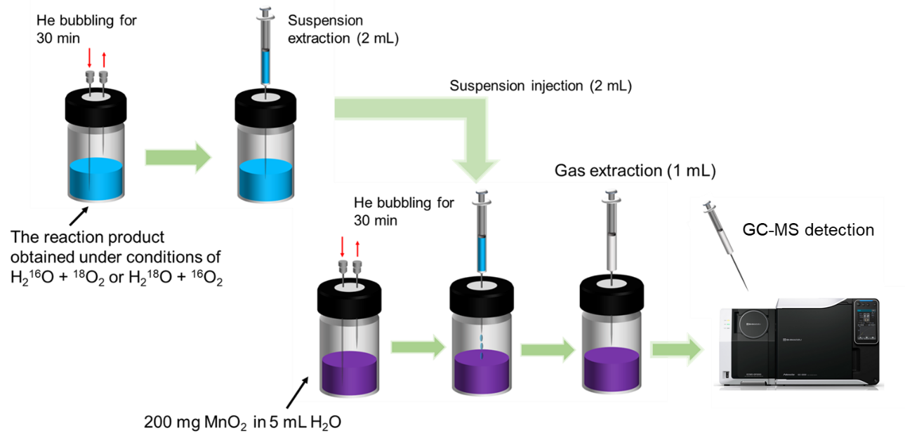
Supplementary Fig. 36. Schematic illustrating the isotopic experimental procedure used to identify the oxygen source in H₂O₂ production.

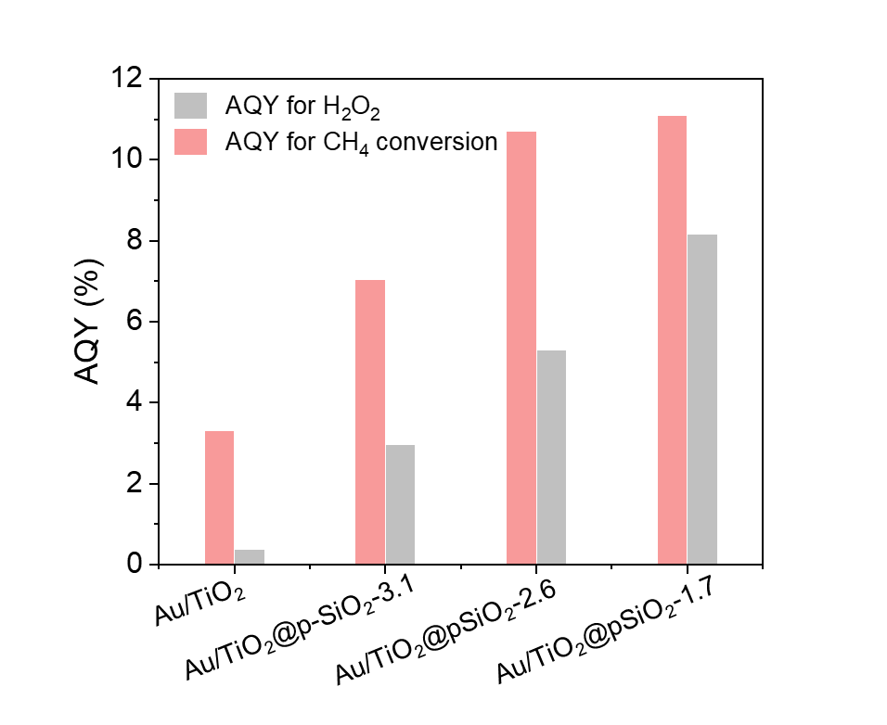
Supplementary Fig. 37. AQY calculation for different photocatalysts.

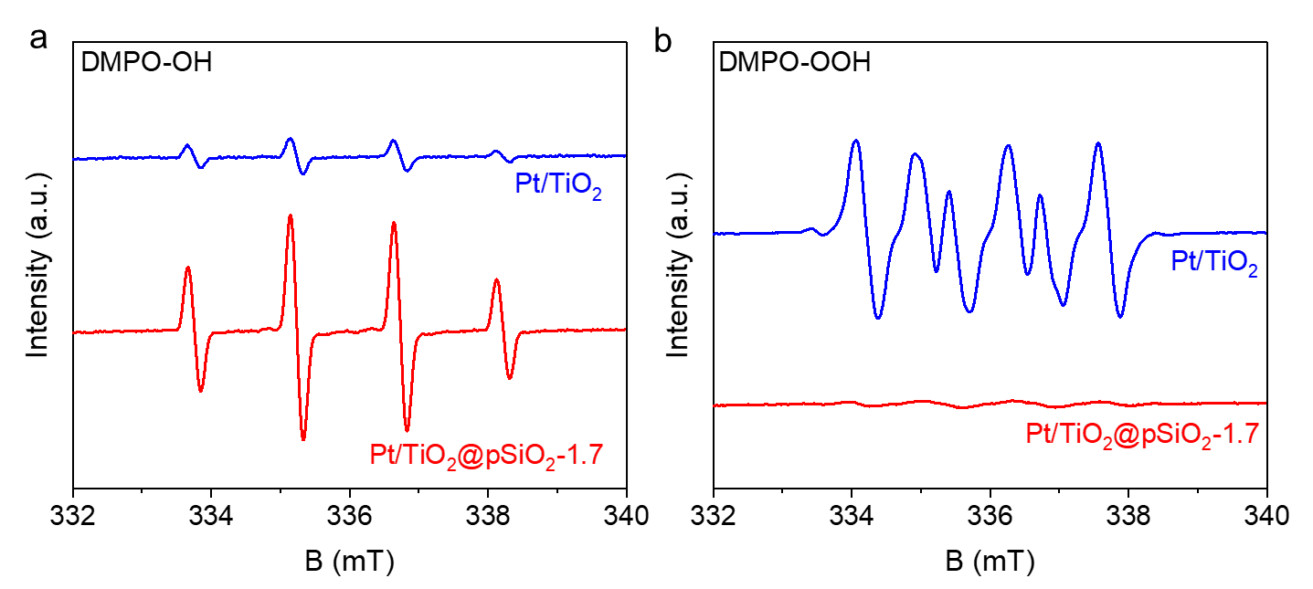
Supplementary Fig. 38. In situ EPR spectra for •OH and •OOH radical detection over Pt/TiO₂ and Pt/TiO₂@pSiO₂-1.7. a, EPR spectra for DMPO-OH. b, EPR spectra for DMPO-OOH.

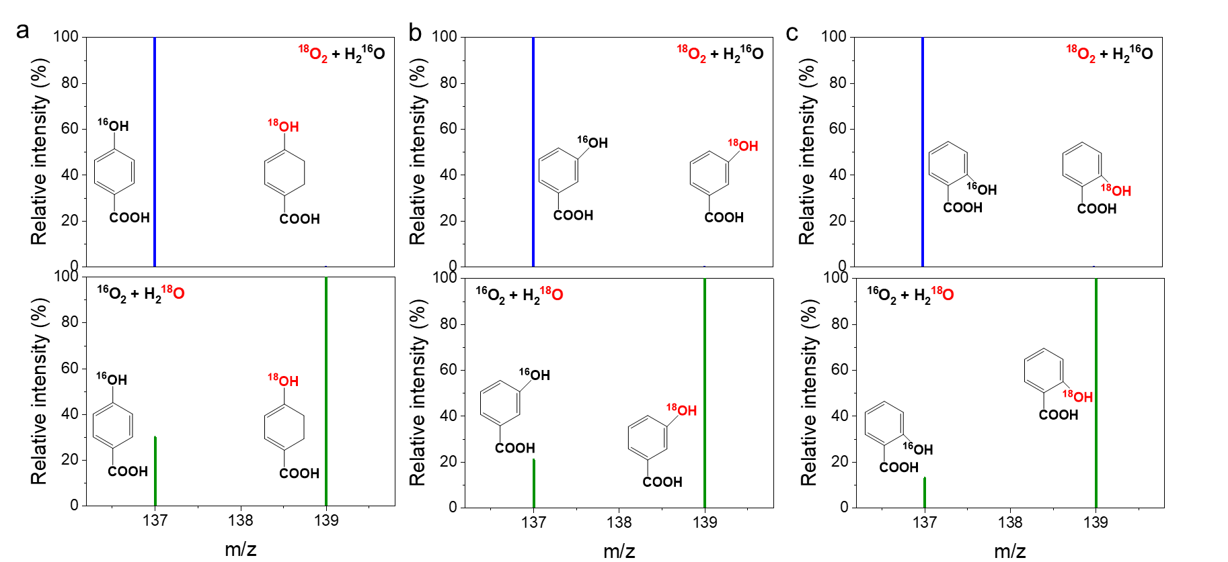
Supplementary Fig. 39. ¹⁸O isotopic studies on the origins of •OH radicals over Pt/TiO₂@pSiO₂-1.7 catalyst. Benzoic acid was used as a probe to in situ capture •OH, resulting in the formation of hydroxybenzoic acid a, Mass spectra of 4-hydroxybenzoic acid. b, Mass spectra of 3-hydroxybenzoic acid. c, Mass spectra of 2-hydroxybenzoic acid. Reaction conditions: 2 mg catalyst, 1 mL 1 mM BA/H₂¹⁸O + ¹⁶O₂ bubbling or 1 mL 1 mM BA/H₂¹⁶O + ¹⁸O₂ bubbling, UV 10 min.
Note: Under BA/H₂¹⁶O + ¹⁸O₂ conditions, only products of H¹⁶OC₆H₄CO₂H (m/z=137) were observed; with BA/H₂¹⁸O + ¹⁶O₂, roughly 80% of products corresponds to H¹⁸OC₆H₄CO₂H (m/z=139). These results suggest that both H₂O is the major contributor for •OH radical generation over Pt/TiO₂@pSiO₂.

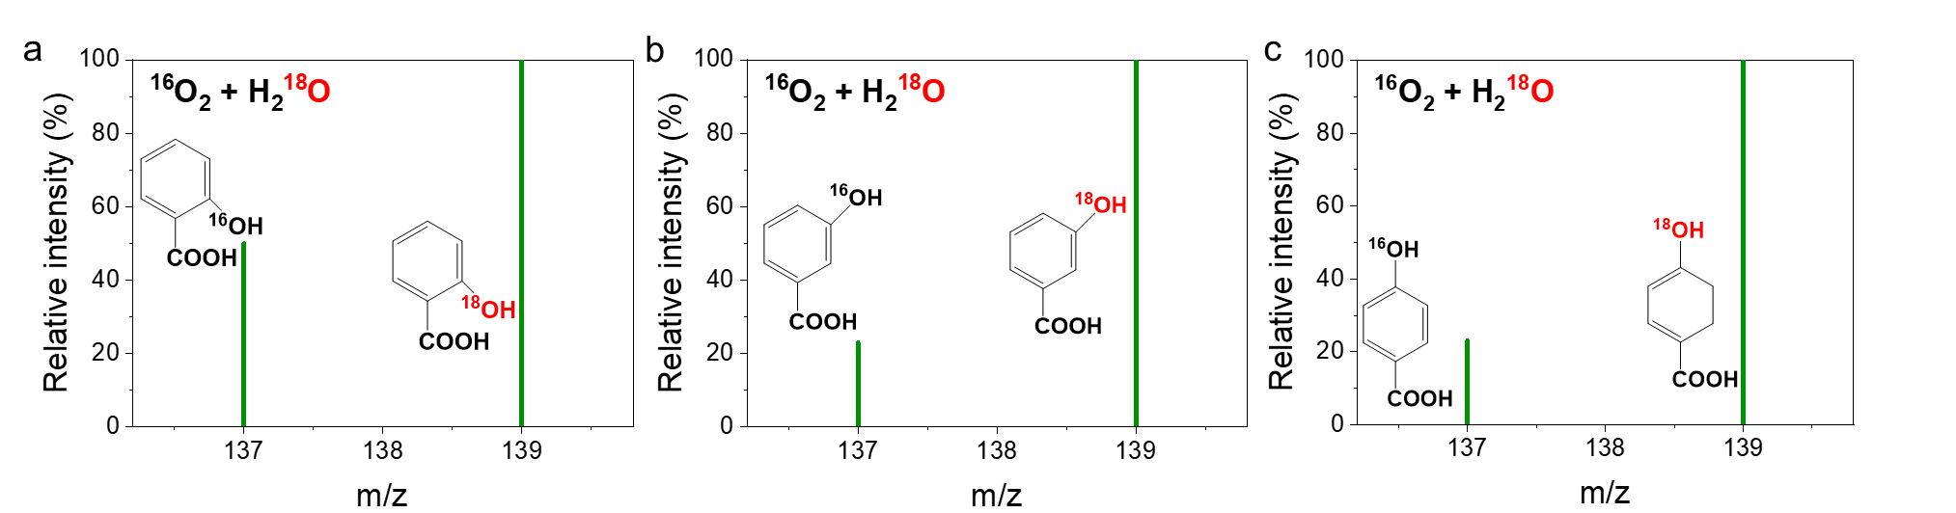
Supplementary Fig. 40. ¹⁸O isotopic studies on the origins of •OH radicals over Pt/TiO₂. Benzoic acid was used as a probe to in situ capture •OH, resulting in the formation of hydroxybenzoic acid a, Mass spectra of 2-hydroxybenzoic acid. b, Mass spectra of 3-hydroxybenzoic acid. c, Mass spectra of 4-hydroxybenzoic acid. Reaction conditions: 2 mg catalyst, 1 mL 1 mM BA/H₂¹⁸O + ¹⁶O₂ bubbling, UV 10 min.

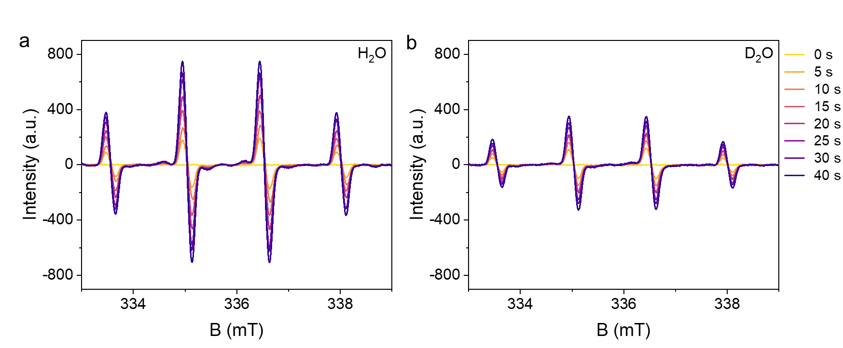
Supplementary Fig. 41. KIE study on •OH radical production from WOR over Au/TiO₂@pSiO₂-1.7. a, b, In situ EPR spectra for monitoring •OH radical generation in H₂O (a) and D₂O (b).

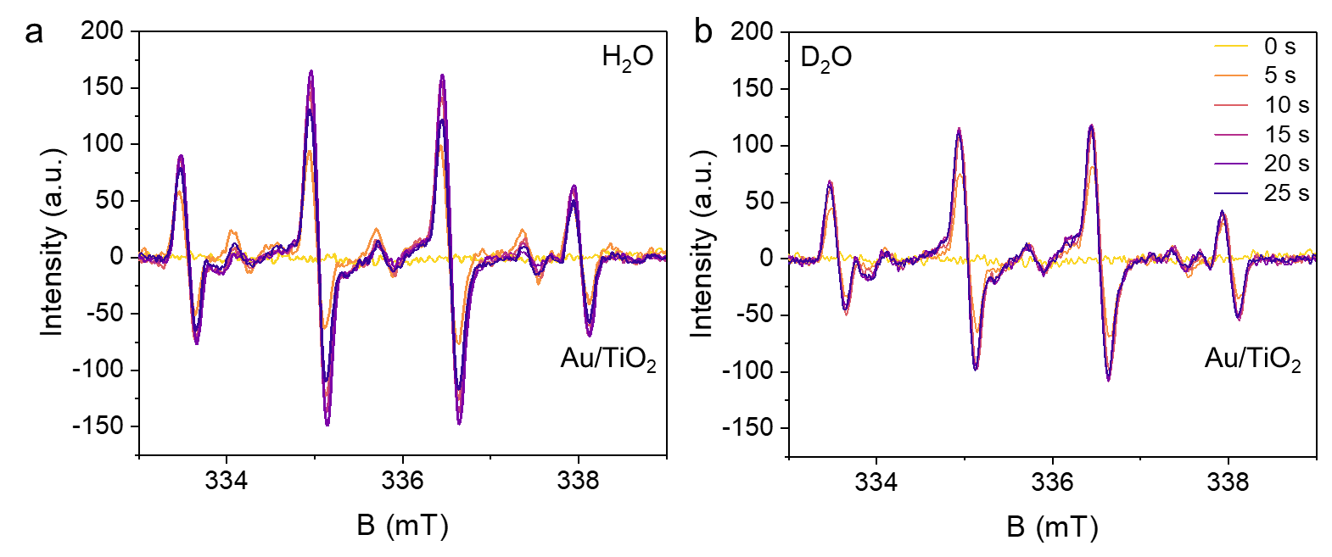
Supplementary Fig. 42. KIE study on •OH radical production from WOR over Au/TiO₂. a, b, In situ EPR spectra for monitoring •OH radical generation in H₂O (a) and D₂O (b).

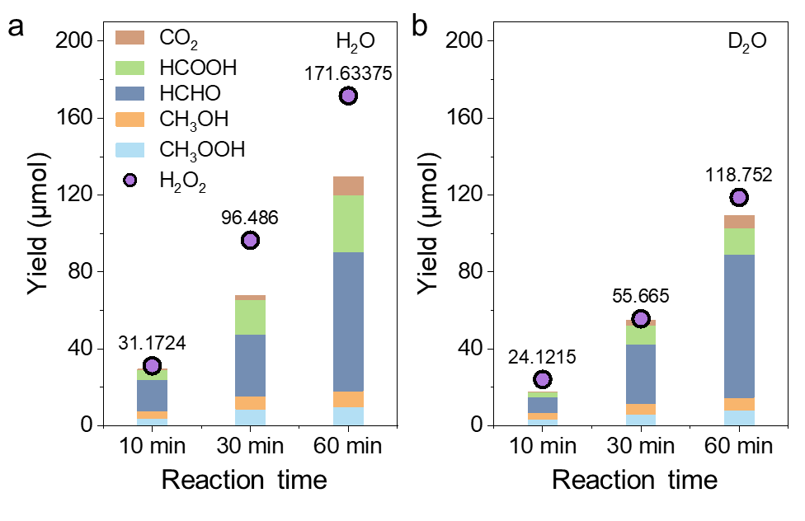
Supplementary Fig. 43. Photocatalytic CH₄ conversion over Au/TiO₂@pSiO₂-1.7 in H₂O and D₂O. a, Oxygenate yields and H₂O₂ yields in H₂O. b, Oxygenate yields and H₂O₂ yields in D₂O. Reaction conditions: 10 mg Catalyst, 10 mL H₂O or D₂O, UV LED, 2.5 MPa CH₄, 1MPa O₂.

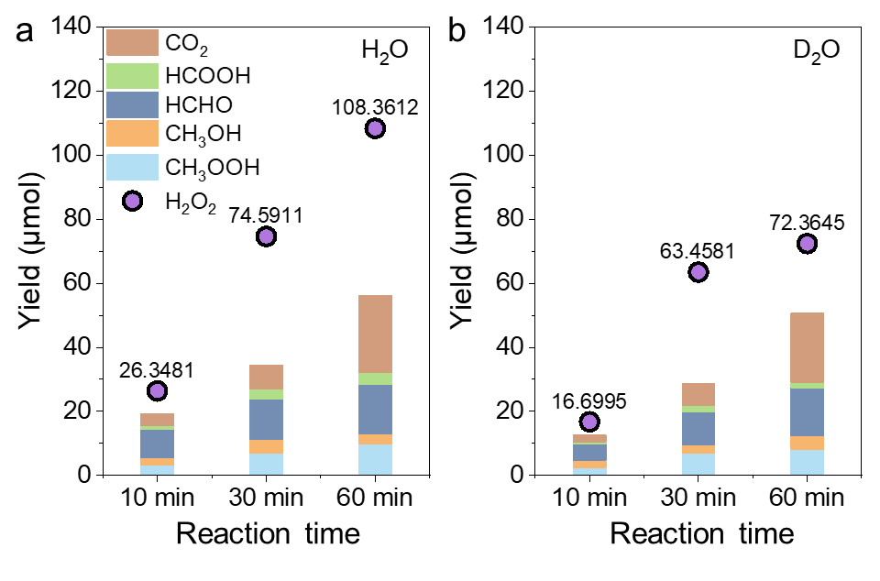
Supplementary Fig. 44. Photocatalytic CH₄ conversion over Au/TiO₂@pSiO₂-3.1 in H₂O and D₂O. a, Oxygenate yields and H₂O₂ yields in H₂O. b, Oxygenate yields and H₂O₂ yields in D₂O. Reaction conditions: 10 mg Catalyst, 10 mL H₂O or D₂O, UV LED, 2.5 MPa CH₄, 1MPa O₂.

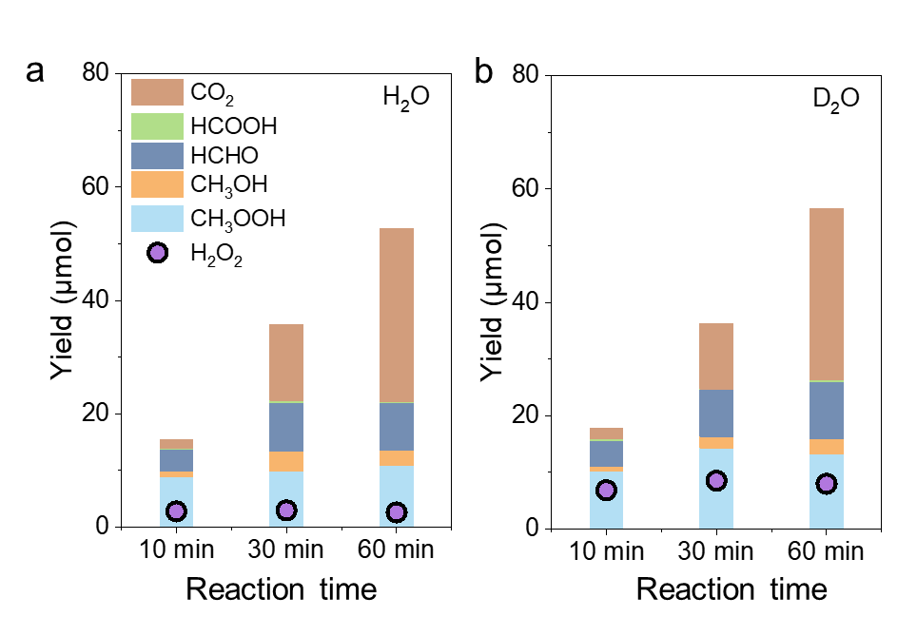
Supplementary Fig. 45. Photocatalytic CH₄ conversion over Au/TiO₂ in H₂O and D₂O. a, Oxygenate yields and H₂O₂ yields in H₂O. b, Oxygenate yields and H₂O₂ yields in D₂O. Reaction conditions: 10 mg Catalyst, 10 mL H₂O or D₂O, UV LED, 2.5 MPa CH₄, 1MPa O₂.

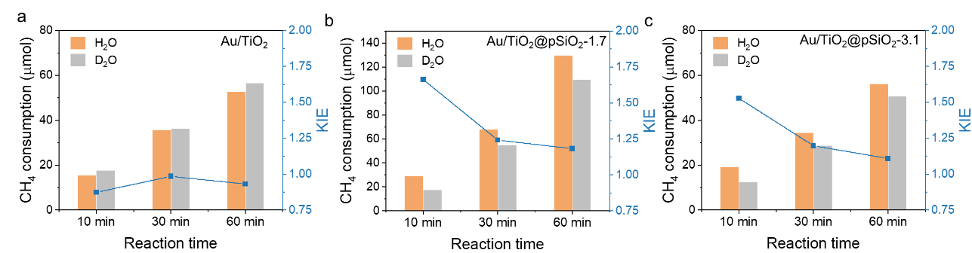
Supplementary Fig. 46. KIE study on CH₄ conversion. a-c, CH₄ consumption under different light irradiation times on Au/TiO₂ (a), Au/TiO₂@pSiO₂-1.7 (b), and Au/TiO₂@pSiO₂-3.1 (c). Reaction conditions: 10 mg catalyst, 10 mL H₂O or D₂O, 2.5 MPa CH₄, 1 MPa O₂, UV LED as light source.

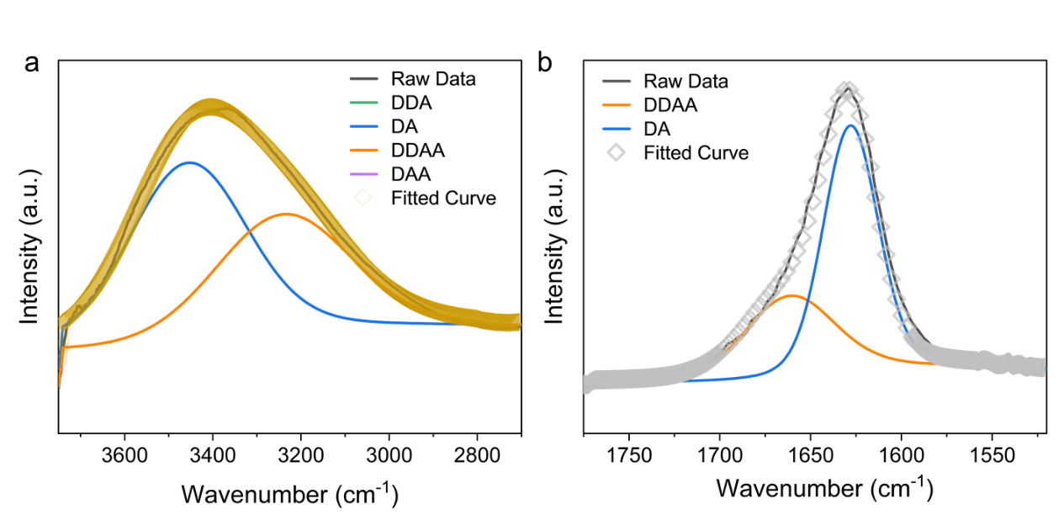
Supplementary Fig. 47. Fourier Transform Infrared analysis of Au/TiO₂@pSiO₂-1.7 at RH = 8.9%. a, Gaussian deconvolution of the OH stretching band of the water within the pores. b, Gaussian deconvolution of the HOH bending band of the water within the pores.

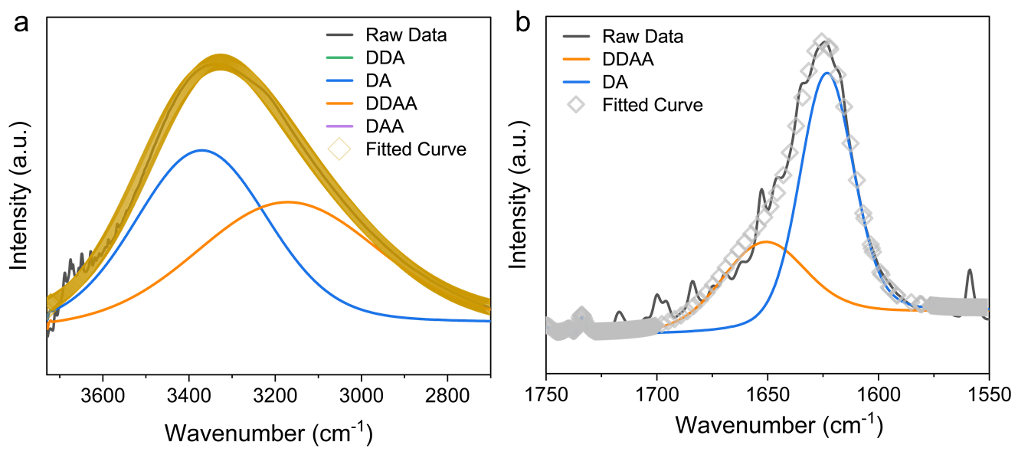
Supplementary Fig. 48. Fourier Transform Infrared analysis of Au/TiO₂@pSiO₂-3.1 at RH = 8.9%. a, Gaussian deconvolution of the OH stretching band of the water within the pores. b, Gaussian deconvolution of the HOH bending band of the water within the pores.

Supplementary Table 1. N₂ physisorption data for different catalysts.
Catalysts | Specific surface area(m²/g) | Pore size(nm)
Au/TiO₂@pSiO₂-3.1 | 339.639 | 3.1
Au/TiO₂@pSiO₂-2.6 | 440.605 | 2.6
Au/TiO₂@pSiO₂-1.7 | 562.633 | 1.7
Au/TiO₂ | 70.605 | -
Au/TiO₂@SiO₂ | 20.74 | -
pSiO₂-1.7 | 433.49 | 1.7

Supplementary Table 2. ICP-OES results of different photocatalysts.
Catalysts | Metal mass loading (%)
Au/TiO₂@pSiO₂-1.7 | 0.083
Au/TiO₂@pSiO₂-2.6 | 0.082
Au/TiO₂@pSiO₂-3.1 | 0.104
Au/TiO₂ | 0.092
Au/TiO₂@SiO₂ | 0.11

Supplementary Table 3. Product yields of various catalysts for direct oxidation of CH₄ using O₂ as the oxidant in water.
Entry | Catalysts | Amounts of products from CH₄ (μmol) |  |  |  |  | All products (μmol) | H₂O₂ Product  (μmol)
Entry | Catalysts | CH₃OOH | CH₃OH | HCHO | HCOOH | CO₂ | All products (μmol) | H₂O₂ Product  (μmol)
1 | Au/TiO₂@pSiO₂-1.7 | 58.0 | 35.3 | 154.4 | 26.8 | 7.8 | 282.3 | 446.0
2 | Au/TiO₂@pSiO₂-2.6 | 55.1 | 34.9 | 133.6 | 37.5 | 8.9 | 270.0 | 289.5
3 | Au/TiO₂@pSiO₂-3.1 | 50.4 | 35.7 | 88.8 | 5.0 | 14.6 | 194.6 | 161.4
4 | Au/TiO₂@SiO₂ | 36.6 | 15.9 | 65.6 | 8.8 | 7.5 | 134.4 | 154.0
5 | Au/TiO₂ | 59.9 | 11.0 | 21.6 | 0 | 17.7 | 110.2 | 20.4
6 | Pt/TiO₂@pSiO₂-1.7 | 41.1 | 56.2 | 212.5 | 17.4 | 15.4 | 342.7 | 79.8
7 | Pt/TiO₂ | 1.3 | 53.4 | 9.1 | 5.0 | 79.3 | 148.1 | 0
8 | Au/TiO₂ + pSiO₂-1.7 physical mixture | 60.4 | 6.6 | 13.8 | 0 | 6.7 | 87.6 | 5.0
9ª | Au/TiO₂@pSiO₂-1.7 | 0 | 0 | 0 | 0 | 0 | 0 | 0
10^{b} | Au/TiO₂@pSiO₂-1.7 | 0 | 0 | 0 | 0 | 0 | 0 | 0
11^{c} | - | 0 | 0 | 0 | 0 | 0 | 0 | 0
Reaction condition (unless specified): 10 mg catalysts, 100 mL H₂O, 2.5 MPa CH₄, 1.0 MPa O₂, 25±3 ᵒC reaction temperature, 1h reaction time, light source: 365nm UV LED with light intensity of 80 mW/cm².
ª Entry 9: reaction is conducted without light illumination (dark condition)
^{b} Entry 10: 2.5 MPa Ar gas instead of CH₄ (No CH₄ in the system)
^{c} Entry 11: no catalyst used

Supplementary Table 4. Apparent Quantum yield (AQY) of CH₄ oxidation for various photocatalysts.
Catalysts | N(photons)ª | Amount of products (μmol) |  |  |  |  | AQY  (%)
Catalysts | N(photons)ª | CH₃OOH | CH₃OH | HCHO | HCOOH | CO₂ | AQY  (%)
Pt/TiO₂@pSiO₂-1.7 | 79.6 | 41.1 | 56.2 | 212.5 | 17.4 | 15.4 | 14.1
Au/TiO₂@pSiO₂-1.7 | 79.6 | 58.0 | 35.3 | 154.4 | 26.8 | 7.8 | 10.9
Au/TiO₂@pSiO₂-2.6 | 79.6 | 55.1 | 34.9 | 133.6 | 37.5 | 8.9 | 10.7
Au/TiO₂@pSiO₂-3.1 | 79.6 | 50.4 | 35.7 | 88.8 | 5.0 | 14.6 | 7.0
Au/TiO₂ | 79.6 | 59.9 | 11.0 | 21.6 | 0 | 17.7 | 3.3
Pt/TiO₂ | 79.6 | 1.3 | 53.4 | 9.1 | 5.0 | 79.3 | 8.8
Reaction conditions: 10 mg catalysts, 2.5 MPa CH₄, 1 MPa O₂, 100 mL H₂O, 1 h reaction time, reaction temperature of 25 °C, light source: 365 nm UV LED, 80 mW/cm².
ª Light intensity: 80 mW/cm², irradiation area: 12.56 cm², light incident time: 1h

Supplementary Table 5 Comparison of H₂O₂ production over different photocatalysts.
Photocatalyst | Solvent | Gas | λ  (nm) | H₂O₂ rate  (mmol g^{–1} h^{–1}) | H₂O₂ conc. (mM g^{–1} h^{–1}) | AQY  (%) | Ref
Au/TiO₂@pSiO₂-1.7 | H₂O | O₂ | 365 | 44.6 | 446.0 | 8.2  (365 nm) | This work
Nano-BZT | H₂O | O₂ | > 420 | 1.5 | 2.9 | - | 7
Pd/APTMS/TiO₂ | PBS buffer | Air | - | 2.7 | 270.0 | 0.23 | 8
Pt/TiO₂ | H₂O | - | AM 1.5G | 5.1 | 255.0 | - | 9
PF2FBT/  TiO₂ | H₂O | O₂ | > 420 | 0.1 | 2.2 | 0.3  (420 nm) | 10
EBA-COF | H₂O /EtOH (9:1) | O₂ | 420 | 1.8 | 732.0 | 4.4  (420nm) | 11
TPB-DMTP* | H₂O | O₂ | > 420 | 1.6 | 31.0 | 18.4  (420nm) | 12
CoPc-BTM-COF | H₂O /EtOH (9:1) | O₂ | > 400 | 2.1 | 42 | 7.2  (630 nm) | 13
DMCR-1NH | H₂O/IPA (10:1) | O₂ | 420-700 | 2.6 | 129.0 | 10.2  (420 nm) | 14
TpDz | H₂O | O₂ | > 420 | 7.3 | 407.0 | 11.9  (420 nm) | 15
Hz-TP-BT-COF | H₂O | Air | 420-600 | 5.7 | 378.0 | 17.5  (420nm) | 16
few-layered C₃N₄ (fl-CN) | H₂O/EtOH  (9:1) | O₂ | 420-780 | 0.95 | 19.4 | 9.0  (420 nm) | 17
Sb-SAPC15 | H₂O | O₂ | > 420 | 0.6 | 12.0 | 17.6  (420 nm) | 18
MIL-125-R | H₂O /BnOH  (2:5) | O₂ | > 420 | 1.0 | 500.0 | - | 19
CoO_{x}/Mo:  BiVO₄/Pd | PBS buffer | O₂ | AM 1.5G | 8.6 | 713.0 | 5.8  (420 nm) | 20

Supplementary Table 6. Performance comparison of photocatalytic CH₄ oxidation with O₂ over different photocatalysts.
Catalysts | Reaction conditions | Oxygenate yield  (μmol g⁻¹ h⁻¹) | Selectivity  (%) | AQY(%) | Ref
Pt/TiO₂@pSiO₂₋1.7 | 2.5 MPa CH₄, 1 MPa O₂, 25 ºC | 32728.9 | 94.6 | 14.1  (365nm) | This work
Au/TiO₂@pSiO₂-1.7 | 2.5 MPa CH₄, 1 MPa O₂, 25 ºC | 27441.0 | 97.2 | 10.9  (365nm) | This work
Au-CoO_{x}/TiO₂ | 20 bar CH₄, 1bar O₂, 25 ºC | 2540.0 | 95.0 | 1.2  (368 nm) | 1
Cu-def-WO₃ | 20 bar CH₄, 0.1 MPa O₂, 25 °C | 2489.5 | 100 | 1.14  (420 nm) | 21
Au/In₂O₃ | 20 bar CH₄, 10 bar O₂, 25 ºC | 2030.0 | 97.6 | 1.4  (365 nm) | 22
N-doped TiO₂ | 19 bar CH₄, 1 bar O₂, 25°C | 25926.0 | 99.0 | 1.4  (365 nm) | 23
TiO₂@SiO₂-AuPd | 6.9 bar CH₄, 2.75 bar O₂, 25 ºC | 15400.0 | 94.5 | 2.45  (365 nm) | 5
Ni-NC/TiO₂ | 20 bar CH₄, 1bar O₂, 25ºC | 730.0 | 93.0 | 1.9  (360 nm) | 24
AC-Co₁/PCN | 8 bar CH₄, 25°C | 312.5 | 99.9 | 3.51  (365 nm) | 25
Ru₁O_{x}/ZnO | 2.0 MPa CH₄, 0.1 MPa O₂, 25 °C | 353.0 | 100.0 | 5.1  (320 nm) | 26
q-BiVO₄ | 10 bar CH₄, 10 bar O₂, 25 ºC | 370.0 | 96.6 | 3.1  (365 nm) | 2
Au/ZnO | 20 bar CH₄, 1 bar O₂, 25 ºC | 12550.0 | 95.4 | 11.7  (368 nm) | 4
Au-Pd/ZnO | 29 bar CH₄, 1bar O₂, 25 ºC | 8100.0 | 97.2 | 6.4  (365 nm) | 27
Defective TiO₂ | 1.9 MPa CH₄, 0.1 MPa O₂, 25 ºC | 362.0 | 93.1 | 7.96  (360 nm) | 28
Au-Cu/ZnO | 20 bar CH₄, 1 bar O₂, 25 ºC | 11225.0 | 100.0 | 14.1  (365 nm) | 6
Au/ZnO | 29 bar CH₄, 1 bar O₂, 25 ºC | 36400.0 | 100.0 | 3.8  (365 nm) | 29
Pd/def-In₂O₃ | 1.9 MPa CH₄, 0.1 MPaO₂, 25 ºC | 2995.0 | 100.0 | 2.9  (420 nm) | 30
Cu−W−TiO₂ | 20 bar CH₄, 2 bar O₂, 30 ºC | 17250.0 | 97.1 | - | 31
90% Anatase TiO₂ | 2.0 MPa CH₄, 0.5 MPa O₂, 25 ºC | 8090 | 97.4 | - | 32
Fe-MOF | 1 atm CH₄/O₂ (1:1), 25 °C | 8810.0 | 100.0 | - | 33
few-layered C₃N₄  (fl-CN) | 19 bar CH₄, 1 bar O₂, 25 °C | 1893.0 | 99.2 | - | 17
AuPd/TiO₂ | 30 bar CH₄, 10 bar O₂, 25 ºC | 20000.0 | 98.0 | - | 34
CuO_{x}/ZnO | 30 °C, 19 bar CH₄, 1bar O₂ | 21250.0 | 100.0 | - | 35

Supplementary Table 6 (continued). Performance comparison of photocatalytic CH₄ oxidation with O₂ over different photocatalysts.
Catalysts | Reaction conditions | Oxygenate yield  (μmol g_{cat}⁻¹ h⁻¹) | Selectivity  (%) | AQY(%) | Ref
Fe SA−NC/C₃N₄ | 1 bar O₂, 19 bar CH₄, 30 °C, 1 h | 5020 | 98.5 | - | 36
Ag/TiO₂ | 20 bar CH₄, 1bar O₂, 25 ºC | ~5400.0 | ~90.0 | - | 37
Ga₂O₃ | 5 mL CH₄, 40 ºC | 354.7 | 94.8 | - | 38
ZnO/Fe₂O₃ | 1atm CH₄, 25 ºC | 118.84 | 100.0 | - | 39
0.5Pd-ZnTi-LDH-A200 | 19 bar CH₄,1 bar O₂, 25 ºC | 4924.47 | 100.0 | - | 40
Au/WO₃ | 1.9 MPa CH₄, 0.1 MPa O₂, 25 ºC | 300.0 | 99 | - | 41

Supplementary Table 7. Average number of hydrogen bonds of water molecules in Au/TiO₂ and Au/TiO₂@pSiO₂-X at different RH values.
Catalysts | Average number of H-bonds
Catalysts | RH = 100% | RH = 8.9%
Au/TiO₂ | 3.18 | -
Au/TiO₂@pSiO₂-3.1 | 3.02 | 2.98
Au/TiO₂@pSiO₂-1.7 | 2.90 | 2.85

Supplementary Note 1: O₂ pressure dependence study
O₂ is known to plays a crucial role in photocatalytic CH₄ oxidation. Compared to bare Au/TiO₂, Au/TiO₂@pSiO₂-X offers a higher surface area due to its porous silica shell. Thus, one possible explanation for the high yields of liquid oxygenates and H₂O₂ is the enhanced O₂ enrichment near Au/TiO₂ interface, attributed to the increased surface area. However, the following findings invalidate this assumption.
We examined the effect of O₂ partial pressure on catalytic performance for Au/TiO₂ and Au/TiO₂@pSiO₂-X catalysts and their metal free counterparts (TiO₂ and TiO₂@pSiO₂). If the nanoporous silica shell facilitated O₂ enrichment in aqueous solutions, TiO₂@pSiO₂ would be expected to exhibit higher oxygenates and H₂O₂ production compared to TiO₂; yet, however, the opposite was observed (Supplementary Fig. 14c, d). TiO₂ achieved maximum oxygenates yield of 13.1 mmol g⁻¹ h⁻¹ at 0.21 MPa O₂, with no further increase beyond this pressure. Conversely, TiO₂@pSiO₂-2.6 showed gradual increase in oxygenates yields with O₂ pressure; however, even at 0.5 MPa, it only reached 2.58 mmol g⁻¹ h⁻¹, four times lower than bare TiO₂. For Au/TiO₂ and Au/TiO₂@pSiO₂-1.7, the porous SiO₂ shell also requires a higher O₂ pressure (1 MPa compared to 0.042 MPa) to achieve optimal yields (Supplementary Fig. 14a, b), which suggests that the hydrophilic silica channels hinder O₂ transport rather than facilitate its enrichment. This is likely due to the competitive adsorption of water and oxygen in an aqueous solution, compounded by the capillary effect. Water molecules adsorb inside the silica pores, filling them with liquid water. In contrast to the easy transport of O₂ gas through silica pores in the gas phase, the hydrophilic silica saturated with water makes it challenging for the hydrophobic O₂ gas to permeate in an aqueous solution.
Depositing Au on TiO₂ and TiO₂@pSiO₂ significantly improved product yields across all O₂ pressures, underscoring the role of Au in enhancing O₂ adsorption and activation. Only 0.042 MPa O₂ is required to reach the maximum oxygenates yields for Au/TiO₂, compared to 0.21 MPa for TiO₂ (Supplementary Fig. 14a, c). The comparison between Au/TiO₂@pSiO₂ and TiO₂@pSiO₂ shows the similar trends (Fig. 2d, Supplementary Fig. 14d). Furthermore, moving Au from the TiO₂ surface to the SiO₂ surface, forming TiO₂@pSiO₂-Au catalyst, resulted in a fourfold reduction in CH₄ conversion (Supplementary Fig. 16). This highlights the importance of the Au/TiO₂ interface for effective O₂ adsorption and activation in methane oxidation.
Supplementary Note 2: Generalization of the confinement strategy
- Investigations with different metal co-catalysts
Similar enhancement trends were observed when Pt, Rh, or Pd were deposited as cocatalysts (Fig. 3a). Among these, the Pt/TiO₂@pSiO₂-1.7 catalyst exhibited the highest oxygenate production. This led us to further investigate Pt-based systems. We synthesized a series of Pt based catalysts with varying silica pore size, and the oxygenates yields followed the trend: Pt/TiO₂@pSiO₂-1.7 > Pt/TiO₂@pSiO₂-2.6 > Pt/TiO₂@pSiO₂-3.1 > Pt/TiO₂ (Supplementary Fig. 22). In addition, Pt/TiO₂@pSiO₂ showed a significantly higher H₂O₂ production compared to Pt/TiO₂, which did not produce any H₂O₂ (Fig. 3a, Supplementary Fig. 22).
We conducted in situ EPR and ¹⁸O isotope labeling experiment to identify key radicals and their formation pathway over Pt/TiO₂@pSiO₂. Consistent with previous findings on Au/TiO₂@pSiO₂, •OH radical production increased as silica pore size decreased, while •OOH radical production showed the opposite trend (Supplementary Fig. 38). The ¹⁸O isotope labeling experiment, using benzoic acid as an •OH radical trap, confirmed that for Pt/TiO₂@pSiO₂, •OH radicals primarily originate from H₂O rather than O₂ (Supplementary Fig. 39). In contrast, for Pt/TiO₂, approximately half of the •OH radicals derive from H₂O oxidation and the other half from O₂ reduction (Supplementary Fig. 40). This observation is also consistent with what we observed for Au/TiO₂@pSiO₂ and Au/TiO₂.
These results for Pt/TiO₂@pSiO₂ closely resemble those observed for Au/TiO₂@pSiO₂, not only in terms of oxygenate and H₂O₂ production but also in radical generation and their formation pathways. This similarity further suggests that the nanoporous confinement strategy is applicable across different noble metal cocatalysts.
- Investigations with different oxide semiconductors
We also investigated the versatility of the confinement approach by replacing P25 TiO₂ with anatase TiO₂, BiVO₄ and ZnO. Both BiVO₄ and anatase TiO₂ (A-TiO₂), when coated with silica (Au/BiVO₄@pSiO₂ and Au/A-TiO₂@pSiO₂), showed notably enhanced CH₄ conversion (Fig. 3a, and Supplementary Fig. 23-24) Specifically, Au/BiVO₄@pSiO₂-2.6 achieved oxygenate yields of 3.1 mmol g⁻¹ h⁻¹, which is 13 times higher than Au/BiVO₄. Au/anatase TiO₂@pSiO₂ shows similar observation.
In the case of ZnO, we found that encapsulating ZnO with porous SiO₂ significantly decreased its CH₄ conversion rates (Supplementary Fig. 25a), likely due to ZnO dissolution in the ammonia solution used during SiO₂ coating. This is supported by XRD analysis (Supplementary Fig. 25b), which shows broader and more noisy peaks for Au/ZnO@pSiO₂-2.6 compared to Au/ZnO, indicating a reduced ZnO crystallite size after SiO₂ coating.
Supplementary Note 3: AQY calculation for CH₄ conversion and H₂O₂ formation.
In the photochemical CH₄ oxidation with O₂, CH₄ is oxidized to various oxygenates, including CH₃OOH, CH₃OH, HCHO, HCOOH and CO₂, primarily consuming holes. Meanwhile, O₂ is reduced to H₂O₂ by consuming electrons, as supported by the ¹⁸O labeling experiments (Fig. 4f).
The reactions for CH₄ oxidation to oxygenates are presented as follows:
- H₂O + h⁺ $→$ •OH + H⁺
- CH₄ + •OH $→$ •CH₃ + H⁺
- •CH₃ + O₂ $→$ CH₃OO•
- CH₃OO + e⁻ + H⁺ $→$ CH₃OOH
- CH₃OOH + 2e⁻ + 2H⁺ $→$ CH₃OH + H₂O
- CH₃OH + 2OH $→$ HCHO + H₂O or CH₃OH + 2h⁺$→$ HCHO + 2H⁺
- HCHO + 0.5O₂ + 2h⁺ $→$ HCOOH
- HCHO + O₂ + 4h⁺ $→$ CO₂ + H₂O
The reactions for O₂ reduction to H₂O₂ is
- O₂ + 2e⁻ + 2H⁺ $→$ H₂O₂
Given these reactions, we can calculate the AQY based on two processes: CH₄ oxidation, which primarily involves the consumption of holes, and O₂ reduction, which reflects the consumption of electrons. The AQY value at monochromatic wavelength of 365 nm was calculated according to the following equation:
$$AQY= \frac{N\left(used photons\right)}{N(incident photons)}×100\%$$
where N(used photons) and N(incident photons) represent the number of photogenerated charges and the number of incident photons, respectively. N(photons) = IAt/E, where I, A, t and E represent incident light 𝜆 intensity (W/cm²), irradiation area (cm²), light incident time (s) and photo energy (J), respectively.
For CH₄ oxidation to oxygenates, N(used photons) = n(CH₃OOH) + 3n(CH₃OH) + 5n(HCHO) + 7n(HCOOH) + 9n(CO₂), where n(CH₃OOH), n(CH₃OH), n(HCHO), n(HCOOH) and n(CO₂) represent the mole numbers of produced CH₃OOH, CH₃OH, HCHO, HCOOH and CO₂, respectively. For O₂ reduction to H₂O₂, N(used photons) = 2n(H₂O₂). The calculated AQY for CH₄ oxidation to oxygenates and AQY for H₂O₂ generation over different photocatalyst are presented in Supplementary Fig. 37 and Supplementary Table 4.
By comparing the AQY from CH₄ oxidation to oxygenates, which primarily consumes holes, and O₂ reduction to H₂O₂, which consumed electrons, we could calculate the selectivity of H₂O₂ across different photocatalysts using the formula: H₂O₂ selectivity (%) = AQY (H₂O₂ generation)/AQY (CH₄ oxidation) $×$ 100%.
Supplementary Note 4: H/D exchange between CH₄ and D₂O during KIE measurement
For the overall CH₄ oxidation to oxygenates, we observed a decrease in KIE over time for Au/TiO₂@pSiO₂-1.7, likely due to H/D exchange between CH₄ and D₂O during reactions:
- D₂O + h⁺ OD + D⁺
- O₂ + 2e⁻ + 2D⁺ D₂O₂
- CH₄ + OD CD₃ + HDO
- CH₃ + O₂ + e⁻ + D⁺ CH₃OOD
- CH₃OOD + 2e⁻ + 2D⁺ CH₃OD + D₂O
- CH₃OD + OD CH₂OD + HDO
- CH₂OD + OD DOCH₂OD HCDO + HDO
- HCDO + O₂ + 4h⁺ CO₂ + HDO

Supplementary References
  - Song, H. et al. Selective Photo-oxidation of Methane to Methanol with Oxygen over Dual-Cocatalyst-Modified Titanium Dioxide. ACS Catalysis 10, 14318-14326, doi:10.1021/acscatal.0c04329 (2020).
  - Fan, Y. et al. Selective photocatalytic oxidation of methane by quantum-sized bismuth vanadate. Nature Sustainability 4, 509-515, doi:10.1038/s41893-021-00682-x (2021).
  - Agarwal, N. et al. Aqueous Au-Pd colloids catalyze selective CH₄ oxidation to CH₃OH with O₂ under mild conditions. Science 358, 223-227, doi:10.1126/science.aan6515 (2017).
  - Song, H. et al. Direct and Selective Photocatalytic Oxidation of CH₄ to Oxygenates with O₂ on Cocatalysts/ZnO at Room Temperature in Water. Journal of the American Chemical Society 141, 20507-20515, doi:10.1021/jacs.9b11440 (2019).
  - Xie, C. et al. Transport Mediating Core–Shell Photocatalyst Architecture for Selective Alkane Oxidation. Nano Letters 23, 2039-2045, doi:10.1021/acs.nanolett.2c04567 (2023).
  - Luo, L. et al. Binary Au–Cu Reaction Sites Decorated ZnO for Selective Methane Oxidation to C₁ Oxygenates with Nearly 100% Selectivity at Room Temperature. Journal of the American Chemical Society 144, 740-750, doi:10.1021/jacs.1c09141 (2022).
  - Liu, B., Zhang, W., Zhang, Q., Guan, Y. & Lu, Z. Synergistic Promotion of the Photocatalytic Preparation of Hydrogen Peroxide (H₂O₂) from Oxygen by Benzoxazine and Si─O─Ti Bond. Small 19, 2303907, doi:https://doi.org/10.1002/smll.202303907 (2023).
  - Chu, C. et al. Electronic Tuning of Metal Nanoparticles for Highly Efficient Photocatalytic Hydrogen Peroxide Production. ACS Catalysis 9, 626-631, doi:10.1021/acscatal.8b03738 (2019).
  - Wang, L. et al. Simultaneous hydrogen and peroxide production by photocatalytic water splitting. Chinese Journal of Catalysis 40, 470-475, doi:https://doi.org/10.1016/S1872-2067(19)63274-2 (2019).
  - Hong, Y. et al. Unassisted photocatalytic H₂O₂ production under visible light by fluorinated polymer-TiO₂ heterojunction. Chemical Engineering Journal 418, 129346, doi:https://doi.org/10.1016/j.cej.2021.129346 (2021).
  - Zhai, L. et al. Constructing Synergistic Triazine and Acetylene Cores in Fully Conjugated Covalent Organic Frameworks for Cascade Photocatalytic H₂O₂ Production. Chemistry of Materials 34, 5232-5240, doi:10.1021/acs.chemmater.2c00910 (2022).
  - Li, L., Xu, L., Hu, Z. & Yu, J. C. Enhanced Mass Transfer of Oxygen through a Gas–Liquid–Solid Interface for Photocatalytic Hydrogen Peroxide Production. Advanced Functional Materials 31, 2106120, doi:https://doi.org/10.1002/adfm.202106120 (2021).
  - Zhi, Q. et al. Piperazine-Linked Metalphthalocyanine Frameworks for Highly Efficient Visible-Light-Driven H₂O₂ Photosynthesis. Journal of the American Chemical Society 144, 21328-21336, doi:10.1021/jacs.2c09482 (2022).
  - Das, P. et al. Integrating Bifunctionality and Chemical Stability in Covalent Organic Frameworks via One-Pot Multicomponent Reactions for Solar-Driven H₂O₂ Production. Journal of the American Chemical Society 145, 2975-2984, doi:10.1021/jacs.2c11454 (2023).
  - Liao, Q. et al. Regulating Relative Nitrogen Locations of Diazine Functionalized Covalent Organic Frameworks for Overall H₂O₂ Photosynthesis. Angewandte Chemie International Edition 62, e202310556, doi:https://doi.org/10.1002/anie.202310556 (2023).
  - Liu, R. et al. Linkage-engineered donor–acceptor covalent organic frameworks for optimal photosynthesis of hydrogen peroxide from water and air. Nature Catalysis 7, 195-206, doi:10.1038/s41929-023-01102-3 (2024).
  - Feng, B. et al. Tailored Exfoliation of Polymeric Carbon Nitride for Photocatalytic H₂O₂ Production and CH₄ Valorization Mediated by O₂ Activation. Angewandte Chemie International Edition 63, e202401884, doi:https://doi.org/10.1002/anie.202401884 (2024).
  - Teng, Z. et al. Atomically dispersed antimony on carbon nitride for the artificial photosynthesis of hydrogen peroxide. Nature Catalysis 4, 374-384, doi:10.1038/s41929-021-00605-1 (2021).
  - Isaka, Y., Kawase, Y., Kuwahara, Y., Mori, K. & Yamashita, H. Two-Phase System Utilizing Hydrophobic Metal–Organic Frameworks (MOFs) for Photocatalytic Synthesis of Hydrogen Peroxide. Angewandte Chemie International Edition 58, 5402-5406, doi:https://doi.org/10.1002/anie.201901961 (2019).
  - Liu, T. et al. Overall photosynthesis of H₂O₂ by an inorganic semiconductor. Nature Communications 13, 1034, doi:10.1038/s41467-022-28686-x (2022).
  - Luo, L. et al. Nearly 100% selective and visible-light-driven methane conversion to formaldehyde via. single-atom Cu and W^{δ+}. Nature Communications 14, 2690, doi:10.1038/s41467-023-38334-7 (2023).
  - Jiang, Y. et al. Enabling Specific Photocatalytic Methane Oxidation by Controlling Free Radical Type. Journal of the American Chemical Society 145, 2698-2707, doi:10.1021/jacs.2c13313 (2023).
  - Zhang, R. et al. Direct Photocatalytic Methane Oxidation to Formaldehyde by N Doping Co-Decorated Mixed Crystal TiO₂. ACS Nano 18, 12994-13005, doi:10.1021/acsnano.4c01318 (2024).
  - Song, H. et al. Atomically Dispersed Nickel Anchored on a Nitrogen-Doped Carbon/TiO₂ Composite for Efficient and Selective Photocatalytic CH₄ Oxidation to Oxygenates. Angewandte Chemie International Edition 62, e202215057, doi:https://doi.org/10.1002/anie.202215057 (2023).
  - Ding, J. et al. Asymmetrically coordinated cobalt single atom on carbon nitride for highly selective photocatalytic oxidation of CH₄ to CH₃OH. Chem 9, 1017-1035, doi:https://doi.org/10.1016/j.chempr.2023.02.011 (2023).
  - Gong, H. et al. Selective Photocatalytic Aerobic Oxidation of Methane to Methyl Hydroperoxide by ZnO-Loaded Single-Atomic Ruthenium Oxide Catalyst. Journal of the American Chemical Society 147, 9134-9146, doi:10.1021/jacs.4c11685 (2025).
  - Zhou, Q. et al. Selective Photocatalytic Oxidation of Methane to Methanol by Constructing a Rapid O₂ Conversion Pathway over Au–Pd/ZnO. ACS Catalysis 14, 955-964, doi:10.1021/acscatal.3c04374 (2024).
  - Luo, P.-P., Zhou, X.-K., Li, Y. & Lu, T.-B. Simultaneously Accelerating Carrier Transfer and Enhancing O₂/CH₄ Activation via Tailoring the Oxygen-Vacancy-Rich Surface Layer for Cocatalyst-Free Selective Photocatalytic CH₄ Conversion. ACS Applied Materials & Interfaces 14, 21069-21078, doi:10.1021/acsami.2c03671 (2022).
  - Zhou, Q. et al. Selective photocatalytic oxidation of methane to C₁ oxygenates by regulating sizes and facets over Au/ZnO. Nano Research 17, 3810-3818, doi:10.1007/s12274-023-6323-5 (2024).
  - Luo, L. et al. Synergy of Pd atoms and oxygen vacancies on In₂O₃ for methane conversion under visible light. Nature Communications 13, 2930, doi:10.1038/s41467-022-30434-0 (2022).
  - Huang, M. et al. Selective Photocatalytic Oxidation of Methane to Oxygenates over Cu–W–TiO₂ with Significant Carrier Traps. ACS Catalysis 12, 9515-9525, doi:10.1021/acscatal.2c02424 (2022).
  - Jiang, Y. et al. Elevating Photooxidation of Methane to Formaldehyde via TiO₂ Crystal Phase Engineering. Journal of the American Chemical Society 144, 15977-15987, doi:10.1021/jacs.2c04884 (2022).
  - An, B. et al. Direct photo-oxidation of methane to methanol over a mono-iron hydroxyl site. Nature Materials 21, 932-938, doi:10.1038/s41563-022-01279-1 (2022).
  - Cai, X., Fang, S. & Hu, Y. H. Unprecedentedly high efficiency for photocatalytic conversion of methane to methanol over Au–Pd/TiO₂ – what is the role of each component in the system? Journal of Materials Chemistry A 9, 10796-10802, doi:10.1039/D1TA00420D (2021).
  - Cui, Y. et al. Largely Promoted C–H Activation in Methane with O₂ via d-Orbital Hybridization Induced by CuO_{x} Supported on ZnO. ACS Catalysis 15, 1607-1615, doi:10.1021/acscatal.4c06051 (2025).
  - Xu, Y. et al. Iron Oxide Clusters as Electron Donors Under Light Enhance Oxygen Reduction Kinetics at Atomically Dispersed Fe for Photocatalytic CH₄ Partial Oxidation. Angewandte Chemie International Edition 64, e202419075, doi:https://doi.org/10.1002/anie.202419075 (2025).
  - Feng, N. et al. Efficient and selective photocatalytic CH₄ conversion to CH₃OH with O₂ by controlling overoxidation on TiO₂. Nature Communications 12, 4652, doi:10.1038/s41467-021-24912-0 (2021).
  - Han, C. et al. Selective Cleavage of Chemical Bonds in Targeted Intermediates for Highly Selective Photooxidation of Methane to Methanol. Journal of the American Chemical Society 145, 8609-8620, doi:10.1021/jacs.3c01317 (2023).
  - Zheng, K. et al. Room-Temperature Photooxidation of CH₄ to CH₃OH with Nearly 100% Selectivity over Hetero-ZnO/Fe₂O₃ Porous Nanosheets. Journal of the American Chemical Society 144, 12357-12366, doi:10.1021/jacs.2c03866 (2022).
  - Fu, L. et al. Highly Selective Conversion of CH₄ to High Value-Added C₁ Oxygenates over Pd Loaded ZnTi-LDH. Advanced Energy Materials 13, 2301118, doi:https://doi.org/10.1002/aenm.202301118 (2023).
  - Wei, S. et al. Aerobic oxidation of methane to formaldehyde mediated by crystal-O over gold modified tungsten trioxide via photocatalysis. Applied Catalysis B: Environmental 283, 119661, doi:https://doi.org/10.1016/j.apcatb.2020.119661 (2021).

