**Supplementary Figures**

# Extended Data Fig.1: Regional patterns of mouse cerebellum after fear conditioning

**a,** Visium spatial transcriptomics data of the mouse cerebellum in HC, CD, and TN conditions. Spot color indicates cell type abundance of cell type located within the cerebellar region, calculated by cell2location. **b,** Comparison of the anatomical locations of the medulla, fourth ventricle, and molecular layer within the nodulus region using *in situ* hybridization (ISH) data from the Allen Brain Atlas and Visium spatial transcriptomics data. Red border highlights the annotated region in the Allen Brain Atlas (left)**.** Visium spots corresponding to the same region are shown (right). **c,** UMAP representation of the Visium spatial transcriptomics dataset, colored by annotated region and split by condition. **d,** Barplot showing the proportion of each region across different conditions.

**Extended Data Fig.2: Spatial transcriptomics profile of the Purkinje region after different phases of fear learning**

**a,** Spatial plot of the Purkinje layer of the dataset colored by spatial clusters. Unsupervised spatial clustering was conducted using Bayesspace. **b,** Anatomical and spatial plot of the Purkinje layer in HC and CD samples. Anatomical plot is divided based on the cerebellar lobules, with reference to the Allen Brain Atlas. Purkinje layer spots in the spatial plot were split manually based on the anatomical plot. **c,** Spatial plots of normalized gene expressions of *ZebrinII*-positive marker *Aldoc* and *ZebrinII*-negative marker *Nptn*. Plot shown is the TN sample. **d,** Venn diagram of subregion-specific DEGs identified in each vermis and hemisphere for each pairwise comparison among the three conditions, HC, CD, and TN. **e,** Enrichment analysis results for TN vs CD DEGs in the vermis region using GO biological processes. Color of bar indicates the direction of enrichment. FDR values show significance.

**Extended Data Fig.3: Significant LRT DEGs per region**

Barplot showing the number of significant DEGs using a likelihood ratio test. Significant DEGs were defined by adjusted *P* < 0.05.

**Extended Data Fig.4: Transcriptional profile of the DCN region after different phases of fear learning**

**a,** Violin plot showing expression of well-known marker gene of each cell type. **b,** Number of significant DEGs per cell type for comparison of CD vs HC (top) and TN vs HC (bottom). Significant DEGs were defined by adjusted *P* < 0.05 and log2FC > ±0.1. **c,** Heatmap of most highly differentially regulated TFs in oligodendrocytes between fear conditioning and tone retrieval phase. The log2FC between regulon activity scores (RAS) is represented by color. The significance of the comparative test of RAS is marked with asterisks. *P*-values were calculated using Wilcoxon’s test, with the Bonferroni correction. *Adjusted *P* < 0.01.

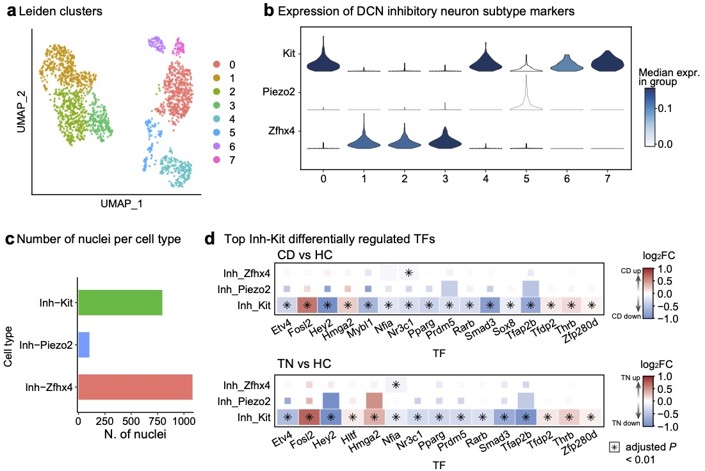

**Extended Data Fig.5: Transcriptional profile of inhibitory neuron subtypes in the DCN region after different phases of fear learning**

**a,** UMAP representation of the snRNA-seq dataset, colored by clusters derived from Leiden clustering. **b,** Violin plot showing expression of markers of DCN inhibitory neuron subtypes (*Kit*, *Piezo2*, *Zfhx4*) per each cluster. **c,** Barplot showing the number of nuclei for each inhibitory neuron subtypes Inh-Kit, Inh-Piezo2, and Inh-Zfhx4. **d,** Heatmap of most highly differentially regulated TFs in Inh-Kit between homecage and fear conditioning (top), and tone retrieval (bottom) comparison. The log2FC between RAS is represented by color. The significance of the comparative test of RAS is marked with asterisks. *P*-values were calculated using Wilcoxon’s test, with the Bonferroni correction. *Adjusted *P* < 0.01.

**Extended Data Fig.6: Analyses of inhibitory cells in DCN**

**a,** Percentage of *Gad2*+ cell in DCN. One-way ANOVA: DCN: F (2,9)=0.3434, *P*=0.7183. **b,** Percentage of *Gad2*+ cell for each subnuclei. **c,** Percentage of *Kit*+ cell in *Gad2*+ cell in DCN. One-way ANOVA: F (2,9)=1.879, *P*=0.2080. **d,** Percentage of *Kit*+ cell in *Gad2*+ cell for each subnuclei. **e,** Quantification of *Grm5* expression level in *Kit*+ inhibitory cell in each subnuclei. One-way ANOVA*:* FN: F (2,9)=5.607, *P*=0.0287. Dunnett’s multiple comparisons test: \**P*=0.0172 (HC vs CD), *P*=0.1933 (HC vs TN). One-way ANOVA*:* IPN: F (2,9)=3.214, *P*=0.0884. Dunnett’s multiple comparisons test: *P*=0.0645 (HC vs CD), *P*=0.1849 (HC vs TN). One-way ANOVA*:* DN: F (2,9)=3.339, *P*=0.0823. Dunnett’s multiple comparisons test: *P*=0.2031 (HC vs CD), *P*=0.0571 (HC vs TN).

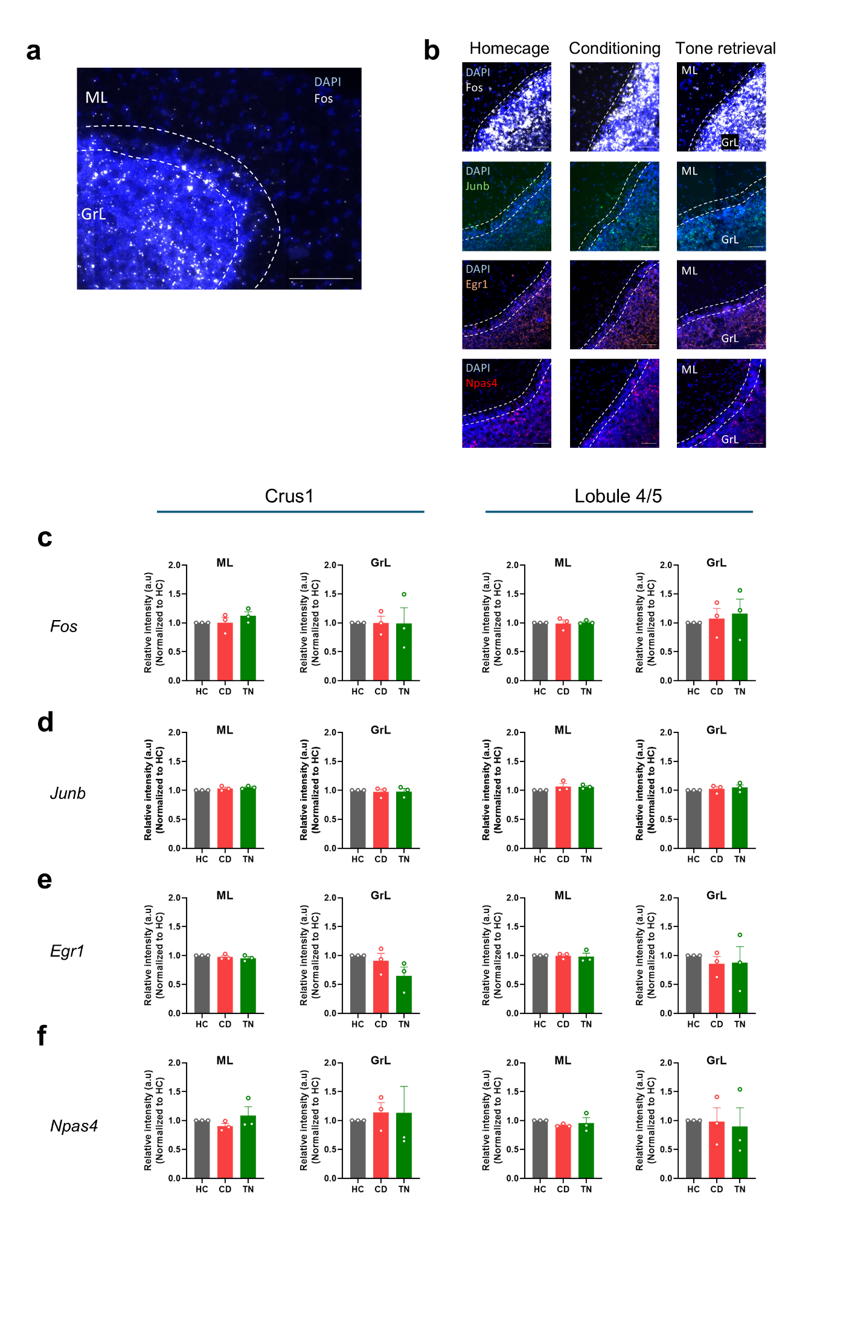

**Extended Data Fig.7: IEGs expression in the cerebellar cortex**

**a**, Representative images for cerebellar cortex layers. (ML, molecular layer; GcL, granule cell layer). Scale bar: 100 μm. **b,** ISH results showing IEGs expression in the cerebellar cortex. Scale bar: 50 μm. **c,** Quantification of ISH data for *Fos* expression level in the cerebellar cortex. Crus1: ML: One-way ANOVA: F (2,6) = 1.055, *P* = 0.4051. Dunnett’s multiple comparisons test: *P*=0.9994 (HC vs CD), *P*=0.3957 (HC vs TN). Crus1: GrL: One-way ANOVA: F (2,6) = 0.0005278, *P* = 0.9995. Dunnett’s multiple comparisons test: *P>0.9999* (HC vs CD), *P*=0.9993 (HC vs TN). L4/5: ML: One-way ANOVA: F (2,6) = 0.07518, *P* = 0.9284. Dunnett’s multiple comparisons test: *P*=0.9774 (HC vs CD), *P*=0.9683 (HC vs TN). L4/5: GrL: One-way ANOVA: F (2,6) = 0.2136, *P* = 0.8136. Dunnett’s multiple comparisons test: *P*=0.9373 (HC vs CD), *P*=0.7497 (HC vs TN). **d,** Quantification of ISH data for *Junb* expression level in the cerebellar cortex. Crus1: ML: One-way ANOVA: F (2,6) = 2.805, *P* = 0.1380. Dunnett’s multiple comparisons test: *P*=0.2911 (HC vs CD), *P*=0.0999 (HC vs TN). Crus1: GrL: One-way ANOVA: F (2,6) = 0.1267, *P* = 0.8833. Dunnett’s multiple comparisons test: *P=0.8429* (HC vs CD), *P*=0.9255 (HC vs TN). L4/5: ML: One-way ANOVA: F (2,6) = 1.388, *P* = 0.3195. Dunnett’s multiple comparisons test: *P*=0.2968 (HC vs CD), *P*=0.3494 (HC vs TN). L4/5: GrL: One-way ANOVA: F (2,6) = 0.4901, *P* = 0.6351. Dunnett’s multiple comparisons test: *P*=0.8390 (HC vs CD), *P*=0.5442 (HC vs TN). **e,** Quantification of ISH data for *Egr1* expression level in the cerebellar cortex. Crus1: ML: One-way ANOVA: F (2,6) = 0.9910, *P* = 0.4247. Dunnett’s multiple comparisons test: *P*=0.6792 (HC vs CD), *P*=0.3356 (HC vs TN). Crus1: GrL: One-way ANOVA: F (2,6) = 2.477, *P* = 0.1643. Dunnett’s multiple comparisons test: *P=*0.8058 (HC vs CD), *P*=0.1281 (HC vs TN). L4/5: ML: One-way ANOVA: F (2,6) = 0.05700, *P* = 0.9451. Dunnett’s multiple comparisons test: *P*=0.9976 (HC vs CD), *P*=0.9303 (HC vs TN). L4/5: GrL: One-way ANOVA: F (2,6) = 0.1894, *P* = 0.8323. Dunnett’s multiple comparisons test: *P*=0.8043 (HC vs CD), *P*=0.8410 (HC vs TN). **f,** Quantification of ISH data for *Npas4* expression level in the cerebellar cortex. Crus1: ML: One-way ANOVA: F (2,6) = 1.034, *P* = 0.4114. Dunnett’s multiple comparisons test: *P*=0.6934 (HC vs CD), *P*=0.7246 (HC vs TN). Crus1: GrL: One-way ANOVA: F (2,6) = 0.08126, *P* = 0.9229. Dunnett’s multiple comparisons test: *P=*0.9128 (HC vs CD), *P*=0.9203 (HC vs TN). L4/5: ML: One-way ANOVA: F (2,6) = 0.6044, *P* = 0.5766. Dunnett’s multiple comparisons test: *P*=0.4827 (HC vs CD), *P*=0.8063 (HC vs TN). L4/5: GrL: One-way ANOVA: F (2,6) = 0.05800, *P* = 0.9442. Dunnett’s multiple comparisons test: *P*=0.9982 (HC vs CD), *P*=0.9304 (HC vs TN).

**Supplementary Tables**

Supplementary Table S1: Fisher’s test of cell type abundance score of each spatial cluster

Supplementary Table S2: Transcriptional comparison of subregions of Purkinje layer subregions

Supplementary Table S3: Region-specific DEGs of the cerebellum after different phases of fear learning

Supplementary Table S4: Cell type-specific transcriptional changes of the DCN region after different phases of fear learning

Supplementary Table S5: Subtype-specific transcriptional changes of DCN region inhibitory neurons after different phases of fear learning