Supplementary materials:
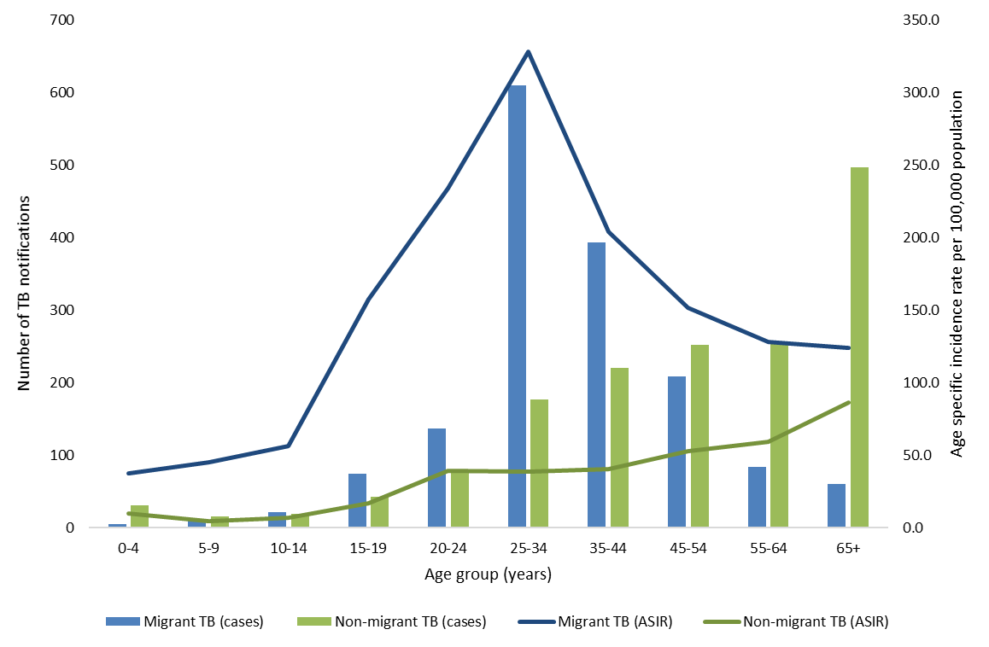

Figure S1: Cumulative number of TB patients and age-specific incidence rate per 100, 000 population by migrant status

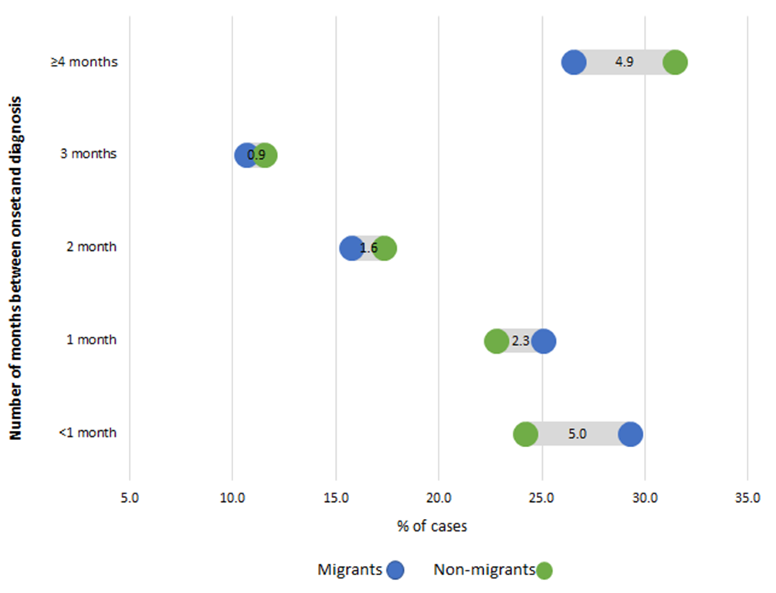

Figure S2: Interval between onset and diagnosis in months by migrant status for TB patients in Ireland

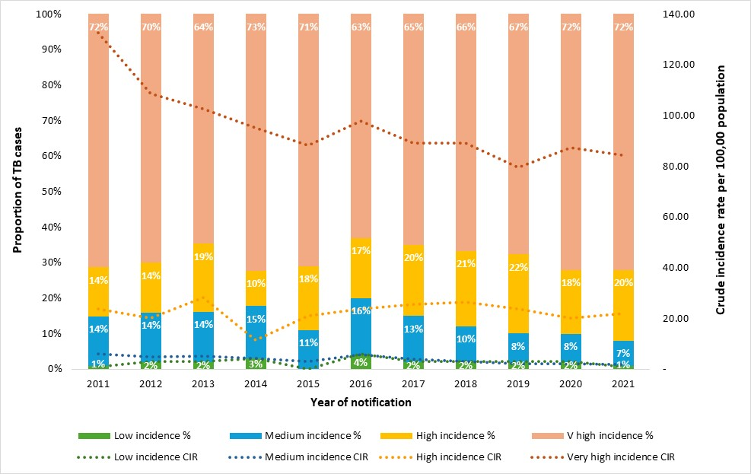

Figure S3: Annual proportion and crude incidence rates by WHO incidence categories for migrants with TB in Ireland

Table S1: Characteristics of migrants with TB by WHO incidence estimate category, Ireland
Characteristic | WHO TB incidence category |  |  |  |  | p-value
Characteristic | Overall  N = 1,602 | Low  N = 30 | Medium  N = 193 | High  N = 280 | Very high  N = 1,099 | p-value
Median age (years), (IQR) | 34.0 (16.0) | 43.5 (25.5) | 36.0 (23.3) | 35.0 (16.0) | 33.0 (15.0) | <0.001
(% missing) | 0.1 | 0 | 0.5 | 0 | <0.1
Sex |  |  |  |  |  | 0.035
Female | 687 (43%) | 11 (37%) | 74 (39%) | 104 (37%) | 498 (45%)
Male | 911 (57%) | 19 (63%) | 118 (61%) | 176 (63%) | 598 (55%)
(% missing) | 0.2 | 0 | 0.5 | 0 | 0.3
International Protection Applicant |  |  |  |  |  | <0.001
No | 1,088 (88%) | 24 (100%) | 155 (95%) | 194 (93%) | 715 (85%)
Yes | 148 (12%) | 0 (0%) | 8 (4.9%) | 14 (6.7%) | 126 (15%)
(% missing) | 23 | 20 | 16 | 26 | 23
People living with HIV |  |  |  |  |  | 0.20
Negative | 711 (87%) | 13 (93%) | 73 (91%) | 129 (91%) | 496 (85%)
Positive | 106 (13%) | 1 (7.1%) | 7 (8.8%) | 13 (9.2%) | 85 (15%)
(% missing) | 49 | 53 | 59 | 49 | 47
Disease site |  |  |  |  |  | <0.001
Pulmonary | 916 (58%) | 24 (80%) | 157 (82%) | 204 (73%) | 531 (49%)
Extrapulmonary | 667 (42%) | 6 (20%) | 35 (18%) | 75 (27%) | 551 (51%)
(% missing) | 1.2 | 0 | 0.5 | 0.4 | 1.5
Outbreak associated |  |  |  |  |  | 0.021
Not linked to outbreak | 1,527 (95%) | 27 (90%) | 177 (92%) | 266 (95%) | 1,057 (96%)
Outbreak associated | 75 (4.7%) | 3 (10%) | 16 (8.3%) | 14 (5.0%) | 42 (3.8%)
(% missing) | 0 | 0 | 0 | 0 | 0
Previous TB screening in Ireland |  |  |  |  |  | 0.072
No | 1,042 (89%) | 22 (100%) | 136 (90%) | 192 (92%) | 692 (87%)
Yes | 134 (11%) | 0 (0%) | 15 (9.9%) | 17 (8.1%) | 102 (13%)
(% missing) | 27 | 27 | 22 | 25 | 28
Previous TB diagnosis) |  |  |  |  |  | 0.14
No | 1,097 (92%) | 22 (96%) | 136 (93%) | 180 (88%) | 759 (93%)
Yes | 92 (7.7%) | 1 (4.3%) | 11 (7.5%) | 24 (12%) | 56 (6.9%)
(% missing) | 26 | 23 | 24 | 27 | 26
First line drug resistance |  |  |  |  |  | 0.94
Sensitive | 1,017 (83%) | 16 (80%) | 125 (84%) | 192 (82%) | 684 (83%)
Resistant | 213 (17%) | 4 (20%) | 24 (16%) | 42 (18%) | 143 (17%)
(% missing) | 23 | 33 | 23 | 16 | 25
M/XDR-TB |  |  |  |  |  | 0.038
No | 1,187 (97%) | 20 (100%) | 141 (95%) | 220 (94%) | 806 (97%)
Yes | 43 (3.5%) | 0 (0%) | 8 (5.4%) | 14 (6.0%) | 21 (2.5%)
(% missing) | 23 | 33 | 23 | 16 | 25

WHO incidence estimates were not available for two countries, Kosovo (n=2 patients) and Reunion (n=1 patient), in the Irish dataset.
Kruskal-Wallis rank sum test; Pearson's Chi-squared test; Fisher's exact test

