Table.1 Name and Structure of Phytoconstituents
Sr. No. | Compound name | Structure
 | (S)-6-Methoxy-2,8-dimethyl-2-[(4S,8S)-4,8,12-trimethyltridecyl] chroman-5-D | 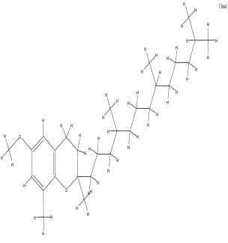
 | 1,2-Cyclopentanedione | 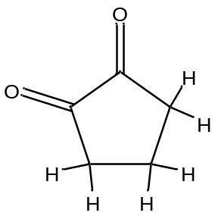
 | 1,3-Cyclopentanedione | 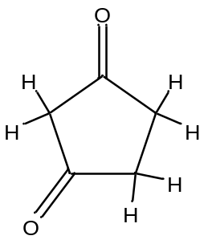
 | 1-Heptadecene | 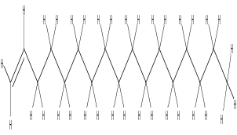
 | 1-Pentadecene | 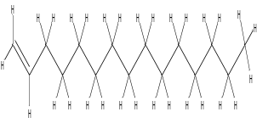
 | 1-Tetradecanol | 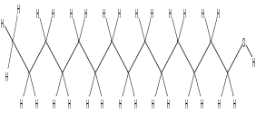
 | 1-Tridecanol | 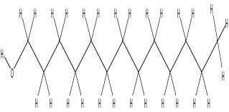
 | 2,3-Bis(1-methylallyl) pyrrolidine | 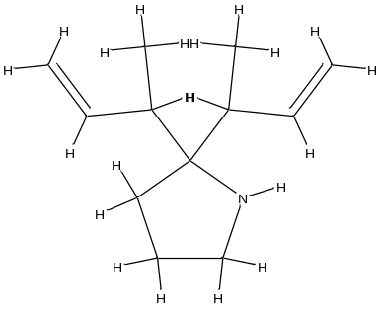
 | 2,3-Dihydrobenzofuran | 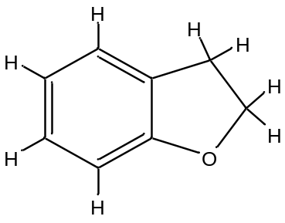
 | 2',4',5'-Trimethoxycinnamic acid | 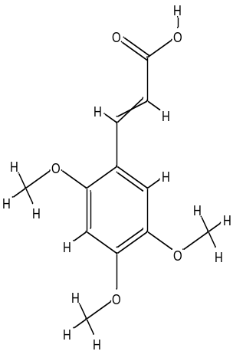
 | 2,4-Dihydroxy-2,5-dimethyl-3(2H)-furanone | 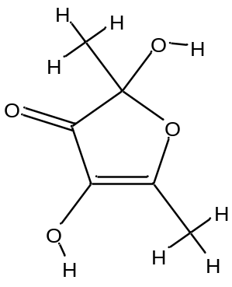
 | 2-Bornanone, ethoxycarbonylhydrazone | 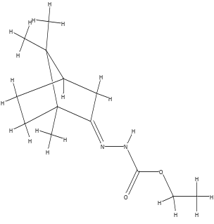
 | 2-Cyclohexen-1-one,4-hydroxy-3,5,5-trimethyl-4-(1-methyl-3-oxo-1-butenyl) | 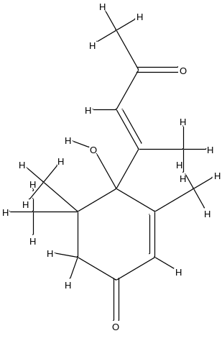2-
 | 2-Hydroxycyclopent-2-en-1-one | 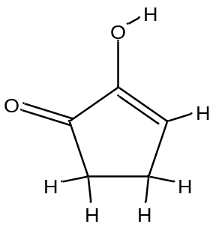
 | 2-Methoxy-4-(oxiranylmethyl)phenol | 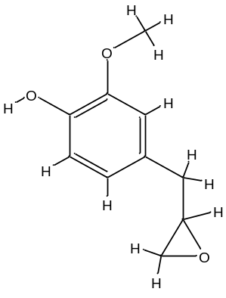
 | 2-Methoxy-4-vinylphenol | 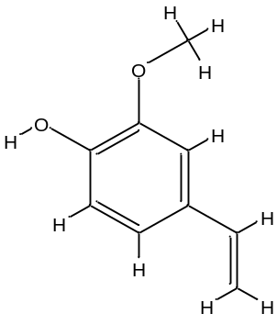
 | 2-Methoxyphenethylamine | 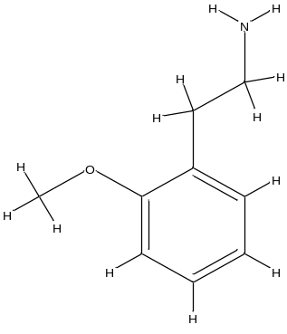
 | 2-Methylbenzaldehyde | 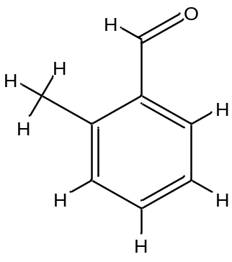
 | 2-Oxoglutaric acid | 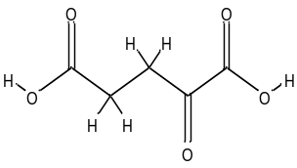
 | 2-Propenoic acid, 3-(3,4,5-trimethoxyphenyl) | 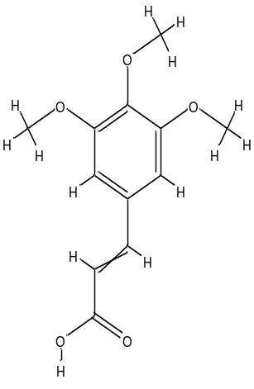
 | 3,4-Dihydroxystyrene | 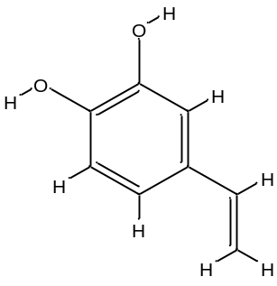
 | 3,7,11,15-Tetramethyl-2-hexadecen-1-ol | 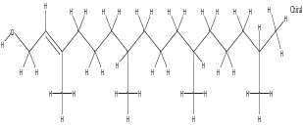
 | 3-Methoxy-4-nitrobenzyl alcohol, n-propyl ether | 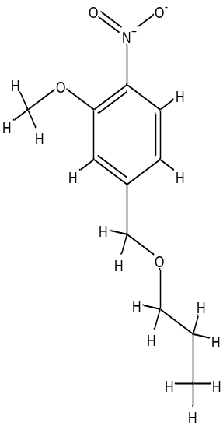
 | 4H-Pyran-4-one, 2,3-dihydro-3,5-dihydroxy-6-methyl- | 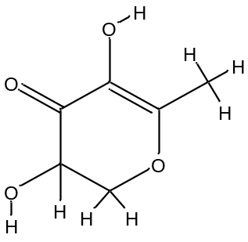
 | 4-Hydroxy-2-methylacetophenone | 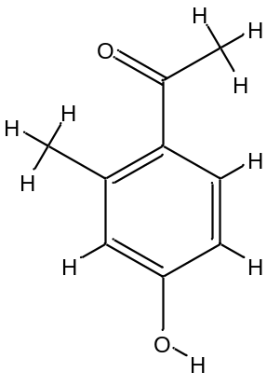
 | 4-hydroxy-3,5,5-trimethyl-4-[(1E)-3-oxobut-1-en-1-yl] cyclohex-2-en-1-one | 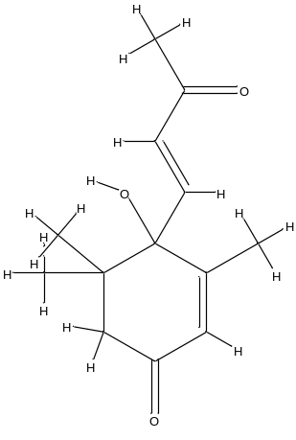
 | 4'-Hydroxy-3'-methylacetophenone | 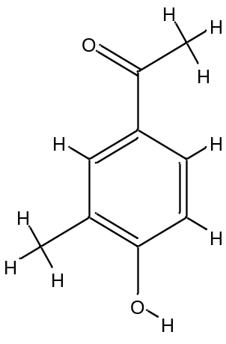
 | 4-Methylbenzaldehyde | 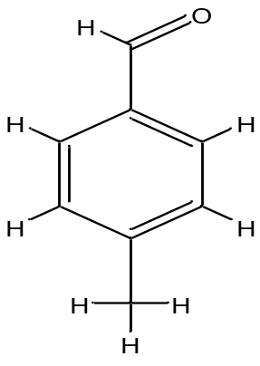
 | 5,5,8a-Trimethyl-3,5,6,7,8,8a-hexahydro-2H-chromene | 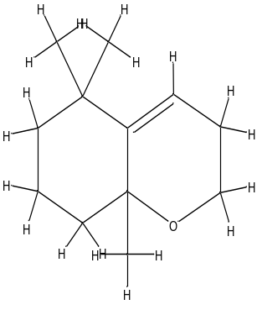
 | 5,6,7-Trimethoxycoumarin | 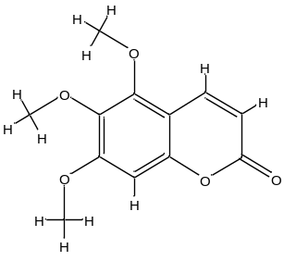
 | 5-Ethenyl-2-methoxyphenol | 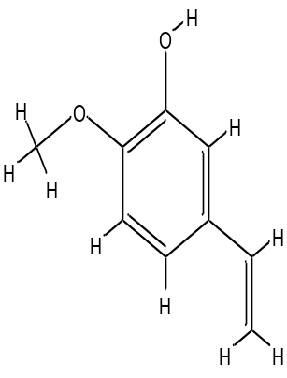
 | 9-Eicosene, (E) | 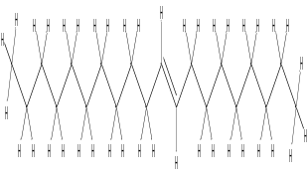
 | 26,26-Dimethyl-5,24(28)-ergostadien-3beta-ol | 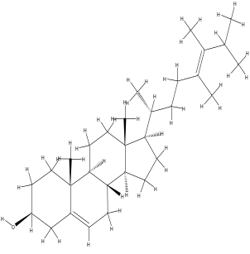
 | Allyl isovalerate | 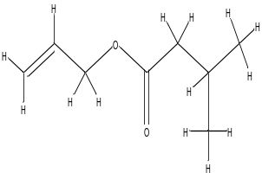
 | alpha-Tocopherol-beta-D-mannoside | 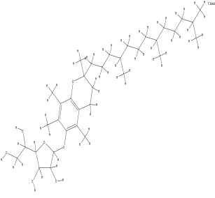
 | Beta-Citronellol | 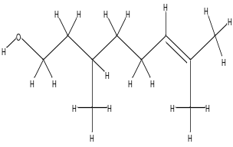
 | Campesterol | 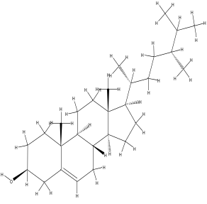
 | Cetyl Alcohol | 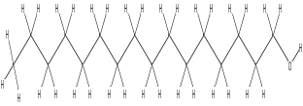
 | E-14-Hexadecenal | 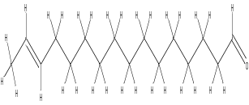
 | Ethyl 2-acetylhexanoate | 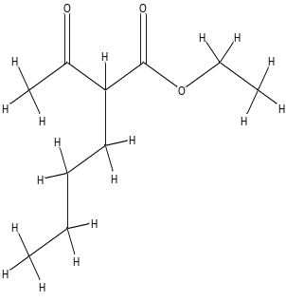
 | Fraxinol | 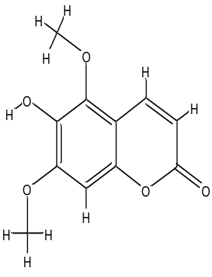
 | Fucosterol | 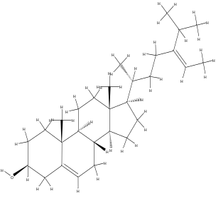
 | Gamma-Tocopherol | 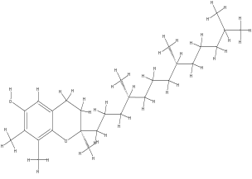
 | Lup-20(29)-en-3-one | 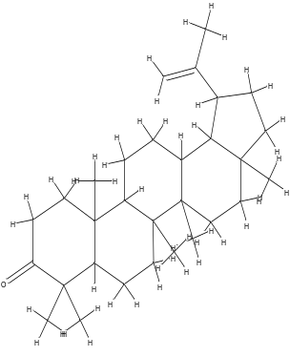
 | Methyl 14-methylhexadecanoate | 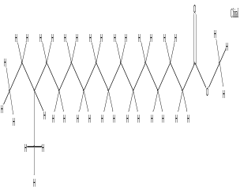
 | N-(1-Methoxycarbonyl-1-methylethyl)-4-methyl-2-aza-1,3-dioxane | 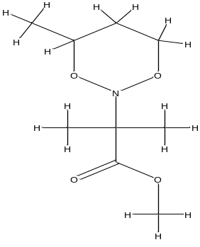
 | N-Ethoxycarbonyl alpha-Methyl-L-valine | 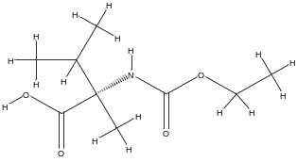
 | n-Hexadecanoic acid | 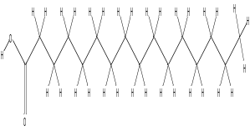
 | Phthalic acid, butyl undecyl ester | 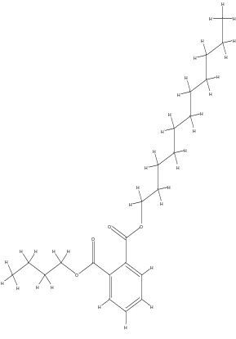
 | Phthalic acid, entyl undec-2-en-1-yl ester | 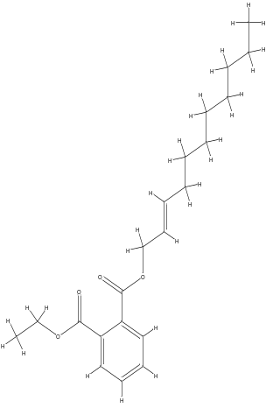
 | Phytol | 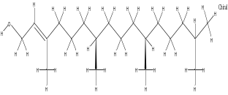
 | Pinoresinol monomethyl ether | 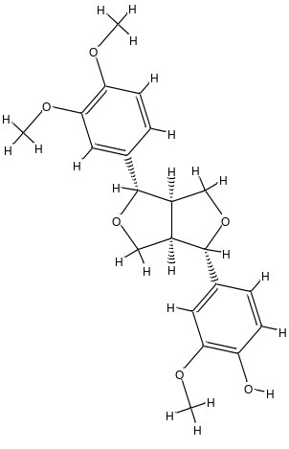
 | Pinoresinol | 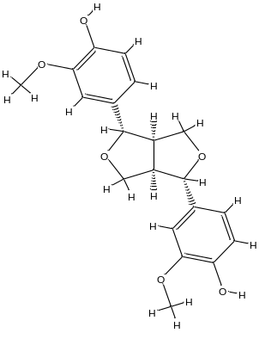
 | Prop-2-yn-1-yl 2-methylbutanoate | 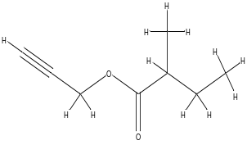
 | Reticulol | 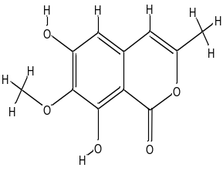
 | Salicylaldehyde hydrazine | 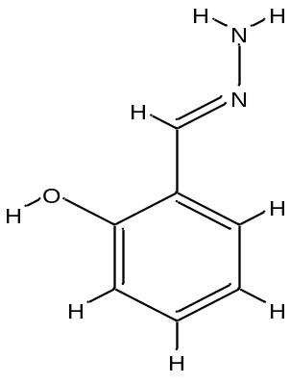
 | Sesamin | 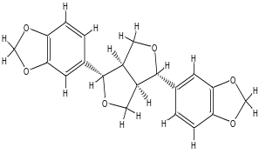
 | Spirosta-5,7-dien-3-yl acetate | 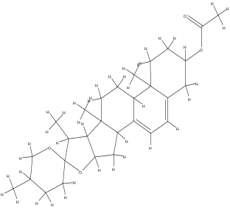
 | Stigmasta-5,22-dien-3-ol, acetate, (3beta) | 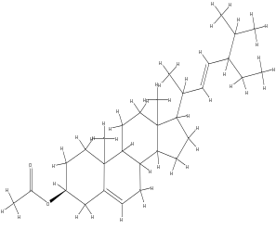
 | Succinic acid, dodec-2-en-1-yl 2-chloro-4-methylphenyl ester | 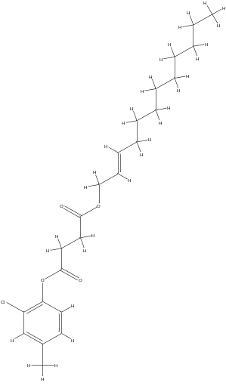
 | Tetradecyl trifluoroacetate | 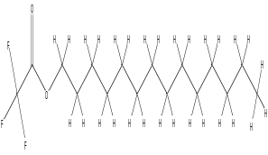
 | Lumasiran  (Standard) | 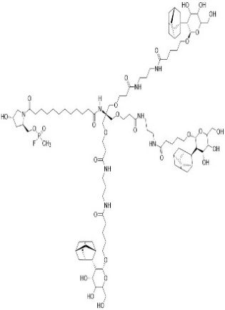

Table.2 Docking score with pose of best lead compounds and standard.
S.No. | Compound | Docking Pose | Binding Energy(kcal/mol)
1 | Compound 27 | 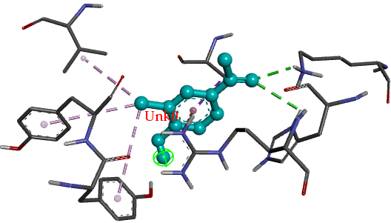 | -7.5
2 | Compound 37 | 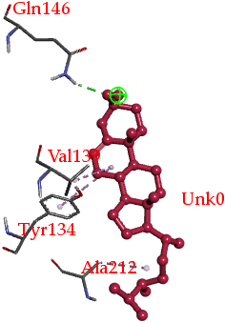 | -7.7
3 | Compound 44 | 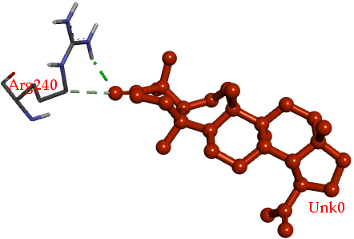 | -7.6
4 | Compound 56 | 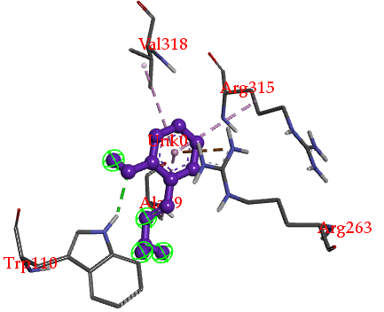 | -7.5
5 | Compound 58 | 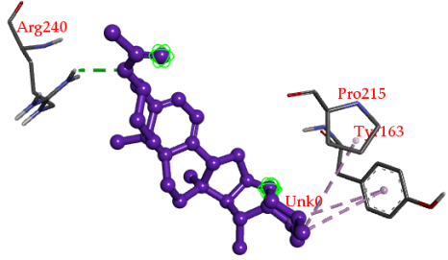 | -8.5
5 | Lumasiran  (Standard) | 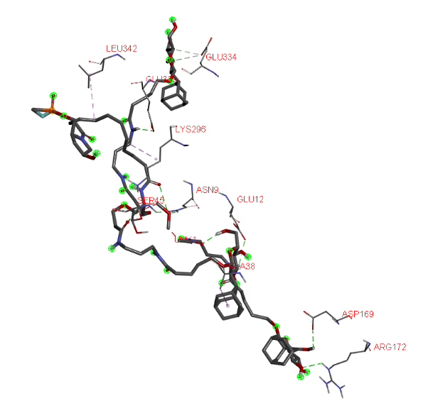 | -6.4

