New diversity form of ice polymorphism:
Discovery of second hydrogen ordered phase of ice VI

Ryo Yamane, Kazuki Komatsu, Jun Gouchi, Yoshiya Uwatoko, Shinich Machida, Takanori Hattori, Hayate Ito, and Hiroyuki Kagi

Correspondence to: r.yamane@issp.u-tokyo.ac.jp

Contents

1. Supplementary Figures and Tables for Methods

2. Supplementary Methods:
-Dielectric measurements
-Details of the 18 candidates
-The criterion of “higher and lower symmetry” space group
1. Supplementary Figures and Tables for Methods

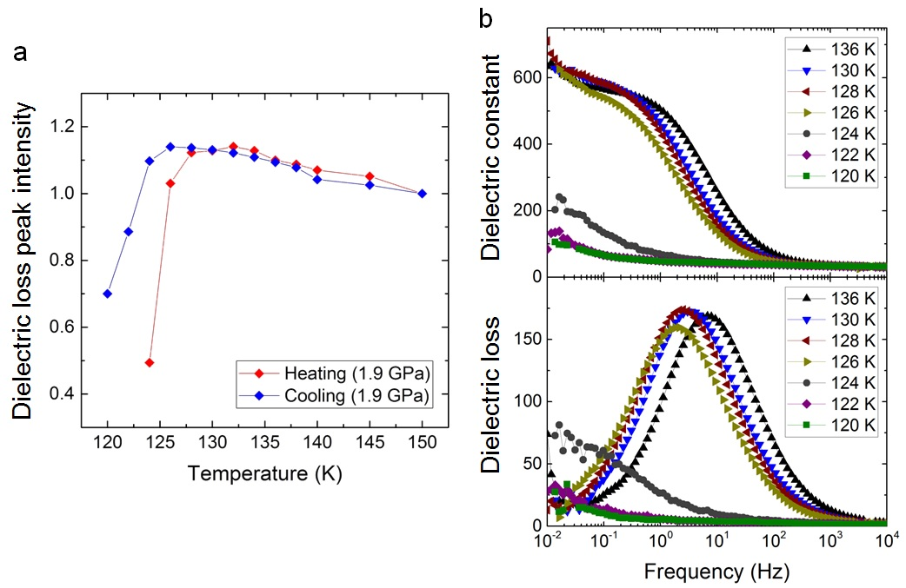

Supplementary Figure 1| Comparison of the phase transition in cooling and heating runs at 1.9 GPa. a, Each peak intensity of dielectric loss is normalised by that obtained at the highest temperature in each run. At temperatures lower than the lowest temperature points shown in the figure, the dielectric response of ice XIX almost disappeared in the measured frequency region; thus, the peak intensity in that region is not shown here. Each of the cooling and heating results corresponds to the data shown in Fig. 2A (main text) and this Fig. S1B, respectively. b, Dielectric constant and dielectric loss of HCl-doped ice VI and its hydrogen-ordered phase (ice XIX) obtained at 1.9 GPa upon heating. The measured frequency ranged from 3 mHz to 2 MHz.

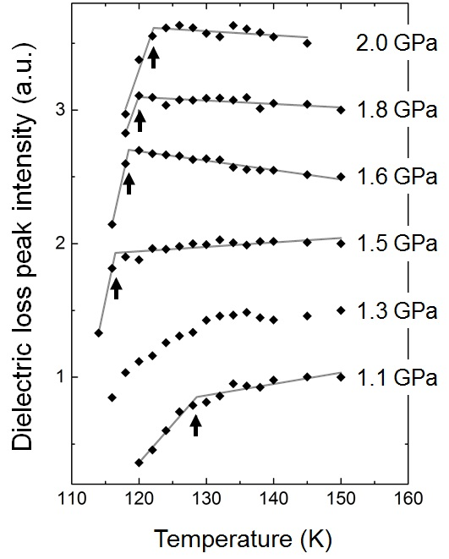

Supplementary Figure 2| Temperature dependence of dielectric loss peak intensity of DCl-doped D₂O ice VI and its hydrogen ordered phases obtained from 1.1 to 2.0 GPa. Peak intensities are normalised by that obtained at the highest temperature in each pressure run. Each plot was shifted by 0.5 with increasing measured pressure for clarity. The black diamonds represent obtained data. The grey lines were separately fitted to the data of loss peak intensity originating from ice VI and its hydrogen-ordered phases at each pressure (Fitted lines for 1.3 GPa are not shown due to its ambiguous change in the slope). The black arrow indicates the phase transition temperature at each pressure.

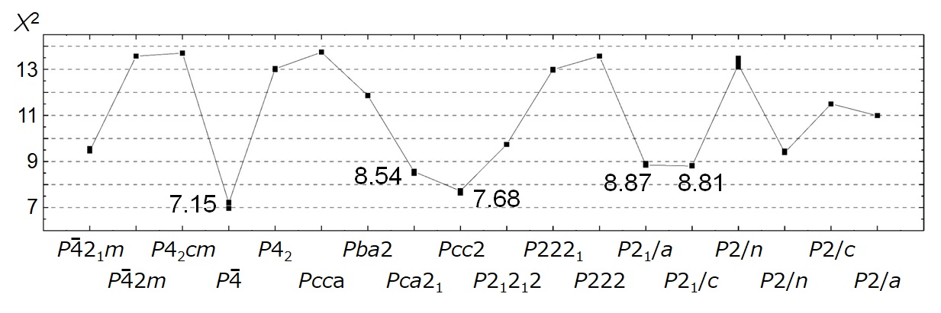

Supplementary Figure 3| Comparison of χ² values obtained by Rietveld analysis for the neutron diffraction pattern obtained at 1.6 GPa and 80 K using the 18 structure models. Structure refinements were conducted several times for each model to confirm their reproducibility; these results are plotted in this figure. The numerical values are shown only for five candidates with χ² < 9, which are averaged values over several refinement results. Site occupancies of hydrogen atoms were initially refined by fixing the atomic positions of hydrogen.

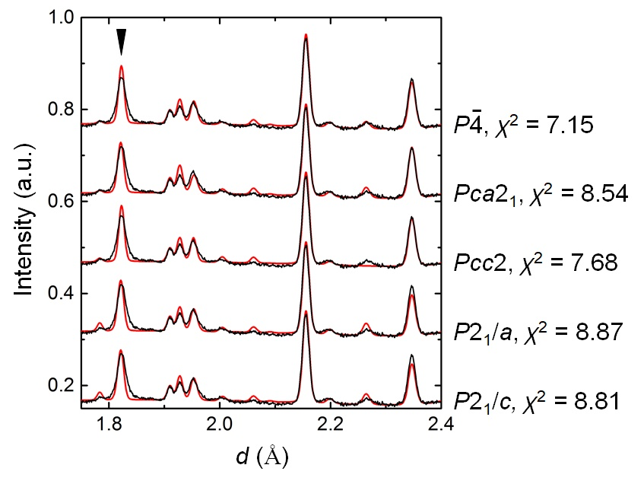

Supplementary Figure 4| Comparison of structure refinements of the five possible candidates. Black lines show the neutron diffraction patterns observed at 1.6 GPa and 80 K. The results of the simulation for each model are shown by red lines. Space groups and χ² values of the models are listed on the right-hand side of this figure. The black triangle indicates a Bragg peak that shows peak broadening compared to the simulated results.

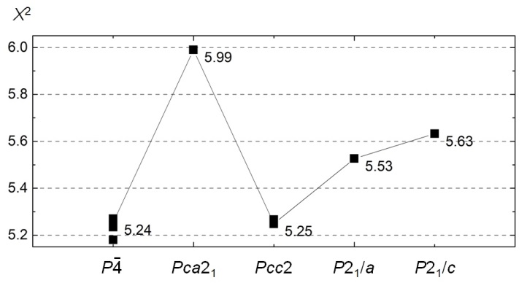

Supplementary Figure 5| Comparison of χ² values obtained by Rietveld analysis for neutron diffraction pattern at 1.6 GPa and 80 K using the five plausible structure models. In the refinements, atomic positions of hydrogen as well as the site occupancies of hydrogen atoms are refined. The χ² values shown for each structure model is the averaged value obtained over repeated refinements.

Supplementary Table 1| Atomic fractional coordinates for ice XIX using P$\overline{4}$ (tetragonal) structure model (lattice parameters: $a=b=8.61941\left(7\right)$ and $c=5.59297\left(8\right)$)

Atom | x | y | z | Occupancy
O1a | 0.0 | 0.5 | 0.007(3) | 1.0
O1b | 0.0 | 0.0 | 0.5 | 1.0
O1c | 0.5 | 0.5 | 0.5 | 1.0
O2a | 0.1436(15) | 0.6429(18) | 0.368(2) | 1.0
O2b | 0.3663(19) | 0.8575(19) | 0.376(2) | 1.0
O2c | 0.8660(19) | 0.8480(14) | 0.116(3) | 1.0
O2d | 0.635(2) | 0.6411(18) | 0.111(3) | 1.0
D1a | 0.116(5) | 0.593(5) | 0.269(6) | 0.324(14)
D1b | 0.895(3) | 0.904(4) | 0.260(6) | 0.5
D1c | 0.394(3) | 0.903(3) | 0.226(4) | 0.676(14)
D1d | 0.602(4) | 0.611(3) | 0.282(6) | 0.5
D2a | 0.061(3) | 0.565(3) | 0.103(3) | 0.676(14)
D2b | 0.939(4) | 0.939(4) | 0.415(6) | 0.5
D2c | 0.442(5) | 0.959(5) | 0.138(6) | 0.324(14)
D2d | 0.547(4) | 0.565(4) | 0.393(7) | 0.5
D3a | 0.221(4) | 0.719(4) | 0.376(4) | 0.55(3)
D3b | 0.782(4) | 0.784(5) | 0.128(8) | 0.5
D3c | 0.283(4) | 0.780(5) | 0.371(5) | 0.45(3)
D3d | 0.723(4) | 0.711(4) | 0.122(8) | 0.5
D4a | 0.833(3) | 0.952(3) | 0.039(4) | 0.69(2)
D4b | 0.177(5) | 0.549(5) | 0.450(6) | 0.40(2)
D4c | 0.666(2) | 0.551(3) | 0.034(4) | 0.78(2)
D4d | 0.308(5) | 0.934(4) | 0.414(6) | 0.27(7)
D4e | 0.950(3) | 0.333(3) | 0.466(4) | 0.73(7)
D4f | 0.544(8) | 0.672(8) | 0.031(11) | 0.22(2)
D4g | 0.550(3) | 0.168(4) | 0.469(5) | 0.60(2)
D4h | 0.954(3) | 0.877(3) | 0.010(5) | 0.32(2)

Supplementary Table 2| Atomic fractional coordinates for ice XIX using Pcc2 (orthorhombic) structure model (lattice parameters: $a=8.6111\left(4\right)$, $b=8.6280\left(4\right)$, and $c=5.59302\left(8\right)$)

Atom | x | y | z | Occupancy
O1 | 0.2536(15) | 0.752(2) | 0.760(3) | 1.0
O2a | 0.3846(17) | 0.8931(17) | 0.133(3) | 1.0
O2b | 0.1037(15) | 0.1150(16) | 0.869(5) | 1.0
O2c | 0.1108(18) | 0.3905(17) | 0.623(3) | 1.0
O2d | 0.6070(16) | 0.6066(17) | 0.8698 | 1.0
D1a | 0.355(3) | 0.865(3) | 0.989(5) | 0.62(2)
D1b | 0.145(5) | 0.159(4) | 0.030(6) | 0.42(3)
D1c | 0.139(4) | 0.334(3) | 0.501(7) | 0.44(3)
D1d | 0.640(4) | 0.651(3) | 0.022(4) | 0.52(3)
D2a | 0.310(4) | 0.800(4) | 0.867(8) | 0.38(2)
D2b | 0.189(3) | 0.191(3) | 0.145(5) | 0.58(3)
D2c | 0.204(3) | 0.316(3) | 0.372(5) | 0.56(3)
D2d | 0.682(3) | 0.687(3) | 0.178(5) | 0.48(2)
D3a | 0.475(3) | 0.967(3) | 0.129(6) | 0.5
D3b | 0.030(3) | 0.028(3) | 0.871(4) | 0.5
D3c | 0.037(3) | 0.469(3) | 0.616(4) | 0.5
D3d | 0.540(3) | 0.528(3) | 0.877(5) | 0.5
D4a | 0.065(4) | 0.192(5) | 0.831(6) | 0.29(2)
D4b | 0.413(3) | 0.790(3) | 0.221(6) | 0.67(2)
D4c | 0.809(3) | 0.076(2) | 0.285(5) | 0.79(3)
D4d | 0.199(5) | 0.431(4) | 0.713(8) | 0.35(3)
D4e | 0.586(5) | 0.708(6) | 0.789(9) | 0.33(2)
D4f | 0.917(2) | 0.303(2) | 0.221(5) | 0.71(2)
D4g | 0.300(3) | 0.589(2) | 0.291(5) | 0.65(3)
D4h | 0.709(4) | 0.8577 | 0.726(8) | 0.21(3)

2. Supplementary Methods:
Dielectric measurements
Dielectric experiments were conducted using a newly developed cell assembly for in-situ dielectric measurements under high pressure (Fig. S6). The cell assembly is based on piston-cylinder type high-pressure apparatus. The left side of Fig. S6 shows an overall of the piston-cylinder cell. The Developed cell assembly is shown on the right side of Fig. S6. A sample is loaded along to the vertical direction, and electric leads are introduced into the sample holder, PTFE capsule, through the holed CuBe plug. Plastic fiber (Edmund Optics, Φ 0.25 mm) is introduced together for the in-situ pressure calibration using ruby fluorescence methods. The sample is sealed by epoxy resin (STYCAST 2850) immersed with the Cu leads and plastic fiber. If a volume of the epoxy resin is too small compared with the plastic fiber and leads, the epoxy resin cannot keep sample pressure under compression; this means that the sample blows out through the hole. For a similar reason, it is necessary to put epoxy resin on the plug as high as 1.8 mm from the top side of the CuBe plug (this value has been optimized). A small ruby tip (almost the same size of the diameter of plastic fiber) is introduced below the electrode and exposed from the incident 532 nm laser beam travel through the plastic fiber, and the induced fluorescence was also traveled through the fiber to the detector (Ocean optics, USB2000+). The parallel electrodes are fixed on the epoxy resin in the cell assembly. The vertically fixed electrodes ensure a condition that electrode separation and area are constant under compression. It should be noted that the length of the electrode (about 6.0 mm) is an important parameter not to collapse during the compression. If we lengthen the electrodes to expand electrode area (corresponding to enlarge sample capacitance from a principle equation, $C=ε_{0}εS/d$), electrode deformation might occur. It may also cause short-circuit between the electrodes. From our experience, the electrode length must be less than 7.0 mm at most, which is the half-length of the initial sample space. The cell assembly allows us to measure dielectric properties of the liquid sample under high pressure.
Figure S7 shows an example of dielectric data of non-doped ice VI obtained at 1.73 GPa and 240 K. Figure S7A and B show temperature dependence of the dielectric constant and loss of non-doped ice VI obtained at 1.73 GPa, respectively. Similar temperature dependence of dielectric properties of non-doped ice VI was reported by Johari et al. at 1.1 GPa (30). The dielectric response in the lower frequency region (below 10 Hz at 240 K) is derived from the DC electric conductivity of the sample. Temperature dependence of dielectric constants and loss shows that the frequency dispersion derived from the molecular rotation (10³ Hz at 240 K) shifts to lower frequency with decreasing temperature. This means that the dynamics of molecular rotation becomes slowdown with decreasing temperature. As the most important point shown in Figure S7, the dielectric response of non-doped ice VI almost disappears at 160 K in the measured frequency range due to the slowdown of the molecular-rotation dynamics. No dielectric response was shown at the hydrogen-ordering temperature of ice VI observed in HCl-doped sample (at ~120 K).

Details of the 18 candidates
Figure S8 shows definitions of site labels of hydrogen atoms for the 18 structure models. Corresponded site occupancies of the hydrogen atom sites are represented by one or a few variables, denoted by Greek letters (Table S3), which are actually fitting parameters for the Rietveld refinements using hydrogen site occupancies.

The criterion of “higher and lower symmetry” space group
We only took account of 18 candidates of “higher symmetry” space groups for the structure analysis of ice XIX as mentioned in the main text. Considering two structure models, whose space groups are related by group-subgroup relationship, the subgroup structure model generally shows better agreement with the experimental data comparing with the structure model of its parent space group. Hence we set a criterion of “lower symmetry” space groups disregarded in this study based on a quantitative index, Group-Subgroup index. We consider a space group, represented by G. G is an infinite group due to its translation symmetry. Its translation operations make normal subgroup, H, of the space group, G. A coset of G by H, denoted by G/H, makes a quotient group. G/H is composed of finite elements and the number of elements is called order of G/H, represented by |G/H|. For example, let us take P1 as an example space group of a crystal structure, S. When we choose a minimum unit cell of the S, T(P1) is defined by all translation operations corresponding to the unit cell. Then, |P1/T(P1)| = 1 holds. Hereafter, we consider a case that S is the crystal structure of ice VI. In the case of the space group of ice VI, P4₂/nmc, |P4₂/nmc/T(P4₂/nmc)| is 16. When the unit cell of ice VI is expanded to $\sqrt{2}×\sqrt{2}×1$, the cell volume becomes two times larger. We represent corresponded translation operations as $T_{\sqrt{2}×\sqrt{2}×1}$(P4₂/nmc). Then an order |P4₂/nmc/$T_{\sqrt{2}×\sqrt{2}×1}$(P4₂/nmc)| is 32. The Group-Subgroup index, s, is defined as follows:
$$s=\frac{\left|{P4_{2}/nmc}/{T_{\sqrt{2}×\sqrt{2}×1}\left(P4_{2}/nmc\right)}\right|}{\left|H/{T\left(H\right)}\right|}=\frac{32}{\left|H/{T\left(H\right)}\right|},$$
where H is a subgroup of P4₂/nmc. For example in a case, H = P$\overline{1}$, Group-Subgroup index, s, is 16. Because, P$\overline{1}$/T(P$\overline{1}$) includes two elements; one is for trivial equivalent symmetry and the other one is about inversion symmetry. In this study, we ignored five space groups, Pc, P2₁, P2 and P$\overline{1}$ and P1, and this means that we only considered space groups, whose Group-Subgroup indexes are less than 8 from their sufficient refinement agreements for the neutron diffraction patterns. Space groups with indexes, 16 and 32, are Pc, P2₁, P2 and P$\overline{1}$ and P1, respectively. It is noted that subgroups of P$\overline{4}$ are P2 and P1 both of which belong to pyroelectric groups as well as Pcc2.

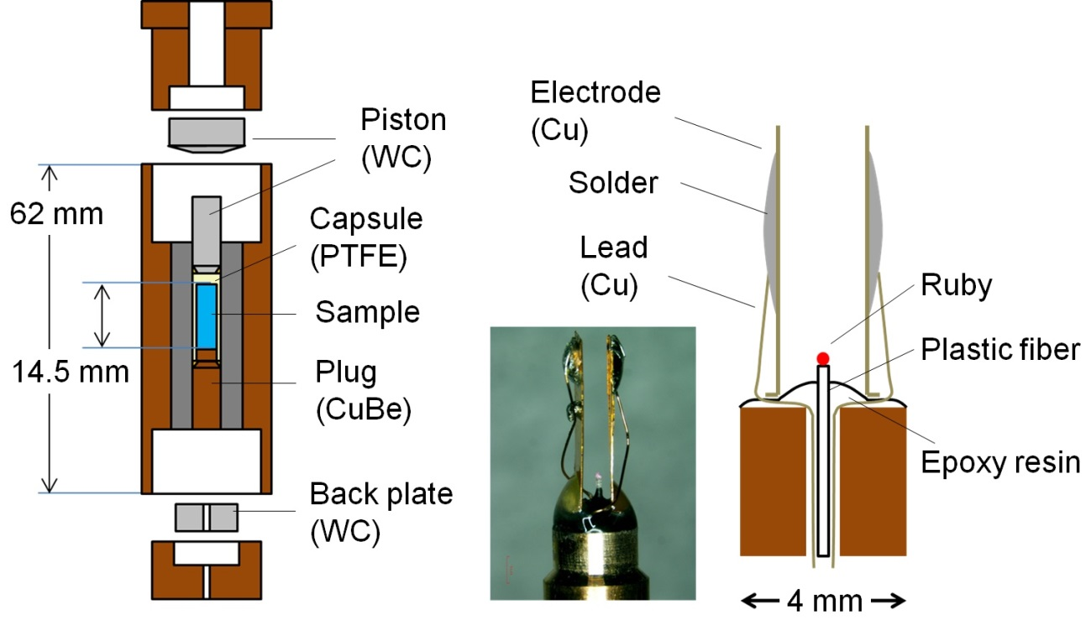

Supplementary Figure 6| Developed cell assembly of piston cylinder for in-situ dielectric measurements under high pressure. An overall drawing (left) and a picture (center) and schematic drawing around sample space (right) of the developed cell assembly. Separated pistons are made of tungsten carbide abbreviated WC in the figure and cylinder is made of CuBe (outer, colored blown) and NiCrAl (inner, colored gray). The two electrodes compose parallel electrodes.

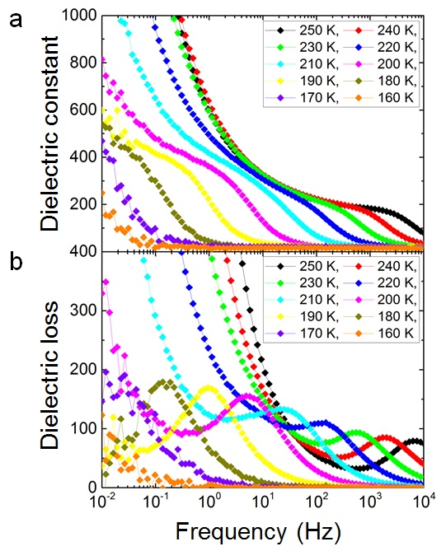

Supplementary Figure 7| Dielectric properties of non-doped ice VI. a and b, Temperature dependence of dielectric constant and loss of non-doped ice VI obtained at 1.73 GPa.
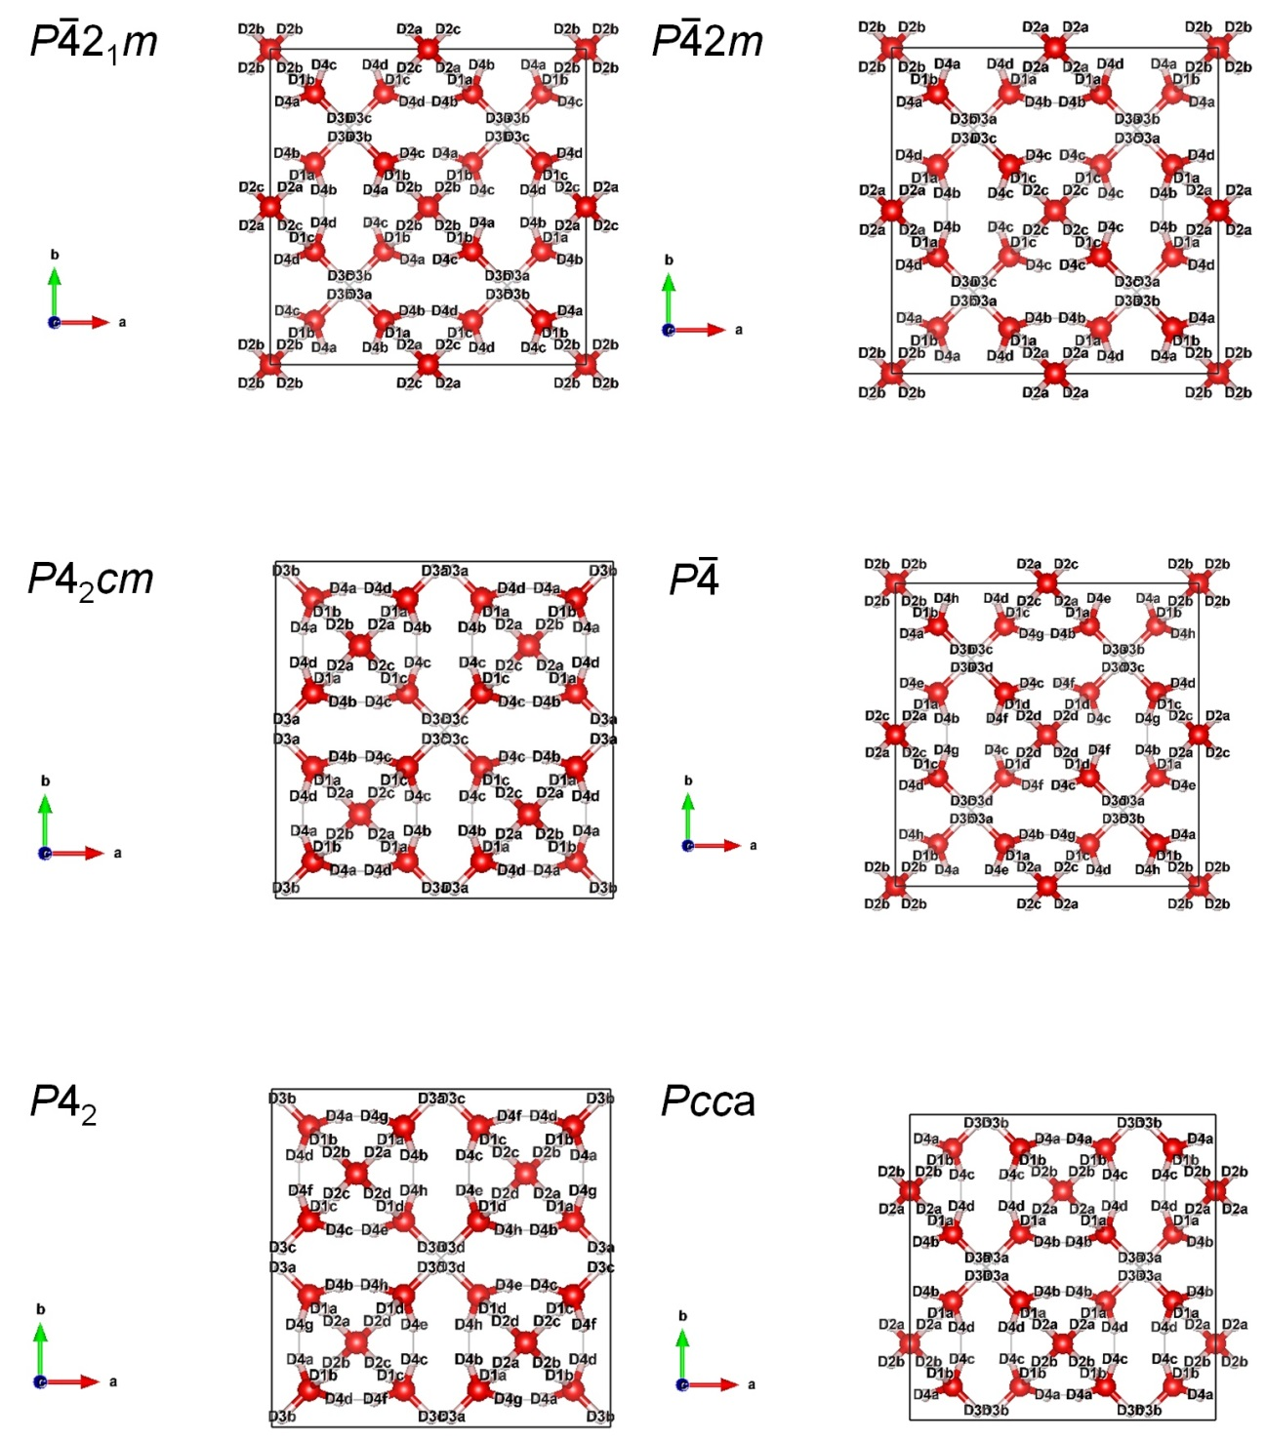

Supplementary Figure 8| Site labels of hydrogen atoms in the 18 structure models. Each corresponded space group is denoted left upper of its crystal structure. Black squares mean unit cells and each crystal axis is denoted in the left bottom.

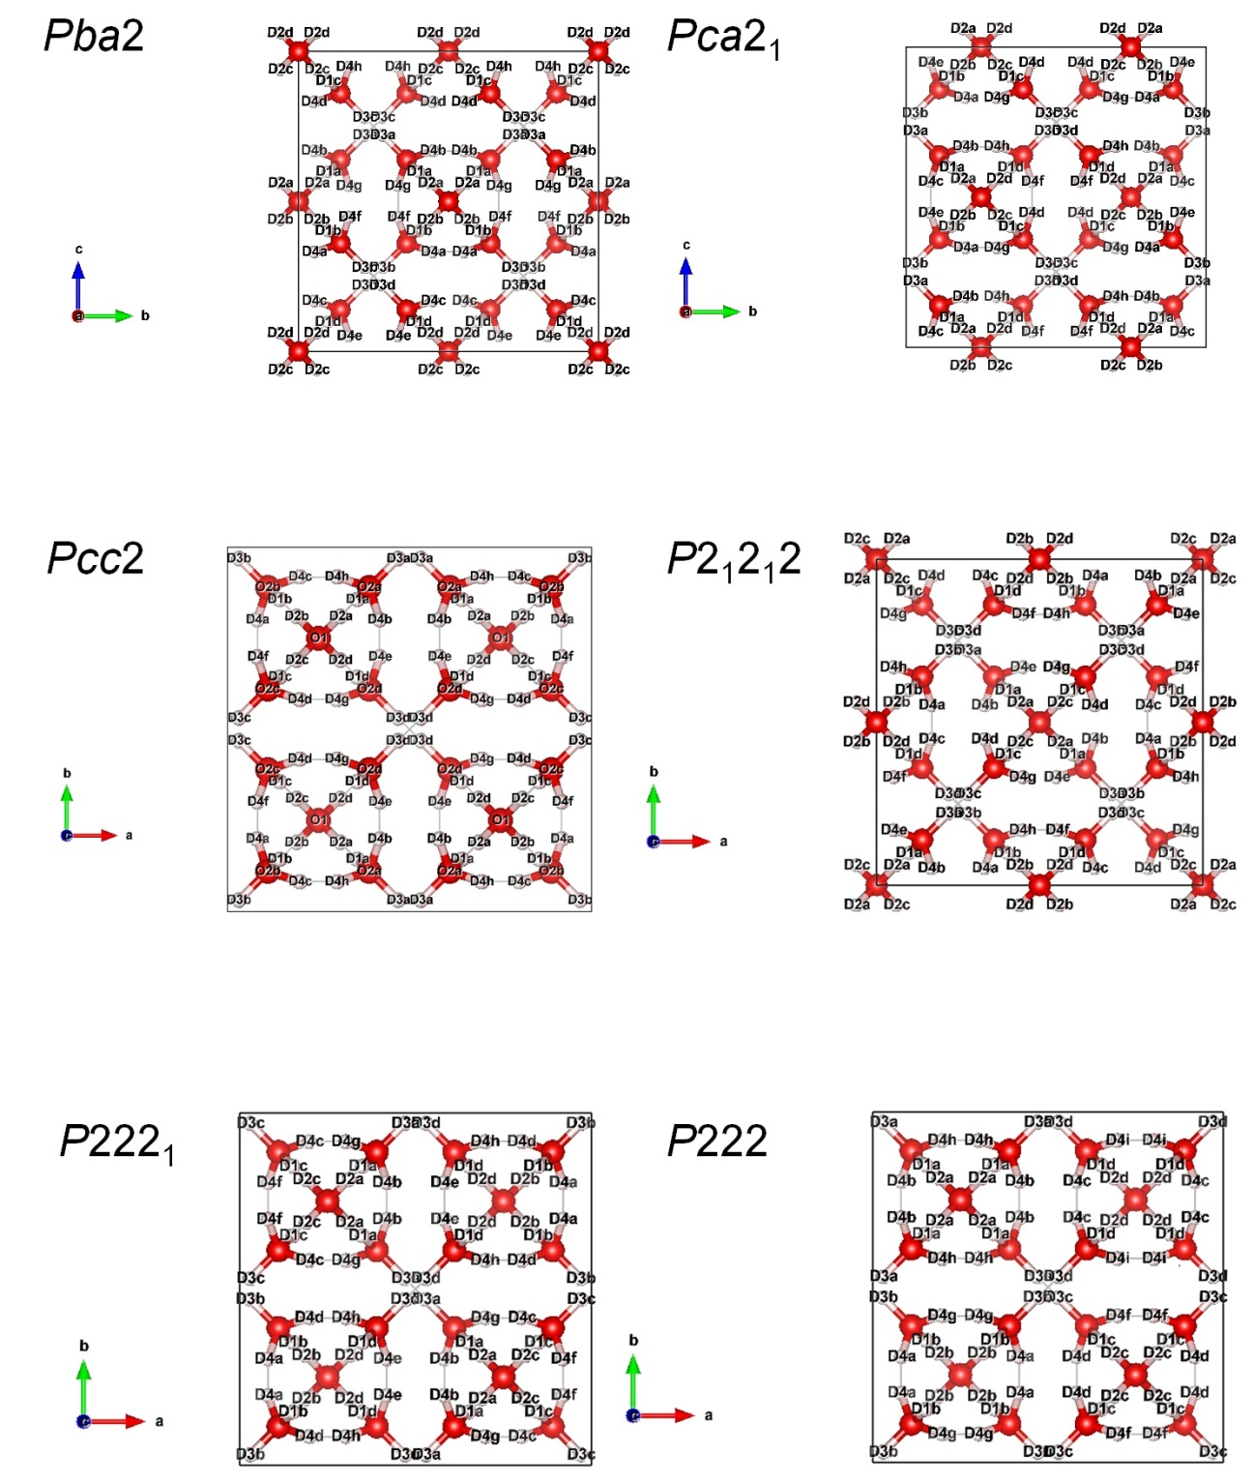

Supplementary Figure 8| (continuous) Site labels of hydrogen atoms in the 18 structure models. Each corresponded space group is denoted left upper of its crystal structure. Black squares mean unit cells and each crystal axis is denoted in the left bottom.
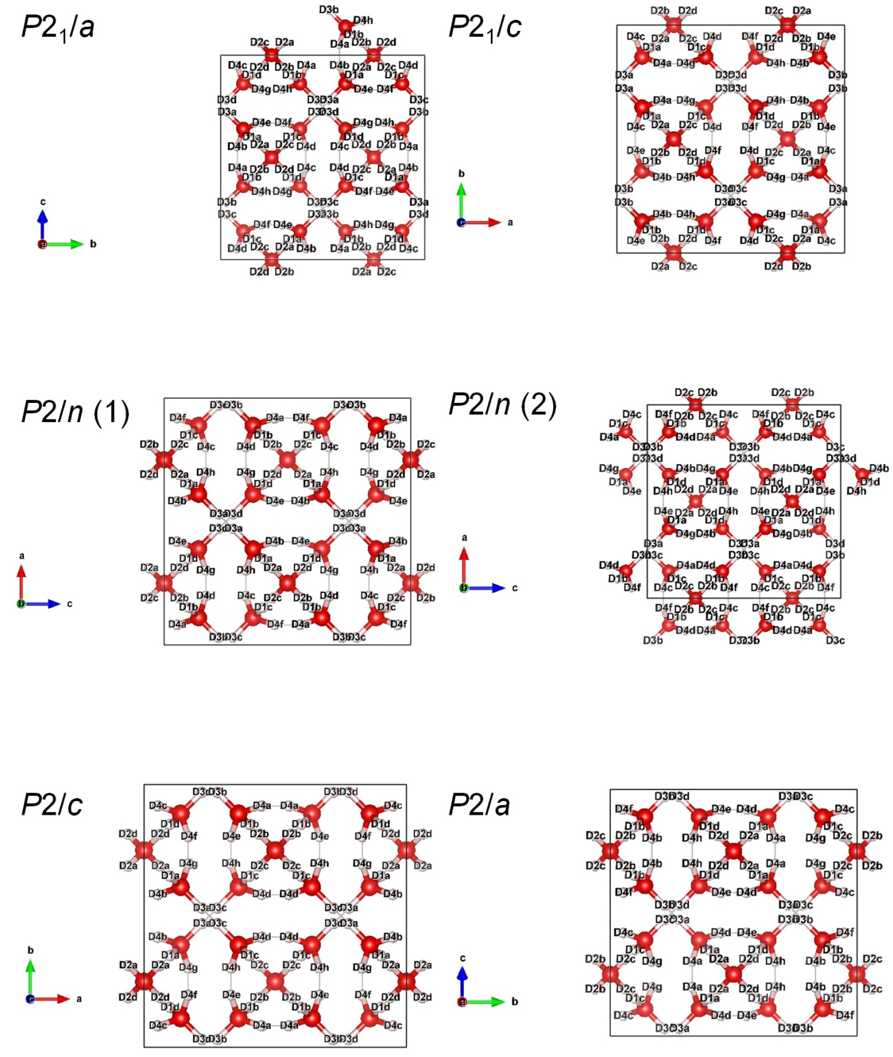

Supplementary Figure 8| (continuous) Site labels of hydrogen atoms in the 18 structure models. Each corresponded space group is denoted left upper of its crystal structure. Black squares mean unit cells and each crystal axis is denoted in the left bottom. P2/n has two structure models, denoted by (1) and (2), depending on their geometric elements.

Supplementary Table 3| Representations of hydrogen site occupancies for the 18 structure models

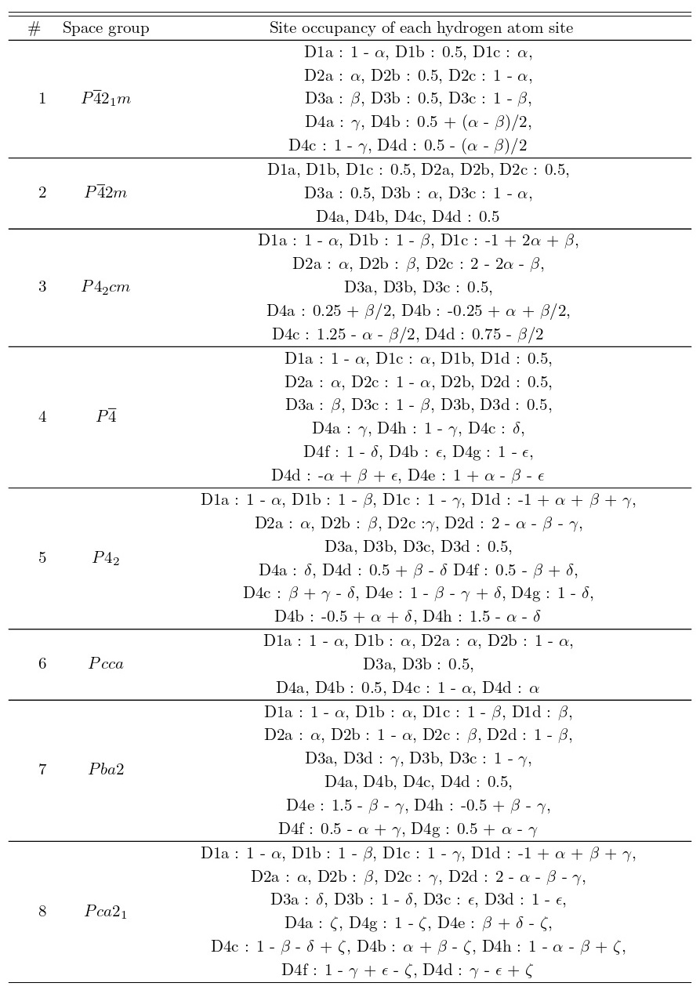

Supplementary Table 3| (continuous) Representations of hydrogen site occupancies for the 18 structure models

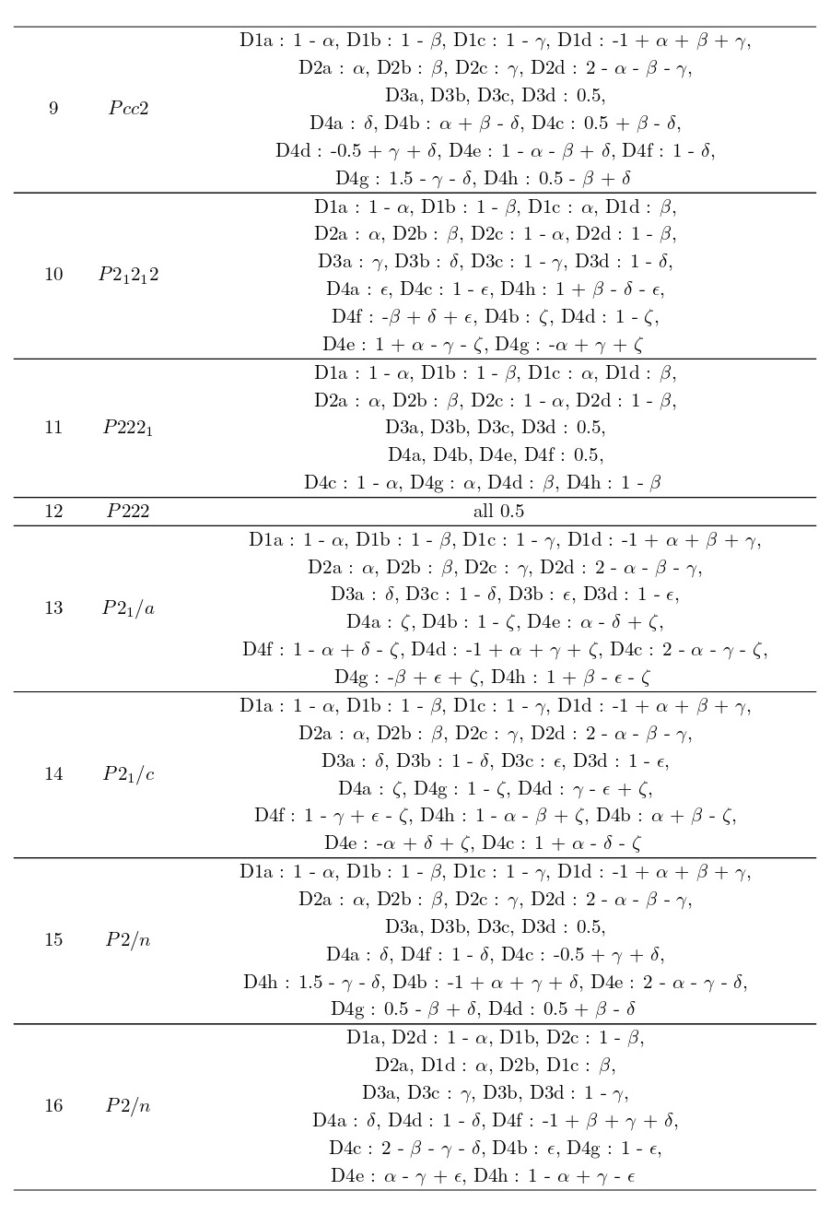

Supplementary Table 3| (continuous) Representations of hydrogen site occupancies for the 18 structure models

