Additional Material
Additional Table 1. Demographic, anthropometric, and clinical disease characteristics in the two groups.
 | Group A (n=7) | Group B (n=7) | p value
Gender (female, n [%]) | 2 (28.6) | 2 (28.6) | 1.0
Age at diagnosis, y | 10.3 (8.7, 14.6) | 12.1 (11.6, 14.9) | 0.404
Age at diagnosis, n (%) |  |  | 0.28
A1a | 4 (57.1) | 2 (29.5)
A1b | 3 (42.9) | 5 (71.4)
Weight (kg) | 39.9 (27.4, 47.1) | 41.7 (31.6, 53.1) | 0.374
Weight (z score) | -0.34 (-0.83, 0.06) | -0.09 (-0.41, -0.03) | 0.791
Height (z score) | -0.34 (-0.83, 0.09) | -0.22 (-1.41, 0.78) | 0.941
BMI (z score) | -0.20 (-0.55, 0.05) | -0.43 (-0.61, 0.46) | 0.553
wPCDAI at end of EEN | 0 (0, 0) | 5 (0, 10) | 0.115
First EEN course, n (%) | 6 (85.7) | 6 (85.7) | 1.0
MEN(%kcal) | 17.9 (0, 26.8) | 16.7 (0, 26.8) | 0.726
MEN (%EAR) | 16.2 (0, 24.6) | 16.7 (0, 18.8) | 0.972
Immunomodulators (azathioprine/methotrexate), n (%) | 5 (71.4) | 6 (85.7) | 0.515
Disease location (Paris classification), n (%)
L2, L4a, B1 | 2 (28.6) | 1 (14.3)
L2, L4a, L4b, B1, p | 0 (0) | 1 (14.3)
L3, B1 | 0 (0) | 1 (14.3)
L3, B1, p | 1 (14.3) | 0 (0)
L3, L4a, B1 | 2 (28.6) | 1 (14.3)
L3, L4a, L4b, B1 | 2 (28.6) | 3 (42.9)
Days of food reintroduction prior to sample collection | 20 (14, 30) | 51 (16, 67) | 0.227
Group A: patients with faecal calprotectin levels above the median levels at food reintroduction, Group B: patients with faecal calprotectin values below the median levels at food reintroduction. Values are presented as medians (Q1, Q3) for continuous variables and as counts (frequencies) for categorical variables. Bold values indicate statistical significance. wPCDAI: weighted Paediatric Crohn’s Disease Activity Index, MEN: Maintenance enteral nutrition
Additional Table 2. Correlations between the intake of nutrients and levels of FC at food reintroduction in all 14 patients.
Nutrients | Coefficient | p value | Nutrients | Coefficient | p value
Total Energy (kcal) | 0.34 | 0.242 | Niacin (% RNI) | 0.61 | 0.02
Total energy (% EAR) | 0.49 | 0.075 | Folic acid (ug) | 0.34 | 0.235
Fat (g) | 0.04 | 0.927 | Folic acid (% RNI) | 0.43 | 0.124
Fat (% kcal) | -0.40 | 0.159 | Vitamin B12 (ug) | 0.04 | 0.891
SFA (g) | -0.14 | 0.642 | Vitamin B12 (% RNI) | 0.14 | 0.634
SFA (% kcal) | -0.35 | 0.216 | Pantothenic acid (mg) | 0.37 | 0.194
MUFA (g) | 0.24 | 0.4 | Biotin (ug) | -0.07 | 0.805
MUFA (% kcal) | -0.03 | 0.917 | Vitamin E (mg) | -0.14 | 0.623
PUFA (g) | 0.34 | 0.232 | Sodium (mg) | 0.39 | 0.166
PUFA (% kcal) | 0.13 | 0.656 | Sodium (% RNI) | 0.39 | 0.166
Carbohydrates (g) | 0.29 | 0.309 | Chloride (mg) | 0.38 | 0.181
Carbohydrates (% kcal) | 0.03 | 0.924 | Chloride (% RNI) | 0.43 | 0.124
Sugars (g)* | 0.15 | 0.615 | Potassium (mg) | 0.34 | 0.237
Sugars (% kcal) | -0.19 | 0.509 | Potassium (% RNI) * | 0.20 | 0.485
Dietary fibre (g)* | 0.42 | 0.132 | Calcium (mg) | 0.18 | 0.546
Dietary fibre (% RNI) | 0.48 | 0.082 | Calcium (% RNI) | 0.15 | 0.605
Starch (g) | 0.24 | 0.4 | Phosphorus (mg) | 0.26 | 0.368
Protein (g) | 0.51 | 0.061 | Phosphorus (% RNI) | 0.41 | 0.15
Protein (% kcal) | 0.50 | 0.069 | Magnesium (mg) | 0.19 | 0.517
Protein (% RNI) | 0.54 | 0.047 | Magnesium (% RNI) | 0.31 | 0.276
Vitamin A (ug) | -0.24 | 0.404 | Iron (mg) | 0.35 | 0.218
Vitamin A (% RNI) | -0.17 | 0.57 | Iron (% RNI) | 0.35 | 0.214
Vitamin D (ug)* | 0.34 | 0.24 | Zinc (mg) | 0.29 | 0.316
Vitamin C (mg) | 0.26 | 0.375 | Zinc (% RNI) | 0.28 | 0.328
Vitamin C (%RNI) | 0.30 | 0.295 | Copper (mg) | 0.05 | 0.862
Thiamine (mg) | 0.57 | 0.033 | Copper (% RNI) | 0.21 | 0.482
Thiamine (% RNI) | 0.67 | 0.006 | Iodine (ug) | -0.26 | 0.372
Vitamin B2 (mg) | -0.07 | 0.808 | Iodine (% RNI) | -0.16 | 0.579
Vitamin B2 (% RNI) | 0.26 | 0.368 | Selenium (ug) | 0.30 | 0.297
Vitamin B6 (mg) | 0.18 | 0.539 | Selenium (% RNI) | 0.37 | 0.197
Vitamin B6 (% RNI) | 0.34 | 0.24 | Cholesterol (mg) | 0.19 | 0.517
Niacin (mg) | 0.52 | 0.058
Pearson correlations were performed except for variables marked with *, for which Spearman rank correlations were performed. Bold values indicate statistical significance. FC: Faecal calprotectin

Additional Table 3. Correlations between the intake of foods and levels of FC at food reintroduction in all 14 patients.
Variables | Coefficient | p value
Cereals and cereal products | 0.36 | 0.213
Gluten containing cereal products | 0.459 | 0.099
Non-gluten containing cereal products* | -0.503 | 0.067
Milk and milk products | -0.14 | 0.628
Eggs and egg dishes * | -0.20 | 0.483
Fat spreads * | 0.12 | 0.686
Red meat * | 0.47 | 0.09
Processed meat | 0.52 | 0.056
Red and processed meat * | 0.62 | 0.019
Meat and meat products * | 0.57 | 0.034
Fish and fish products * | 0.24 | 0.407
Vegetables and potatoes | 0.30 | 0.290
Savoury snacks | -0.45 | 0.110
Fruit * | -0.32 | 0.271
Sugars, preserves and confectionery | -0.31 | 0.284
Non-alcoholic beverages | 0.73 | 0.003
Miscellaneous * | 0.49 | 0.077
Pearson correlations were performed except for variables marked with *, for which Spearman rank correlations were performed. Bold values indicate statistical significance. FC: Faecal calprotectin

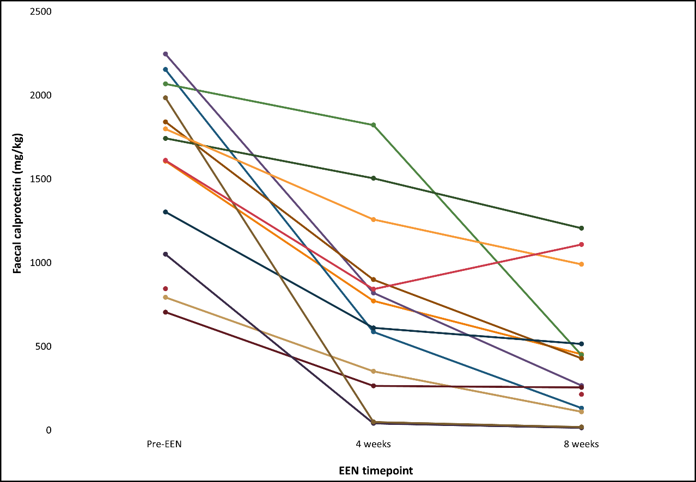
Additional Figure 1.Faecal calprotectin values before the start of EEN treatment and at 4 weeks and 8 weeks of EEN treatment in all 14 patients. Different colours indicate different patients.
AdditionalFigure 2.Hierarchical dendrogram showing the classification of individual food groups to larger level food groups, based on the National Diet and Nutrition Survey(File submitted separately).
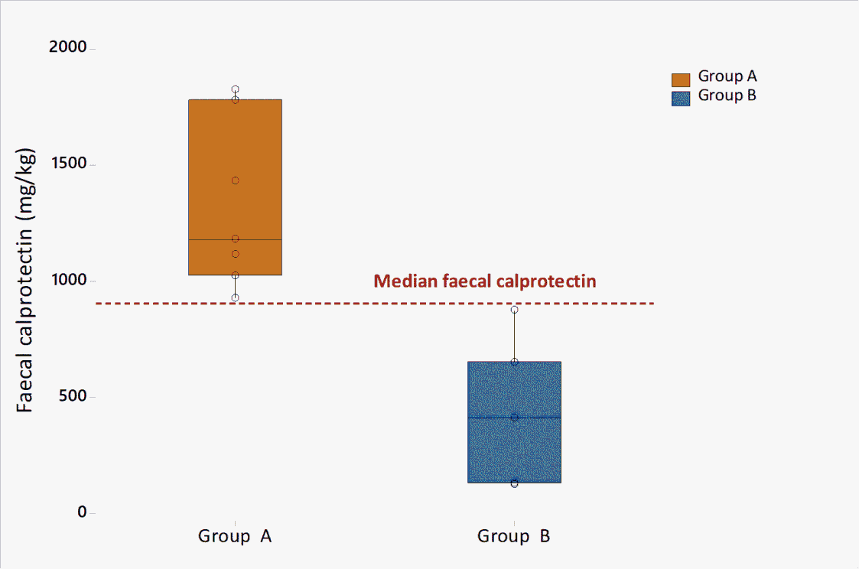
AdditionalFigure 3. Stratification of patients based on the median faecal calprotectin (900 mg/kg) of the entire group at food reintroduction. Group A (n=7): above median faecal calprotectin, Group B (n=7): below median faecal calprotectin.

