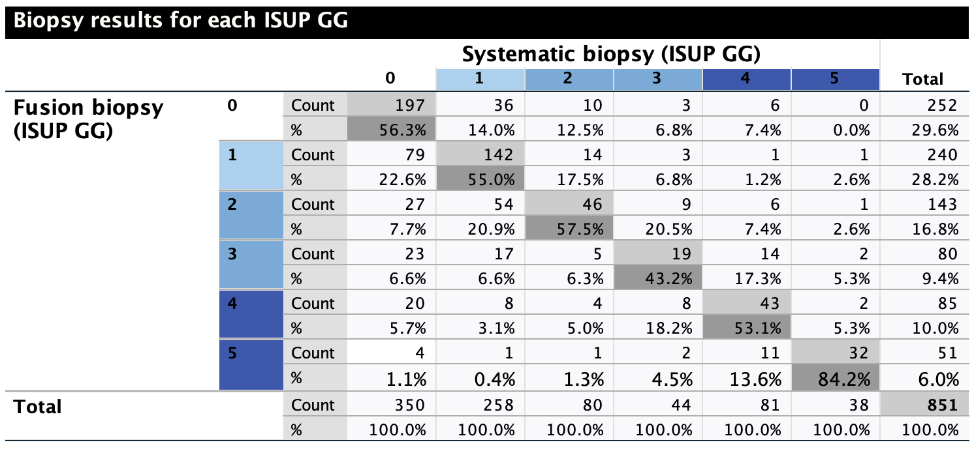
Table 1: Detailed breakdown of the biopsy results for both methods, fusion biopsy (FB) and systemic biopsy (SB). The grey cells highlight the number of patients with the corresponding percentage (%) where both methods provided concordant results.

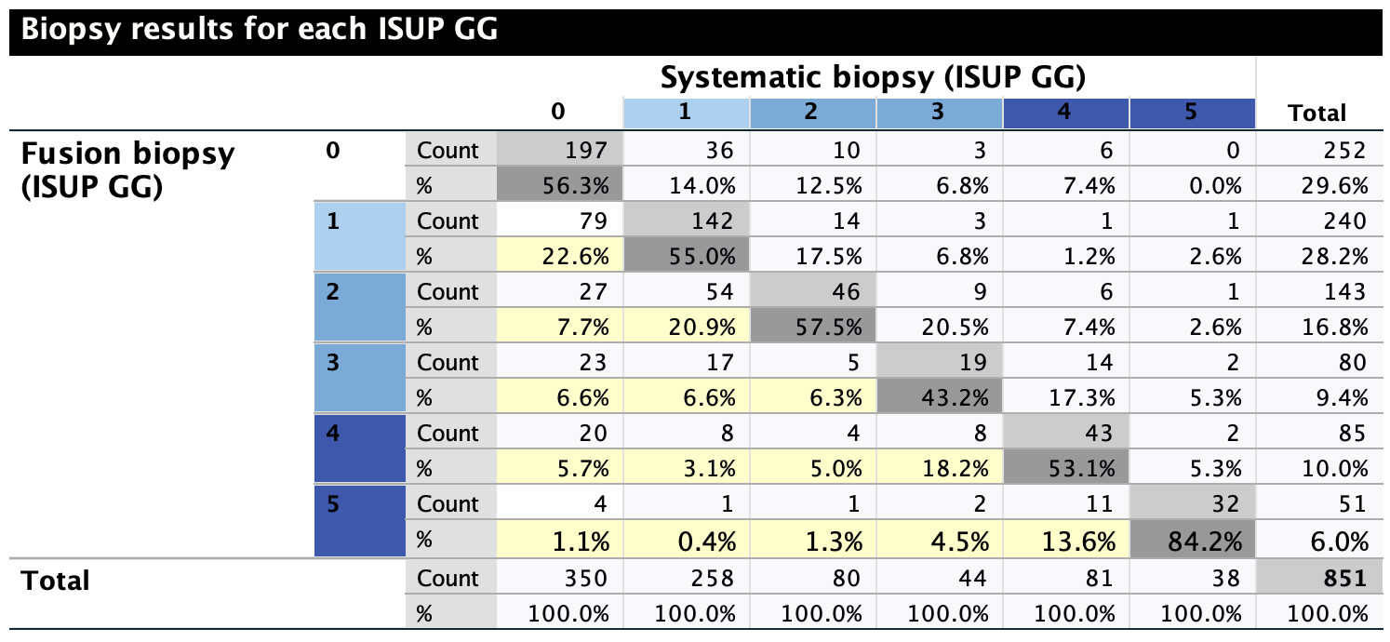
Table 2: Detailed breakdown of the biopsy results for both methods, fusion biopsy (FB) and systemic biopsy (SB). The grey cells highlight the number of patients with the corresponding percentage (%) where both methods provided concordant results. The light-yellow cells represent cases where FB detected a higher ISUP-GG.

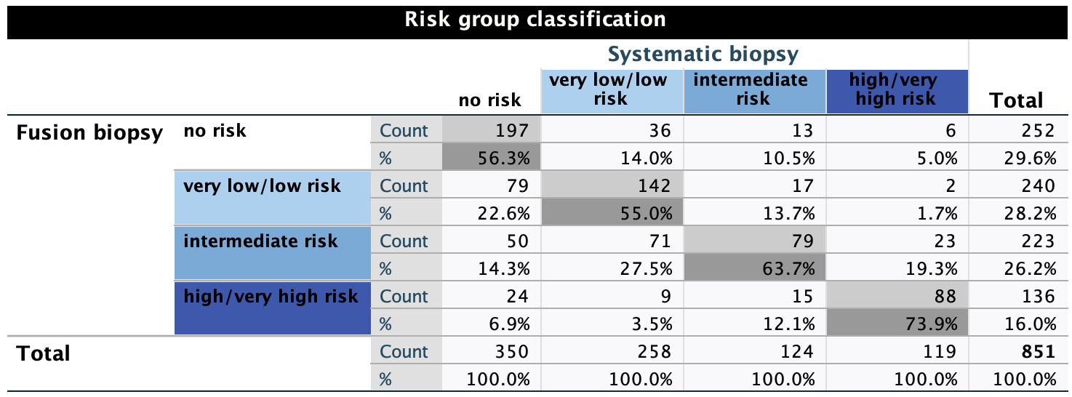
Table 3: Fusion biopsy results and systematic biopsy results (n = patients) and the corresponding percentages (%) according to the risk group classification; grey cells highlighting the concordant results between the biopsy methods.

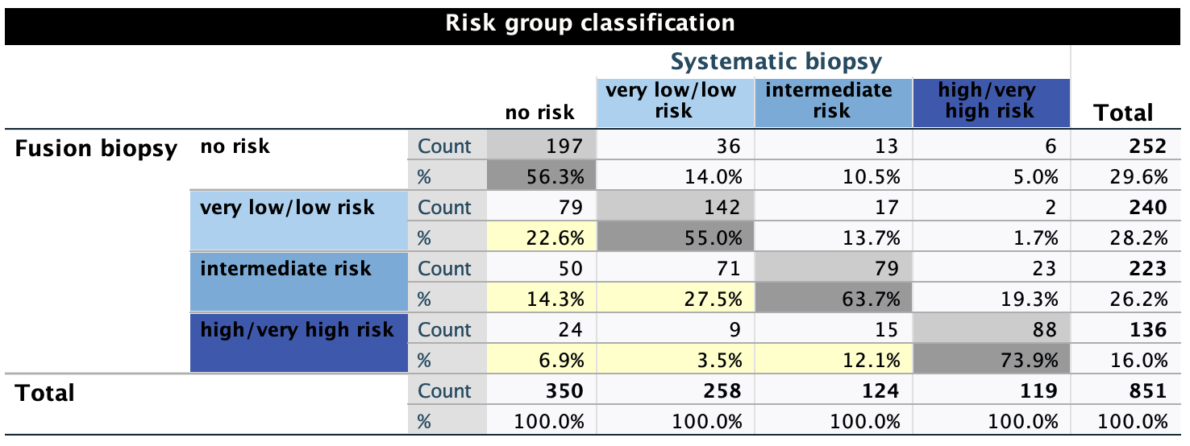
Table 4: Fusion biopsy results and systematic biopsy results (n = patients) and the corresponding percentages (%) according to the risk group classification; grey cells highlighting the concordant results between the biopsy method; yellow cells highlighting the discordant results.

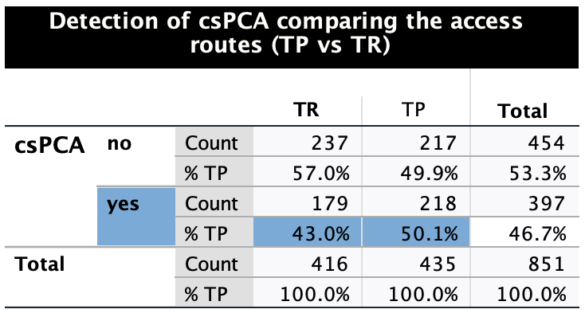
Table 5: Detection rates of Prostate cancer between the transrectal approach (TR) and transperineal approach (TP) with mean values in detecting insignificant Prostate cancer and clinically significant Prostate cancer (csPCA), the latter highlighted with blue cells.

