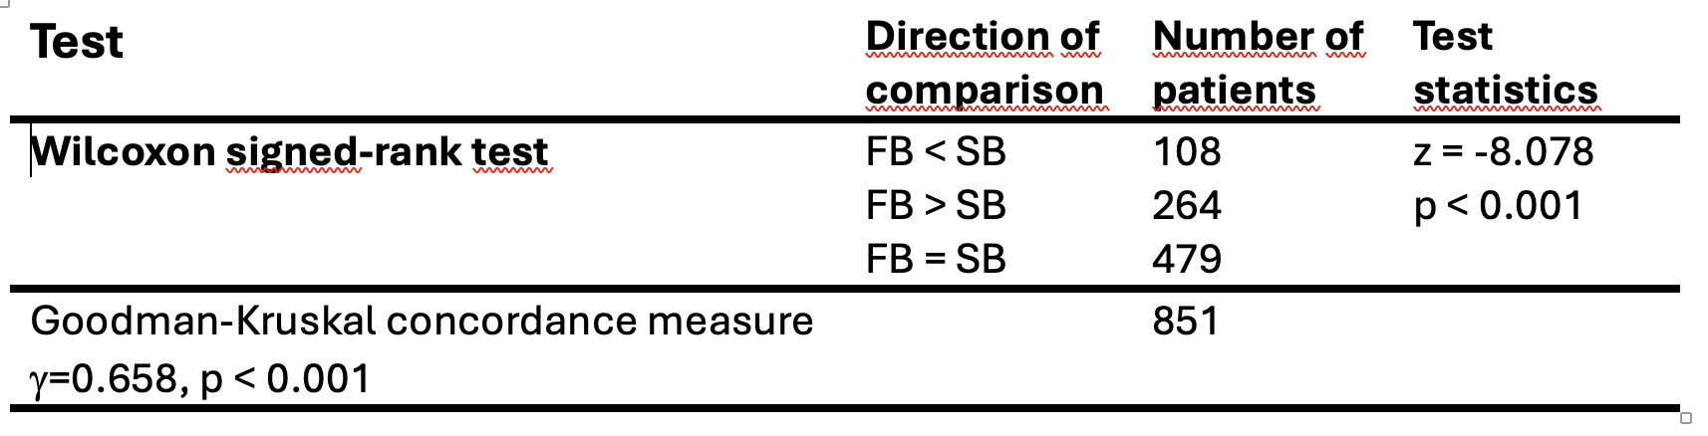
Table S1: Results for detecting the highest ISUP GG using the Goodman and Kruskal´s concordance measure between fusion biopsy (FB) results with systematic biopsy (SB) results.

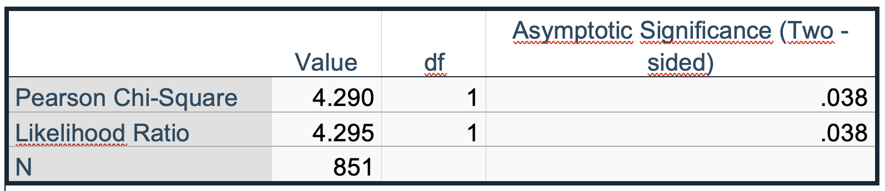
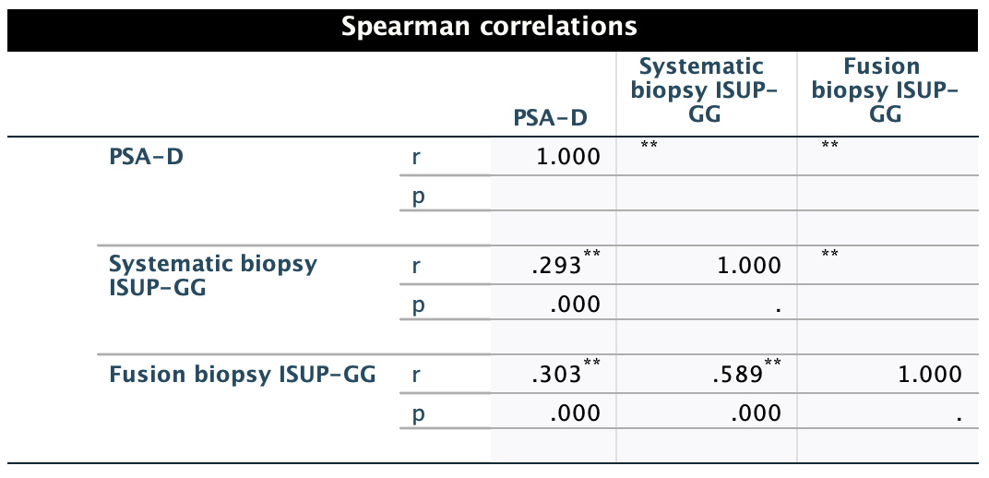
Table S3: Results for the χ²- independence test and the likelihood ratio for the statistical significance between access route and detection rates.

Table S2: Spearman correlations between PSA-D (PSA-density) and ISUP-GG.

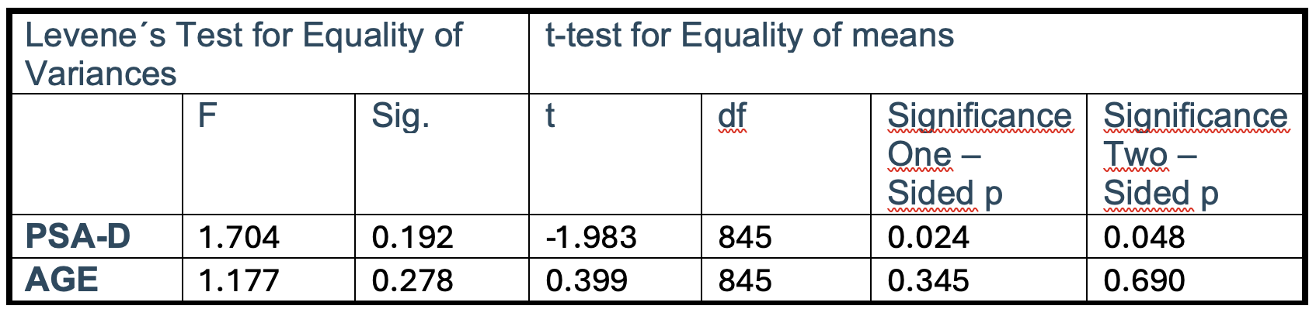
Table S4: Independent sample tests for PSA-D (PSA-density) and age.

