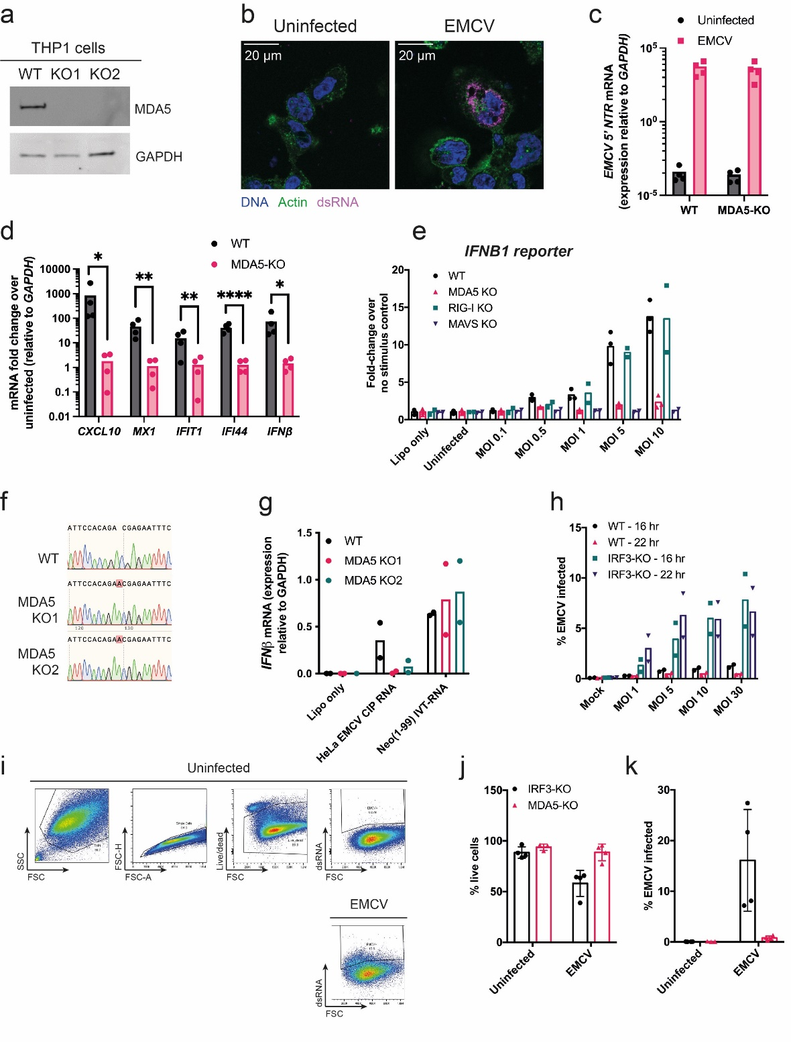
Fig. S1. EMCV infects THP1 cells and induces an MDA5-dependent T1-IFN response.
a, MDA5 protein levels in wild-type (WT) THP1 cells and in two independent clones of MDA5 knockout THP1 cells (KO1 and KO2) were analysed by western blot. GAPDH served as a loading control.
b, THP1 cells were left uninfected or were infected with EMCV (MOI=10) for 16 hours, fixed and stained for dsRNA (J2 antibody; magenta), DNA (DAPI; blue) and actin (phalloidin; green). Images acquired by confocal microscopy are shown.
c-d, WT and MDA5 knockout THP1 cells were infected with EMCV (MOI=5) for 22 hours. RNA was extracted and RT-qPCR performed for the EMCV 5’ non-translated region (NTR) (c) and the indicated mRNAs (d). Data are shown relative to GAPDH.
e, RNA extracted from uninfected THP1 cells or from THP1 cells infected with EMCV for 24 hours was transfected into HEK293 cells of the indicated genotypes stably expressing firefly luciferase under control of the IFNB promoter (p125-HEK). As negative controls, p125-HEK cells were treated with transfection reagent alone (Lipo only). After overnight incubation, luciferase activity in cell lysates was measured. Data from untreated cells were set to 1.
f, Sanger sequencing of WT and MDA5 KO (KO1 and KO2) THP1 cells showed a 1 nucleotide insertion at position 23 in exon 1 of the IFIH1 gene.
g, WT and MDA5 knockout THP1 cells were transfected with CIP-treated RNA from EMCV-infected HeLa cells (HeLa EMCV CIP RNA) or with Neo¹⁻⁹⁹ IVT-RNA for 24 hours. As a control, cells were also treated with Lipofectamine alone (Lipo only). IFNB1 mRNA levels were measured by RT-qPCR. Data are shown relative to GAPDH.
h, WT and IRF3-KO THP1 cells were infected with EMCV at the indicated MOIs for 16 or 22 hours. Cells were stained for dsRNA (J2) and analysed by flow cytometry.
i, Gating strategy for identification of EMCV-infected cells by flow cytometry using staining for dsRNA with J2 antibody. IRF3-KO THP1 cells uninfected or infected with EMCV (MOI = 5) for 22 hr are shown. FSC, forward scatter; SSC, side scatter.
j-k, Proportion of live (j) and EMCV-infected (k) cells in samples used for iCLIP experiments (MOI = 5), measured by flow cytometry.
Data in (b) are representative of three independent experiments. Data points in
(c-d) represent four independent biological repeats, and bars represent average. Data in (e) are technical replicates from one experiment, and bars represent the average. Data points in
(g-h) represent two independent biological repeats, and bars represent average. Data in (i) are representative of four biological repeats. Data points in (j-k) represent four independent biological repeats, bars represent the average, and error bars represent the standard error of the means from technical duplicates.
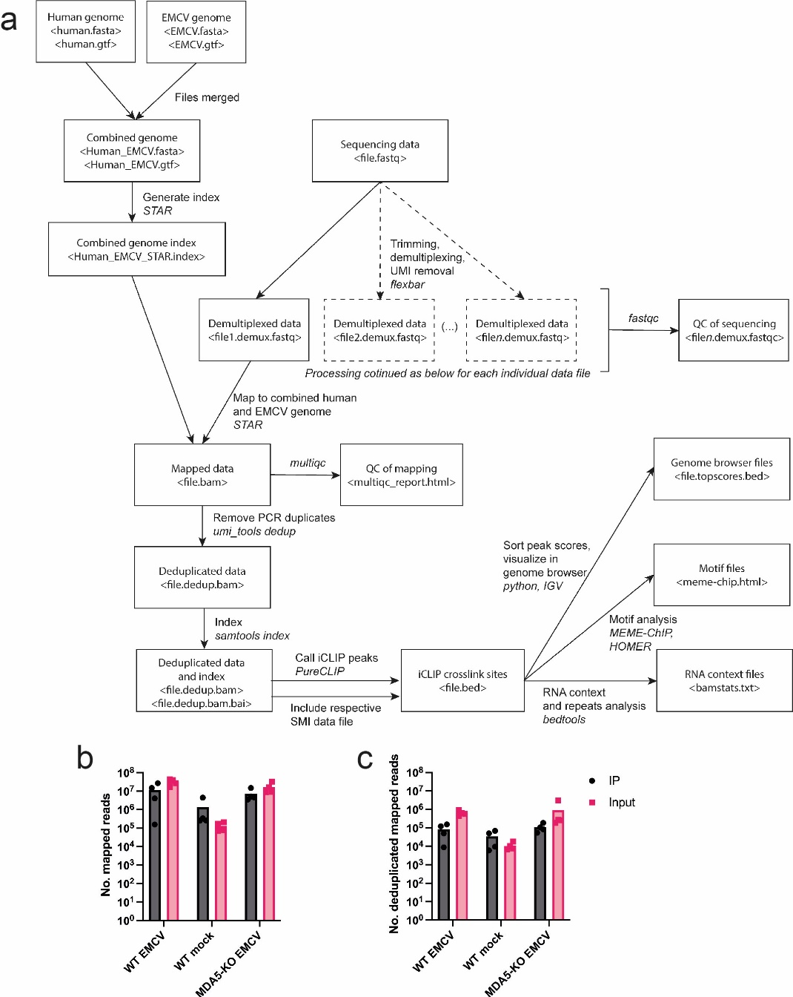
Fig S2. Workflow of iCLIP computational data analysis and mapping rates of MDA5 iCLIP sequencing reads.
a, Input files are represented within boxes, with sample file names and extensions in angle brackets. Arrows indicate file transformations, and computational tools used are shown in italics.
b-c, Number of iCLIP sequencing reads that mapped to the combined human and EMCV genome before (b) and after (c) removal of PCR duplicates.
Data points in (b-c) are from four independent biological repeats, and bars represent the average.
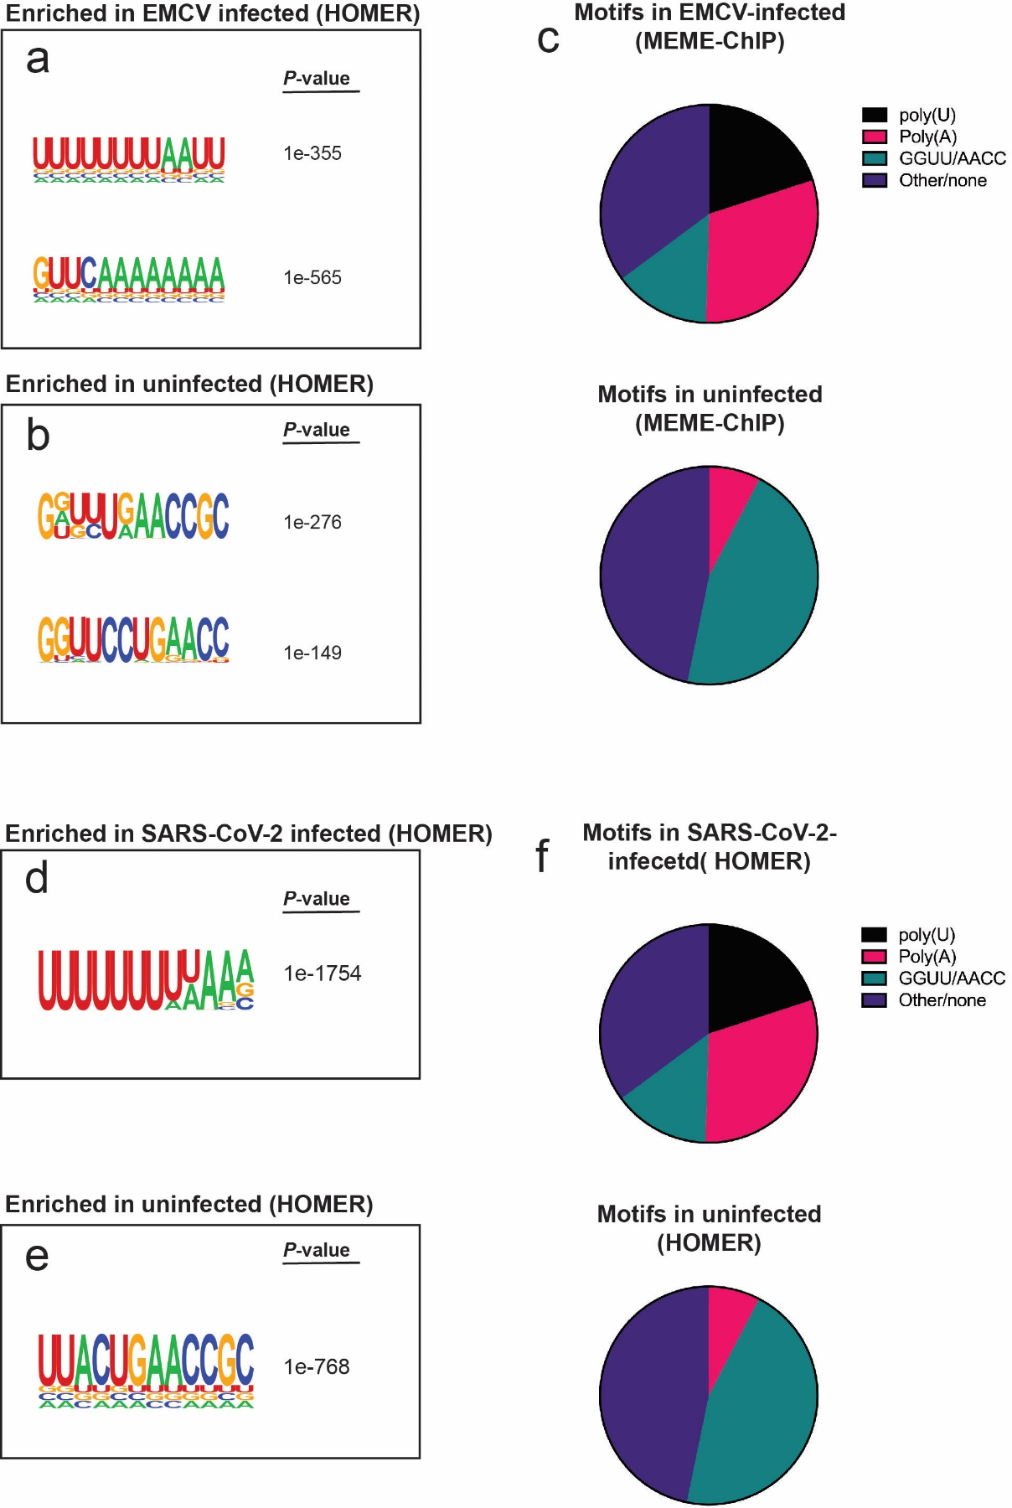
Fig. S3. HOMER motif analysis of MDA5 binding sites from uninfected and virus-infected cells.
a-d, 101 nt regions (50 nt upstream and downstream of single nucleotide binding site) around MDA5 binding sites were analysed for de novo RNA motifs using HOMER. Specific motifs enriched in EMCV-infected samples compared to uninfected samples (a), and in uninfected samples (b). Associated P-values are shown. Proportion of motifs in MDA5 binding sites from uninfected or EMCV-infected cells is shown in c.
d-f, As above, but with SARS-CoV-2-infected cells.
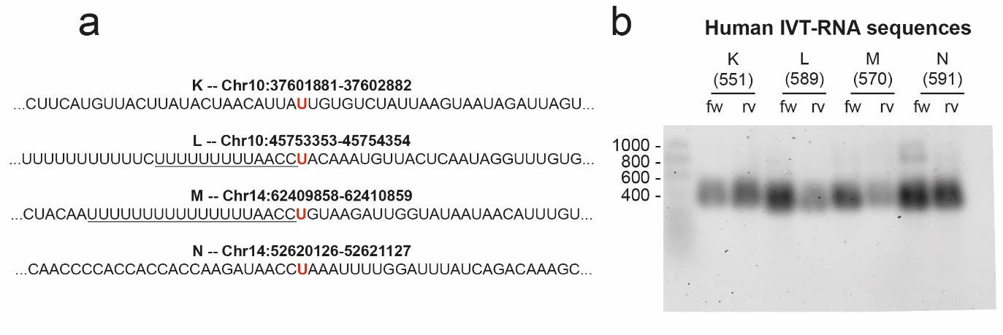
Fig. S4. Preparation of dsRNA from human sequences containing MDA5 iCLIP binding sites.
a, Regions from high-scoring MDA5 iCLIP crosslink sites (crosslinked base highlighted in red; motifs from Fig. 2 underlined) were selected for generation of IVT-RNA.
b, Forward (fw) and reverse (rv) IVT-RNAs were resolved on a denaturing agarose gel. The expected nucleotide lengths are indicated in parentheses. Data is from one experiment.
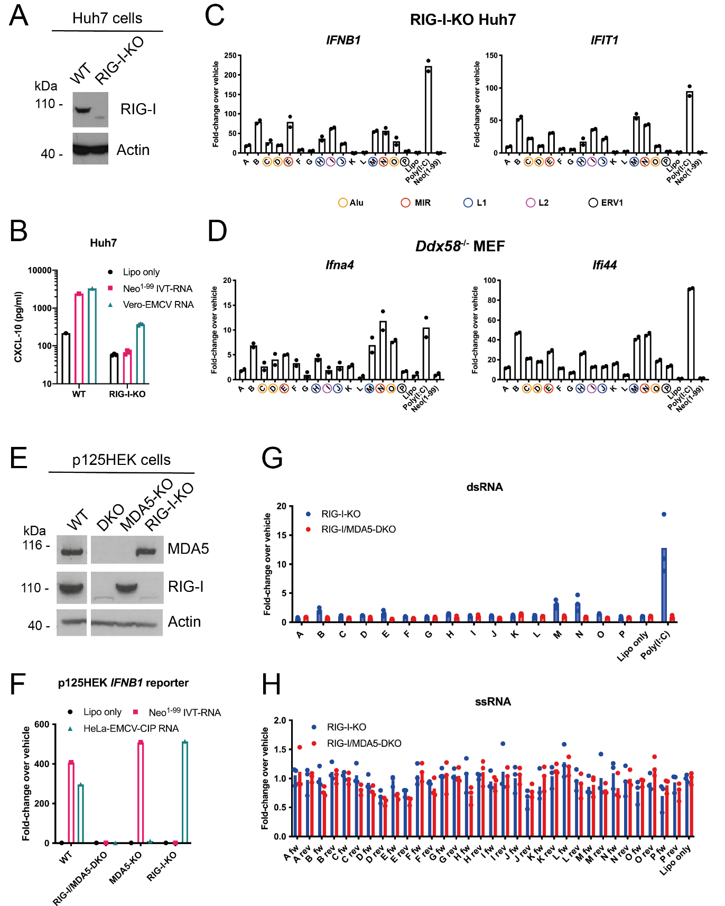

Fig. S5. Analysis of IFN stimulation by MDA5-binding regions from cellular RNAs.
a, RIG-I-KO Huh7 cells were generated using CRISPR/Cas9 gene targeting. Western blot indicated absence of RIG-I protein.
b, RIG-I-KO Huh7 cells were transfected with Neo¹⁻⁹⁹ IVT-RNA, RNA from EMCV-infected Vero cells (Vero-EMCV RNA), or were treated with transfection reagent alone (Lipo only). After 24 hr, CXCL-10 in the cell culture supernatant was measured by ELISA.
c-d, RIG-I-KO Huh7 cells (c) and Ddx58^{-/-} MEFs (d) were transfected with the indicated IVT-dsRNAs, Poly(I:C), or Neo¹⁻⁹⁹ IVT-RNA, or were treated with transfection reagent alone (Lipo only). After overnight incubation, RNA was extracted and RT-qPCR analysis was performed for IFNB1 and IFIT1 (Huh7), or Ifna4 and Ifi44 (MEF). Data are shown relative to GAPDH. IVT-dsRNAs containing repeat elements are indicated (see also Tab. S1).
e, p125HEK MDA5 and RIG-I double knockout (DKO) cells were generated using CRISPR/Cas9 gene targeting. Cells were treated with 100 U/ml IFN-A/D for 24 hr. Western blot indicates absence of both RIG-I and MDA5 in DKO cells.
f, p125HEK WT, RIG-I/MDA5-DKO, RIG-I-KO and MDA5-KO cells were transfected with Neo¹⁻⁹⁹ IVT-RNA, CIP-treated RNA from EMCV-infected HeLa cells (HeLa-EMCV-CIP RNA), or were treated with transfection reagent alone (Lipo only). After overnight incubation, luciferase activity in cell lysates was measured.
g-h, Double-stranded (g) or single-stranded (h) IVT-RNA was transfected into RIG-I-KO or RIG-I-KO/MDA5-KO p125HEK IFNB1 reporter cells. As negative controls, p125HEK cells were treated with transfection reagent alone (Lipo only). After overnight incubation, luciferase activity in cell lysates was measured. Data from untreated cells were set to 1.
All data are from single experiments. Data points in (c) and (d) represent technical duplicates, and data points in (g) and (h) represent technical triplicates.
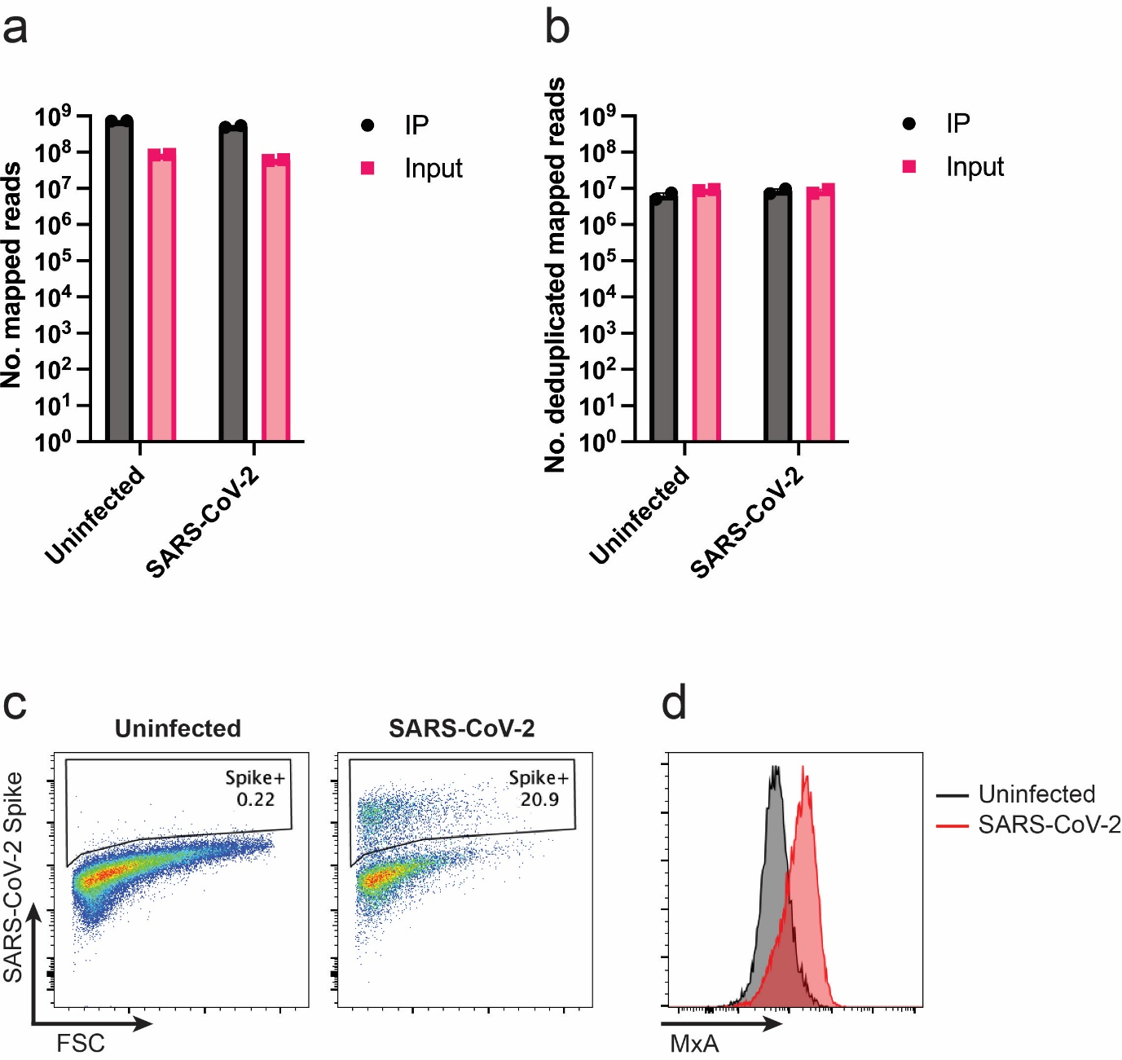

Fig. S6. SARS-CoV-2 infectivity in Calu-3 cells and mapping rates of MDA5 iCLIP sequencing reads.
a-b, Number of iCLIP sequencing reads that mapped to the combined human and EMCV genome before (a) and after (b) removal of PCR duplicates. Data points represent two independent biological repeats and bars represent the mean.
c-d, Calu-3 cells uninfected or infected for 48 hours (MOI=0.1) with SARS-CoV-2. Cells were stained for SARS-CoV-2-Spike (c) and MxA (d) and analysed by flow cytometry. Data shown are representative of two independent experiments. FSC = forward scatter.
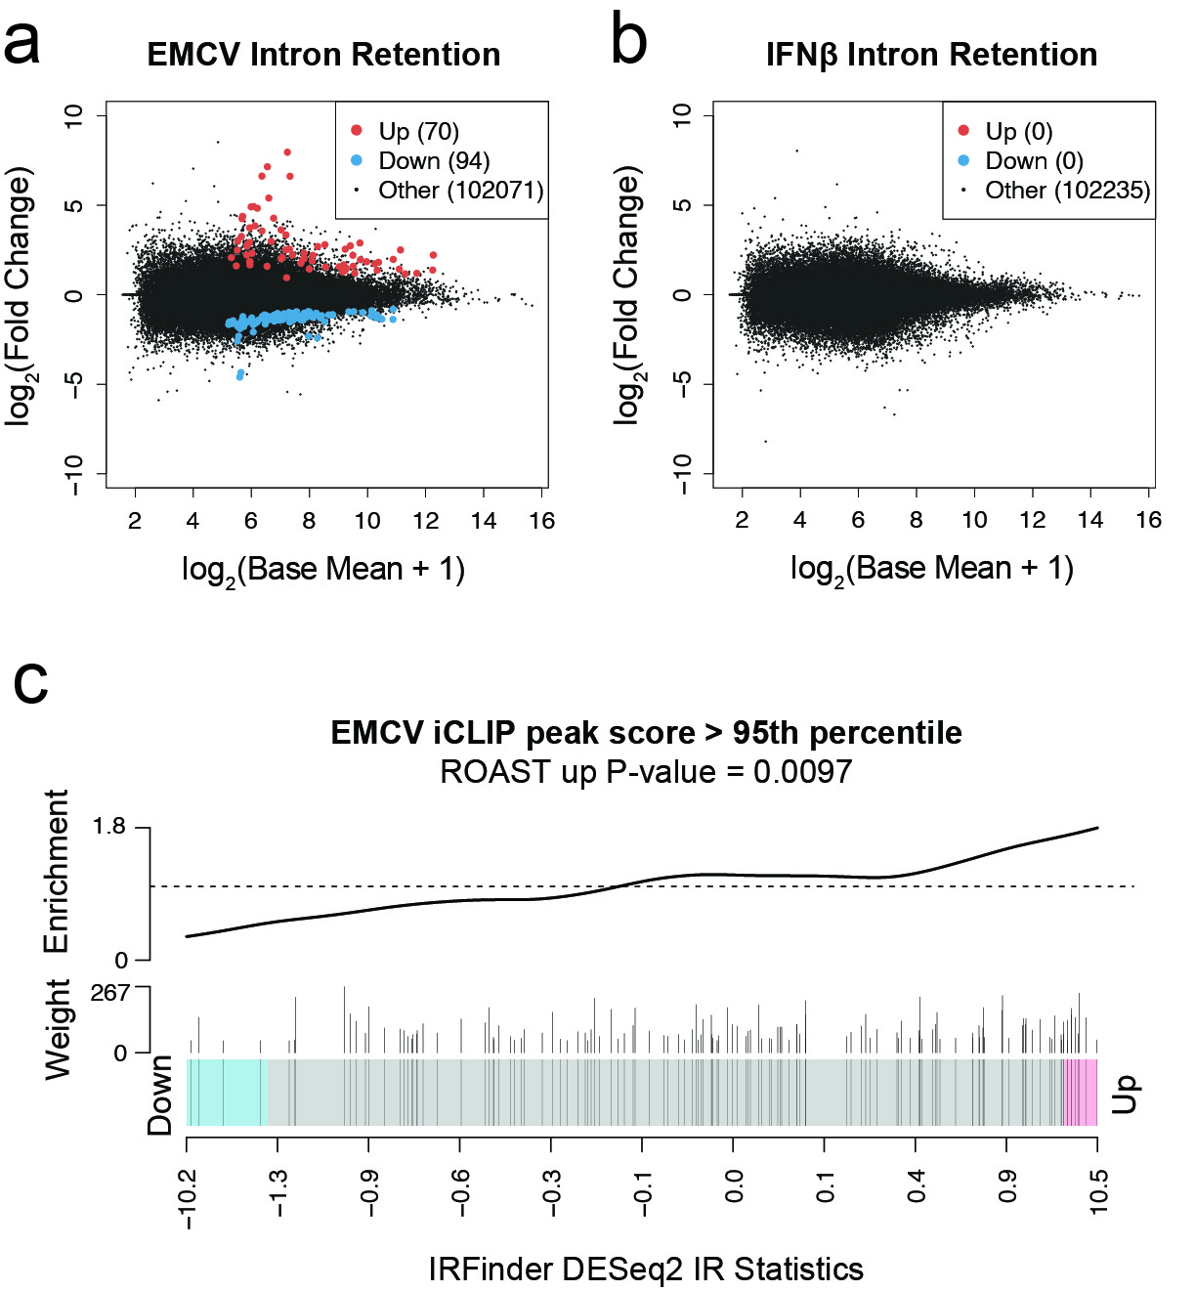

Fig. S7. Intron retention analysis in EMCV-infected cells.
a-b, IRF3-KO THP1 cells were left untreated, infected with EMCV (MOI = 2) for 20 hours, or treated with IFNβ (100 U/ml) for 6 hours (EMCV and untreated, n=4 independent biological repeats; IFNβ, n=3). RNA was extracted from the cytoplasmic fractions, rRNA-depleted and sequenced. Intron retention determined by IRFinder analysis on EMCV-infected cells (a) and IFNβ-treated cells (b) compared to untreated cells, with upregulated (red) and downregulated (blue) intron regions compared to surrounding exon regions highlighted.
c, Barcode plots showing the association of EMCV iCLIP peaks with intron retention by IRFinder analysis. Vertical lines indicate introns that overlapped with the most highly scoring intronic iCLIP peaks (score > 95th percentile), weighted by iCLIP score and arranged according to differential expression statistics. The overall enrichment is indicated by the enrichment line above and significance was calculated using ROAST.

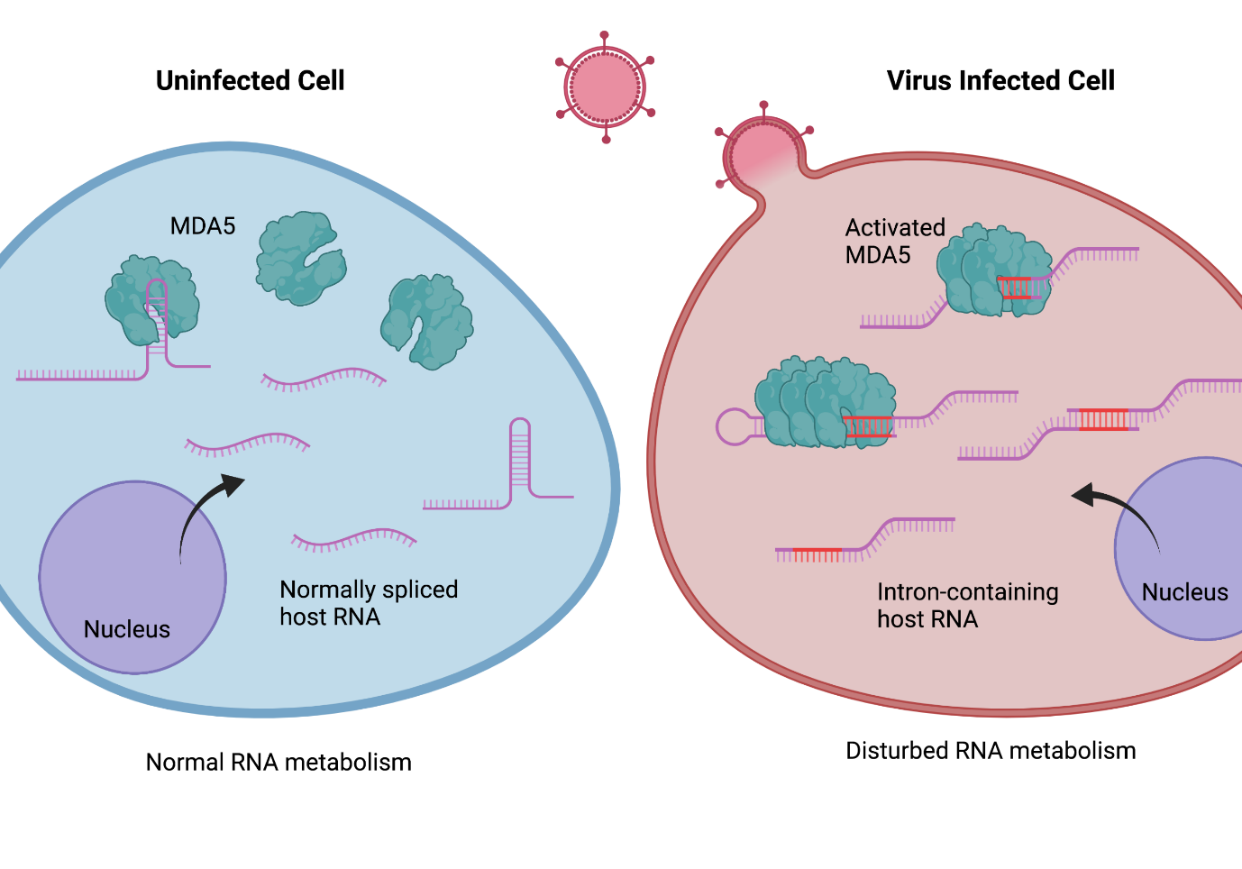
Fig. S8. Graphical abstract.
Table S1 – in vitro transcribed RNA regions

IVT-RNA code | Genome location | Genomic feature | Repeat type | poly(U)AACC motif? | poly(A)CC motif?
A | chr1 178479528-178480529 | exon | - | yes | no
B | chr2 140222384-140223385 | intergenic | - | no | no
C | chr4 39018551-39019552 | repeat | Alu | yes | no
D | chr4 87455177-87456178 | intron | Alu | yes | no
E | chr5 173168418-173169419 | repeat | MIR | no | no
F | chr6 105763342-105764343 | intergenic | - | no | yes
G | chr7 12265267-12266268 | intergenic | - | yes | no
H | chr8 120427649-120428650 | repeat | L1 | no | yes
I | chr8 127351876-127352877 | intron | L2 | yes | no
J | chr9 101873671-101874672 | repeat | L1 | yes | no
K | chr10 37601881-37602882 | exon | - | no | no
L | chr10 45753353-45754354 | intron | - | yes | no
M | chr14 52620126-52621127 | repeat | L1 | no | no
N | chr14 62409858-62410859 | repeat | MIR | yes | no
O | chr15 42176691-42177692 | repeat | Alu | no | yes
P | chr18 43170031-43171032 | repeat | ERV1 | yes | no

Table S2 – DNA primer/probe sequences

Name | Method | Sequence
Rt1clip | iCLIP reverse transcription | /5Phos/NN AACC NNN AGATCGGAAGAGCGTCGTGgatcCTGAACCGC
Rt2clip | iCLIP reverse transcription | /5Phos/NN ACAA NNN AGATCGGAAGAGCGTCGTGgatcCTGAACCGC
Rt3clip | iCLIP reverse transcription | /5Phos/NN ATTG NNN AGATCGGAAGAGCGTCGTGgatcCTGAACCGC
Rt4clip | iCLIP reverse transcription | /5Phos/NN AGGT NNN AGATCGGAAGAGCGTCGTGgatcCTGAACCGC
Rt8clip | iCLIP reverse transcription | /5Phos/NN CATT NNN AGATCGGAAGAGCGTCGTGgatcCTGAACCGC
Rt9clip | iCLIP reverse transcription | /5Phos/NN GCCA NNN AGATCGGAAGAGCGTCGTGgatcCTGAACCGC
iiCLIP_ddRT_12 | iCLIP reverse transcription | /5Phos/ WWW GTGGA NNNN AGATCGGAAGAGCGTCGTGAT  /iSp18/ GGATCC /iSp18/ TACTGAACCGC
iiCLIP_ddRT_13 | iCLIP reverse transcription | /5Phos/ WWW TCCGG NNNN AGATCGGAAGAGCGTCGTGAT  /iSp18/ GGATCC /iSp18/ TACTGAACCGC
iiCLIP_ddRT_14 | iCLIP reverse transcription | /5Phos/ WWW TGCCT NNNN AGATCGGAAGAGCGTCGTGAT  /iSp18/ GGATCC /iSp18/ TACTGAACCGC
iiCLIP_ddRT_15 | iCLIP reverse transcription | /5Phos/ WWW TATTC NNNN AGATCGGAAGAGCGTCGTGAT  /iSp18/ GGATCC /iSp18/ TACTGAACCGC
iiCLIP_ddRT_16 | iCLIP reverse transcription | /5Phos/ WWW TTAAA NNNN AGATCGGAAGAGCGTCGTGAT  /iSp18/ GGATCC /iSp18/ TACTGAACCGC
iiCLIP_ddRT_17 | iCLIP reverse transcription | /5Phos/ WWW AAATG NNNN AGATCGGAAGAGCGTCGTGAT  /iSp18/ GGATCC /iSp18/ TACTGAACCGC
iiCLIP_ddRT_18 | iCLIP reverse transcription | /5Phos/ WWW AAGGT NNNN AGATCGGAAGAGCGTCGTGAT  /iSp18/ GGATCC /iSp18/ TACTGAACCGC
iiCLIP_ddRT_19 | iCLIP reverse transcription | /5Phos/ WWW AATAC NNNN AGATCGGAAGAGCGTCGTGAT  /iSp18/ GGATCC /iSp18/ TACTGAACCGC
iiCLIP_ddRT_20 | iCLIP reverse transcription | /5Phos/ WWW ACGCA NNNN AGATCGGAAGAGCGTCGTGAT  /iSp18/ GGATCC /iSp18/ TACTGAACCGC
iiCLIP_ddRT_21 | iCLIP reverse transcription | /5Phos/ WWW ACTTG NNNN AGATCGGAAGAGCGTCGTGAT  /iSp18/ GGATCC /iSp18/ TACTGAACCGC
iiCLIP_ddRT_22 | iCLIP reverse transcription | /5Phos/ WWW AGAGC NNNN AGATCGGAAGAGCGTCGTGAT  /iSp18/ GGATCC /iSp18/ TACTGAACCGC
iiCLIP_ddRT_23 | iCLIP reverse transcription | /5Phos/ WWW AGTCT NNNN AGATCGGAAGAGCGTCGTGAT  /iSp18/ GGATCC /iSp18/ TACTGAACCGC
EMCV 5NTR_F | SYBR Green qPCR | GTCTGTAGCGACCCTTTG
EMCV 5NTR_R | SYBR Green qPCR | CCTTGTTGAATACGCTTGAG
EMCV_VP1_F | SYBR Green qPCR | GCTTCAGAAAAGATCCTGGC
EMCV_VP1_R | SYBR Green qPCR | CCAGTTTTCACCAGGTAGTGC
EMCV_VP2_F | SYBR Green qPCR | ACCAAACGAAGGTGGCTTTC
EMCV_VP2_R | SYBR Green qPCR | TCCTGTTTGGATTTAAGCGG
EMCV_helicase_F | SYBR Green qPCR | CAAGTCAGGTTATTGCCCAG
EMCV_helicase_R | SYBR Green qPCR | GGTAGTCGAAACCATCTGACAG
EMCV_protease_F | SYBR Green qPCR | TGGTTTTGTCTACCCCACTG
EMCV_protease_R | SYBR Green qPCR | TGTGTGACTCCACGCACTAC
EMCV_RNApol_F | SYBR Green qPCR | GTCTTCCAACCAGCATATGC
EMCV_RNApol_R | SYBR Green qPCR | CCATTCTAAACACTGGTGGG
hISG15F | SYBR Green qPCR | GCGAACTCATCTTTGCCAGT
hISG15R | SYBR Green qPCR | AGCATCTTCACCGTCAGGTC
hIFI44F | SYBR Green qPCR | CAGACAGAGCAGCTACCCTCA
hIFI44R | SYBR Green qPCR | GTGCAACCATGTCAAACGAG
hIFI44LF | SYBR Green qPCR | ACCGTGGCTGCTCGATAAA
hIFI44LR | SYBR Green qPCR | AGCTTGCGCAGATGATTTTC
hDDX58-fwd | SYBR Green qPCR | AAAAACAACAAGGGCCCAAT
hDDX58-Rev | SYBR Green qPCR | TCCCAACTTTCAATGGCTTC
hOAS1-fwd | SYBR Green qPCR | CCGTGAAGTTTGAGGTCCAG
hOAS1-Rev | SYBR Green qPCR | GGTTTATAGCCGCCAGTCAA
hOAS2F | SYBR Green qPCR | GAAGCCCTACGAAGAATGTCAGA
hOAS2R | SYBR Green qPCR | TCGGAGTTGCCTCTTAAGACTGT
hMX1F | SYBR Green qPCR | GGTGGTGGTCCCCAGTAATG
hMX1R | SYBR Green qPCR | ACCACGTCCACAACCTTGTCT
hIFNB1_F | SYBR Green qPCR | GAGCTGTAGTGGAGAAGCACA
hIFNB1_R | SYBR Green qPCR | GCGACACTGTTCGTGTTGTC
hIFNa2-fwd | SYBR Green qPCR | TGGGCTGTGATCTGCCTCAAAC
hIFNa2-rev | SYBR Green qPCR | CAGCCTTTTGGAACTGGTTGCC
hGAPDHF | SYBR Green qPCR | CCTCCTGTTCGACAGTCAGC
hGAPDHR | SYBR Green qPCR | CCTAGCCTCCCGGGTTTCTC
EMCV_Probe_2_biotin | EMCV RNA depletion | /5BioTinTEG/ATTGCCTTCCGAGGAGGAGTTATTCTTGTCTGAGG/3BioTEG/
EMCV_probe_5_biotin | EMCV RNA depletion | /5BioTinTEG/TATCACTGAGTTCGGGCAAGTCCCATTAGAGAACG/3BioTEG/
EMCV_probe_7_biotin | EMCV RNA depletion | /5BioTinTEG/CCCAAACCAATCAACCACCTTTTCCACAGTCTTGA/3BioTEG/
EMCV_probe_10_biotin | EMCV RNA depletion | /5BioTinTEG/TCTCTGAATAGAGGACCAGAAGAGAGGCGGATGAA/3BioTEG/
EMCV_probe_13_biotin | EMCV RNA depletion | /5BioTinTEG/TTATATCCTGTCTTTGCGAGGCTTGCTCTCACCTT/3BioTEG/

