Extended Data

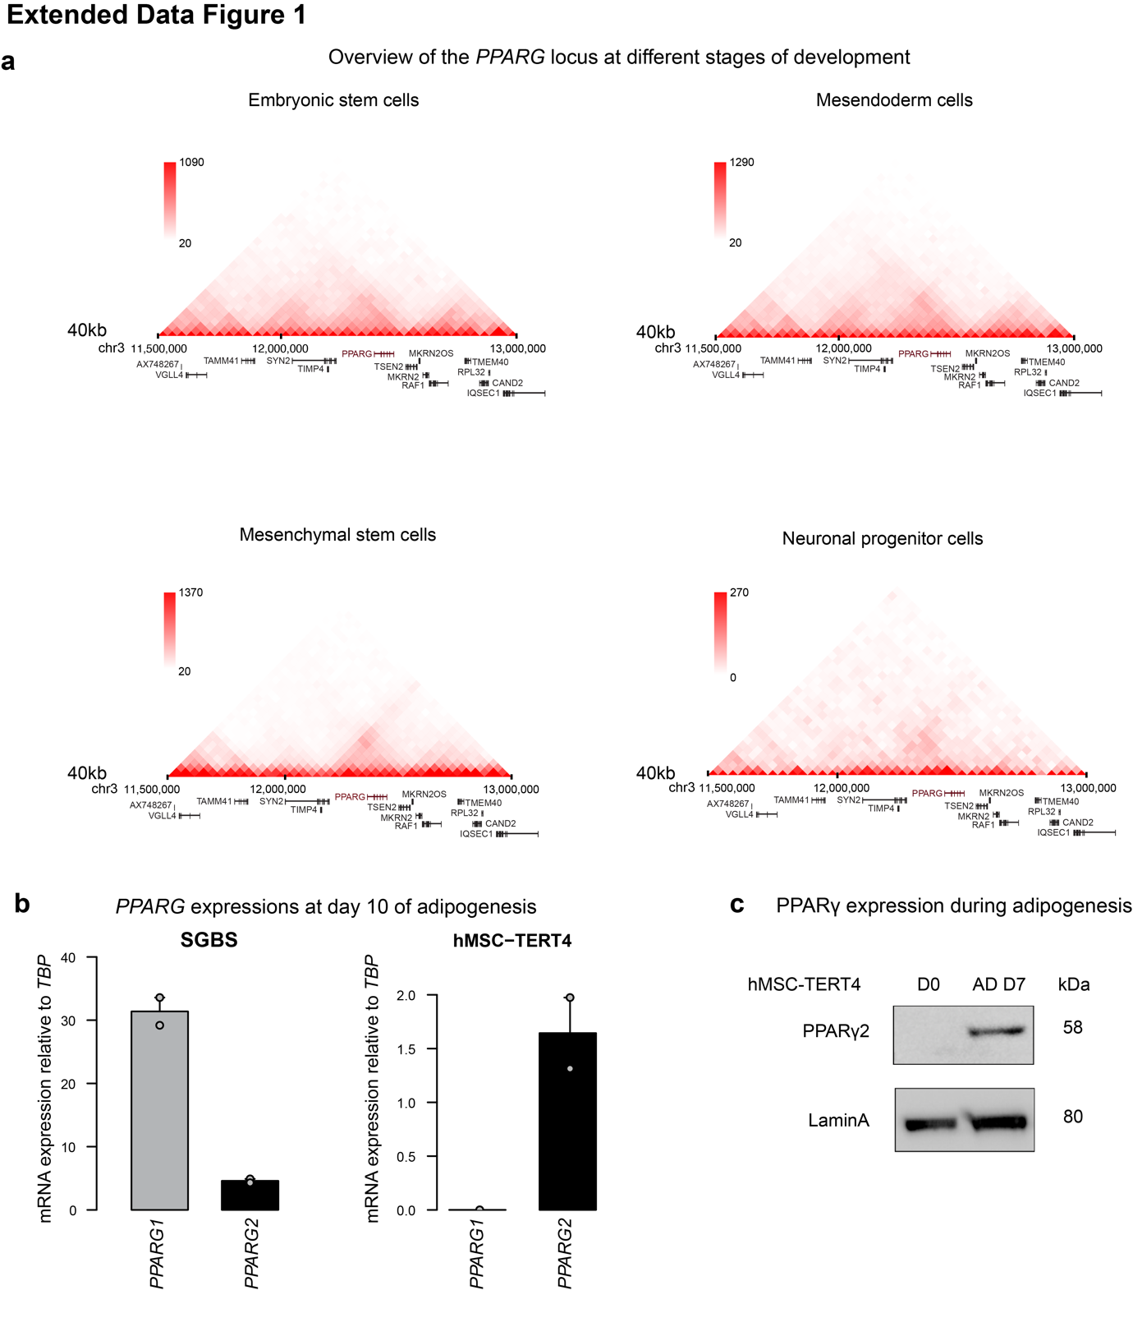
Extended Data Fig. 1: Structure of the PPARG genomic region and expression levels of PPARγ isoforms. a, Hi-C maps (Dixon et al., 2015) of the PPARG locus and neighboring loci in embryonic stem cells, mesendoderm cells, mesenchymal stem cells, and neural progenitor cells at 40 kb resolution. Contact Hi-C matrixes visualized using 3DGenome from YUE lab. b, Relative mRNA expression of the PPARG2 isoforms was assayed by qPCR at day 10 of adipogenesis in the SGBS and the hMSC-TERT4 cell lines. n=2 biological replicates. c, Western blot analysis of PPARγ and Lamin A (control) expression in hMSC-TERT4 adipogenesis. Protein was harvested at day 0, and day 7 of adipogenesis in hMSC-TERT4. PPARγ expression was detected using an antibody recognizing both PPARγ1 and 2. Images have been cropped. Representative of one replicate.

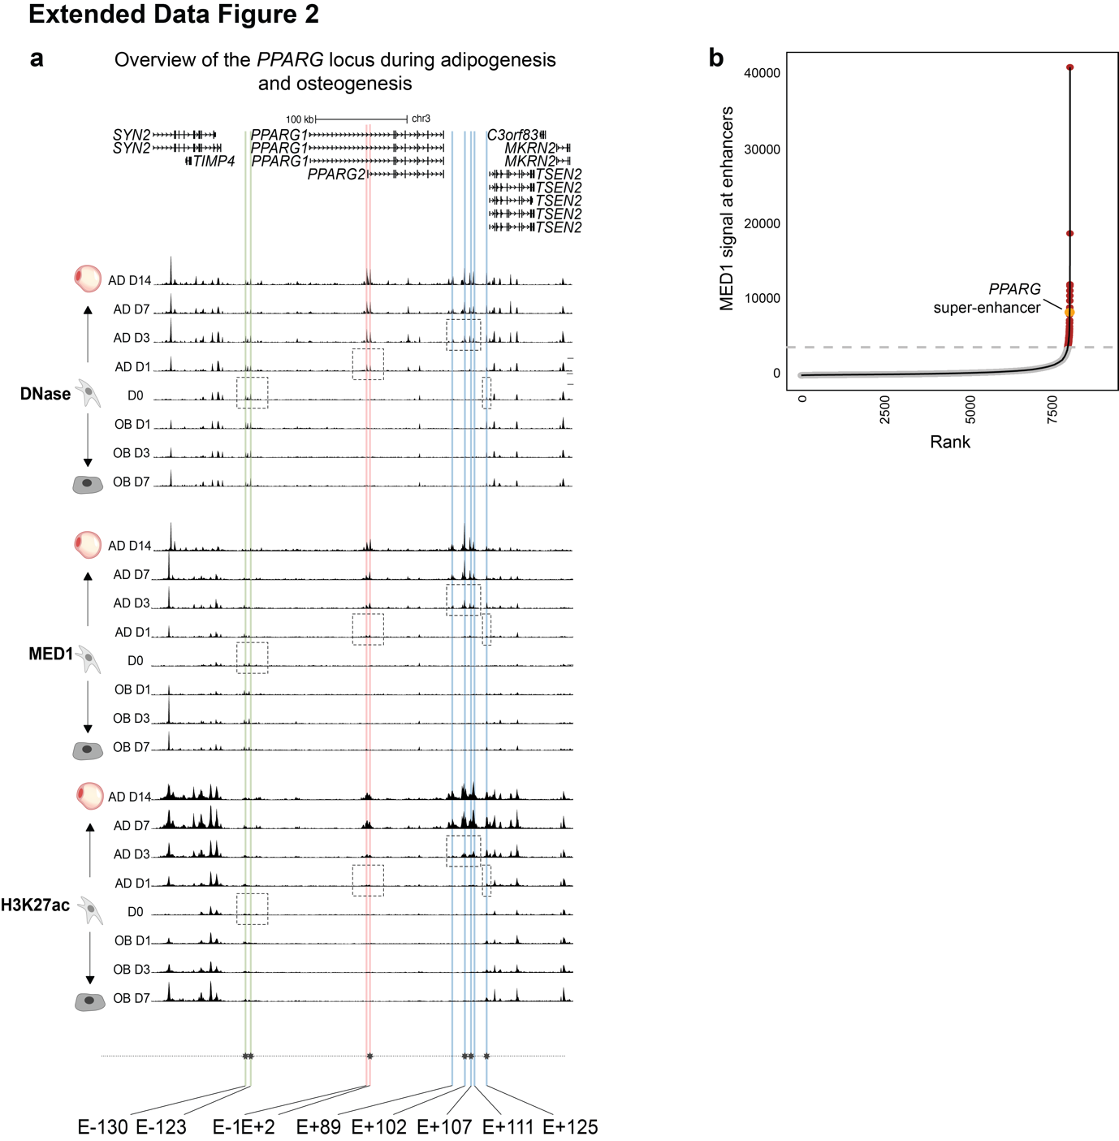
Extended Data Fig. 2: Overview of the epigenomic structure of the PPARG locus during adipogenesis and osteogenesis. hMSC-TERT4 cells were stimulated to undergo adipogenesis and osteogenesis. a, DNase- and MED1- and H3K27ac ChIP-seq tracks from day 0, and day 1, 3, 7 and 14 of adipogenesis and day 1, 3, and 7 of osteogenesis. Putative key enhancers are highlighted by green, red, and blue vertical lines. n=2 biological replicates. b, Hockey plot depicting ranking of enhancer regions called by ROSE algorithm (Lovén et al., 2013; Warren et al., 2013) on MED1 signal at day 14 of adipogenesis.
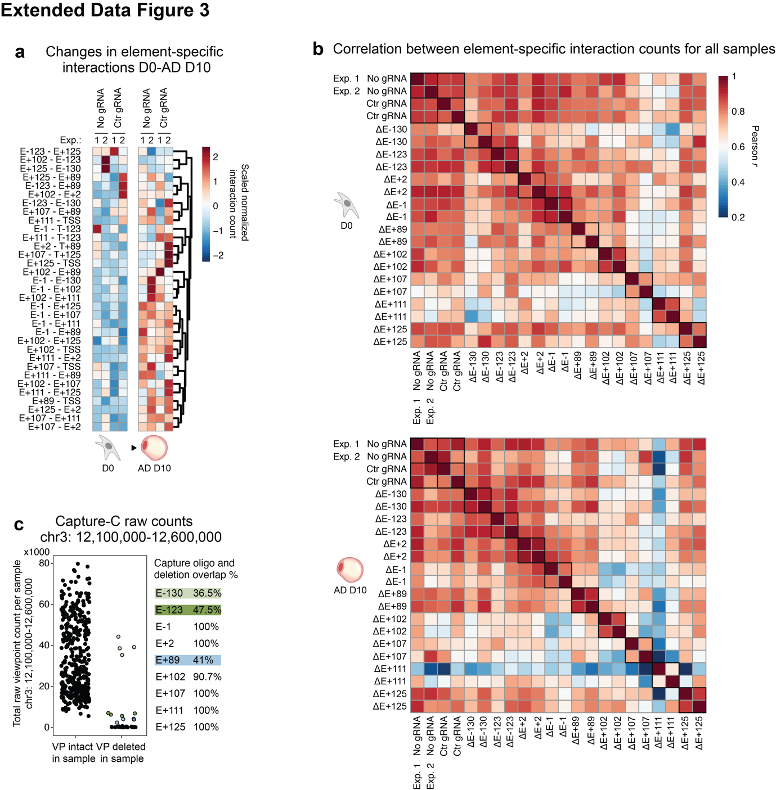
Extended Data Fig. 3: Capture-C analyses of the PPARG locus. hMSC-TERT4/iCas9-4 controls (‘No gRNA’ and ‘Ctr gRNA’) and clones with the indicated enhancer deletions were induced to differentiate to adipocytes and Capture-C was performed on day 0 and 10. a, Heatmap of normalized interaction count for significant (FDR ≤ 0.01 in combined controls or any deletion) element-specific Capture-C interactions (left labels). Normalized interaction count was scaled and centered on 0 across rows for visualization. Samples from two independent experiments are shown (top labels). FDR was obtained by two-tailed Student’s t-test and Benjamini-Hochberg correction. b, Heatmap of correlation (Pearson r) between normalized interaction count for site-specific Capture Hi-C. All samples from two independent experiments are shown. c, Capture-C raw interaction counts within the indicated genomic region for each viewpoint (VP) in each sample where the viewpoint was intact, and each sample where the viewpoint had been deleted. Right: Percent overlap between enhancer capture oligo and enhancer deletion. Colored dots in the plot refer to colored enhancers to the right.
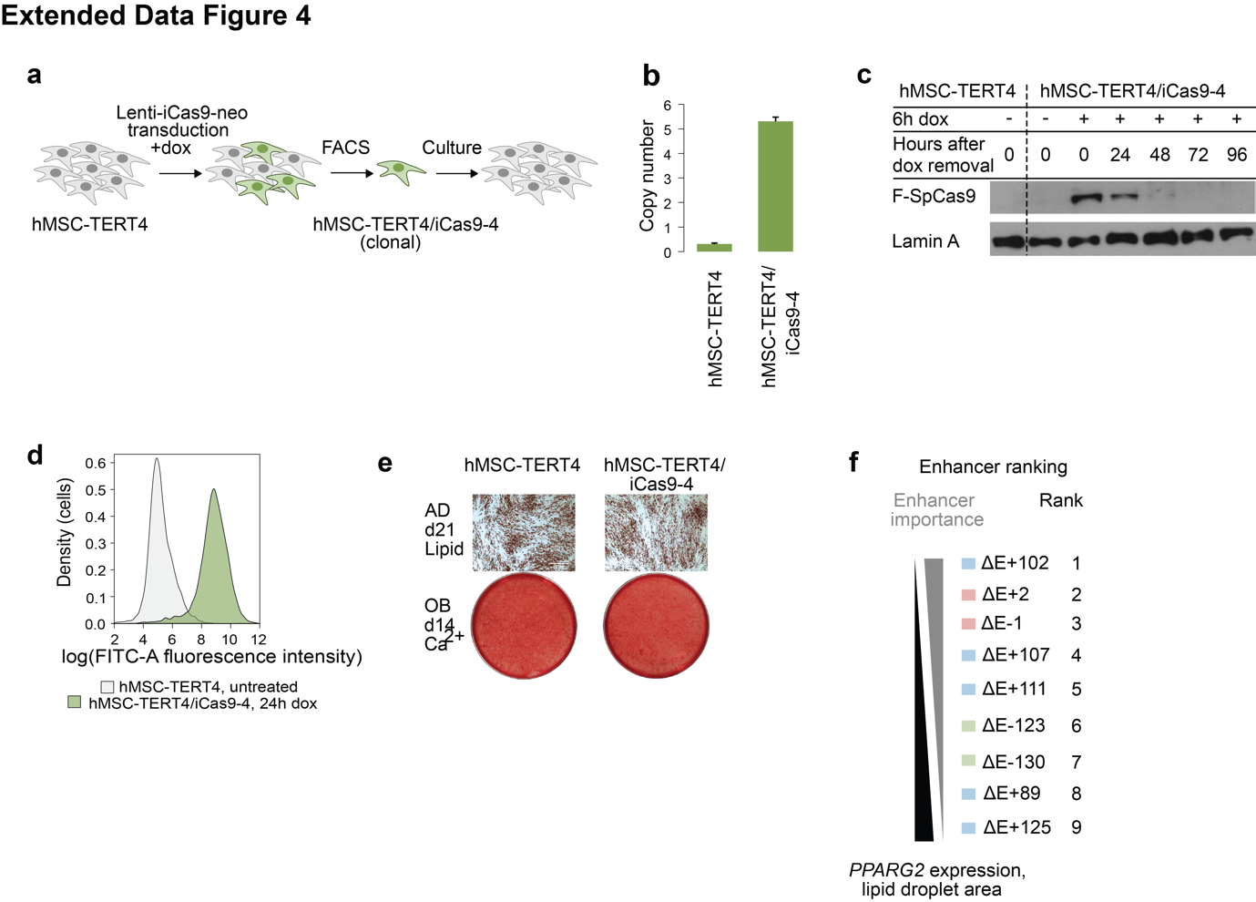
Extended Data Fig. 4: Generation and characterization of inducible lentivirus-based delivery of Cas9 in hMSC-TERT4/iCas9-4 for genome editing. a, Workflow for production and characterization of hMSC-TERT4/iCas9-4. b, Transgene copy number in hMSC-TERT4 and hMSC-TET4/iCas9-4 was determined by qPCR on genomic DNA (technical duplicate). Bars indicate mean+1/2 range between technical duplicates. n=1 biological replicate. c, Western blot analysis of FLAG-tagged Cas9 and Lamin A (loading control) expression in response to doxycycline treatment. hMSC-TERT4 and hMSC-TERT4/iCas9-4 were treated with doxycycline for 6 hours, and protein was harvested at the indicated timepoints after doxycycline removal. n=1 biological replicate. d, Untreated hMSC-TERT4 and hMSC-TERT4/iCas9-4 treated with doxycycline for 24 h were analyzed by FACS based on GFP signal. n=1 biological replicate. e, hMSC-TERT4 and hMSC-TET4/iCas9-4 were stimulated with osteogenic and adipogenic cocktails for 14 and 21 days, respectively. Osteogenic potential was assessed by Alizarin Red staining for calcified extracellular matrix, adipogenic potential by Oil-red-O staining for lipid accumulation. Microscopy pictures were taken at 40x total magnification with differential interference contrast. Scale bar is 250 μm. Representative of n=3 biological replicates. f, Ranking of enhancers in the PPARG community according to PPARG2 expression and lipid droplet area. Larger negative impact on PPARG2 expression and lipid formation, higher in rank for an importance for community functions.
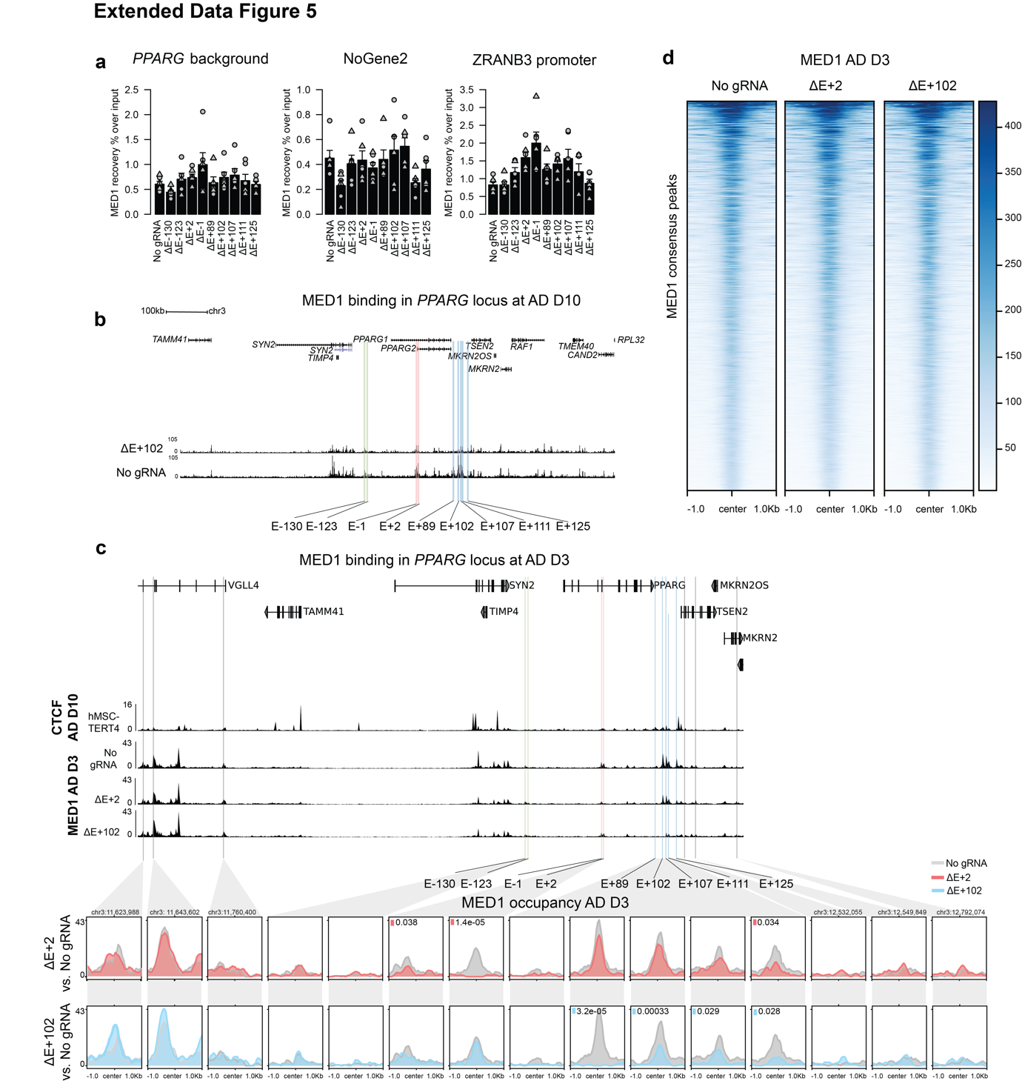
Extended Data Fig. 5: PPARG enhancer deletions only affect MED1 occupancy in the PPARG locus. hMSC-TERT4/iCas9-4 controls and clones with the indicated enhancer deletions were induced to differentiate to adipocytes and MED1 occupancy was assessed by ChIP-qPCR or ChIP-seq. a, MED1 ChIP-qPCR at day 10 of adipogenesis indicated as recovery % over input in control regions (PPARG background, NoGene2; and ZRANB3 promoter to adjust for ChIP efficiency). Bars represent mean +1 SEM. Points represent individual measurements in three independent clones, where circles and triangles represent two independent differentiations, i.e. n=2 biological replicates. b, MED1 ChIP-seq tracks at day 10 of adipogenesis in ‘No gRNA’ control and E+102 deletion clones. Putative enhancers are highlighted by green, red, and blue vertical lines. n=2 biological replicates. c, Top: CTCF ChIP-seq at day 10 of adipogenesis in hMSC-TERT4. n=2 biological replicates. Normalized and averaged MED1 ChIP-seq tracks at day 3 of adipogenesis in ‘No gRNA’ control, E+2 deletion, and E+102 deletion clones. n=2 biological replicates, n=2 clonal cell lines per condition. Putative enhancers within the PPARG community are highlighted by green, red, and blue vertical lines; putative enhances located outside the PPARG TAD are highlighted by grey vertical lines. Bottom: Normalized and averaged MED1 ChIP-seq in the PPARG locus and neighboring regions at day 3 of adipogenesis in ‘No gRNA’ control, E+2 deletion, and E+102 deletion clones. Colors indicate MED1 occupancy as follows: ‘No gRNA’ control 2 – grey, E+2 deletion – red, E+102 deletion – blue. Visualized using deepTools (Ramírez et al., 2014). Respective colored squares indicate enhancers with a significant change in MED1 occupancy (EdgeR, P-value ≤ 0.05). n=2 biological replicates, n=2 clonal cell lines per condition. d, Heatmap of MED1 ChIP-seq at MED1 peaks at day 3 of adipogenesis in ‘No gRNA’ control, and E+2 and E+102 deletion clones, data represented in a plot profile and heatmap ±1000 kb from the center of the peak.

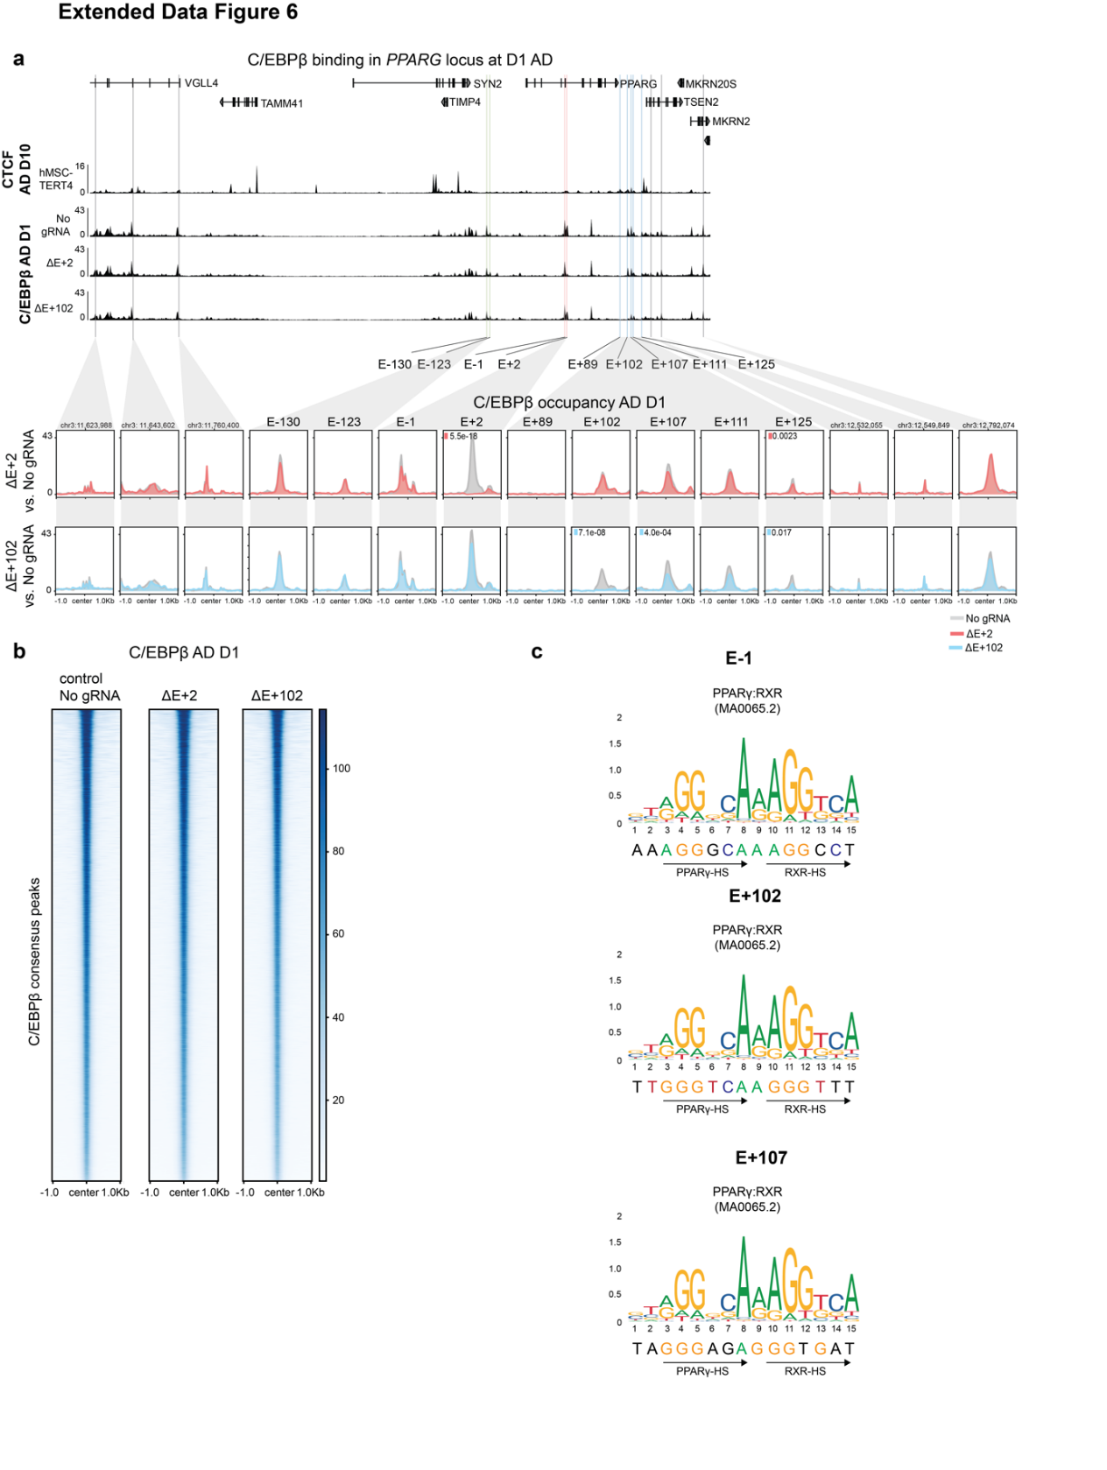
Extended Data Fig. 6: PPARG enhancer deletions only affect C/EBPβ occupancy in the PPARG enhancer community. hMSC-TERT4/iCas9-4 controls and clones with the indicated enhancer deletions were induced to differentiate to adipocytes and C/EBPβ occupancy was assessed by ChIP-seq at day 1 of differntiation. a, Top: CTCF ChIP-seq tracks at day 10 of adipogenesis. n=2 biological replicates. Normalized and averaged C/EBPβ ChIP-seq tracks at day 1 of adipogenesis in ‘No gRNA’ control, and E+2 and E+102 deletion clones. n=2 biological replicates, n=2 clonal cell lines per condition. Enhancers within the PPARG enhancer community are highlighted by green, red, and blue vertical lines; enhancers located outside the PPARG TAD are highlighted by grey vertical lines. Bottom: Plot profile of normalized and averaged C/EBPβ ChIP-seq occupancy at studied enhancers within the PPARG community and in regions outside the PPARG TAD at day 1 of adipogenesis in ‘No gRNA’ control, and E+2 and E+102 deletion clones. Colors represent MED1 occupancy as follows: ‘No gRNA’ control – grey, E+2 – red, E+102 – blue. Visualized using deepTools (Ramírez et al., 2014). Respective colored squares indicate enhancers with a significant change in C/EBPβ occupancy (EdgeR, P-value ≤ 0.05). n=2 biological replicates, n=2 clonal cell lines per condition. b, C/EBPβ binding as determined by C/EBPβ ChIP-seq at C/EBPβ peaks at day 1 of adipogenesis in ‘No gRNA’ control, and E+2 and E+102 deletion clones, data represented in a plot profile and heatmap ±1000 kb from the center of the peak. c, Position weight matrix (PWM) for the PPRE from Jaspar database (MA0065.2) and the PPREs identified in PPARy ChIP-seq peaks in E-1, E+102, and E+107, respectively.

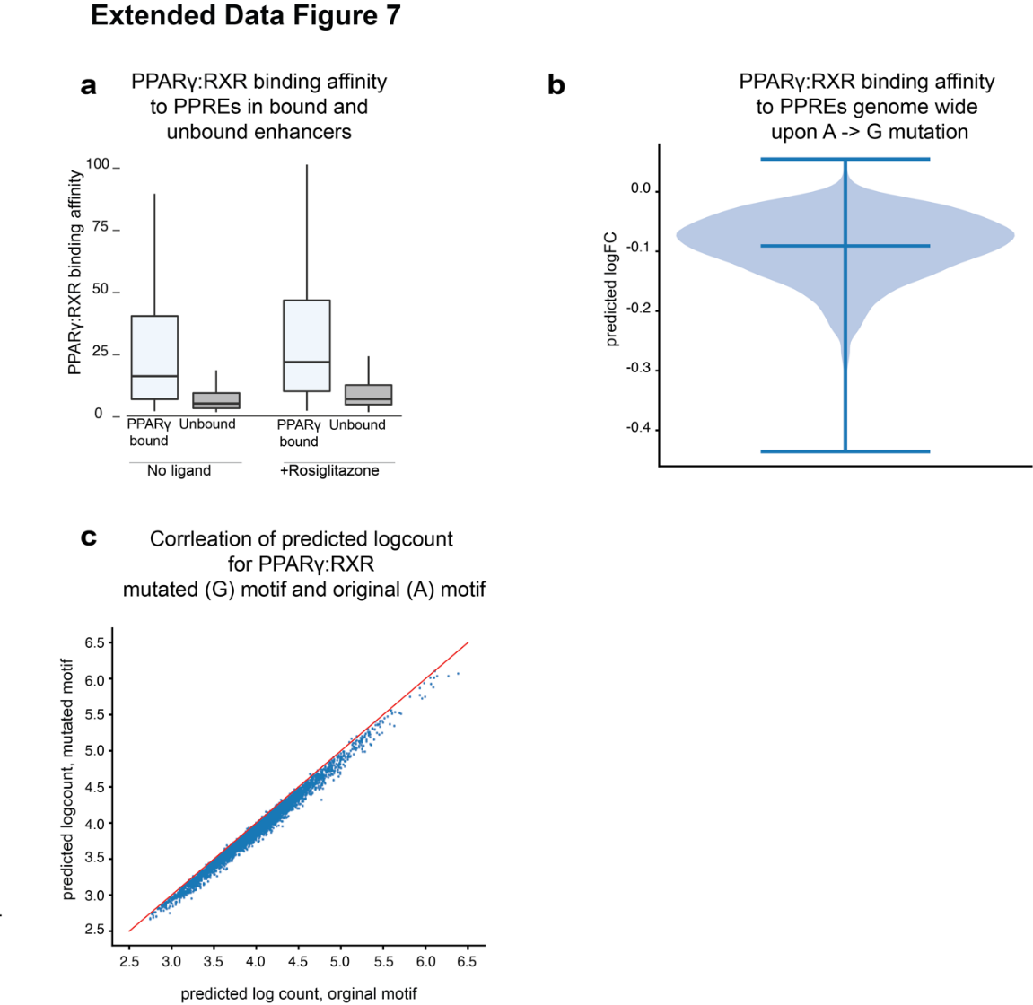
Extended Data Fig. 7: The effect of A>G variant in the spacer of PPREs. a, Box plot indicating inferred PPARy binding affinity in the top 1000 PPARγ bound enhancers (based on PPARγ ChIP peaks at day 10 of adipogenesis in hMSC-TERT4 cell, and reproducible DNase-seq and MED1 ChIP peaks at day 14 of adipogenesis in hMSC-TERT4), and in 1000 non-bound random enhancers (based on reproducible DNase-seq and MED1 ChIP peaks at day 14 adipogenesis in hMSC-TERT4), see methods for details. b, Violin plot of BPNet-predicted logFC upon introducing the A>G mutation in genome-wide PPARγ ChIP-seq peak regions containing a high-scoring PPARγ motif instance from PPARγ ChIP-seq at day 10 of adipogenesis in hMSC-TERT4. The central line indicates the mean logFC of -0.09. c, BPNet predicted log counts in unmutated vs mutated genomic regions, based on genome-wide PPARγ ChIP-seq data at day 10 of adipogenesis in hMSC-TERT4.

Extended Data Table 1: Top 40 SNPs within PPARG locus with predicted the highest positive or negative Enformer effect on PPARG2 signal
Rank no. | Enhancer location | SNP | PPARG2 CAGE effect | Minor allele | Major allele | Alfa_MAF | Traits
1 |  | rs75364007 | 6,80 | G | C | 1,22E-02 | HbA1c
2 | E-1 | rs4135245 | 6,68 | G | C | 7,01E-05 | Waist-hip ratio adj BMI
3 |  | rs4135334 | 5,25 | T | A | 1,00E-04 | Total cholesterol
4 |  | rs142461679 | 4,64 | A | G | 1,00E-04 | HbA1c
5 |  | rs17793951 | 3,83 | G | A | 3,35E-01 | HbA1c
6 |  | rs9842021 | 3,73 | G | T | 5,23E-04 | Type 2 diabetes adj BMI
7 | E+102 | rs141217211 | 3,23 | C | A | 3,51E-04 | Diabetic nephropathy
8 | E+89 | rs57294685 | 3,01 | C | G | 1,02E-04 | Triglycerides
9 |  | rs184145673 | 2,84 | C | T | 6,30E-04 | Type 2 diabetes adj BMI
10 | E-1 | rs17036333 | 2,72 | A | G | 1,11E-04 | Triglycerides
11 |  | rs4135364 | 2,58 | T | C | 1,00E-04 | hip circumference
12 |  | rs76818696 | 2,15 | A | G | 1,42E-01 | Body mass index
13 |  | rs4135300 | 1,82 | T | C | 1,02E-01 | Type 2 diabetes adj BMI
14 | E-1 | rs12486170 | 1,81 | G | A | 2,96E-01 | Type 2 diabetes
15 |  | rs140129716 | 1,68 | G | C | 2,59E-03 | Insulin sensitivity
16 |  | rs184520978 | 1,66 | G | A | 6,93E-04 | Fasting glucose
17 |  | rs59549880 | 1,61 | T | C | 9,92E-01 | Body mass index
18 |  | rs4135302 | 1,54 | A | G | 9.05E-05 | Type 2 diabetes
19 | E-1 | rs7614873 | 1,4 | G | T | 1,20E-03 | Weight
20 |  | rs184951389 | 1,35 | C | T | 8,00E-03 | Type 2 diabetes
1 |  | rs145806574 | -42,07 | G | A | 2,29E-03 | Ratio total to HDL cholesterol
2 |  | rs193239395 | -10,80 | A | G | 3,15E-04 | Aspartate aminotransferase
3 | E-1 | rs7649970 | -5,65 | T | C | 8,58E-02 | Type 2 diabetes
4 | E-1 | rs7647481 | -3,26 | A | G | 1,17E-01 | Type 2 diabetes
5 | E-1 | rs139154644 | -3,05 | C | T | 6,37E-03 | Body mass index
6 |  | rs199995596 | -2,48 | A | G | 1,52E-04 | Triglyceride levels without T2D
7 |  | rs116404274 | -2,38 | T | C | 1,04E-03 | Aspartate aminotransferase
8 |  | rs6809832 | -2,22 | C | T | 1,50E-01 | Body mass index
9 |  | rs4135261 | -2,09 | C | T | 5,10E-05 | NAFLD
10 |  | rs142771488 | -1,79 | C | T | 5,65E-02 | Body mass index
11 |  | rs114773793 | -1,74 | T | C | 1,60E-03 | Hematocrit
12 |  | rs199970439 | -1,71 | A | G | 3,15E-04 | HbA1c adj BMI
13 | E+102 | rs181025382 | -1,70 | G | A | 1,02E-04 | Total cholesterol
14 |  | rs2938392 | -1,70 | A | G | 4,66E-01 | HbA1c
15 |  | rs148844673 | -1,69 | A | C | 2.23E-05 | Type 2 diabetes
16 |  | rs76003730 | -1,67 | G | A | 1,00E-04 | Glucose at 60 min at V1
17 |  | rs1152006 | -1,6 | T | C | 6,58E-01 | Total cholesterol
18 |  | rs112421682 | -1,52 | A | G | 1,20E-02 | HDL cholesterol
19 |  | rs35705837 | -1,52 | G | A | 6,00E-03 | SHBG level
20 |  | rs115051419 | -1,48 | A | G | 7,40E-03 | Total cholesterol
Legend: HbA1c- haemoglobin A1c, BMI- body mass index, T2D- type 2 diabetes, NAFLD- nonalcoholic fatty liver disease, HDL- high-density lipoprotein, SHBG- sex hormone binding globulin.
Extended Data Table 2: Top 40 SNPs within PPARG locus with predicted the highest positive or negative Enformer effect on enhancer accessibility
Rank no. | Enhancer location | SNP | PPARG2 enhancer effect | Minor allele | Major allele | Alfa_MAF | Traits
1 |  | rs141366937 | 1,94 | A | G | 1,52E-04 | HDL cholesterol
2 |  | rs182537530 | 1,88 | G | T | 3,56E-04 | Body mass index
3 |  | rs115116103 | 1,83 | A | G | 4,87E-04 | Triglyceride levels without T2D
4 |  | rs140748822 | 1,81 | T | C | 2,14E-04 | Fasting insulin adj BMI
5 |  | rs138701402 | 1,71 | T | C | 1,53E-03 | Waist-hip ratio adj BMI
6 |  | rs190801209 | 1,56 | T | A | 5,41E-05 | Non-HDL Cholesterol
7 |  | rs187567130 | 1,51 | C | T | 8,32E-04 | HDL cholesterol
8 |  | rs75364007 | 1,50 | G | C | 1,22E-02 | HbA1c
9 | E+89 | rs57294685 | 1,45 | C | G | 1,02E-04 | Triglycerides
10 | E+125 | rs112604978 | 1,44 | C | T | 6,30E-03 | Body mass index
11 |  | rs182704256 | 1,43 | C | T | 4,06E-03 | Body mass index
12 |  | rs139572870 | 1,42 | T | G | 7,56E-03 | HbA1c
13 |  | rs191582861 | 1,42 | T | C | 1,39E-04 | Body mass index
14 |  | rs184899802 | 1,40 | C | G | 3,05E-04 | Fasting glucose
15 |  | rs4135268 | 1,38 | G | C | 5,45E-02 | HbA1c
16 |  | rs113716686 | 1,37 | A | G | 6,51E-03 | HbA1c
17 |  | rs4135264 | 1,35 | G | A | 1,85E-04 | Glucose at 60 min at V1
18 |  | rs140822977 | 1,32 | A | G | 1,03E-04 | Fasting insulin adj BMI
19 |  | rs149740484 | 1,30 | G | A | 2,08E-04 | HbA1c
20 | E+2 | rs4135305 | 1,29 | G | A | 1,01E-04 | Coronary artery disease in T2D
1 |  | rs114773793 | -9,71 | T | C | 1,60E-03 | Hematocrit
2 |  | rs145806574 | -7,05 | G | A | 2,29E-03 | Ratio total to HDL cholesterol
3 |  | rs147667955 | -4,22 | T | C | 1,59E-02 | Fasting insulin adj BMI
4 |  | rs187544915 | -4,15 | T | C | 3,51E-04 | Insulin sensitivity adj BMI
5 |  | rs111509182 | -3,37 | T | G | 2,59E-03 | LDL cholesterol
6 |  | rs35125975 | -3,00 | G | C | 8,32E-04 | Aspartate aminotransferase
7 | E-1 | rs139154644 | -2,15 | C | T | 6,37E-03 | Body mass index
8 |  | rs6809832 | -1,99 | C | T | 1,50E-01 | Body mass index
9 |  | rs192312813 | -1,78 | T | C | 8,32E-04 | Total cholesterol
10 | E-1 | rs17036333 | -1,73 | A | G | 1,11E-04 | Triglycerides
11 |  | rs144914490 | -1,65 | A | G | 5,61E-04 | Non-HDL cholesterol
12 |  | rs148347308 | -1,55 | A | G | 1,43E-03 | Alkaline phospatase
13 |  | rs142754164 | -1,52 | T | C | 1,03E-04 | HDL cholesterol
14 |  | rs193239395 | -1,51 | A | G | 3,15E-04 | Aspartate aminotransferase
15 |  | rs147439015 | -1,46 | A | G | 4,20E-04 | Type 2 diabetes adj BMI
16 |  | rs149904892 | -1,40 | A | G | 2,04E-04 | Body fat percentage
17 |  | rs111657362 | -1,28 | T | C | 3,08E-03 | HbA1c
18 |  | rs36073622 | -1,22 | G | A | 1,26E-02 | HDL cholesterol
19 |  | rs113303080 | -1,20 | A | G | 4,00E-02 | HbA1c
20 |  | rs7615916 | -1,20 | A | G | 2,42E-01 | Type 2 diabetes adj BMI
Legend: HbA1c- haemoglobin A1c, BMI- body mass index, T2D- type 2 diabetes, HDL- high-density lipoprotein, LDL- low-density lipoprotein
Extended Data Table 3: Enhancer and deletion coordinate and size overview

Enhancer name | DNase-sequencing peak | Expected deletion | DNase-sequencing peak size | Expected deletion size | Sanger sequencing confirmed deletion size (2 alleles, 3 clones) | Capture-C restriction fragment | Capture oligo
PPP1R12C intron 1 | - | chr19:55,626,111-55,626,671 | - | 564 | 563/563 | - | -
 |  |  |  |  | 563/563 | - | -
 |  |  |  |  | 563/563 | - | -
E-130 | chr3:12,263,928-12,264,811 | chr3:12,264,262-12,264,682 | 884 | 421 | 421/421 | chr3:12264117-12264346 | chr3:12264117-12264346
 |  |  |  |  | 421/423 | chr3:12264117-12264346 | chr3:12264117-12264346
 |  |  |  |  | 421/515 | chr3:12264117-12264346 | chr3:12264117-12264346
E-123 | chr3:12,269,004-12,270,019 | chr3:12,269,429-12,269,803 | 1016 | 375 | 376/376 | chr3:12269335-12269532 | chr3:12269335-12269532
 |  |  |  |  | 376/376 | chr3:12269335-12269532 | chr3:12269335-12269532
 |  |  |  |  | 376/397 | chr3:12269335-12269532 | chr3:12269335-12269532
E-1 | chr3:12,391,559-12,393,171 | chr3:12,391,804-12,392,529 | 1613 | 726 | 727/727 | chr3:12392277-12392408 | chr3:12392277-12392408
 |  |  |  |  | 727/727 | chr3:12392277-12392408 | chr3:12392277-12392408
 |  |  |  |  | 728/728 | chr3:12392277-12392408 | chr3:12392277-12392408
E+2 | chr3:12,395,077-12,395,876 | chr3:12,395,202-12,395,744 | 800 | 543 | 598/598 | chr3:12395565-12395699 | chr3:12395565-12395699
 |  |  |  |  | 560/560 | chr3:12395565-12395699 | chr3:12395565-12395699
 |  |  |  |  | 560/550 | chr3:12395565-12395699 | chr3:12395565-12395699
E+89 | chr3:12,482,240-12,483,022 | chr3:12,482,401-12,482,884 | 783 | 484 | 484/484 | chr3: 12482284-12482569 | chr3:12482284-12482569
 |  |  |  |  | 484/484 | chr3: 12482284-12482569 | chr3:12482284-12482569
 |  |  |  |  | 484/484 | chr3: 12482284-12482569 | chr3:12482284-12482569
E+102 | chr3:12,494,125-12,495,006 | chr3:12,494,415-12,494,893 | 882 | 479 | 479/479 | chr3:12494786-12494903 | chr3:12494786-12494903
 |  |  |  |  | 479/479 | chr3:12494786-12494903 | chr3:12494786-12494903
 |  |  |  |  | 482/482 | chr3:12494786-12494903 | chr3:12494786-12494903
E+107 | chr3:12,500,068-12,500,864 | chr3:12,500,385-12,500,693 | 797 | 309 | 308/309 | chr3:12500499-12500661 | chr3:12500499-12500661
 |  |  |  |  | 308/309 | chr3:12500499-12500661 | chr3:12500499-12500661
 |  |  |  |  | 309/309 | chr3:12500499-12500661 | chr3:12500499-12500661
E+111 | chr3:12,504,060-12,504,669 | chr3:12,504,099-12,504,470 | 610 | 372 | 373/373 | chr3:12504284-12504440 | chr3:12504284-12504440
 |  |  |  |  | 373/373 | chr3:12504284-12504440 | chr3:12504284-12504440
 |  |  |  |  | 372/372 | chr3:12504284-12504440 | chr3:12504284-12504440
E+125 | chr3:12,517,607-12,518,753 | chr3:12,517,843-12,518,540 | 1146 | 698 | 548/548 | chr3:12518244-12518359 | chr3:12518244-12518359
 |  |  |  |  | 698/698 | chr3:12518244-12518359 | chr3:12518244-12518359
 |  |  |  |  | 698/698 | chr3:12518244-12518359 | chr3:12518244-12518359
PPARG2 TSS | - | - | - | - | - | chr3:12393332-12393466 | chr3:12393332-12393466

