Table 1. Descriptions of vegetation types in southeast Angola, gathered through participatory methods that leverage local knowledge
Local Name | Correspondence with English names | Structure | Dominating Tree Species | Main Activities | Animals | Management | Notes
Lihumbu | Dense woodland | High stem density with diverse tree sizes, dominated by small-diameter stems. Moss covers soils, with few grasses, and abundant shrubs | Cryptosepalum exfoliatum subsp. pseudotaxus, Burkea africana, Diospyros mespiliformis subsp. brevicalyx, Brachystegia bakeriana, B. spiciformis, Landolphia camptoloba | Agriculture, collection of wild foods and construction materials, hunting, honey production | Gazelle, guineafowl, wild pigs, monkeys | Rarely burns; edges may burn from nearby agricultural fires. Trees mainly cut for agriculture and construction | Essential for agriculture; crops include corn, pearl millet, cassava, and beans | 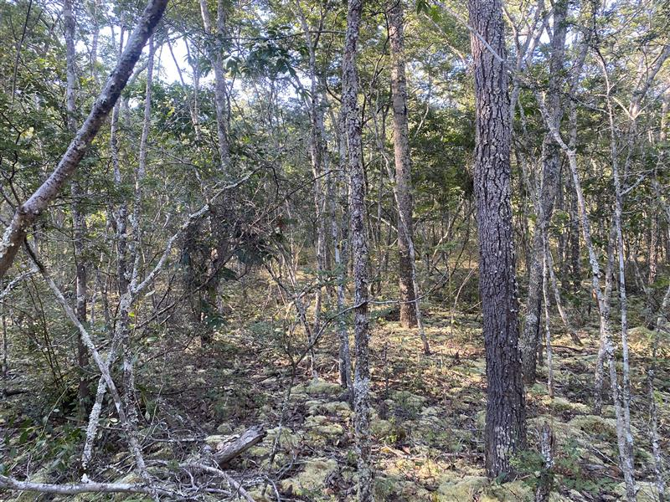
Nkangala | Miombo woodland | Open with tall, thick trees | Julbernardia paniculata, Brachystegia spiciformis, Erythrophleum africanum, Parinari curatellifolia, Guibourtia coleosperma | Agriculture (best place for cassava), honey production, hunting, wild foods collection | Sable antelope, wild pigs, deer, monkeys, lions | Patchy burning every 2-3 years; fire used to clear land, improve visibility, and for honey harvesting | Some patches experience animal scarcity. Larger trees are fire-resistant. Vegetation gets denser further from rivers | 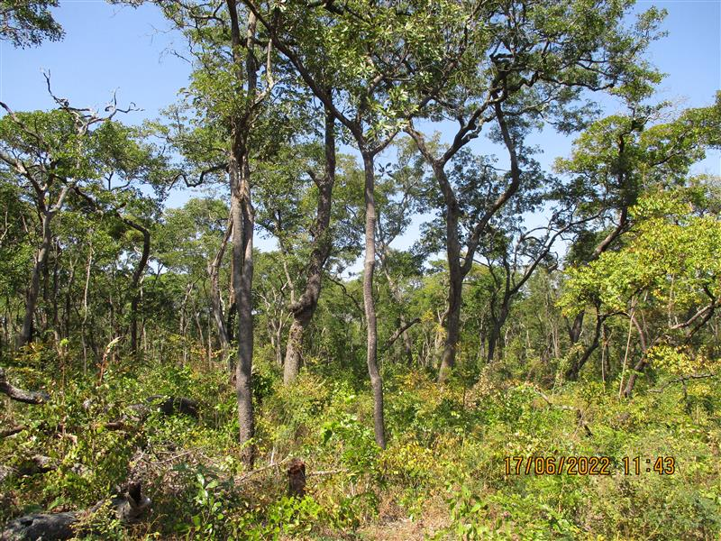
Chitete | Shrubland | Abundant shrubs with few large trees; variable grass cover | Brachystegia bakeriana (mainly as a shrub), Monotes spp., Erythrophleum africanum, Burkea africana, Guibourtia coleosperma, Julbernardia paniculata, Brachystegia longifolia | Firewood collection, medicine and wild foods collection | Deer, rodents, wild pigs | Burned to clear understorey, stimulate leaf growth, and improve safety (by deterring snakes) | Firewood scarcity reported, leading to increased travel distances for collection | 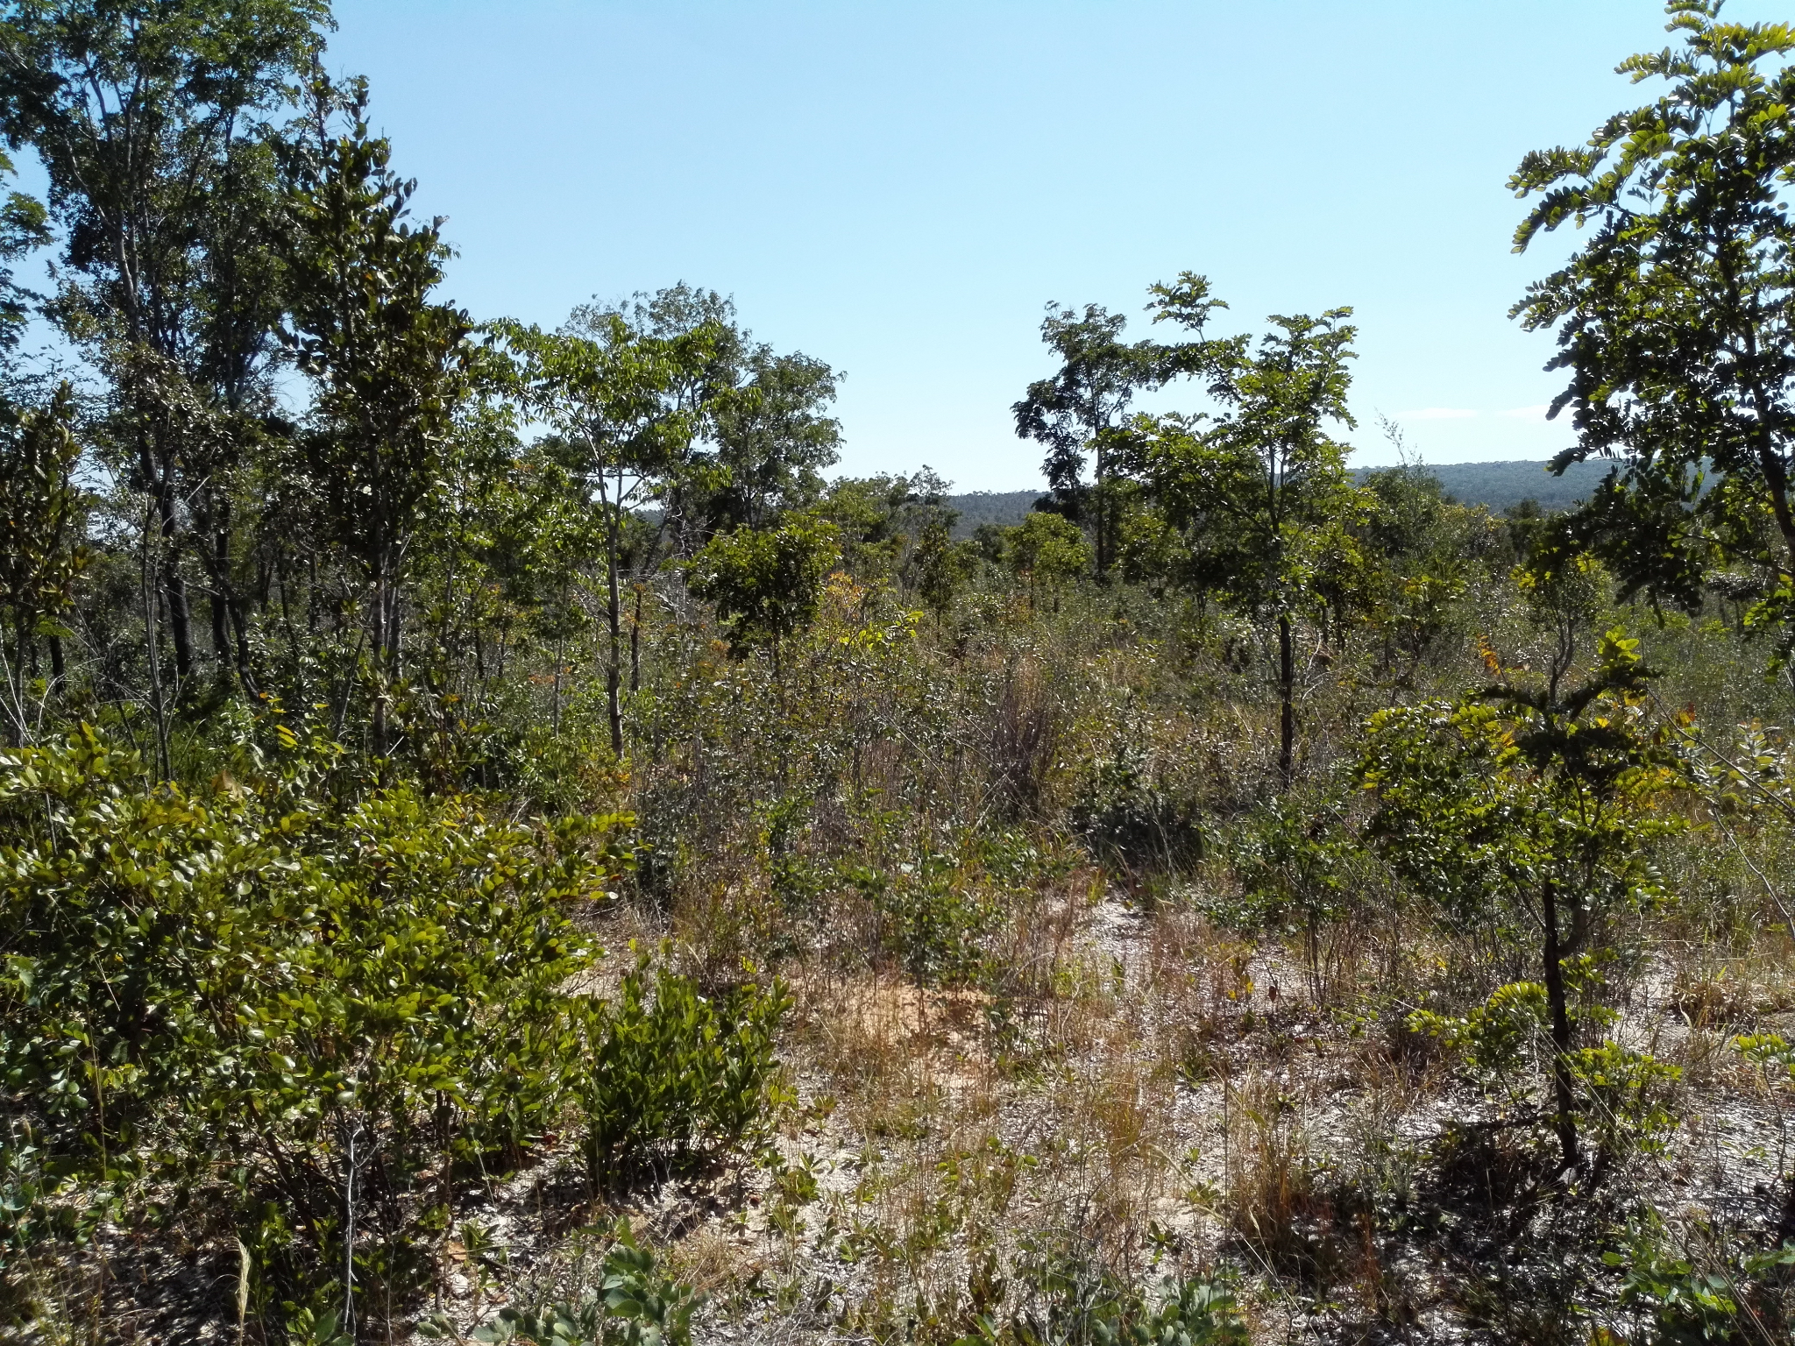
Chana | Open savanna | Grass-dominated understorey with scattered small trees and shrubs | Burkea africana (in savannas by the river), Erythrophleum africanum, Pterocarpus angolensis, Terminalia brachystemma, Strychnos spp., Monotes spp., Diplorhynchus condylocarpon | Wild foods, medicine, and grass collection, hunting | Wild pigs, hares, rabbits, rodents | Mostly burned early in the dry season (often annually) to deter snakes, stimulate grass, underground trees and herbaceous growth. Leaf regrowth helps attract animals for hunting | Important for wild honey production (from Cryptosepalum maraviense, underground trees) and construction materials from termite mounds; usually lower stem density near rivers and higher at greater elevations | 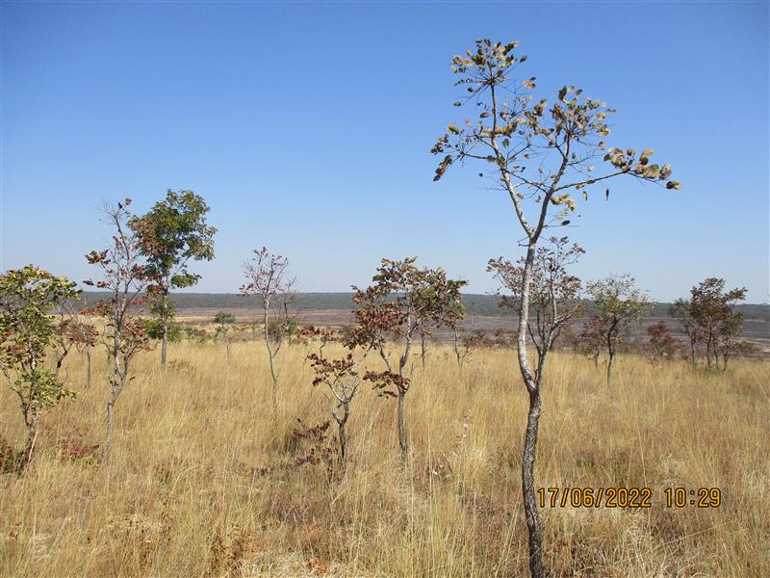
Chipapa | Open woodland | Open wooded areas; defined as a mix of miombo and savanna and as former dense woodland altered by fire | Hymenocardia acida, Dialium englerianum, Burkea africana, Guibourtia coleosperma, Diplorhynchus condylocarpon, Erythrophleum africanum, Monotes spp. | Wild foods and medicine collection, construction materials, hunting, beekeeping | Deer, wild pigs | Burned heavily, often annually due to fires from nearby crop fields | Bracken common in the understorey; not greatly valued or used for any livelihood activity | 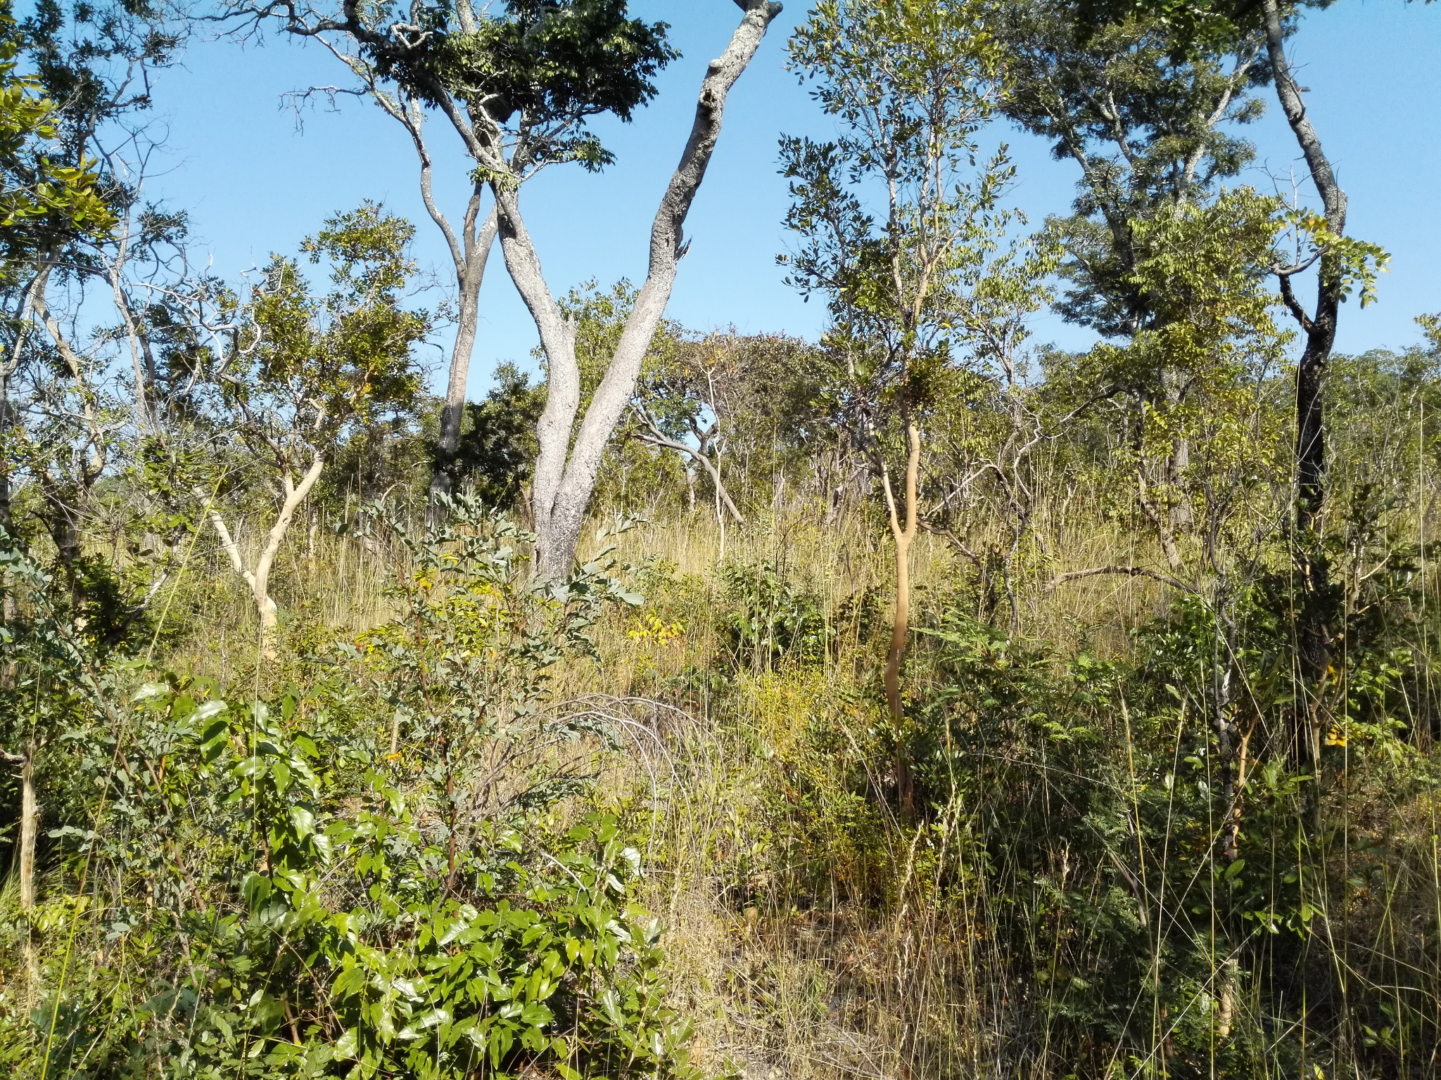
Chizansa | Riverine grassland | No trees, dominated by grasses, mainly Loudetia spp. | - | Soils used for growing vegetables. Grass used for construction materials (ceilings, walls, brooms) | - | Burned either accidentally by spill-over fires or for soil preparation for vegetable gardens | Remains waterlogged year-round | 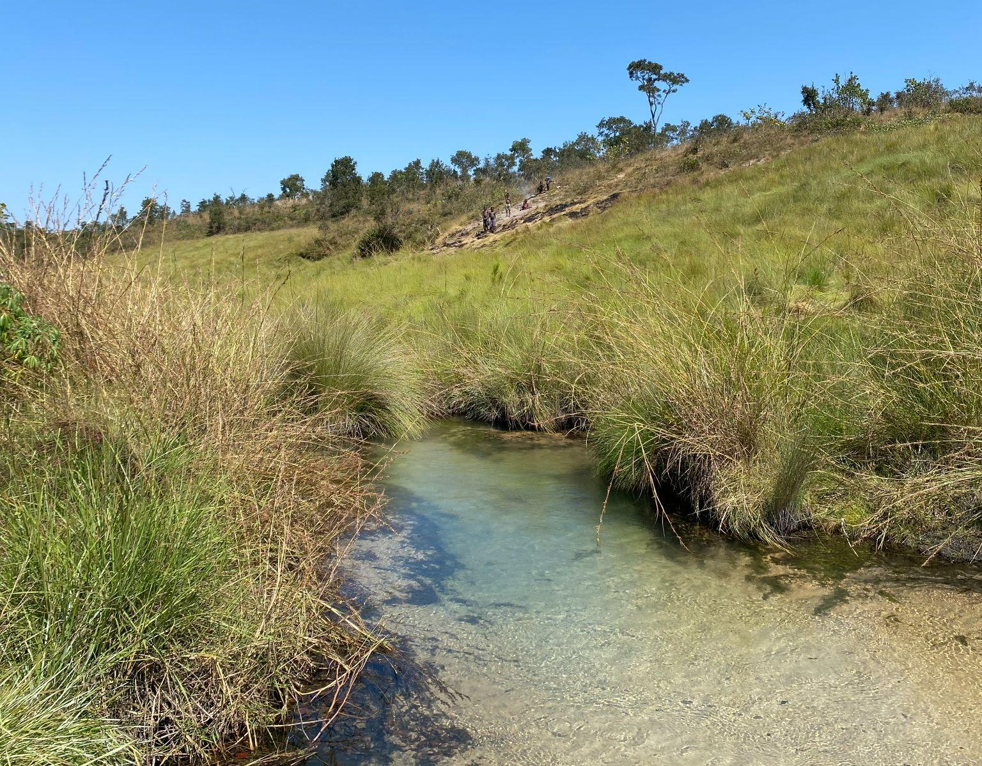
Chimpoka | Upland grassland | Dominated by grasses and geoxylic suffructices | - | Grass used for construction materials (ceilings, walls, brooms) | - | Burned accidentally by spill-over fires | Remains wet only during the rainy season | 