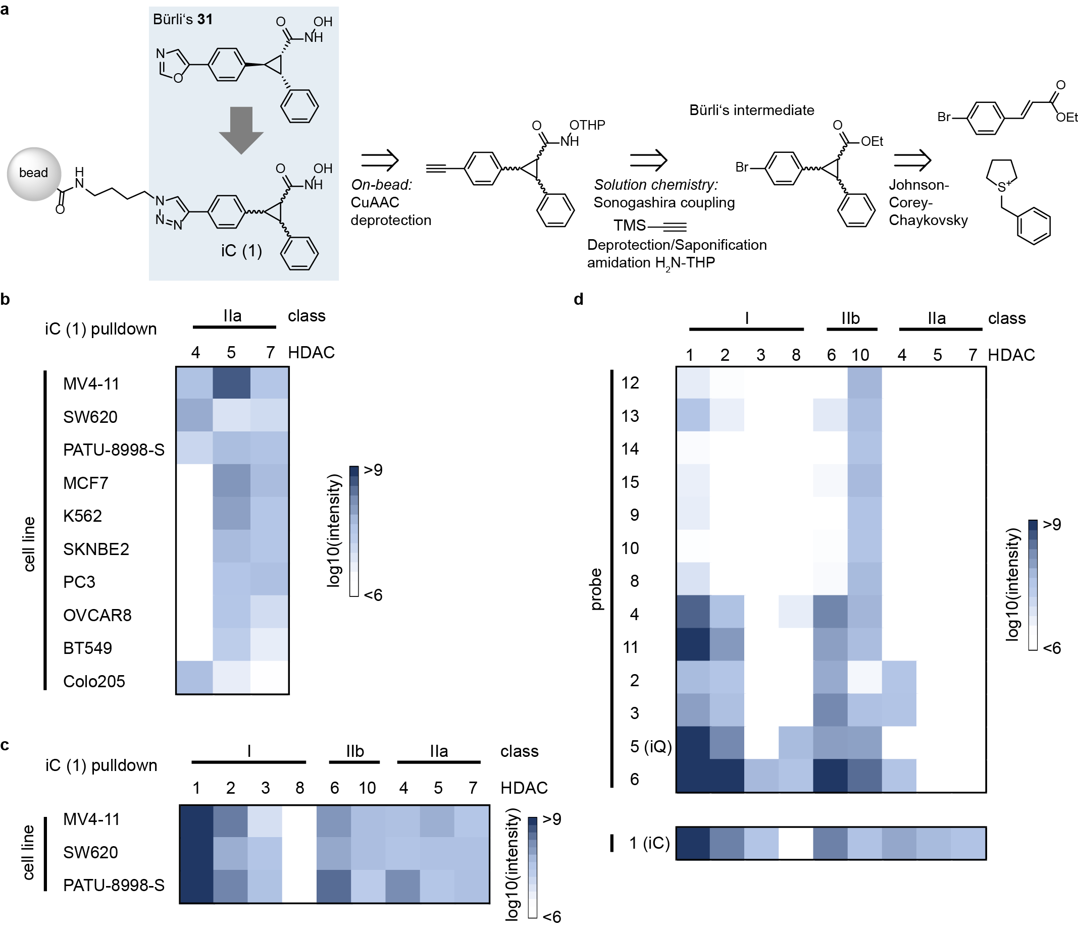
Fig. S1 | Evaluation of affinity probes for capturing HDACs in cancer cell lysates. a, Strategy and retro-synthesis scheme for the design and preparation of class IIa affinity probe iC (1). The analogation of lead oxazole 31 to a triazole allows for immobilisation on Sepharose beads. The matrix is conveniently obtained by on-bead Copper-catalysed Azide-Alkyne Cycloaddition (CuAAC) of a hydroxamate-protected alkyne precursor with azide-functionalised beads, followed by deprotection. The alkyne precursor was prepared by converting Bürli’s bromo ester intermediate in 3 steps: Sonogashira coupling with TMS-acetylene, simultaneous deprotection/saponification and conversion to protected hydroxamic acid. An almost equimolar mixture of 3 enantiomer pairs (only all-cis isomers are not obtained during the Johnson-Corey-Chaykovsky synthetic step) constitute iC. b, Screening cancer cell lines for class IIa HDAC expression using iC affinity probe. The heatmap depicts the average protein intensity of class IIa HDACs pulled down by iC (MS raw intensity). c, Intensities of HDACs pulled down by iC from three most promising cell lines from a different lysis batch. d, Evaluating HDAC affinity matrices for HDAC pulldown capabilities. The heatmap shows protein intensities of pulled down HDACs by 15 distinct affinity probes using cell lysate mixes of MV4-11 and SW620. For probes 2-15 a 1:1 mix of SW620 and MV4-11 cell lysate was used, while the heatmap for probe 1 represents an average of detected protein intensities from 2 single pulldowns in SW620 and MV4-11 cell lysate. All pulldowns were performed in three technical replicates.

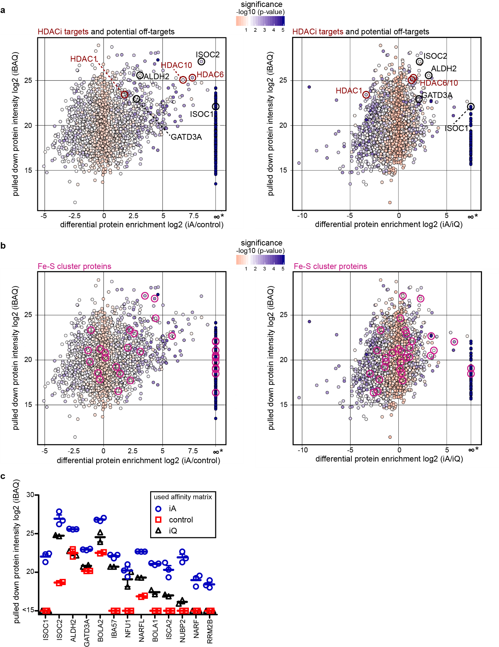
Fig. S2 | Evaluation of metalloprotein affinity matrix iA for pulling down metalloproteins. a and b, enrichment of proteins from PATU-8998-S lysate by iA relative to control beads or iQ is plotted against the intensity of the corresponding proteins in iA pulldown. iBAQ intensity values were employed as proxy for the protein amount. Asterisks on the x-axis mark proteins that have been identified in each replicate of the iA pulldown but in none of control or iQ replicates and thus represent highly significantly enriched proteins. a, significantly enriched HDACs and proposed off-targets are highlighted. b, enrichment of FeS-cluster proteins (pink circle) as most significantly enriched metalloprotein class compared to control beads and iQ. c, iBAQ intensities of selected significantly enriched proteins from the single pulldown experiments. All pulldowns were performed in technical replicates. As control beads we used the same sepharose beads for affinity matrix generation, but, instead of affinity probes, we coupled 2-aminoethanol to the NHS-activated Sepharose.

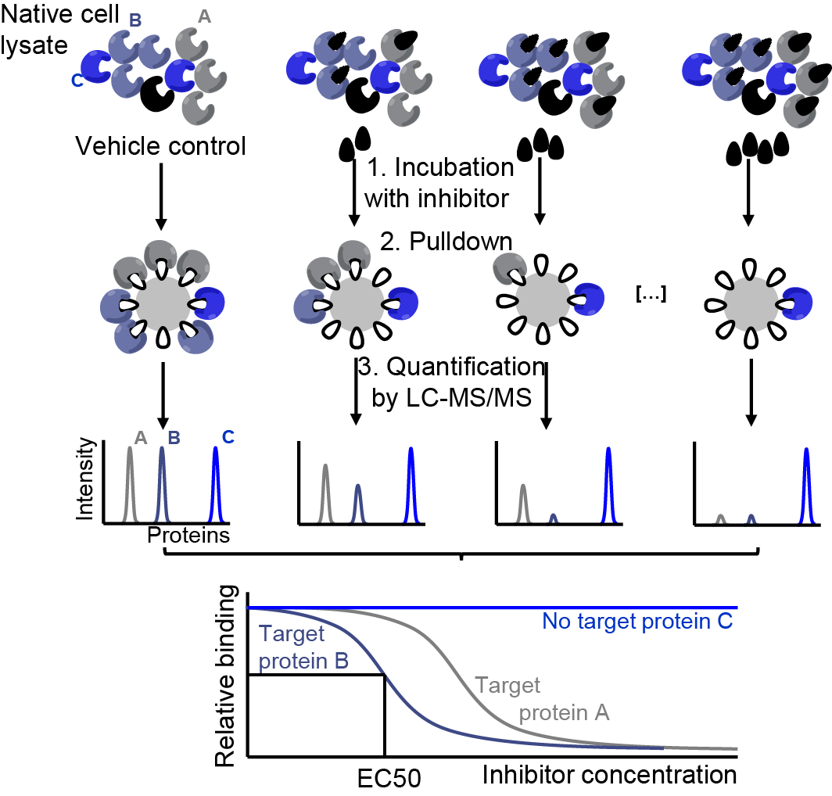
Fig. S3 | Schematic representation of a chemoproteomics competition assay. Endogenously expressed and folded proteins from native cell lysate containing co-factors and maintaining biomolecular interactions (e.g. protein complexes) can be pulled down by affinity matrices and quantified via LC-MSMS. Prior competition for target protein binding between immobilized active site binding molecules and free (not immobilized) drugs of interest reduces specific binding to the affinity matrix and leads to an LC-MSMS-intensity decrease of target protein. Increasing concentrations of free drug lead to a dose dependent reduction of the specific target binding to the affinity matrix, yielding a typical sigmoidal dose-response binding curve. From this curve, half maximal target engagement values (EC₅₀) can be derived. While Protein A shows mediocre affinity to the free drug and thus is competed off the matrix only at higher concentrations, protein B shows lower EC₅₀s, indicating higher drug-target affinity. Protein C is not bound by the free drug and therefore shows no dose-dependent competition.

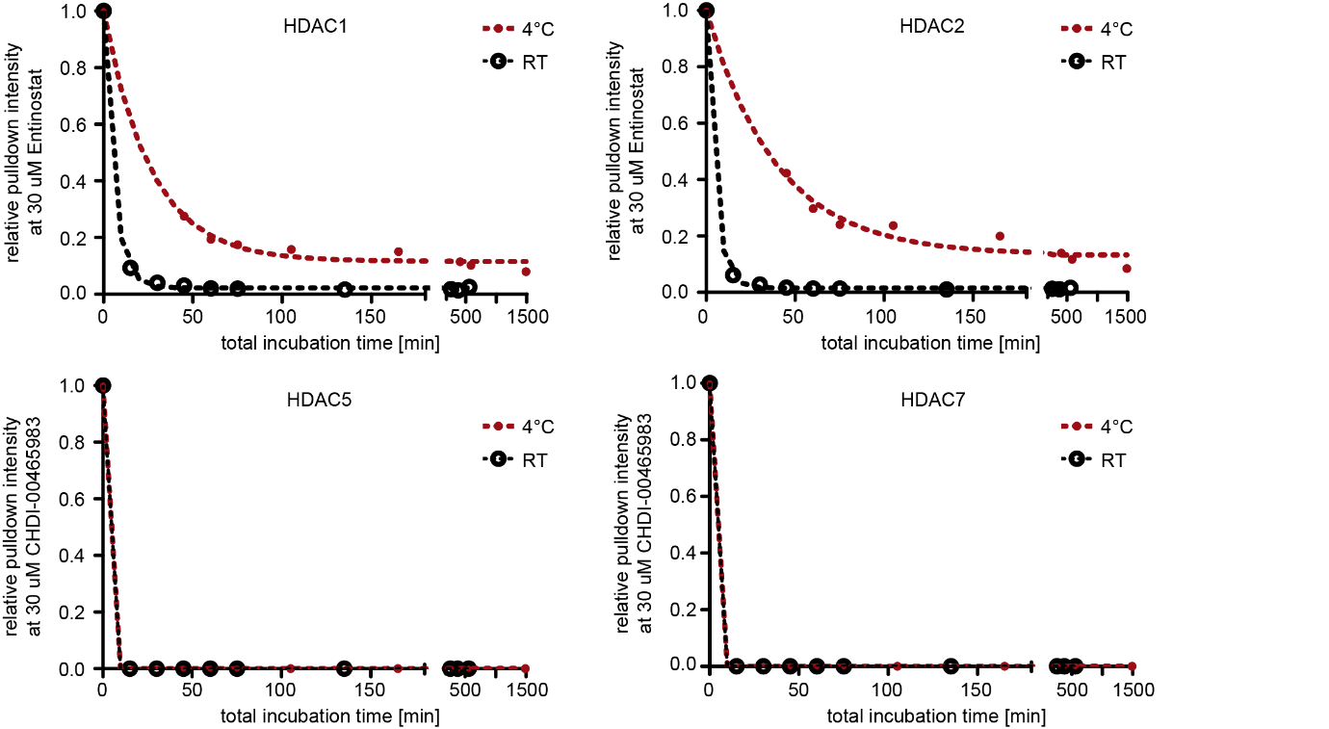
Fig. S4 | Evaluation of binding kinetics at different incubation temperatures for Entinostat and CHDI00465983. A 1:1 mix of SW620 and MV4-11 cell lysate was incubated with excess drug (30 μM) for different periods of time at either room temperature (22 °C) or 4 °C before pulling down HDACs with iQ (for Entinostat) or iC (for CHDI00465983). HDAC1 and HDAC2 competition depends on the incubation temperature and Entinostat shows relatively slow binding kinetics compared to CHDI00465983.

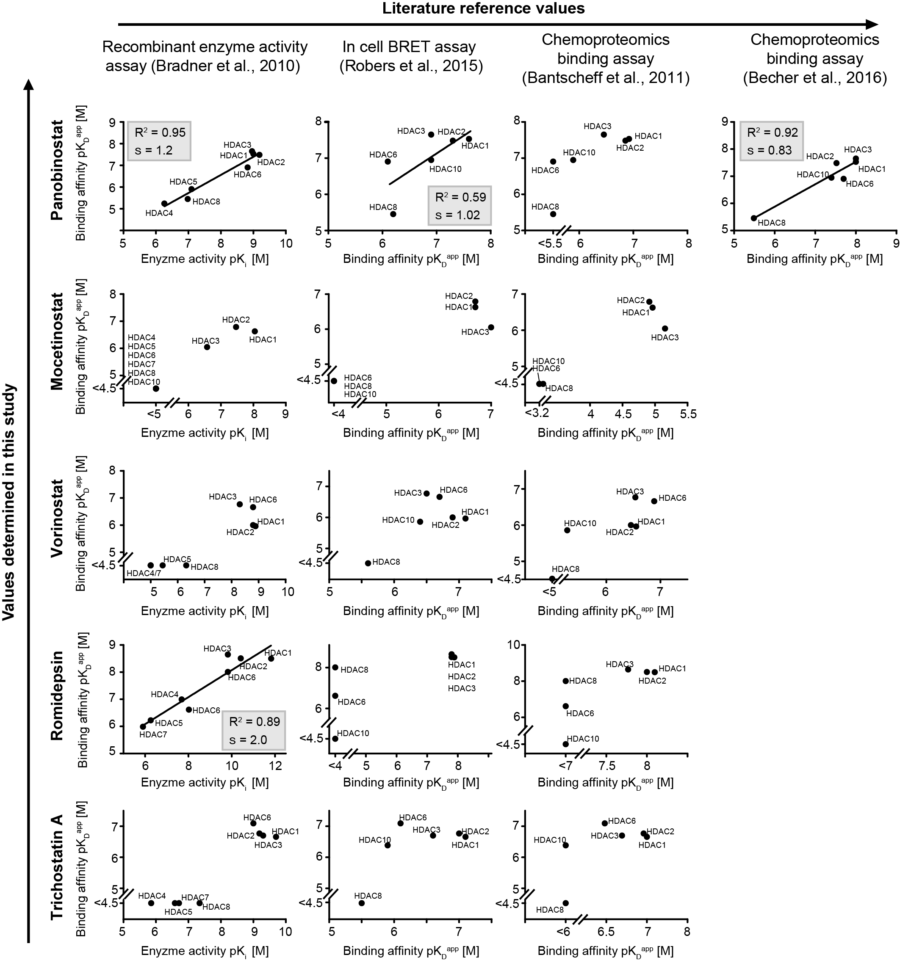
Fig. S5 | Comparison of acquired affinity data to literature data. pK_{d}^{app} values determined in this study were plotted against pK_{d} values from three former HDACi profiling studies¹⁻³ and in case of Panobinostat to another optimized chemoproteomics study using immobilized Panobinostat as probe². For data sets without missing values, regression lines were plotted (s = slope of regression line). In general good correlation is observable between recombinant enzyme activity assay data (Bradner et al.)³ and our study as well as for the comparison to the optimized chemoproteomics assay using immobilized Panobinostat as affinity matrix (Becher et al.)².

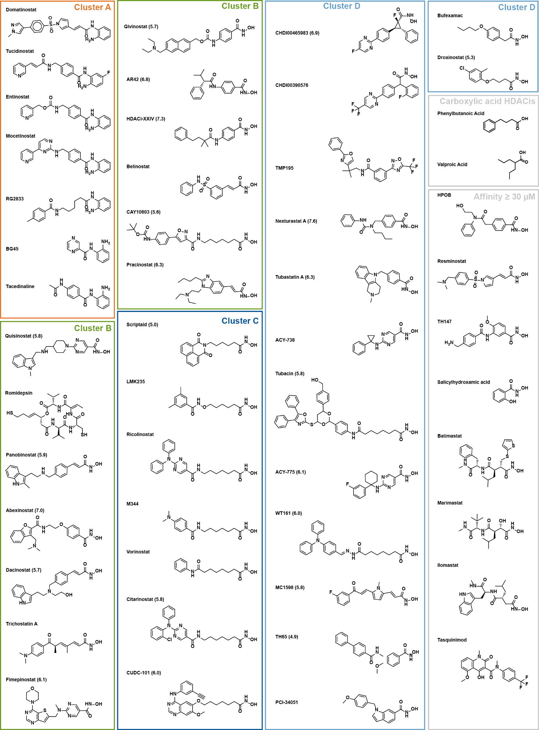
Fig. S6 | Structures of molecules profiled by the chemoproteomics competition assay, ordered by groups according to the drug target map (Fig. 2a, pK_{d} for MBLAC2 in brackets).

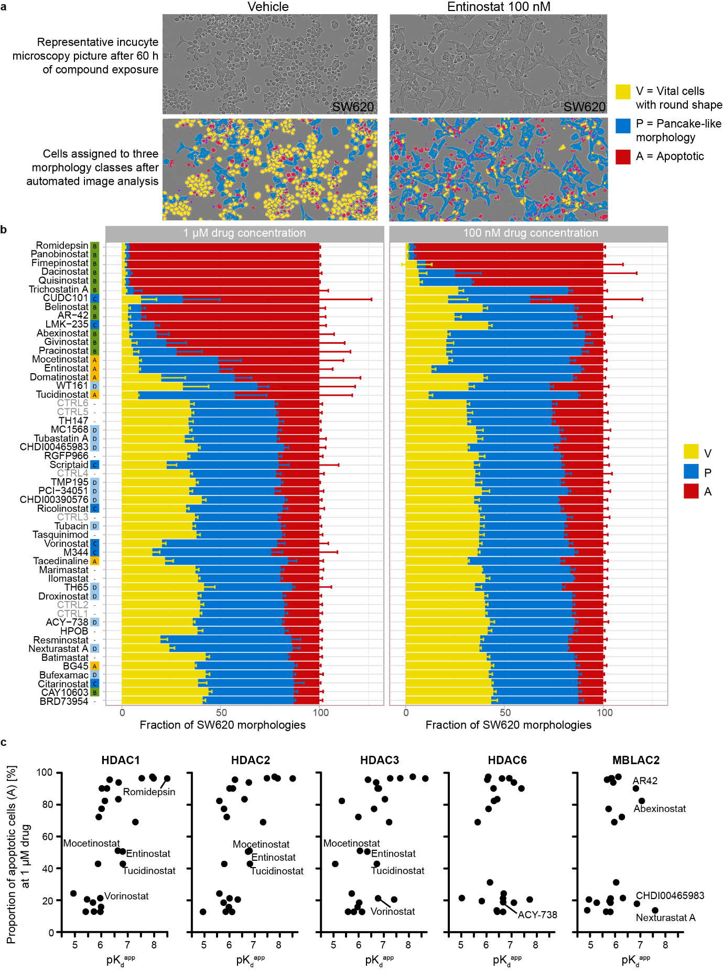
Fig. S7 | 2-Dose cell viability and morphology screen with HDACi library on SW620 cells. a, Representative images of vehicle (DMSO) and drug treated cells (100 nM Entinostat) after 60 h of incubation. Bright light images (upper panel) were recorded using an Incucyte S3 and processed by ilastik⁴, a supervised machine learning toolkit for automated image analysis. Vital round shaped (V), flattened/pancake-like shaped (P) and apoptotic cell morphologies (A) were identified and labelled accordingly (lower panel). b, Relative areas covered by the the three cell morphologies after drug treatment, performed in quadruplicates. Pixels of the ilastic software output classification were counted and divided by the sum of all cells pixels: bar chart displays the means and standard deviations of quadruplicate experiments in 96-well plates. Treatments were ranked from highest to lowest cytotoxicity (i.e. high proportion of apoptotic cells (A) for the 100 nM and 1 µM treatment). Control DMSO treatments are listed as CTRL1-6. Drugs are assigned to groups according to their target spectrum (see Fig. 2c). c, Correlation between drug affinities (pK_{d}^{app} of HDAC1,2,3,6 and MBLAC2) and proportion of apoptotic cells after 1 µM drug treatment. Representative clinical drugs Romidepsin (depsipeptide), aminoanilides (Mocetinostat, Entinostat, Tucidinostat) and hydroxamates (Vorinostat, AR-42, Abexinostat) as well as some particularly interesting tool compounds (ACY-738, Nexturastat A, CHDI00465983) are highlighted in the plots for orientation. In accordance to literature, class I inhibition correlated with cytotoxicity, while HDAC6 and MBLAC2 inhibition does not correlate with cytotoxicity but clusters into two clouds, defined by the drugs additional class I target affinity (cytotoxicity mainly mediated by class I inhibition). As expected, drugs of similar class I target affinity show distinct cytotoxicity, most probably reflecting distinct intracellular drug concentrations (e.g. via cellular uptake, metabolism, active export). Chemically similar drugs (Mocetinostat, Entinostat, and Tucidinostat) that share the same target space and most probably similar intracellular distributions according to their similar physicochemical properties cluster together.

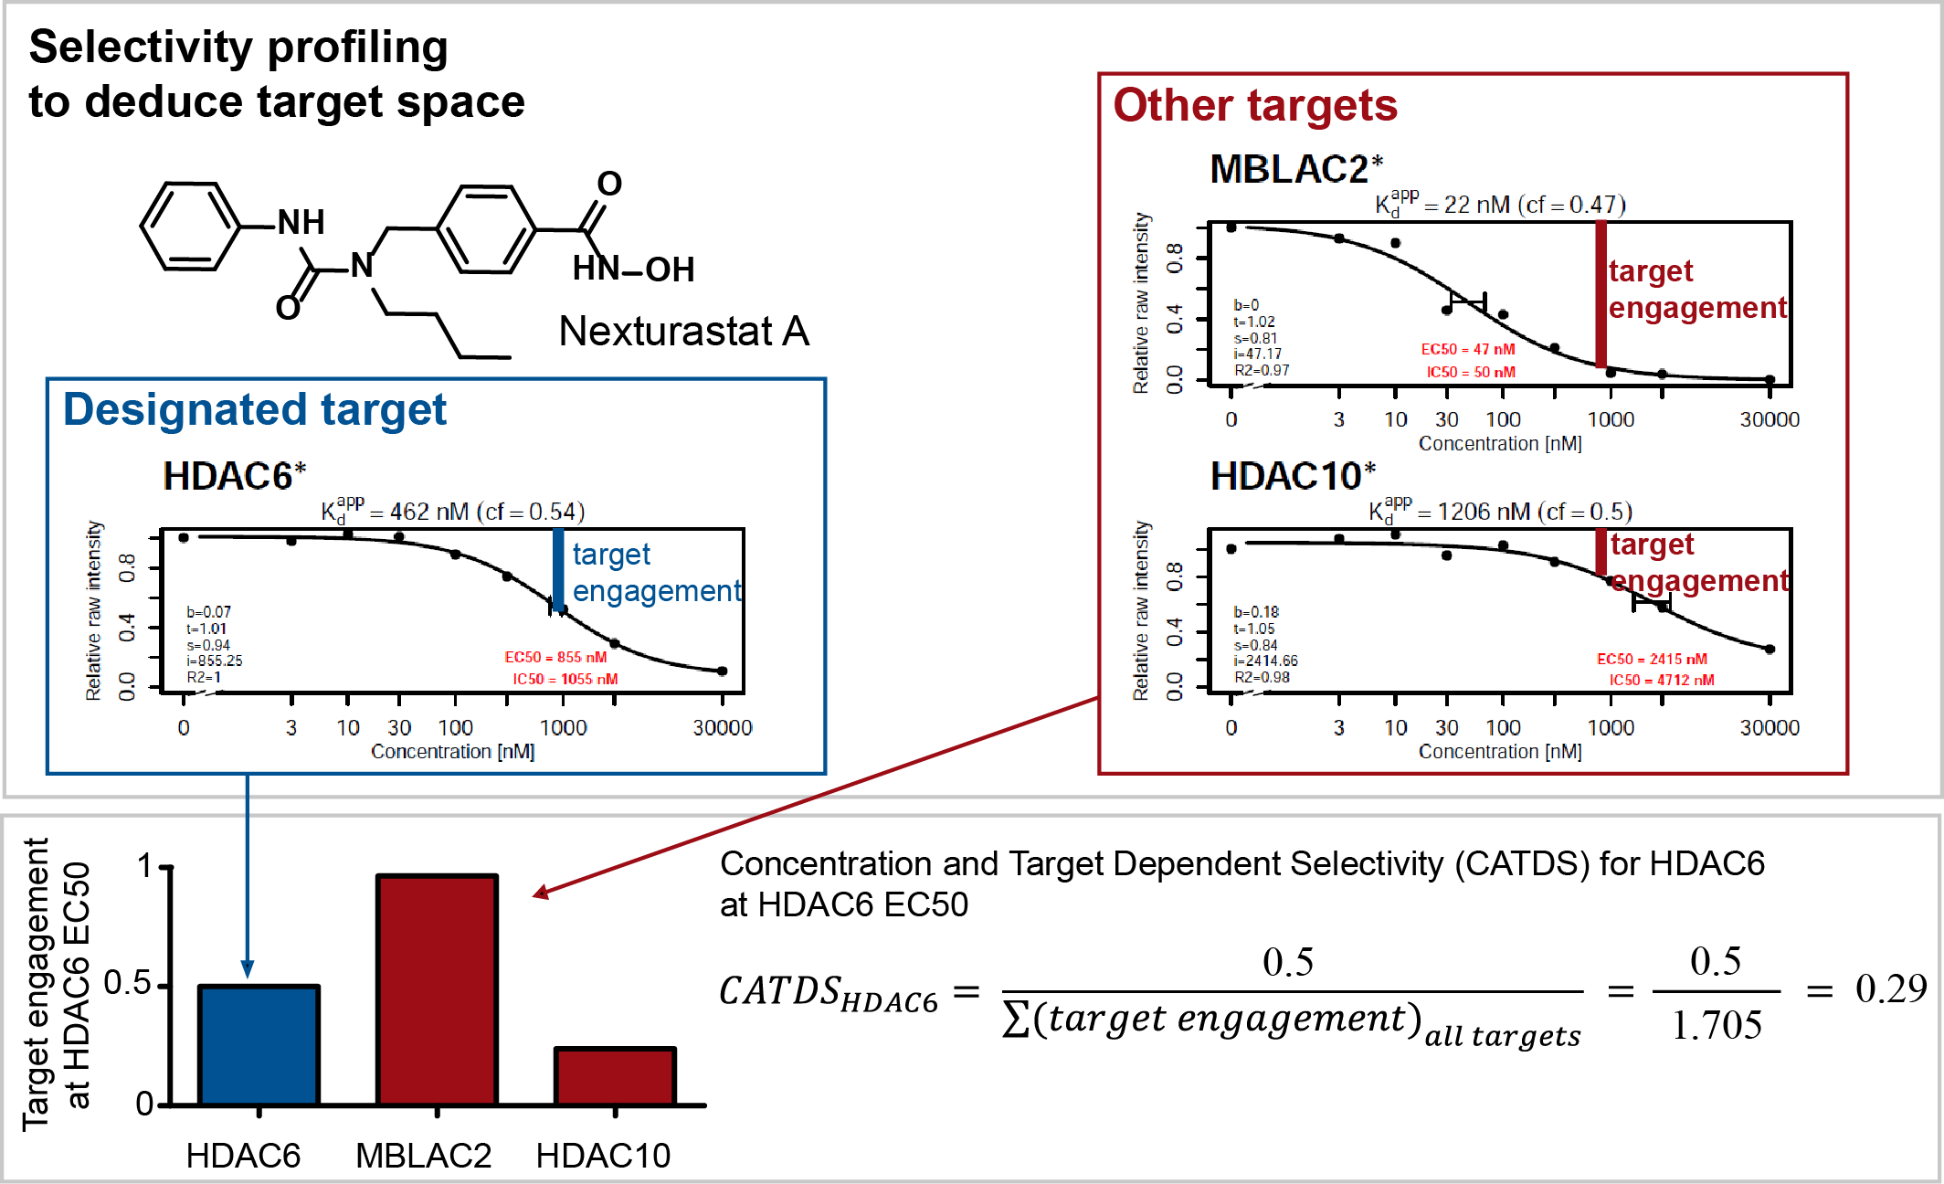
Fig. S8 | Concentration And Target Dependent Selectivity (CATDS) score determination. An example of CATDS score calculation for Nexturastat A-HDAC6 selectivity is provided. Chemoproteomics profiling determined three Nexturastat A targets. The target engagement (blue/red vertical bars in dose-response profiles) at Nexturastat A EC₅₀ is indicated for all targets. The selectivity of Nexturastat A for HDAC6 CATDS_{HDAC6} can be calculated by dividing the target engagement of HDAC6 (at its EC₅₀ by definition 0.5) by the sum of all target engagements (blue and red bars) at the same concentration. Alternatively to EC₅₀s, the CATDS_{HDAC6} can be calculated at the corresponding K_{d}^{app} values by applying the correction factor to the curve function (see methods).

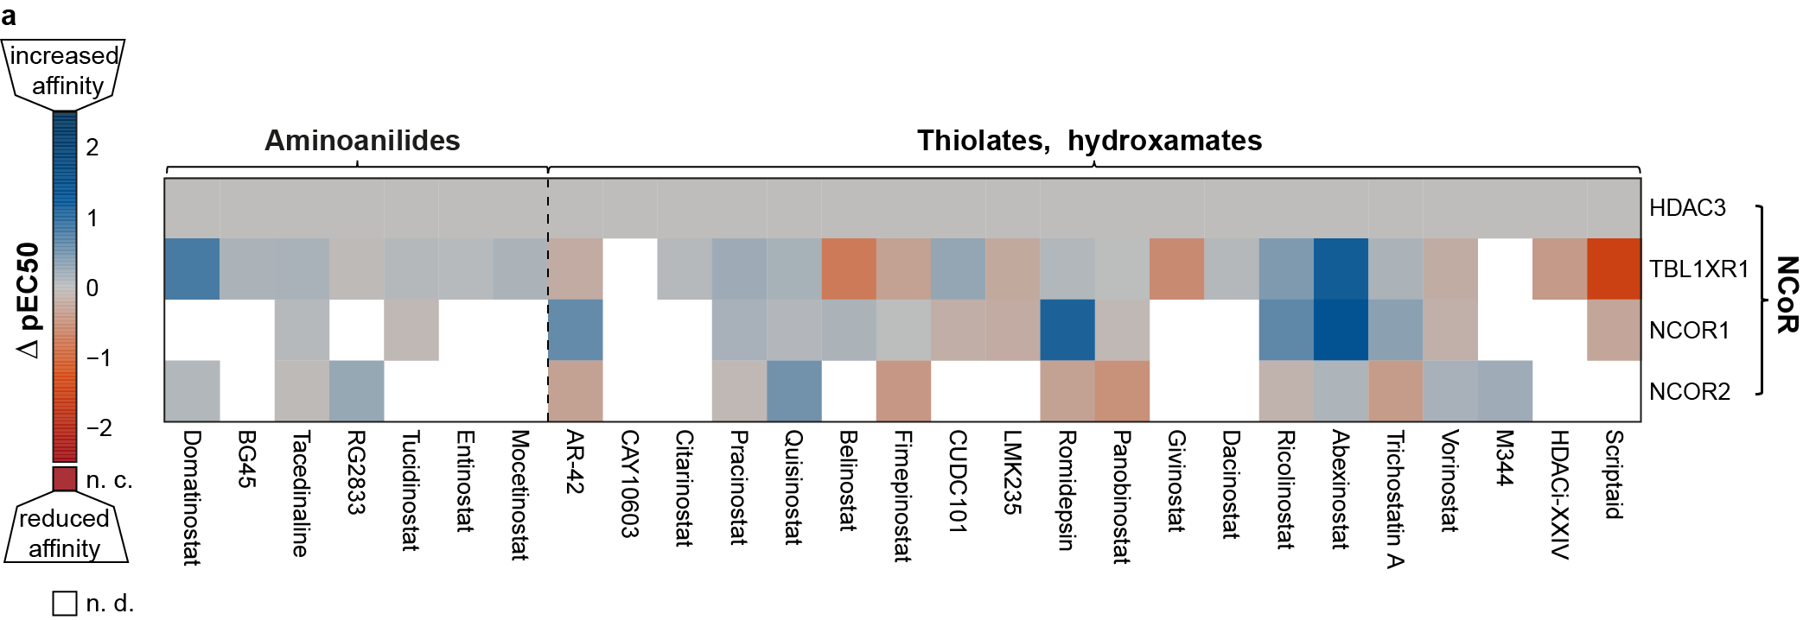
Fig. S9 | Complex selectivity of class I HDACis. Complex selectivity map for class I HDACis. The colours of the heatmap indicate differences in affinity to HDAC3 (∆pEC₅₀) depending on its interaction partners of the NCoR complex. Colour shades of blue show that HDACi affinity is increased upon interaction between HDAC3 and the corresponding interaction partner, red shades indicate that HDACi loses binding affinity to HDACs interacting with the corresponding interaction partner (Blank space: lack of robust protein quantification prevents precise EC₅₀ value determination).

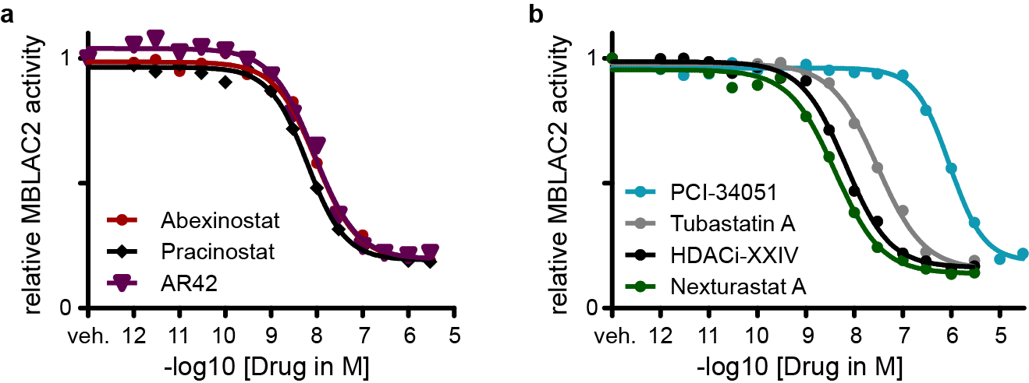
Fig. S10 | Dose dependent inhibition of MBLAC2 hydrolase activity by HDAC inhibitors. a, Clinical drugs Abexinostat, Pracinostat and AR-42 all show EC₅₀ inhibition values below 10 nM (assay threshold). b, Tool compounds and pre-clinical drugs also engage with MBLAC2. While potent MBLAC2 binders from the chemoproteomic profiling show inhibition with nanomolar affinities, PCI-34051 (non-binder chemoproteomic assay) shows over 100-fold lower activity against MBLAC2 (pEC₅₀ = 6.0).

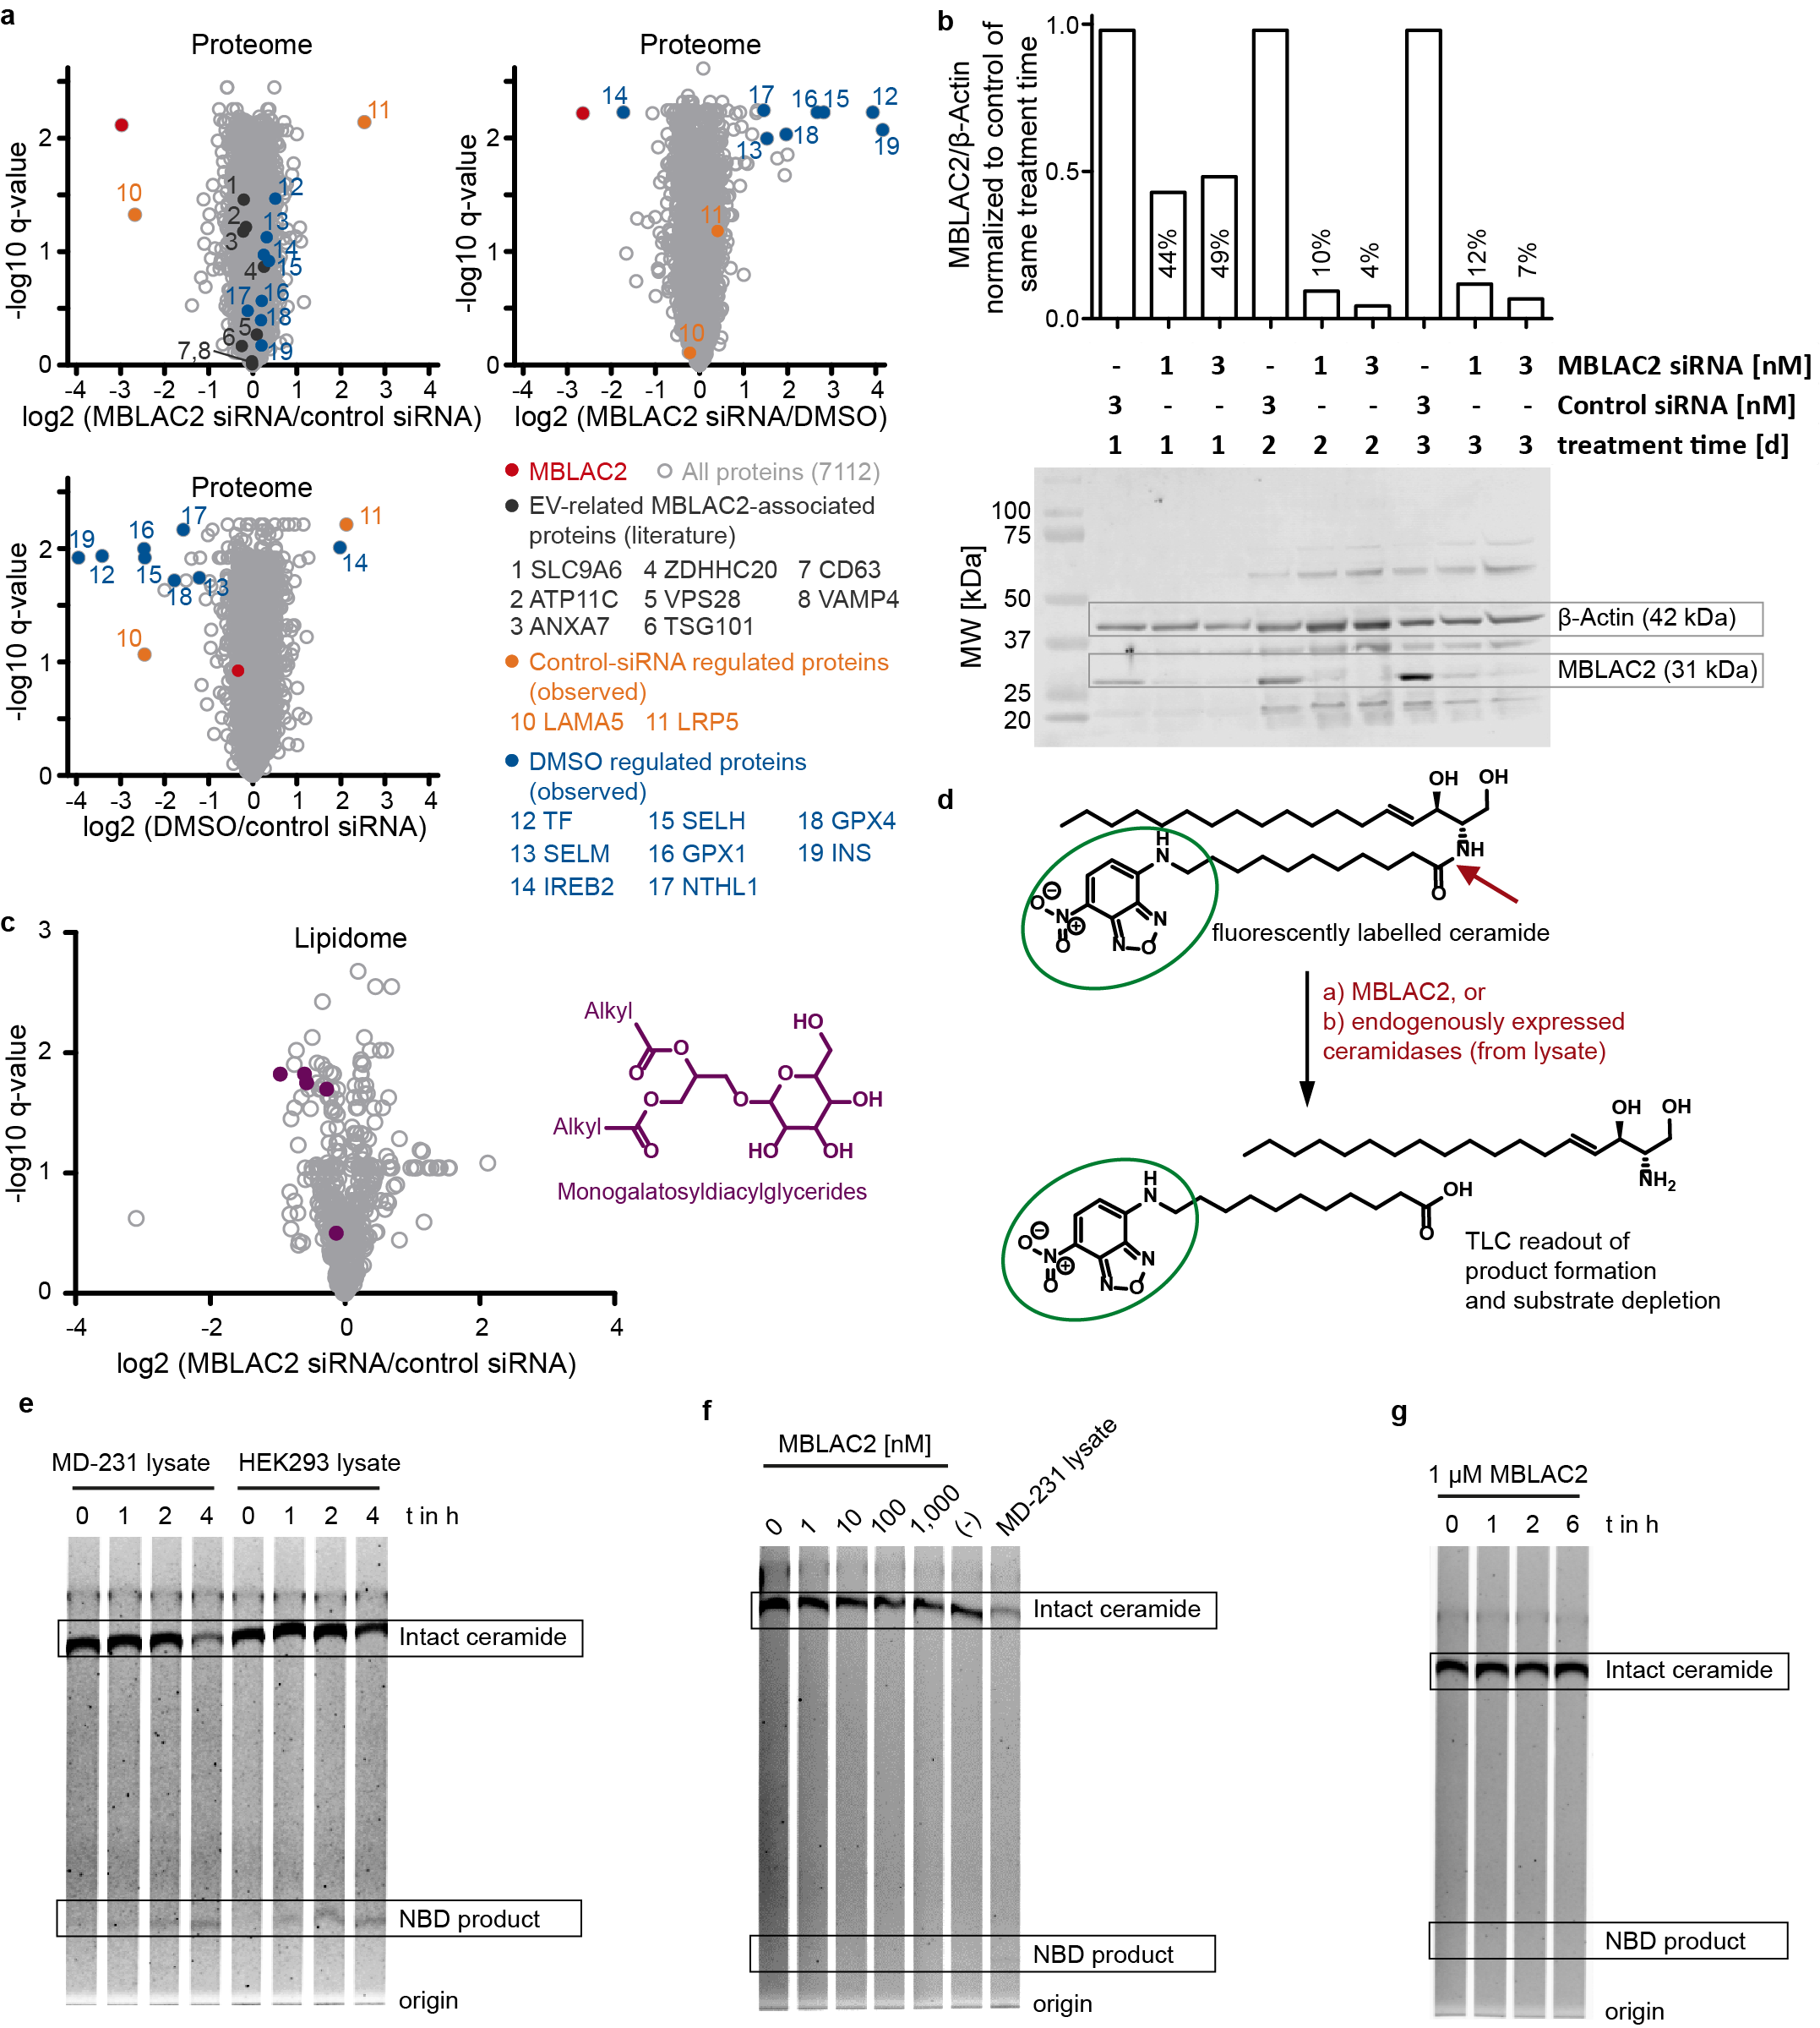
Fig. S11 | MBLAC2 inhibition and knockdown effects on proteome and lipidome. a, siRNA-mediated MBLAC2 knockdown does not lead to major changes of intracellular protein levels. Volcano plots display the difference in protein abundances of HEK293 cells after DMSO treatment of transfection with MBLAC2-directed siPOOL or control siPOOL (biological triplicates). HEK293 were lysed and submitted to a deep bottom-up proteomics workflow, including SP3-bead protein digestion protocol and TMT-labelling for robust quantification. While MBLAC2 knockdown is still efficient 3.5 d after transfection with siRNA POOL (13% compared to control siRNA), the whole proteome is generally unaffected. Intracellular levels of proteins involved in extracellular vesicle biogenesis and associated to MBLAC2 do not change significantly (labelled in grey are potential interaction partners or co-regulated proteins TSG101, ATP11C, SLC9A6, VAMP4, ZHHDC20, CD63, ANXA7, VPS28). We attribute the apparent LRP5 upregulation and LAMA5 downregulation (orange) to effects caused by transfection with control siRNA, since they are only affected in control siRNA pool treated cells. In analogy, proteins marked in blue are only regulated in DMSO treated cells and therefor attributed to DMSO-related effects (e.g. oxidative mechanisms). b, Western blot against human MBLAC2 (and beta-Aktin as loading control), showing knockdown efficiencies in dependence of transfection amount and duration. Bands were quantified with the Licor software (see methods) and normalized to the loading control. This normalized MBLAC2 expression was then again normalized to control siRNA treated cells of corresponding knockdown duration to give a relative and time-dependent knockdown efficiency of MBLAC2. In concordance with the full proteome data, knockdown is still sufficient three days after transfection. c, MBLAC2 knockdown leads to abundance changes of intracellular lipid families. MBLAC2 knockdown leads to global intracellular downregulation of monogalactosylceramides (general structure scaffold indicated) in HEK293 cells. Volcano plot shows the ratio and statistical significance (q-value) of lipid quantities between MBLAC2 knockdown (MBLAC2-KD - siRNA POOL in triplicate) and control (control siRNA in triplicate), as measured by mass-spectrometry based lipidomics, after MeOH/CHCl3 lipid extraction. d, Schematic of Ceramidase activity assay. A fluorescently labelled C12-NBD-Ceramide was incubated for different time periods with varying concentrations of WT MBLAC2 or native cell lysates containing endogenously expressed ceramidases. The reaction was terminated by boiling and solvent evaporated. The reaction products were resuspended in CHCl₃/MeOH run on a TLC plate and developed with CHCl₃/MeOH/NH₄OH. Fluorescent substrates and products were read out at 488 nm. e, Ceramidase assay evaluation. Incubation of the fluorescently labelled ceramide with native cell lysates from MD-231 and HEK293 cells at 37 °C shows significant turnover of the substrate after 4 h of incubation and confirms the functional setup. f, Incubation of fluorescently labelled Ceramide with increasing concentration of MBLAC2 for 2h at 37 °C does not show significant turnover compared to negative control (-), while incubation with cell lysate reduces significantly the signal of intact ceramide substrate. g, Extended incubation of ceramide substrate with 1 µM WT MBLAC2 at 37 °C for increasing periods of time does not lead to significant substrate turnover even after 6 h incubation.

1. Bantscheff, M. et al. Chemoproteomics profiling of HDAC inhibitors reveals selective targeting of HDAC complexes. Nat Biotechnol 29, 255-265 (2011).
2. Becher, I. et al. Thermal profiling reveals phenylalanine hydroxylase as an off-target of panobinostat. Nat Chem Biol 12, 908-910 (2016).
3. Bradner, J.E. et al. Chemical phylogenetics of histone deacetylases. Nat Chem Biol 6, 238-243 (2010).
4. Berg, S. et al. ilastik: interactive machine learning for (bio)image analysis. Nat Methods 16, 1226-1232 (2019).

