SUPPLEMENTAL INFORMATION

TITLE
Accelerated bacterial activity in response to local plant secondary metabolites corresponds with the Home-Field Advantage of leaf litter decomposition in freshwater ecosystems

AUTHORS
Jonathan R. Dickey^{1*}, Andrés Mauricio Caraballo-Rodríguez^{2,3,4}, Pieter C. Dorrestein^{2,3,4}, and Sara L. Jackrel^{1*}

*CORRESPONDING AUTHORS
For correspondence, please contact both Jonathan R. Dickey (jrdickey@ucsd.edu) or Sara L. Jackrel (sjackrel@ucsd.edu).

AFFILIATIONS
¹University of California San Diego
School of Biological Sciences
9500 Gilman Drive
La Jolla, California 92093, USA

²University of California San Diego
Skaggs School of Pharmacy and Pharmaceutical Sciences
La Jolla, California, 92093, USA

³University of California San Diego
Collaborative Mass Spectrometry Innovation Center
Skaggs School of Pharmacy and Pharmaceutical Sciences
La Jolla, California, 92093, USA

⁴University of California San Diego
Center for Microbiome Innovation
La Jolla, California, 92093, USA

SUPPLEMENTAL METHODS

Metabolomics Acquisition: LC-MS/MS instrumentation parameters and methodology
Electrospray ionization parameters were set to 52 L/min sheath gas flow, 14 L/min auxiliary gas flow, 0 L/min sweep gas flow and 400°C auxiliary gas temperature. Spray voltage was set to 3.5 kV with the inlet capillary set to 320°C. Full MS scan range was set to 100 to 1100 m/z at a resolution at m/z 200 (R_{m/z 200}) of 35,000 with one micro-scan. Maximum injection ion time (IT) was set to 100 ms with an automated gain control (AGC) target of 5.0E5. Up to 5 MS/MS spectra per micro-scan were recorded in DDA mode with R_{m/z 200} of 17,500 with one micro-scan. Similarly, the maximum IT for MS/MS scans were 100 ms with AGC target of 5.0E5 ions. Normalized collision energy was set to increase from 20, 30, to 40 % with z = 1 as the default charge state. Within 2 to 15 s of their first occurrence, MS/MS scans were triggered at their apex chromatographic peaks with dynamic exclusion set to 10 s. Ions with unassigned charge states and isotope peaks were excluded from MS/MS acquisition. Analytical blanks, quality controls (QC: mixture of sulfamethazine, sulfamethizole, sulfachloropyridazine, sulfadimethoxine, amitriptyline, and coumarin-314 (10 µM)) and pooled samples (PoolQC) were injected after every 10 samples as quality control for monitoring LC-MS performance.

Metabolomics Analyses: Feature Detection and Molecular Networking
Parameters for feature extraction within MZmine v.4.8.5 were as follows.¹ Chromatogram building parameters were set to 4 minimum consecutive scans, 1.0E4 minimum absolute height and 20 ppm m/z tolerance. Chromatograms were then split using local minimum feature resolver with the following parameters: 80% chromatographic threshold, 0.075 minimum search range retention time and 1.8 minimum ratio of peak top/edge with a minimum of 4 scans. Next, the 13C isotope filter and finder was applied before feature alignment with the following join aligner parameters: 85% weight for m/z and a 0.35 retention time tolerance. We then conducted gap filling and filtered for duplicate peaks. Ion identity networking was completed with the metaCorrelate feature grouping algorithm. We then exported the .mfg files (MS/MS spectra lists) and the final feature table using the GNPS and SIRIUS export functions. Next, we conducted GNPS2 feature-based molecular networking (FBMN) with library analog search enabled with 0.05 for both precursor and fragment ion tolerance, 0.7 minimum cosine score, minimum 5 matching peaks, 10 Top K and 100 max component size.^{2,3} Library search parameters for FBMN were set as 0.7 minimum cosine score and 5 minimum matching peaks. See GNPS2 task ID: 64e685bc829c4bb4bc881337ee1cf6c1 for further FBMN details. For molecular fingerprinting and CANOPUS annotations, we utilized SIRIUS 6.3.0.^{4,5}
The feature table of peak areas from MZmine, annotations from GNPS2, FBMN and SIRIUS, and metadata were imported into R for further processing and analysis. We first examined successful injection of each sample by evaluating the total ion current (TIC) value and presence of the internal standard, sulfadimethoxine, which feature was then removed. We removed one sample (tree ID: Sekiu 1-2) that had a partial injection. Non-biological features were removed when found in any QC mix or extraction blanks that were not found at an average intensity of 5 times or greater within PoolQC samples. We then used HomologDiscoverer⁶ to further identify and remove contaminant features found in any homolog runs or correlation group with the following annotations: polyethylene glycols (PEGs), solvents, surfactants, or other known lab contaminants. We then utilized the edge table from our FBMN analysis to remove any features with a positive or negative deltamz from a previously removed contaminant feature, where deltamz had a magnitude ≥ 44.02 and ≤ 44.03 or ≥ 88.05 and ≤ 88.06 (i.e., features with a change in mass indicative of PEG polymers).⁷ Lastly, we removed blanks, PoolQC and QC mix samples along with any features present in only a single sample from the feature table prior to analysis.

Metabolomics Analyses: Feature normalization and filtering
Features were normalized using the known internal standard, sulfachlorpyridazine. We first calculated the coefficient of variation across all samples to evaluate internal standard consistency. For each sample, we then divided all feature intensities by the per-sample internal standard intensity and rescaled each feature by multiplying by the internal standard’s global mean intensity. Features detected in fewer than four samples were removed to reduce rare signals. The remaining features were filtered to retain only those with a maximum intensity > 20,000, ensuring that low intensity noise was removed. Lastly, features with no SIRIUS annotation at the superclass level were removed. We applied a log-transformation to stabilize variance in feature intensity.
SUPPLEMENTAL TABLES

Table S1. Bacterial and fungal communities of decomposing leaves primarily originate from prior successional leaf communities in comparison to the freshwater column. Microbial “sink” communities are bacterial and fungal communities collected from decomposing leaves on Days 5 – 20, whereas “source” communities originate from leaves from the prior time point, the water column of the prior time point, the water column at the current time point, or from an unknown source. Significant differences in the proportional contribution of each source to each sink community were determined using a generalized linear mixed effects model with a beta distribution and a logit link function. Predicted proportions and 95% confidence intervals were estimated from each regression and reported to illustrate non overlapping intervals and strongly separated proportions per source contribution. We do note a significant proportion of sink communities are explained by unknown sources within bacterial communities throughout leaf litter decomposition as determined by SourceTracker2⁸.

Table S2. Pairwise comparisons of bacterial and fungal community temporal turnover among fresh leaves and decomposing leaves. Summary table for the Tukey’s HSD performed on bacterial and fungal community temporal turnover, as measured by the Temporal Beta-diversity Index (TBI), which calculates the D_{Ruz} coefficient from ASV relative abundances between two consecutive time points. In the table below, “Estimate” corresponds to the mean difference in the observed TBI between the two intervals, after accounting for leaf origin, deployment river and random tree-ID effects. Interval 1, 2, 3 and 4 correspond to Day 0 – Day 5, Day 5 – Day 10, Day 10 – Day 15, and Day 15 – Day 20 respectively. For example, bacterial temporal turnover in Interval 1 is 0.103 units greater than Interval 2. In addition, we report the standard error of the estimated difference, the test statistic z from each linear hypothesis and each p-value after adjustment for multiple comparisons. Significance strength is denoted by asterisks, where “.” indicates p < 0.10, “*” indicates p <0.05, “**” indicates p < 0.01, and “***” indicates p < 0.001.

Table S3. The A. rubra leaf metabolome is dominated by plant secondary metabolites. The below summary table represents all features recovered via tandem liquid chromatography-mass spectrometry from fresh leaf tissue. As annotated by SIRIUS, plant secondary metabolites (PSMs) are listed in bold alongside the number of features and median feature intensity per superclass. For example, the most abundant PSMs are phenolic acids which contain ellagitannins (n = 327 features), triterpenoids (n = 217) and flavonoids (n = 116). While less numerous, diarylheptanoids, phenylethanoids, and octadecanoids had, on average, the highest feature intensities among A. rubra PSMs found in trees growing along the Hoko and Sekiu Rivers. Feature intensities were standardized by per sample internal standard and reported here with a log transformation.

Table S4. Variables Importance in Projection (VIPs) for the Partial Least Squared Discriminant Analyses (PLS-DA) for diarylheptanoids and ellagitannins found within A. rubra fresh leaves. The top VIPs from each model are described with their Feature ID, mass of parent molecule in positive mode (m/z), retention time (RT), VIP Scores for PLS-DA Component 1 and 2, the group each VIP contributes to most and the Zodiac score for SIRIUS Superclass annotation⁴. Ellagitannins were nested within the SIRIUS superclass, Phenolic Acids (C6 - C1) and were manually verified using each feature’s chromatogram and MS2 diagnostic fragments.

Table S5. The A. rubra leaf metabolome is composed of a diverse set of PSMs as defined by SIRIUS Superclass annotation and verified by supporting literature. Leaf metabolites were classified as PSMs upon verification with pre-existing, peer-reviewed literature. Below, SIRIUS Superclasses⁴ are listed for putative PSMs with the adjacent supporting citations. PSM superclasses are ordered alphabetically. Lastly, for simplicity, we chose to list the authors and the journal with full citations found at the end of this supplemental file.^{9–50}

Table S6. Significant temporal turnover of ASVs assigned to Burkholderiales across leaf litter decomposition, with the largest temporal change between intermediate and late-stage decomposition. Summary table of the Tukey’s HSD test performed on the temporal turnover of the Burkholderiales, as measured by the Temporal Beta-diversity Index (TBI), which calculates the D_{Ruz} coefficient from ASV relative abundances between two consecutive time points. Similar to Table S2, “Estimate” corresponds to the mean difference in the observed TBI between the two intervals, after accounting for leaf origin, deployment river and random tree-ID effects. We examined temporal turnover for Burkholderiales throughout decomposition in streams, thus Interval 2, 3 and 4 correspond to Day 5 – Day 10, Day 10 – Day 15, and Day 15 – Day 20 respectively. In addition, we report the standard error of the estimated difference, the test statistic z from each linear hypothesis and each p-value after adjustment for multiple comparisons. The strength of significance is denoted by asterisks, where “.” indicates p < 0.10, “*” indicates p <0.05, “**” indicates p < 0.01, and “***” indicates p < 0.001.

Table S7. Ecological characteristics of the upstream and downstream sites within the Hoko and Sekiu Rivers. Temperature, pH, conductivity, and dissolved oxygen were measured with a
Hach Meter HQ2100 portable multi-meter.

River: | Hoko River |  | Sekiu River
Location | Upstream | Downstream | Upstream | Downstream
Latitude (48°N+°) | 0.257 | 0.259 | 0.284 | 0.284
Longitude (124°W+°) | 0.352 | 0.352 | 0.408 | 0.205
Average Temperature (°C) | 16.8 | 18.1 | 16.8 | 16.6
Width (m) | 13.74 | 12.93 | 15.49 | 8.001
Depth (cm) | NA | 43.18 | 40.64 | 19.1
Flow rate (cm/s) | 31.92 | 18.2 | 12.97 | 56.76
pH | 6.46 | 6.38 | 6.26 | 6.35
Conductivity (μs/cm) | 85.3 | 75.1 | 74.9 | 75.3
Dissolved Oxygen (mg/L) | 10.15 | 9.94 | 9.59 | 9.57

SUPPLEMENTAL FIGURES
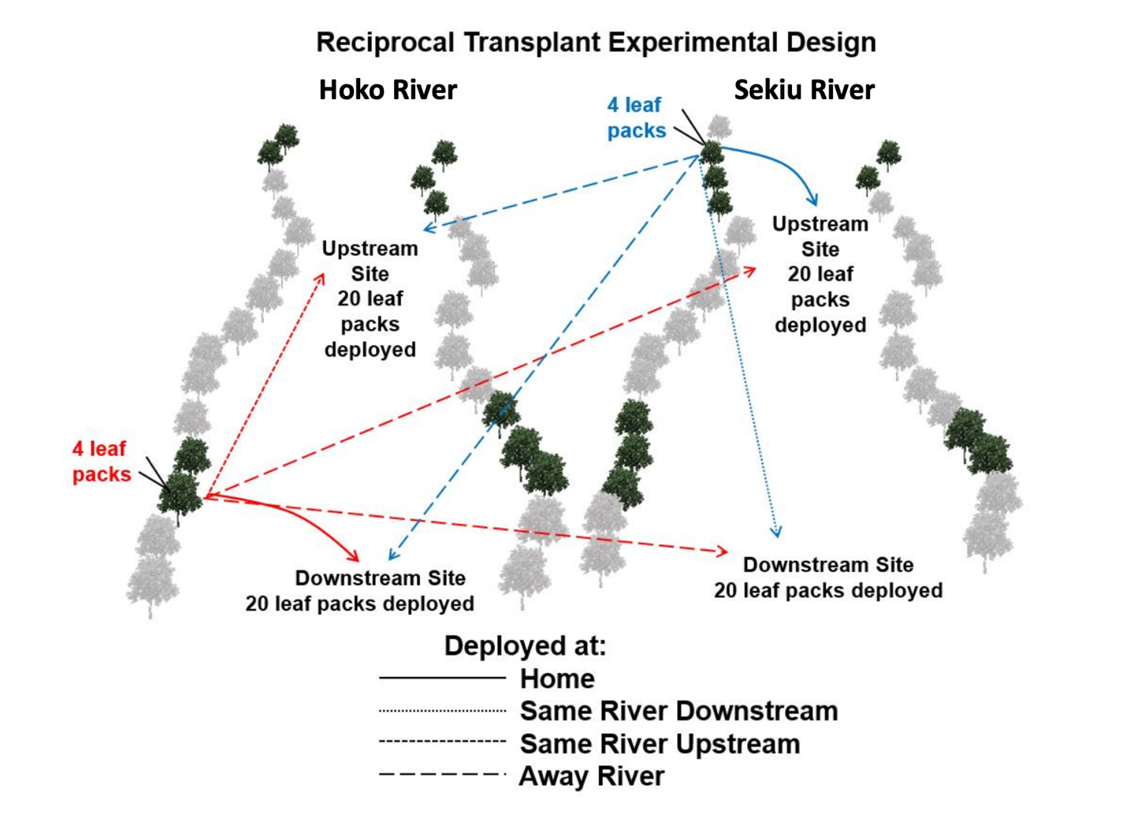
Figure S1. Reciprocal transplant experimental design for the decomposition of A. rubra leaves at Home and Away sites. Five A. rubra trees were selected at the upstream and downstream sites on the Hoko and Sekiu Rivers. From each tree, four identical leaf packs were made containing 22 leaves total (10 within the outer leaf pack and 12 within the inner leaf pack). From those four leaf packs, each was randomly assigned for deployment and decomposition at one of the four sites. Arrows are shown for only one tree of five per site and for only two of the four sites as a partial example of the complete design. In total, 20 unique leaf packs, 5 from each site, were deployed for freshwater decomposition at each site. This figure was adapted from Jackrel et al. 2014.⁵¹

Figure S2. Distinct and convergent successional trends in bacterial and fungal phylogenetic membership inhabiting leaf litter in rivers. (a) Bacterial communities inhabiting decomposing leaves showed distinct phylogenetic membership across days of decomposition and were statistically different among deployment sites (distance-based redundancy analysis (db-RDA) on weighted UniFrac distances— Day: F_{3, 280} = 98.39, p < 0.0001; River: F_{1, 280} = 12.35, p < 0.0001). In contrast, (b) fungal communities varied in phylogenetic membership among early-stage decomposition, but then converged from Days 10 through 20 regardless of which river they were sourced from (db-RDA on weighted UniFrac distances— Day: F_{3, 258} = 113.96, p < 0.0001; River: F_{1, 258} = 1.70, p = 0.18). For all db-RDAs, bacterial and fungal communities contained 308 and 286 replicates, respectively, due to differences in rarefaction depths in each dataset. Each model was analyzed with a permutational ANOVA (nperm = 10,000).
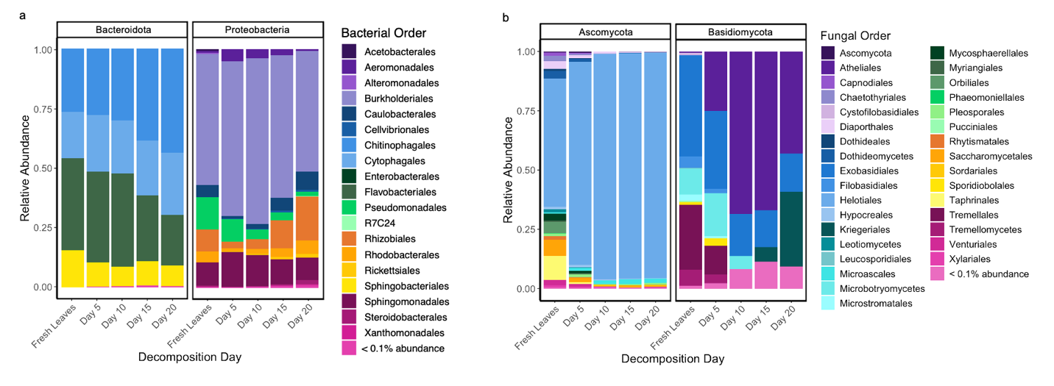
Figure S3. Successional changes in bacterial and fungal taxonomy over the duration of freshwater leaf litter decomposition. (a) The bacterial orders, Bacteroidota and Proteobacteria were the two most abundant Phyla throughout leaf litter decomposition within this study. The bacterial orders within these phyla show changes in relative abundance from fresh leaves and throughout leaf litter decomposition. For example, within Bacteroidota, the relative abundance of Chitinophagales increased throughout leaf litter decomposition in comparison to orders like Flavobacteriales and Sphingobacteriales, which decrease in relative abundance throughout time in comparison to fresh leaf microbiomes. Rhizobiales ASVs initially decreased in relative abundance once deployed in each river, but then increased throughout Days 5 to Day 20 of leaf litter decomposition, exceeding their initial relative abundance found within fresh leaves. This specific pattern in relative abundance could illustrate Rhizobiales unique ability to cooperate with fungal endosymbionts and degrade plant derived carbon and promote fungal colonization of sclerotized tissues.⁵² (b) Within the two most abundant fungal Phyla, Ascomycota and Basidiomycota, fungal orders vary in relative abundance from fresh leaves and throughout stages on freshwater decomposition. Notably, ASVs belonging to Atheliales became consistently abundant by Day 5, whereas ASVs in Tremellales and Tremellomycetes deceased in relative abundance. We also observed relative increases in Helotiales, a diverse order of plant endophytes that harbor enzymes needed to break down cellulose.⁵³
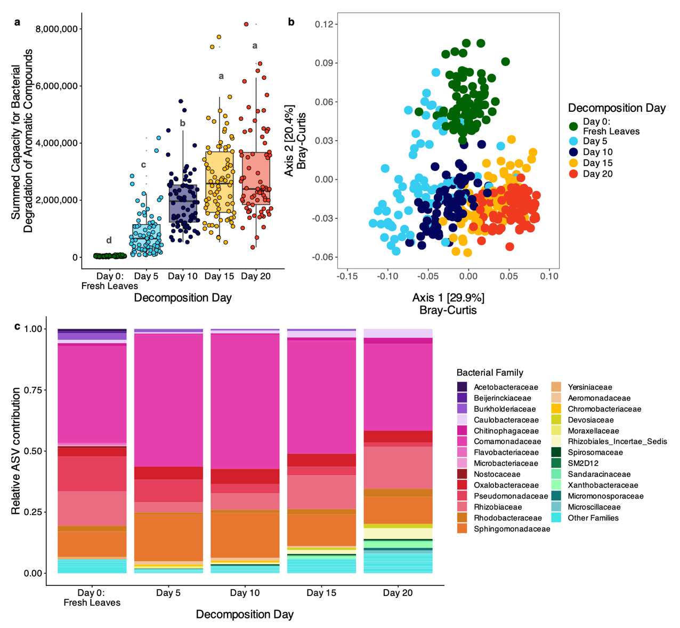
Figure S4. Predicted bacterial capacity to degrade aromatic compounds varies throughout stages of A. rubra leaf litter decomposition. As inferred by PICRUSt2⁵⁴, (a) the predicted gene content of KEGG Terms within the degradation of aromatic compounds pathway (ko01220) increase from fresh leaves through Day 20 (linear model (LM)— Day: F_{4, 383} = 230.80, p < 0.0001, n = 388). Summed capacity for bacterial degradation of aromatic compounds was defined as the sum of all KEGG Terms found within this pathway, which can be interpreted as the total predicted functional capacity per sample. On average, Day 15 had the largest summed capacity (μ = 2,582,331 ± 164,053.3 SE), however did not significantly differ from Day 20 (μ = 2,392,172 ± 176203.7 SE). Similarity, as determined through a Tukey’s HSD test, among decomposition days is represented by a compact letter display. Similarly, (b) the composition of predicted bacterial genes relevant for the breakdown of aromatic compounds significantly varies throughout leaf litter decomposition in rivers (db-RDA on Hellinger transformed Bray-Curtis distances with permutational ANOVA (nperm = 10,000)— F_{4, 364} = 68.06, p < 0.0001, n= 388). Notably, fresh leaf bacterial communities contain a distinct composition of predicted bacterial genes within the aromatic degradation pathway that differ from communities sourced from decomposing leaves. In addition, (c) bacterial families such as, Comamonadaceae, Rhizobiaceae and Sphingomonadaceae consistently contribute to predicted genes found within the degradation of aromatic compounds pathway (ko01220) throughout leaf litter decomposition.
Figure S5. Predicted fungal functional guilds differ in relative abundance from fresh leaves through early to late stages of decomposition. We utilized the open-source database FungalTraits to assign fungal functional trophic guilds based on taxonomy assigned by UNITE at the genus level.^{55,56} Throughout leaf litter decomposition we observed a large breadth in predicted functional fungal guilds ranging from the most dominant, Plant Pathogens and Endophytes to more rare functional guilds like Ericoid Mycorrhizal. We observed no apparent geographic differences in fungal functional guilds between communities inhabiting decomposing leaves within the Hoko and Sekiu Rivers. Fungal communities also were diverse in specialized saprotrophic life strategies through time including genera with the functional capacity to decompose fresh leaves, decomposing litter, wood and soil. Many fungi fill multiple ecological niches in functional space and retain multiple complex life strategies, such as endophytic fungi with the capacity to become parasitic to plants or other fungi. We note that many of these functional guilds are broad in their categorization and likely only begins to illuminate which functional guilds are dominant during the decomposition of terrestrial derived litter in fresh water streams.
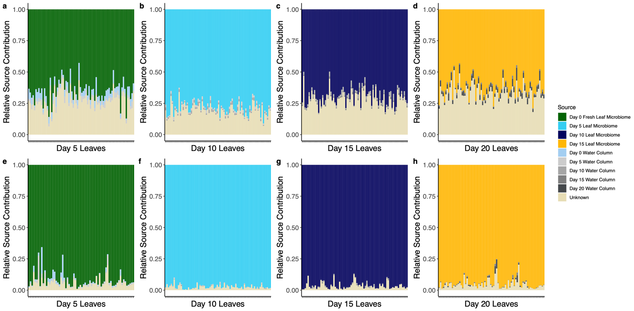
Figure S6. Bacterial and fungal communities found within decomposing leaves originate primarily from leaves of the previous timepoint with small contributions from the water column through time. Each panel represents communities sampled from decomposing leaves in the Hoko and Sekiu rivers at a single timepoint. (a - d) The relative source contribution of bacterial ASVs originated primarily from leaves of the previous time point, an unknown source, and then finally from water column samples. In contrast, fungal communities (e - h) were comprised of fungal ASVs originating from the previous timepoint, but had a much smaller relative source contribution from unknown sources. By employing SourceTracker2, we can infer that through time, colonization of bacteria and fungi from the water column is the greatest before and at Day 5, while new contributions from the water column are relatively small as decomposition progressed.⁸ However, given the sizable unknown source contribution to bacterial communities throughout decomposition, future work should investigate whether conditionally rare bacterial taxa that were undetected in our surveyed environments, may be contributing to these successional trends in bacterial composition.⁵⁷ See Table S1 for a full summary illustrating significant differences between source communities per decomposition time point.

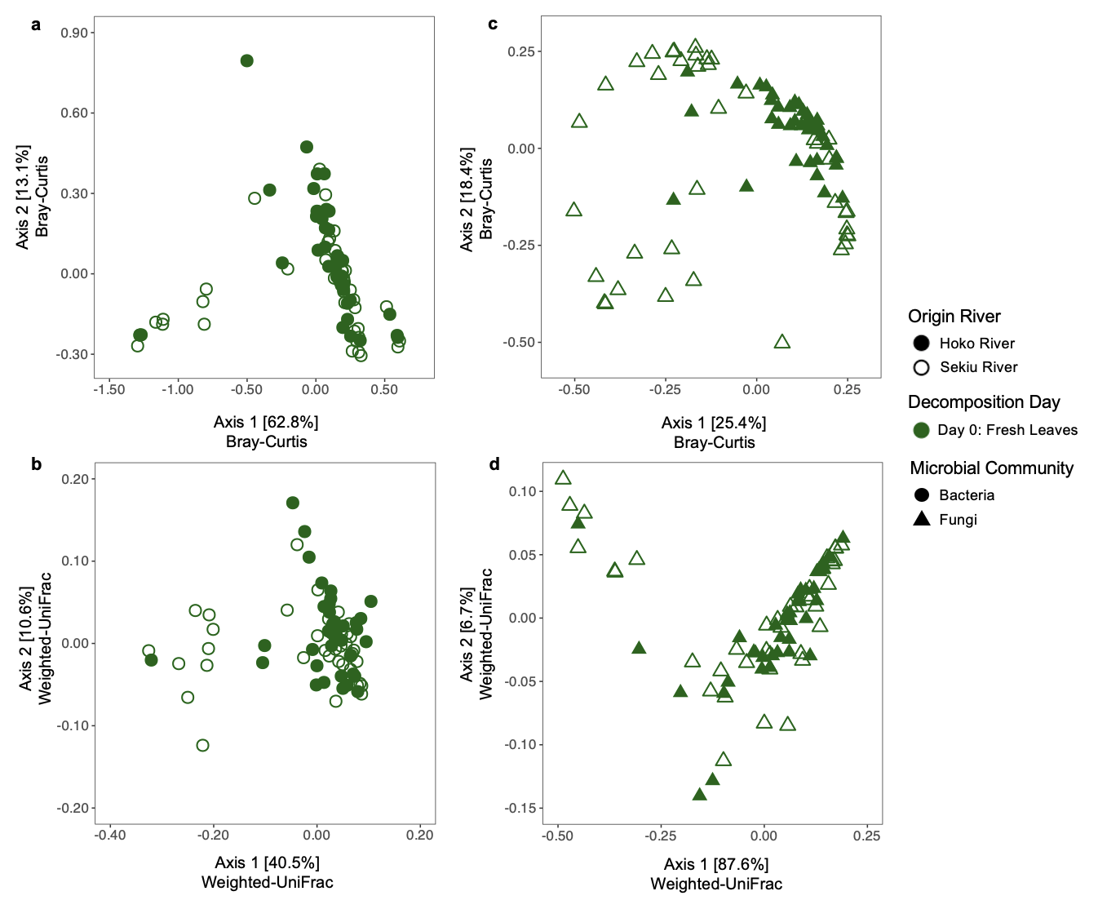
Figure S7. Microbial communities inhabiting fresh A. rubra leaves from trees growing along the Hoko and Sekiu Rivers. (a - b) Bacterial communities inhabiting fresh leaves differed between A. rubra populations originating from the Hoko and Sekiu Rivers (db-RDA on Bray-Curtis distances— F_{1,78} = 2.16, p = 0.04; weighted UniFrac distances— F_{1, 78} = 2.86, p = 0.01, n = 80). (c - d) Fungal communities inhabiting fresh leaves differed between A. rubra populations in composition (db-RDA on Bray-Curtis distances— F_{1, 78} = 8.28, p < 0.001, n = 80), but not based on phylogenetic membership (db-RDA on weighted-UniFrac— F_{1, 78} = 1.96, p = 0.15, n = 80), indicating significant differences in relative abundances were largely among closely-related taxa rather than distantly related groups. Since use of specific carbon substrates, such as PSMs, are not thought to be deeply conserved among microbes,⁵⁸ this suggests that the bacterial phyllosphere may have been more functionally divergent in their carbon-use traits across the Hoko and Sekiu Rivers compared to the fungal phyllosphere. For this supplementary analysis, we chose to use non-rarefied data due to low read depth after removal of host chloroplast sequences. All db-RDAs were analyzed with a permutational ANOVA (nperm = 10,000).
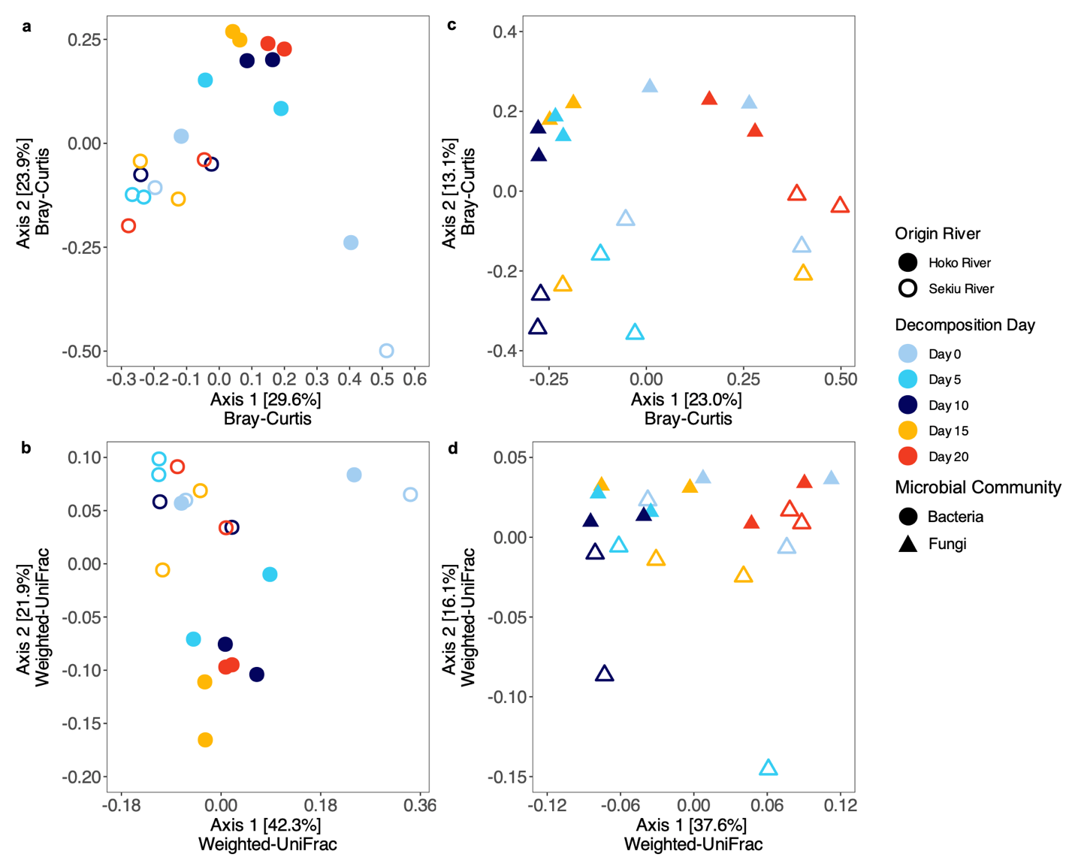
Figure S8. Freshwater microbial communities suspended in the water column differ between the Hoko and Sekiu Rivers over the length of our reciprocal transplant experiment. Microbial communities from the center of each river channel prior to leaf pack deployment (Day 0) and every subsequent five days of decomposition were sampled from upstream and downstream sites along the Hoko and Sekiu Rivers. (a - b) Freshwater bacterial communities differ in their community composition more strongly between rivers than across days (db-RDA on Bray-Curtis distances— Origin River: F_{1, 14} = 5.20, p = 0.0002, Day: F_{4, 14} = 1.39, p = 0.09, n = 20). Further, these bacterial communities remain phylogenetically distinct between rivers (db-RDA on weighted-UniFrac distances— Origin River: F_{1, 14} = 3.47, p = 0.006, Day: F_{4, 14} = 1.50, p = 0.10, n = 20). (c – d) Freshwater fungal decomposers were also distinct in community composition and phylogenetic membership among rivers, however were more variable through time than bacterial decomposer communities (db-RDA on Bray-Curtis distances— Origin River: F_{1, 14} = 3.14, p = 0.0009, Day: F_{4, 14} = 1.83, p = 0.002; db-RDA on weighted-UniFrac distances— Origin River: F_{1, 14} = 2.76, p = 0.02, Day: F_{4, 14} = 2.26, p = 0.004, n = 20 per analysis). Each db-RDA was analyzed using a permutational ANOVA (nperm = 10,000).

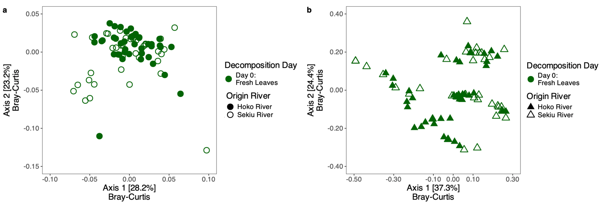
Figure S9. Predicted functions of the bacterial and fungal phyllosphere are similar between populations of A. rubra trees found along the Hoko and Sekiu Rivers. Bacterial functional predictions for fresh leaf communities were similarly inferred via PICRUSt2. (a) Among bacterial communities inhabiting fresh leaves, the composition of predicted genes within the aromatic degradation pathway do not differ between populations of A. rubra along the Hoko and Sekiu Rivers (db-RDA on Hellinger transformed Bray-Curtis distances— Origin River: F_{1, 78} = 1.40, p = 0.20, n = 80). We also used the FungalTraits database to examine functional fungal guilds within fresh leaf communities of A. rubra. Similarly, (b) fungal communities of the A. rubra phyllosphere did not show functional differences between populations of A. rubra along the Hoko and Sekiu Rivers (db-RDA on Bray-Curtis distances— Origin River: F_{1, 78} = 2.15, p = 0.07, n = 80).
Figure S10. Bacterial communities, but not fungal communities, that inhabit the water columns of the Hoko versus Sekiu river differ in their predicted functions. Among bacterial communities suspended in the water columns of the Hoko and Sekiu Rivers, (a) the total predicted capacity to degrade aromatic compounds did not differ (LM— Origin River: F_{1, 18} = 0.027, p = 0.87, n = 20). However, (b) geographic differences between these bacterial communities inhabiting the Hoko versus Sekiu rivers became apparent when investigating compositional differences in the specific predicted bacterial genes involved in aromatic degradation (db-RDA on Hellinger transformed Bray-Curtis distances— Origin River: F_{1, 14} = 3.96, p = 0.03; Day: F_{4, 14} = 1.34, p = 0.25, n= 20). Similar to fresh and decomposing leaves, (c) bacterial families such as Comamonadaceae, Rhizobiaceae and Sphingomonadaceae consistently possess genes that contribute to aromatic degradation. Lastly, we used FungalTraits to infer functional trophic guilds between aquatic fungal communities of the Hoko and Sekiu rivers. (d) Freshwater fungal communities showed no geographic or temporal differences in their predicted functional guilds (db-RDA on Bray-Curtis distances— Day: F_{4, 14} = 1.13, p = 0.34; River: F_{1, 14} = 0.86, p = 0.48, n = 20). Functional traits for fungi are commonly conserved at the genus level, where in some instances fungal genera can have a diverse set of ecological trophic strategies and thus fall into multiple functional guilds.^{59,60} Functional guilds via FungalTraits are delineated by a hyphen (e.g., Animal Pathogen-Endophyte-Wood Saprotroph), whereby they are ordered by the most characteristic for each genus. (e) Freshwater fungal communities suspended in the water column of the Hoko and Sekiu Rivers are primarily dominated by genera within the functional guilds, Endophytes-Plant Pathogen-Wood Saprotrophs and Plant Pathogens. As rivers act as conduits for fungal spore dispersal, we also observed some more rare functional guilds such as Ectomycorrhizal and Lichen Parasites, which may originate from riparian soil environments or from nearby tree canopies. All db-RDA was analyzed using a permutational ANOVA (nperm = 10,000).
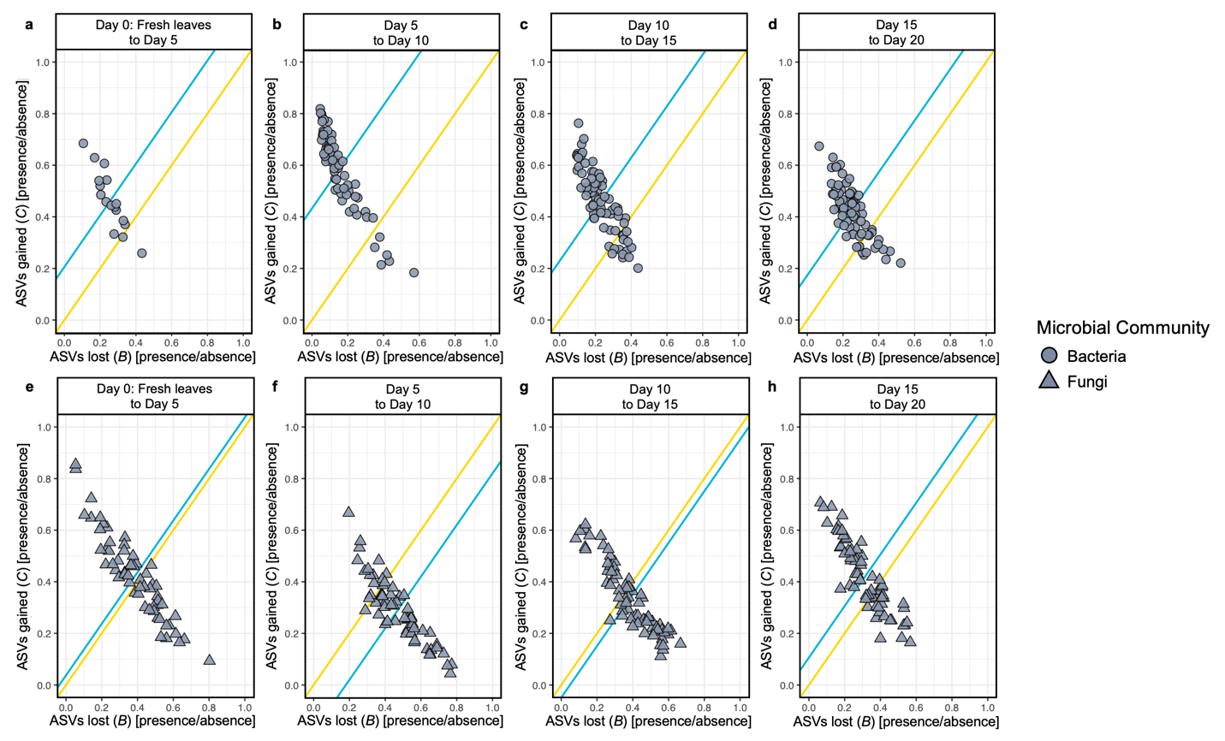
Figure S11. Bacterial and fungal communities experience different rates of species lost and species gained over the duration of leaf litter decomposition in rivers. Here, we represent species lost and gained as B-C plots⁶¹, where the proportion of ASVs lost or gained between sequential time intervals was calculated from presence-absence ASV matrices. Gold lines have a slope of 1 and indicate where ASV losses and gains are equal. Teal lines are drawn parallel to gold lines and cross through the centroid of each cluster. Its position above the gold lines indicates that on average, more ASVs were gained between that time point than lost. As seen in (a - d) bacterial communities on average gain more ASVs throughout leaf litter decomposition, where the greatest gains in new bacterial taxa were seen between Day 5 and Day 10 (linear mixed effects model (LMM)— ASV gains: F_{3, 238} = 24.04, p < 0.0001; LMM— ASV losses: F_{3, 238} = 16.34, p < 0.0001, n = 247). In comparison, fungal communities (e - h) experience, on average, more ASV losses than gains over the duration of leaf litter decomposition, where the greatest loss of fungal ASVs was observed between Day 5 and 10 (LMM— ASV gains: F_{3, 251} = 13.57, p < 0.0001; LMM— ASV losses: F_{3, 251} = 14.31, p < 0.0001, n = 260).
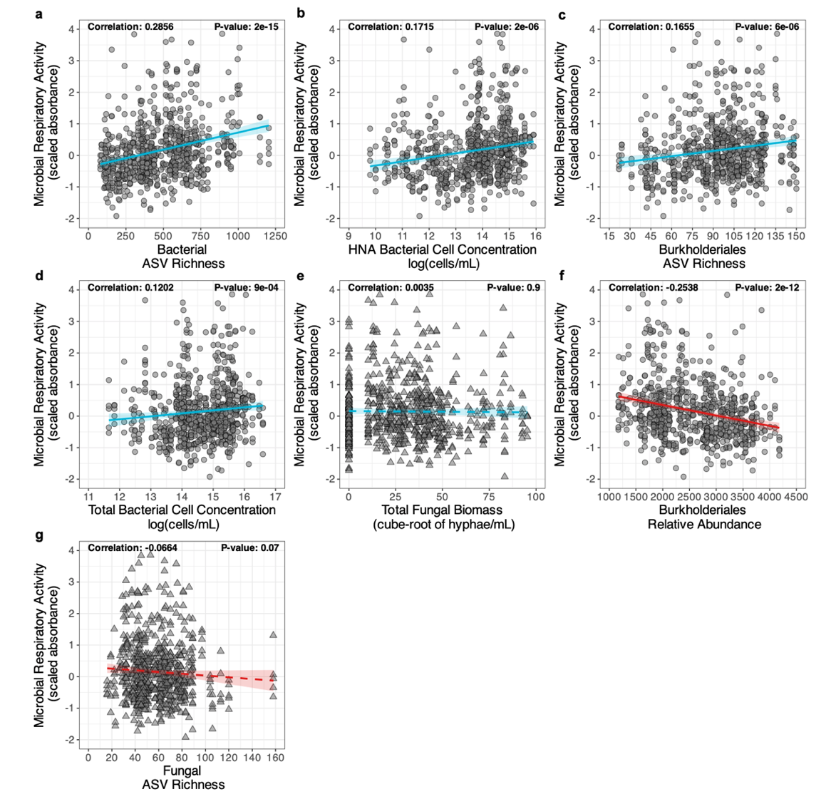
Figure S12. Bacterial community metrics correlate with microbial respiratory activity more consistently than fungal community metrics. Throughout decomposition (a) microbial respiratory activity in response to the presence of local A. rubra metabolomes correlated most strongly with bacterial ASV richness (Pearson’s r = 0.29, p = 2e-15 via correlation test, n = 760), followed by (b) the HNA fraction of bacterial communities (Pearson’s r = 0.17, p = 2e-06 via correlation test, n = 760). As Burkholderiales are known to breakdown complex PSMs, we examined community metrics within this bacterial phylum, where (c) we observed increases in Burkholderiales ASV richness with microbial respiratory activity throughout decomposition (Pearson’s r = 0.17, p = 6e-06 via correlation test, n = 760). In addition, (d) total bacterial cell concentration increases with respiratory activity (Pearson’s r = 0.12, p = 9e-04 via correlation test, n = 755). Lastly, (e) total fungal biomass as quantified by hyphal biovolume lacked a significant correlation with microbial respiratory activity throughout decomposition (Pearson’s r = 0.00, p = 0.9 via correlation test, n = 760). In contrast to Burkholderiales ASV richness, (f) the relative abundance of this bacterial phylum negatively correlates with microbial respiratory activity throughout decomposition (Pearson’s r = -0.25, p = 2e-12 via correlation test, n = 760). Lastly, we observed a nonsignificant slightly negative correlation between fungal ASV richness and respiration activity (Pearson’s r = -0.07, p = 0.07 via correlation test, n = 760), suggesting a minimal role in the degradation of specialized A. rubra PSMs. Blue and red regression lines indicate positive and negative correlations. Solid and dashed regression lines indicate significant and nonsignificant correlations, respectively.
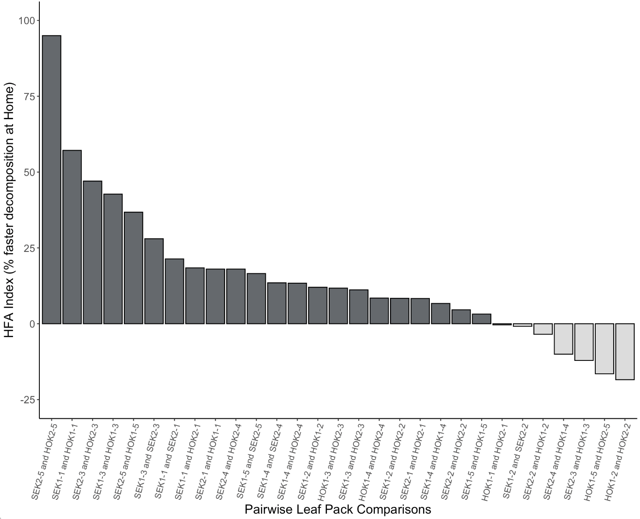
Figure S13. Accelerated leaf litter decomposition at home among all total pairwise leaf pack comparisons from our reciprocal transplant decomposition experiment. On Day 20, all leaf packs from each site were collected and final weight of the 12 leaves allocated to the inner leaf pack was measured. The HFA Index score was then calculated following Ayres et al. (2009), which represents the relative degree that A. rubra leaves decompose more quickly at Home sites than Away sites from the Hoko and Sekiu Rivers.⁶² The mean HFA Index score across all leaf pack comparisons was 15.14%, where 78.86% of reciprocal comparisons showed positive HFAI (t₂₈ = 3.55, p = 0.0007, via student t-test). Leaf pack are noted as “Origin Site – Tree ID”.
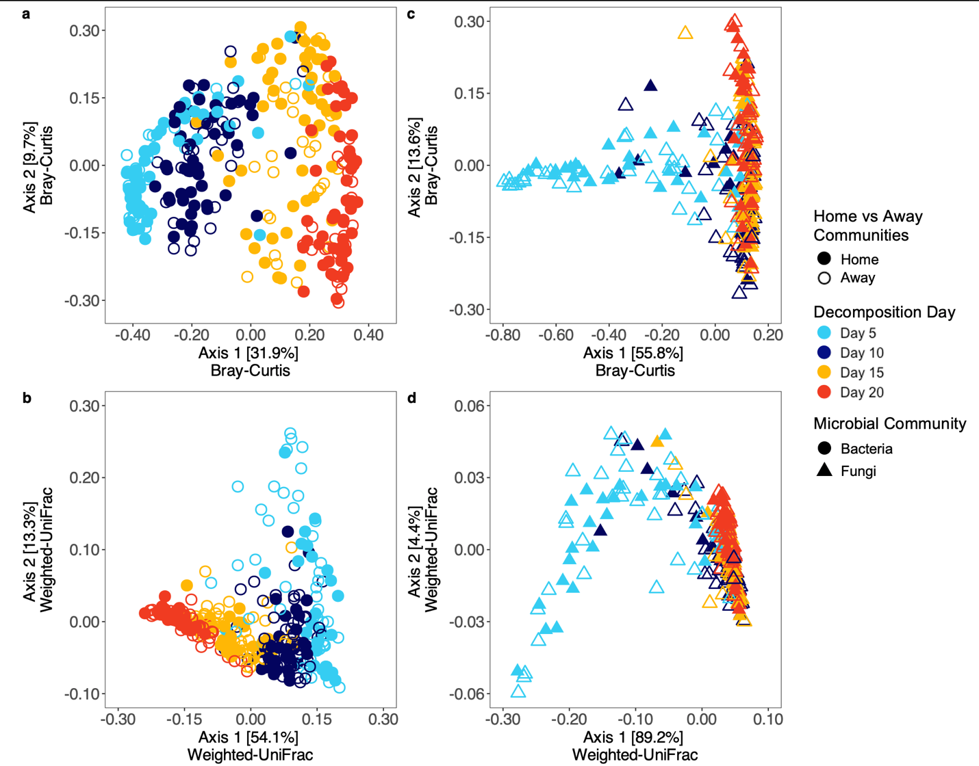
Figure S14. Decomposer communities vary in successional patterns throughout leaf litter decomposition in rivers. (a - b) Bacterial decomposer communities significantly differ in taxonomic community succession between Home and Away sites (db-RDA on Bray-Curtis distances— HFA: F_{4, 280} = 2.33, p < 0.0001), whereas differences in phylogenetic membership varied more weakly (db-RDA on weighted UniFrac distances— HFA: F_{4, 280} = 2.04, p = 0.03). (c - d) On the contrary, fungal communities inhabiting decomposing leaves at each successional stage did not differ between Home and Away sites (db-RDA on Bray-Curtis distances— HFA: F_{4, 258} = 1.59, p = 0.09; weighted UniFrac distances— HFA: F_{4, 258} = 0.94, p = 0.44). For all db-RDAs, bacterial and fungal communities contained 308 and 286 replicates, respectively, due to differences in rarefaction depths in each dataset. In addition, each db-RDA was analyzed with a permutational ANOVA (nperm = 10,000).

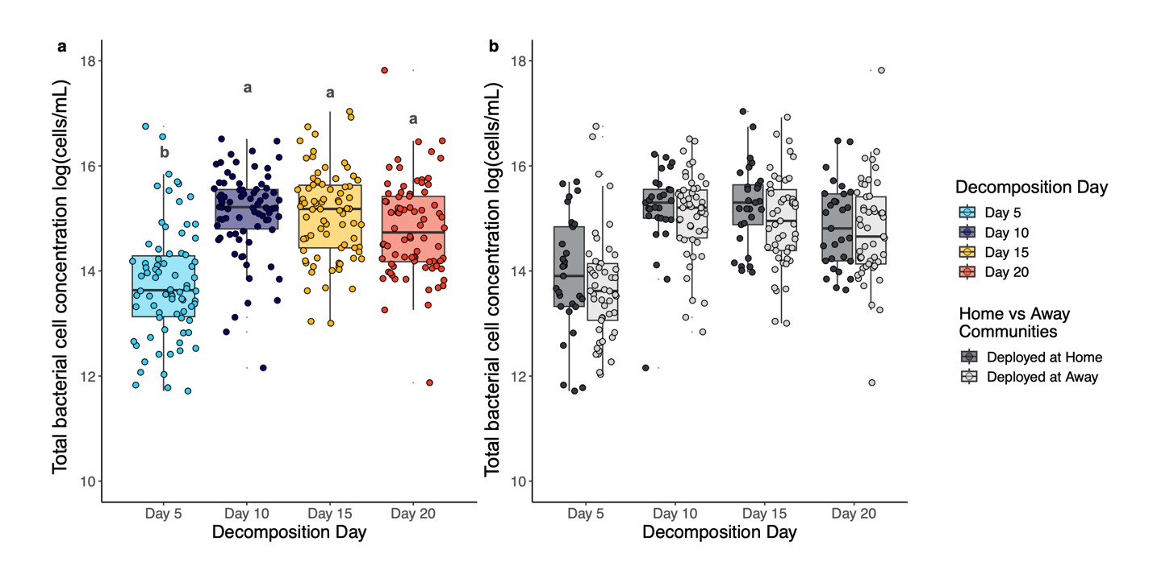
Figure S15. Total bacterial cell concentration collected from decomposing leaf packs varied across time and between Home versus Away treatments. Absolute bacterial cell abundances as enumerated through flow cytometry, from decomposing leaf packs (a) differ by day with Day 5 driving the significant differences (LMM— Day: F_{3, 288.1} = 38.85, p < 0.0001, n = 312). A Tukey’s HSD post-hoc test was conducted, where shared letters denote similarity between absolute cell concentrations among days. Whereas, (b) there was no statistically significant trend in absolute cell abundances between leaf packs deployed at Home and Away sites, despite Home sites having a visible greater average of cell concentration particularly on Days 5 and 15 (LMM— HFA: F_{1, 303.8} = 2.69, p = 0.10, n = 312).

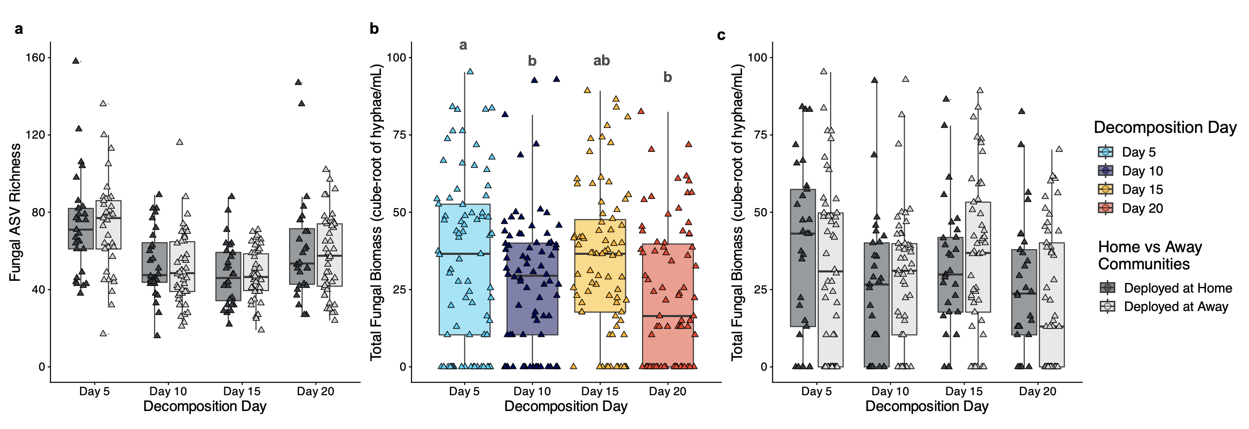
Figure S16. Fungal ASV richness and hyphal biomass vary throughout decomposition, but do show no differences among leaves decomposing at Home and Away sites. Fungal ASV richness differs from freshwater fungal communities and varies throughout leaf litter decomposition (see Main Fig. 1d). (a) Leaf packs deployed at Home versus Away sites did not significantly differ in fungal ASV richness (LMM— HFA: F_{4, 125.6} = 1.56, p = 0.18, n = 286). Fungal biomass, as measured by hyphal biovolume, (b - c) varied significantly upon entry and decomposition within freshwater rivers (zero-inflated generalized LMM (gLMM)— Day: 𝜒²₃ = 12.86, p < 0.001, n = 312). Whereas, fungal biomass did not differ among A. rubra leaves decomposing at Home versus Away sites (gLMM—HFA: 𝜒²₁ = 0.89, p = 0.35, n = 312). For visualization, we represent fungal biomass as the cube root of hyphae per mL in order to preserve biologically meaningful absences.

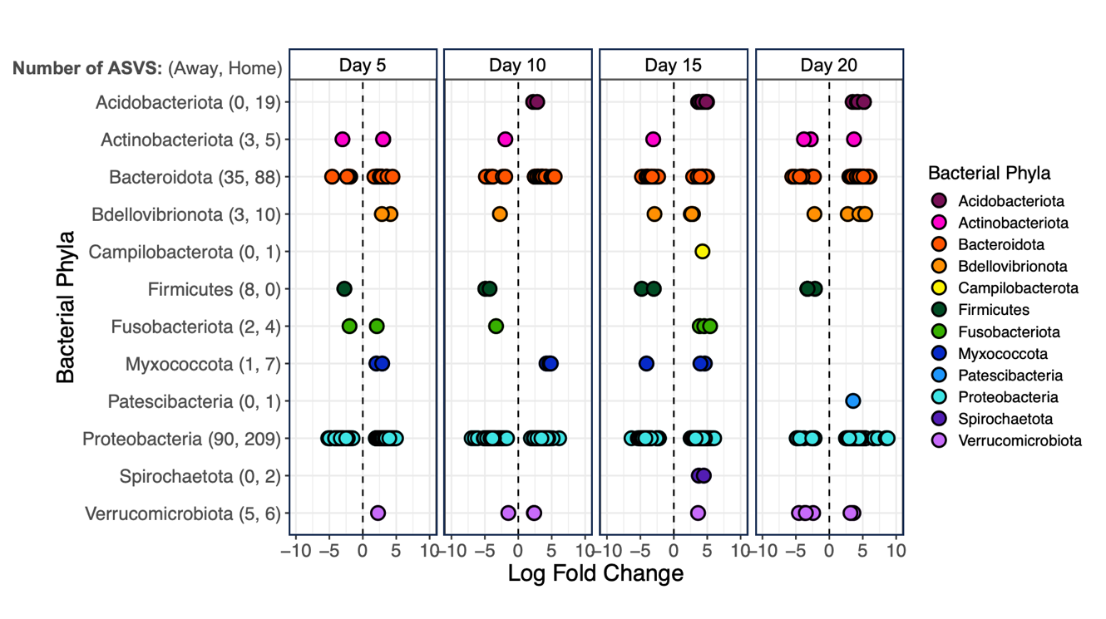
Figure S17. Differential abundance of bacterial phyla throughout aquatic leaf litter decomposition. Positive log fold change indicates bacterial ASVs that are significantly over-represented at Home sites (n = 350 ASVs) in the Hoko and Sekiu rivers, while negative log fold change values reflect bacterial taxa that are under-represented in aquatic decomposer communities at Home sites (n = 149 ASVs). The number of ASVs represented in Home and Away sites, across all decomposition days, is listed after each bacterial phyla in parentheses (e.g., Proteobacteria (90 ASVs at Away, 209 at Home). Significance was determined with edgeR, p < 0.001 after false discovery rate correction.

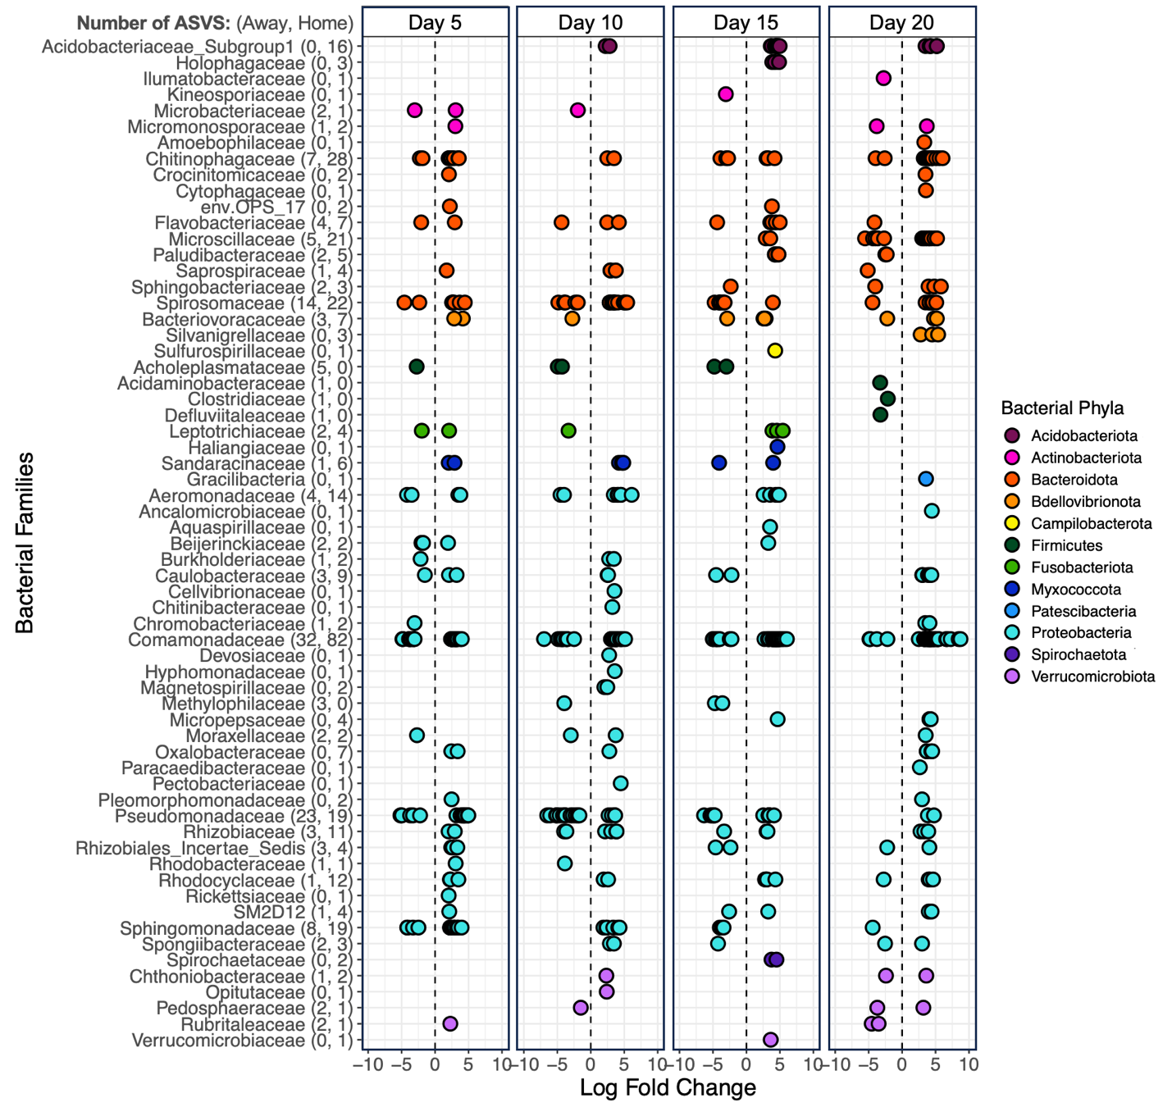
Figure S18. Differential abundance of bacterial families throughout aquatic leaf litter decomposition. Positive log fold change indicates bacterial ASVs that are significantly over-represented at Home sites (n = 350 ASVs) in the Hoko and Sekiu rivers, while negative log fold change values reflect bacterial taxa that are under-represented in aquatic decomposer communities at Home sites (n = 149 ASVs). The number of ASVs represented in Home and Away sites, across all decomposition days, is listed after each bacterial families in parentheses (e.g., Comamonadaceae (32 ASVs at Away, 82 at Home). Significance was determined with edgeR, p < 0.001 after false discovery rate correction.

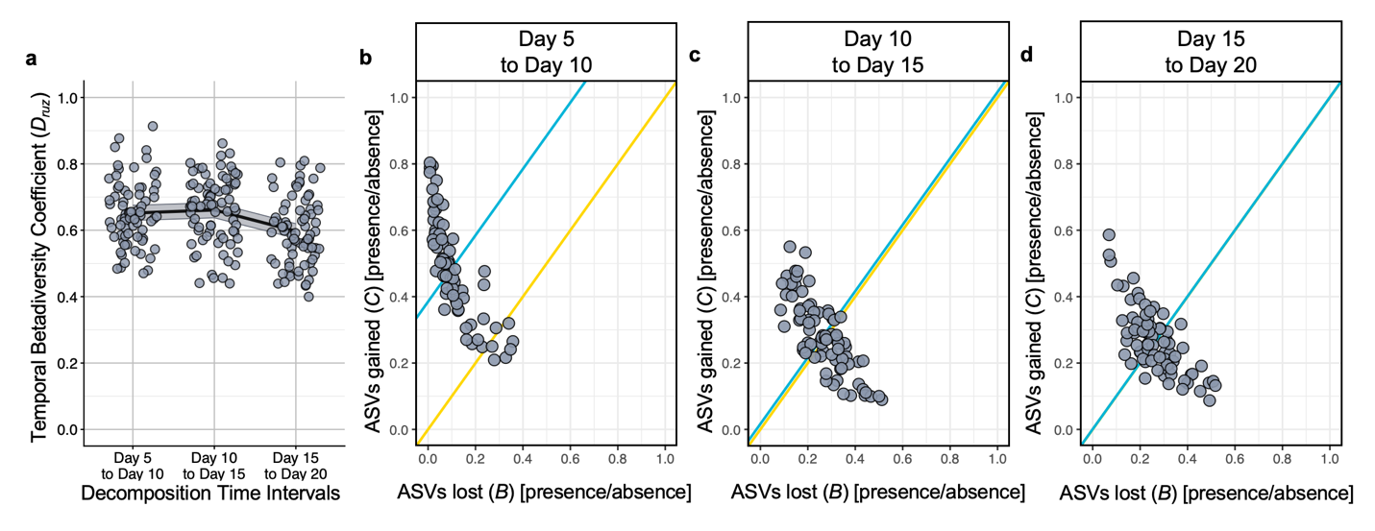
Figure S19. Across leaf litter decomposition in rivers, variation in community turnover within the Burkholderiales differ with the largest mean change observed between Day 10 and Day 15. Beta diversity of Burkholderiales, as represented by temporal turnover (a) between consecutive time intervals, varies throughout aquatic leaf litter decomposition (LMM— Day: F_{2, 204} = 9.76, p < 0.0001, n = 308). The shaded ribbon represents the 95% confidence interval around the mean temporal turnover for Burkholderiales. (b - d) Further, Burkholderiales ASV gains and losses varied over the course of decomposition, with the largest on average gain in ASVs seen between Day 5 and Day 10 (LMM— ASV gains: F_{2, 222} = 80.34, p < 0.0001; LMM— ASV losses: F_{2, 222} = 67.48, p < 0.0001, n= 308). We represent species lost and gained as B-C plots⁶¹, where the proportion of ASVs lost or gained between sequential time intervals was calculated from presence-absence ASV matrices. Gold lines have a slope of 1 and indicate where ASV losses and gains are equal. Teal lines are drawn parallel to gold lines and cross through the centroid of each cluster. Its position above the gold lines indicates that on average, more ASVs were gained between that time point than lost. Note in the Day 15 to Day 20 interval, ASVs lost and gained were very similar such that the gold line lies directly beneath the teal line. For a full report on the Tukey’s HSD examining pairwise differences in temporal turnover, see Table S6.

Figure S20. Phylogenetic membership within the bacterial order Burkholderiales varies throughout leaf litter decomposition in rivers. Communities of Burkholderiales vary in phylogenetic membership as defined by a weighted UniFrac distance throughout aquatic leaf litter decomposition and between Home and Away sites within the Hoko and Sekiu rivers (db-RDA on weighted UniFrac distances— Day: F_{3, 280} = 79.52, p < 0.0001; HFA: F_{4, 280} =1.96, p = 0.03; River: F_{1, 280} = 19.14, p < 0.0001, n = 308).

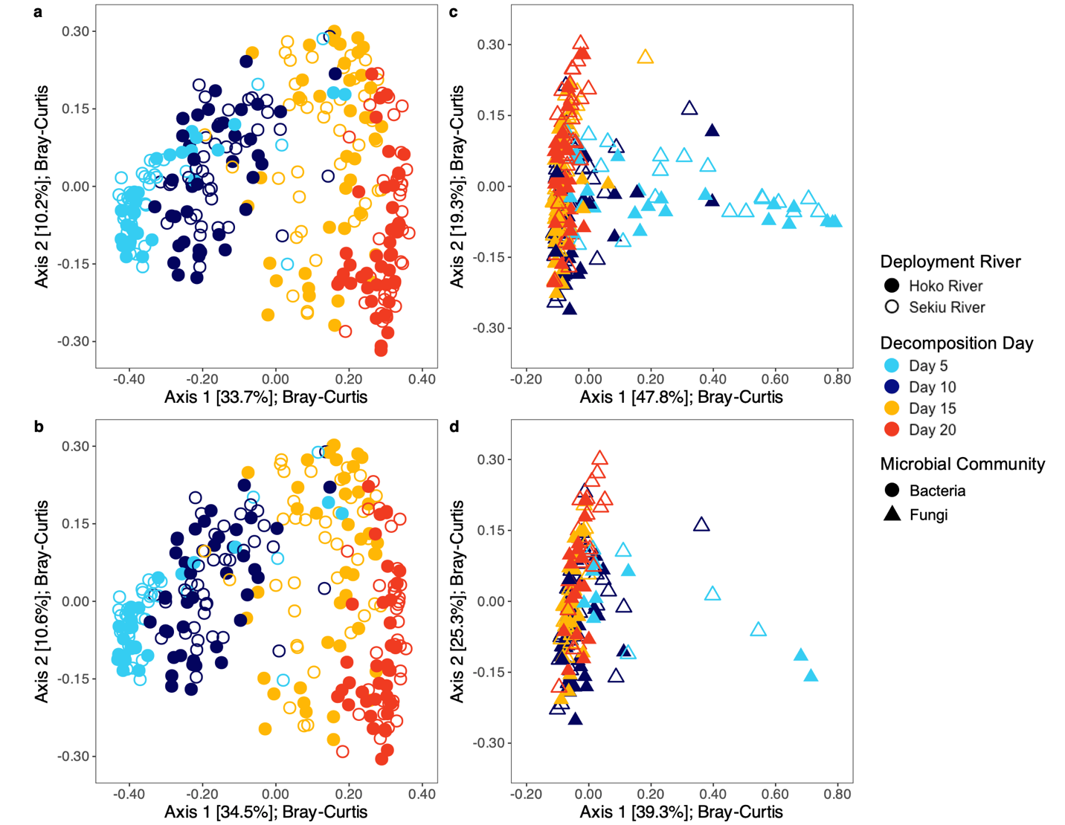
Figure S21. Successional patterns of bacterial and fungal decomposer communities throughout decomposition remain consistent across rarefaction depths. To illustrate this robustness, communities were rarefied to approximately 10K (Bacterial: 9,923; Fungal: 10,049) and 20K reads per sample (Bacterial: 20,795, Fungal: 20,016). (a - b) Bacterial communities show distinct successional stages throughout decomposition within the Hoko and Sekiu Rivers, mirroring patterns observed at lower rarefaction depth as seen in Fig. 1 (10K— Day: F_{3, 273} = 59.04, p < 0.0001, River: F_{1, 273} = 16.59, p < 0.0001, HFA: F_{4, 273} = 2.32, p = 0.002, n = 301; 20K— Day: F_{3, 265} = 58.61, p < 0.0001, River: F_{1, 265} = 17.24, p < 0.0001, HFA: F_{4, 265} = 17.24, p < 0.0001, n = 293). (c - d) Fungal communities vary the most throughout early stages of decomposition and then show strong signs of convergence in community composition, as similarly observed at lower rarefaction depths (10K— Day: F_{3, 216} = 33.26, p < 0.0001, River: F_{1, 216} = 7.22, p < 0.0001, HFA: F_{4, 216} = 1.24, p = 0.22, n = 244; 20K— Day: F_{3, 125} = 14.63, p < 0.0001, River: F_{1, 125} = 6.47, p < 0.0001, HFA: F_{4, 125} = 1.27, p = 0.18, n = 153). Community dissimilarities were analyzed using Bray-Curtis distances and db-RDAs following the same model structure as main text analyses. Significance testing conducted via a permutational ANOVA (nperm= 10,000). For simplicity, we chose to illustrate this robustness using two of our three main factors (Day and River, but not HFA).

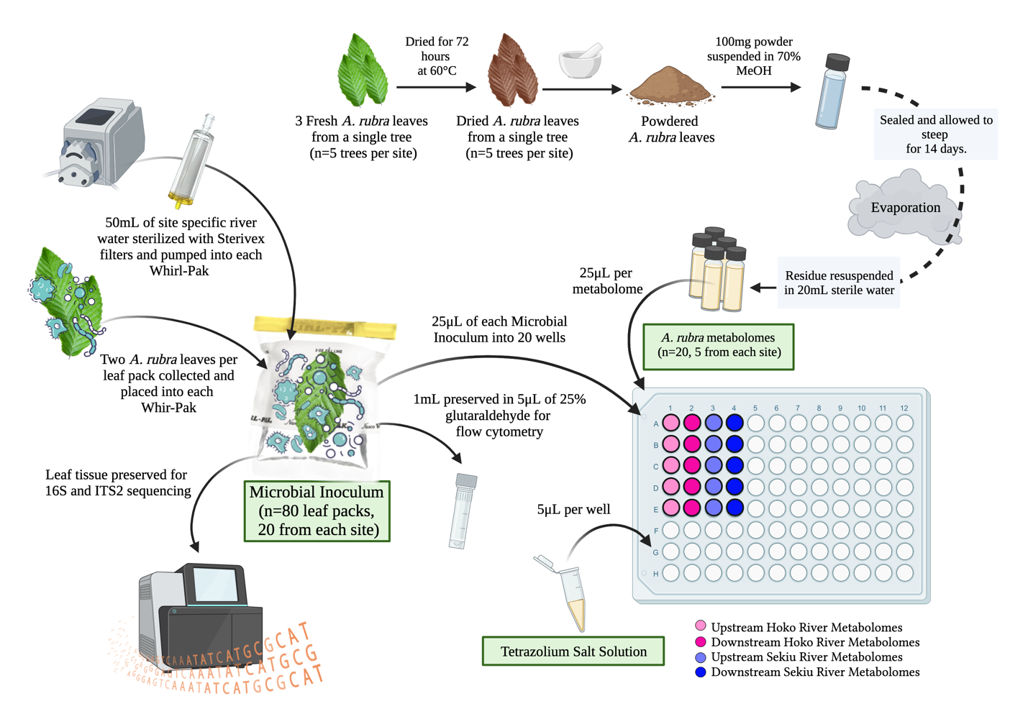
Figure S22. Illustration of heterotrophic microbial respiratory activity assays that quantified the response of microbial communities to the presence of A. rubra metabolomes. To create the metabolome extracts used in the assay, metabolomes were extracted from dried leaf powder using 70% methanol. To obtain the leaf-associated microbial communities that were assayed for their respiratory activity in response to alder metabolomes, two leaves were collected from either fresh leaves or from decomposing leaf packs (Day 5, 10, 15, and 20) and shaken in Whirl-Paks of sterile river water to dislodge microbes into the water. A subsample of this microbial community was then added into 20 wells containing one of the 20 A. rubra metabolomes that were extracted from each of the 5 targeted individuals at each site. After 12 hours, heterotrophic respiratory activity of microbes in response to A. rubra metabolomes was then measured by absorbance readings at 590 nm on a Byonoy Absorbance 96 Reader. Simultaneous to plate setup, we also preserved 1 mL of each microbial community for measurement of absolute cell abundance via flow cytometry and microscopy. All remaining river water was then discarded from Whirl paks and leaves were frozen to later quantify bacterial and fungal community composition via amplicon sequencing. Figure was generated using BioRender.

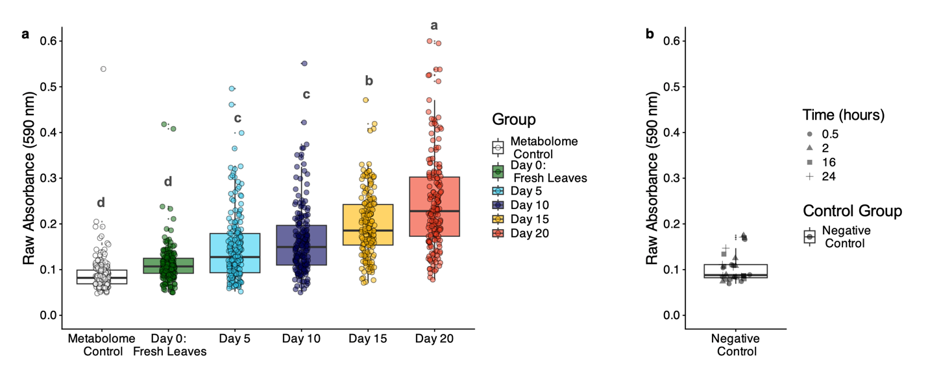
Figure S23. Heterotrophic respiratory activity by microbial decomposers is on average higher than metabolome controls and negative controls. (a) Metabolome controls consisted of sterile A. rubra metabolomes and tetrazolium salt and were measured on Day 0 prior to the inoculation of microbial communities. Raw absorbance of these controls was negligible relative to raw 12-hour absorbance by microbial communities collected from decomposing leaf packs (LMM— F_{5, 1115.4} = 93.78, p < 0.0001, n = 190 per group). (b) In a follow up study using the same methodology, we show that negative controls containing microbial inoculums and tetrazolium salt have similar absorbance throughout the duration of this assay (LM— F_{1,109} = 0.39, p = 0.53) and on average similar to metabolome controls. Together, these results indicate that color development in these assays was driven by respiratory activity of heterotrophic microbes in response to A. rubra PSMs rather than the intrinsic color of metabolome extracts or any unknown carbon source introduced with the microbial inoculum, such as dissolved organic carbon or microscopic leaf particulates. Significant differences among groups were determined using a Tukey’s HSD and denoted here using a compact letter display above each boxplot.

LITERATURE CITED
1. Schmid, R. et al. Integrative analysis of multimodal mass spectrometry data in MZmine 3. Nat. Biotechnol. 41, 447–449 (2023).
2. Nothias, L. F. et al. Feature-based molecular networking in the GNPS analysis environment. Nat. Methods 17, 905–908 (2020).
3. Schmid, R. et al. Ion identity molecular networking for mass spectrometry-based metabolomics in the GNPS environment. Nat. Commun. 12, (2021).
4. Dührkop, K. et al. SIRIUS 4: a rapid tool for turning tandem mass spectra into metabolite structure information. Nat. Methods 16, 299–302 (2019).
5. Kim, H. W. et al. NPClassifier: A deep neural network-based structural classification tool for natural products. J. Nat. Prod. 84, 2795–2807 (2021).
6. Mildau, K. et al. Homologue series detection and management in LC-MS data with homologueDiscoverer. Bioinformatics 38, 5139–5140 (2022).
7. Shannon, P. et al. Cytoscape: A software environment for integrated models of biomolecular interaction networks. Genome Res. 13, 2498–2504 (2003).
8. Knights, D. et al. Bayesian community-wide culture-independent microbial source tracking. Nat. Methods 8, 761–765 (2011).
9. Mithöfer, A. & Boland, W. Plant defense against herbivores: Chemical aspects. Annu. Rev. Plant Biol. 63, 431–450 (2012).
10. Neilson, E. H., Goodger, J. Q. D., Woodrow, I. E. & Møller, B. L. Plant chemical defense: at what cost? Trends Plant Sci. 18, 250–258 (2013).
11. Jha, Y. & Mohamed, H. I. Plant secondary metabolites as a tool to investigate biotic stress tolerance in plants: a review. Gesunde Pflanzen 74, 771–790 (2022).
12. Hilal, B., Khan, M. M. & Fariduddin, Q. Recent advancements in deciphering the therapeutic properties of plant secondary metabolites: phenolics, terpenes, and alkaloids. Plant Physiology and Biochemistry 211, 108674 (2024).
13. Moreno, J. C., Mi, J., Alagoz, Y. & Al‐Babili, S. Plant apocarotenoids: from retrograde signaling to interspecific communication. The Plant Journal 105, 351–375 (2021).
14. Han, J. W., Choi, G. J. & Kim, B. S. Antimicrobial aromatic polyketides: A review of their antimicrobial properties and potential use in plant disease control. World J. Microbiol. Biotechnol. 34, 163 (2018).
15. Bartley, G. E. & Scolnik, P. A. Plant carotenoids: pigments for photoprotection, visual attraction, and human health. Plant Cell 7, 1027 (1995).
16. Heath, J. J., Cipollini, D. F. & Stireman III, J. O. The role of carotenoids and their derivatives in mediating interactions between insects and their environment. Arthropod. Plant. Interact. 7, 1–20 (2013).
17. Gaspar, A., Garrido, E. M. P. J., Borges, F. & Garrido, J. M. P. J. Biological and medicinal properties of natural chromones and chromanones. ACS Omega 9, 21706–21726 (2024).
18. Stringlis, I. A., De Jonge, R. & Pieterse, C. M. J. The age of coumarins in plant–microbe interactions. Plant Cell Physiol. 60, 1405–1419 (2019).
19. Yu, O. & Jez, J. M. Nature’s assembly line: biosynthesis of simple phenylpropanoids and polyketides. The Plant Journal 54, 750–762 (2008).
20. Lea, C. S., Bradbury, S. G. & Constabel, C. P. Anti-herbivore activity of oregonin, a diarylheptanoid found in leaves and bark of red alder (Alnus rubra). J. Chem. Ecol. 47, 215–226 (2021).
21. Ilic-Tomic, T. et al. Diarylheptanoids from Alnus viridis ssp. viridis and Alnus glutinosa: Modulation of quorum sensing activity in Pseudomonas aeruginosa. Planta Med. 83, 117–125 (2017).
22. Moore, B. D., Andrew, R. L., Külheim, C. & Foley, W. J. Explaining intraspecific diversity in plant secondary metabolites in an ecological context. New Phytologist 201, 733–750 (2014).
23. Berg, A., Papenfuhs, C. K. & Fraley, A. E. Diterpenoid Diversity across Land Plants. Helv. Chim. Acta e00222 (2026).
24. Asai, T. & Fujimoto, Y. Cyclic fatty acyl glycosides in the glandular trichome exudate of Silene gallica. Phytochemistry 71, 1410–1417 (2010).
25. Grellet Bournonville, C. et al. Strawberry fatty acyl glycosides enhance disease protection, have antibiotic activity and stimulate plant growth. Sci. Rep. 10, 8196 (2020).
26. Kim, S.-C., Chapman, K. D. & Blancaflor, E. B. Fatty acid amide lipid mediators in plants. Plant science 178, 411–419 (2010).
27. Treutter, D. Significance of flavonoids in plant resistance: a review. Environ. Chem. Lett. 4, 147–157 (2006).
28. Górniak, I., Bartoszewski, R. & Króliczewski, J. Comprehensive review of antimicrobial activities of plant flavonoids. Phytochemistry reviews 18, 241–272 (2019).
29. Bhambhani, S., Kondhare, K. R. & Giri, A. P. Diversity in chemical structures and biological properties of plant alkaloids. Molecules 26, 3374 (2021).
30. Wang, X. et al. Natural guanidine alkaloids in tea (Camellia sinensis): Identification, quantification and α-glucosidase inhibitory activity of cis-and trans-cinnamoylagmatines. Food Chem. 492, 145311 (2025).
31. Dixon, R. A. & Steele, C. L. Flavonoids and isoflavonoids–a gold mine for metabolic engineering. Trends Plant Sci. 4, 394–400 (1999).
32. Ramaroson, M.-L. et al. Role of phenylpropanoids and flavonoids in plant resistance to pests and diseases. Molecules 27, 8371 (2022).
33. Zálešák, F., Bon, D. J.-Y. D. & Pospíšil, J. Lignans and Neolignans: Plant secondary metabolites as a reservoir of biologically active substances. Pharmacol. Res. 146, 104284 (2019).
34. Harmatha, J. & Dinan, L. Biological activities of lignans and stilbenoids associated with plant-insect chemical interactions. Phytochemistry Reviews 2, 321–330 (2003).
35. Fuloria, N. K. et al. Biological activities of meroterpenoids isolated from different sources. Front. Pharmacol. 13, 830103 (2022).
36. Riedlmeier, M. et al. Monoterpenes support systemic acquired resistance within and between plants. Plant Cell 29, 1440–1459 (2017).
37. Pichersky, E. & Raguso, R. A. Why do plants produce so many terpenoid compounds? New Phytologist 220, 692–702 (2018).
38. Ibrahim, S. R. M. & Mohamed, G. A. Naturally occurring naphthalenes: chemistry, biosynthesis, structural elucidation, and biological activities. Phytochemistry reviews 15, 279–295 (2016).
39. Doares, S. H., Syrovets, T., Weiler, E. W. & Ryan, C. A. Oligogalacturonides and chitosan activate plant defensive genes through the octadecanoid pathway. Proceedings of the National Academy of Sciences 92, 4095–4098 (1995).
40. Bennett, R. N. & Wallsgrove, R. M. Secondary metabolites in plant defence mechanisms. New phytologist 127, 617–633 (1994).
41. Mandal, S. M., Chakraborty, D. & Dey, S. Phenolic acids act as signaling molecules in plant-microbe symbioses. Plant Signal. Behav. 5, 359–368 (2010).
42. Cheynier, V. Phenolic compounds: from plants to foods. Phytochemistry reviews 11, 153–177 (2012).
43. Wu, L. et al. Therapeutic potential of phenylethanoid glycosides: A systematic review. Med. Res. Rev. 40, 2605–2649 (2020).
44. Ortiz, A. & Sansinenea, E. Phenylpropanoid Derivatives and Their Role in Plants’ Health and as antimicrobials: A. Ortiz, E. Sansinenea. Curr. Microbiol. 80, 380 (2023).
45. Singh, I. P. & Bharate, S. B. Phloroglucinol compounds of natural origin. Nat. Prod. Rep. 23, 558–591 (2006).
46. Khan, F., Tabassum, N., Bamunuarachchi, N. I. & Kim, Y.-M. Phloroglucinol and its derivatives: antimicrobial properties toward microbial pathogens. J. Agric. Food Chem. 70, 4817–4838 (2022).
47. Chadwick, M., Trewin, H., Gawthrop, F. & Wagstaff, C. Sesquiterpenoids lactones: benefits to plants and people. Int. J. Mol. Sci. 14, 12780–12805 (2013).
48. Akinwumi, B. C., Bordun, K.-A. M. & Anderson, H. D. Biological activities of stilbenoids. Int. J. Mol. Sci. 19, 792 (2018).
49. Ndom, J. C. et al. Styrylpyrone glucosides with antimicrobial activity from Senecio mannii Hook.(Asteraceae). Bol. Latinoam. Caribe Plantas Med. Aromat. 6, 73–80 (2007).
50. Mathur, V. et al. Beyond bitter: plant triterpenoids in the battle against herbivorous insects. J. Exp. Bot. 76, 4441–4457 (2025).
51. Jackrel, S. L. & Wootton, J. T. Local adaptation of stream communities to intraspecific variation in a terrestrial ecosystem subsidy. Ecology 95, 37–43 (2014).
52. Gómez-Brandón, M. et al. Fungal communities and their association with nitrogen-fixing bacteria affect early decomposition of Norway spruce deadwood. Sci. Rep. 10, 1–11 (2020).
53. Žifčáková, L., Dobiášová, P., Kolářová, Z., Koukol, O. & Baldrian, P. Enzyme activities of fungi associated with Picea abies needles. Fungal Ecol. 4, 427–436 (2011).
54. Douglas, G. M. et al. PICRUSt2 for prediction of metagenome functions. Nat. Biotechnol. 38, 685–688 (2020).
55. Abarenkov, K. et al. The UNITE database for molecular identification and taxonomic communication of fungi and other eukaryotes: sequences, taxa and classifications reconsidered. Nucleic Acids Res. 52, D791–D797 (2024).
56. Põlme, S. et al. FungalTraits: a user-friendly traits database of fungi and fungus-like stramenopiles. Fungal Divers. 105, (2020).
57. Shade, A. et al. Conditionally rare taxa disproportionately contribute to temporal changes in microbial diversity. mBio 5, 1–9 (2014).
58. Martiny, J. B. H., Jones, S. E., Lennon, J. T. & Martiny, A. C. Microbiomes in light of traits: A phylogenetic perspective. Science (1979). 350, (2015).
59. Zanne, A. E. et al. Fungal functional ecology: bringing a trait-based approach to plant-associated fungi. Biological Reviews 95, 409–433 (2020).
60. Selosse, M. A., Schneider-Maunoury, L. & Martos, F. Time to re-think fungal ecology? Fungal ecological niches are often prejudged. New Phytologist 217, 968–972 (2018).
61. Legendre, P. A temporal beta-diversity index to identify sites that have changed in exceptional ways in space–time surveys. Ecol. Evol. 9, 3500–3514 (2019).
62. Ayres, E. et al. Home-field advantage accelerates leaf litter decomposition in forests. Soil Biol. Biochem. 41, 606–610 (2009).

