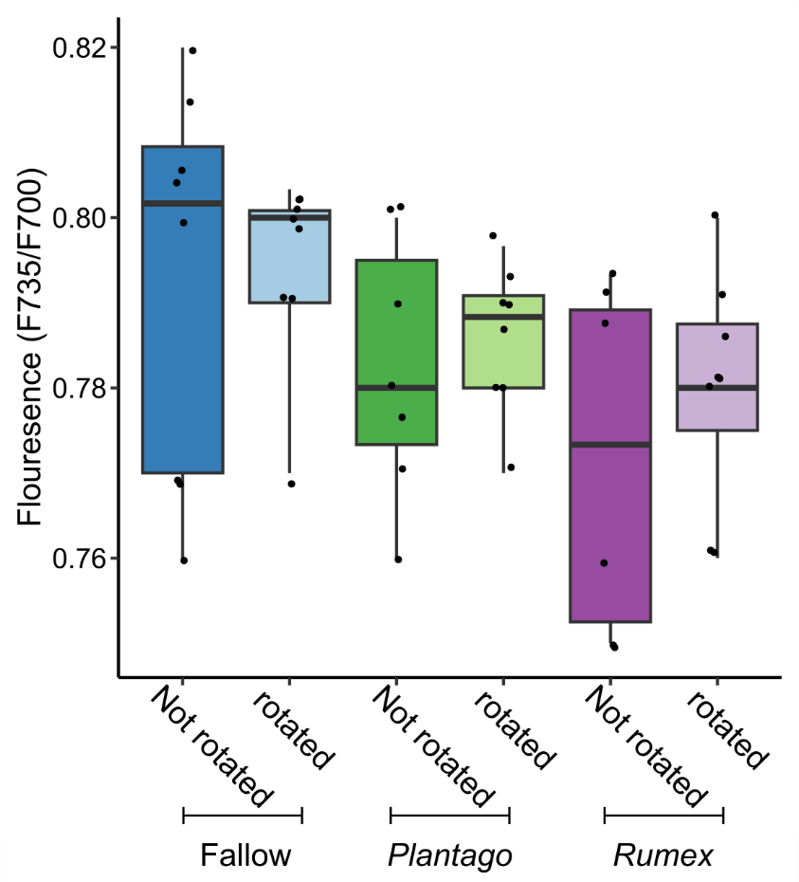
Fig. S1 The effect of plant radial community and the rotation of an in-growth core on the chlorophyll fluorescence of Plantago lanceolata.

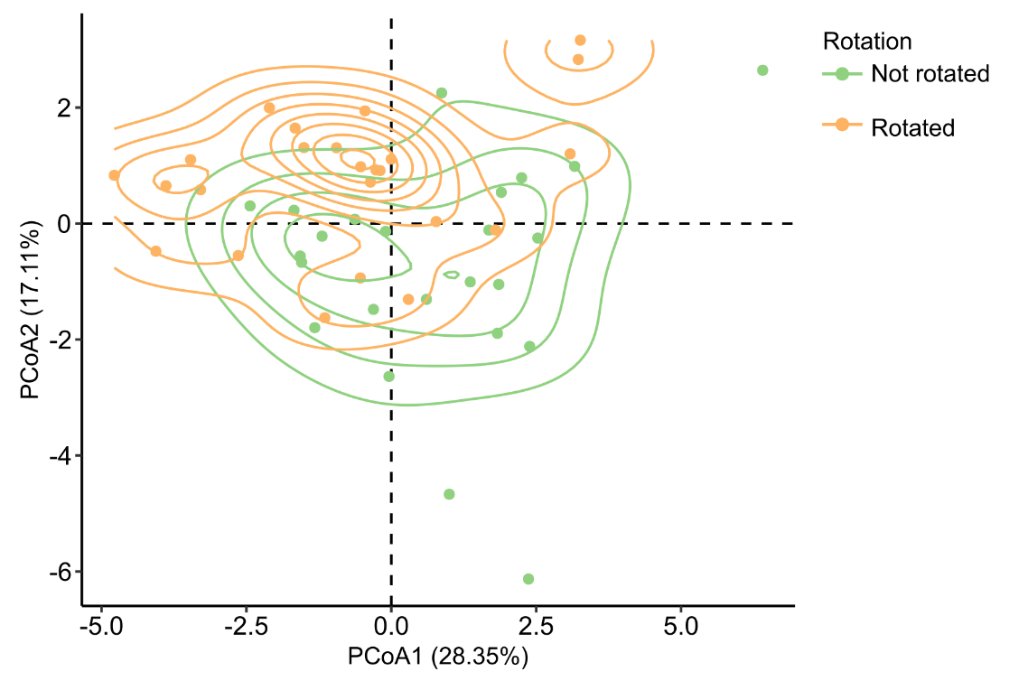
Fig S2 A plot of principal coordinate analysis of Euclidean distance between elemental composition of the leaves of Plantago lanceolata. Points are coloured by the effect of the rotation of the in-growth core. Contour lines represent two-dimensional kernel density showing an estimation of probability density. Box plots on the x and y axis show the primary and secondary axis scores between treatments.

Table S1 The effect of radial plant community (radial) and core rotation (rotation) on the total amount of carbon exudated and gross ecosystem exchange (GEE) per gram of dry biomass of Plantago lanceolata.

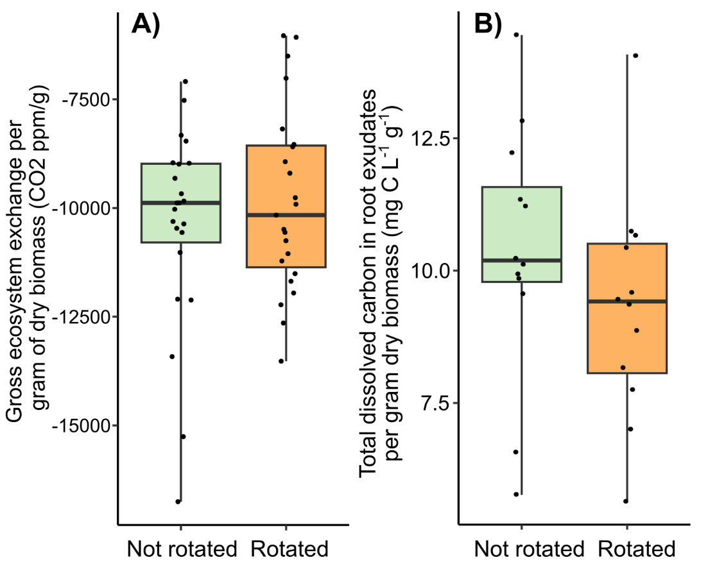
Fig. S3 The effect of the rotation of an in-growth core on A) net ecosystem exchange and B) total carbon in root exudates per gram of dry biomass of Plantago lanceolata. Boxplots show the range and interquartile range of each treatment. Dots overlaid show individual data points. Significance between treatments is shown: *** < 0.001, ** < 0.01, and * < 0.05.

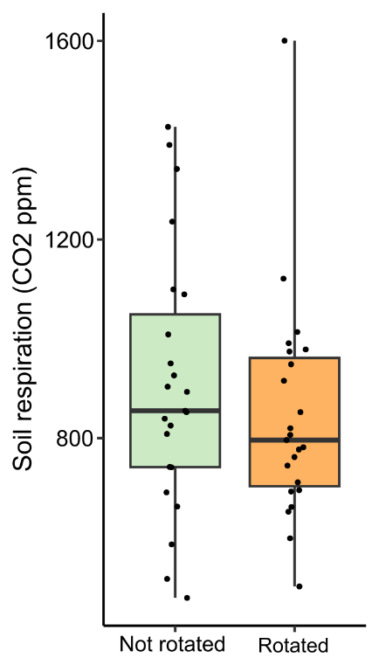

Fig. S4 Impact of in-growth core rotation on soil respiration in Plantago lanceolata mesocosms. Boxplots show the range and interquartile range of each treatment. Dots overlaid show individual data points.

