Supplementary information
Observation of anomalous Hall effect in Mn₃GaN P-wave magnet
Jingyao Wang^{1, 2, #}, Kewen Shi^{1, 2, #,} *, Yuhao Jiang^{1, 2, #}, Ying Sun³, Sihao Deng⁴, Jin Cui¹, Hongde Wang², Wenlong Cai^{1, 2}, Daoqian Zhu^{1, 2}, Guang Yang^{1, 2}, Christoph Sürgers⁵, Weisheng Zhao^{1, 2,} *, Cong Wang ^{1, 2,} *
¹ National Key Lab of Spintronics, International Innovation Institute, Beihang University, Hangzhou, 311115, PR China
² School of Integrated Circuit Science and Engineering, Beihang University, Beijing, 100191, PR China
³School of Physics, Beihang University, Beijing, 100191, PR China
⁴Spallation Neutron Source Science Center, Dongguan, 523803, PR China
⁵Physikalisches Institut, Karlsruhe Institute of Technology, Karlsruhe, 76049, Germany
# These authors contribute equally.
* Corresponding authors: shikewen@buaa.edu.cn; congwang@buaa.edu.cn; weisheng.zhao@buaa.edu.cn

Supplementary Fig. 1 Specular θ-2θ diffraction patterns of different orientations of a, 20 nm-thick and b, 80 nm-thick Mn₃GaN films at room temperature.

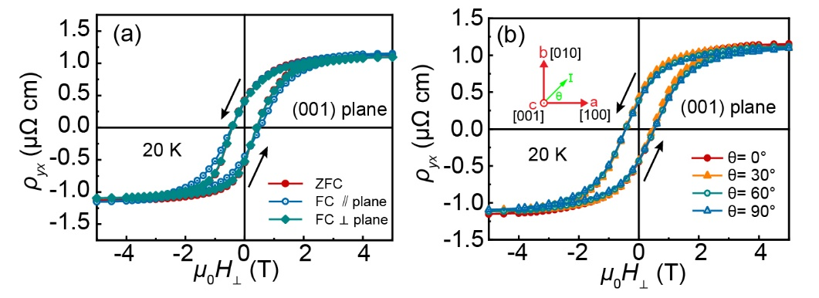
Supplementary Fig. 2 a, Anomalous Hall resistivity (ρ_{yx}) loops under different cooling conditions: zero-field cooling (ZFC), field cooling (FC) parallel and normal to the film plane, respectively. b, ρ_{yx} loops for (001)-oriented films with the current applied along different in-plane crystallographic directions.

Supplementary Fig. 3 Anomalous Hall resistivity (ρ_{yx)} loops of 40 nm-thin a, (011)-oriented and b, (111)-oriented Mn₃GaN films at various temperatures.
Supplementary Fig. 4 Anomalous Hall resistivity (ρ_{yx)} loops of (001)-oriented a, 20 nm-thin and b, 80 nm-thin Mn₃GaN films at various temperatures.

Supplementary Fig. 5 Magnetization dependence of ρ_{yx} for a, different orientations of Mn₃GaN films at 20K and b, (111)-oriented Mn₃GaN films at various temperatures.

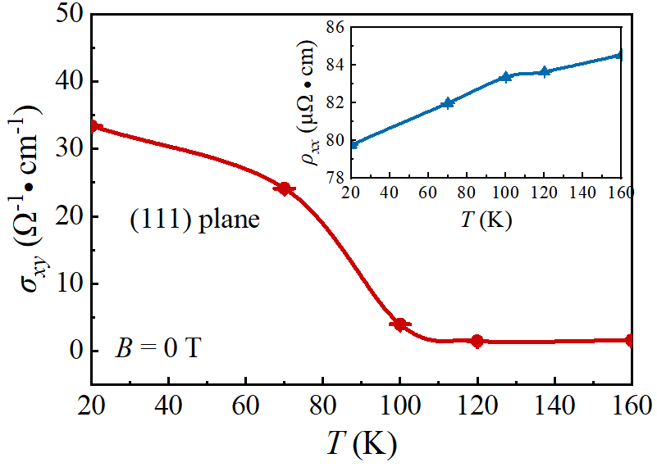
Supplementary Fig. 6 Temperature dependence of the anomalous Hall conductivity σ_{xy} at magnetic field B = 0 T of 40 nm-thin (111)-oriented Mn₃GaN films. The inset graph presents the temperature dependence of the zero-field resistivity ρ_{xx}.

