CD34 is a target for covalent EGFR inhibitors to eliminate stem/progenitor cells in acute and chronic myeloid leukemia

Li Xia^{1*}, Li-Xue Yang^{1*}, Hong-Chen Liu^{2*}, Yue Jiang ^{2*}, Zhi-Jie Kang², Cheng-Tao Zhang¹, Bei-Bei Gao², Xue-Hong Zhang², Edmund K. Waller^{3#}, Jin-Song Yan^{2#}, Ying Lu^{1,2, #}

Supplementary Figures
Supplementary Figure 1. Lack of EGFR expression in primary CD34⁺ cells.
a, EGFR expression was measured by western blot using antibodies against EGFR or Y1068-phosphorylated EGFR in purified primary CD34⁺ AML cells b,c, Immunofluorescent staining of EGFR in primary CD34⁺ AML and CML cells(b) and flow cytometry analysis using antibodies against EGFR or Y1068-phosphorylated EGFR in primary CD34⁺ AML cells(c).

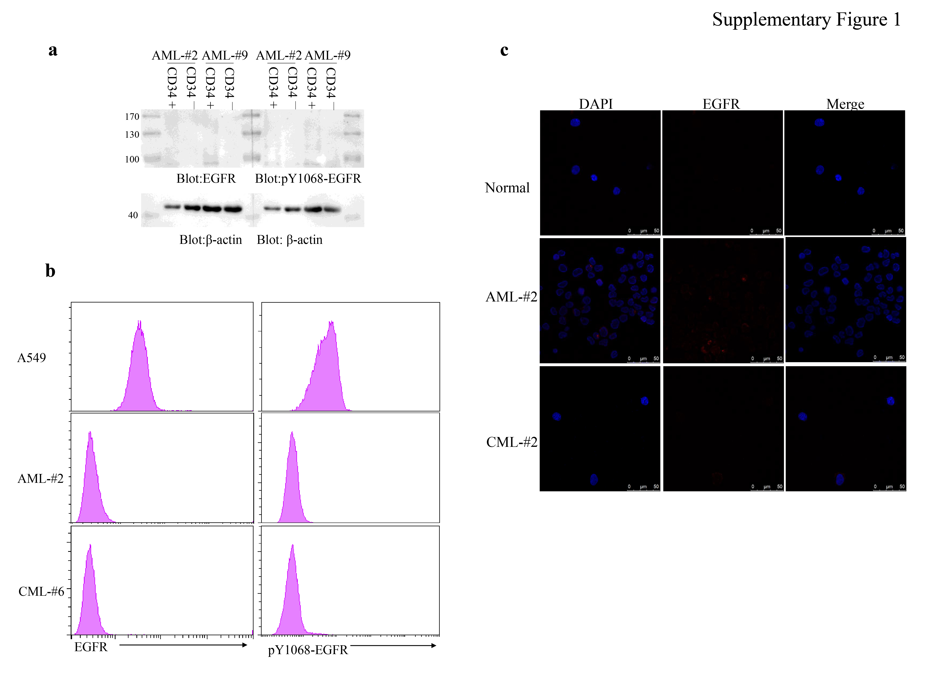

Supplementary Figure 2. Identification of Y329-phosphorylated CD34 peptide. a,b, MS spectrum and MS/MS spectrum of CD34 peptide containing non-phosphorylated Y329(A) and phosphorylated Y329(b). c, The extracted ion chromatogram (XIC) of the monoisotopic parent ion of CD34 peptide containing Y329.
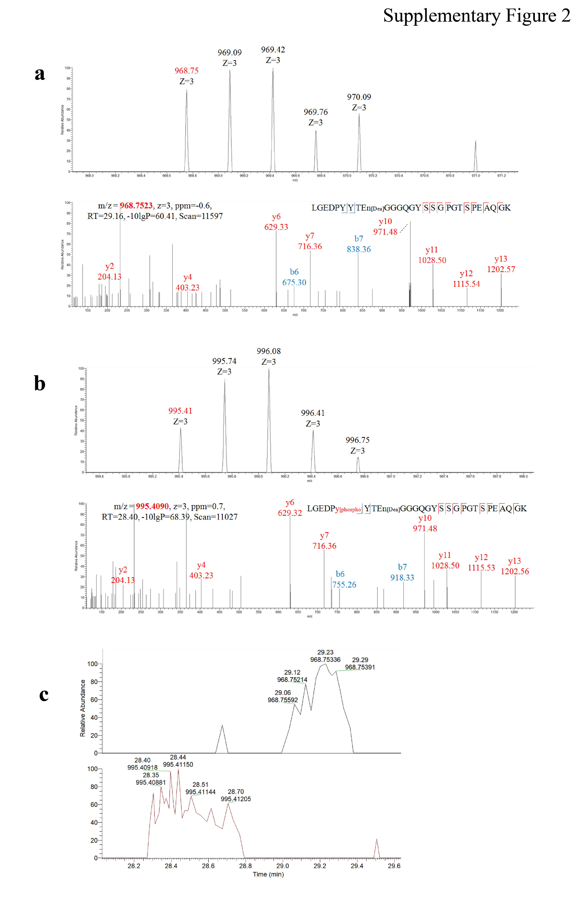
Supplementary Figure 3. PRM-MS analysis of Y329-phosphorylation in KG-1 cells. Intensity histogram of non-phosphorylated (a) and phosphorylated(b) Y329-containing peptide of CD34 protein quantified by PRM-MS assays in osimertinib treated or untreated CD34⁺ cells.
a b
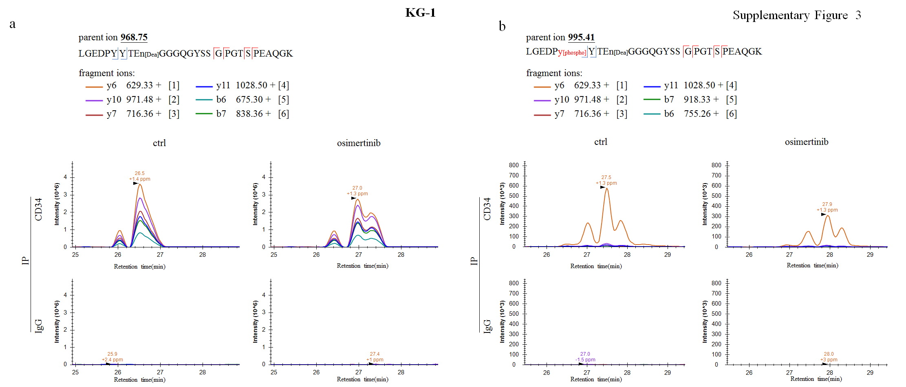

Supplementary Figure 4. PRM-MS analysis of Y329-phosphorylation in Kasumi-1 cells. Intensity histogram of non-phosphorylated (a) and phosphorylated(b) Y329-containing peptide of CD34 protein quantified by PRM-MS assays in osimertinib treated or untreated CD34⁺ cells.
a b
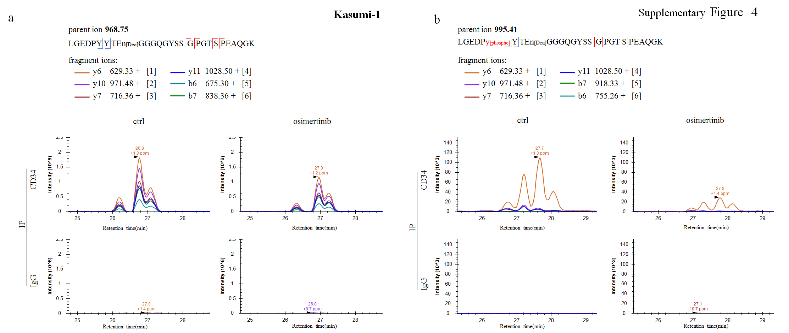

Supplementary Figure 5. PRM-MS analysis of Y329-phosphorylation in CD34⁺ cells purified from AML-#9. Intensity histogram of non-phosphorylated (a) and phosphorylated(b) Y329-containing peptide of CD34 protein quantified by PRM-MS assays in osimertinib treated or untreated CD34⁺ cells.
a b
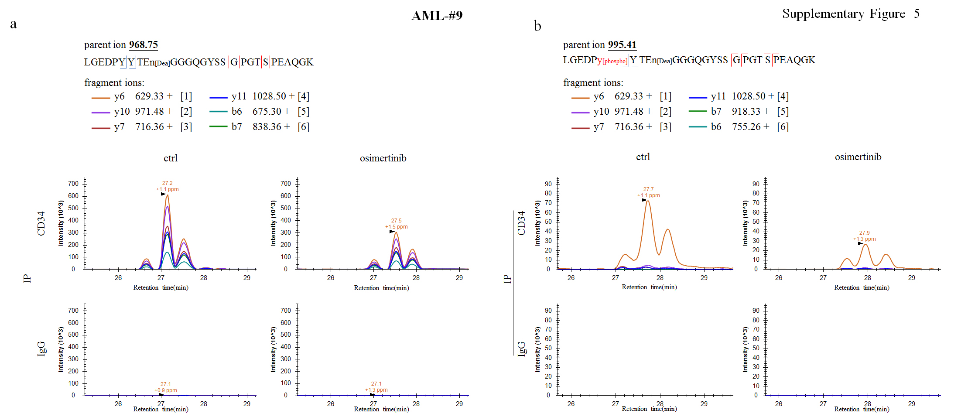

Supplementary Figure 6. PRM-MS analysis of Y329-phosphorylation in CD34⁺ cells purified from AML-#10. Intensity histogram of non-phosphorylated (a) and phosphorylated(b) Y329-containing peptide of CD34 protein quantified by PRM-MS assays in osimertinib treated or untreated CD34⁺ cells.
a b
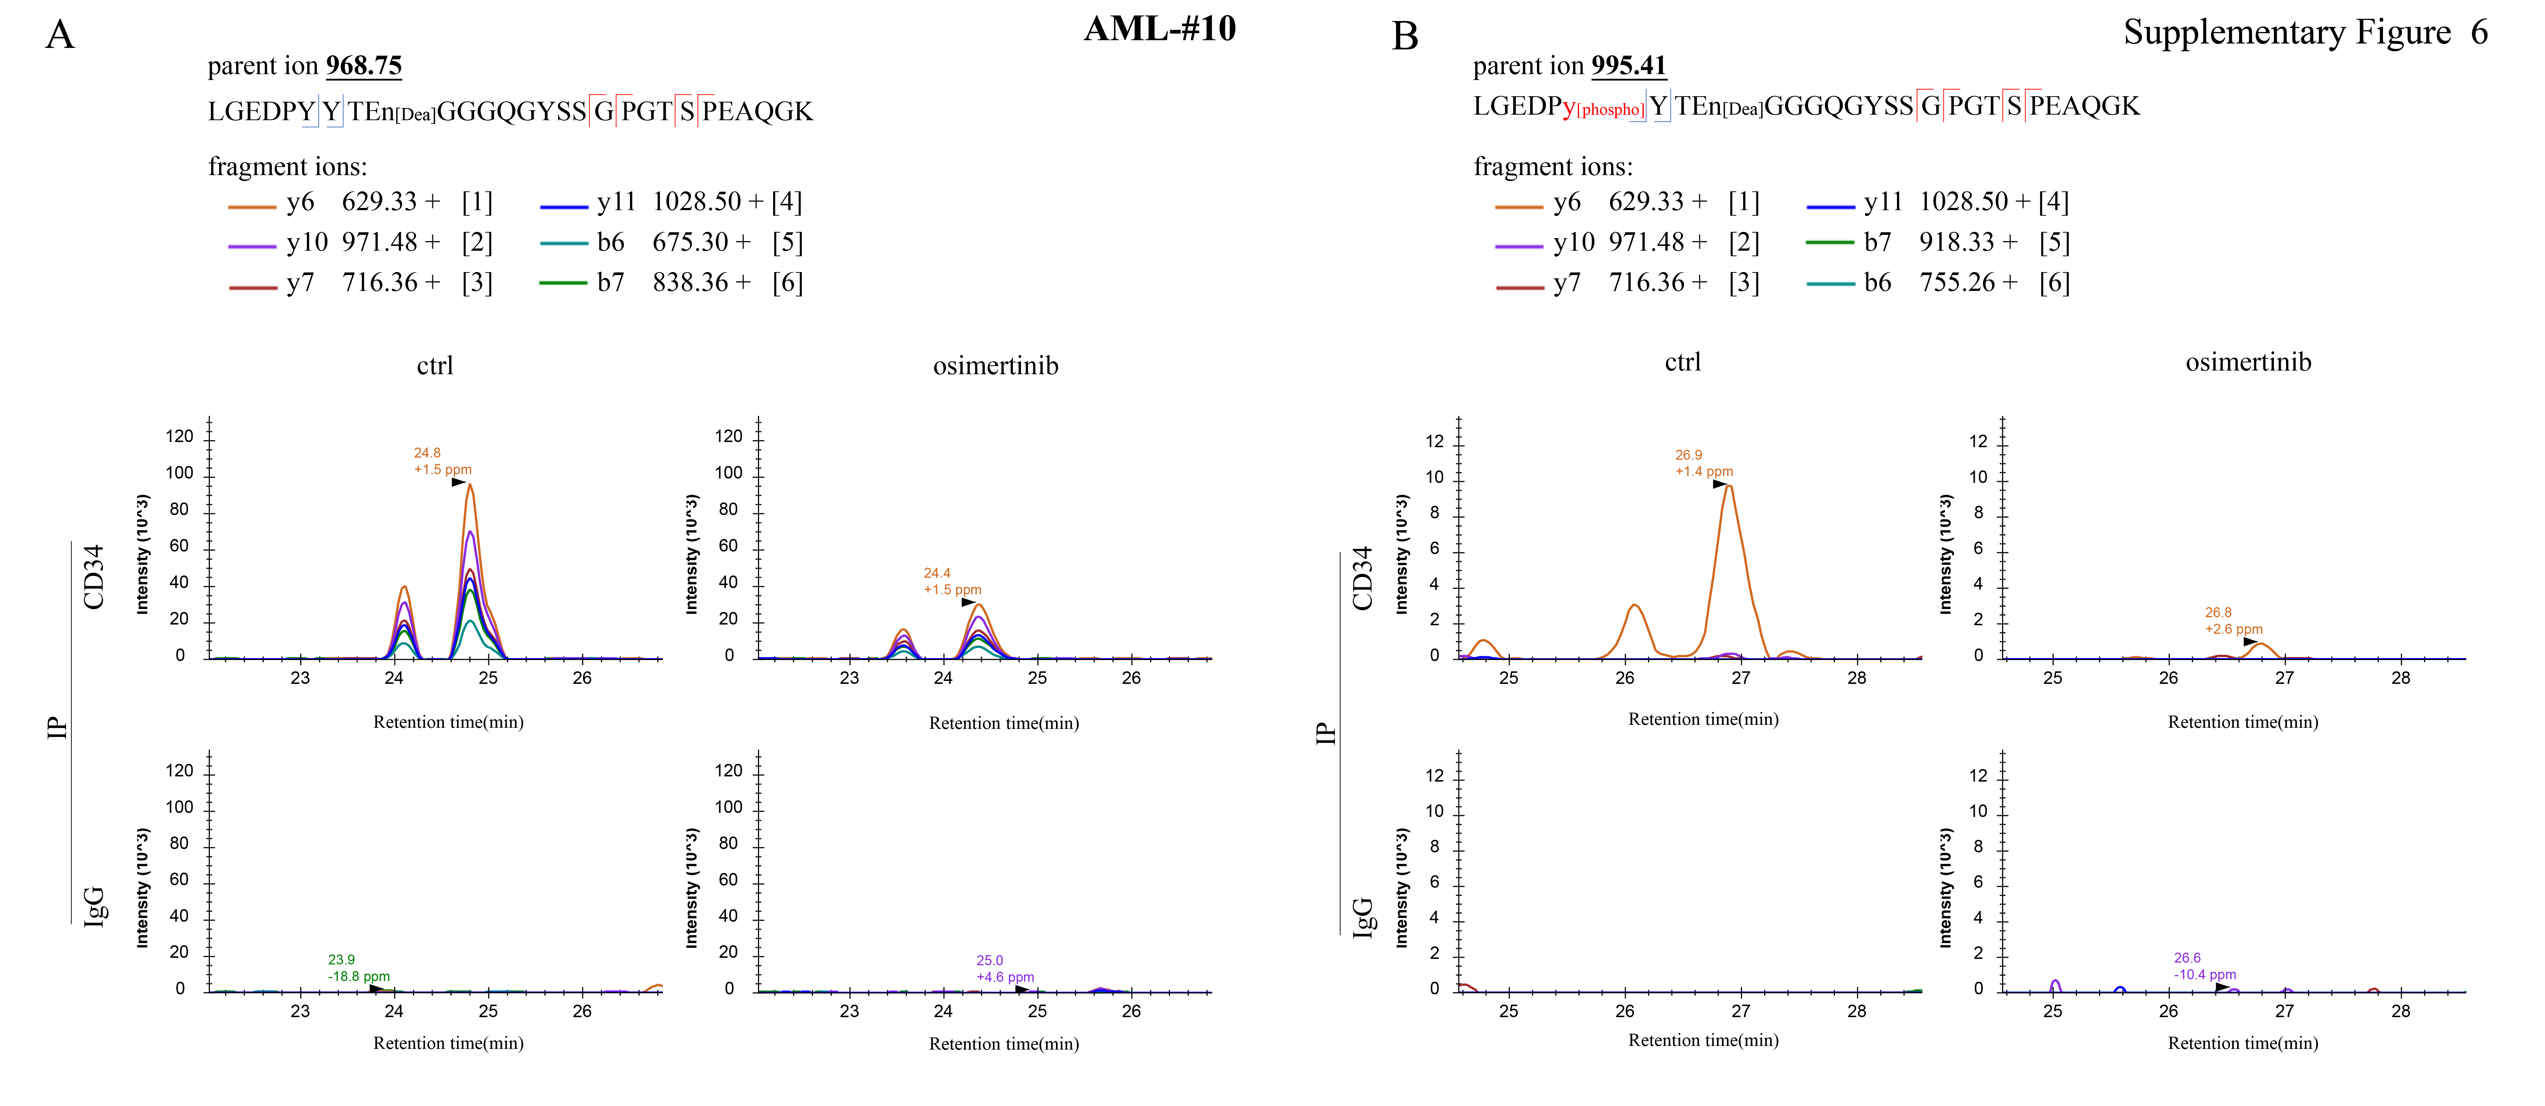

Supplementary Figure 7. PRM-MS analysis of Y329-phosphorylation in CD34⁺ cells purified from AML-#11. Intensity histogram of non-phosphorylated (a) and phosphorylated(b) Y329-containing peptide of CD34 protein quantified by PRM-MS assays in osimertinib treated or untreated CD34⁺ cells.
a b
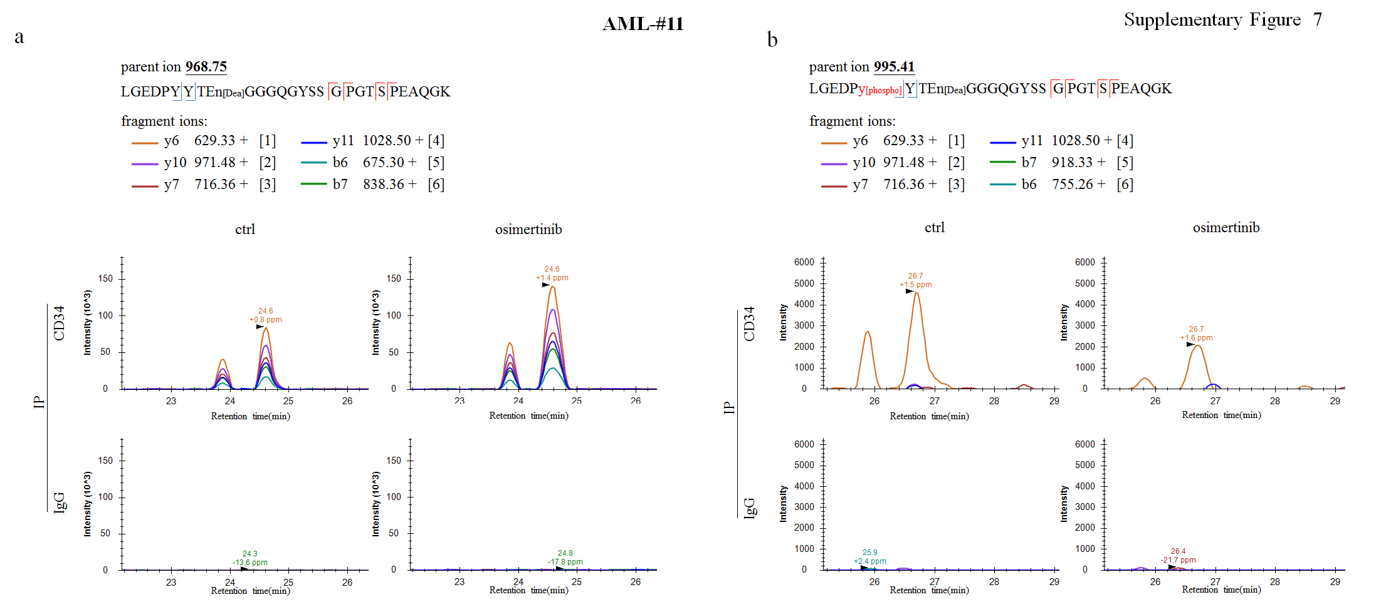

Supplementary Figure 8. PRM-MS analysis of Y329-phosphorylation in CD34⁺ cells purified from AML-#12. Intensity histogram of non-phosphorylated (a) and phosphorylated(b) Y329-containing peptide of CD34 protein quantified by PRM-MS assays in osimertinib treated or untreated CD34⁺ cells.
a b
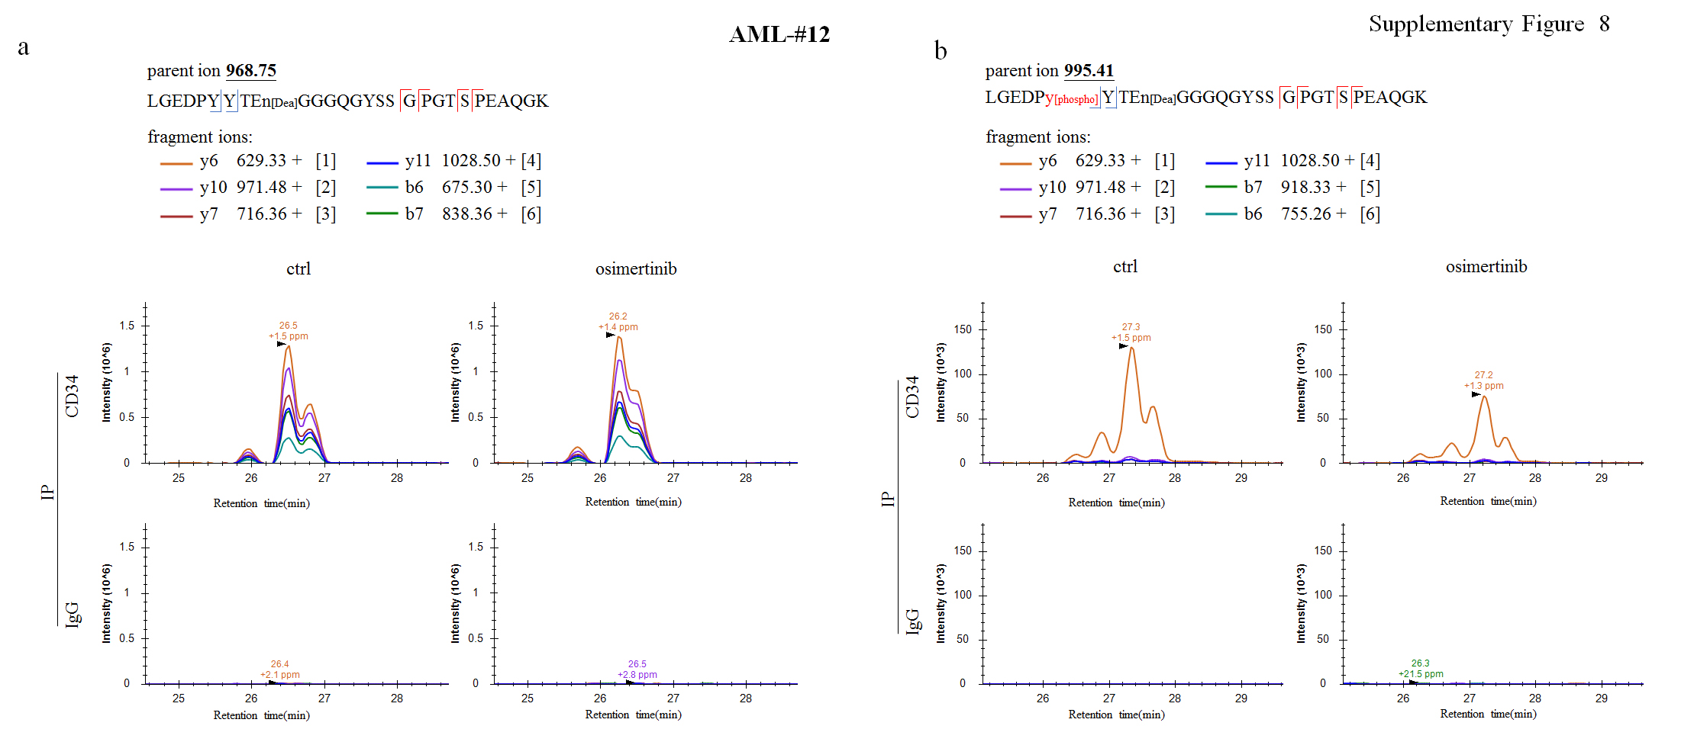

Supplementary Figure 9. Level of Y329-phosphorylation of CD34 measured by Western blots. Kasumi-1, KG-1 cells and the CD34⁺ cells purified from AML individuals were treated with 2µM osimertinib for 48 hours and western blots were conducted using CD34-Y329 antibody.
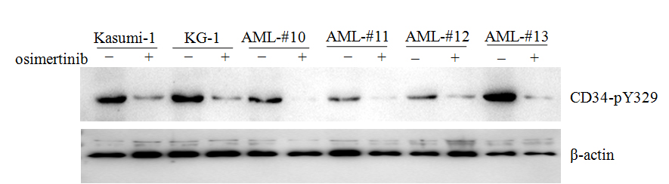

Supplementary Materials and Methods.
Cell culture
Human CD34⁺ cells were enriched from bone marrow mononuclear cells using MiniMACS (Miltenyi Biotech) following the manufacturer’s instructions. Purified CD34⁺ cells were grown in serum-free hematopoietic growth medium (HPGM; Lonza) supplemented with 10 ng/mL recombinant human(rh) TPO, 10 ng/mL rhFLT3 and 50 ng/mL stem cell factor (PeproTech). KG-1 and Kasumi-1 were maintained in RPMI 1640 medium (Sigma-Aldrich), supplemented with 10% or 20% fetal bovine serum (FBS; Gibco BRL).
Plasmids. Human CD34 cDNA was amplified from KG-1 cells by RT-PCR and then cloned into pLV-Neo or psumo3 vectors. To get cysteine 199- mutated CD34 proteins (C199S), plasmids with site-directed mutants were constructed using QuikChangeTM site-directed mutagenesis kit (Stratagene). The plasmids were confirmed a 100% identities match by DNA sequencing.
Purification of Recombinant Proteins. His-tagged WT and mutant CD34 were expressed in bacteria BL21 (DE3) by induction with 0.5mM isopropylthiogalactopyranoside (IPTG) at 30°C and purified from the cytosol of the expressed cells by affinity chromatography on Ni-NTA-agarose (Qiagen).
Western Blots. Protein extracts were equally loaded on 8-10% SDS-polyacrylamide gel, electrophoresed, and transferred to nitrocellulose membrane (Amersham Bioscience). The blots were stained with 0.2% Ponceau S red to ensure equal protein loading. After blocking with 5%(w/v) nonfat milk in PBS, the membranes were incubated with indicated antibodies, followed by horseradish perioxidase (HRP)-linked secondary antibodies (Cell Signaling Technology). Detection was performed by chemiluminescence phototope-HRP kit (Cell Signaling Technology).
Cell counting and apoptosis assays
CD34⁺ cells were seeded at 1×10⁶ cells/ml before treatment and counted by trypan blue (Sigma-Aldrich) exclusion. Apoptosis was quantified by staining with AnnexinV–FITC and PI (BD Biosciences, 556547).
Affinity enrichment of phosphotyrosine peptides
Purified CD34⁺ cells isolated from AML individuals were treated with DMSO or osimertinib for 1 day. After being washed with ice-cold PBS, the cells were lysed with 2% SDS buffer containing 100 mM Tris-Hcl (pH 8.0), followed by being denaturing by 50 mM DTT for 20 min at room temperature (RT) and boiled at 100°C for 5min. The sample was alkylated for 1 hour at RT in the dark by addition of a final concentration of 200 mM iodoacetamide (IAA). Then five volumes of pre-cooled acetone were added to precipitate protein overnight at -20°C. Finally, the protein precipitates were resolved and digested by sequencing grade modified trypsin (Promega) at a protein-to-enzyme of 50:1 at 37°C overnight. Tryptic peptides were lyophilized using a SpeedVac (Thermo Savant), and resuspended in water for lyophilizing for 3 times. The desalted peptides were resuspended in NP40 lysis buffer (50 mM Tris-HCl, pH 7.6; 150 mM NaCl; 1 mM EDTA; 1% NP-40) and incubated overnight with indicated antibodies P-Tyr-100 and PY-99 at 4°C. Then the beads were intensively washed with washing buffer (50 mM Tris-HCl, pH 7.6; 300 mM NaCl; 1 mM EDTA; 0.5% NP-40). The enriched phosphotyrosine peptides were eluted by 0.15% TFA for global phosphotyrosine peptides identification.
Mass spectrometry(MS) analysis
The eluted peptides were lyophilized using a SpeedVac and resuspended in 10μl 1% formic acid/5% acetonitrile. All mass spectrometric experiments are performed on a Orbitrap Fusion LUMOS mass spectrometer (Thermo Fisher Scientific) connected to an Easy-nLC 1200 via an Easy Spray (Thermo Fisher Scientific). The peptides mixture was loaded onto a self-packed analytical PicoFrit column with integrated spray tip (New Objective) (75μm x 20cm length) packed with 130A C18 1.7 μm (waters) and separated within a 60-minute linear gradient from 95% solvent A (0.1% formic acid/2% acetonitrile/98% water) to 28% solvent B (0.1% formic acid/80% acetonitrile) at a flow rate of 300 nl/min at 50°C. The spray voltage was set to 2.1KV and the temperature of ion transfer capillary was 275°C, and RF lens was 40%. The mass spectrometer was operated in positive ion mode and employed in the data-dependent acquisition (DDA) mode within the specialized cycle time (3s) to automatically switch between MS and MS/MS. One full MS scan from 350 to 1500 m/z was acquired at high resolution R=120,000 (defined at m/z=400); MS/MS scans were performed at a resolution of 30,000 with an isolation window of 4 Da and higher energy collisional dissociation (HCD) fragmentation with collision energy of 30% +/- 5. Dynamic exclusion was set to 30s.
MS data processing
All MS/MS ion spectra were analyzed using PEAKS X (Bioinformatics Solutions) for processing, de novo sequencing, database searching and label-free quantification. Resulting sequences were searched against the UniProt Human Proteome database (downloaded 5 May 2018) with mass error tolerances of 10 ppm and 0.02 Da for parent and fragment, respectively, the digestion enzyme semiTrypsin allowed for two missed tryptic cleavages, Carbamidomethyl of cysteine specified as a fixed modification, and Oxidation of methionine, acetyl of the N-terminus and phosphorylation of tyrosine, serine and threonine as variable modifications. FDR estimation was enabled. Peptides were filtered for −10log P ≥ 15, and proteins were filtered for −10log P ≥ 15 and one unique peptide. For all experiments, this gave an FDR of <1% at the peptide-spectrum match level. Proteins sharing significant peptide evidence were grouped. Gene Ontology annotation was performed using DAVID (https://david.ncifcrf.gov/ v.6.8) or STRING (https://string-db.org/ v11.0). Protein-protein interaction network was constructed by STRING.
Parallel reaction monitoring-based targeted MS (PRM-MS) quantification.
PRM-MS assay was performed on the same Orbitrap Fusion LUMOS system with the same liquid chromatography setting as global phosphotyrosine peptides identification. The CD34-phosphotyrosine peptide “LGEDPY[329-Pho] YTEN[Dea]GGGQGYSSGPGTSPEAQGK” and its non-phospho parental peptide “LGEDPYYTEN[Dea]GGGQGYSSGPGTSPEAQGK” identified from previous AML samples were assigned for the PRM assay. The PRM acquisition method was programmed by combining a full MS scan followed by up to 2 PRM scans of precursor ions. One full MS scan from 350 to 1500 m/z was acquired at high resolution with R=120,000 (defined at m/z=400), AGC target of 7 × 10⁵ and maximum injection time of 100 millisecond (ms). The isolated target precursors within a window of 1.7Th were fragmentated at higher energy collisional dissociation (HCD) energy of 30% +/- 5. MS/MS san for the product ions were acquired at high resolution of 60,000 (at m/z 200), AGC target of 1 × 10⁶ and maximum injection time of 300 ms. All raw data were analyzed by Skyline (v.4.2.0.19072) to extract and calculate the transition peak areas, and manually inspected by a single experienced person. All the PRM Data were compared with the DDA data from previous global identification, and some followed criteria should be met: peptides retention time (iRT) within ±5 min, linear regression >0.9, mass difference within ±5 ppm, dot-product (dotp) score ≥ 0.75, and the same pattern of the top 3 most abundant ions. Relative abundance of phosphotyrosine peptide was calculated by normalizing against its non-phosphotyrosine peptide.
Immunofluorescence microscopy
KG-1 and Kasumi-1 cells were harvested and spotted onto slides coated with poly-l-lysine and fixed with 3.7% (w/v) formaldehyde and permeabilized using a 0.25% (w/v) Triton-PBS solution for 15min. Cells were blocked with 5% (w/v) BSA-PBS and stained with primary and secondary antibodies. Cells were concurrently stained with DAPI. Fluorescence signals were detected on a Nikon A1R confocal laser microscope.
CRISPR–Cas9 knockout (KO) cells.
CD34-KO cell lines were generated according to a previously described protocol²⁵. Briefly, the sequences targeting CD34 (F: CACCGGTTTAGTGGGAGATGTTGCA; R: AAACCTGTAATCAGCACAGTGTTCC) were cloned into lentiCRISPR v2 vector (Addgene plasmid no. 52961). The sequences targeting EGFP (EGFP-cas9-F: CAC CGGGGCGAGGAGCTGTTCACCG; EGFP-cas9-R: AAACCGGTGAACAGCTCC TCGCCCC) were used as negative control. The lentiCRISPR v2 vector containing sgRNA, psPAX2, and pMD2G were transfected using Lipofectamine 2000 (Thermo Fisher Scientific) into HEK293T cells. Supernatant were harvested 48 hours after transfection and infected the indicated leukemia cells using polybrene (Sigma-Aldrich). The infected cells were selected in medium containing puromycin (Sigma-Aldrich), and single-cell clones were selected and were evaluated by western blot.
Immunoprecipitation (IP) assay
Cell fraction or whole-cell extracts were prepared in 300 μl of lysis buffer and incubated overnight with indicated antibodies (including anti-CD34 or anti-Src) and protein A/G plus-agarose (Santa Cruz Biotechnology) at 4 °C. After IP, the beads were intensively washed with washing buffer (50 mM Tris-HCl, pH 7.6; 300 mM NaCl; 1 mM EDTA; 0.5% Nonidet P-40; 10% glycerol). Then the precipitates were analyzed by Western blot or MS.

