Supplementary Information

Plasma and pericardial fluid metabolomic signatures of patients
with ischemic heart disease

Federica De Castro^{1,†}, Chiara Coppola^{2,†}, Egeria Scoditti³, Giuseppe Santarpino^{4,5,6}, Stefania Marazia⁷, Michele Maffia^{8,9*}, Francesco Paolo Fanizzi^{1,*}

¹Department of Biological and Environmental Sciences and Technologies (DiSTeBA), University of Salento,
Via Monteroni, Lecce, Italy
²Department of Mathematics and Physics “E. De Giorgi”, University of Salento, Via Lecce—Arnesano, Lecce, Italy
³Institute of Clinical Physiology (IFC), National Research Council (CNR), Lecce, Italy
⁴Department of Cardiac Surgery, Città di Lecce Hospital, GVM Care & Research, Lecce, Italy
⁵Department of Experimental and Clinical Medicine, Magna Graecia University of Catanzaro, Catanzaro, Italy
⁶Department of Cardiac Surgery, Paracelsus Medical University, Nuremberg, Germany
⁷Department of Cardiology, PO Fazzi, ASL_LE, Piazzale Muratore, Lecce, Italy
⁸Department of Experimental Medicine, University of Salento, Lecce, Via Monteroni, Italy
⁹Lab of Clinical Proteomic, PO Fazzi, ASL_LE Piazzale Muratore, Lecce, Italy

† The authors contributed equally
* The authors contributed equally

Table S1. ¹H-NMR chemical shifts (δ in ppm) of low molecular weight plasma and pericardial fluid metabolites

Metabolites | ¹H NMR chemical shift (δ, ppm)
2-hydroxybutyrate | 1.13(d); 2.55(m)
3-hydroxybutyrate | 1.20(d); 2.31(m)
τ-methylhistidine (P) | 7.06 (s); 7.76 (s)
Acetate | 1.92(s)
Acetoacetate | 2.22(s)
Alanine | 1.48(d); 3.78(q)
Citrate | 2.52(d); 2.69(d)
Creatine | 3.04(s); 3.93(s)
Creatine phosphate | 3.05(s); 3.94(s)
Formate | 8.46(s)
Glutamate | 2.10(m); 2.35(m); 3.78(t)
Glutamine | 2.14(m); 2.46(m)*; 3.78(t)
Histidine | 3.14(m); 3.25(m); 3.99(m); 7.09(s); 7.85(s)
Isoleucine | 0.94(t); 1.01(d); 1.26(m); 1.46(m); 1.98(m); 3.67(d)
Lactate | 1.33(d); 4.12(q)
Leucine | 0.96(d); 0.97(d); 1.70(m); 3.75(m)
Lipoproteins (LDL, VLDL)/ lipids | 0.87(t); 0.93(m); 1.25(m); 1.29(m); 5.30-5.35(m)
myo-Inositol | 3.25(t); 3.61(dd); 4.07(t)
NAG | 2.04(s)
Phenylalanine | 3.13(m); 3.28(m); 4.00(m); 7.33(d); 7.38(t); 7.43(m)
Pyruvate | 2.37 (s)
Saccarophine | 3.6 (t), δ 3.5 (t), 2.9 (t), 2.3 (t), 1.95 (dd), 1.78 (m)
Succinate | 2.41(s)
Taurine | 3.25(t); 3.43(t)
Threonine | 1.33(d); 3.59(d); 4.25(m)
Tyrosine | 3.06(m); 3.20(m); 3.94(m); 6.92(d); 7.20(d)
Valine | 0.99(d); 1.04(d); 2.28(m); 3.61(d)
α-Glucose | 3.42(t); 3.54(dd); 3.71(t); 3.74(m); 3.84(m); 5.24(d)
β-Glucose | 3.25(dd); 3.41(t); 3.46(m); 3.49(t); 3.72(dd); 3.90(dd); 4.65(d)
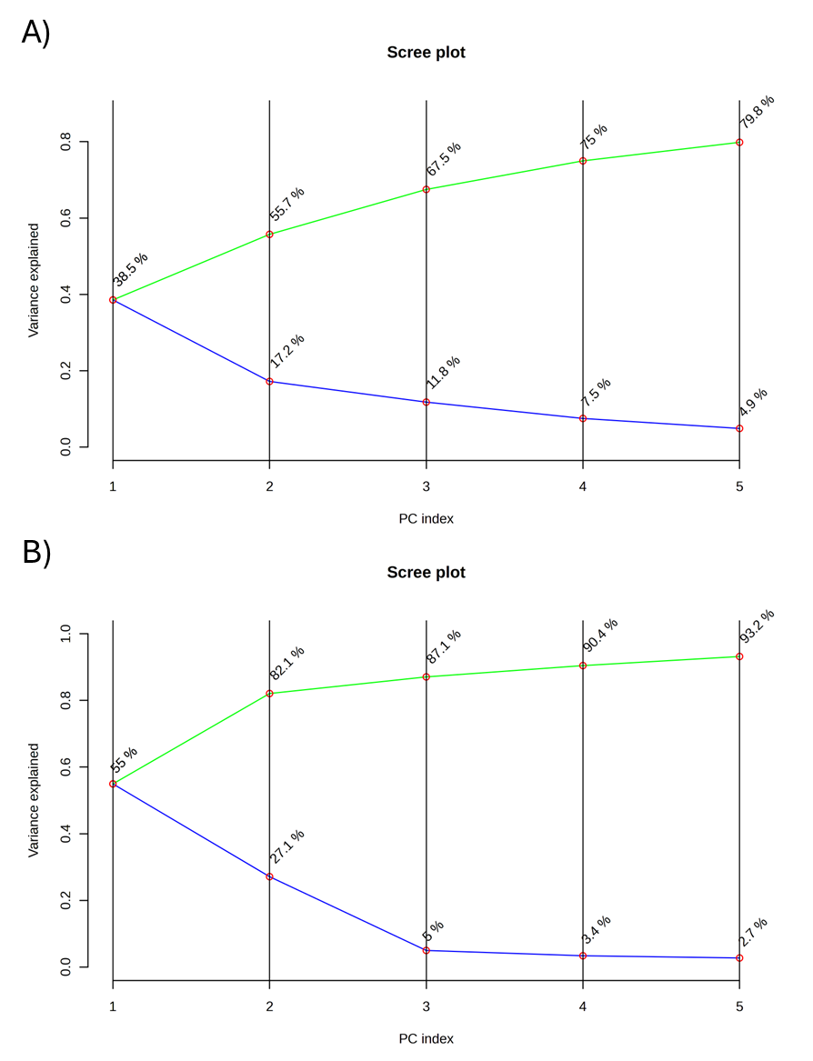

Figure S1. Scree plot showing the percentage of variance explained by each component in the principal component analysis (PCA) model, obtained by comparing patients with ischemic heart disease (IHD) to control subjects.

Table S2. t-test on plasma

Name | p.value | FDR
3-Hydroxybutyrate | 4.8281E-6 | 1.1587E-4
Acetone | 1.1557E-5 | 1.3869E-4
Alanine | 4.4417E-5 | 3.5534E-4
Acetoacetate | 8.9674E-5 | 5.3804E-4
Isoleucine | 3.0783E-4 | 0.0014776
Valine | 3.7878E-4 | 0.0015151
Leucine | 9.7619E-4 | 0.0033469
Tyrosine | 0.0019819 | 0.0059457
Lactate | 0.0024099 | 0.0064265
Phenylalanine | 0.0043551 | 0.010452
Acetate | 0.019859 | 0.043328

Table S3. t-test on pericardial fluid

Name | p.value | FDR
Succinate | 0.001234 | 0.027149
3-hydroxybutyrate | 0.002756 | 0.029261
Acetoacetate | 0.00399 | 0.029261

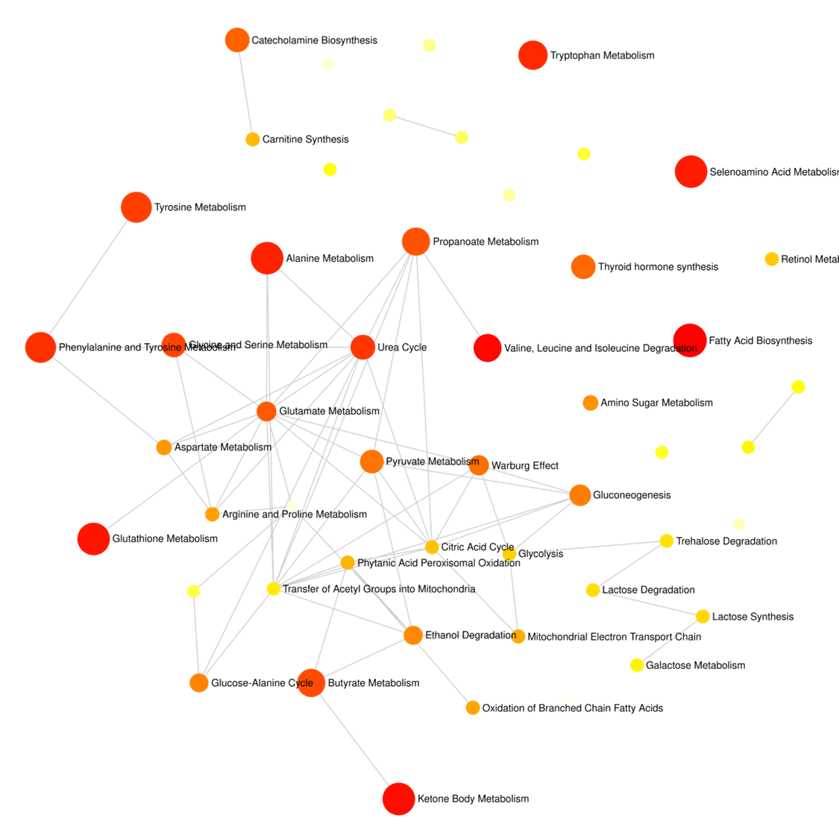
A
B

Figure S2. Metabolic network analysis of the differentiated metabolites. The bubble size refers to the enrichment factor of the pathway and the colour represents the FDR-adjusted P value of pathway significance. A) Plasma; B) Pericardial fluid.

Table 1. Demographic, anthropometric, laboratory and clinical characteristics of IHD and control patients.
Characteristic | Mitral insufficiency (Control, n=10) | IHD (n=10) | p-value³
Age | 57.1 (8.70) | 60,9 (5,74) | 0.4
Sex |  |  | >0.3
F | 2 (20%) | 2 (20%)
M | 8 (80%) | 8 (80%)
BMI, Kg/m² ² | 26.7 (1.34) | 27.50 (1.51) | 0.3
Smokers¹ | 4 (40%) | 3 (30%) | 0.9
Ex-Smokers¹ | 2 (20%) | 2 (20%) | 0.9
Familiarity¹ | 1 (10%) | 5 (50%) | 0.14
Medication¹ | 4 (40%) | 5 (50%) | >0.9
LDL Cholesterol, mg/dl² | 104 (20) | 110 (16) | 0.9
WBC, 10³/µl ² | 8.30 (1.45) | 7.42 (1.48) | 0.4
RBC, 10⁶/µl ² | 4.50 (0.33) | 4.88 (0.61) | 0.072
Hb g/dl ² | 13.22 (1.30) | 14.56 (1.82) | 0.062
Hct ² | 39.0 (3.3) | 42.5 (4.98) | 0.071
PLT, 10³/µl ² | 235 (60) | 202 (70) | 0.5
Fibrinogen, mg/dl ² | 422 (138) | 358 (126) | 0.4
Glucose, mg/dl ² | 91.7 (6.1) | 90.6 (4.7) | >0.9
Creatinine, mg/dl ² | 0.87 (0.18) | 0.84 (0.14) | 0.7
Got-Ast, UI/l ² | 17.4 (4.6) | 21.0 (5.2) | 0.2
Gpt-Alt, UI/l ² | 21 (10) | 21 (8) | 0.9
CPK, UI/l ² | 76 (54) | 107 (44) | 0.2
CPK-MB, UI/l² | 13.7 (6.9) | 13.5 (5.7) | >0.9
BMI: Body Mass Index; LDL: Low-Density Lipoprotein; WBC: White Blood Cell count; RBC: Red Blood Cell count; Hb: Hemoglobin; Hct: Hematocrit; PLT: Platelets; eGFR: Estimated Glomerular Filtration; Got-Ast: Glutamate Oxaloacetate Transaminase-Aspartate Aminotransferase; Gpt-Alt: Glutamate Pyruvate Transaminase-Alanine Aminotransferase; CPK: Creatine Phosphokinase; CPK-MB: Creatine Phosphokinase MB.
¹ n (%).
² Mean (SD).
³ Fisher's exact test; Wilcoxon rank sum test; Wilcoxon rank sum exact test.

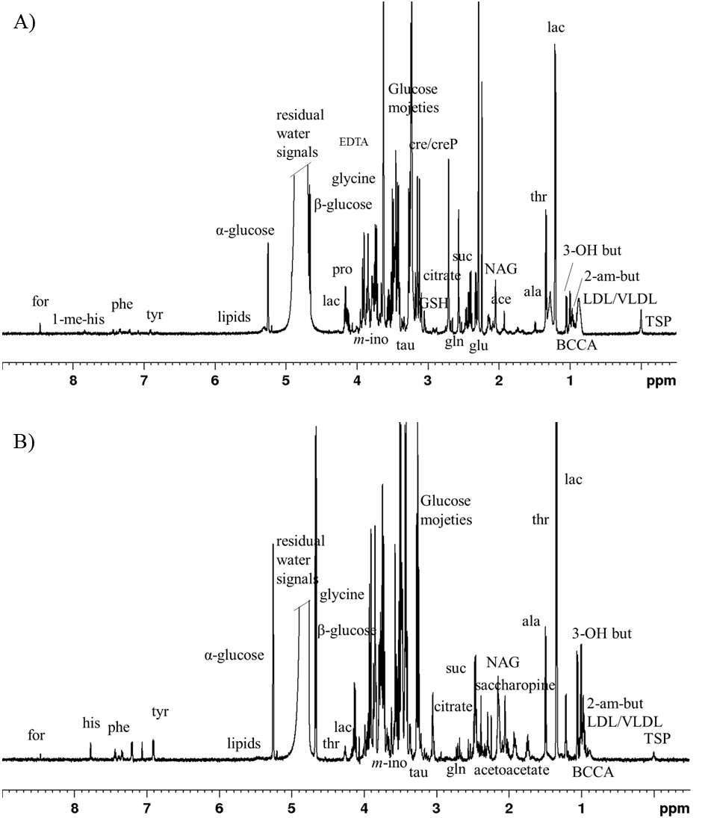
Figure 1. Representative ¹H CPMG NMR spectra of: A) plasma; B) pericardial fluid in IHD patients. From left to right: for =formate, 1-me-his = 1- methyl histidine, his= histidine, phe =phenylalanine, tyr =tyrosine, thr=threonine, lac=lactate, m-ino= myoinositol, tau=taurine, cre/creP= creatine/creatinephosphate, GSH=glutathione, gln= glutamine, suc=succinate, glu= glutamate, , NAG= N-acetylglicoprotein, ace =acetate, ala = alanine, 3-OH-but =3-hydroxybutyrate, BCAA =Branched Chain Amino acids (isoleucine, leucine, valine) 2-am-but =2-aminobutyrate.
Figure 2. Principal component analysis, PCA. A) Plasma, P. Principal component 2 and 3 (PC2 vs PC3) score plot explain the 29% of the total variance of the dataset. B) Pericardial fluid, PF. (PC1 vs PC2) score plot explain the 77.1% of the total variance of the dataset. CTRL = control group.
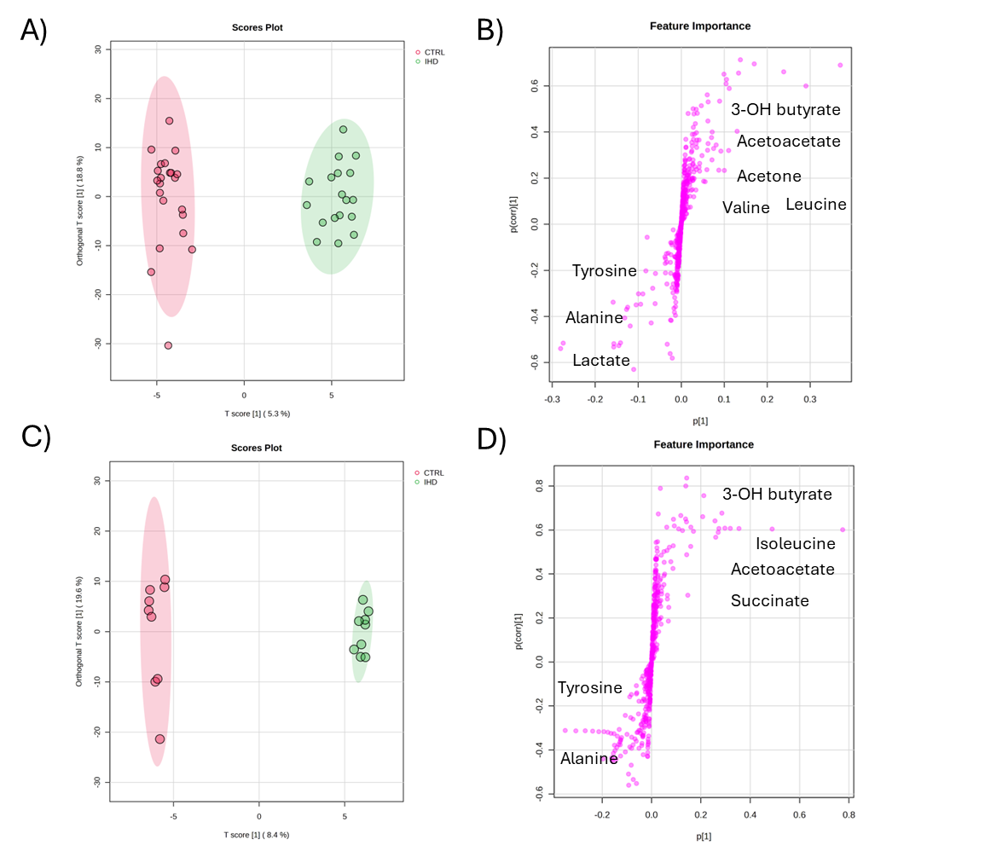
Figure 3. Orthogonal partial least squares discriminant analysis (OPLS-DA) score plots discriminating patients affected with IHD and controls and their corresponding S-line plots for Plasma: panels A and B; Pericardial fluid: panels C and D. Panels B and D: Upper right zone: metabolites that are more abundant in patients with IHD than controls. Lower left zone: metabolites that are more abundant in controls than in patients with IHD.
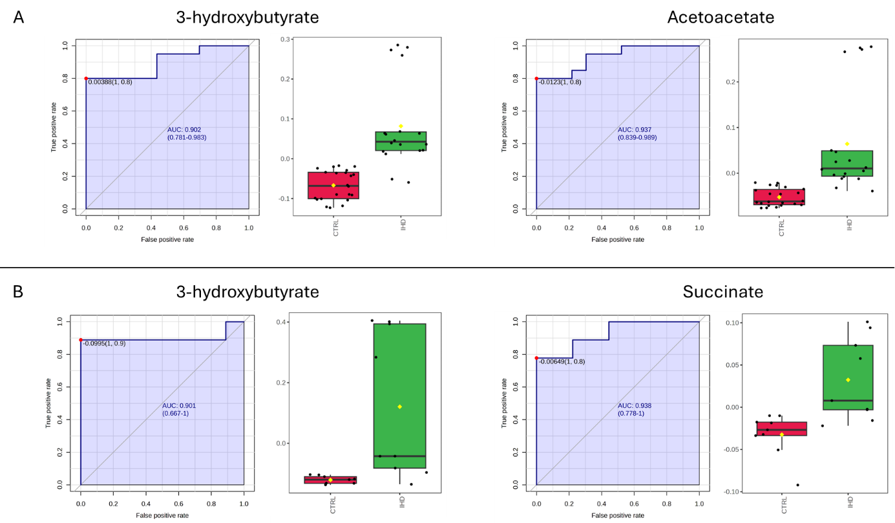

Figure 4. ROC curve analysis for identified biomarkers, and Box and Whiskers plots of their content distribution in the different conditions (control and IHD). A) Plasma; B) Pericardial fluid. CTRL = control.
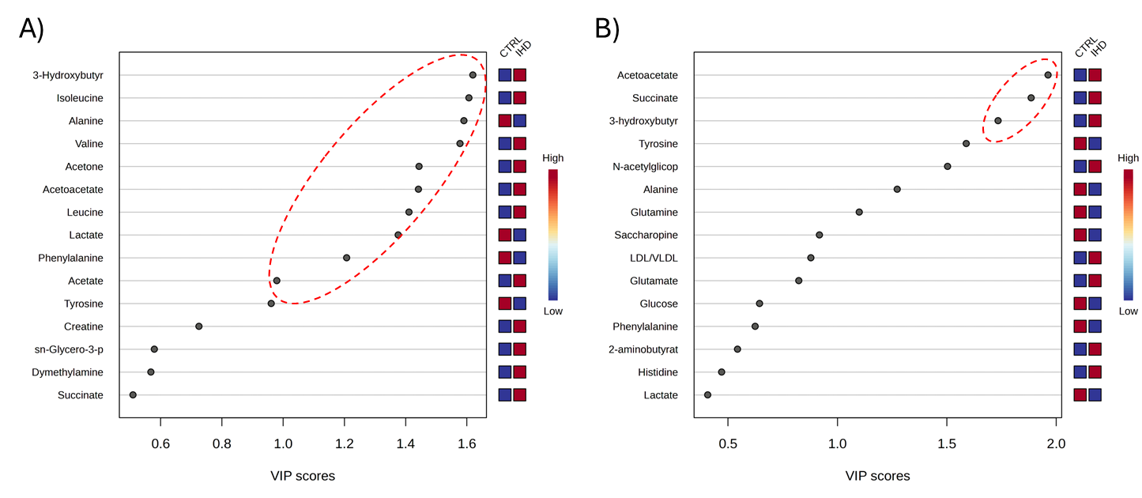

Figure 5. Variable importance in projection (VIP) plot displaying the top 15 most important metabolite features identified by OPLS-DA. A) Plasma; B) Pericardial fluid. Colored boxes on the right indicate relative concentration of corresponding metabolite. Red and blue colours mean higher and lower amount of metabolites, respectively, in control and IHD comparisons.
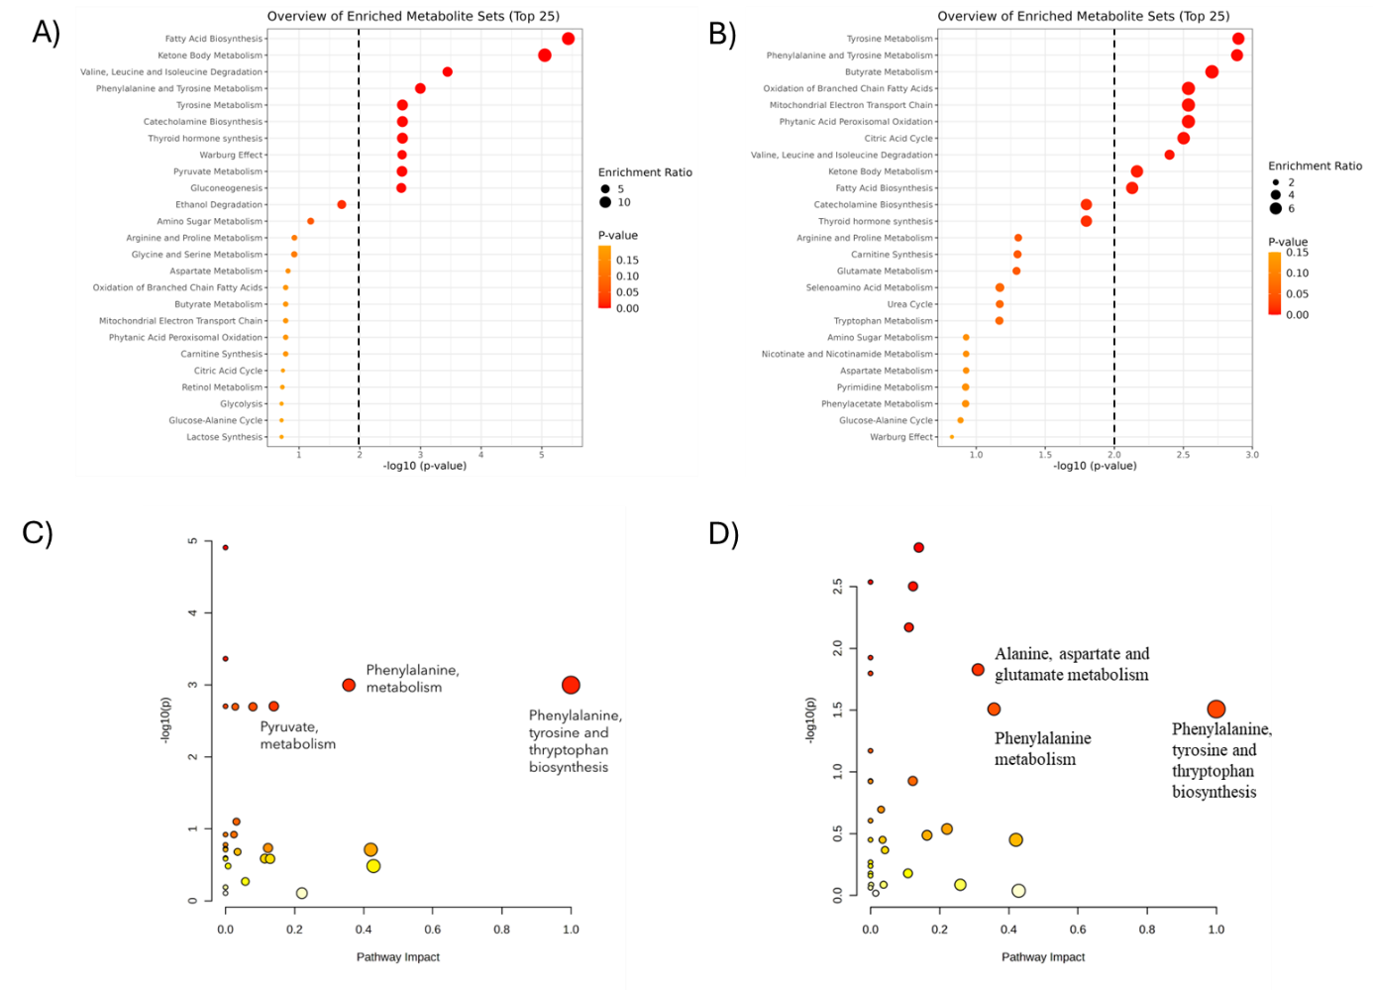
Figure 6. Comprehensive metabolic changes associated with IHD. Top panels: Pathway enrichment analysis of the differentiated metabolites in plasma (A) and pericardial fluid (B). The vertical dotted line represents the cut-off value. Bottom panels: Scatter plot representing the overall enrichment of metabolic pathways from metabolomic pathway analysis in plasma (C) and pericardial fluid (D). Colours, varying from yellow to red, mean that the metabolites are in the data with different levels of significance (yellow: p-value < 0.1; light orange: p-value < 0.05; orange: p-value < 0.01; and red: p-value < 0.001). Circle size, varying from small to big, means the impact of metabolites in data on the pathway alteration (small circle−low impact and large circle−high impact).

