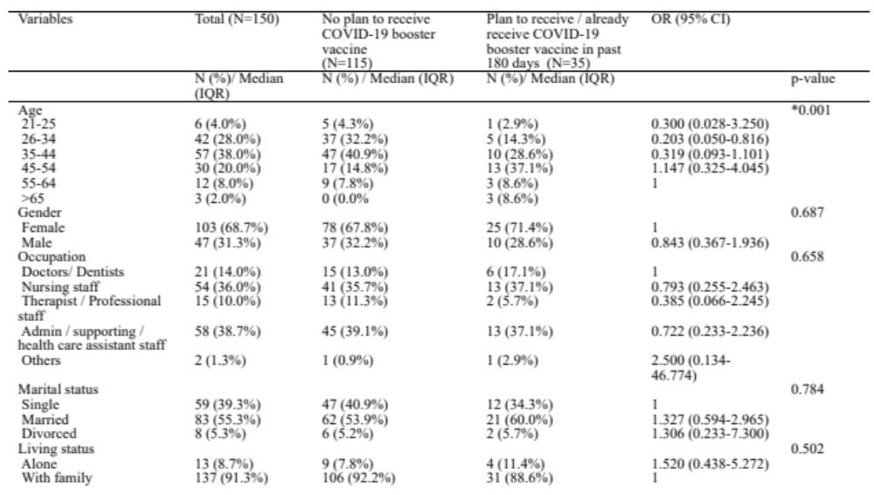
N: Number, OR: Odd Ratio, IQR: interquartile range, CI: Confidence Interval
Table 1 Demographics and vaccine acceptance characteristics
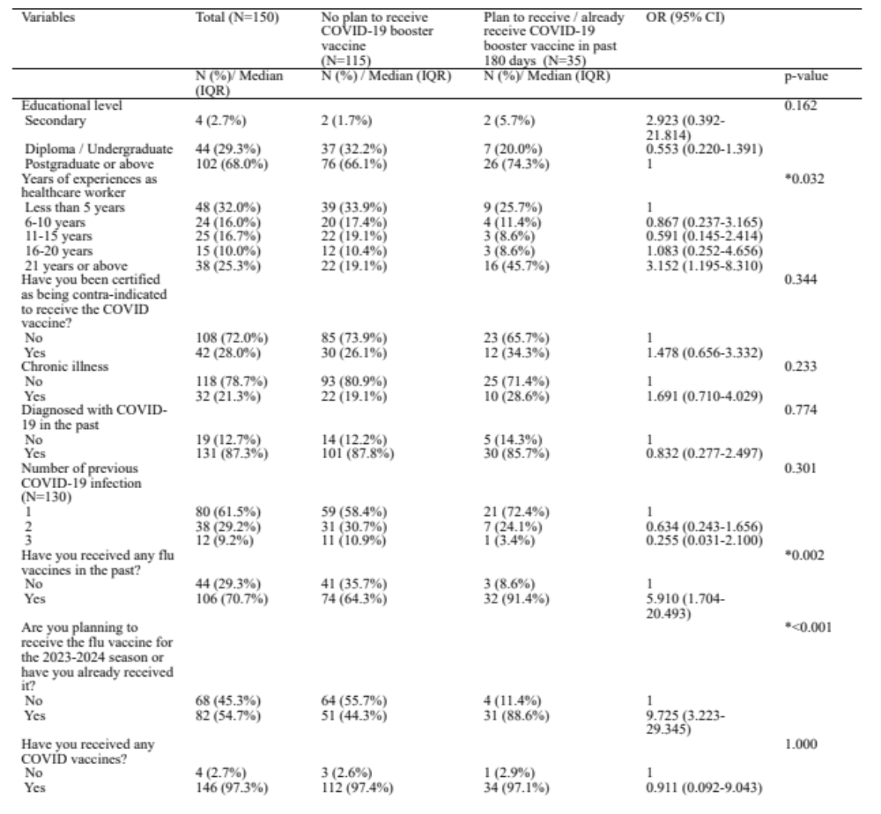
N: Number, OR: Odd Ratio, IQR: interquartile range, CI: Confidence Interval
Table 2 Factors associated with booster vaccine acceptance

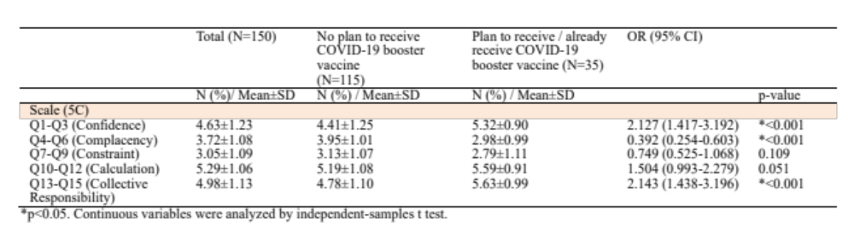

N: number, SD: Standard Deviation, OR: Odd-ratio

Table 3 5C mean score between vaccine acceptance and hesitancy groups

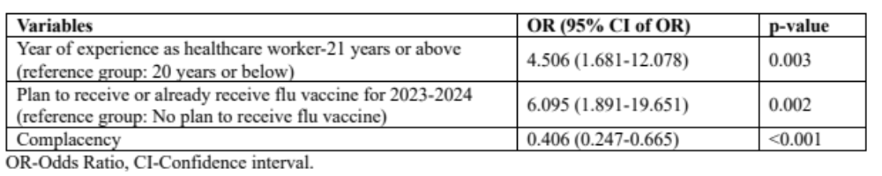
Table 4 Logistic regression model for planning to receive /already received vaccine within 180 days

