Appendix
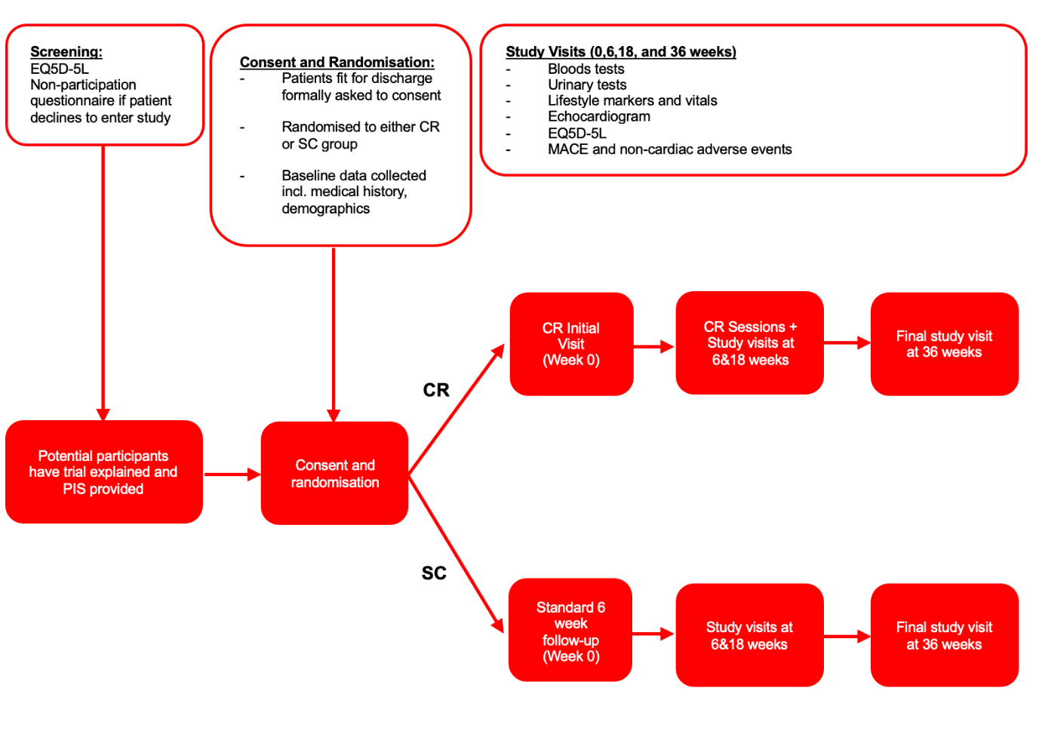

Supplementary Figure 1: Trial structure. PIS – Participant Information Sheet. CR – Cardiac Rehabilitation. SC – Standard Care. MACE – Major Adverse Cardiovascular Events.

Supplementary Figure 2 – Reasons for non-participation in study for participants excluded pre-randomisation.

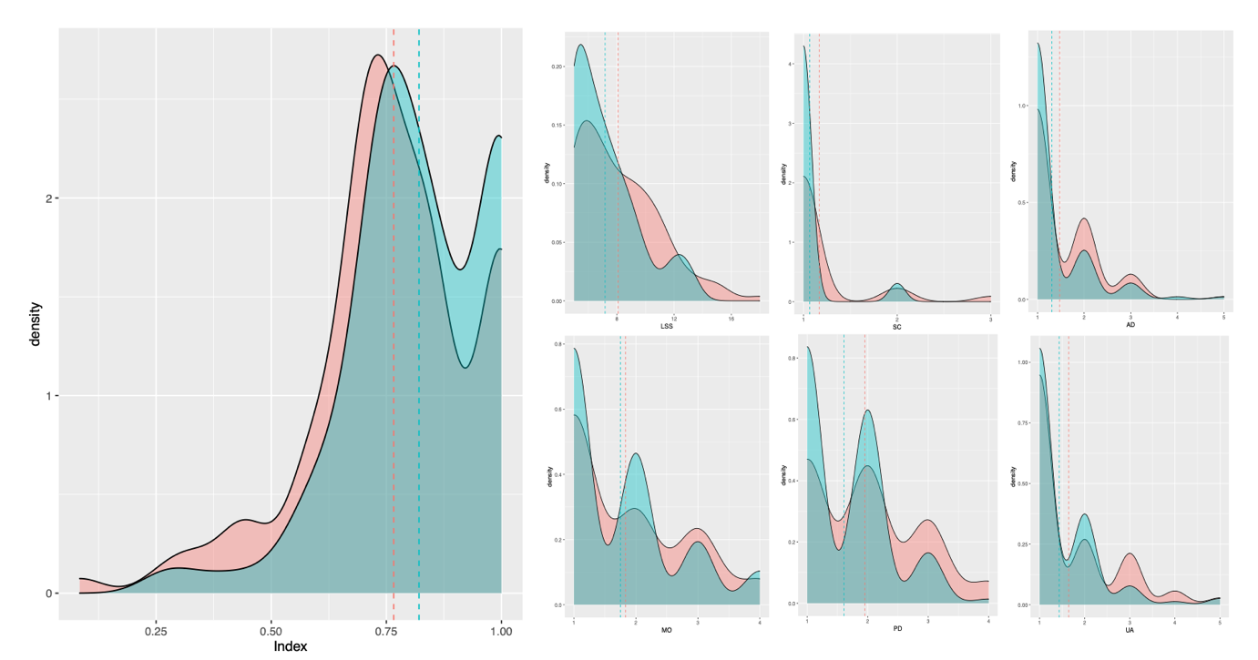
Supplementary Figure 3 – Density plots for CR vs SC across all time points combined: Index, Level Sum Score (LSS), Mobility (MO), Self-Care (SC), Usual Activity (UA), Physical Discomfort (PD) and Anxiety and Depression (AD).
Supplementary Table 1 – Non-cardiac comorbidities
 | Cardiac Rehab  (N=34) | Standard Care  (N=34) | Overall  (N=68)
Other Co-Morbidities
Renal disease | 4 (11.8%) | 8 (23.5%) | 12 (17.6%)
Respiratory disease | 14 (41.2%) | 7 (20.6%) | 21 (30.9%)
Cancer | 4 (11.8%) | 3 (8.8%) | 7 (10.3%)
Hepatic disease | 1 (2.9%) | 1 (2.9%) | 2 (2.9%)
Neurological disease | 1 (2.9%) | 0 (0%) | 1 (1.5%)
GI disease | 8 (23.5%) | 7 (20.6%) | 15 (22.1%)
Psychiatric disease | 1 (2.9%) | 0 (0.0%) | 1 (1.5%)
Genitourinary disease | 6 (17.6%) | 7 (20.6%) | 13 (19.1%)
Rheumatological disease | 2 (5.9%) | 0 (0.0%) | 2 (2.9%)
Dermatological disease | 1 (2.9%) | 0 (0.0%) | 1 (1.5%)
Endocrine disease | 4 (11.8%) | 1 (2.9%) | 5 (7.4%)
Allergy | 3 (8.8%) | 2 (5.9%) | 5 (7.4%)
Haematologic disease | 4 (11.8%) | 2 (5.9%) | 6 (8.8%)
ENT disease | 3 (8.8%) | 1 (2.9%) | 4 (5.9%)
MSK disease | 5 (14.7%) | 4 (11.8%) | 9 (13.2%)
Other disease | 7 (20.6%) | 5 (14.7%) | 12 (17.6%)

Supplementary Table 2 – Medications history. Total 258 medications in CR, and 205 medications in CS group. *multiple medications per patient classed as ‘other’. PPI – Proton Pump Inhibitor. ARB – Angiotensin receptor blockers. ACEi – ACE Inhibitors. CCB – Calcium Channel Blockers.
 | Cardiac Rehab  (N=34) | Standard Care  (N=34) | Overall  (N=68)
Medication Class
Aspirin | 24 (70.6%) | 20 (58.8%) | 44 (64.7%)
Non-aspirin antiplatelet | 7 (20.6%) | 16 (47.1%) | 23 (33.8%)
Anticoagulant | 7 (20.6%) | 7 (20.6%) | 14 (20.6%)
PPI | 13 (38.2%) | 14 (41.2%) | 27 (39.7%)
Inhalers | 9 (26.5%) | 118 (52.9%) | 27 (39.7%)
Analgesics | 12 (35.3%) | 18 (52.9%) | 15 (44.1%)
Diuretic | 5 (14.7%) | 5 (14.7%) | 5 (14.7%)
ARB | 5 (14.7%) | 2 (5.9%) | 7 (10.3%)
ACEi | 15 (44.1%) | 20 (58.8%) | 35 (51.5%)
Statin | 30 (88.2%) | 33 (97.1%) | 63 (92.6%)
CCB | 12 (35.3%) | 9 (26.5%) | 21 (30.9%)
Antiarrhythmic | 2 (5.9%) | 2 (5.9%) | 4 (5.9%)
Beta-blocker | 14 (41.2%) | 12 (35.3%) | 26 (38.2%)
Oral antidiabetic agents | 4 (11.8%) | 4 (11.8%) | 8 (11.8%)
Nitrates | 1 (2.9%) | 3 (8.8%) | 4 (5.9%)
Other* | 45 | 74 | 119

Supplementary Table 3 – Socioeconomic data. Two patients in CR group and 1 patient in SC group refused providing socioeconomic data.
 | Cardiac Rehab  (N=32) | Standard Care  (N=33) | Overall  (N=65)
Highest level of education
None | 8 (25.0%) | 10 (30.3%) | 18 (27.7%)
CSE/NVQ Level 1 (usually aged 12) | 3 (9.4%) | 0 (0.0%) | 3 (4.6%)
GCSE /O Level/NVQ Level 2 (usually aged 15 or 16) | 9 (28.1%) | 9 (27.2%) | 18 (27.7%)
A Level/BTEC/Diploma/NVQ Level 3 | 3 (9.4%) | 6 (18.1%) | 9 (13.8%)
Degree level | 3 (9.4%) | 4 (12.1%) | 7 (10.8%)
Masters degree/Doctorate | 2 (6.3%) | 1 (3.0%) | 3 (4.6%)
Missing | 4 (12.5%) | 3 (9.1%) | 7 (10.8%)
Employment
Paid employment | 4 (12.5%) | 5 (15.1%) | 9 (13.8%)
Retired | 27 (84.3%) | 24 (72.7%) | 51 (78.4%)
Housewife / husband | 0 (0.0%) | 0 (0.0%) | 0 (0.0%)
Unemployed / Student | 0 (0.0%) | 0 (0.0%) | 0 (0.0%)
Missing | 1 (3.1%) | 4 (12.1%) | 5 (7.7%)
Relationship status
Married / civil partnership | 19 (59.4%) | 23 (69.7%) | 42 (64.6%)
Cohabiting | 1 (3.1%) | 4 (12.1%) | 5 (7.7%)
Spouse / partner deceased | 4 (12.5%) | 2 (6.1%) | 6 (9.2%)
Separated | 0 (0.0%) | 0 (0.0%) | 0 (0.0%)
Divorced | 3 (9.4%) | 3 (9.1%) | 6 (9.2%)
Single / non-cohabiting partner | 3 (9.4%) | 0 (0.0%) | 3 (4.6%)
Missing | 2 (6.3%) | 1 (3.0%) | 3 (4.6%)
Accommodation
Owner occupied house/flat | 23 (71.9%) | 28 (84.5%) | 51 (78.4%)
Privately rented house/flat | 0 (0.0%) | 2 (6.1%) | 2 (3.1%)
House/flat rented from housing associated/local authority | 5 (15.7%) | 2 (6.1%) | 7 (10.8%)
Sheltered housing/warden control | 0 (0.0%) | 1 (3.0%) | 1 (1.5%)
Residential home | 0 (0.0%) | 0 (0.0%) | 0 (0.0%)
Nursing home | 0 (0.0%) | 0 (0.0%) | 0 (0.0%)
Other | 1 (3.1%) | 0 (0.0%) | 1 (1.5%)
Missing | 3 (9.4%) | 0 (0.0%) | 3 (4.6%)

Supplementary table 4 – Adverse Events
 | Cardiac Rehab  (N=21) | Standard Care  (N=28) | Overall  (N=49)
Type of Adverse Event
Respiratory | 6 (25.0%) | 2 (7.1%) | 8 (15.4%)
Hepatic | 1 (4.2%) | 0 (0.0%) | 1 (1.9%)
Gastro-intestinal | 1 (4.2%) | 2 (7.1%) | 3 (5.8%)
Genito-urinary/renal | 0 (0.0%) | 2 (7.1%) | 2 (3.8%)
Endocrine | 0 (0.0%) | 0 (0.0%) | 0 (0.0%)
Haematological | 0 (0.0%) | 1 (3.6%) | 1 (1.9%)
Musculo-skeletal | 4 (16.7%) | 8 (28.6%) | 12 (23.1%)
Neurological | 0 (0.0%) | 0 (0.0%) | 0 (0.0%)
Psychological | 0 (0.0%) | 0 (0.0%) | 0 (0.0%)
Immunological | 0 (0.0%) | 0 (0.0%) | 0 (0.0%)
Dermatological | 1 (4.2%) | 0 (0.0%) | 1 (1.9%)
Allergies | 0 (0.0%) | 1 (3.6%) | 1 (1.9%)
Eyes, ear, nose, throat | 0 (0.0%) | 1 (3.6%) | 1 (1.9%)
Cardiovascular | 4 (16.7%) | 7 (25.0%) | 11 (21.5%)
Other | 7 (29.2%) | 4 (14.3%) | 11 (21.5%)
Intensity
Mild | 15 (62.5%) | 13 (46.4%) | 28 (53.8%)
Moderate | 6 (25.0%) | 12 (42.9%) | 18 (34.6%)
Severe | 3 (12.5%) | 3 (10.7%) | 6 (11.5%)

Supplementary Table 5 – Biochemical and haematological risk factors. CR – Cardiac Rehabilitation. SC – Standard Care. HDL – High Density Lipoprotein. LDL – Low Density Lipoprotein. ANOVA test p-values reported.
Marker | Time | CR |  |  |  | SC
 |  | n | Median | Min | Max | n | Median | Min | Max
Urea | 0 | 34 | 6.50 | 4.0 | 11.0 | 32 | 6.65 | 3.3 | 14.2
 | 6 | 27 | 6.40 | 3.4 | 15.0 | 30 | 6.40 | 3.5 | 12.1
 | 18 | 23 | 6.20 | 3.8 | 12.1 | 25 | 6.90 | 2.7 | 12.9
 | 32 | 24 | 6.35 | 3.3 | 13.5 | 24 | 5.75 | 3.0 | 14.8
ANOVA |  | 0.75 |  |  |  | 0.74
Sodium | 0 | 34 | 139 | 132 | 143 | 33 | 139.0 | 131 | 145
 | 6 | 27 | 140 | 133 | 145 | 30 | 139.5 | 133 | 144
 | 18 | 25 | 140 | 134 | 146 | 25 | 140.0 | 136 | 143
 | 32 | 24 | 140 | 132 | 145 | 27 | 140.0 | 133 | 149
ANOVA |  | 0.075 |  |  |  | 0.49
Potassium | 0 | 34 | 4.4 | 3.7 | 5.1 | 31 | 4.30 | 3.6 | 5.5
 | 6 | 27 | 4.4 | 3.7 | 6.2 | 30 | 4.45 | 3.8 | 5.1
 | 18 | 25 | 4.4 | 3.6 | 5.4 | 25 | 4.40 | 3.7 | 5.5
 | 32 | 24 | 4.4 | 3.6 | 5.2 | 27 | 4.50 | 3.9 | 5.1
ANOVA |  | 0.76 |  |  |  | 0.59
Creatinine | 0 | 34 | 84.5 | 56 | 160 | 33 | 83.0 | 53 | 205
 | 6 | 27 | 89.0 | 48 | 217 | 30 | 89.5 | 57 | 167
 | 18 | 25 | 89.0 | 64 | 204 | 25 | 94.0 | 76 | 183
 | 32 | 24 | 100.0 | 65 | 185 | 27 | 88.0 | 41 | 165
ANOVA |  | 0.33 |  |  |  | 0.51
Homocysteine | 6 | 23 | 19 | 8 | 29 | 21 | 25 | 14 | 43
 | 18 | 17 | 19 | 7 | 27 | 19 | 22 | 13 | 97
 | 32 | 9 | 15 | 11 | 24 | 13 | 22 | 14 | 87
ANOVA |  | 0.72 |  |  |  | 0.7
Troponin | 0 | 3 | 17 | 17 | 17 | 1 | 17.0 | 17 | 17
 | 6 | 25 | 18 | 6 | 40 | 29 | 17.0 | 5 | 39
 | 18 | 23 | 17 | 4 | 67 | 26 | 20.0 | 3 | 90
 | 32 | 23 | 16 | 6 | 48 | 26 | 17.5 | 5 | 58
ANOVA |  | 0.8 |  |  |  | 0.66
hsCRP | 6 | 25 | 3.4 | 0.2 | 22.9 | 27 | 6.00 | 0.5 | 29.6
 | 18 | 24 | 2.3 | 0.2 | 21.5 | 25 | 4.50 | 0.4 | 47.4
 | 32 | 23 | 3.2 | 0.4 | 12.6 | 22 | 3.45 | 0.5 | 12.2
ANOVA |  | 0.24 |  |  |  | 0.18
BNP | 6 | 27 | 152.0 | 13 | 1971 | 24 | 153.5 | 3 | 3447
 | 18 | 22 | 119.5 | 15 | 807 | 27 | 157.0 | 13 | 3090
 | 32 | 21 | 156.0 | 30 | 1467 | 24 | 170.0 | 13 | 2299
ANOVA |  | 0.49 |  |  |  | 0.88
Fibrinogen | 0 | 12 | 3.80 | 2.2 | 6.4 | 18 | 3.45 | 1.9 | 4.8
 | 6 | 23 | 3.40 | 2.6 | 5.8 | 29 | 3.60 | 2.5 | 5.7
 | 18 | 21 | 3.40 | 2.2 | 4.8 | 25 | 3.60 | 2.5 | 4.8
 | 32 | 24 | 3.65 | 2.1 | 5.6 | 26 | 3.50 | 2.5 | 6.6
ANOVA |  | 0.66 |  |  |  | 0.74
HbA1C | 0 | 15 | 38.0 | 33.0 | 50 | 15 | 38.0 | 34.0 | 47
 | 6 | 23 | 37.0 | 27.0 | 50 | 28 | 38.5 | 5.3 | 50
 | 18 | 23 | 39.0 | 22.6 | 52 | 25 | 41.0 | 32.0 | 53
 | 32 | 22 | 38.5 | 23.0 | 52 | 22 | 39.5 | 32.0 | 52
ANOVA |  | 0.78 |  |  |  | 0.39
Total lipids | 0 | 13 | 4.10 | 3.1 | 6.0 | 15 | 3.90 | 2.3 | 8.2
 | 6 | 17 | 3.80 | 2.6 | 5.0 | 15 | 3.80 | 1.3 | 5.8
 | 18 | 22 | 3.65 | 2.8 | 6.2 | 26 | 4.05 | 2.6 | 5.7
 | 32 | 24 | 3.80 | 2.5 | 5.7 | 27 | 3.70 | 2.6 | 5.8
ANOVA |  | 0.52 |  |  |  | 0.953
HDL | 0 | 13 | 1.00 | 0.9 | 2.6 | 14 | 1.00 | 0.9 | 1.9
 | 6 | 15 | 1.20 | 0.8 | 2.6 | 14 | 1.15 | 0.7 | 5.1
 | 18 | 21 | 1.30 | 0.7 | 3.0 | 26 | 1.20 | 0.7 | 1.9
 | 32 | 24 | 1.25 | 0.8 | 3.0 | 24 | 1.20 | 0.8 | 6.2
ANOVA |  | 0.83 |  |  |  | 0.25
LDL | 0 | 11 | 2.0 | 1.4 | 4.4 | 14 | 1.95 | 1.1 | 5.8
 | 6 | 15 | 2.1 | 0.8 | 3.4 | 14 | 2.05 | 1.4 | 4.5
 | 18 | 21 | 1.9 | 0.9 | 3.8 | 26 | 2.05 | 1.0 | 3.7
 | 32 | 24 | 1.8 | 0.7 | 3.3 | 24 | 2.10 | 1.1 | 4.7
ANOVA |  | 0.48 |  |  |  | 0.91
Triglycerides | 0 | 11 | 1.300 | 0.70 | 2.62 | 15 | 1.19 | 0.50 | 1.83
 | 6 | 17 | 1.100 | 0.62 | 1.81 | 15 | 1.30 | 0.70 | 3.80
 | 18 | 22 | 1.045 | 0.66 | 2.25 | 26 | 1.12 | 0.55 | 3.00
 | 32 | 23 | 1.180 | 0.65 | 2.21 | 27 | 1.10 | 0.45 | 3.30
ANOVA |  | 0.53 |  |  |  | 0.19

Supplementary Table 6 – Urinary markers. ACR – Albumin:Creatinine Ratio. ANOVA test p-values reported.
Marker | Time | CR |  |  |  | SC
Albumin |  | n | Median | Min | Max | n | Median | Min | Max
 | 6 | 23 | 14.0 | 0.0 | 82.0 | 22 | 12.5 | 3.0 | 81.0
 | 18 | 22 | 8.5 | 3.0 | 81.0 | 24 | 10.0 | 2.0 | 63.0
 | 36 | 21 | 11.8 | 2.2 | 77.0 | 25 | 12.0 | 1.8 | 82.0
ANOVA |  | 0.99 |  |  |  | 0.81
Creatinine | 6 | 26 | 10.05 | 1.7 | 20.6 | 24 | 8.80 | 2.0 | 19.3
 | 18 | 25 | 7.70 | 1.4 | 20.4 | 25 | 7.55 | 1.9 | 21.5
 | 32 | 24 | 12.15 | 1.2 | 41.9 | 26 | 8.70 | 1.0 | 20.4
ANOVA |  | 0.40 |  |  |  | 0.99
ACR | 6 | 15 | 1.20 | 0.4 | 3.5 | 15 | 1.90 | 0.5 | 7.6
 | 18 | 14 | 1.15 | 0.4 | 5.1 | 21 | 1.50 | 0.3 | 7.1
 | 36 | 17 | 1.10 | 0.3 | 9.8 | 17 | 1.75 | 0.4 | 7.1
ANOVA |  | 0.50 |  |  |  | 0.26

Supplementary Table 7a – Echocardiographic data (continuous variable). LV – Left Ventricle. ANOVA test p-values reported.
Marker | Time | CR |  |  |  | SC
 |  | n | Median | Min | Max | n | Median | Min | Max
LV end systolic diameter (cm) | 0 | 19 | 3.40 | 2.6 | 4.5 | 19 | 3.10 | 2.3 | 4.0
LV end systolic diameter (cm) | 6 | 7 | 3.70 | 2.4 | 5.3 | 8 | 3.35 | 2.4 | 5.5
LV end systolic diameter (cm) | 18 | 23 | 3.40 | 2.0 | 5.1 | 20 | 3.10 | 2.1 | 4.2
LV end systolic diameter (cm) | 36 | 24 | 3.45 | 2.1 | 4.6 | 18 | 3.10 | 1.0 | 4.5
ANOVA |  | 0.40 |  |  |  | 0.45
LV end diastolic diameter (cm) | 0 | 19 | 5.1 | 3.6 | 5.9 | 19 | 4.9 | 3.7 | 5.8
LV end diastolic diameter (cm) | 6 | 7 | 4.5 | 3.0 | 5.2 | 8 | 4.5 | 2.5 | 6.3
LV end diastolic diameter (cm) | 18 | 23 | 4.7 | 3.6 | 6.0 | 20 | 4.5 | 2.8 | 5.9
LV end diastolic diameter (cm) | 36 | 24 | 4.9 | 3.9 | 5.9 | 18 | 4.7 | 2.8 | 5.9
ANOVA |  | 0.68 |  |  |  | 0.65
End-diastolic pulmonary artery pressure (mmHg) | 0 | 4 | 24.0 | 10 | 29 | 1 | 26.0 | 26 | 26
End-diastolic pulmonary artery pressure (mmHg) | 6 | 3 | 30.0 | 25 | 76 | 1 | 22.0 | 22 | 22
End-diastolic pulmonary artery pressure (mmHg) | 18 | 6 | 32.0 | 21 | 87 | 2 | 28.5 | 22 | 35
End-diastolic pulmonary artery pressure (mmHg) | 32 | 6 | 32.5 | 20 | 75 | 2 | 57.5 | 38 | 77
ANOVA |  | 0.47 |  |  |  | 0.11
LV fractional shortening (%) | 0 | 19 | 29 | 2 | 51 | 19 | 36.0 | 24 | 46
LV fractional shortening (%) | 6 | 7 | 26 | 21 | 39 | 8 | 30.5 | 12 | 40
LV fractional shortening (%) | 18 | 23 | 31 | 14 | 44 | 20 | 33.5 | 21 | 53
LV fractional shortening (%) | 32 | 22 | 33 | 14 | 56 | 19 | 34.0 | 24 | 77
ANOVA |  | 0.082 |  |  |  | 0.224
Max Ascending Aorta Diameter (cm) | 0 | 8 | 3.4 | 2.8 | 4.1 | 15 | 3.60 | 2.7 | 4.3
Max Ascending Aorta Diameter (cm) | 6 | 3 | 3.3 | 2.9 | 3.8 | 6 | 3.65 | 3.0 | 4.5
Max Ascending Aorta Diameter (cm) | 18 | 16 | 3.6 | 2.8 | 4.0 | 15 | 3.50 | 2.9 | 4.5
Max Ascending Aorta Diameter (cm) | 32 | 17 | 3.4 | 2.7 | 4.1 | 13 | 3.40 | 3.1 | 4.1
ANOVA |  | 0.64 |  |  |  | 0.26
LVOT Diameter (cm) | 0 | 10 | 2.15 | 1.9 | 3.5 | 10 | 2.20 | 2.0 | 2.8
LVOT Diameter (cm) | 6 | 7 | 2.30 | 2.1 | 2.5 | 8 | 2.25 | 2.1 | 2.6
LVOT Diameter (cm) | 18 | 16 | 2.35 | 1.9 | 2.5 | 11 | 2.30 | 1.8 | 23.6
LVOT Diameter (cm) | 36 | 15 | 2.30 | 1.9 | 2.6 | 12 | 2.10 | 1.9 | 2.8
ANOVA |  | 0.71 |  |  |  | 0.95
Max sinus of valsalva (cm) | 0 | 11 | 3.5 | 3.0 | 4.3 | 14 | 3.55 | 2.7 | 4.9
Max sinus of valsalva (cm) | 6 | 7 | 3.5 | 3.2 | 3.9 | 8 | 3.40 | 3.0 | 4.0
Max sinus of valsalva (cm) | 18 | 13 | 3.7 | 3.0 | 4.5 | 11 | 3.40 | 2.8 | 3.9
Max sinus of valsalva (cm) | 32 | 15 | 3.6 | 3.1 | 3.5 | 12 | 3.45 | 3.2 | 5.0
ANOVA |  | 0.19 |  |  |  | 0.89
Max aortic arch diameter (cm) | 0 | 3 | 2.80 | 2.50 | 3.60 | 3 | 3.10 | 3.10 | 3.70
Max aortic arch diameter (cm) | 6 | 2 | 2.45 | 2.40 | 2.50 | 4 | 3.15 | 2.80 | 4.40
Max aortic arch diameter (cm) | 18 | 4 | 2.65 | 2.30 | 2.80 | 6 | 2.85 | 2.0 | 3.10
Max aortic arch diameter (cm) | 36 | 3 | 2.80 | 2.70 | 3.50 | 3 | 2.80 | 2.70 | 4.40
ANOVA |  | 0.64 |  |  |  | 0.69

 | Baseline CR  (N=34) | Baseline  SC (N=34) | 36 weeks CR  (N=34) | 36 weeks CS  (n=34)
Evidence of RWMA
Yes | 7 (20.6%) | 2 (5.9%) | 6 (17.6%) | 3 (8.9%)
No | 18 (52.3%) | 22 (64.7%) | 19 (55.9%) | 21 (61.8%
Missing | 9 (26.5%) | 10 (29.4%) | 9 (26.5%) | 10 (29.4%)
Evidence of valve disease
MR | 12 (35.3%) | 6 (17.6%) | 3 (8.9%) | 8 (23.5%)
MS | 0 (0.0%) | 0 (0.0%) | 11 (32.3%) | 2 (5.9%)
AR | 5 (14.7%) | 3 (8.9%) | 6 (17.6%) | 6 (17.6%)
AS | 2 (5.9%) | 0 (0.0%) | 5 (14.7%) | 4 (11.8%)
TR | 4 (11.8%) | 6 (17.6%) | 10 (29.4%) | 8 (23.5%)
TS | 0 (0.0%) | 0 (0.0%) | 1 (2.9%) | 0 (0.0%)
PR | 2 (5.9%) | 1 (2.9%) | 0 (0.0%) | 4 (11.8%)
PS | 0 (0.0%) | 0 (0.0%) | 3 (8.9%) | 0 (0.0%)
None | 9 (26.5%) | 9 (26.5%) | 7 (20.6%) | 8 (23.5%)
Severity of valvular disease
Mild | 2 (8.0%) | 0 (0.0%) | 35 (89.7%) | 27 (84.4%)
Mild to Moderate | 23 (92.0%) | 15 (93.8%) | 1 (2.6%) | 3 (9.4%)
Moderate | 0 (0.0%) | 0 (0.0%) | 1 (2.6%) | 0 (0.0%)
Moderate to severe | 0 (0.0%) | 0 (0.0%) | 1 (2.6%) | 0 (0.0%)
Severe | 0 (0.0%) | 0 (0.0%) | 0 (0.0%) | 0 (0.0%)
Missing | 0 (0.0%) | 1 (6.3%) | 1 (2.6%) | 2 (6.3%)
Supplementary Table 7b – Echocardiographic data (categorical variables). CR – Cardiac Rehabilitation. SC – Standard Care. RWMA – Regional Wall Motion Abnormality. MR – Mitral Regurgitation. MS – Mitral Stenosis. AR – Aortic Regurgitation. AS – Aortic Stenosis. TR – Tricuspid Regurgitation. TS – Tricuspid Stenosis. PR – Pulmonary Regurgitation. PS – Pulmonary Stenosis.
Supplementary Table 8 – Comparisons of EQ5D-5L sub-domains across time points (0,6,18,32 weeks). Analysed using Kruskal-Wallis rank sum test.
Domain | Arm | p-value
Index | CR | 0.25
 | SC | 0.28
LSS | CR | 0.49
 | SC | 0.35
MO | CR | 0.53
 | SC | 0.13
SC | CR | 0.89
 | SC | 0.20
UA | CR | 0.12
 | SC | 0.24
PD | CR | 0.53
 | SC | 0.015*
AD | CR | 0.37
 | SC | 0.62

