Supplementary information for

Effect sizes of APOE e4 on the same general cognitive ability test taken by the same people from age 11 to age 90: The Lothian Birth Cohorts 1921 and 1936

Ian J. Deary, Sarah E. Harris, Tom Russ, Simon R Cox, and Janie Corley

Component loadings of the Moray House Test
Oblique rotation of the first two principal components found a first component that accounted for 39.2% of the total variance and a second component accounting for 10.6% (Supplementary Figure 2); these two components had an absolute correlation of 0.39. Using the pattern matrix, the first had highest loadings for verbal knowledge and memory tests, with a Moray House Test loading of 0.67. On the second component, the four tests with loadings greater than 0.6 were assessments of processing speed, and the Moray House Test loaded 0.31.

Table S1. Correlations between Moray House Test (MHT) scores at each age with their standard errors

 | Lothian Birth Cohort 1936
Age | MHT 11 | MHT 70 | MHT 76 | MHT 79
MHT age 11 | 1
MHT age 70 | .686 (0.024) | 1
MHT age 76 | .637 (0.032) | .786 (0.025) | 1
MHT age 79 | .635 (0.037) | .748 (0.031) | .830 (0.026) | 1
 | Lothian Birth Cohort 1921
 | MHT 11 | MHT 79 | MHT 87 | MHT 90
MHT age 11 | 1
MHT age 79 | .645 (0.035) | 1
MHT age 87 | .506 (0.066) | .694 (0.051) | 1
MHT age 90 | .527 (0.084) | .685 (0.067) | .845 (0.049) | 1

Note: Correlations are Pearson’s r values.

Table S2. Sensitivity analysis: main regression models of APOE e4 status on Moray House Test (MHT) score as presented in Table 3 but with exclusions for dementia
 | Lothian Birth Cohort 1936 (N = 903 at baseline)
 |  | Model 1 – age + sex |  |  |  |  | Model 2 – age + sex + health covariates
MHT | N | Std est | SE | P value | 95% CI | N | Std est | SE | P value | 95% CI
Age 11 | 852 | 0.015 | 0.034 | 0.650 | -0.051, 0.081
Age 70 | 898 | -0.012 | 0.033 | 0.714 | -0.077, 0.052 | 886 | -0.014 | 0.033 | 0.661 | -0.079, 0.050
Age 76 | 559 | -0.020 | 0.042 | 0.633 | -0.102, 0.062 | 557 | -0.021 | 0.042 | 0.617 | -0.103, 0.061
Age 79 | 419 | -0.098 | 0.047 | 0.039 | -0.191, 0.005 | 416 | -0.096* | 0.047 | 0.042 | -0.189, -0.004
 | Lothian Birth Cohort 1921 (N = 430 at baseline)
Age 11 | 382 | -0.005 | 0.050 | 0.915 | -0.103, 0.093
Age 79 | 425 | -0.100 | 0.048 | 0.037 | -0.194, -0.006 | 419 | -0.097* | 0.047 | 0.042 | -0.189, -0.004
Age 87 | 137 | -0.206 | 0.089 | 0.021 | -0.382, -0.031 | 135 | -0.189 | 0.090 | 0.036 | -0.365, -0.012
Age 90 | 88 | -0.183 | 0.125 | 0.143 | -0.429, 0.062 | 88 | -0.220 | 0.121 | 0.069 | -0.457, 0.017

Note: The health covariates in model 2 are CVD, diabetes, stroke, and hypertension (yes/no). Dementia cases are those participants who have had dementia status ascertained by medical consensus any time between study baseline and the end of the follow-up period.
*The meta-analytic effect size across both cohorts at age 79 (adjusted model 2–see asterisked values above) is -0.097; SE = 0.033; P < 0.0037; 95%CI = -0.162, -0.031.

Table S3. Sensitivity analysis: main regression models of APOE e4 status on Moray House Test (MHT) score as presented in Table 4a for completers only but with exclusions for dementia
 | Lothian Birth Cohort 1936 (N = 409)
 |  | Model 1 – age + sex |  |  |  |  | Model 2 – age + sex + health covariates
MHT | N | Std est | SE | P value | 95% CI | N | Std est | SE | P value | 95% CI
Age 11 | 383 | -0.042 | 0.051 | 0.409 | -0.141, 0.057
Age 70 | 409 | -0.064 | 0.049 | 0.192 | -0.160, 0.032 | 409 | -0.062 | 0.049 | 0.209 | -0.158, 0.035
Age 76 | 409 | -0.085 | 0.049 | 0.082 | -0.181, -0.011 | 409 | -0.083 | 0.049 | 0.088 | -0.179, 0.012
Age 79 | 409 | -0.116 | 0.048 | 0.016 | -0.210, -0.021 | 406 | -0.115* | 0.048 | 0.017 | -0.210, -0.021
 | Lothian Birth Cohort 1921 (N = 87)
Age 11 | 76 | -0.087 | 0.108 | 0.422 | -0.298, 0.125
Age 79 | 87 | -0.106 | 0.106 | 0.316 | -0.314, 0.101 | 87 | -0.114* | 0.106 | 0.283 | -0.321, 0.094
Age 87 | 87 | -0.097 | 0.106 | 0.360 | -0.305, 0.111 | 87 | -0.121 | 0.110 | 0.269 | -0.336, 0.094
Age 90 | 87 | -0.171 | 0.103 | 0.097 | -0.374, 0.031 | 87 | -0.185 | 0.102 | 0.071 | -0.385, 0.016

Note: Completers are those who attended, and sat the MHT, at all 3 waves in later life. The health covariates in model 2 are CVD, diabetes, stroke, and hypertension (yes/no). Dementia cases are those participants who have had dementia status ascertained by medical consensus any time between study baseline and the end of the follow-up period.
*The meta-analytic effect size across both cohorts at age 79 (adjusted model 2—see asterisked values above) is --0.115; SE = 0.044; P = 0.0086; 95%CI = -0.201, -0.029.

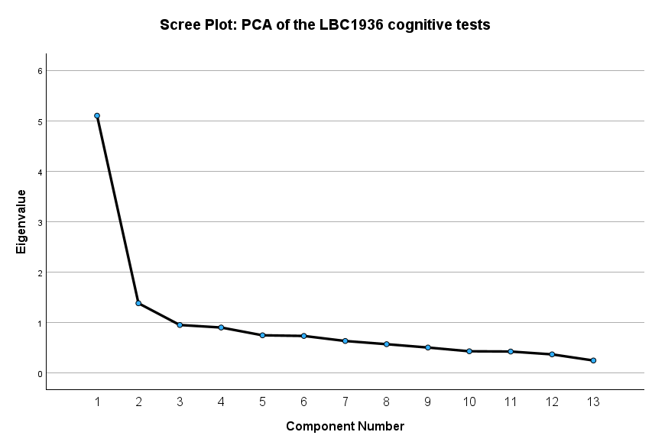

Figure S1. Scree plot for the principal component analysis (PCA) of all 14 individual cognitive tests administered at wave 1 (baseline) in the LBC1936 study. National Adult Reading Test (NART) and Wechsler Test of Adult Reading (WTAR) tests were averaged to produce a single score.

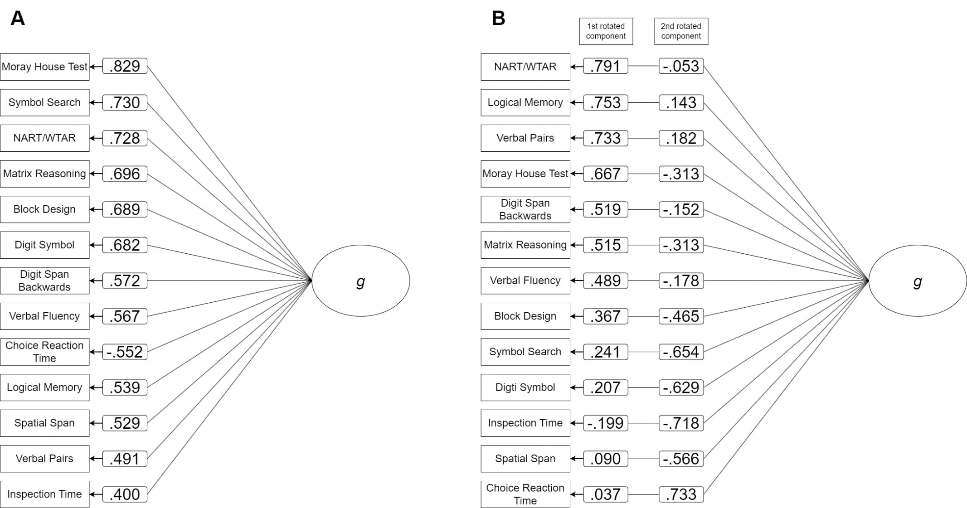

Figure S2. Principal components analysis (PCA) of all 14 cognitive tests in the Lothian Birth Cohort 1936. National Adult Reading Test (NART) and Wechsler Test of Adult Reading (WTAR) tests were averaged to produce a single score. A presents the 1st unrotated component and the loadings of each cognitive test on this component (g) from highest to lowest. The total variance accounted for by g by the first unrotated component is 39%. B presents the rotated components (using oblique rotation) and the factor loadings of each cognitive test from highest to lowest for the 1st rotated component. Total variance accounted for by the two rotated components is 50% (39.2% for the 1st component and 10.6% for the 2nd component).

