Supplementary Table S1 Stern-Volmer quenching constants of RHD alpha subunit fluorescence system at different temperatures (pH = 7.5, λex = 278 nm)
Temperature (K) | K_{SV} (L/mol) | Kq (L/mol/s) | R²
298 | 6.45×10⁴ | 6.45×10¹² | 0.9976
304 | 5.80×10⁴ | 5.80×10¹² | 0.997
310 | 5.51×10⁴ | 5.51×10¹² | 0.9967

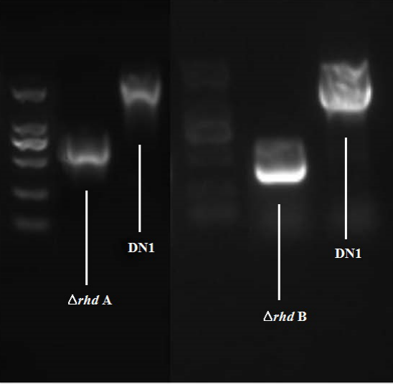
Supplementary Figure S1 Construction of △rhdA and △rhdB.

Supplementary Figure S2 Sequence alignment of amino acid residues of the template 4QUR and the targeted alpha subunit of RHD (A), and sequence alignment of amino acid residues of the template 3VCA and 4QUR (B).

Supplementary Figure S3 The modeled crystal structure of alpha subunit of RHD using a Ramachandran plot (A), schematic of superposition between the modeling alpha subunit of RHD (orange ribbon) and template 4QUR (green ribbon) (B), and schematic of superposition between template 4QUR (green ribbon) and template 3VCA (blue ribbon) (C).

Supplementary Figure S4 The combination state of fluoranthene in the active site of RHD for the homology modeling according to the crystal structure of the template 4QUR (A) and 3VCA (B).

Supplementary Figure S5 The multiple sequence alignment of amino acid residues existed in alpha subunit of RHD from different strains of the genus Pseudomonas (Shading with different colors in all the sequences represent the similarity of side chains of amino acid residues in the alignment. The conserved amino acid residues in all of the sequences are indicated with a blue-black background, and the other colors is in direct proportion to homologous comparison. Pink colors represent 75 % homology of amino acid, wathet blue colors represent 50 % homology of amino acid, and white colors represent 30 % homology of amino acid).

Supplementary Figure S6 Expression and purification of recombinant RhdA protein. A: Soluble analysis of RhdA, B: The prokaryotic expression products were detected by Western Blot, C: Mass expression and Ni column purification of RhdA.

Supplementary Figure S7 The Stern-Volmer plots of RHD alpha subunit quenched by fluoranthene at different temperatures (298, 304 and 310 K).

