Associations of blood gene expression with menopausal status and hormone therapy use in the Norwegian Women and Cancer (NOWAC) postgenome cohort

Nikita Baiju^{1, 2}, Marit Waaseth³, Pål Sætrom^{4, 5, 6, 7}, Torkjel M. Sandanger¹,

Therese H. Nøst^{1, 7, 8, 9*}

Supporting information

Supplementary Figures

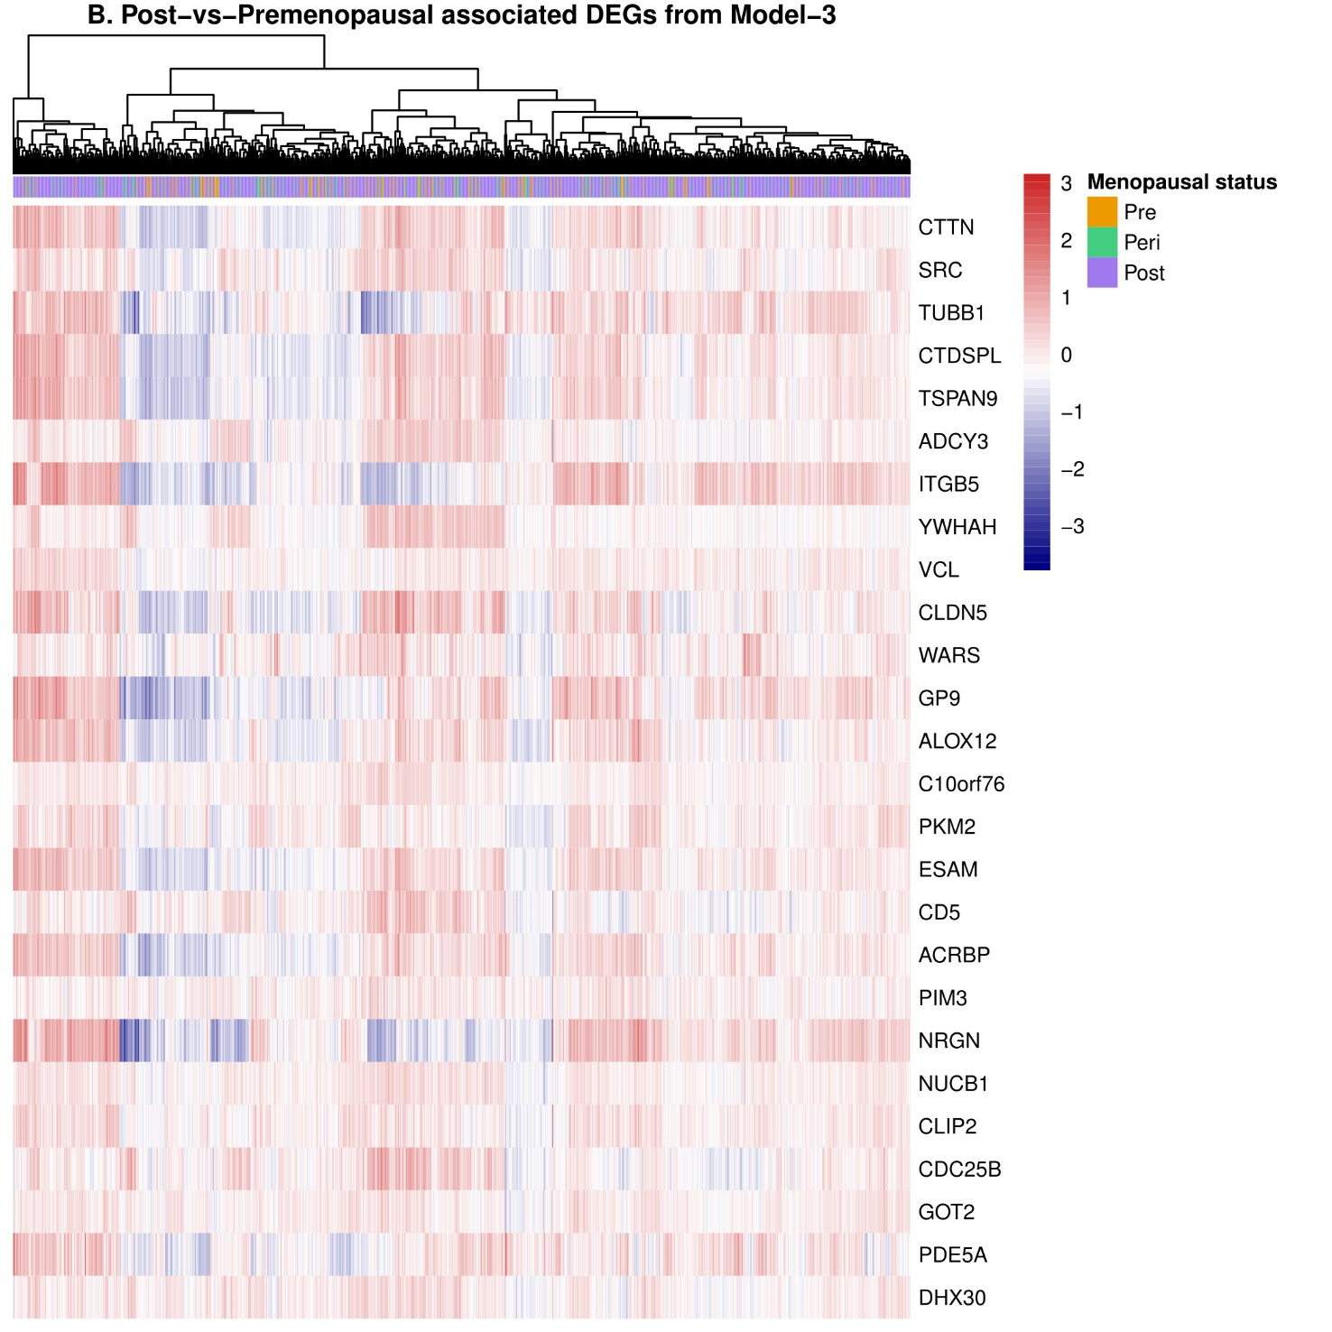

Supplementary Fig. 1. Clustering hierarchical heatmap of post-vs-premenopausal-associated DEGs from Model-2 (without WBC adjustment) (A) and Model-3 (with WBC adjustment) (B). Here, the rows represent genes, and the columns represent women. Expression levels are centered; red colour represents higher expression, while blue colour represents lower expression. DEGs: differentially expressed genes; WBC: white blood cell.
Supplementary Fig. 2. Quantile-quantile plots for different comparisons of menopausal status (A-C) and HT users-vs-non-users (D) in Model-1 (red), Model-2 (yellow), and Model-3 (blue). HT: hormone therapy.

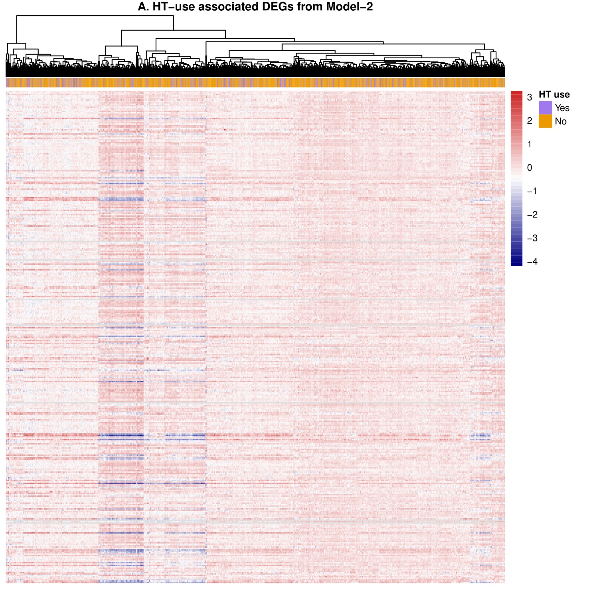

Supplementary Fig. 3. Clustering hierarchical heatmap of HT-associated DEGs from Model-2 (without WBC adjustment) (A) and Model-3 (with WBC adjustment) (B). Here, the rows represent genes, and the columns represent women. Expression levels are centered; red colour represents higher expression, while blue colour represents lower expression. DEGs: differentially expressed genes; HT: hormone therapy; WBC: white blood cell.

Supplementary Fig. 4. Scatter plot showing effect direction (logFC) for DEGs overlapping between for the comparisons of HT users-vs-non-users (Model-3) and post-vs-premenopausal status in Model-2 (A) and in Model-3 (B). Here, the x-axis represents the logFC for overlapped DEGs for HT use (Model-3) and the y-axis represents the logFC for overlapped DEGs for post-vs-premenopausal status in Model-2 in A and Model-3 in B. The blue line represents the regression line with a shaded grey area representing the standard error. DEGs: differentially expressed genes; HT: hormone therapy; logFC: log₂ fold-changes.

Supplementary Fig. 5. Summary of functional enrichment analyses for Post-vs-Pre comparison from Model-3 (with WBC adjustment) for over-expressed (Up-regulated) genes for the GO-BP (A), GO-MF (B), GO-CC (C), KEGG (D), and REACTOME pathway (E) databases. The colour of the dots indicates -log₁₀FDR, where red dots represent the most enriched categories (i.e., ones with the lowest -log₁₀FDR); the ‘GeneRatio’ indicates the proportion of genes overlapping between lists of DEGs and the genes in GO categories. DEGs: differentially expressed genes; FDR: false discovery rate; logFC: log₂ fold-changes; GO: gene ontology; BP: biological processes; MF: molecular functions; CC: cellular components; KEGG: Kyoto Encyclopedia of Genes and Genomes; Post-vs-Pre: comparison of women with postmenopausal versus premenopausal status; U: Over-expressed genes (Up-regulated, FDR≤0.05, logFC>0); WBC: white blood cell.
Supplementary Fig. 6. Summary of functional enrichment analyses for HT use from Model-2 (without WBC adjustment) for over-expressed (Up-regulated) genes for REACTOME pathway databases. The colour of the dots indicates -log₁₀FDR, where red dots represent the most enriched categories (i.e., ones with the lowest -log₁₀FDR); the ‘GeneRatio’ indicates the proportion of genes overlapping between lists of DEGs and the genes in GO categories. DEGs: differentially expressed genes; FDR: false discovery rate; logFC: log₂ fold-changes; HT: hormone therapy; U: Over-expressed genes (Up-regulated, FDR≤0.05, logFC>0); WBC: white blood cell.

