Supplementary information
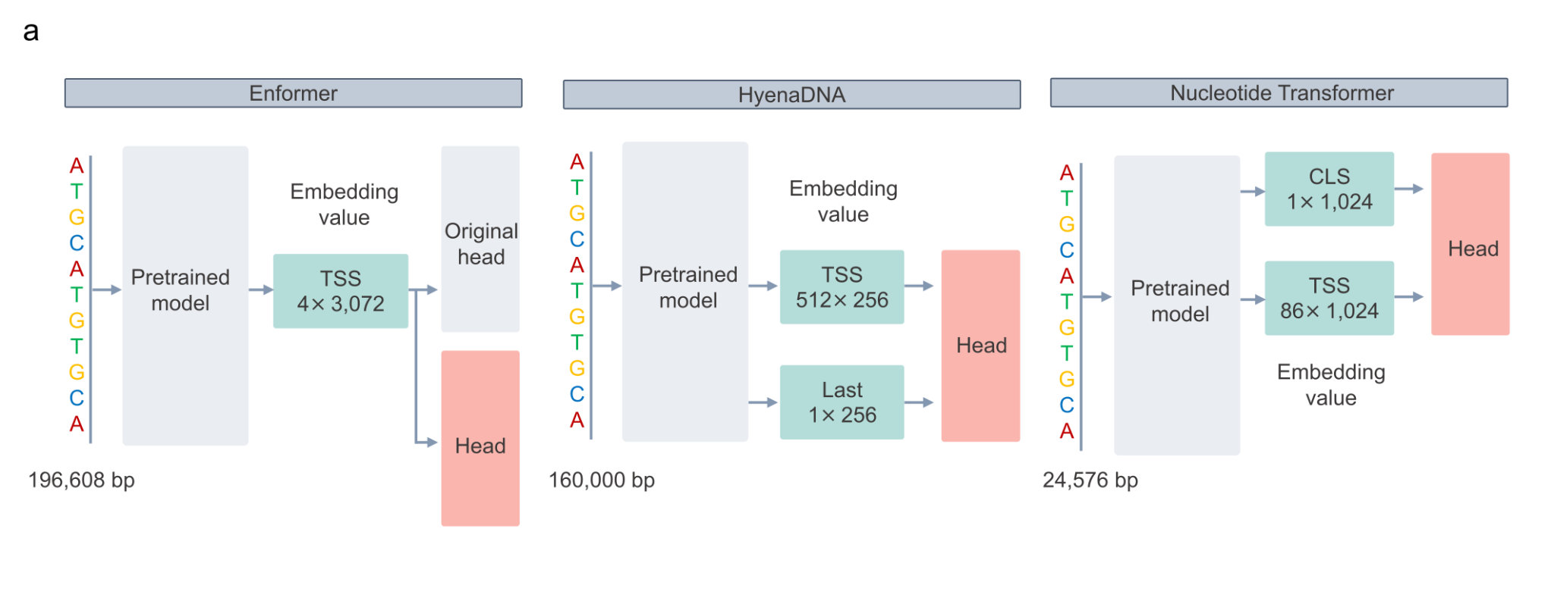
Supplementary Fig. 1. Configuration of transfer learning methods
a, Embedding values used for training as input to the additional head. Enformer (left), HyenaDNA (middle) and Nucleotide Transformer (right).
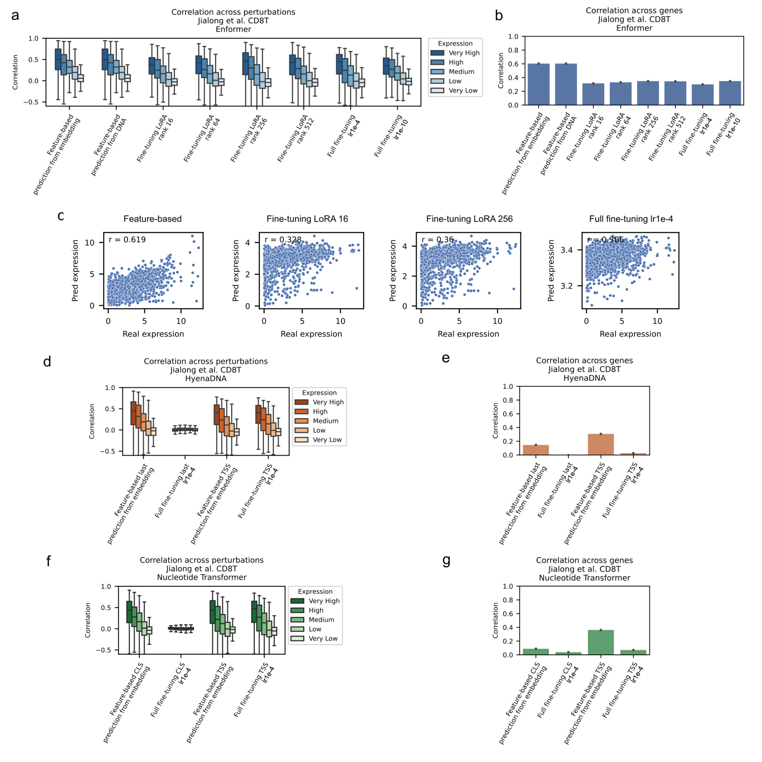
Supplementary Fig. 2. Comparison of transfer learning training methods
a-b, Enformer transfer learning model using the CD8T dataset from Jiang et al.¹ Correlation across perturbations (a) and correlation across genes (b). From left to right: (1) training and prediction via precomputed embedding values, (2) training via precomputed embedding values and prediction from the DNA sequence, (3–6) training via LoRA with varying ranks, and (7–8) updating all the parameters, including the pretrained model, using a learning rate of 1e-4 (the same as that for the head) or a smaller value of 1e-10 for the pretrained model. c, Scatter plots of observed and predicted values for each gene in the nonperturbation group. Training was performed via feature-based, LoRA with ranks of 16 and 256, and all the parameters were fine-tuned from left to right. d-e, HyenaDNA transfer learning model. Correlation across perturbations (d) and correlation across genes (e). Training using feature-based and full fine-tuning, the last token and TSS embedding. f-g, Nucleotide Transformer transfer learning model. Correlation across perturbations (f) and correlation across genes (g). Training using feature-based and full fine-tuning, a CLS token and TSS embedding.

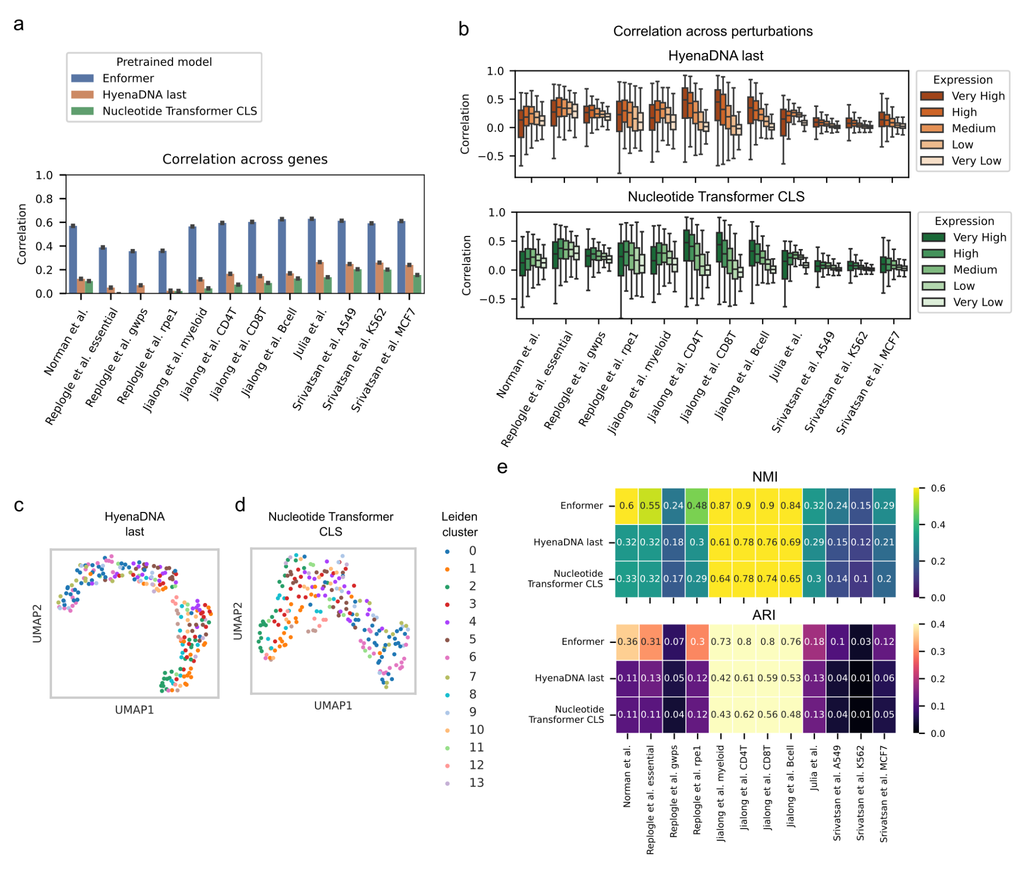
Supplementary Fig. 3. Comparison of correlation coefficients and embeddings among transfer learning models using the last token of HyenaDNA and the CLS token of Nucleotide Transformer
a, Correlations between predicted and observed values across genes after transfer learning. b, Correlation between the predicted and observed values across perturbations after transfer learning. For each dataset, the genes were divided into five groups on the basis of expression level: very high, high, middle, low, and very low, and the correlation coefficients for each group were plotted. The orange box plot represents HyenaDNA, and the green box plot represents Nucleotide Transformer. c-d, UMAPs of the observed and predicted values for each model in the Norman et al.² data, showing HyenaDNA (c) and Nucleotide Transformer (d). The labels from the Leiden clustering of the observed values are coloured and match those in Fig. 3a-d. e, Consistency evaluation between Leiden clustering for the observed and predicted values via the ARI and NMI.

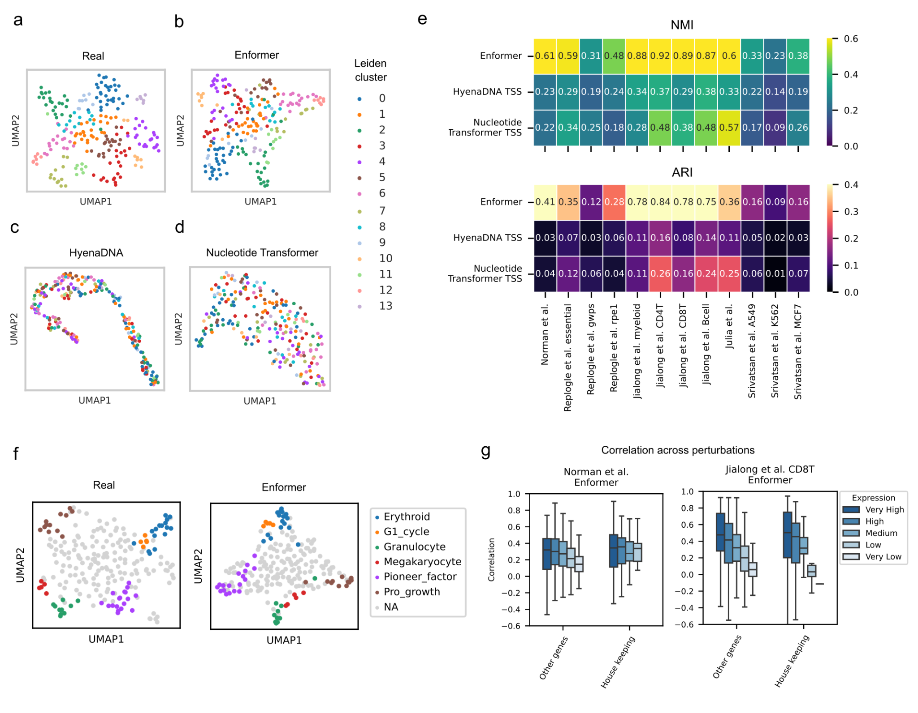Supplementary Fig. 4. Comparison of embedding results of predicted and actual values from the transfer learning model using all genes
a-d, UMAP of observed values and predicted values for each model in Norman et al.², showing observed (a), Enformer (b), HyenaDNA (c), and Nucleotide Transformer (d) data. Gene expression values were used for all genes, including those in the training set. The labels from the Leiden clustering of the observed values are coloured. e, Consistency evaluation between Leiden clustering for observed and predicted values, using the ARI and NMI. f, UMAP plot labelled with the perturbation group obtained from Norman et al.² using the test set instead of all genes to compare Fig. 4a. g, Correlations across perturbations for housekeeping genes and the other genes registered in the HRT Atlas via the test set. Norman et al.² (left) and Jiang et al.¹ CD8+ T cells (right).

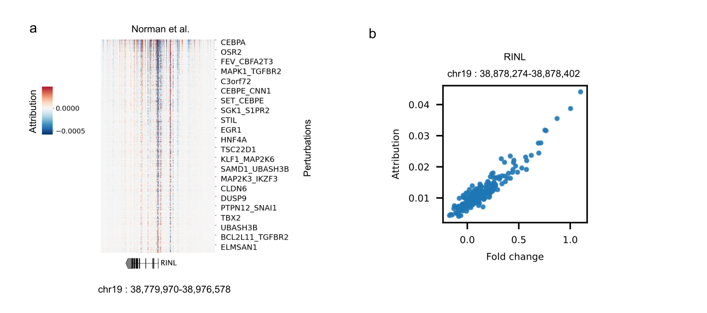
Supplementary Fig. 5. Correlation between the subtraction value of the attribution score and gene expression
a, Distribution of attribution scores centred on the TSS of RINL (values obtained by subtracting the nonperturbation from the perturbation). The x-axis represents the genome region chr19:38,779,970--38,976,578, and the y-axis represents the fold change of each perturbation in ascending order. b, Correlations between attribution scores in specific regions within the genome area described in (a) and fold changes in RINL expression due to perturbations.

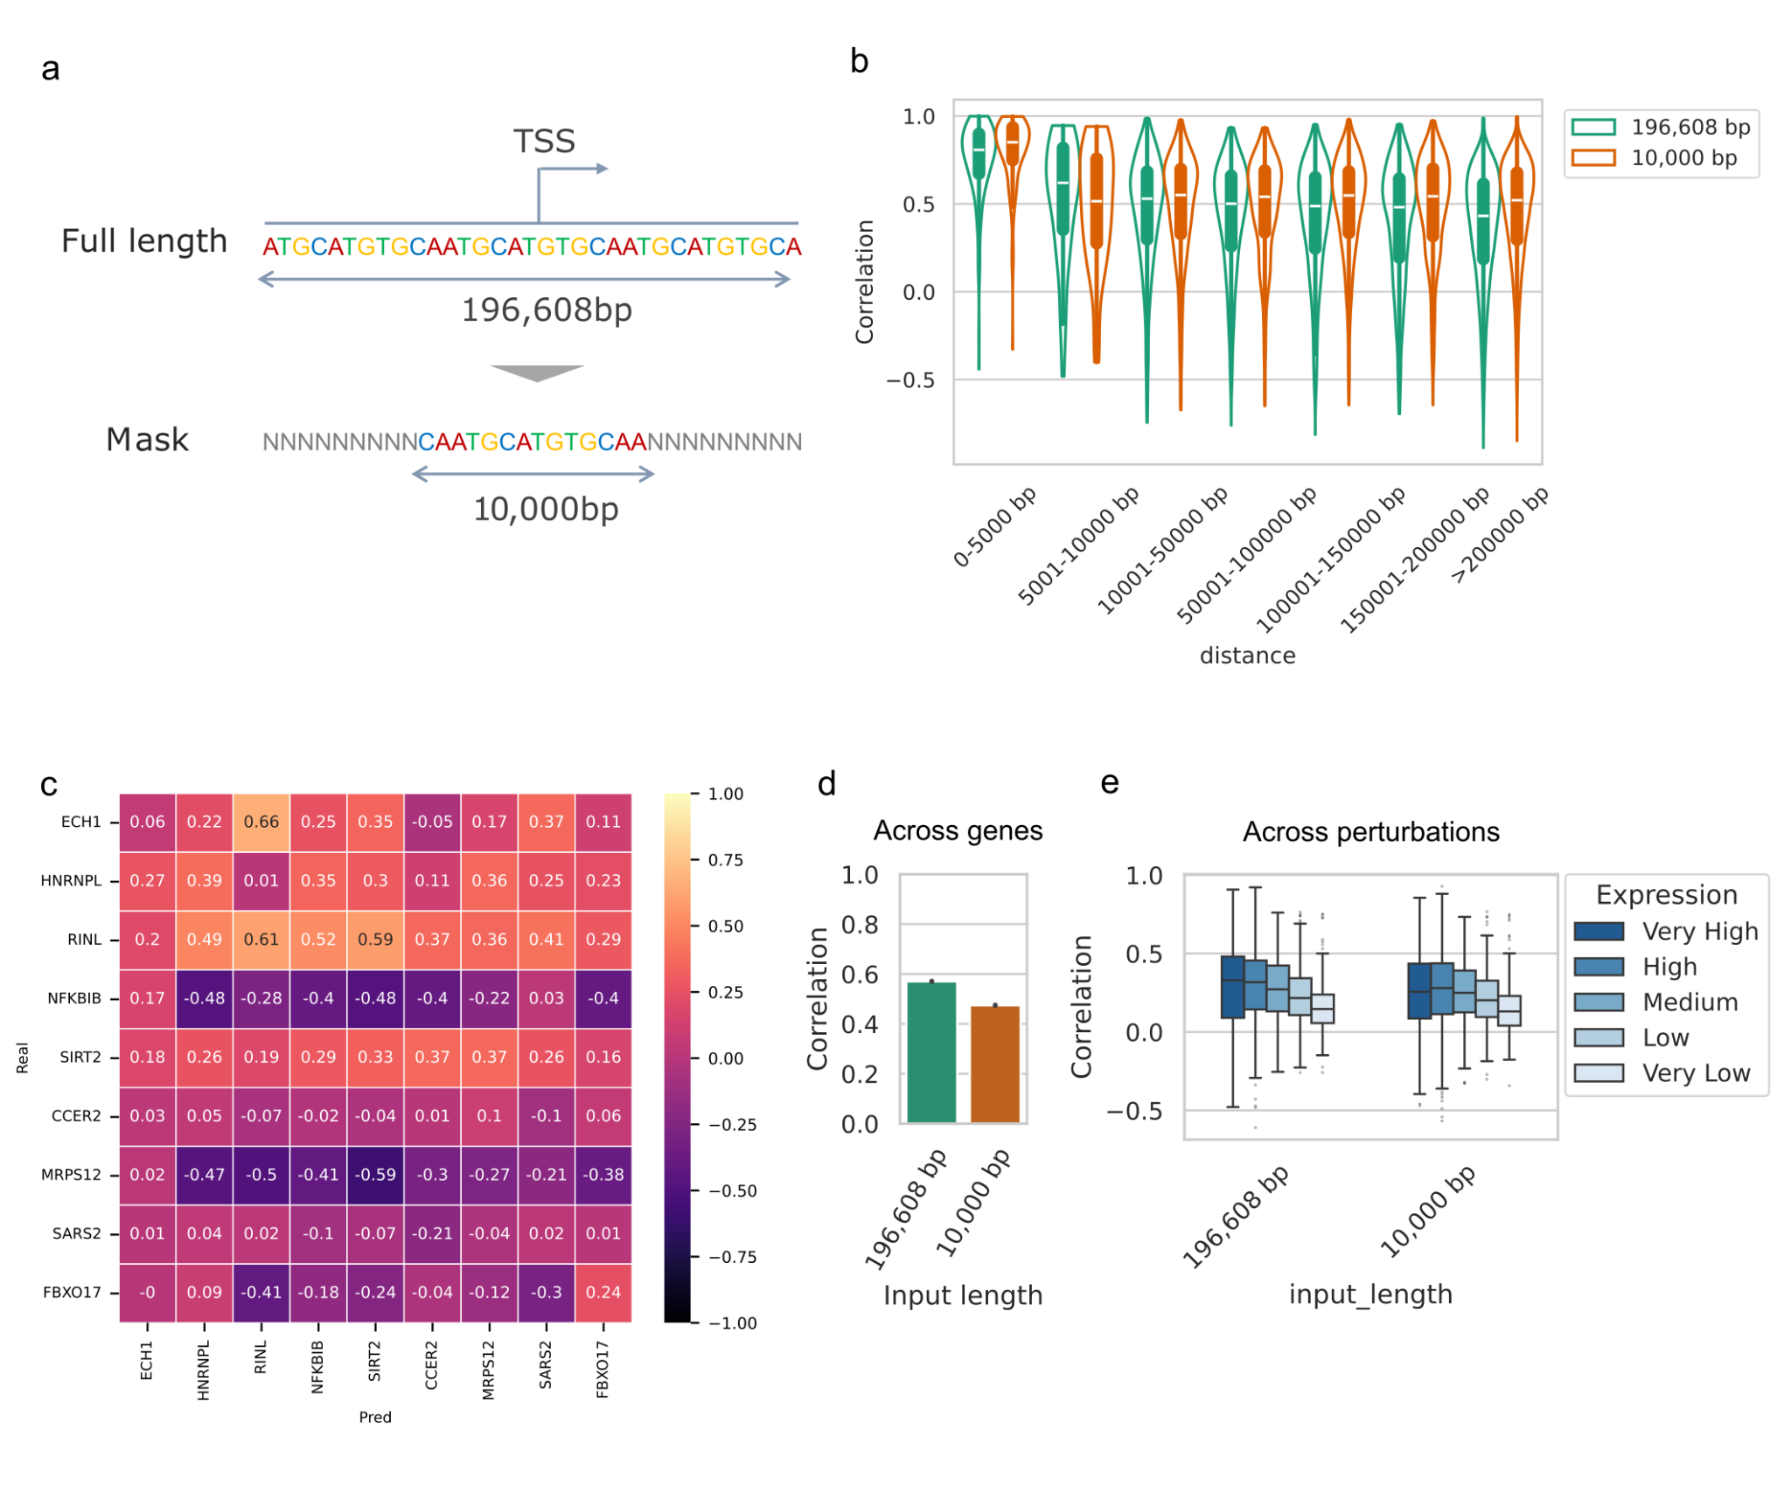
Supplementary Fig. 6. Changes in prediction accuracy due to masking of input DNA
a, Masking scheme for input DNA sequences. b, Comparison between the Enformer transfer learning model trained with input sequence masking regions outside 10 kbp around TSSs and the full-length model. c, Pairwise correlation coefficients of observed values and predicted values for masking model. d, Correlations between predicted and observed values across genes. e, Correlation between the predicted and observed values across perturbations. The genes were divided into five groups on the basis of expression level: very high, high, middle, low, and very low, and the correlation coefficients for each group were plotted.
Supplementary Table 1. Dataset metadata used for training.
Perturbation | Cell type | Paper | Num. genes | Num. perturbations
CRISPRa | K562 | Norman et al. Science 2019 | 12,105 | 220
CRISPRi (gwps) | K562 | Replogle et al. Cell 2022 | 8,078 | 1,545
CRISPRi (essential gene) | K562 | Replogle et al. Cell 2022 | 8,386 | 638
CRISPRi | RPE1 | Replogle et al. Cell 2022 | 8,600 | 409
Compound | Myeloid | Jialong et al. biorxiv 2024 | 12,319 | 496
Compound | CD8T | Jialong et al. biorxiv 2024 | 13,502 | 620
Compound | CD4T | Jialong et al. biorxiv 2024 | 12,839 | 537
Compound | B cell | Jialong et al. biorxiv 2024 | 14,095 | 290
CDS over expression | ES cell | Julia et al. Cell 2023 | 19,538 | 1,315
Compound | A549 | Srivatsan et al. Science 2020 | 27,927 | 703
Compound | K562 | Srivatsan et al. Science 2020 | 27,991 | 683
Compound | MCF7 | Srivatsan et al. Science 2020 | 23,224 | 740

Supplementary Table 2. Download sources for ChIP-seq and ATAC-seq data.
SRX | Target | Cell type
SRX10475577 | HNF4A | HepG2
DRX440350 | TP73 | CD4T
SRX2424509 | IRF1 | K562
SRX4342285 | AHR | GM17212
SRX097105 | CEBPA | K562
SRX1431734 | SPI1 | K562
SRX5732677 | KMT2A | MOLM-13
SRX3070540 | PRDM1 | U-266
SRX2423912 | CEBPB | K562
SRX10478046 | SNAI1 | HepG2
SRX16495812 | JUN | K562
SRX5457220 | ETS2 | K562
SRX2424502 | FOXA1 | K562
SRX3321888 | EGR1 | K562
SRX10184518 | ATAC | K562
SRX10184470 | H3K27 | K562
SRX9243952 | H3K27me3 | K562
SRX8725106 | H3K36me3 | K562
SRX2636149 | H3K4me3 | K562
SRX028593 | H3K9me3 | K562

References
- Jiang, J. et al. D-SPIN constructs gene regulatory network models from multiplexed scRNA-seq data revealing organizing principles of cellular perturbation response. bioRxiv 2023.04.19.537364 (2024).
- Norman, T. M. et al. Exploring genetic interaction manifolds constructed from rich single-cell phenotypes. Science 365, 786–793 (2019).

