Supplementary Information

Journal Name: International Journal of Clinical Oncology

Exploring the crosstalk between the FGF/FGFR pathway and tumor microenvironment in clear cell renal cell carcinoma

Takafumi Narisawa¹, Sei Naito¹, Yoshihide Mitsuda², Rintaro Ohe³, Hidenori Sato⁴, Chizuru Kobayashi², Yuki Miyano⁴, Hiromi Ito¹, Mitsuru Futakuchi³, Norihiko Tsuchiya ¹

¹ Department of Urology, Faculty of Medicine, Yamagata University, Yamagata, Japan
² Eisai Co., Ltd., Tokyo, Japan
³ Department of Pathology, Faculty of Medicine, Yamagata University, Yamagata, Japan
⁴ Division of Multi-omics Research, Yamagata University Well-Being Institute, Yamagata, Japan

Corresponding author: Takafumi Narisawa
Department of Urology, Yamagata University Faculty of Medicine,
2-2-2 Iida-nishi, Yamagata 990-9585, Japan
Email: tnari_0623@yahoo.co.jp
Online Resource 1. Association between FGFR subtype expressions with IMDC risk factors.
 | FGFR1 |  |  | FGFR2 |  |  | FGFR4
Variable | High, n=46 | Low, n=11 | p | High, n=13 | Low, n=44 | p | High, n=8 | Low, n=49 | p
Platelet count, mean (×10⁴/μL) | 26.4 | 22.3 | 0.035 | 22.4 | 26.6 | 0.060 | 25.6 | 25.6 | 0.995
Corrected calcium, mean (mg/dL) | 9.0 | 8.7 | 0.048 | 8.8 | 9.0 | 0.012 | 9.1 | 8.9 | 0.541
Neutrophil count, mean (×10²/μL) | 40.3 | 34.2 | 0.253 | 30.0 | 41.4 | 0.028 | 44.7 | 38.0 | 0.280
Hemoglobin, mean (g/dL) | 13.9 | 14.2 | 0.648 | 14.6 | 13.8 | 0.136 | 13.3 | 14.1 | 0.478

Online Resource 2. Comparison of FGFR Subtype differences in relation to overall survival.
Kaplan-Meier curves showing probability of overall survival across the expression levels of FGFR1 (A), FGFR2 (B), and FGFR4 (C). Sample numbers per group indicated below the graphs.

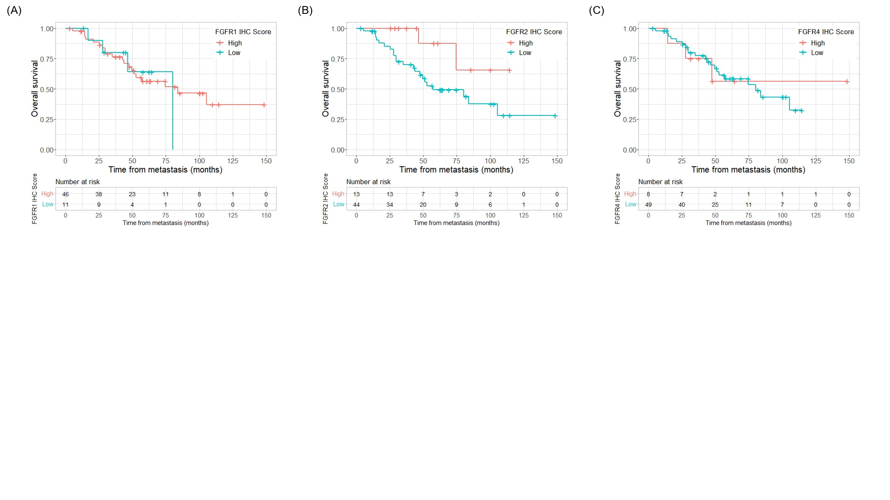

Online Resource 3. Comparison of immunosuppressive phenotypes and ICI treatment response in relation to FGFR2 and FGFR4 expression.
Transcriptome analysis of immune-related genes and evaluation of clinical response of nivolumab. (A) IMmotion150 Teff signature scores across the expression levels of FGFR2 and FGFR4. n.s.; not significant. (B) Correlation between IHC score of FGFR2 or FGFR4 and IFNγ signaling target genes using Pearson’s correlation analysis. (C) Objective response to nivolumab across all treatment lines, comparing differences in FGFR2 and FGFR4 expression levels. CR; complete response, PR; partial response, SD; stable disease, PD; progressive disease.
